NAME: K Yamini
REG NO: 192572181

Write a Prolog Program to implement Best First Search algorithm.
Aim:
To implement the Best First Search algorithm in Prolog and find a path from a starting node to a goal node using heuristic values.
Algorithm:
- Start the program.
- Define the graph with connected nodes.
- Assign a heuristic value to each node.
- Select the starting node.
- Add the starting node to the open list.
- Select the node having the lowest heuristic value.
- Check whether the selected node is the goal.
- If it is the goal, display the path.
- Otherwise, add its unvisited neighboring nodes to the open list.
- Repeat the process until the goal is reached.
- Display the final path.
- Stop the program.
Prolog program:
% EXPERIMENT 27
% Best First Search Algorithm

% Graph connections
edge(a, b).
edge(a, c).
edge(b, d).
edge(b, e).
edge(c, f).
edge(e, g).
edge(f, g).

% Heuristic values
heuristic(a, 6).
heuristic(b, 4).
heuristic(c, 5).
heuristic(d, 3).
heuristic(e, 2).
heuristic(f, 1).
heuristic(g, 0).

% Best First Search
best_first(Start, Goal) :-
search([Start], Goal, [Start]).

% Goal condition
search([Goal|_], Goal, Path) :-
write('Goal reached: '),
write(Goal),
nl,
write('Path: '),
write(Path),
nl.

% Continue search
search([Current|Rest], Goal, Path) :-
findall(
Next,
(
edge(Current, Next),
\+ member(Next, Path)
),
Children
),

choose_best(Children, Best),

write('Current Node: '),
write(Current),
nl,

write('Selected Node: '),
write(Best),
nl,

append([Best], Rest, NewOpen),

search(NewOpen, Goal, [Best|Path]).

% Choose node having lowest heuristic value
choose_best([First|Rest], Best) :-
choose_best_helper(Rest, First, Best).

choose_best_helper([], Best, Best).

choose_best_helper([Node|Rest], CurrentBest, Best) :-
heuristic(Node, H1),
heuristic(CurrentBest, H2),

H1 < H2,
choose_best_helper(Rest, Node, Best).

choose_best_helper([Node|Rest], CurrentBest, Best) :-
heuristic(Node, H1),
heuristic(CurrentBest, H2),

H1 >= H2,
choose_best_helper(Rest, CurrentBest, Best).
Input:
?- best_first(a, g).
Output :
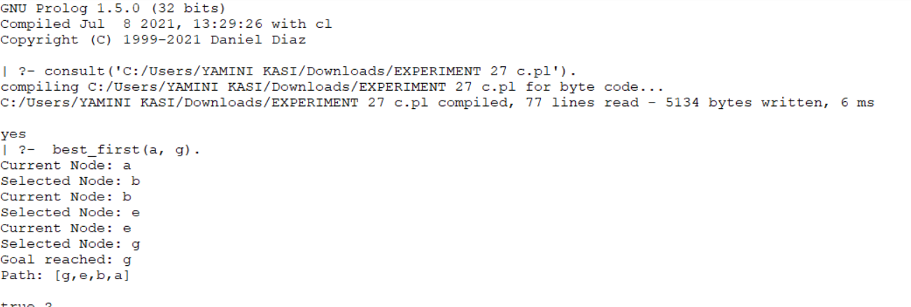
Result:
Thus, the Best First Search algorithm was successfully implemented in Prolog using heuristic values to reach the goal node.

