NAME: K Yamini
REG NO: 192572181

Write a Prolog program for a database with NAME and DOB. Aim:
Write a Prolog program for a database with NAME and DOB.
Algorithm:
- Start the program.
- Create facts containing the person's name and date of birth.
- Define a predicate person(Name, DOB).
- Store the name and DOB as facts.
- Use Prolog queries to retrieve the DOB of a particular person.
- Prolog searches the database and matches the given name.
- Display the corresponding DOB.
- Stop.
Prolog program:
% EXPERIMENT 18
% Database with NAME and DOB

% Facts
person(yamini, '07-09-2008').
person(rahul, '15-03-2007').
person(priya, '22-11-2008').
person(arun, '10-05-2007').
person(sneha, '18-01-2008').

% Predicate to display person's DOB
show_dob(Name) :-
person(Name, DOB),
write('Name: '),
write(Name),
nl,
write('Date of Birth: '),
write(DOB),
nl.
Input:
?- show_dob(yamini).
Output :
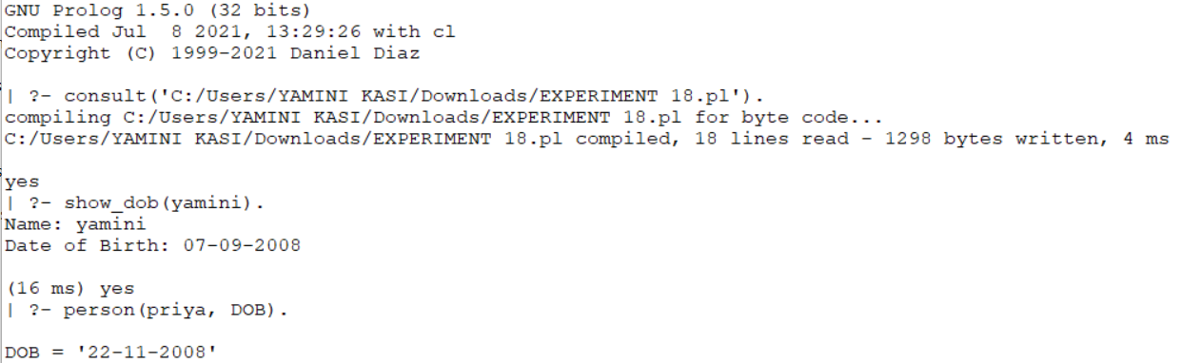
Result:
Thus, the Prolog program for maintaining a database containing NAME and DOB was successfully implemented and the required information was retrieved using Prolog queries.

