NAME: K Yamini
REG NO: 192572181

Write a Python program to implement Minimax algorithm for gaming.
Aim:
To implement the Minimax algorithm to determine the best move for a player in a game (like Tic-Tac-Toe).
Algorithm:
- Represent the game board.
- Define two players:
Maximizer (X)
Minimizer (O)
- Define a function to check winner.
- Define Minimax function:
If Maximizer’s turn → choose maximum score
If Minimizer’s turn → choose minimum score
- Base conditions:
If X wins → return +1
If O wins → return -1
If draw → return 0
- Recursively explore all possible moves.
- Choose the best move for AI.
- Display best move and score.

Python Code:
# Minimax Algorithm for Tic-Tac-Toe

board = ['X', 'O', 'X',
'O', 'O', 'X',
' ', ' ', ' ']

def display(b):
print(b[0], "|", b[1], "|", b[2])
print("--+---+--")
print(b[3], "|", b[4], "|", b[5])
print("--+---+--")
print(b[6], "|", b[7], "|", b[8])

def check_winner(b):
wins = [
[0,1,2], [3,4,5], [6,7,8],
[0,3,6], [1,4,7], [2,5,8],
[0,4,8], [2,4,6]
]

for a, c, d in wins:
if b[a] == b[c] == b[d] and b[a] != ' ':
if b[a] == 'X':
return 1
else:
return -1
return 0

def minimax(b, is_max):
score = check_winner(b)

if score != 0:
return score

if ' ' not in b:
return 0

if is_max:
best = -100

for i in range(9):
if b[i] == ' ':
b[i] = 'X'
best = max(best, minimax(b, False))
b[i] = ' '

return best

else:
best = 100

for i in range(9):
if b[i] == ' ':
b[i] = 'O'
best = min(best, minimax(b, True))
b[i] = ' '

return best

def find_best_move(b):
best_value = -100
best_move = -1

for i in range(9):
if b[i] == ' ':
b[i] = 'X'
value = minimax(b, False)
b[i] = ' '

print("Move", i + 1, "-> Score:", value)

if value > best_value:
best_value = value
best_move = i

return best_move, best_value

print("Initial Board:\n")
display(board)

best_move, best_value = find_best_move(board)

print("\nMinimax Decision Tree:\n")
print(" X")
print(" / | \\")
print(" 7 8 9")
print(" +1 0 -1")
print(" ↑")
print(" BEST MOVE")

print("\nBest Move for X:", best_move + 1)
print("Best Score:", best_value)
Input:
Initial Board:
X O X
O O X
_ _ _
Output :
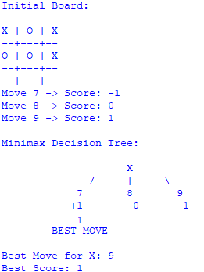
Result:
The Minimax algorithm is successfully implemented and determines the optimal move for the player by evaluating all possible game states.

