NAME: K Yamini
REG NO: 192572181

Write a Python program to implement Breadth First Search (BFS)
Aim:
To traverse a graph using Breadth First Search (BFS) technique.
Algorithm:
- Represent the graph using an adjacency list.
- Choose a starting node.
- Create a queue for BFS traversal.
- Mark the starting node as visited.
- Add the starting node to the queue.
- Repeat until queue is empty:
a. Remove a node from the queue.
b. Print the node.
c. Visit all unvisited adjacent nodes.
d. Mark them visited and add to queue.
- Continue until all nodes are visited.
Python Code:
from collections import deque

graph = {
'A': ['B', 'C'],
'B': ['D', 'E'],
'C': ['F'],
'D': [],
'E': [],
'F': []
}

visited = set()
queue = deque([('A', 'A')])

print("BFS Tree:\n")
print(" A")
print(" / \\")
print(" B C")
print(" / \\ \\")
print(" D E F")

print("\nPaths:")
while queue:
node, path = queue.popleft()

if node not in visited:
visited.add(node)
print(path)

for x in graph[node]:
queue.append((x, path + " -> " + x))
Input:
Graph:
A → B, C
B → D, E
C → F
E → F
Starting Node = A
Output :
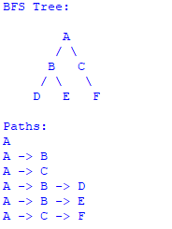
Result:
The graph is successfully traversed using Breadth First Search, visiting nodes level by level.

