NAME: K Yamini
REG NO: 192572181

Write a Python program to implement Depth First Search (DFS)
Aim:
To traverse a graph using Depth First Search (DFS) technique.
Algorithm:
- Represent the graph using an adjacency list.
- Choose a starting node.
- Create a set to store visited nodes.
- Define a recursive DFS function.
- Mark the current node as visited.
- Print the current node.
- For each adjacent node:
If not visited → recursively call DFS
- Continue until all nodes are visited.
Python Code:
graph = {
'A': ['B', 'C'],
'B': ['D', 'E'],
'C': ['F'],
'D': [],
'E': [],
'F': []
}

visited = set()

def dfs(node, path):
visited.add(node)
print("Visit:", node, " Path:", path)

for x in graph[node]:
if x not in visited:
dfs(x, path + " -> " + x)

print("DFS Tree:\n")
print(" A")
print(" / \\")
print(" B C")
print(" / \\ \\")
print(" D E F")

print("\nDFS Steps:")
dfs('A', 'A')
Input:
Graph:
A → B, C
B → D, E
C → F
E → F
Starting Node = A
Output :
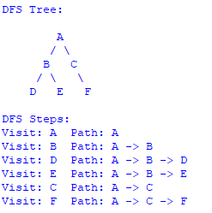
Result:
The graph is successfully traversed using Depth First Search, exploring nodes deeply before backtracking.

