NAME: K Yamini
REG NO: 192572181

Write a Python program to implement Travelling Salesman Problem

Aim:

To find the shortest possible route that visits each city exactly once and returns to the starting city.

Algorithm:

- Represent cities using a distance matrix.
- Start from a fixed city (say city 0).
- Generate all possible permutations of remaining cities.
- For each permutation:
  - Calculate total distance of the route.
  - Include return to starting city.
- Compare all routes and select the minimum cost.
- Print the shortest path and minimum distance.

Python Code:

from itertools import permutations

cost = [
[0, 10, 15, 20],
[10, 0, 35, 25],
[15, 35, 0, 30],
[20, 25, 30, 0]
]

cities = [1, 2, 3]
min_cost = 999
best_path = []

print("TSP Tree:\n")
print(" 1")
print(" / | \\")
print(" 2 3 4")
print(" / \\ / \\ / \\")
print(" 3 4 2 4 2 3")

for p in permutations(cities):
path = [0] + [x - 1 for x in p] + [0]
total = 0

for i in range(len(path) - 1):
total += cost[path[i]][path[i + 1]]

print("\nPath:", " -> ".join(str(x + 1) for x in path))
print("Cost:", total)

if total < min_cost:
min_cost = total
best_path = path

print("\nShortest Path:")
print(" -> ".join(str(x + 1) for x in best_path))
print("Minimum Cost:", min_cost)

Input:

Number of Cities = 4 Distance Matrix:
0 10 15 |  | 20
10 | 0 35 | 25
15 | 35 0 | 30
20 | 25 30 | 0

Output :
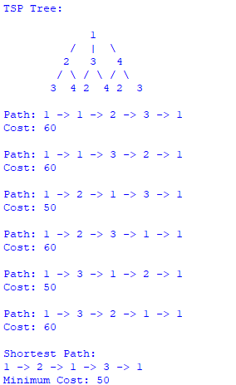

Result:
The Travelling Salesman Problem is solved successfully, and the shortest route with minimum cost is obtained.

