NAME: K Yamini
REG NO: 192572181

Write a Python program to implement Breadth First Search (BFS)
Aim:
To traverse a graph using Breadth First Search (BFS) technique.
Algorithm:
- Represent the graph using an adjacency list.
- Choose a starting node.
- Create a queue for BFS traversal.
- Mark the starting node as visited.
- Add the starting node to the queue.
- Repeat until queue is empty:
a. Remove a node from the queue.
b. Print the node.
c. Visit all unvisited adjacent nodes.
d. Mark them visited and add to queue.
- Continue until all nodes are visited.
Python Code:
from collections import deque
# Graph using adjacency list
graph = {
'A': ['B', 'C'],
'B': ['D', 'E'],
'C': ['F'],
'D': [],
'E': ['F'],
'F': []
}
# BFS function
def bfs(start):
visited = set()
queue = deque()
visited.add(start)
queue.append(start)
print("BFS Traversal:\n")
step = 1
while queue:
node = queue.popleft()
print("Step", step, ":", node)
# Comment explanation
print("# Visiting node", node)
for neighbor in graph[node]:
if neighbor not in visited:
visited.add(neighbor)
queue.append(neighbor)
print("# Adding", neighbor, "to queue")
print()
step += 1
# Input
start_node = 'A'
# Output
print("Starting Node:", start_node, "\n")
bfs(start_node)
Input:
Graph:
A → B, C
B → D, E
C → F
E → F
Starting Node = A
Output :
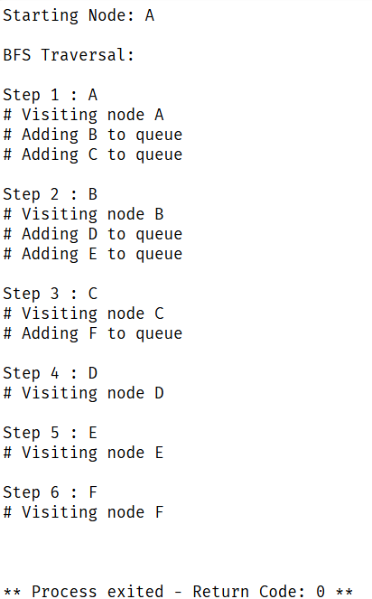
Result:
The graph is successfully traversed using Breadth First Search, visiting nodes level by level.

