NAME: K Yamini
REG NO: 192572181

Write a Python program to implement Depth First Search (DFS)
Aim:
To traverse a graph using Depth First Search (DFS) technique.
Algorithm:
- Represent the graph using an adjacency list.
- Choose a starting node.
- Create a set to store visited nodes.
- Define a recursive DFS function.
- Mark the current node as visited.
- Print the current node.
- For each adjacent node:
If not visited → recursively call DFS
- Continue until all nodes are visited.
Python Code:
# Graph using adjacency list
graph = {
'A': ['B', 'C'],
'B': ['D', 'E'],
'C': ['F'],
'D': [],
'E': ['F'],
'F': []
}

visited = set()

# DFS function
def dfs(node):
if node not in visited:
visited.add(node)

print("Visiting:", node)
print("# Node", node, "visited")

for neighbor in graph[node]:
if neighbor not in visited:
print("# Going deeper to", neighbor)
dfs(neighbor)

# Input
start_node = 'A'

# Output
print("Starting Node:", start_node, "\n")
print("DFS Traversal:\n")

dfs(start_node)

print("\nDFS Completed")
Input:
Graph:
A → B, C
B → D, E
C → F
E → F
Starting Node = A

Output :
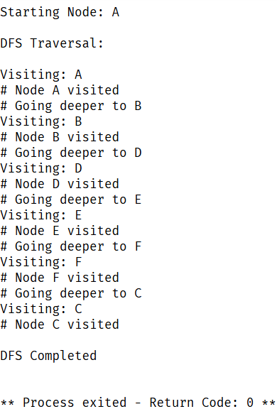
Result:
The graph is successfully traversed using Depth First Search, exploring nodes deeply before backtracking.

