NAME: K Yamini
REG NO: 192572181

Write a Python program for Map Coloring to implement Constraint Satisfaction Problem (CSP)
Aim:
To assign colors to regions of a map such that no two adjacent regions have the same color.
Algorithm:
- Represent the map as a graph (nodes = regions).
- Define adjacency (neighbors).
- Define available colors (e.g., Red, Green, Blue).
- Assign colors using backtracking:
Start with first region
Assign a color
- Check constraints:
Adjacent regions should not have same color
- If valid → move to next region
- If not valid → backtrack and try another color
- Repeat until all regions are colored
- Print final color assignment
Python Code:
# Map Coloring using CSP (Backtracking)
# Graph (Map)
graph = {
'A': ['B', 'C'],
'B': ['A', 'C', 'D'],
'C': ['A', 'B', 'D'],
'D': ['B', 'C']
}
# Available colors
colors = ['Red', 'Green', 'Blue']
# Store result
result = {}
# Check if color is valid
def is_safe(node, color):
for neighbor in graph[node]:
if neighbor in result and result[neighbor] == color:
return False
return True
# Backtracking function
def solve(node_list, index):
if index == len(node_list):
return True
node = node_list[index]
for color in colors:
if is_safe(node, color):
result[node] = color
if solve(node_list, index + 1):
return True
# Backtrack
result[node] = None
return False
# Solve
nodes = list(graph.keys())
if solve(nodes, 0):
print("Color Assignment:\n")
step = 1
for node in result:
print("Region", node, "→", result[node])
print("# Assigning", result[node], "to region", node)
step += 1
else:
print("No solution exists")
Input:
Regions: A, B, C, D
Colors: Red, Green, Blue

Output :
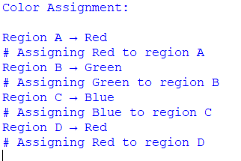
Result:
The Map Coloring problem is solved successfully using CSP and backtracking, ensuring no adjacent regions share the same color.

