NAME: K Yamini
REG NO: 192572181

Write a Python program to implement Minimax algorithm for gaming.
Aim:
To implement the Minimax algorithm to determine the best move for a player in a game (like Tic-Tac-Toe).
Algorithm:
- Represent the game board.
- Define two players:
Maximizer (X)
Minimizer (O)
- Define a function to check winner.
- Define Minimax function:
If Maximizer’s turn → choose maximum score
If Minimizer’s turn → choose minimum score
- Base conditions:
If X wins → return +1
If O wins → return -1
If draw → return 0
- Recursively explore all possible moves.
- Choose the best move for AI.
- Display best move and score.

Python Code:
# Minimax Algorithm for Tic-Tac-Toe
board = ['X', 'O', 'X',
'O', 'O', 'X',
' ', ' ', ' ']
# Display board
def display():
print("\nBoard State:")
for i in range(0, 9, 3):
print(board[i], "|", board[i+1], "|", board[i+2])
print()
# Check winner
def check_winner(b):
win_conditions = [
[0,1,2], [3,4,5], [6,7,8],
[0,3,6], [1,4,7], [2,5,8],
[0,4,8], [2,4,6]
]
for cond in win_conditions:
if b[cond[0]] == b[cond[1]] == b[cond[2]]:
if b[cond[0]] == 'X':
return 1
elif b[cond[0]] == 'O':
return -1
return 0
# Check if moves left
def is_moves_left(b):
return ' ' in b
# Minimax function
def minimax(b, is_max):
score = check_winner(b)
if score == 1 or score == -1:
return score
if not is_moves_left(b):
return 0
if is_max:
best = -100
for i in range(9):
if b[i] == ' ':
b[i] = 'X'
best = max(best, minimax(b, False))
b[i] = ' '
return best
else:
best = 100
for i in range(9):
if b[i] == ' ':
b[i] = 'O'
best = min(best, minimax(b, True))
b[i] = ' '
return best
# Find best move
def find_best_move(b):
best_val = -100
best_move = -1
for i in range(9):
if b[i] == ' ':
b[i] = 'X'
move_val = minimax(b, False)
b[i] = ' '
print("# Checking move at position", i+1, "Score:", move_val)
if move_val > best_val:
best_move = i
best_val = move_val
return best_move
# Run
display()
best_move = find_best_move(board)
print("\nBest Move for X is position:", best_move + 1)
print("# AI selects optimal move using Minimax")
Input:
Initial Board:
X O X
O O X
_ _ _
Output :
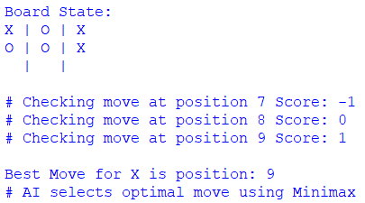
Result:
The Minimax algorithm is successfully implemented and determines the optimal move for the player by evaluating all possible game states.

