Experiment: Empirical Cumulative Distribution Function (ECDF)

Aim
To construct and visualize the Empirical Cumulative Distribution Function (ECDF) for a given dataset using R and interpret the cumulative probabilities.

Objective
- To understand the concept of ECDF.
- To generate an ECDF using R.
- To visualize the cumulative distribution of sample data.
- To interpret cumulative probabilities from the ECDF graph.

Theory
The Empirical Cumulative Distribution Function (ECDF) is a non-parametric estimate of the cumulative distribution function of a dataset. It represents the proportion of observations that are less than or equal to a given value.
Unlike a theoretical CDF, the ECDF is constructed directly from the observed data without assuming any probability distribution.
Formula
ECDF(x)=Number of observations ≤x​
n
Where:
- x = Observation
- n = Total number of observations

Requirements
- R Programming Language
- RStudio
- Sample Dataset

Algorithm / Procedure

Step 1:
Open RStudio.

Step 2:
Create a vector containing the sample data.

Step 3:
Generate the ECDF using the ecdf() function.

Step 4:
Store the ECDF in a variable.

Step 5:
Plot the ECDF using the plot() function.

Step 6:
Add the title, x-axis label, and y-axis label.

Step 7:
(Optional) Add grid lines using the grid() function.

Step 8:
Find the cumulative probability for a specific value using ecdf_name(value).

Step 9:
Interpret the ECDF graph and the cumulative probability.

Program
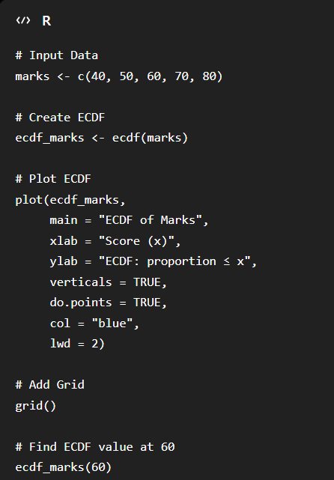
Output
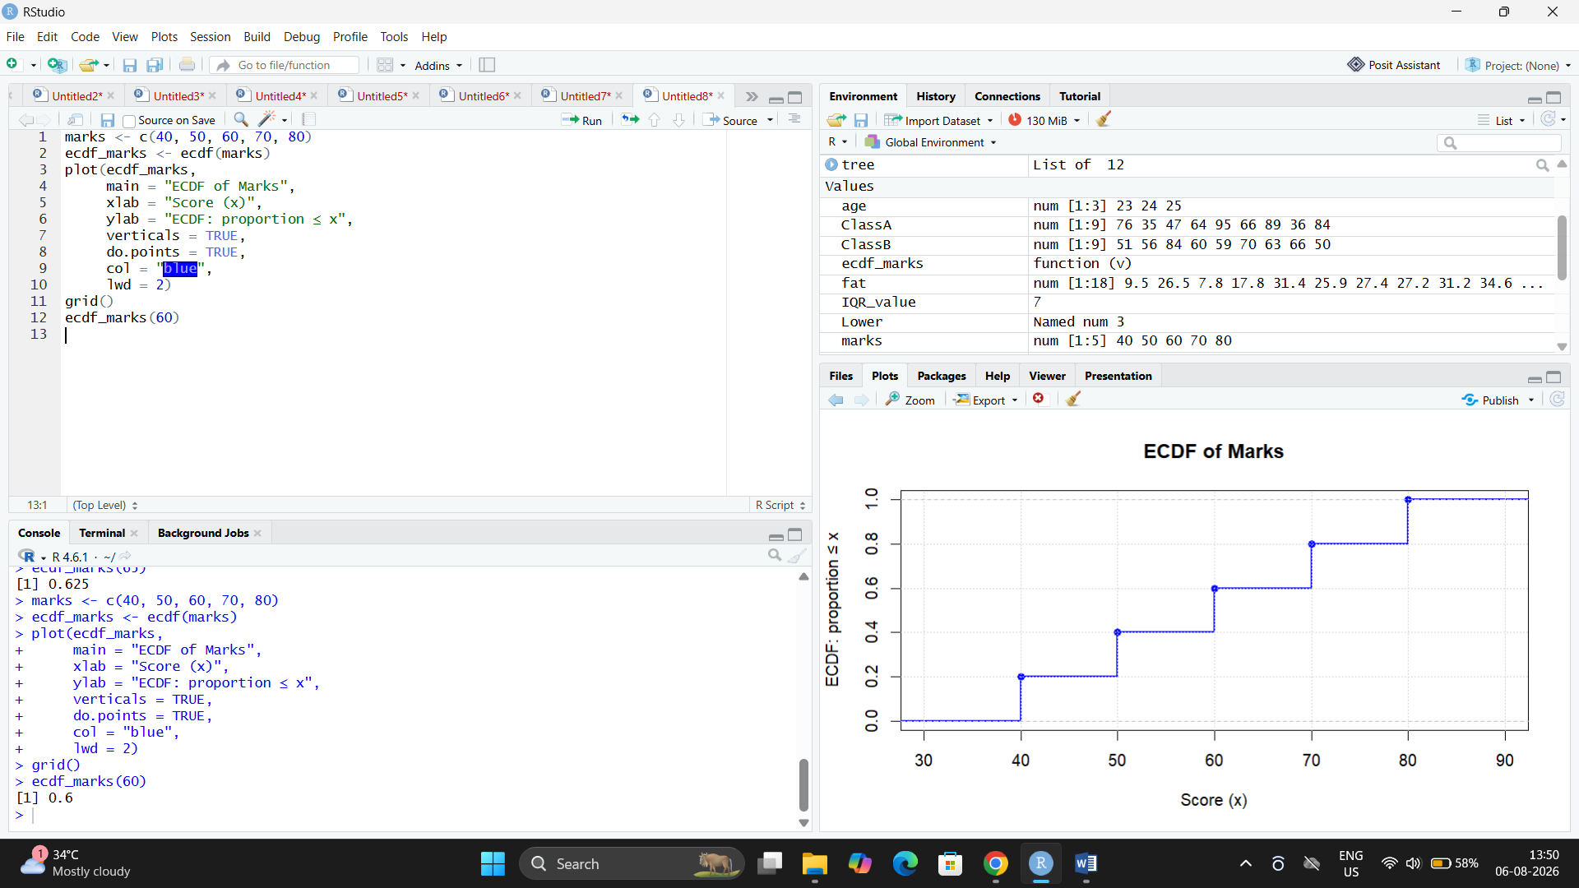

Observation
- The ECDF graph increases in a stepwise manner.
- Each step represents the cumulative proportion of observations.
- At 65, the cumulative probability is 0.625, meaning 62.5% of the observations are less than or equal to 65.

Advantages
- Does not assume any probability distribution.
- Easy to construct and interpret.
- Suitable for small and large datasets.
- Useful for comparing different datasets.

Applications
- Data analysis
- Statistical inference
- Comparing sample distributions
- Reliability analysis
- Machine learning data exploration

Result
The Empirical Cumulative Distribution Function (ECDF) was successfully generated and plotted using R. The cumulative probability for the given dataset was calculated and interpreted correctly.

