SIMATS ENGINEERING
ASSESSMENT TOOL 2: Concept Mapping

COURSE NAME: | Cloud Computing and Big Data Analytics | COURSE CODE: | CSA15

COURSE OUTCOME COVERED
CO1: Apply cloud computing technologies including hardware-software evolution, virtualization, web services, and service models to develop cloud-based solutions. (BL2)
Assessment Tool Weightage: 20%

Dave's Taxonomy: Imitation (Level 1)  Question Count: 4 | Duration: 60 Minutes Total Marks: 20

Code of Conduct
I __Jothiprakash /192573009__ (Name / Reg No) certify that this submission is my original work and that I have adhered to the guidelines specified for this assessment.

I understand that any violation of academic integrity rules will result in disciplinary action.

Signature of the student: ____Jothiprakash M _____

Criteria | Concept Identification (1.25) | Relationship Mapping (1.25) | Hierarchy and Organization (1) | Technical Relevance (1) | Visual Clarity (0.5) | TOTAL (5)
Weightage | 25% | 25% | 20% | 20% | 10% | 100%
Q1
Q2
Q3
Q4

Signature of the Faculty Total Marks Awarded:

Assessment Tasks
Concept Mapping Tasks
Create concept maps for the following tasks. Each map must show key nodes, link labels, and a logical hierarchy.
- Concept Map 1: Cloud Computing Architecture: Include front-end, back-end, client devices, data centers, and distributed servers.
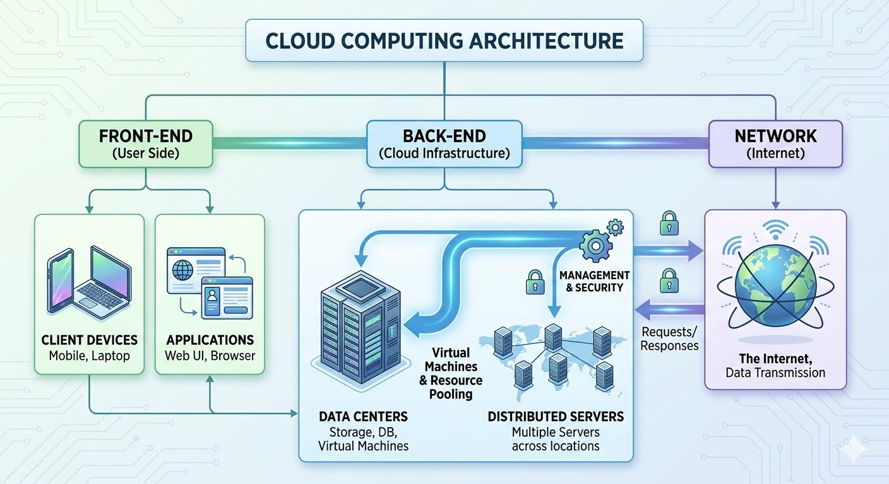
- Concept Map 2: Characteristics of Cloud Computing: Connect on-demand self-service, broad network access, resource pooling, rapid elasticity, and measured service.
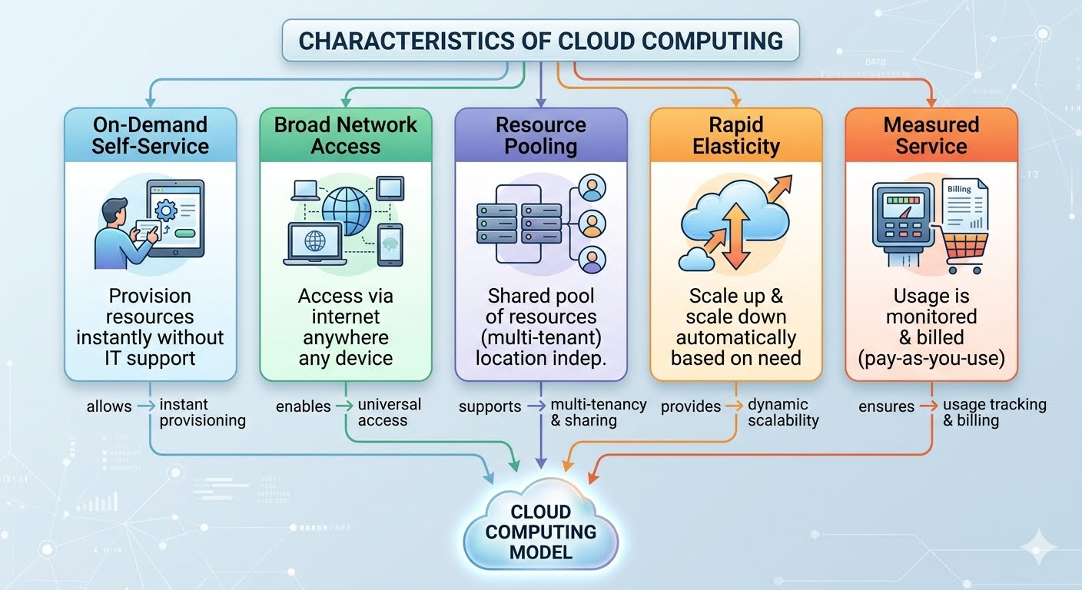

- Concept Map 3: Deployment Models: Map public cloud, private cloud, hybrid cloud, and community cloud with usage scenarios.
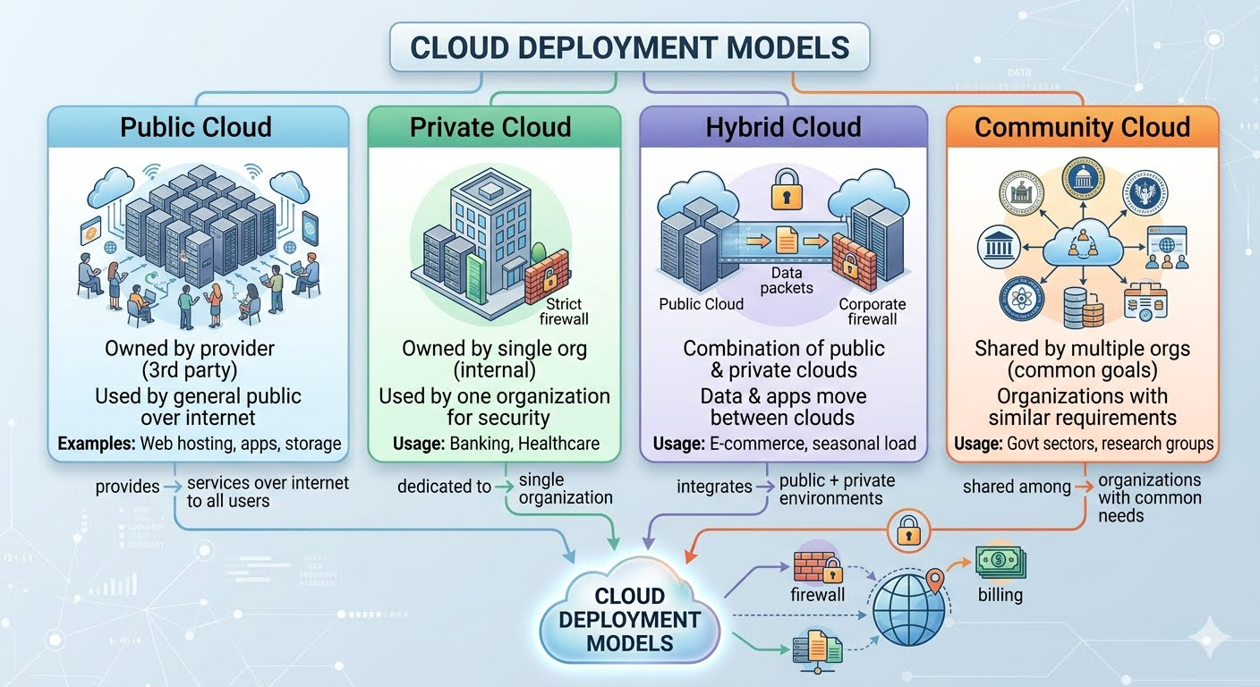
- Concept Map 4: Cloud Benefits vs Challenges: Show advantages (cost efficiency, scalability, flexibility) and limitations (security, downtime, vendor lock-in).
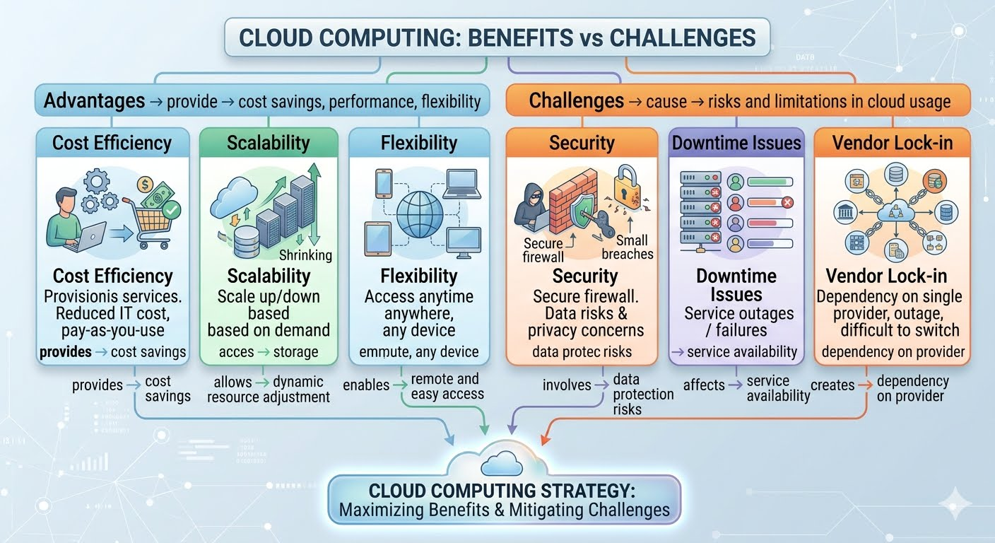

Expected concept nodes:
- Elasticity, scalability, resource pooling, on-demand access, measured service
- Virtual machine, hypervisor, abstraction, API, SOAP, REST, provider, consumer
- Infrastructure layer, platform layer, application layer, shared responsibility

Concept Mapping Rubric
Criteria | Weightage | Level 4 - Exemplary | Level 3 - Proficient | Level 2 - Developing | Level 1 - Beginning
Concept Identification | 25% | All major concepts are accurately identified | Most concepts are identified correctly | Limited concepts are identified | Essential concepts are missing
Relationship Mapping | 25% | Links between concepts are accurate and meaningful | Most links are correct | Some links are weak or unclear | Relationships are mostly incorrect
Hierarchy and Organization | 20% | Excellent structure with clear hierarchy | Mostly organized with minor issues | Basic structure with weak hierarchy | No logical organization
Technical Relevance | 20% | Map strongly reflects cloud course content | Mostly aligned to topic | Partially aligned to topic | Weak alignment to topic
Visual Clarity | 10% | Neat, readable, and easy to interpret | Generally readable | Somewhat cluttered | Poorly presented

