CLOUD COMPUTING – CONCEPT MAPPING ASSESSMENT
Course Outcome: CO1 | Total Marks: 20 | Duration: 60 Minutes
Student Name / Reg. No.: __Jothiprakash M/192573009__
Signature of Student: ______Jothiprakash M ____

Code of Conduct
I ______Jothiprakash /192573009___ (Name / Reg. No.) certify that this submission is my original work and that I have adhered to the guidelines specified for this assessment. I understand that any violation of academic integrity rules will result in disciplinary action.

Answer Key – Concept Maps
The following four concept maps include key concepts, labelled relationships, hierarchy, and cloud-computing terminology. The expected concepts such as elasticity, scalability, resource pooling, on-demand access, measured service, virtual machines, hypervisors, APIs, SOAP, REST, provider, consumer, service layers, and shared responsibility are integrated where relevant.

Q1. Concept Map 1: Cloud Computing Architecture
Cloud computing architecture connects client-side front-end components with provider-side back-end infrastructure. The back-end uses data centers, distributed servers, virtualization, and web-service APIs to deliver cloud resources.
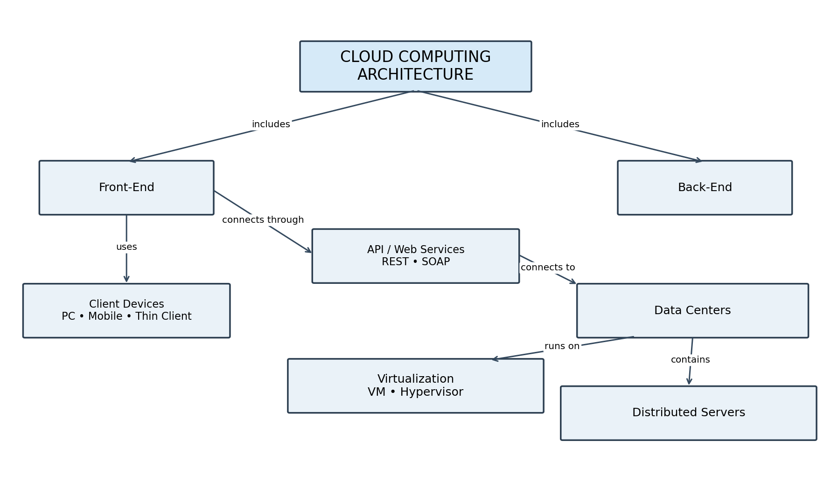
Key technical links: Front-end → API/Web Services → Back-end → Data Centers → Distributed Servers; virtualization uses a hypervisor to run virtual machines and provide abstraction.

Q2. Concept Map 2: Characteristics of Cloud Computing
The five essential characteristics describe how cloud resources are accessed, pooled, scaled, and measured. Together they enable efficient and flexible delivery of cloud services.
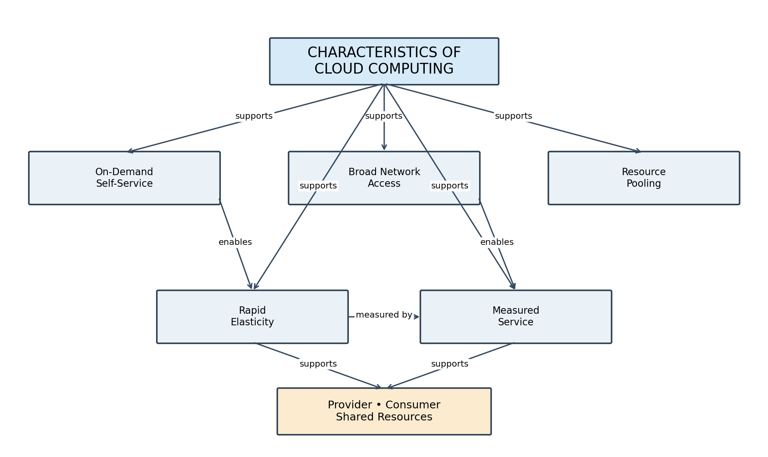
Key links: on-demand self-service provides access without direct provider interaction; resource pooling supports multi-tenancy; rapid elasticity supports scaling; measured service enables usage-based monitoring; broad network access enables access through standard networks and devices.

Q3. Concept Map 3: Cloud Deployment Models
Deployment models describe how cloud infrastructure is owned, managed, and shared. The appropriate model depends on security, cost, control, compliance, and workload requirements.
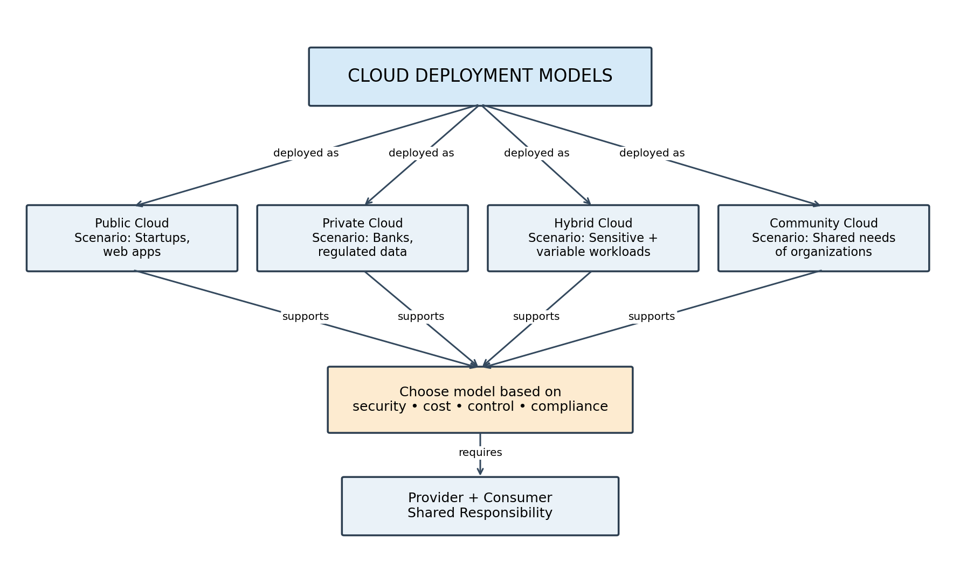
Usage scenarios: Public cloud is suitable for general-purpose workloads; private cloud for organizations needing greater control; hybrid cloud combines private and public resources; community cloud serves organizations with common requirements.

Q4. Concept Map 4: Cloud Benefits vs Challenges
Cloud computing provides economic and operational benefits, but organizations must manage security, availability, and dependency risks. Good governance and mitigation controls help balance these trade-offs.
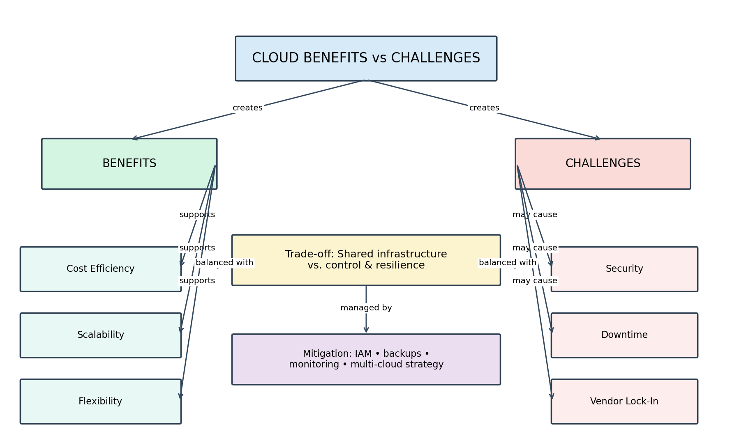
Typical mitigation controls include identity and access management (IAM), backups, monitoring, disaster recovery, portability planning, and multi-cloud or hybrid strategies.

Expected Cloud Computing Concepts Covered
Elasticity / Scalability: Rapidly increase or decrease resources according to workload demand.
Resource Pooling: Provider pools computing resources for multiple consumers using a shared infrastructure.
On-Demand Access: Consumers provision resources when needed, without lengthy manual processes.
Measured Service: Usage is monitored and measured for control, optimization, and billing.
Virtual Machine / Hypervisor: A hypervisor creates and manages virtual machines, providing hardware abstraction.
API / SOAP / REST: APIs expose cloud functionality; SOAP and REST are common web-service approaches.
Provider / Consumer: The provider supplies cloud services; the consumer uses and manages resources according to the service model.
Infrastructure / Platform / Application Layers: IaaS provides infrastructure, PaaS provides a development/runtime platform, and SaaS provides complete applications.
Shared Responsibility: Security and operational responsibilities are divided between provider and consumer depending on the service model.

Rubric Alignment
Criteria | Weight | How the answer addresses it
Concept Identification | 25% | All major concepts requested in each question are explicitly shown.
Relationship Mapping | 25% | Arrow labels such as includes, uses, connects through, enables, supports, and may cause show meaningful relationships.
Hierarchy and Organization | 20% | Each map begins with a central topic, branches to major categories, and then to supporting concepts.
Technical Relevance | 20% | Maps use cloud terms including virtualization, APIs, service characteristics, deployment models, benefits, and risks.
Visual Clarity | 10% | Maps use separate boxes, readable labels, consistent structure, and limited crossing lines.

End of Submission

