Robo-Uber — Week 1 Baseline Evaluation
Task 1a: Baseline evaluation using the supplied starter system unchanged.

1. Objective
Week 1 establishes a quantitative baseline for the supplied Robo-Uber system before intelligent-agent improvements are introduced. The purpose is to measure taxi returns, dispatcher return, joint/system return, and how many taxis remain on duty over a simulated day.

2. Experimental setup
- World: 50 × 50 service area.
- Simulation duration: 1,440 ticks (one simulated day).
- Taxis: 100, 101, 102 and 103.
- Starting taxi positions: (20,0), (49,15), (15,49) and (0,35), respectively.
- Initial taxi daily account/loss budget: 256.
- Traffic simulation: off, matching the supplied configuration.
- Starter taxi, dispatcher and world algorithms were not modified.
- Five independent one-day trials were executed.

3. Results
Run | Taxi 100 | Taxi 101 | Taxi 102 | Taxi 103 | Dispatcher | Joint
1 | -1.000 | -1.000 | -1.000 | -1.000 | 0.000 | -4.000
2 | -1184.000 | -1.000 | -1.000 | -1.000 | 4.444 | -1182.556
3 | -1.000 | -1184.000 | -1.000 | -1.000 | 4.111 | -1182.889
4 | -1146.000 | -1.000 | -1.000 | -1.000 | 8.111 | -1140.889
5 | -1.000 | -1.000 | -10.000 | -1.000 | 12.889 | -0.111
Mean | -466.600 | -237.600 | -2.800 | -1.000 | 5.911 | -702.089
Across the five trials, mean final returns were -466.6 for Taxi 100, -237.6 for Taxi 101, -2.8 for Taxi 102, -1.0 for Taxi 103, 5.91 for the dispatcher, and -702.09 for the combined system.

4. Duty-time behaviour
The average number of taxis on duty over the day was 1.24 out of four (30.9% of the available taxi capacity). The starter taxis normally leave duty when their account reaches zero, although a taxi can remain active while carrying a passenger.
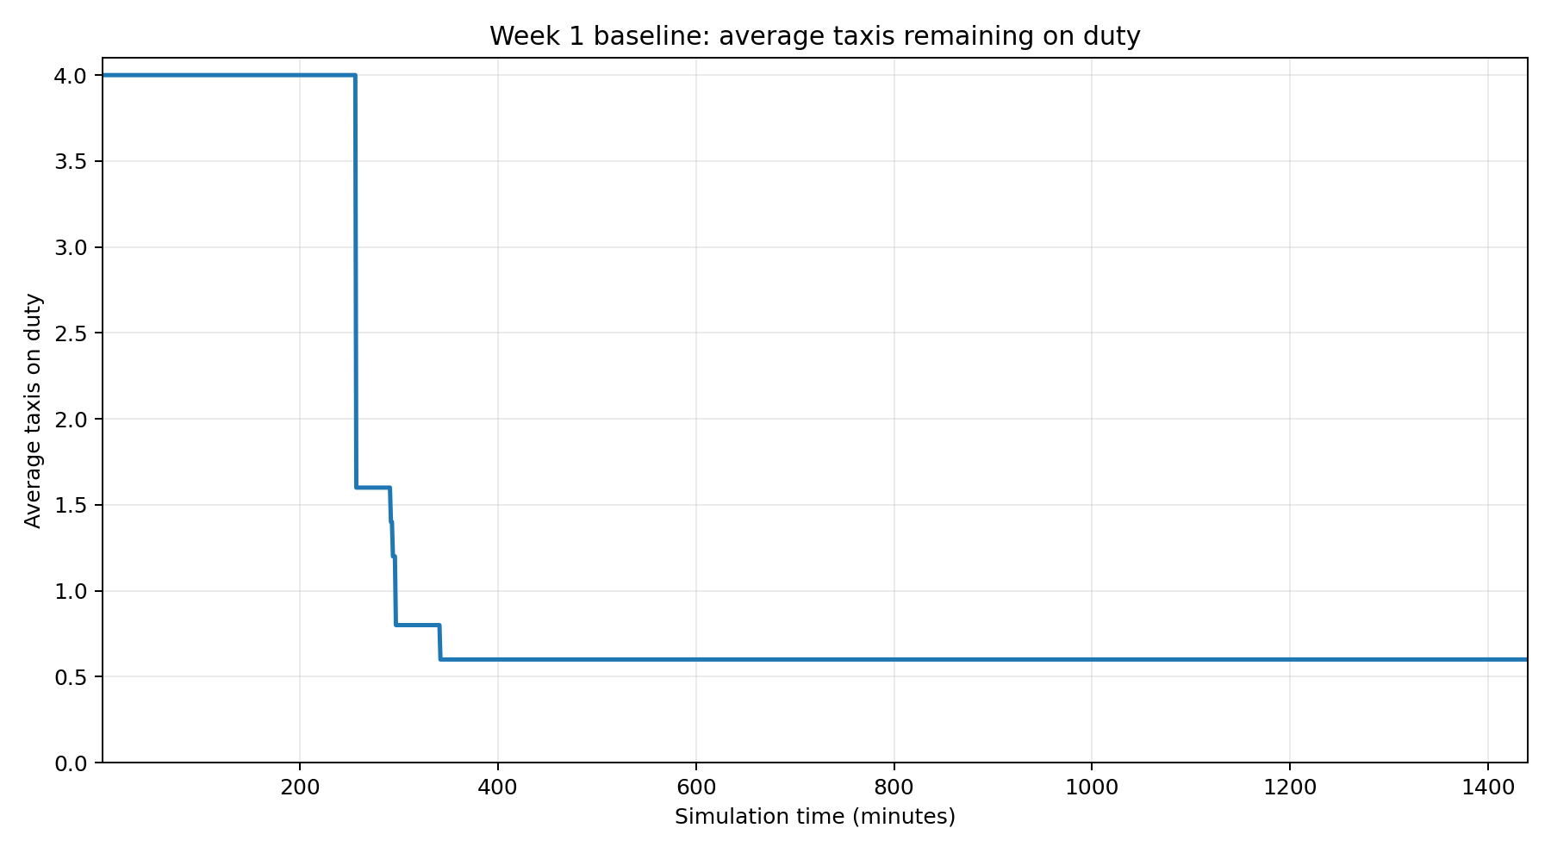

5. Baseline observations
- The baseline produced about 448.4 fare requests per simulated day in these trials.
- Only 2.0 fares were picked up per day on average and 1.4 reached drop-off during the simulated day.
- The very low dispatcher return is consistent with the dispatcher receiving only 10% of completed fare payments.
- Returns are highly variable between runs because fare generation and fare destinations are stochastic.
- Taxi 100 and Taxi 101 sometimes remain negative at the end of the 1,440-tick horizon because they can still be carrying a passenger; the supplied code prevents an on-duty taxi with a passenger from immediately going off duty.
- These results are a baseline, not evidence that the supplied approach is optimal. Later intelligent-agent changes should be compared against the same metrics and experimental conditions.

6. Reproducibility and files
The five raw trial results and the complete minute-by-minute duty series are provided alongside this report. The experiment used the supplied starter source and did not alter the taxi or dispatcher decision logic.

