Robo-Uber Week 4 — Task 3a Taxi Bidding
Evaluation of an expected-return bidding policy against the pre-Task-3a bidding policy. Week 2 path planning and Week 3 dispatcher changes are held constant.

What changed
- Changed only `Taxi._bidOnFare` in `src/taxi.py` for the current policy; `baseline_bidding_src/` preserves the pre-Task-3a combined implementation.
- Rejects bids if the taxi is not on the road, already has a passenger or allocated fare, has invalid/unreachable travel-time estimates, cannot arrive within its wait window, or cannot fund the approach.
- Estimates pickup survival probability with a simple uniform-survival approximation. Expected taxi revenue is 90% of the quoted fare; costs include pickup and passenger-trip time.
- Applies a 15% pickup-time and 25% passenger-trip-time safety margin to account for uncertainty in the simulator travel-time heuristic.

Experimental setup
50×50 world; four taxis; 1,440 simulated ticks per trial; three trials per condition; seed labels 20261013–20261015. Compared original and improved bidding with traffic disabled and with the existing traffic settings enabled. The traffic-on runner edits a temporary copy of ruparams.py, not the tracked source snapshot.
The current tests were run with `python -m unittest discover -s tests -v`: 27 tests passed (8 path-planning, 9 dispatcher, 10 taxi-bidding).

Results
Condition | Mean dispatcher return | Mean joint return | Completed/day | Cancellation rate | Avg taxis on duty
Baseline · no traffic | £72.78 | £61.42 | 19.00 | 87.0% | 1.17
Improved · no traffic | £100.00 | £87.33 | 26.67 | 86.6% | 1.34
Baseline · traffic | £47.41 | £41.74 | 12.00 | 87.9% | 1.01
Improved · traffic | £64.15 | £59.14 | 17.00 | 88.5% | 1.11
In the no-traffic condition, improved bidding increased mean completed fares from 19.0 to 26.7 per day (+40.4%) and mean joint return from £61.42 to £87.33 (+42.2%). With traffic enabled, completed fares changed from 12.0 to 17.0 per day (+41.7%) and joint return changed from £41.74 to £59.14 (+41.7%).
The cancellation rate remains high and rises slightly in these three-trial samples. Three trials are a useful initial check but are not enough to establish statistical confidence; rerun with at least five trials per condition before relying on these findings in the final submission. Seed labels are shared across variants, but because the variants consume randomness differently, the runs are not perfectly paired.

Graphs

Dispatcher return
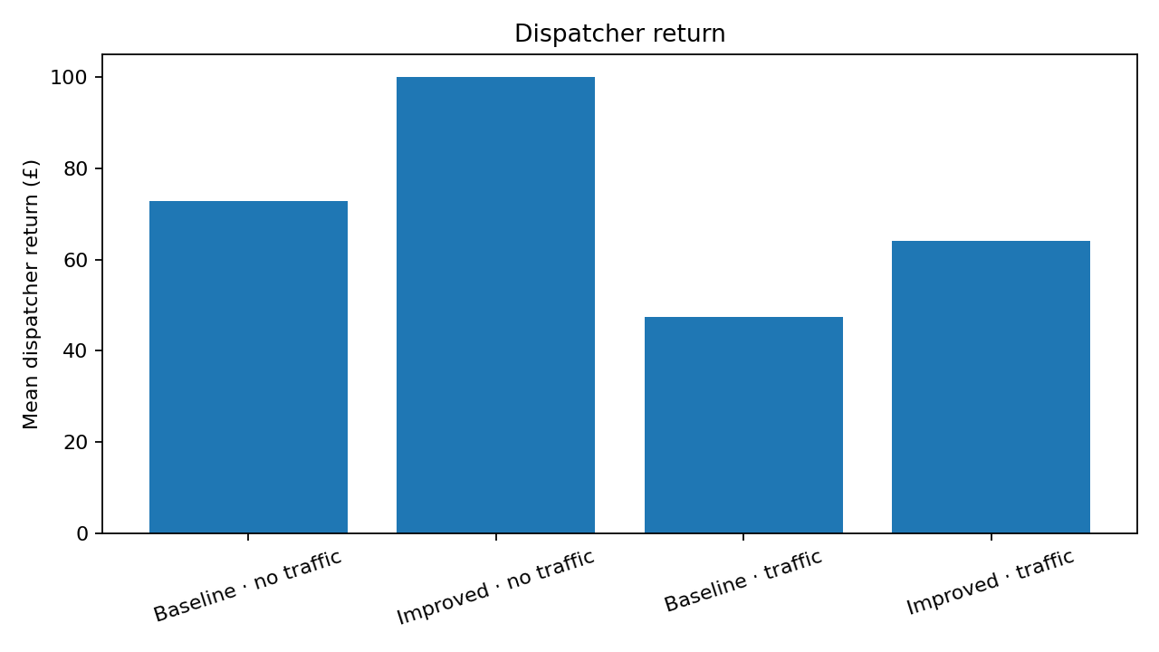

Joint return
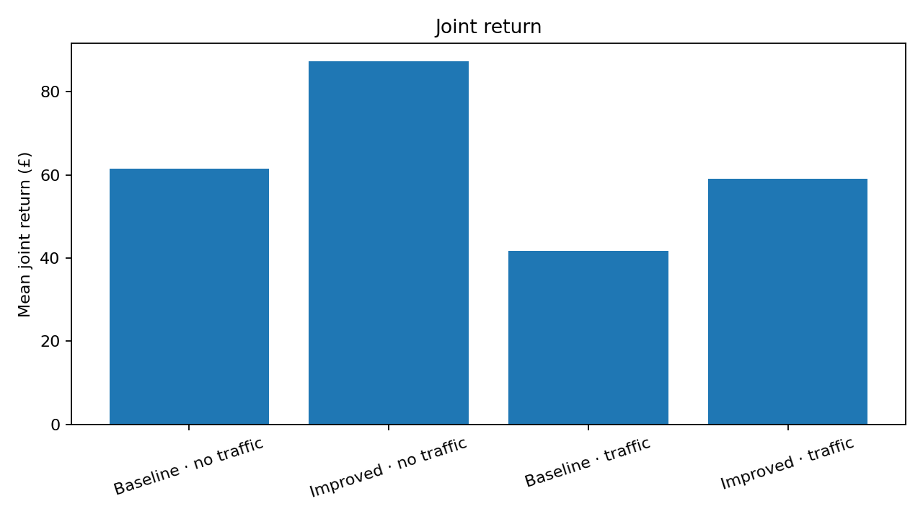

Completed fares
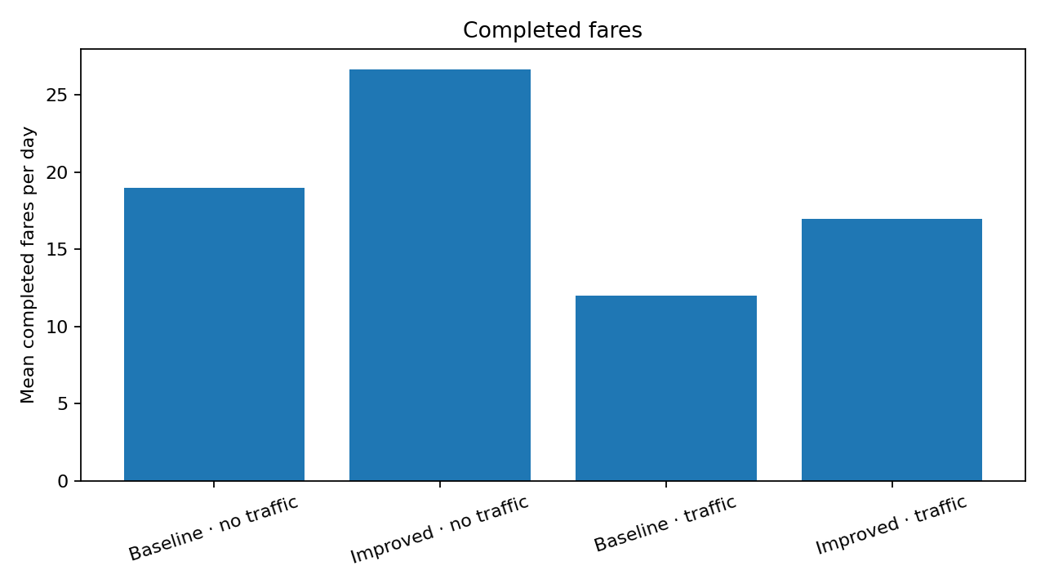

Average taxis on duty
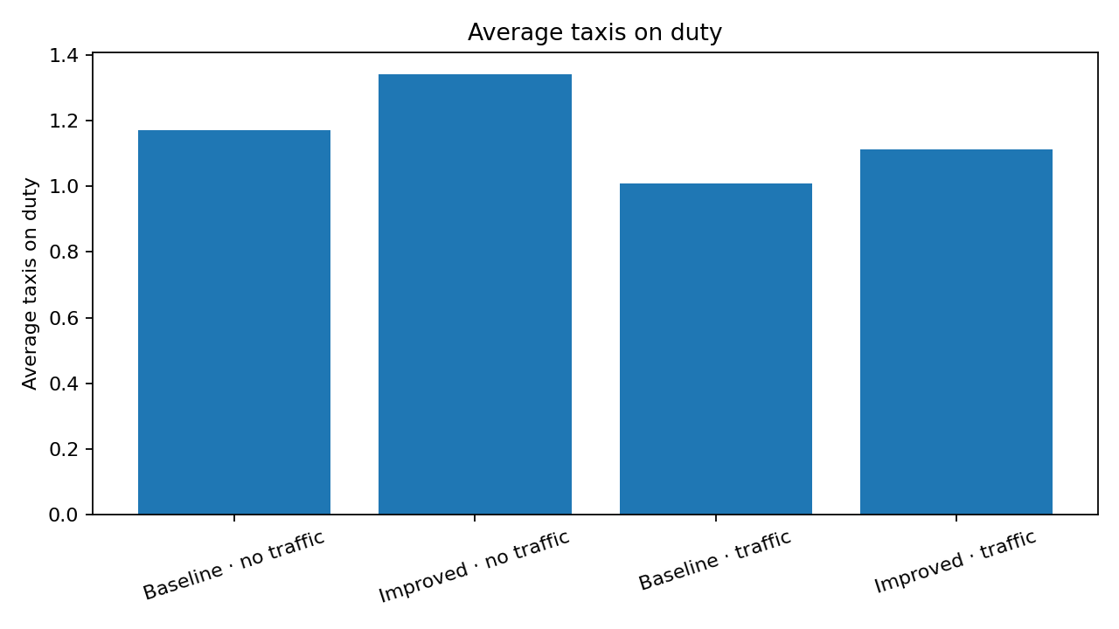

How to reproduce
From the project root run: `python -m unittest discover -s tests -v` and `python run_week4_experiments.py`. The default runs three trials per condition. For five trials, use `python run_week4_experiments.py --trials 5`.

