Robo-Uber — Week 2 Route Planning
Task 1b implementation and controlled comparison against the unchanged starter planner.

1. Objective and scope
Week 2 improves only Taxi._planPath. The starter uses recursive depth-first search (DFS), which returns the first route it encounters rather than guaranteeing the minimum-distance route. Other taxi/dispatcher decision logic and the supplied map/configuration were left unchanged.

2. Algorithm
The replacement uses Dijkstra’s shortest-path algorithm over the taxi’s adjacency map. Each edge weight is the distance supplied by NetWorld.exportMap. All weights are non-negative Euclidean segment distances, so Dijkstra guarantees a minimum-total-distance route on the known graph.
- Priority queue selects the currently cheapest discovered node.
- A settled set prevents re-expanding nodes.
- Predecessor links reconstruct the route from destination to origin.
- The return value preserves the existing contract: a list including origin and destination; [origin] when already there; [] when either node is unknown or destination is unreachable.
- The existing special case for origin=None is preserved.
Complexity: O((V + E) log V) time and O(V) auxiliary space for a graph with V nodes and E edges, using a binary heap. This is preferable to DFS for route optimality and avoids recursive stack growth.

3. Testing
Eight unit tests pass. They cover direct routes, a weighted graph where the fewest-edge route is not the shortest, a removed/blocked edge, unreachable and unknown destinations, identical origin/destination, the missing-origin convention, and route-edge validity.
A whole-map validation was also run on the supplied interpolated road map: 396 nodes, all 156,816 ordered origin/destination pairs reachable; every returned path began/ended at the requested endpoints and every consecutive pair was an actual map edge. Runtime for all pairs in this validation was approximately 23.2 seconds in this environment.

4. Experimental method
Five one-day trials were run for each version. Both versions used the same five seed labels (20261013–20261017), 50×50 world, 1,440 ticks, four taxis (100–103), the supplied road/junction layout, traffic off, same fare settings, and the same dispatcher and fare-bidding logic. The baseline uses an untouched copy of the supplied taxi.py; the improved version changes only Taxi._planPath.
Fare request, pickup, completion and cancellation counts were collected by a measurement harness. “Average taxis on duty” is estimated from the simulation’s per-minute taxi-position records, so it is a recorded-presence measure rather than a separate internal duty flag.

5. Results
Metric | Starter DFS mean | Dijkstra mean | Change
Taxi 100 | -1.000 | -1.000 | 0.000
Taxi 101 | -1.200 | -1.000 | 0.200
Taxi 102 | -232.000 | -1.000 | 231.000
Taxi 103 | -1.000 | -1.000 | 0.000
Dispatcher | 9.178 | 41.911 | 32.733
Joint | -226.022 | 37.911 | 263.933
Requests | 555.400 | 556.400 | 1.000
Pickups | 2.400 | 10.400 | 8.000
Completed | 2.200 | 10.400 | 8.200
Cancelled | 487.000 | 486.400 | -0.600
Cancellation rate | 0.877 | 0.874 | -0.003
Average taxis on duty | 0.929 | 0.973 | 0.044
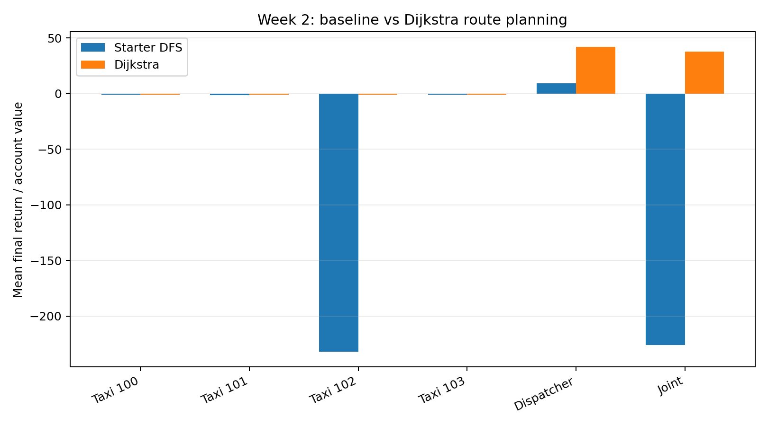
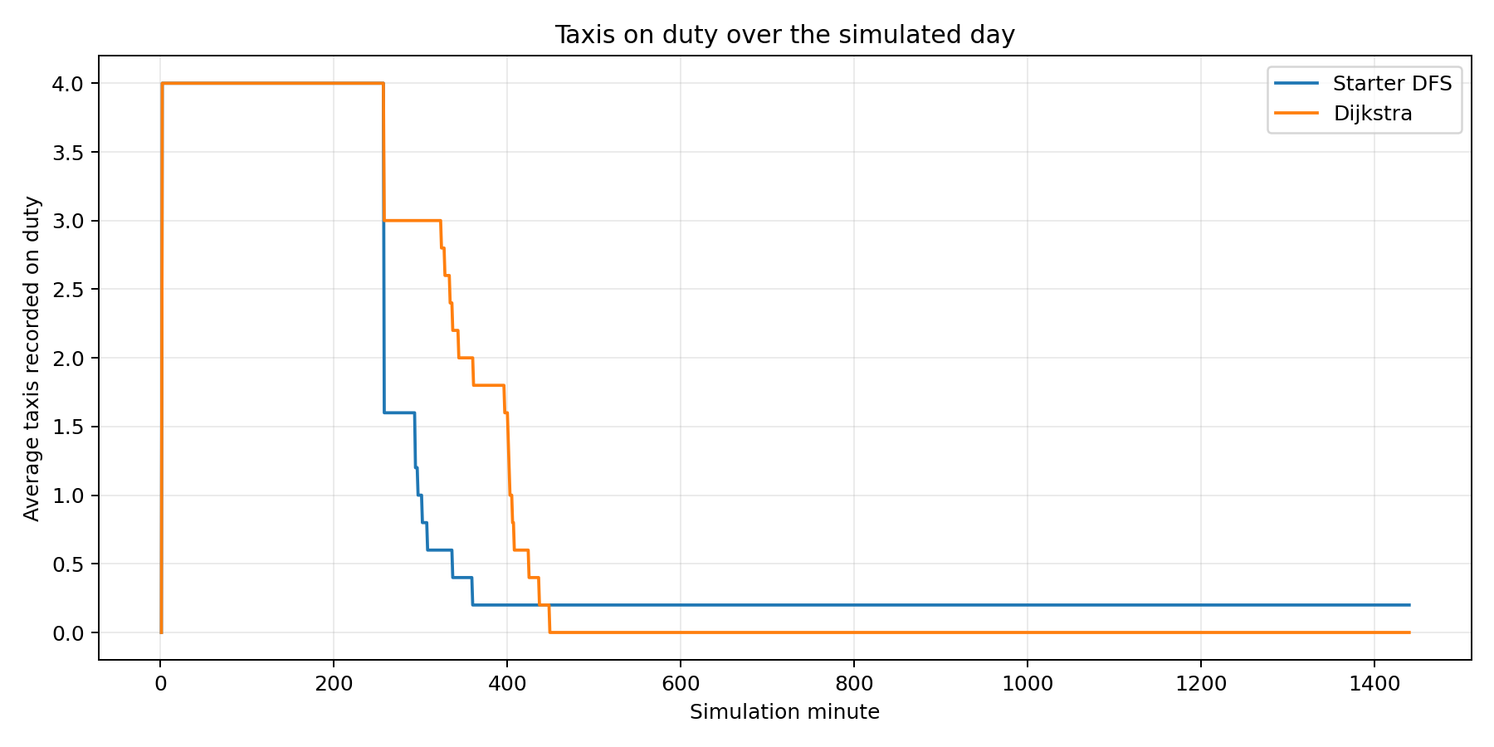

6. Interpretation
Across these five trials, mean completed fares rose from 2.20 to 10.40 per day; mean pickups rose from 2.40 to 10.40. Mean dispatcher revenue rose from 9.18 to 41.91, and mean joint return rose from -226.02 to 37.91.
This is encouraging evidence that route quality affects system performance: taxis can take shorter routes and are more likely to reach fares/drop-offs before passengers abandon. However, five trials are a small sample, fare generation is stochastic, and the dispatcher/taxi bidding policies remain unchanged. The results support a promising improvement, not a claim of statistical significance or a complete solution to all service problems.
The final taxi account values often end at -1 because taxis leave duty after their account is exhausted; joint return is therefore especially useful alongside completed fares and dispatcher revenue. Cancellation rates remain high, indicating that route planning alone cannot solve the system’s allocation/waiting-time problems.

7. Limitations and next steps
- The planner optimises geometric road distance, not dynamic travel time or traffic congestion. This matches the requested shortest-distance route objective and the traffic-off baseline.
- A shortest route is optimal only relative to the taxi’s currently known map and its edge weights; a stale or incomplete map can still lead to failure.
- Next, consider a separately scoped dispatcher allocation improvement only after this task is assessed, so route-planning effects remain identifiable.

8. Reproducibility
The package includes the modified taxi.py, unit tests, the original starter source used for the baseline, the trial data, the comparison workbook, and the plots. Run tests with: python -m unittest discover -s tests -v. The simulation harness is run_trials.py; it can select the baseline source using ROBO_SRC and name output files with ROBO_LABEL.

