Robo-Uber — Task 2: Dispatcher Optimisation
Week 3 coursework work: Task 2a allocation and Task 2b fare costing.

1. Scope and alignment with the brief
The coursework brief assigns Task 2 to the dispatcher (15% of the module): Task 2a modifies Dispatcher._allocateFare to improve overall returns while considering service time, bid-waiting and fairness; Task 2b updates Dispatcher._costFare to set reasonable fare bounds and evaluate revenue. The Taxi._bidOnFare routine belongs to Task 3a, so it is not the main implementation in this package.

2. Experimental method
- Five 1,440-tick simulation trials per configuration, with seed labels 20261013–20261017.
- World setup, four taxi starting locations, fare-generation parameters and the Week 2 Dijkstra path planner held constant.
- Four configurations compared: original dispatcher; allocation-only improvement; pricing-only improvement; both improvements together.
- The baseline uses the Week 2 path planner with the original dispatcher methods, so this experiment isolates Task 2 from the Week 2 path-planning change.
- Measures: taxi/dispatcher/joint return, completed fares, cancellations and cancellation rate, and average taxis on duty.

3. Implementation

Task 2a — allocation
The new allocator estimates shortest road distance using Dijkstra over the dispatcher map, rather than using straight-line distance alone. It filters invalid, off-duty and unreachable bidders; deduplicates repeated bid indices; waits at least two ticks and at most four ticks when a valid bid exists, unless all on-duty taxis have already bid; and ranks feasible bidders by approach distance plus a mild penalty for taxis that have received more allocations. This improves response time while reducing the tendency for the same nearby taxi to win every fare.

Task 2b — costing
The new pricing function uses the world travel-time estimate, falls back to road distance when the world reports an indefinite estimate, includes a fixed contribution above estimated passenger-trip time, and applies a bounded gross quote. The taxi receives 90% of the quoted price, so the target is expressed in the taxi share and converted to gross price by dividing by 0.9. Quotes are bounded between 10 and 120 simulation currency units.

4. Results
Configuration | Dispatcher mean | Joint return mean | Completed/day | Cancel rate | Taxis on duty
Original dispatcher | 52.33 | 46.93 | 12.80 | 87.2% | 1.04
Allocation improved | 81.04 | 73.84 | 19.60 | 87.0% | 1.22
Pricing improved | 73.29 | 63.88 | 19.20 | 86.6% | 1.17
Both improved | 65.75 | 57.15 | 17.00 | 87.4% | 1.13
Compared with the original dispatcher, the combined implementation increased mean dispatcher return from 52.33 to 65.75 (25.6%), mean joint return from 46.93 to 57.15 (21.8%), and completed fares from 12.80 to 17.00 per day (32.8%).
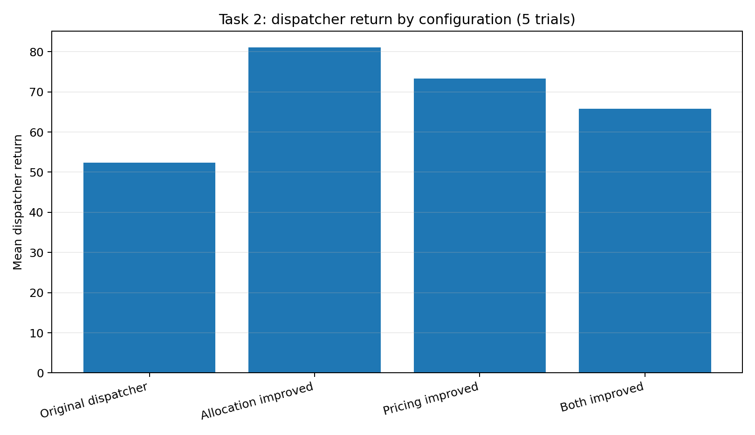
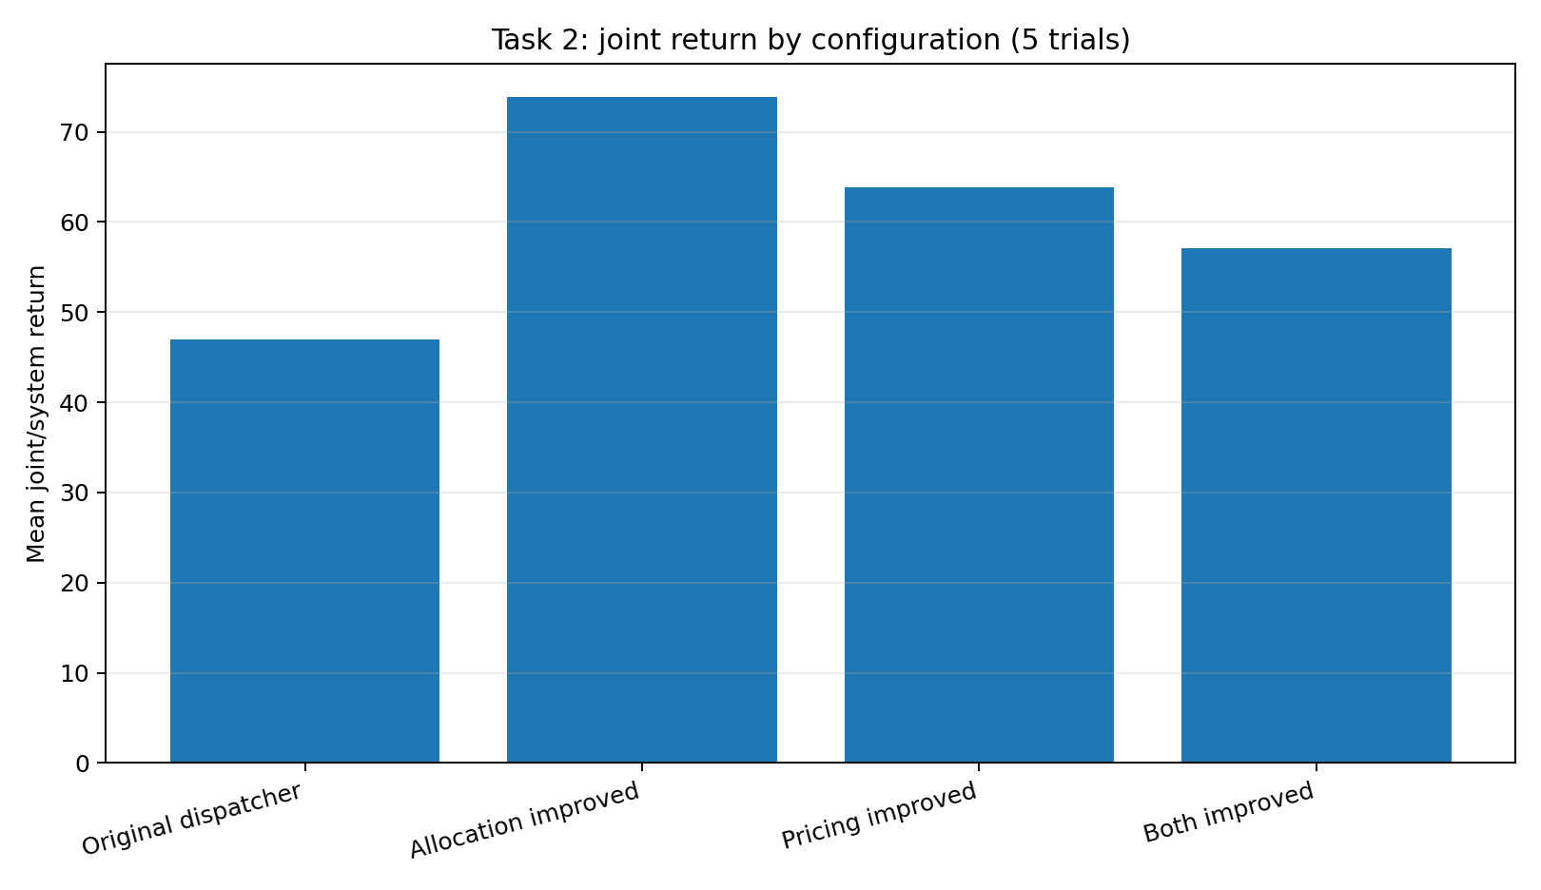
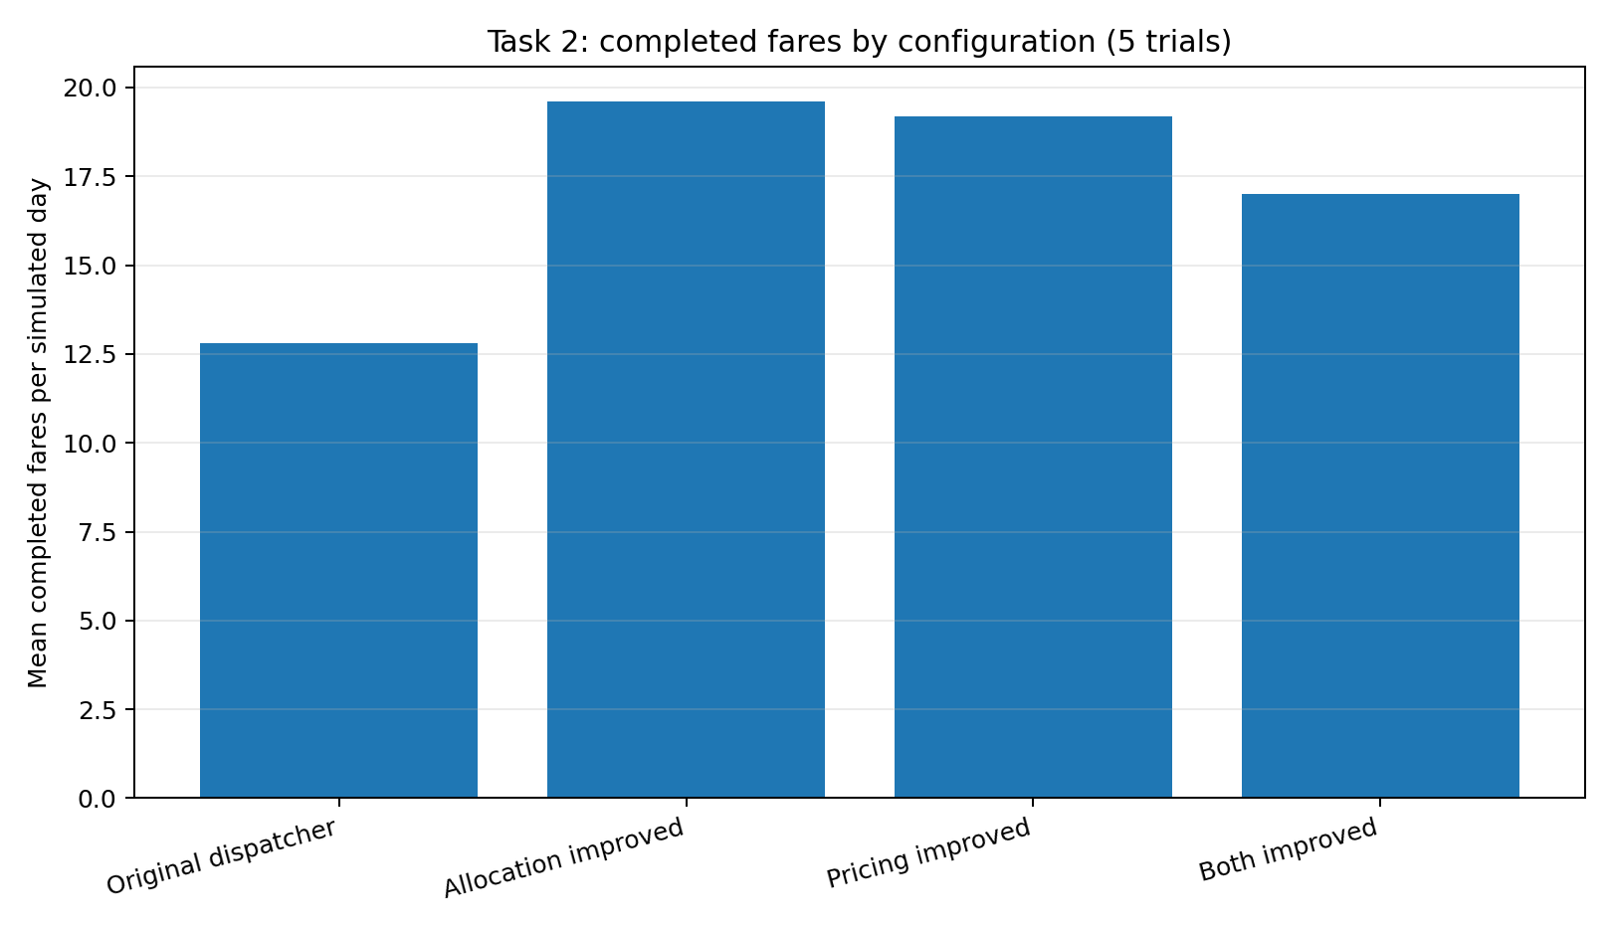
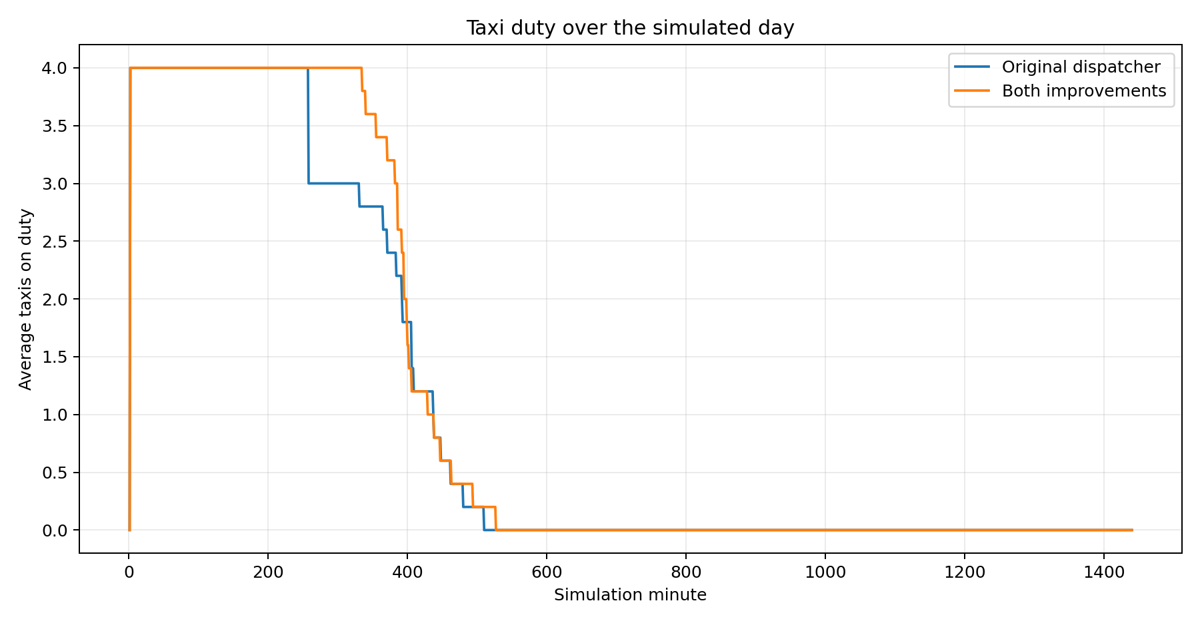

5. Interpretation and limitations
- The allocation-only configuration performed best in these trials: mean dispatcher return 81.04, joint return 73.84, and 19.60 completed fares/day.
- The pricing-only configuration also improved over the baseline in this sample: dispatcher return 73.29, joint return 63.88, and 19.20 completed fares/day.
- The combined configuration did not outperform each individual ablation; the allocation and pricing changes interact, and further tuning is warranted. The correct conclusion is that the combined configuration improves over the original dispatcher in these trials, not that the two changes are additive or globally optimal.
- The cancellation rate remained high (baseline 87.2% versus combined 87.4%). Fare acceptance and cancellation remain important limitations outside the scope of Task 2.
- Five trials are a limited sample. Seed labels were held constant, but different agent decisions can change the sequence of random events, so results should be treated as an empirical comparison rather than proof of statistical significance.
- The fairness term is a heuristic based on prior allocations, not a formal global optimiser. A future extension could evaluate expected profit and taxi availability over the remaining day, with more seeds and confidence intervals.

6. Automated tests and reproduction
The package includes the 8 Week 2 path-planning tests and 9 dispatcher tests. The tests cover shortest road-distance calculation, disconnected nodes, bounded pricing, initial bid wait, shortest-approach allocation, fairness tie-breaking, invalid/off-duty/unreachable bidders, duplicate bids, and invalid pickup locations. Run from the project root:
python -m unittest discover -s tests -v
Re-run the experiments with ROBO_SRC=baseline_dispatcher_src ROBO_LABEL=baseline python run_trials.py, ROBO_SRC=allocation_only_src ROBO_LABEL=allocation_only python run_trials.py, ROBO_SRC=cost_only_src ROBO_LABEL=cost_only python run_trials.py, or ROBO_SRC=src ROBO_LABEL=combined python run_trials.py.

