DBMS Project Roll No: 1932
College Management System
Demo Video Link : https://drive.google.com/file/d/1OhsM_0Fi0baWL-gC7OH8qI18JUn64-yk/view?usp=drivesdk

- Introduction
College Management System is a web portal aims at providing information to some levels of management of college. For a given registrar/faculty/student login and registeration is created. Faculty/Student can access the system to view the information from the database.
The project includes modules like Student, Department, Faculty. Student record is stored.
Front-end : HTML & CSS
Back-end : PHP & MySQL

- Objectives :
The main objective of the project is to manage the student , faculty, department record details .

- User requirements
- User should be able to login to the system.
- User should be able to see student, department and faculty list.
- Admin will manage department, student and faculty record.
- Admin will be able to edit, delete student details.

- ERD

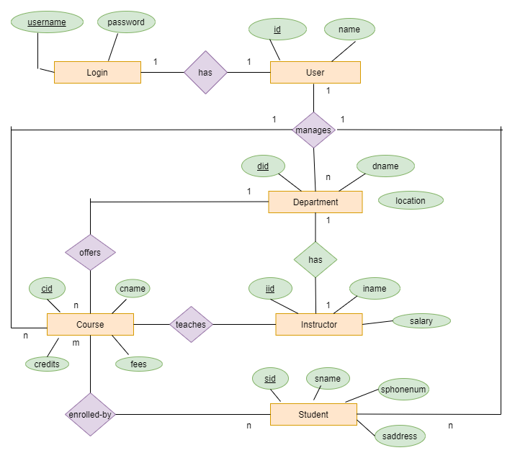

- Use Case Diagram
