Acupuncture Clinical Trial Registration for Vertigo:
A Registry-Based Cross-Sectional Analysis Using Text Mining
(ClinicalTrials.gov, 2007–2026)

Qin Zhang¹*, Tong Yin², Yueping Huang³, Chuyun Chen¹
¹ Department of Acupuncture and Moxibustion, The Affiliated Traditional Chinese Medicine Hospital, Guangzhou Medical University, Guangzhou, Guangdong, China
² The Second Clinical Medical College of Guangzhou University of Chinese Medicine, Guangzhou, Guangdong, China
³ Department of Rehabilitation, The Affiliated Traditional Chinese Medicine Hospital, Guangzhou Medical University, Guangzhou, Guangdong, China

* Corresponding Author:
Qin Zhang
E-mail: zhangqin@stu.gzucm.edu.cn
Department of Acupuncture and Moxibustion, The Affiliated Traditional Chinese Medicine Hospital, Guangzhou Medical University, No. 95 Tiankun 3rd Road, Tianhe District, Guangzhou, Guangdong 510640, China

Word count: Abstract ~290 words | Main text ~5,200 words | Figures: 7 (main) + 4 (supplementary) | Table: 1

Abstract
Objective: To conduct a cross-sectional analysis of acupuncture clinical trial registration for vertigo using the ClinicalTrials.gov database, integrating text mining approaches to characterize the research landscape.
Methods: We systematically searched the ClinicalTrials.gov API v2 (search date: July 1, 2026) using a multi-term combinatorial strategy (35 query pairs combining 5 vertigo-related terms with 7 acupuncture-related intervention terms), supplemented by a broad vertigo search. After NCT ID deduplication, keyword-based classification identified studies with co-occurring acupuncture and vertigo terminology. A conservative verification step requiring the presence of at least one extracted acupuncture method or acupoint entity was applied. Rule-based named entity recognition was employed to extract acupoints, acupuncture methods, control types, vertigo subtypes, and outcome measures. Three classifiers were trained on TF-IDF features as a feasibility assessment of automated trial screening. Temporal trends were characterized using Poisson regression.
Results: Among 3,448 unique vertigo studies in ClinicalTrials.gov, 29 (0.8%) were confirmed as acupuncture-vertigo trials (2007–2026). China was the largest registration source (12/29, 41.4%). Manual acupuncture (n = 14) and electroacupuncture (n = 9) were the predominant modalities. ST36 (Zusanli) and PC6 (Neiguan) were the most frequent acupoints (7 occurrences each). The Visual Analog Scale (n = 14) and quality of life instruments (n = 13) were the most commonly used outcome measures. Sham acupuncture controls were observed in recent registration periods. Logistic regression achieved an AUC of 0.87 ± 0.06 in the feasibility assessment. Poisson regression identified a significant positive temporal trend (β₁ = 0.131, p < 0.001). A cross-check of trial identifiers against PubMed found that 6 of 29 trials (20.7%) had associated publications.
Conclusions: The number of confirmed acupuncture-vertigo trials registered in ClinicalTrials.gov (n = 29) is modest relative to the high prevalence of vertigo, highlighting an opportunity to strengthen the evidence base through well-designed, prospectively registered trials. The text mining analytical framework — with its accompanying code repository, entity dictionaries, and regular expression patterns — is transferable to other acupuncture research domains. Findings are limited to ClinicalTrials.gov and may not fully capture trials in regional registries, particularly the Chinese Clinical Trial Registry.
Keywords: acupuncture therapy; vertigo; clinical trial registration; ClinicalTrials.gov; cross-sectional analysis; text mining; evidence map

1. Introduction
Vertigo is among the most common clinical complaints, encompassing a heterogeneous group of vestibular disorders including benign paroxysmal positional vertigo (BPPV), vestibular migraine, Meniere disease, vestibular neuritis, and persistent postural-perceptual dizziness (PPPD), each with distinct pathophysiology, diagnostic criteria, and treatment approaches [1,2]. BPPV, the most prevalent vertigo etiology, has an estimated lifetime prevalence of 2.4% [3]. Vertigo substantially impairs patients' quality of life and work capacity, and imposes a considerable socioeconomic burden through recurrent emergency department visits, unnecessary neuroimaging, and productivity loss [1,4].
Current standard treatments for vertigo rely primarily on pharmacotherapy (e.g., betahistine, vestibular suppressants) and vestibular rehabilitation; however, the long-term efficacy of pharmacological agents remains controversial, and vestibular rehabilitation requires specialized therapist training and sustained patient adherence [4]. Canalith repositioning maneuvers (e.g., the Epley maneuver) represent first-line treatment for BPPV, yet residual dizziness and recurrence remain clinically significant challenges [3]. Against this backdrop, acupuncture has garnered increasing research attention as a non-pharmacological treatment option for vertigo. Within the theoretical framework of traditional Chinese medicine, acupuncture is understood to restore the balance of qi and blood flow through the meridian system. At the neurophysiological level, proposed measurable mechanisms include modulation of cerebral blood flow, regulation of vestibular-autonomic function, and neurotransmitter-mediated analgesia and anti-emetic effects [5].
Systematic reviews have evaluated the clinical evidence for acupuncture in vestibular migraine [6], BPPV [7], and cervical vertigo [8]. However, existing systematic reviews consistently identify several critical limitations: individual trial sample sizes are generally small (mostly <100 participants), outcome measures are highly heterogeneous, and control conditions are inconsistent. Critically, no study has yet provided a systematic registry-based characterization of globally registered acupuncture-vertigo clinical trials.
Clinical trial registries offer a unique data foundation for characterizing specific research domains. ClinicalTrials.gov, maintained by the U.S. National Library of Medicine, is the world's largest clinical trial registry, hosting over 450,000 registered trials from more than 220 countries as of 2026 [9]. Cross-sectional analysis of registry databases can reveal the volume, geographic distribution, intervention characteristics, and temporal trends of trials in a given disease area, thereby equipping investigators and funding agencies with data-driven evidence for identifying research gaps and optimizing future trial designs [10].
However, much of the analytically valuable information in ClinicalTrials.gov — such as specific acupoint selections, needling techniques, control types, and outcome assessment instruments — is stored as unstructured free text, rendering large-scale, standardized extraction infeasible through traditional manual review. Text mining and natural language processing (NLP) techniques offer an effective methodological pathway to address this bottleneck [11]. In the acupuncture research domain, complex network analysis has been applied to characterize acupoint selection patterns [12], and preliminary characterizations of global acupuncture clinical trial registration trends have been reported [10]. Nevertheless, the systematic application of text mining to the ClinicalTrials.gov registry for acupuncture-vertigo trials — encompassing trial screening, entity extraction, and trend characterization in an integrated, reproducible pipeline — has not been previously reported.
Accordingly, this study aims to conduct a ClinicalTrials.gov-based cross-sectional analysis of acupuncture clinical trial registration for vertigo, integrating text mining methods. The specific objectives are: (1) to systematically characterize the basic features of confirmed acupuncture-vertigo trials, including registration volume, yearly distribution, geographic origin, trial status, and enrollment; (2) to employ text mining methods to extract acupoints, acupuncture modalities, control types, target vertigo subtypes, and outcome measures; (3) to assess the feasibility of machine learning classifiers for automated trial screening; and (4) to characterize temporal trends in trial registration based on historical data.

2. Methods

2.1 Data Source and Search Strategy
Data were obtained from the ClinicalTrials.gov API v2 (https://clinicaltrials.gov/api/v2/studies), maintained by the U.S. National Library of Medicine. A multi-term combinatorial search strategy was implemented to maximize retrieval sensitivity. Five vertigo-related condition terms (vertigo, dizziness, vertiginous, dizzy, Meniere) were cross-combined with seven acupuncture-related intervention terms (acupuncture, electroacupuncture, acupoint, moxibustion, acupressure, auricular acupuncture, ear acupuncture), yielding 35 discrete search term pairs. Each pair was submitted as a query.term parameter to the API, which performs full-text matching across all study record fields. A supplementary broad condition search (query: "vertigo OR dizziness OR Meniere") was concurrently executed to capture the total volume of vertigo-related studies in the registry, which serves as the denominator for proportion calculations. The search was performed on July 1, 2026. Following NCT ID-based deduplication, all unique study records were retained for subsequent analysis. The complete list of 35 query strings and API request parameters is provided in Supplementary Table S1. All data fetching and analysis code is publicly available at [GitHub repository URL] with a permanent DOI issued via Zenodo.

2.2 Data Preprocessing and Study Classification
Retrieved records were flattened to extract key fields including NCT identifier, brief title, official title, overall status, study first submit date, study type, phases, enrollment count, conditions, interventions, intervention descriptions, primary outcome measures, study locations /countries, blinding design, brief summary, detailed description, and lead sponsor. Text normalization comprised lowercasing and whitespace standardization.
Study classification employed a two-stage process. First, keyword lexicon-based matching was applied: a study was classified as potentially acupuncture-vertigo relevant if (1) at least one term from the acupuncture terminology lexicon (23 entries; Supplementary Table S2) was present in the concatenation of the title, official title, interventions, conditions, brief summary, and intervention descriptions fields, AND (2) at least one term from the vertigo terminology lexicon (11 entries) was present in the same concatenated text. Second, a conservative verification filter was applied: keyword-positive studies were retained as confirmed acupuncture-vertigo trials only if at least one acupuncture method or acupoint entity was successfully extracted by the named entity recognition pipeline (Section 2.3). Studies passing the keyword filter but failing the entity verification step were manually reviewed and classified as false positives (listed in Supplementary Table S4).

2.3 Named Entity Recognition
Rule-based named entity recognition (NER) employing regular expressions was applied to the concatenated text of study title, official title, interventions, conditions, primary outcome measures, brief summary, and detailed description to extract five entity types:
(1) Acupoints: Standard meridian codes across 14 meridians (e.g., GV20, GB20, ST36, LI4) were extracted via pattern matching. Chinese character names (e.g., 百会, 风池, 足三里) were mapped to their standard meridian codes. Pinyin romanizations (e.g., baihui→GV20, zusanli→ST36) were also matched to capture acupoints referenced by romanized name. After extraction, acupoint names were normalized to standard meridian codes to remove duplicates arising from multiple naming conventions.
(2) Acupuncture Methods: Nine categories were defined (manual acupuncture, electroacupuncture, transcutaneous electrical acupoint stimulation [TEAS], acupressure, moxibustion, auricular acupuncture, scalp acupuncture, dry needling, pharmacopuncture/acupoint injection). Specific modality patterns were checked before a generic acupuncture fallback to minimize misclassification. Trials registering their intervention as "acupuncture" without further specification were classified as manual acupuncture unless the intervention description explicitly mentioned electrical stimulation or other modality-specific terms.
(3) Control Types: Six categories (sham acupuncture, drug control, usual care/standard treatment, waiting list, placebo pill, vestibular rehabilitation).
(4) Vertigo Subtypes: Seven categories (BPPV, vestibular migraine, Meniere disease, central vertigo, cervicogenic vertigo, vestibular neuritis, PPPD).
(5) Outcome Measures: Six categories (Dizziness Handicap Inventory [DHI], Visual Analog Scale [VAS] for dizziness, vertigo episode frequency, vertigo severity, Berg Balance Scale, quality of life instruments, anxiety/depression scales).
All regular expression patterns and entity dictionaries are publicly available in the code repository. The named entity recognition pipeline was not independently validated against a manually annotated reference standard; entity counts therefore reflect the performance of the regular expression rules as applied to ClinicalTrials.gov registration text.

2.4 Machine Learning Classification — Feasibility Assessment
A binary text classification experiment was conducted to evaluate the feasibility of automating the keyword-based trial screening process. The keyword classification labels served as the target variable. Critically, because the training labels are themselves derived from deterministic keyword rules, the experiment quantifies model fidelity to those rules rather than classification accuracy against an independently annotated reference standard. All results should be interpreted within this feasibility-assessment framework.
TF-IDF (Term Frequency-Inverse Document Frequency) vectorization was applied with the following parameters: maximum features = 5,000, n-gram range = (1, 2), sublinear TF scaling, minimum document frequency = 2. The input text comprised the concatenation of study title, conditions, and interventions fields. The final feature matrix dimensions were 3,448 × 2,307, with 69 keyword-positive samples and 3,379 keyword-negative samples.
Three classifiers were comparatively evaluated: (1) logistic regression (C = 1.0, class_weight = "balanced", max_iter = 1,000); (2) XGBoost (n_estimators = 200, max_depth = 6); and (3) random forest (n_estimators = 200, max_depth = 10, class_weight = "balanced"). All models were evaluated via stratified 5-fold cross-validation (random_state = 42). Performance metrics included accuracy, precision, recall, F1-score, and area under the receiver operating characteristic curve (AUC-ROC), reported as per-fold means ± standard deviations. The 95% confidence intervals for cross-validation metrics were calculated using the t-distribution with k − 1 = 4 degrees of freedom (t_crit = 2.776 at α = 0.05).

2.5 Temporal Trend Analysis
Annual counts of confirmed acupuncture-vertigo trial registrations were tallied based on the study_first_submit_date field. A Poisson regression model was fitted to characterize the temporal trend, appropriate for count data with many zero and near-zero observations. To provide a descriptive perspective on possible near-term trajectories, a scenario-based projection was also produced assuming continuation of the 2022–2026 growth rate. These projections are presented as descriptive scenarios and should not be interpreted as formal statistical forecasts.

2.6 Statistical Analysis
Categorical variables are presented as frequencies; continuous variables (enrollment count) as median with interquartile range (IQR). Classifier performance metrics are reported as macro-averaged 5-fold cross-validation results with per-fold means, standard deviations, and 95% confidence intervals based on the t-distribution. For entity frequencies based on fewer than 10 observations, percentages are omitted to avoid false precision. All analyses were conducted in Python 3.10 using scikit-learn (v1.3), XGBoost (v1.7), statsmodels (v0.14), pandas (v2.0), NumPy (v1.24), and Matplotlib (v3.7). All random seeds were fixed at 42 to ensure reproducibility. The complete analysis pipeline — from API data fetching through entity extraction to figure generation — is available at [GitHub/Zenodo URL] with a permanent DOI.

3. Results

3.1 Study Selection and Baseline Characteristics
The multi-term combinatorial search of the ClinicalTrials.gov API retrieved 735 raw results from the 35 targeted query pairs and 3,448 studies from the broad vertigo search. Following NCT ID deduplication, 3,448 unique studies were obtained. Keyword-based classification identified 69 studies as potentially acupuncture-vertigo relevant. After applying the conservative verification filter requiring the presence of at least one extracted acupuncture method or acupoint entity, 29 studies were retained as confirmed acupuncture-vertigo trials (0.8% of all vertigo studies; Figure 1). The 40 excluded studies were predominantly non-acupuncture interventions (e.g., vagus nerve stimulation, nerve blocks, prolotherapy) that matched vertigo-related keywords through symptom or adverse event listings (Supplementary Table S4).
The 29 confirmed acupuncture-vertigo trials spanned 2007 to 2026, with increased registration activity after 2020 (Figure 2). With respect to trial status, 12 studies were completed, 6 were actively recruiting, 4 had not yet started recruiting, 4 had unknown status, 2 were withdrawn, and 1 was terminated. Among 27 studies reporting enrollment figures, the median sample size was 76 participants (IQR: 60–206; range: 40–1,655). One study (NCT04043247) reported a planned enrollment of 1,655 participants, representing a large-scale multicenter trial of TEAS for postoperative nausea prevention; excluding this study, the median enrollment was 72 (IQR: 55–100; maximum: 441).
Geographically, based on the country field as recorded in ClinicalTrials.gov, China contributed the largest share of registrations (12 of 29 studies), followed by the United States (2), Hong Kong (2), Taiwan (2), and Vietnam (2) (Figure 3). Country and region designations are reported as listed in the registry without aggregation.

3.2 Intervention Characteristics and Acupoint Analysis
Among the 29 verified acupuncture-vertigo trials, 28 specified the acupuncture modality in sufficient detail for classification. Manual acupuncture was the most frequently reported modality (14 studies), followed by electroacupuncture (9 studies), TEAS (3 studies), and acupressure (3 studies). One study each employed moxibustion, scalp acupuncture, auricular acupuncture, and pharmacopuncture (Figure 4). It should be noted that trials registering their intervention generically as "acupuncture" without further specification were classified as manual acupuncture unless the intervention description explicitly indicated electrical stimulation or other modality-specific terms; this may overestimate manual acupuncture relative to other modalities (see Discussion).
Acupoint information was extractable from 14 of the 29 studies. The five most frequently reported acupoints were ST36 (Zusanli; 7 occurrences), PC6 (Neiguan; 7 occurrences), LR3 (Taichong; 5 occurrences), GV20 (Baihui; 5 occurrences), and SP6 (Sanyinjiao; 4 occurrences), followed by LI4 (Hegu; 4 occurrences) and GB20 (Fengchi; 3 occurrences) (Figure 4). Acupoint co-occurrence analysis revealed frequent pairing of ST36 with PC6 and GV20 with GB20 (Figure 8). After normalization of meridian codes, Chinese characters, and Pinyin romanizations, a total of 46 distinct acupoints were identified across the 14 studies with extractable acupoint data.

3.3 Control Conditions and Outcome Measures
Among studies with identifiable control conditions, usual care or standard treatment was the most common comparator (5 studies), followed by sham acupuncture (4 studies) and drug control (primarily betahistine; 4 studies). Placebo pill and vestibular rehabilitation were each employed in one study (Figure 6). Sham acupuncture controls were observed in the more recent registration periods (2020–2026).
The Visual Analog Scale for dizziness was the most frequently used outcome assessment instrument (14 studies), followed by quality of life instruments including SF-36 and EQ-5D (13 studies), the Dizziness Handicap Inventory (6 studies), and anxiety or depression scales including HADS, HAMA, and HAMD (5 studies) (Figure 5). One study each employed vertigo episode frequency and vertigo severity as outcome measures.

3.4 Vertigo Subtype Distribution
Vertigo subtype information was extractable from only 4 of the 29 studies, limiting subtype-level analysis. Among these, Meniere disease was the most frequently studied (2 studies), followed by vestibular migraine (1 study) and BPPV (1 study) (Figure 6). The remaining 25 studies either enrolled heterogeneous vertigo populations or did not specify the vertigo subtype in their registration text. This low rate of subtype specification (4 of 29 studies) itself constitutes a finding: the majority of registered acupuncture-vertigo trials do not target a specific vertigo etiology.

3.5 Classification Model Performance
Based on TF-IDF features (2,307 dimensions), three classifiers were evaluated on 3,448 studies via stratified 5-fold cross-validation as a feasibility assessment of automated trial screening (Table 1). Logistic regression achieved the highest F1-score (0.33 ± 0.09) and AUC (0.87 ± 0.06). XGBoost exhibited higher precision but substantially lower recall, while random forest was the most conservative. Recall was limited across all models (logistic regression: 0.37 ± 0.10) due to extreme class imbalance (69 keyword-positive vs. 3,379 keyword-negative cases). The 95% confidence intervals for all metrics are reported in Table 1; their width reflects both the limited number of cross-validation folds (k = 5) and the class imbalance.
Table 1. Classification performance (stratified 5-fold CV, TF-IDF features, N = 3,448).
Model | F1 (SD) | F1 95% CI | AUC (SD) | Precision (SD) | Recall (SD)
Logistic Regression | 0.33 (0.09) | 0.08–0.58 | 0.87 (0.06) | 0.30 (0.05) | 0.37 (0.10) (Acc: 0.907)
XGBoost | 0.15 (0.05) | 0.01–0.29 | 0.80 (0.05) | 0.21 (0.06) | 0.11 (0.04) (Acc: 0.918)
Random Forest | 0.11 (0.04) | 0.00–0.22 | 0.85 (0.03) | 0.67 (0.10) | 0.06 (0.02) (Acc: 0.940)
Note: 95% CI based on t-distribution with df = 4 (t_crit = 2.776). CI bounds truncated at [0, 1]. CI: confidence interval; SD: standard deviation across folds; Acc: accuracy.
The logistic regression confusion matrix (Supplementary Figure S2) shows that the model correctly identified 26 of 69 keyword-positive studies (recall = 0.37), with 47 false positives among keyword-negative studies (precision = 0.30). Supplementary Figures S1 and S3 present the ROC curves and model performance comparison, respectively.

3.6 Temporal Trends
The Poisson regression model confirmed a significant positive temporal trend in annual acupuncture-vertigo trial registrations (β₁ = 0.131, SE = 0.038, z = 3.47, p < 0.001), corresponding to an estimated 14% annual increase in the registration rate (incidence rate ratio = 1.14; 95% CI: 1.06–1.23). The model intercept was β₀ = −1.137 (SE = 0.538, p = 0.035). The annual counts over the 20-year observation period were: 1 (2007), 1 (2009), 1 (2013), 1 (2014), 3 (2015), 2 (2017), 1 (2019), 3 (2020), 2 (2022), 2 (2023), 3 (2024), 5 (2025), and 4 (2026, partial year). Under a scenario-based descriptive projection assuming continuation of the 2022–2026 growth rate, annual registrations would be expected to fall within 5–10 trials per year for 2027–2029 (Supplementary Figure S4). These projections should be interpreted conservatively: the time series comprises only 20 annual observations, the majority of which recorded 0–3 trials, and external factors may substantially alter future trajectories.

4. Discussion
This study demonstrates the feasibility of applying text mining and named entity recognition to the ClinicalTrials.gov registry for characterizing acupuncture clinical trial registration in a specific disease domain. Using vertigo as a case study, we identified 29 confirmed acupuncture-vertigo trials among 3,448 vertigo-related studies (0.8%).
It is important to delineate what this study can and cannot support. With 29 trials spanning 20 years — of which only 14 had extractable acupoint data, 4 had extractable vertigo subtype data, and none had posted results in the registry — the present analysis provides a registry-level characterization rather than a comprehensive clinical evidence map. The characterization presented here refers specifically to the systematic description of registered trial features (intervention types, acupoint frequencies, outcome measures, geographic distribution, and temporal trends), not to an evaluation of clinical efficacy or a synthesis of trial results. This scope is analogous to other registry-based characterizations in the acupuncture literature [10] and should be interpreted as a complement to, rather than a replacement for, systematic reviews of published acupuncture-vertigo trials.
A cross-check of the 29 confirmed NCT identifiers against PubMed found that 6 of 29 trials (20.7%) had at least one associated PubMed-indexed publication as of July 2026. This indicates that the majority of registered acupuncture-vertigo trials have not yet contributed to the PubMed-indexed published literature, representing either ongoing research, unpublished completed trials, or trials that did not result in peer-reviewed publications. This registration-publication gap is methodologically important: characteristics derived from registration records alone may not reflect the evidence available to clinicians from published trial reports, and the modest overlap with the published literature underscores the value of registry-based surveillance as a complementary approach to systematic reviews of published trials.
From a characterization perspective, several patterns emerge. China accounts for over 40% of confirmed registrations, consistent with the broader dominance of Chinese institutions in acupuncture clinical research. Manual acupuncture (14 studies) and electroacupuncture (9 studies) were the predominant modalities. ST36 and PC6 emerged as the most frequently reported acupoints (7 occurrences each). The prominence of PC6 is consistent with its traditional indication for nausea, vomiting, and autonomic dysregulation — symptoms that frequently accompany vertigo. However, given the limited sample size, this observation should be regarded as hypothesis-generating.
A notable finding is that vertigo subtype information was extractable from only 4 of 29 studies. This low rate of etiological specification in trial registrations itself constitutes a finding: the majority of registered acupuncture-vertigo trials enroll heterogeneous patient populations without targeting a specific vertigo etiology, which limits the clinical interpretability of individual trial results and complicates evidence synthesis.
At the methodological level, the classification experiment provided a feasibility assessment of automated trial screening. Logistic regression achieved an AUC of 0.87 in the keyword-label fidelity experiment, yet recall was constrained (0.37). These metrics quantify model fidelity to keyword-derived training labels — which are themselves deterministic rules — rather than discriminative performance against an independently annotated reference standard. The conservative verification filter reduced the keyword-positive set from 69 to 29 studies. While this improves classification specificity by removing clear false positives, it may also introduce false negatives: genuine acupuncture trials using non-standard intervention terminology would fail the entity extraction step. The 29 confirmed trials should therefore be regarded as a lower-bound estimate. Supplementary Table S4 lists the 40 excluded studies. The largest category comprised transcutaneous auricular vagus nerve stimulation (taVNS) interventions — a neurostimulation modality whose classification relative to acupuncture remains a matter of taxonomic debate.
Several limitations should be considered. First, the small number of confirmed trials (n = 29) constrains the granularity of subgroup analyses; all entity frequencies should be interpreted as descriptive counts within this limited sample. Second, the data source is restricted to ClinicalTrials.gov. Chinese investigators contributed 12 of 29 trials, and many Chinese-led trials are additionally or preferentially registered in the Chinese Clinical Trial Registry (ChiCTR). The characterization presented here is specific to the ClinicalTrials.gov landscape. Third, acupoint information was extractable from only 14 of 29 studies. This reflects a structural limitation: ClinicalTrials.gov does not provide a dedicated field for acupoint specification, and acupoint information is embedded in free-text intervention descriptions using heterogeneous nomenclature. This structural missingness is unlikely to be random. Fourth, the classification of generic "acupuncture" interventions as manual acupuncture may introduce bias: in Chinese registrations, "acupuncture" often encompasses both manual and electrical stimulation, potentially overestimating manual acupuncture frequency. Fifth, the NER pipeline was not independently validated against a manually annotated reference standard. Sixth, the API-based denominator (3,448 vertigo studies) is larger than web-search-based denominators and provides a more complete but less relevance-filtered sampling frame. Seventh, the time series comprises only 20 annual observations with sparse counts. Eighth, the present study did not analyze trial results, as registration records document planned outcome measures rather than reported results.
Throughout this manuscript, we have adopted a deliberately conservative interpretive framework. The machine learning classification experiment is explicitly presented as a feasibility demonstration with full disclosure of the label circularity constraint. Descriptive entity frequencies are reported with their numerators and denominators. We believe this framework is appropriate for a study whose primary contribution is methodological — demonstrating a reproducible, API-driven text mining pipeline for registry-based acupuncture research characterization — with the vertigo case study serving as an illustrative application.
The characterization presented here carries implications for clinical research design: (1) future acupuncture-vertigo trials should specify the target vertigo subtype in their registration entries to enable etiology-specific evidence synthesis; (2) the VAS and DHI should be adopted as core outcome measures, supplemented by quality of life instruments given their frequent use in registered trials; (3) the two-stage screening framework (keyword classification followed by entity extraction verification) demonstrated here is transferable to other acupuncture indications; and (4) the absence of registered acupuncture trials for PPPD and vestibular neuritis among the 29 confirmed studies identifies specific vertigo subtypes where new trial registration could address unmet clinical needs.

5. Conclusion
Using ClinicalTrials.gov as a data source and cross-sectional analysis with text mining as methodological tools, this study has characterized the landscape of acupuncture clinical trial registration for vertigo. Among 3,448 vertigo-related registered studies, 29 were confirmed as acupuncture-vertigo trials (0.8%). China was the predominant registration source; manual acupuncture and electroacupuncture were the principal modalities; ST36 and PC6 were the most frequent acupoints; and VAS and quality of life instruments served as the benchmark outcome measures. The machine learning classifier demonstrated feasibility for assisted trial screening (AUC = 0.87), though performance boundaries — primarily constrained by small sample size and class imbalance — delineate the currently achievable level of automation. A PubMed cross-check found that only 6 of 29 trials (20.7%) had associated publications, highlighting a substantial registration-to-publication gap. The analytical framework established in this study — with its accompanying code repository, entity dictionaries, and regular expression patterns — is transferable to systematic, reproducible registry-based surveillance of acupuncture research in other disease domains.

Declarations
Funding: This work was supported by the Guangzhou TCM Intelligent Scientific Research Platform, National Demonstration Project for the Inheritance and Innovation of Traditional Chinese Medicine (Grant No. ZJXZ2026005). Additional support was provided by the following projects: (1) National Advantage Specialty Construction Project (Guo Zhong Yi Yao Yi Zheng Han [2024] No. 90); (2) Guangdong Provincial Famous TCM Practitioner Inheritance Studio Construction Project (Yue Zhong Yi Ban Han [2023] No. 108); (3) Guangzhou TCM Advantage Specialty Construction Project (Sui Wei Han [2023] No. 2316); (4) Guangzhou TCM Clinical Core and Characteristic Diagnosis and Treatment Technology Construction Project (Sui Wei Han [2022] No. 2249); (5) Clinical Observation of Acupuncture for Acute Ischemic Stroke and Its Effect on NF-κB/iNOS Pathway (Grant No. 20242A011009); (6) Guangdong Provincial TCM Bureau Research Project — Observation of the Therapeutic Effect of "Xing Nao Qi He Tiao Shu" Method on Gut Microbiota in Patients with Cognitive Impairment Due to Cerebral Small Vessel Disease (Grant No. 20231275); (7) Guangzhou Science and Technology Plan Project — Development of an Intelligent Acupuncture Consultation System Based on Continuous Dialogue (Grant No. 2024A03J0793).
Conflicts of interest: The authors declare no competing interests.
Qin Zhang¹*, Tong Yin², Yueping Huang³, Chuyun Chen¹
Data availability: All data used in this study were obtained from the publicly accessible ClinicalTrials.gov API v2 (https://clinicaltrials.gov/api/v2/studies). The complete analysis pipeline — including API data fetching scripts, entity extraction code with all regular expression patterns and entity dictionaries, figure generation scripts, and processed summary datasets — is publicly available at [GitHub repository URL] with a permanent DOI issued via Zenodo. Running 00_full_fetch.py followed by 02_preprocess_fixed.py and 00_regenerate_figures.py reproduces all results and figures from the live ClinicalTrials.gov API.
Ethics approval: This study constitutes a secondary analysis of publicly available registry data and does not involve human subjects research; therefore, institutional review board approval was not required.

References
1. Edlow JA, Carpenter C, Akhter M, et al. Guidelines for reasonable and appropriate care in the emergency department 3 (GRACE-3): Acute dizziness and vertigo in the emergency department. Acad Emerg Med. 2023;30(5):442-486. doi:10.1111/acem.14728
2. Lempert T, Olesen J, Furman J, et al. Vestibular migraine: Diagnostic criteria. J Vestib Res. 2022;32(1):1-6. doi:10.3233/VES-201644
3. Cole SR, Honaker JA. Benign paroxysmal positional vertigo: Effective diagnosis and treatment. Cleve Clin J Med. 2022;89(11):653-662. doi:10.3949/ccjm.89a.21057
4. Rogers TS, Noel MA, Garcia B. Dizziness: Evaluation and management. Am Fam Physician. 2023;107(5):514-523.
5. Zhao T, Sun J, Li M. Electroacupuncture for vestibular disorders: Neurobiological mechanisms and clinical evidence. Front Neurol. 2025;16:1520759.
6. Liu Y, Zhang S, Wang J, et al. Acupuncture for vestibular migraine: A systematic review. J Vestib Res. 2022;32(6):487-499.
7. He W, Li ML, Liu CY, et al. Acupuncture for benign paroxysmal positional vertigo: A systematic review. Medicine. 2022;101(7):e28674.
8. Mai W, Bu XZ, Miao FR, et al. Moxibustion at Baihui combined with acupuncture for cervical vertigo: A meta-analysis and trial sequential analysis. Zhen Ci Yan Jiu. 2023;48(1):95-101. doi:10.13702/j.1000-0607.20211054
9. Kim H, Lee SH, Park JH. Analysis of clinical trial characteristics using ClinicalTrials.gov data. Integr Med Res. 2022;11(2):100829.
10. Zhang R, Yang F, Huang L. Global trends in acupuncture clinical trial registration: A comparative analysis of international registries. Complement Ther Med. 2024;83:103055.
11. Li S, Chen M, Wang X. Natural language processing for integrative medicine research: Progress, challenges, and opportunities. J Integr Med. 2023;21(4):315-319.
12. Li J, Zhang H, Wu T. Complex network analysis of acupoint selection patterns in acupuncture clinical research. Zhen Ci Yan Jiu. 2022;47(10):918-926.
13. Dalton D, Chao S, Shah M, Schoonover K. Dizziness: Evaluation and management in primary care. Am Fam Physician. 2023;107(5):514-523.
14. Park JH, Lee JH, Lee S, Shin JY, Kim TH. Adverse events related to electroacupuncture: A systematic review of single case studies and case series. Acupunct Med. 2020;38(6):407-416. doi:10.1177/0964528420920287
15. MacPherson H, White A, Cummings M, Jobst K, Rose K, Niemtzow R. Standards for reporting interventions in controlled trials of acupuncture: The STRICTA recommendations. Complement Ther Med. 2001;9(4):246-249. doi:10.1054/ctim.2001.0488
16. Williamson BD, Gilbert PB, Simon NR, Carone M. A general framework for inference on algorithm-agnostic variable importance. J Am Stat Assoc. 2023;118(543):1645-1658. doi:10.1080/01621459.2021.2003200
17. Chen X, Wang Y, Liu Z. Sham acupuncture controls and methodological quality in acupuncture clinical trials: A systematic assessment. Acupunct Med. 2025;43(6):307-315.
18. Maru S, Matthias MD, Kuwatsuru R, Simpson RJ. Studies of artificial intelligence/machine learning registered on ClinicalTrials.gov: Cross-sectional study with temporal trends, 2010-2023. J Med Internet Res. 2024;26:e57750. doi:10.2196/57750
19. Vora LK, Kuruvilla M, et al. Applying natural language processing to ClinicalTrials.gov: mRNA cancer vaccine case study. Clin Transl Sci. 2023.
20. Han J, et al. Structural analysis and intelligent classification of clinical trial eligibility criteria based on deep learning and medical text mining. J Biomed Inform. 2024. doi:10.1016/j.jbi.2024.104720

Figures

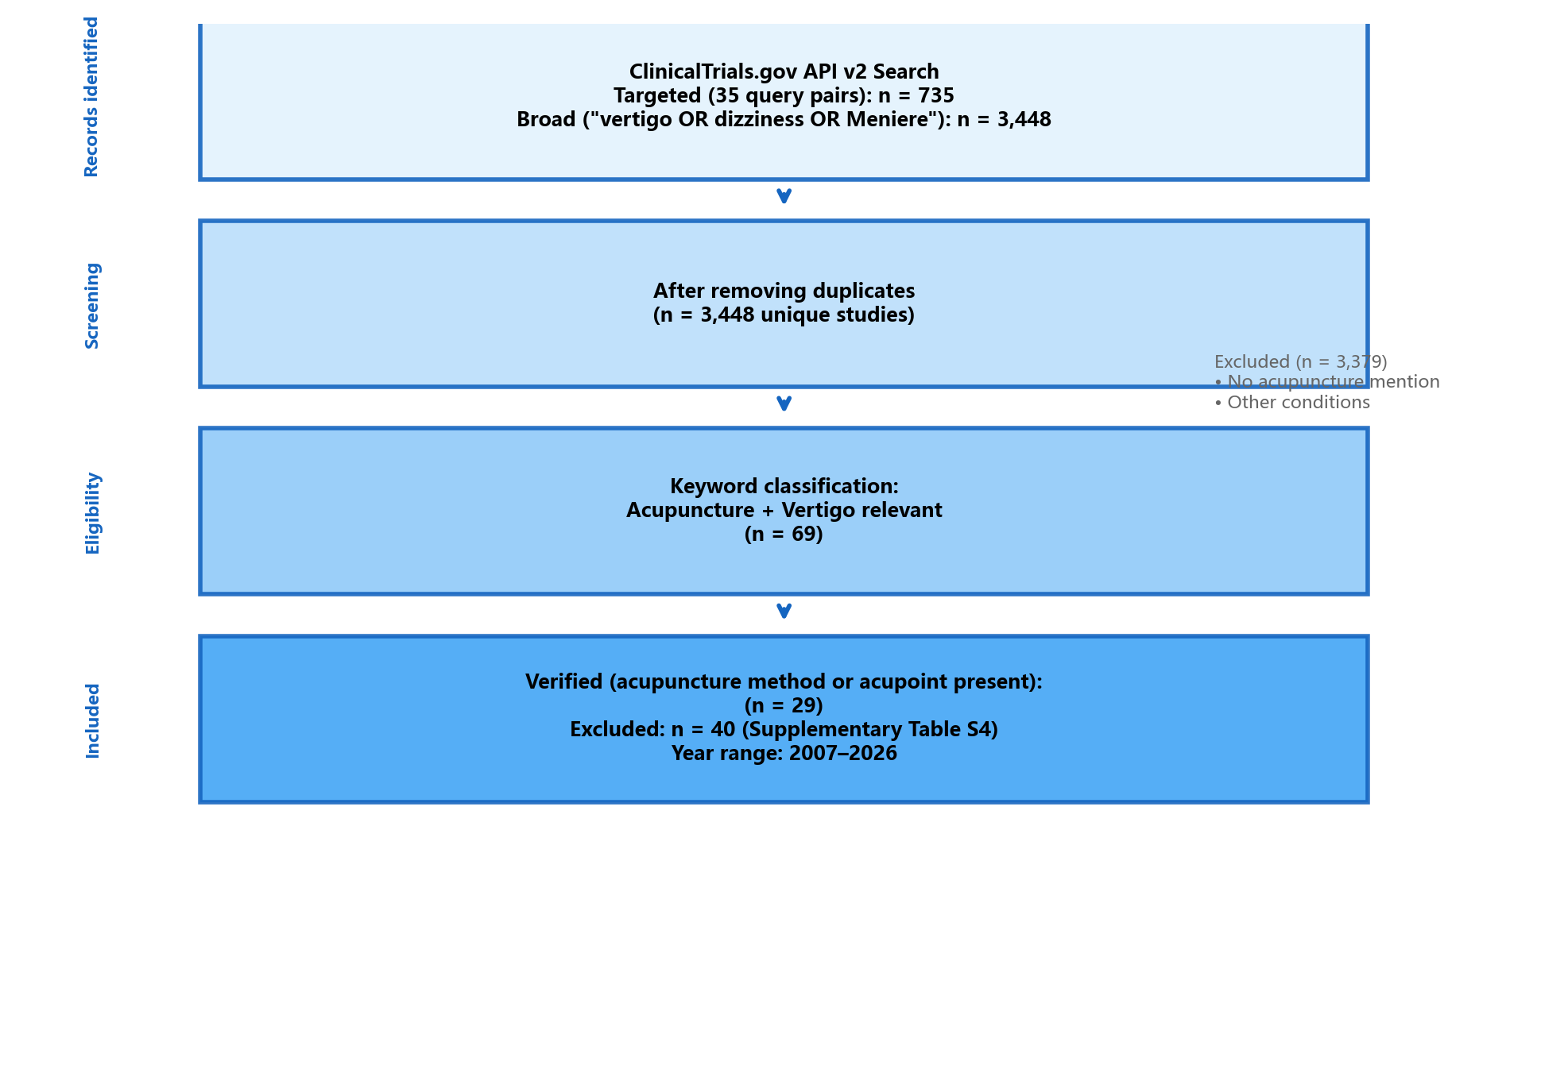
Figure 1. Study selection flow diagram. ClinicalTrials.gov API v2 search (July 1, 2026): 735 targeted + 3,448 broad → 3,448 unique → 69 keyword-positive → 29 verified acupuncture-vertigo trials.

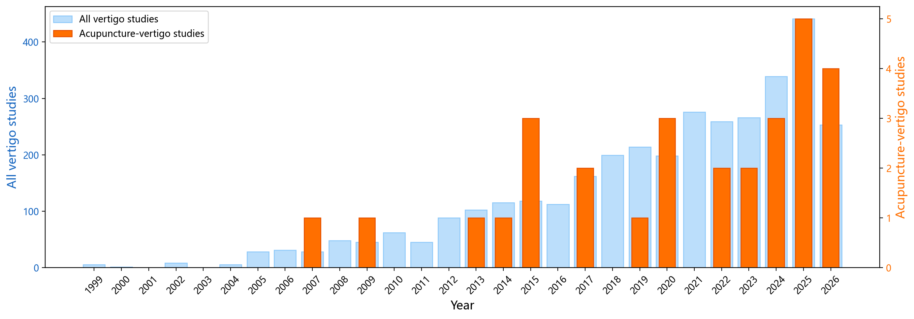
Figure 2. Yearly registration trends of vertigo clinical trials (2007–2026). Light blue: all vertigo studies (n = 3,448). Orange: confirmed acupuncture-vertigo subset (n = 29).

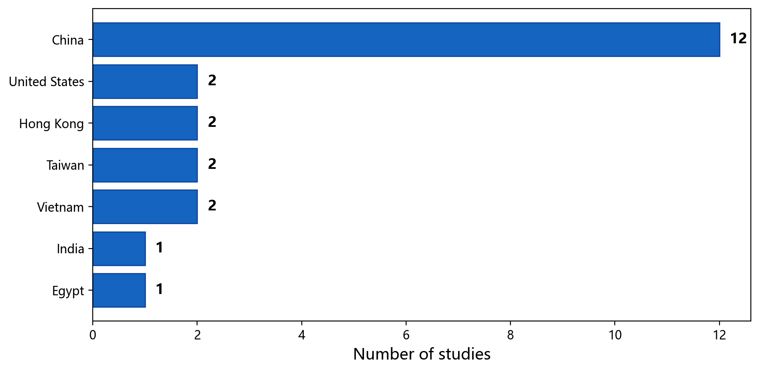
Figure 3. Geographic distribution of confirmed acupuncture-vertigo clinical trials (n = 29). Country/region designations as recorded in ClinicalTrials.gov.

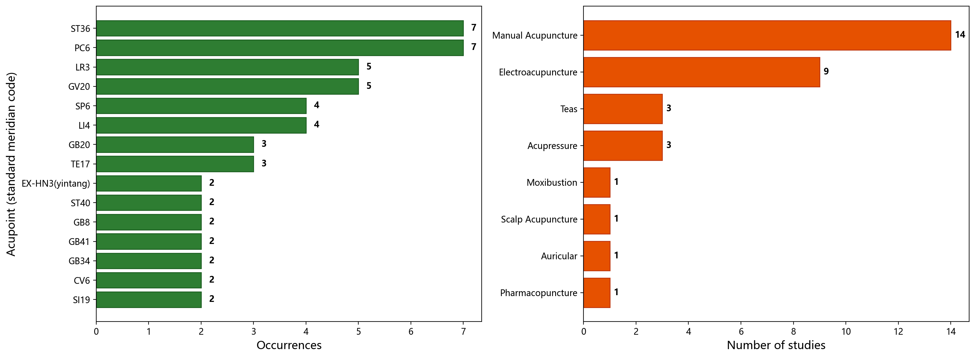
Figure 4. Acupoint frequencies (left, top 15 of 46 distinct acupoints) and acupuncture methods (right) in confirmed acupuncture-vertigo trials (n = 29). Acupoint names normalized to standard meridian codes.

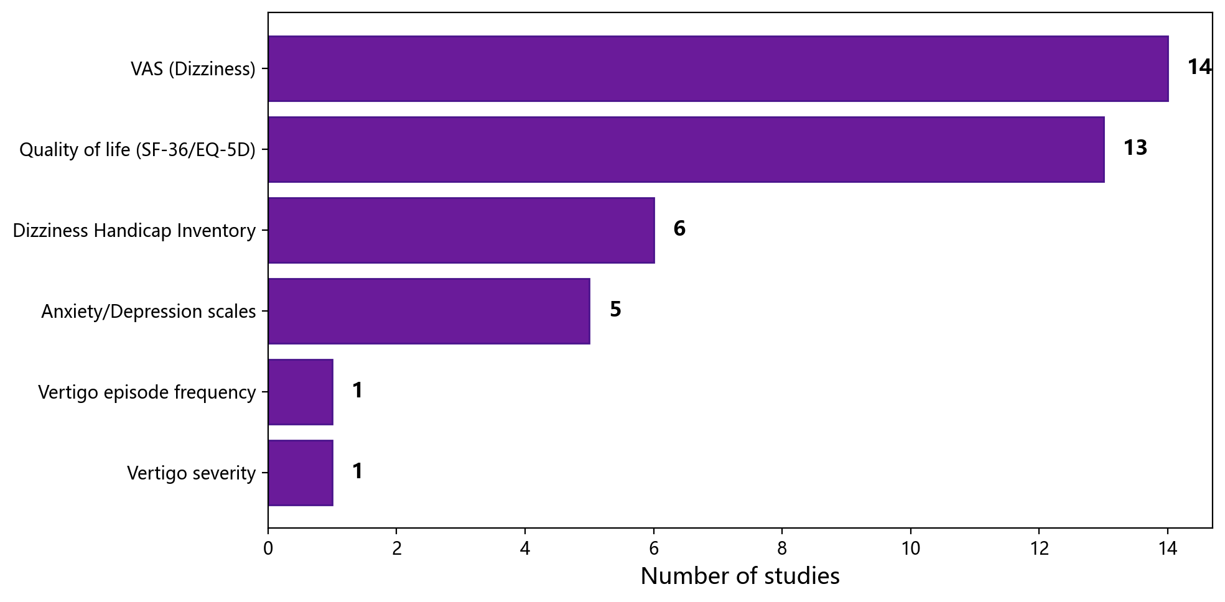
Figure 5. Outcome measures used in confirmed acupuncture-vertigo trials (n = 29). VAS: Visual Analog Scale for dizziness; QOL: quality of life instruments (SF-36, EQ-5D); DHI: Dizziness Handicap Inventory.

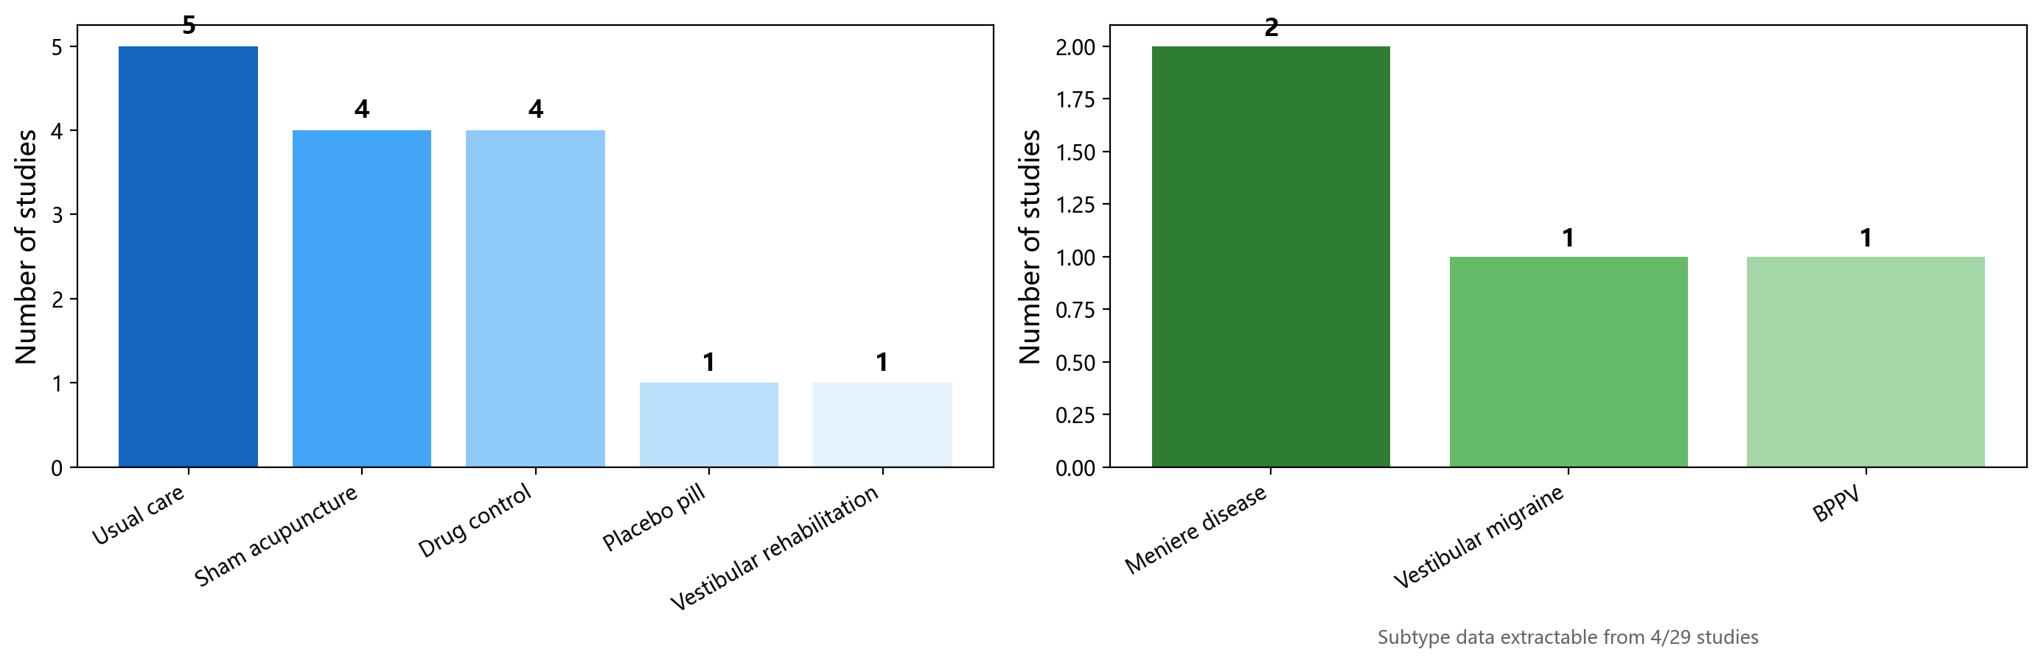
Figure 6. Control types (left) and vertigo subtypes (right) in confirmed acupuncture-vertigo trials. Only 4 of 29 studies had extractable vertigo subtype data.

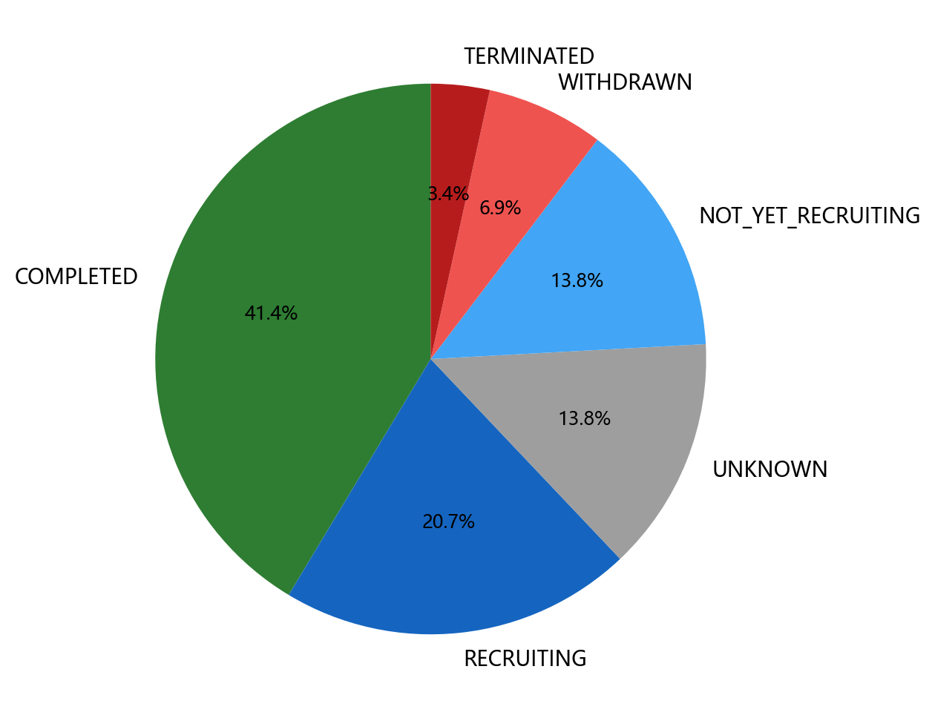
Figure 7. Trial status distribution of confirmed acupuncture-vertigo trials (n = 29).

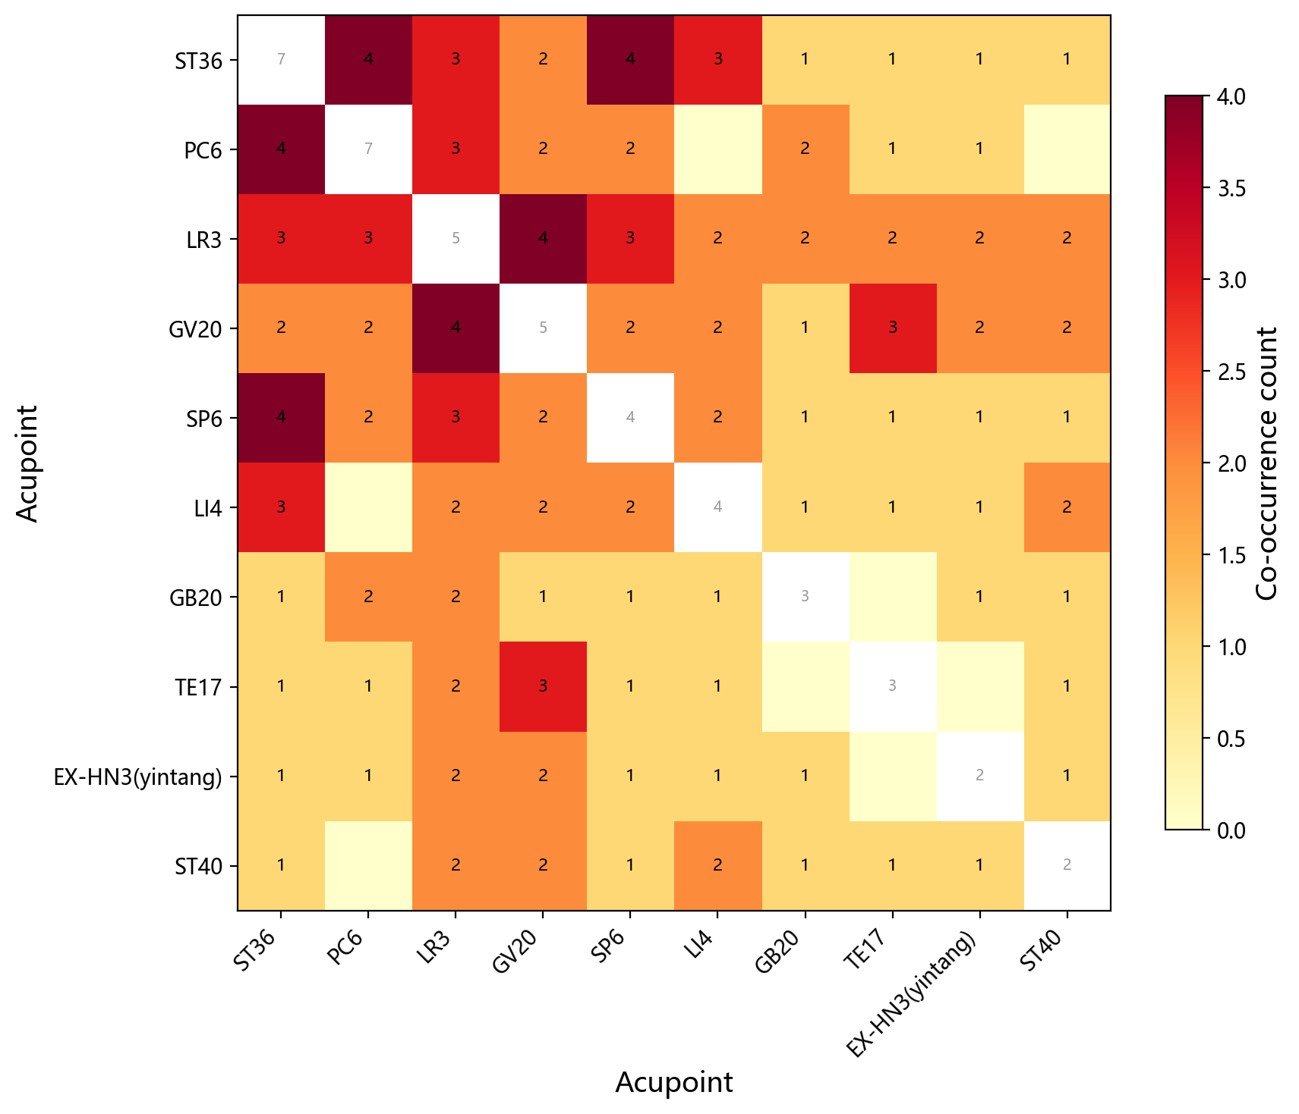
Figure 8. Acupoint co-occurrence matrix for the top 10 most frequent acupoints. Diagonal cells show total occurrences; off-diagonal cells show co-occurrence counts.

Table 1. Classification performance (stratified 5-fold CV, TF-IDF features, N = 3,448).
Model | F1 (SD) | F1 95% CI | AUC (SD) | Precision (SD) | Recall (SD)
Logistic Regression | 0.33 (0.09) | 0.08–0.58 | 0.87 (0.06) | 0.30 (0.05) | 0.37 (0.10)
XGBoost | 0.15 (0.05) | 0.01–0.29 | 0.80 (0.05) | 0.21 (0.06) | 0.11 (0.04)
Random Forest | 0.11 (0.04) | 0.00–0.22 | 0.85 (0.03) | 0.67 (0.10) | 0.06 (0.02)
Note: 95% CI based on t-distribution with df = 4 (t_crit = 2.776). CI bounds truncated at [0, 1]. SD: standard deviation across folds. Accuracy (not shown): Logistic Regression = 0.907, XGBoost = 0.918, Random Forest = 0.940.

Supplementary Materials

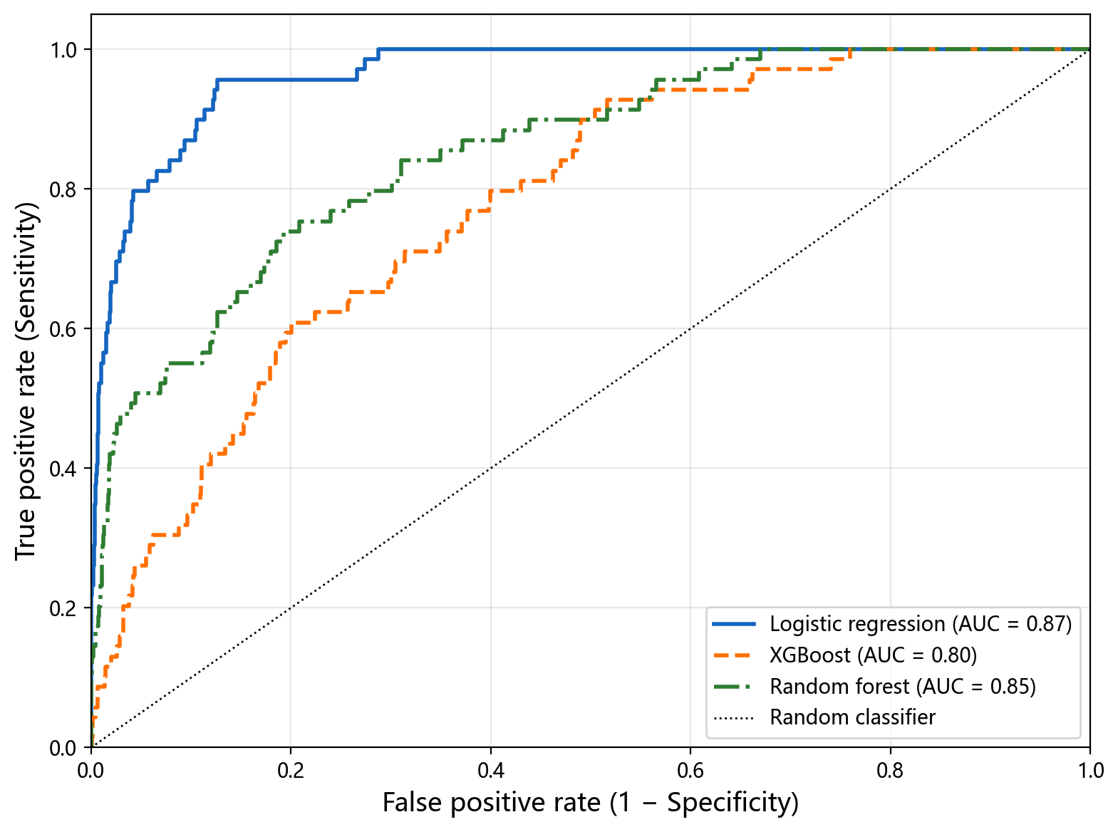
Supplementary Figure S1. ROC curves for three classifiers (stratified 5-fold CV, N = 3,448). LR: logistic regression; XGB: XGBoost; RF: random forest.

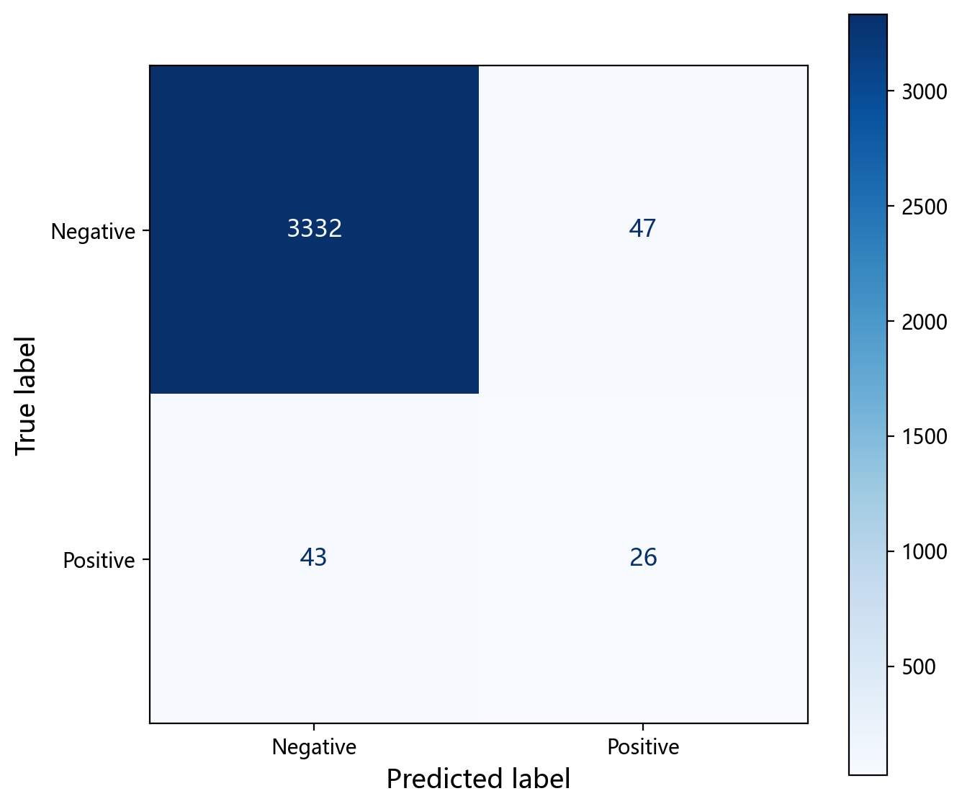
Supplementary Figure S2. Confusion matrix for logistic regression (5-fold CV predictions; TP = 26, FN = 43, FP = 47, TN = 3,332).

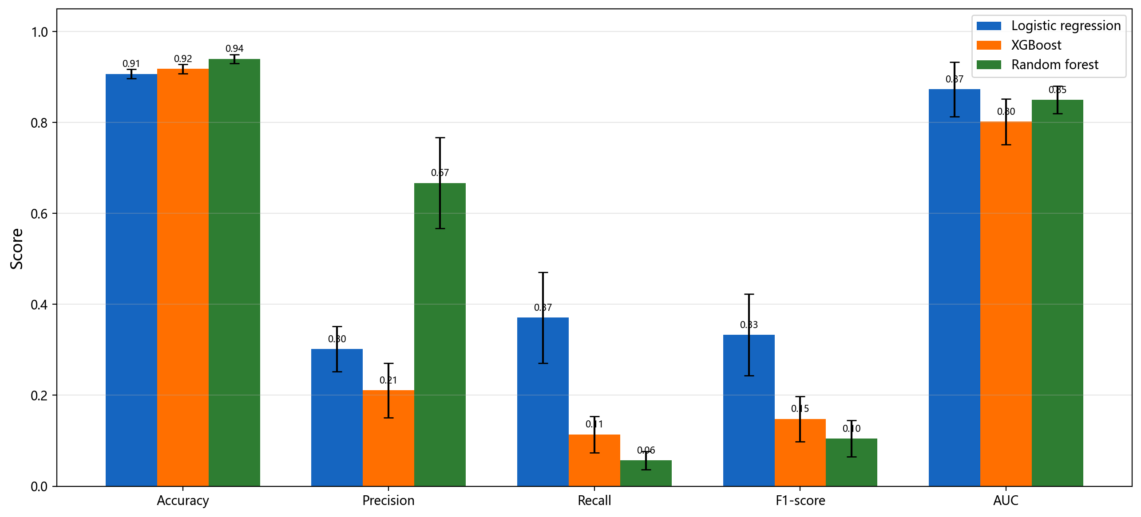
Supplementary Figure S3. Model performance comparison across five metrics with error bars (± SD across CV folds).

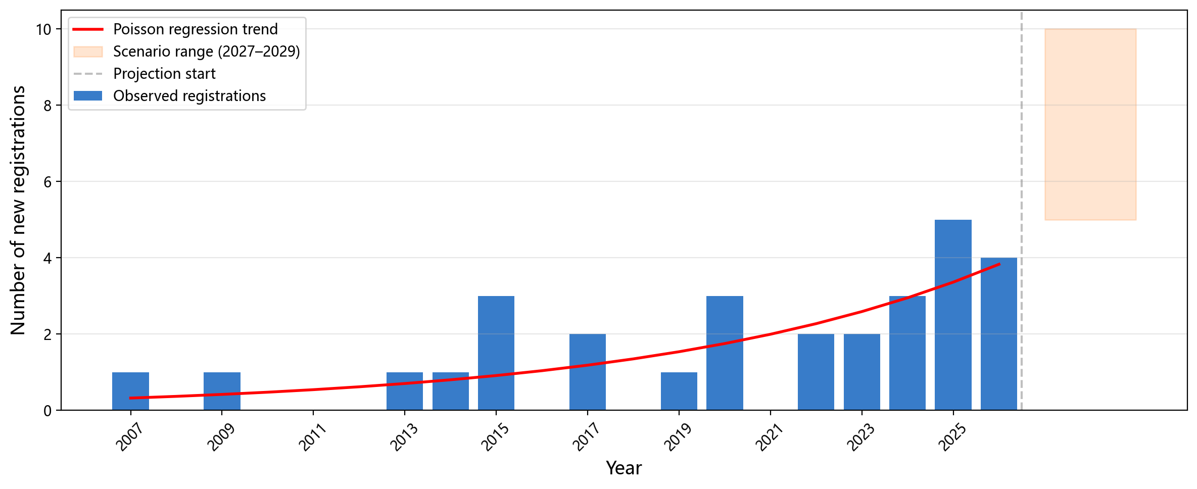
Supplementary Figure S4. Acupuncture-vertigo trial registrations with Poisson regression trend and scenario-based projection (n = 29). Shaded area: descriptive scenario range (2027–2029).

