Week 3 – 2:

--Coding-C-Language Features-Optional.

ROLL NO.:240801194

Name: Manojkumaar R

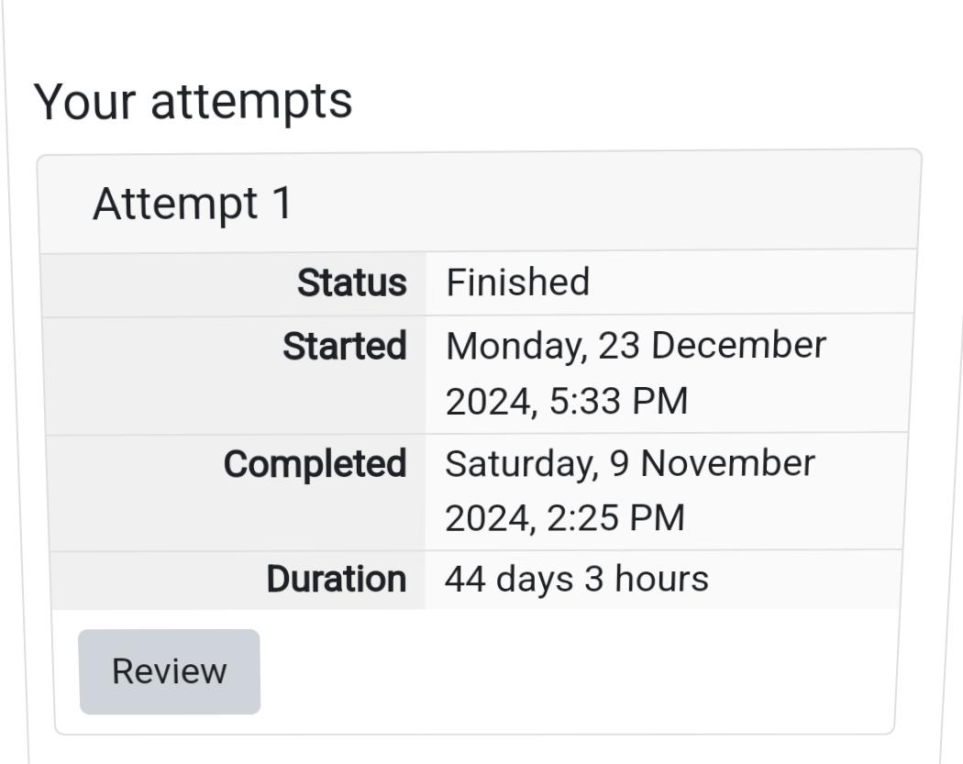

Q1) Write a program that determines the name of a shape from its number of sides. Read the number of sides from the user and then report the appropriate name as part of a meaningful message. Your program should support shapes with anywhere from 3 up to (and including) 10 sides. If a number of sides outside of this range is entered then your program should display an appropriate error message.

Sample Input 1

3

Sample Output 1

Triangle

Sample Input 2

7

Sample Output 2

Heptagon

Sample Input 3

11

Sample Output 3

The number of sides is not supported.

Code:

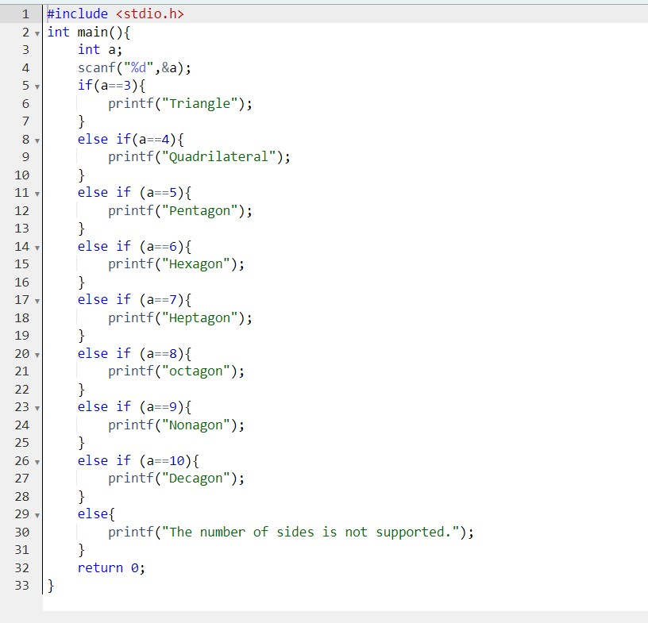

OUTPUT:

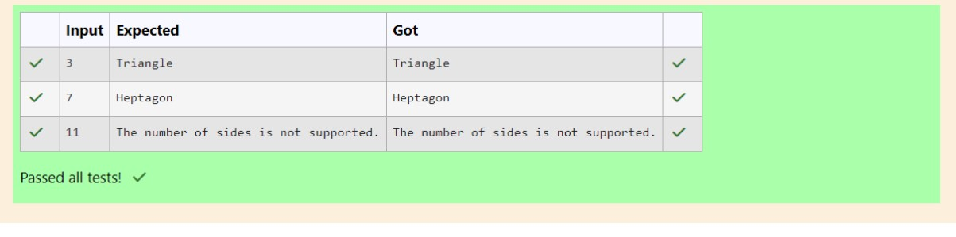

Q2) The Chinese zodiac assigns animals to years in a 12-year cycle. One 12-year cycle is shown in the table below. The pattern repeats from there, with 2012 being another year of the Dragon, and 1999 being another year of the Hare.

Year Animal

1. Dragon
2. Snake 2002 Horse
3. Sheep
4. Monkey
5. Rooster
6. Dog
7. Pig
8. Rat
9. Ox
10. Tiger
11. Hare

Write a program that reads a year from the user and displays the animal associated with that year. Your program should work correctly for any year greater than or equal to zero, not just the ones listed in the table.

Sample Input 1

2004

Sample Output 1

Monkey

Sample Input 2

2010

Sample Output 2

Tiger

Code:

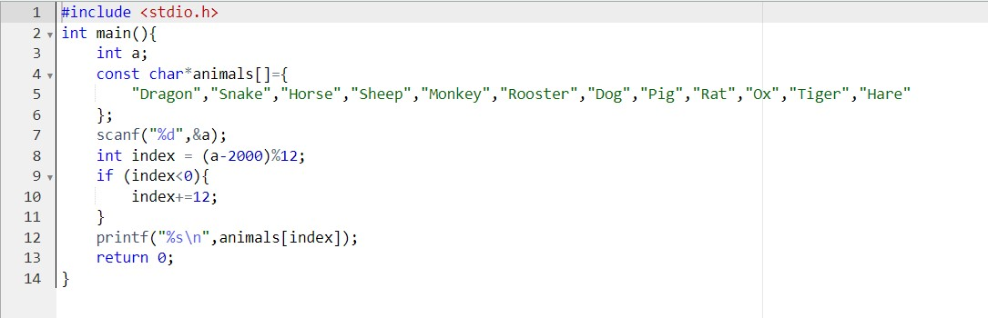

OUTPUT:

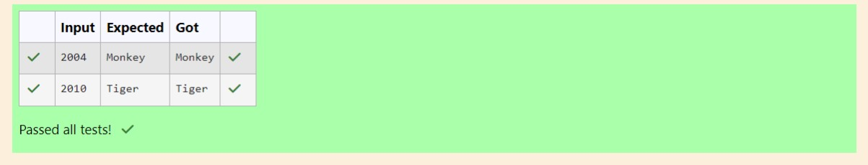

Q3)

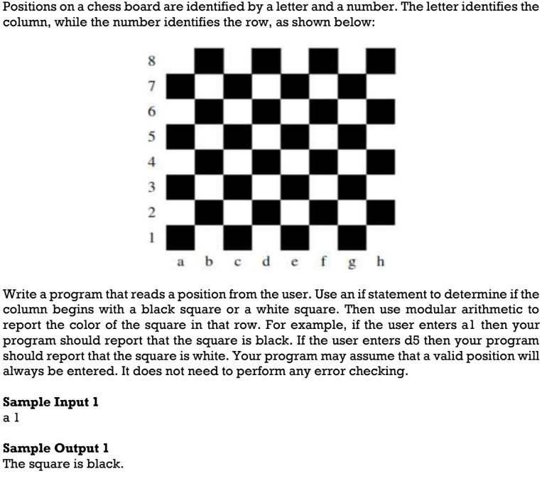

Code:

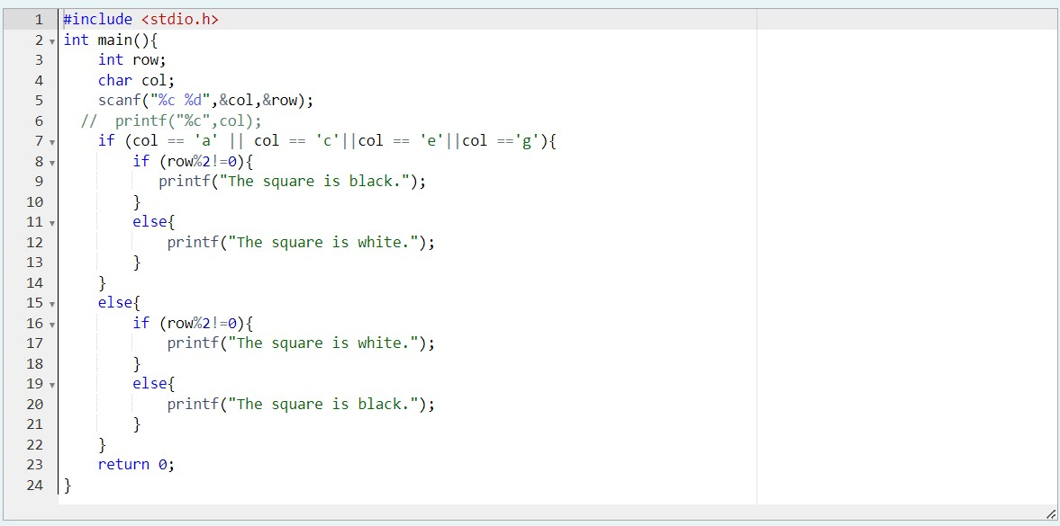

OUTPUT:

