# Hyperledger Workshop

## What are we going to do?

We will setup the last version of the Hyperledger Fabric (v1.2) in two different DigitalOcean’s droplets. Also, we will use the Hyperledger Composer in order to publish an example business network definition in our Hyperledger Fabric.

## Where will we do it?

As we said, you will have two personal DigitalOcean’s droplets already configured, those droplets will contain:

* Ubuntu v16.04
* Docker v17.12

You will need to install some more tools later.

## How will we do it?

We will follow the guide located in this [GitHub repository](https://github.com/1950Labs/2018_SET_HyperLedger_Workshop).  
This guide will show us step by step, using one of the examples of the Hyperledger Fabric Official page, how to setup our Hyperledger Fabric and publish a business network definition in it.

## What will we need to do it?

If you will use Windows, you will need to install a couple of tools in order to accomplish this Workshop.

* Git Bash
  + <https://git-scm.com/downloads>
  + You will use it to connect to our droplets using the ssh command.
* FileZilla
  + <https://filezilla-project.org/download.php?type=server>
  + You will use it to send file through your servers

Of course, if you feel more comfortable using other software you are free to use it, is not mandatory to use this application.

## Configure FileZilla

In order to connect to our droplets using FileZilla we will need to configure the application.  
We will click the first button from the left, the one that looks like 3 servers, under the File button.

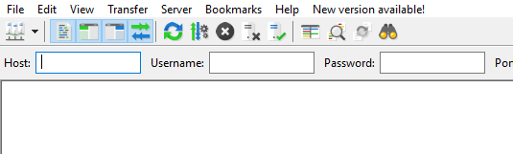

You will need to create two sites, clicking the “New Site” button in the bottom section of the window.

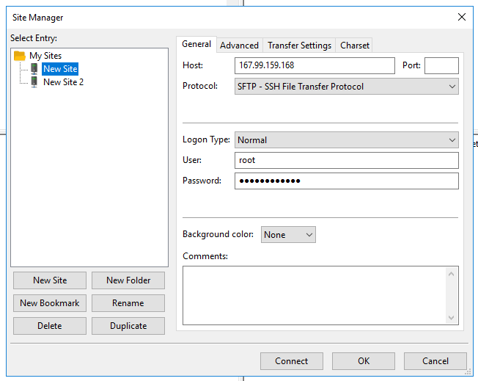

And fill all your server information in it, and click “OK”, if everything it’s fine, you should connect by clicking the arrow next to the “Servers” button and picking the server you want to connect.

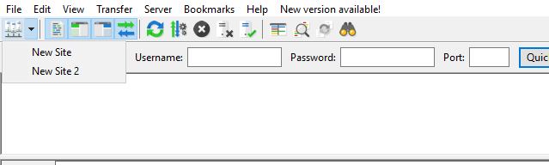

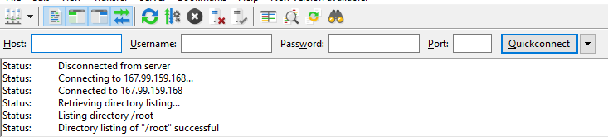

## Docker Commands

We will use some docker commands in order to publish and verify that everything is working with our Hyperledger Fabric. It’s nice to know what we are doing while we are sending those commands.

**docker ps**  
Will show a list of all running containers, we can send the “-a” parameter in order to show all of them, in case we want to delete an stopped one.

**docker logs <containerId>**  
Will show the logs of the container specified.

**docker stop $(docker ps -a -q)**  
Will stop all running containers.

**docker rm $(docker ps -a -q)**  
Will delete all available containers.

**docker-compose -f <yml file name> down**  
Stops containers and removes containers, networks, volumes, and images in the yml file specified.

**docker-compose -f <yml file name> up –d <services>**  
Builds, (re)creates, starts, and attaches to containers for a service.

**docker exec**  
Command runs a new command in a running container.

## Glossary

**Hyperledger Fabric**  
Is a blockchain framework implementation and one of the Hyperledger projects hosted by The Linux Foundation. Intended as a foundation for developing applications or solutions with a modular architecture

**Digital Ocean**  
Is an American cloud infrastructure provider headquartered in New York City with data centers worldwide. DigitalOcean provides developers cloud services that help to deploy and scale applications that run simultaneously on multiple computers. As of January 2018, DigitalOcean was the third-largest hosting company in the world in terms of web-facing computers.

**Droplets**  
Droplets are a scalable compute platform with add-on storage, security, and monitoring capabilities to easily run production applications.

**Hyperledger Composer**  
Is an extensive, open development toolset and framework to make developing blockchain applications easier. Our primary goal is to accelerate time to value, and make it easier to integrate your blockchain applications with the existing business systems.

**Business Network Definition**  
Is a key concept of the Hyperledger Composer programming model. Basically, is a program that runs over our Hyperledger Fabric

**Docker**  
Is an open platform for developers and sysadmins to build, ship, and run distributed applications, whether on laptops, data center VMs, or the cloud.

**Docker Container**  
Is a lightweight, standalone, executable package of software that includes everything needed to run an application: code, runtime, system tools, system libraries and settings.