Mesh Networks for Simultaneous Localization and Communication

**ECE 4012 - Senior Design II Final Project Report**

Section A05, Team 1961C

Advisor: Ma, Xiaoli

Abraham, Kevin

Bennani, Yassine

Molugoori, Sai

Nicholson, Keenan

Nicholson, Norris

*Submitted: 1 May, 2019*

# Executive Summary

Sailboat regattas are a series of competitive boat races conducted by schools, clubs, organizations, and other event conductors. The duration of each race (in collegiate regattas) ranges from 20 to 40 minutes, with 6 to 10 races in each regatta [13]. Traditionally, spectators stand on the shore and watch as boats race around a course on the water. However, these races are difficult to observe from shore and would greatly benefit from real time tracking. The cost of individual GPS modules for each boat combined with a reliable method of transmission can be prohibitive. To solve this problem, we proposed to create a mesh network of radios that use distance measurement techniques to discover the location of each boat in the water. Each boat had a node attached: a self-contained water proof unit including an external antenna, a PCB board with a MCU and DW1000 module, and a 18650 cell for the power supply. The node was securely attached to the mast in an easily accessible location. There was also a main base station that contained equipment for hosting the web app over Wi-Fi, offloading visual processing of the map to client devices. The web app offered spectators a convenient way to watch the race and know the position of the boats. The app can also be used by the race committee to check for any misconduct between boats. By tracking boats in this way, the cost per boat will be reduced to $40. For a complete system with two base stations and twelve nodes in a sailboat regatta, this will cost a total of $800, assuming economics of scale can be utilized for cheap production.

**Contents**

Executive Summary………………………………………………………………………………. **1**

Introduction……………………………………………………………………………………….. 4

Objective……………………………………………………………………………………… 4

Motivation……………………………………………………………………………………. .5

Background…………………………………………………………………………………… 5

Project Description and Goals…………………………………………………………………….6

Technical Specifications…………………………………………………………………………..7

Design Approach and Details…………………………………………………………………… 11

Design Approach……………………………………………………………………………. 11

Radio Transceiver……………………………………………………………………….. 11

Antennas………………………………………………………………………………… 12

Microcontrollers…………………………………………………………………………. 12

Power Supply…………………………………………………………………………….13

Printed Circuit Board……………………………………………………………………. 13

Algorithm………………………………………………………………………………... 13

Critical Path Tasks………………………………………………………………………. 15

Unresolved Aspects and Improvements…………………………………………………. 15

Codes and Standards……………………………………………………………………….... 16

Constraints, Alternatives, and Tradeoffs……………………………………………………. 16

Schedule, Tasks, and Milestones………………………………………………………………... 17

Project Demonstration…………………………………………………………………………... 17

Physical Validation………………………………………………………………………….. 18

Marketing and Cost Analysis……………………………………………………………………. 20

Marketing Analysis…………………………………………………………………………. 20

Cost Analysis………………………………………………………………………………... 21

Parts and Materials………………………………………………………………………. 22

Total Development Hours……………………………………………………………….. 22

Total Development Costs………………………………………………………………... 22

Conclusion………………………………………………………………………………………. 23

Leadership Roles…………………………………………………………………………………24

References……………………………………………………………………………………….. 25

Appendix A……………………………………………………………………………………… 27

Appendix B……………………………………………………………………………………… 39

Appendix C……………………………………………………………………………………… 31

Appendix D……………………………………………………………………………………… **33**

Mesh Networks for Simultaneous Localization and Communication

# Introduction

Team 1961Cs main object was to develop a mesh network solution for simultaneous localization and communication. It was meant to be a cheaper method for mapping boats participating in sailboat regattas, as well as other device localization applications. The end result concluded in a web app to view the map and multiple self-contained units containing electronics such as radios, antennas, PCBs, etc. The team requested $700 of funding to accomplish this.

## Objective

The objective of Team 1961C was to develop a solution for real-time tracking of all the sailboats participating in a regatta. The created user interface was intended to show the location of the boats throughout the race for the audience and race committee to see. The solution used a mesh network of radios which can use distance measurement techniques to pinpoint the location of each boat on the water. This information relayed back to a base station using the same network. There were at least two base radio towers with known locations, which enabled the base to determine the position of the boats using different methods depending on location of the boats. For boats in the triangulation area (i.e. within range of at least 2 towers), the base directly triangulated the location of the node. For boats outside this range, each node must measure the distances between itself and at least three nearby nodes and transfer it to shore using the mesh network. This data was processed by the base station to determine the location of each node.

## Motivation

Sailboat regattas are difficult to observe since the races take place around buoys ~100m offshore. Creating a real-time map of all the sailboats made it easier for the audience to see as well as for judges to determine racecourse violations. Using mesh networks for this task was a more affordable option compared to using GPS modules plus a method of transmission, and it resulted in similar accuracy [14]. The Georgia Tech sailing team could utilize this system, along with other schools, clubs, and organizations that conduct regattas. Additionally, this technology could be used to track other competitive events where the course is obscured or difficult to see. Other applications beyond sports events would also benefit from low-cost mesh-based localization.

## Background

The basic technology supporting this method of localization is Time of Flight distance measurement. Variations on this technology have been used as far back as the mid twentieth century with the advent of DME (Distance Measurement Equipment) for use in the aviation industry [9]. DME operates in the VHF band (200 MHz) and is accurate to within 200 ft.

Another prominent technology which uses a variation of Time of Flight distance measurement is the GPS system, although click synchronization is a key component in its accuracy [4].

In recent years, systems operating in the GHz bands have begun to surface for use in factories and warehouses in order to track materials. These systems are the direct foundation for the node based tracking system proposed here for use with regattas.

As it relates directly to tracking vessels on a regatta course, most modern systems use GPS combined with either a VHF transmission system or a cellular module. These systems are optimized for offshore regattas on larger boats. The aim of Team 1961C was to develop a system optimized for use on smaller boats in local water at a much more reasonable cost [16].

# Project Description and Goals

Team 1961C focused on creating a prototype system consisting of at least three nodes and two base stations. The prototypes were tested using three C420 sailboats owned by the Georgia Tech Sailing Club at Lake Lanier [3]. Each of the nodes were attached to the top of the mast of one of the sailboats. The two base stations were positioned on shore at least 100 feet apart.

For the project to be successful, the system (three nodes and two base stations) tasks we assigned ourselves were:

* Track the position of each node within 7 feet of their actual location
* Communicate this information to shore
* Present the position of each node to a user using a locally hosted web app
* Each node should cost less than $40 (the baseline price for a GPS system that accomplishes the same function) [5]
* Each base station should cost less than $50

Furthermore, each node was successfully a a self-contained unit that housed all of the processing hardware, transmission systems, and power sources.

# Technical Specifications

|  |  |  |
| --- | --- | --- |
| **Project Element** | **Category** | **Specification** |
| Radio Systems | Localization | Updated Value: Positional accuracy of within 7 feet or better  Measured Value: 1.64 feet |
| Updated Value: Position measurement rate not less than once every three seconds (for entire fleet)  Measured Value: 1.5 Hz |
| Updated Value: Each node must be individually identifiable  Measured Value: Node assigned unique number |
| Communication | Updated Value: Communication range between two nodes not less than 300 feet  Measured Value: 330 feet |
| Updated Value: Communication range between a node and a base station not less than 400 feet.  Measured Value: 330 feet |
| Updated Value: Sufficient data throughput to outpace fleet-wide localization measurements  Measured Value: Success |
| Updated Value: Nodes must be able to relay messages for other nodes if a direct link between a node and a base station cannot be made  Measured Value: Success, using COM frames |
| Network | Updated Value: System must operate with as little as one (1) node and up to a maximum of twelve (12) nodes  Measured Value:   * Maximum: 4 tested * Minimum: 1 |
| Updated Value: System must operate with as little as two (2) base stations (provides they are positioned such that boats can only sail to one side of them) and up to a maximum of three (3) base stations (for full position triangulation on both sides of the station formation)  Measured Value: Minimum 2, Maximum N/A (tested 2) |
| Node Module | Enclosure | Updated Value: No larger than 8”x5”x5”  Measured Value: 5.2” x 4.8 “ x 2” |
| Updated Value: No heavier than 3 lbs  Measured Value: 0.17 lbs = 2.72 ounces |
| Updated Value: Water resistant to a depth of 25 feet for up to 5 minutes  Measured Value: Waterproof (IP64) |
| Updated Value: Must be easy to disassemble for charging  Measured Value: Easy to open lid latch |
| Antenna | Updated Value: Must be securely mounted to the enclosure (inside or out)  Measured Value: Mounted to drilled holes in node enclosure |
| Power | Updated Value: Must be rechargeable in less than 6 hours  Measured Value: 4 hours |
| Updated Value: Battery system must last for not less than 4 hours total time, with not less than 2 hours of active position tracking  Measured Value:   * Sleep Mode: 2 months * Active : 16 hours |
| Updated Value: Must be able to withstand temperatures up to 130 °F and down to 40 °F for up to 8 hours  Measured Value: Tested ~50°F to ~80°F |
| Interface | Updated Value: Must have internal buttons and indicators to distinguish between applicable operation modes.  Measured Value: RGB LED displays color based on mode |
| Updated Value: Must be controllable via the base stations using the radio interface  Measured Value: Success |
| Base Station | Enclosure | Updated Value: Must affix to the top of a tripod or other lifting device  Measured Value: Base enclosure contains nut compatible with common camera-to-tripod mount adapters |
| Updated Value: Excluding the tripod or lifting device, must be no larger than 10”x6”x6”  Measured Value: 9.5”x5”x5” |
| Updated Value: Excluding the tripod or lifting device, must be no heavier than 5 lbs  Measured Value: 2.76 lbs |
| Antenna | Updated Value: Must be securely mounted to the enclosure (inside or out)  Measured Value: Mounted to hole drilled in node enclosure |
| Power | Updated Value: Must be capable of switching between external 120VAC input and internal battery (if equipped)  Measured Value: 120VAC supply via 5VDC microUSB power adapter |
| Updated Value: Internal battery (if equipped) must be rechargeable in less than 6 hours, and last for not less than 8 hours, with not less than 6 hours of active position tracking  Measured Value:   * Sleep Mode: 2 months * Active : 16 hours |
| Updated Value: Must be able to withstand temperatures up to 130 °F and down to 40 °F for up to 8 hours  Measured Value: Tested ~50°F to ~80°F |
| Interface | Updated Value: Must host a wifi network for user devices to connect to  Measured Value: Superseded by linking to backend on WAN |
| Updated Value: Must host a web app to allow user interactions  Measured Value: Superseded by hosting web app on WAN, and pushing data up from the base station |
| Updated Value: Must contain settings relevant to the regatta including but not limited to:   * Defining the base station’s exact location * Starting and stopping races * Enabling lower power modes for the nodes   Measured Value: Functionality implementation is in progress for editing of base station locations graphically, but the same can be achieved from an engineering interface. Engineering interface also allows for sleeping nodes to a lower power state. |
| Updated Value: Must present a map to clients so that they can see the location of each node (boat) in real time  Measured Value: User interface contains map displaying information |

# Design Approach and Details

## Design Approach

### Radio Transceiver

The radio transceiver for this project was the DW1000 by DecaWave [5]. This module was chosen in order to streamline the overall project design. It is specifically designed for warehouse inventory management and comes equipped with a Time of Flight distance measurement unit that is compatible with other modules of the same time. Additionally, the DW1000 allows the radio to be used for communication as well, however it required an external microcontroller to give it each instruction. Three DWM1000 modules (DW1000 modules with an added on-board antenna) were acquired along with breakout boards allowing them to be connected to a breadboard. The boards were designed and fabricated before purchasing the DW1000 modules. Module testing and vetting were completed at the beginning of the semester. [6].

### Antennas

The DW1000 radio transceiver required an external antenna. Omni-directional antennas such as loop or dipole antennas were the best choice. The antennas that we used on the nodes ended up being the “Linx MON Series LTE” antennas. These antennas were used to find other nodes attached to the sailboats to acquire data and form a mesh network. A directional antenna was preferred on the base stations (similar to a Yagi-Uda or a end-fire array antenna with a high half power beamwidth), since the base stations on the shore will only need to communicate in the direction of the race course, not the beach. However, due to these antennas costing over $10,000, we used rubber duck antennas on the base station provided by our senior design advisor.

### Microcontrollers

A 32-bit ARM microcontroller (ATSAMD21G18 Cortex M0+) was used to control each node [1, 17]. These interfaced directly with the DW1000 and the onboard power management hardware. The microcontroller was responsible for implementing the mesh communication network, determining distances between nodes and base stations (with hardware support from the  DW1000), and controlling low power modes as commanded by the network. Additionally, the ARM microcontroller interfaced with onboard sensors (to include an accelerometer/compass IC and voltage regulation and management ICs). All microcontrollers are compatible with the Arduino IDE and will be programed in C. This will allow much of the transmission and localization code to be reused between systems.

The base stations are functionally identical to node devices, however they run slightly differing firmware. A serial interface connects the main base station to a laptop. Over this interface, the software running on the laptop has access to all message data present throughout the node network. From this information, the laptop software is able to triangulate the location of each node in the network. Finally, the laptop uploads the resolved locations of each node to a hosted webapp. The app itself was directly hosted using HTML, CSS, and JavaScript. WebSockets served as the primary communication method between clients using the web app and the laptop software.

* + 1. **Power Supply**

The power being supplied to all the electronics in each node was taken care of by a 18650 battery cell [7]. The 18650 cells are cheaper and more thermally and volumetrically efficient, and have a higher charge cycle count (~1800 times). The dimensions of a single cell are 18mm by 65mm, making it the approximately the same size as our PCB boards.

* + 1. **Printed Circuit Boards**

The printed circuit boards were designed in Autodesk Eagle. An image of the completed board layout is given in Appendix D. The PCB is broken into four major components: the microcontroller, the radio transceiver, the power supply, and the accelerometer/compass. The board was designed with four layers, and all Radio Frequency RF traces were routed with impedance matching in mind. The transceiver was surrounded with pads for mounting RF shielding (although none was used in the final product) and the PCB border had a strip of exposed ground plane to absorb any electromagnetic interference from handling.

### Algorithm

A localization algorithm was developed to convert the numerous direct Time of Flight distance measurements between individual nodes (and base stations) into a cohesive map of the race course. MATLAB simulations were executed in order to test and debug this algorithm before deployment. One of the most prominent “problem areas” with this algorithm has been accounting for an overconstrained system (where there are too many distance measurements between too many nodes). It will likely use probability to determine a “best guess” of each node’s location given all of the overconstrained possabilities. See ***Appendix B*** for diagrams relating to localization situations that this system will have to deal with.

The algorithm uses two distinct strategies to localize nodes in the network: triangulation and approximation. Triangulation occurs when the algorithm can use two nodes with known positions to calculation the position of another node. This process can recursively map the entire network by first resolving the location of nodes that are close to the base stations (which are themselves resolved nodes by definition) and then using newly resolved nodes to location nodes which may not have a direct connection with the base station. The algorithm prefers to use direct triangulation from “older” node localizations (such as the base stations themselves, or one of the first nodes located). This process repeats each system “cycle”, starting from a blank canvas. Historical localization guesses are factored into the algorithm as an additional guess which averages with the new guess.

When a node in the network cannot be resolved, the algorithm uses an approximation algorithm to make an educated “best guess”, as outlined below:

1. Use historical data to inver the location of the node by introducing it as a possible guess. If enough other guesses can be inferred from other nodes in the network, this additional historical guess may be enough to resolve the node.
2. If there are multiple guesses for the nodes location, taken using distance measurements from several different nodes in the network, take the average location of the proposed guesses. A minimum of three guesses is required.
3. If there are only two possible guesses at which the node in question is located, pick the guess that is further from other resolved nodes in the network. This relies on the assumption that if the node was close to other nodes, it would have received distance measurements from it, and therefore would be positively resolved.

Refer to ***Appendix*** ***C*** for an example of a meshed network.

### Critical Path Tasks

The major critical path task was evaluating the power consumption, range, and accuracy of the chosen radios. This task took up the most time before we could move forward. To be prepared, we had purchased a few parts early in the process so that evaluation is not hindered. Another major critical path task was the initial hardware design, as the software development is entirely dependent on the specifics of this task. We solved this problem by running this task in parallel with all other initial tasks to complete it as early as possible. This way, the information that is needed for software development is available within the first week of the task.

**1.4.8** **Unresolved Aspects and Improvements**

We completed approximately 98% of the tasks we set for ourselves. The only unresolved aspect is a robust mount for the extender base station. We could not print a enclosure in time due to restrictions in the senior design lab. The next steps to take in improving this project would be: build more nodes and test system on a larger scale, buy better antennas to increase overall range of the system, increase efficiency of the meshing algorithm, studier mounting platform for both base stations, and obtaining a band license to increase transmit power.

## Codes and Standards

The IEEE 802.15.4 standard defines the operation of low-rate wireless personal area networks, which our communications fall under [11]. The radios we chose must adhere to this standard. Thus, we chose a commercially available radio transceiver which already conforms with these standards.

The IEC 60529 standard defines solid and liquid ingress protection [12]. Our finished product was able to achieve at least an IP64 rating (complete protection from dust, and protection from water spray at up to 60º from the horizon).

## Constraints, Alternatives, and Tradeoffs

We originally intended to use standard D-Cell batteries, however, the 18650 batteries have more voltage and much better current capabilities when used in parallel [7]. If the 18650 cells are being used in a pack, when one cell goes bad the rest of the pack will still function with minimal damage. If a slimmer battery is required and parallel performance is deemed unnecessary, a flat-style lithium-ion battery, such as the 785060 2500mAh battery pack can be used [10].

Each node needed to be capable of measuring the distance to another node within radio range. Measuring inter-node distance was done with hardware support from the radio module. This limited our choice of radios, but allowed for a more accurate solution with minimal software overhead. Measuring inter-node distance could also done entirely in software. This could be done with any radio, but comes at the cost of decreased accuracy. We chose to implement distance measurement using hardware support from the radio.

Some sort of user interface was necessary to view the generated data. One option was to run the UI directly on the base station. Either the processor must be powerful enough to support the UI without affecting triangulations, or another processor must be added. Both of these options would have increased cost significantly. Another option was to have the base station host a server, to which client devices could connect to. The base station would only have to process a stream of data, which would put minimal load on the processor. The visual processing could then be offloaded to the client device (smartphone, tablet, laptop, etc). We chose the client-server approach to implement the UI [15].

# Schedule, Tasks, and Milestones

In ***Appendix A***, our GANTT chart shows the list of tasks, task assignments, estimated completion of each task, as well as accomplished tasks. Critical path tasks include evaluating the chosen radios, initial hardware design, and software development-testing iterations. All team members contributed, however, Norris and Keenan Nicholson have contributed the most to this project. Most of the tasks completed were difficult and required a lot of research. The most difficult tasks were soldering all the components manually onto the PCB board and then writing the code for the communication between the nodes. The GANTT chart shows the tasks assigned to each group member. The tasks were assigned to each member based off of previous experience and/or interest in the task. There was discussion between the group and members chose which task they believed would best suit their interests.

# Project Demonstration

The project had two main testing phasing. The first testing location was at Lake Lanier with the Georgia Tech sailing club. We attached each node to the top of the C420 sailboats and set up base stations at the clubhouse. Then, as the sailboats cruised around the lake with the nodes constantly transmitting packets, the base station was receiving the packets along with distance measurements. In addition, the webpage and mobile app were successfully running the GUI showing the location and distance of the nodes along with other information.

The second main testing location was at Piedmont Park. We wanted to conduct more testing to gather more data. To imitate the nodes being at the top of the mast, we took long rods to which we zip tied the nodes at the very top. Then we went to a large open field and walked around imitating a race at a regatta to gather more data.

During the expo, the demo consisted of:

* User interface displaying the location of the nodes relative to each other
* Distance between the nodes
* Real time movement. We attached a node to a pole and walked around our table and the GUI would update and follow the movement accurately.
* Meshing Algorithm

Check **APPENDIX C** for pictures.

## Physical Validation

Each physical attribute of the enclosure and base station was measured and compared to the requirements listed in Section 3 as prototypes were developed. Physical requirements were kept in mind throughout the design process, and checked continually. For portions of the project that resulted in physical results (the node case in particular), physical reviews were conducted with each iteration design.

Components such as the radio systems, node modules, and base stations were tested individually based on the criteria listed in Section 3 to ensure compliance with requirements throughout the design and testing process.

# Marketing and Cost Analysis

## Marketing Analysis

This product was meant to appeal to groups seeking fast, low cost relative positioning information for nodes that will be confined to a certain area. Functionally, the product was able to produce similar results to a constellation of GPS receivers with a messaging interface. A suitable comparison would be the BARTUN® Vehicle tracker, which can continuously track its location via GPS and relay it to a cloud service as long as GSM/GPRS access is available [2]. This proposed product is be considerably cheaper per device, and will not have the GSM/GPRS reliance, allowing for more realistic device tracking for well-defined regions.

A real-world example is tracking sailboats in a fleet race, where it can be challenging to see locations of boats from shore. Other applications include but are not limited to warehouse forklift tracking, small aerial drone localization, indoor robotic tracking, and other sport applications.

Compared to the competition, this proposed product will be cheaper, relying on local positioning rather than expensive GPS receivers, and utilizing a contract-less local communication network, removing the need for expensive GPRS packages and SIM card contracts [14]. This allows for, and benefits from, larger-scale device deployment, where many devices are tracked concurrently and relative to each other.

This product will be marketed as a localization solution, with at least two base stations and a node being the minimum required components. Additional base stations and nodes can be added to expand the usability and utilization of the system, as the buyer sees fit.

## Cost Analysis

### Parts and Materials

The system was be composed of five nodes and two base stations. Both nodes and base stations contained a radio transmitter, suitable antennas, a board (includes the microcontroller), and a power supply. Additionally, we needed wires and cables for inter-components communication. Finally, the system required packaging and mounting parts. The table below shows the costs of each item.

|  |  |
| --- | --- |
| **Item** | **Cost** |
| Radio Transceiver | $20.00 |
| Node Antenna | $15.00 |
| Node Board | $15.00 |
| Node Power Supply | $5.00 |
| Node Total | $55.00 |
| Base Antenna | $15.00 |
| Base Board | $15.00 |
| Base Power Supply | $30.00 |
| Base Total | $60.00 |
| Packaging + wires | $21.75 |
| PCBs | $57.28 |
| System Total (5 nodes, 2 bases) | $474.03 |

### 

### Total Development Hours

Five engineers completed the design and development of the nodes and bases stations. The total hours for the project per engineer (per 2 semester, not including class times) are included in the following table.

|  |  |
| --- | --- |
| **Task** | **Engineer-Semester Hours** |
| Weekly Meeting | 80 |
| Reports | 30 |
| Research | 20 |
| Presentation | 10 |
| Fabrication | 90 |
| Assembly | 45 |
| Testing | 80 |
| Total | 355 |

### 

### Total Development Costs

Given a salary of $55,000 per year per engineer and 355 hours of work we estimated an amount of $30,000 for the labor. Additionally, we needed to plan for unexpected expenses as they usually occur.

|  |  |
| --- | --- |
| **Development Component** | **Cost** |
| Parts | $474.03 |
| Labor | $30,000 |
| Unexpected Expenses | $100 |
| Total Development Costs | $30,574.03 |

The selling price of the system (5 nodes and 2 base stations) will be $520. Additionally, it is possible to buy either an individual node for a price of $60 or a base station for $120. We will provide significant discounts on high quantity purchases. These prices are very similar to the prototype costs listed above, however when translated to full production, economics of scale would reduce the production cost, thereby increasing profit margin.

# Conclusion

We were able to follow our GANTT chart successfully throughout the semester. There was a delay in shipping by one week, however, we accounted for this time and started working on the software aspect of things while we waited for hardware too come in. Other than one of our nodes not working due to a defective DW1000 module, everything else went according to plan. The current status of our project is: base stations can successfully receive packets from nodes and display information on the web and mobile app, time of flight calculations give accurate distance measurements with an error of few centimeters, antennas are calibrated to decrease the amount of error, and algorithm uses nodes to create mesh network and detect other nodes that base station cannot detect directly. If we were to do this project from the beginning, we would place the order to purchase parts earlier to give more time for the meshing algorithm. When continuing the project, the most complicated and important aspect to review is the code and understand how the communication between the nodes and base stations works as well as how they implement hops to implement the meshing algorithm. The most important lesson to learn is to expect things to go wrong and always have a back-up plan or purchase spare parts to prevent wasting time.

1. **Leadership Roles**

Kevin was the webmaster and was also in charge of user interface and video production. Yassine was the Expo coordinator. His additional tasks included device enclosures, 3D modeling, and poster work. Sai was the document coordinator. He was also assigned with antenna and power supply tasks. Norris and Keenan Nicholson were the leads on the project using their vast knowledge to assist the team members in coding and hardware design. They took the lead with PCB design and writing code for the node communication and algorithm. Although we were all assigned tasks, everyone participated in all parts of the project, assisting each other throughout the semester while teaching and learning as the project progressed.

# References

[1] Atmel, “8-bit AVR Microcontroller with 4/8/16/32K Bytes In-System Programmable Flash,” *8-bit AVR Microcontroller with 4/8/16/32K Bytes In-System Programmable Flash*. Atmel, 2009.

[2] BARTUN, “BARTUN Vehicles GPS Tracker,” *BARTUN Vehicles GPS Tracker*. BARTUN, 2018.

[3] “Club 420,” *Pro Opti Sailboats – Optimist Sailboats from Zim Sailing*. [Online]. Available: https://www.zimsailing.com/club-420.html. [Accessed: 20-Nov-2018].

[4] D. Kalman, “An Underdetermined Linear System for GPS,” *THE COLLEGE MATHEMATICS JOURNAL*, vol. 33, no. 5, pp. 384–390, Nov. 2002.

[5] DECAWAVE, “DW1000 Product Overview,” *DW1000 Product Overview*. 2015. DW1000 802.15.4-2011

[6] DECAWAVE, “DWM1000 Product Overview,” *DWM1000 Product Overview*. 2015. DW1000 802.15.4-2011

[7] EM3, “Lithium-ion Battery DATA SHEET ,” *Lithium-ion Battery DATA SHEET* . 2010. LIR18650 2600mAh

[8] Espressif Systems, “ESP8266EX Datasheet,” *ESP8266EX Datasheet*. 2018.

[9] “Federal Radionavigation Systems,” National Technical Information Service, Springfield, VA, rep., 2001.

[10] Hunan Sounddon New Energy, “785060 Product Specification,” *785060 Product Specification*. 785060 2500mAh

[11] “IEEE Standard for Local and metropolitan area networks--Part 15.4: Low-Rate Wireless Personal Area Networks (LR-WPANs).”

[12] “Ingress Protection IEC 60529 IP,” *SST*, pp. 1–2.

[13] “International 420 Class Rules,” *World Sailing Class Association*, 2017.

[14] L. Quaglietta, B. H. Martins, A. D. Jongh, A. Mira, and L. Boitani, “A Low-Cost GPS GSM/GPRS Telemetry System: Performance in Stationary Field Tests and Preliminary Data on Wild Otters (Lutra lutra),” *PLoS ONE*, vol. 7, no. 1, May 2012.

[15] Mildred Moy, “Approaches to Building Client/Server Applications,” *Government Technology: State & Local Government News Articles*, 30-Sep-1995. [Online]. Available: http://www.govtech.com/magazines/gt/Approaches-to-Building-ClientServer-Applications.html. [Accessed: 24-Nov-2018].

[16] SICK, “Efficient solutions for Warehouse and Distribution,” *Efficient solutions for Warehouse and Distribution*. SICK.

[17] “Teensy 3.2 & 3.1 - New Features,” PJRC. [Online]. Available: https://www.pjrc.com/teensy/teensy31.html. [Accessed: 22-Nov-2018].

# Appendix A



# Appendix B

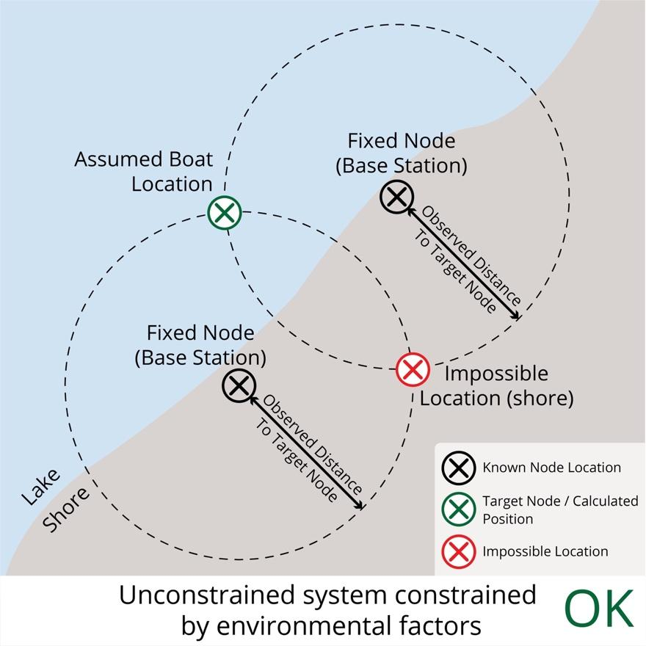

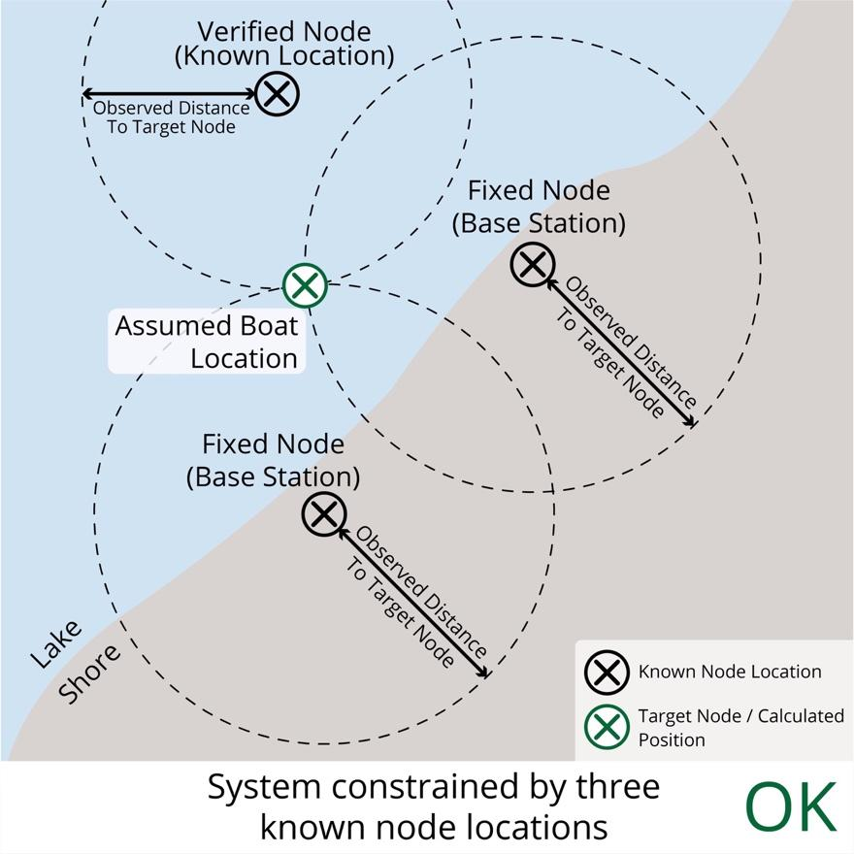

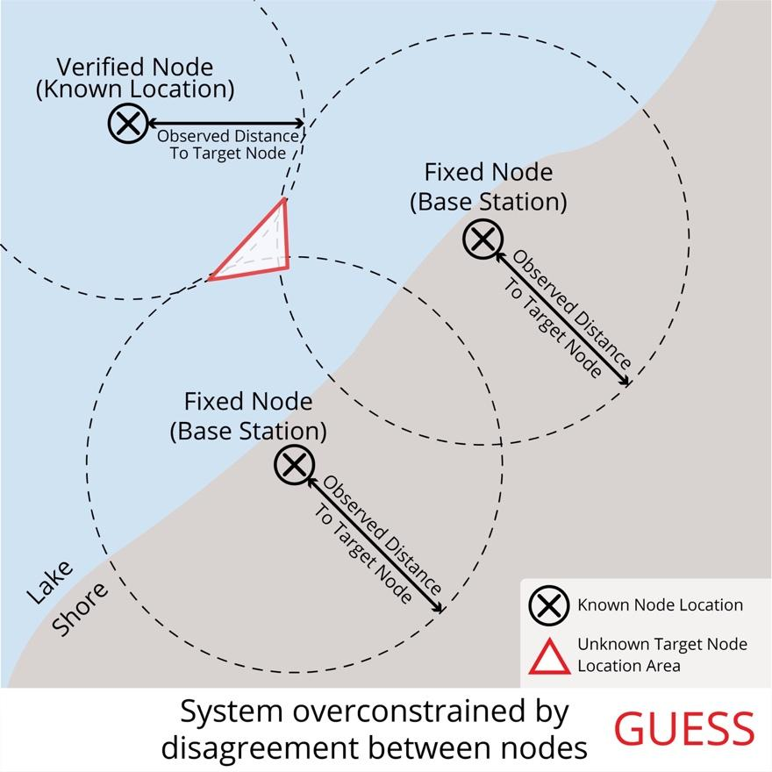

# Appendix C

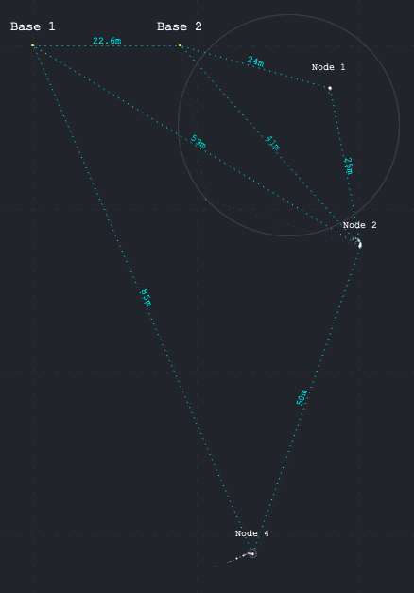

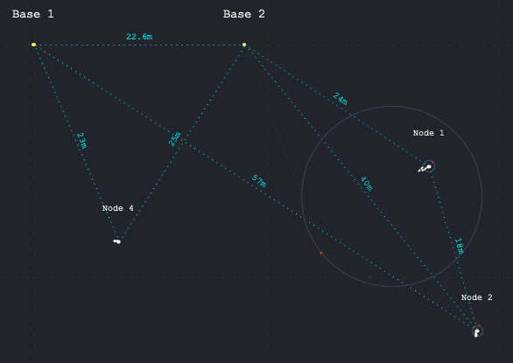

# Appendix D

Top Layer

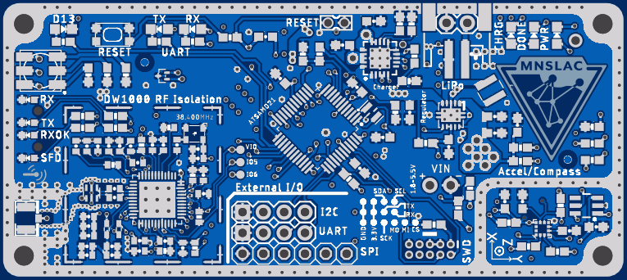

Internal Layer 1

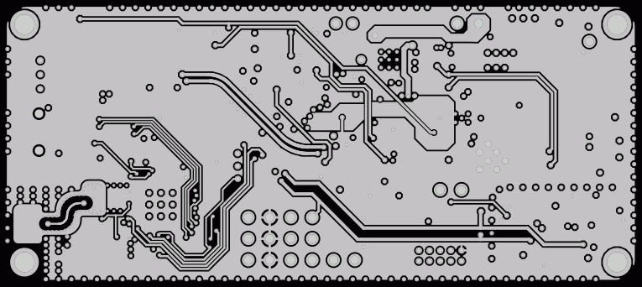

Internal Layer 2

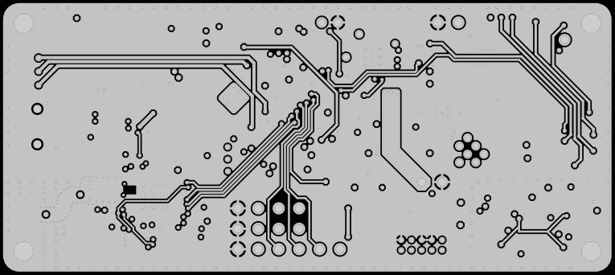

Bottom Layer

