Predicción de la inflación en Uruguay a partir de modelos de series de tiempo

Trabajo final del curso Modelos de pronósticos. Un enfoque Moderno.

Alvaro Fuentes Coiana

’2020-12-04

# Predicción de la inflación en Uruguay a partir de modelos de series de tiempo

##   
## Attaching package: 'lubridate'

## The following objects are masked from 'package:base':  
##   
## date, intersect, setdiff, union

##   
## Attaching package: 'zoo'

## The following objects are masked from 'package:base':  
##   
## as.Date, as.Date.numeric

## Registered S3 method overwritten by 'quantmod':  
## method from  
## as.zoo.data.frame zoo

## Loading required package: Matrix

## Loaded glmnet 4.0-2

## corrplot 0.84 loaded

## Loading required package: lattice

## Objetivo

El objetivo de este estudio es comparar un conjunto de modelos de predicción de la inflación en Uruguay, basados en la aplicación de las metodologías estudiadas en el curso dictado por Walter Sosa Escudero y Magdalena Cornejo.

## Justificación

La inflación en Uruguay muestra una persistencia llamativa en comparación con la experiencia internacional. En efecto, aún en un período de relativa calma, como el registrado tras la crisis de 2002, los niveles de inflación en el país se han mantenido estables, pero elevados en torno al 8% anual, un valor que lo sitúa entre los países de inflación media a nivel mundial. Esta situación sin embargo, no parece haber generado grandes sobresaltos en términos de su econmía, habida cuenta que el período post crisis ha coincidido con el de mayor crecimientocontinuado del PIB desde que se llevan estimaciones. Al parecer, los agentes se han acostumbrado a convivir con un nivel de inflación estable, aunque el mismo pueda ser elevado en consideración a lo sucedido en el resto del mundo donde esta se ha mostrado en caída, en un nivel bastante inferior al que se da en el país.

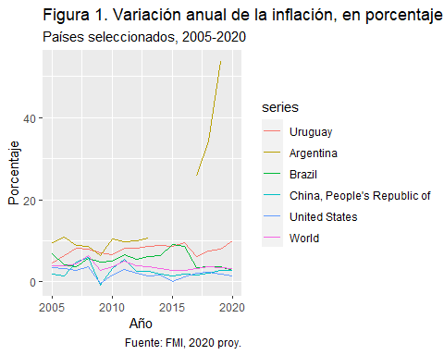

## Metodología

La metodología a aplicar sigue alguna de las técnicas presentadas en el curso. En particular, se estimará un conjunto de modelos univariados y multivariados, basados en técnicas de series temporales, comparándolos en términos de su poder predictivo. Partiendo de la base de un modelo univariado, se incorporará al análisis distintas características, que permitirán complejizar los modelos, recorriendo un camino que va desde el más sencillo al más complejo. Esto permi- tirá no solo evaluar sus predicciones sino también, aportar evidencia respecto de cuáles de esos factores resultaron los de mayor importancia en el proceso inflacionario.

El período a analizar será el posterior a la mencionada crisis debido a que, es para este con que se cuenta con una mayor disponibilidad de indicadores que pueden oficiar como covariables de la inflación. El análisis parte desde enero de 2005 y se extiende hasta setiembre de 2020 que es el último mes para el que se encontraban disponibles algunas de las covariables mencionadas.

El documento se estructura de la siguiente forma: en la segunda sección, se realiza un estudio estadístico descriptivo de la serie de IPC en Uruguay así como de las características incluidas en el set de datos. En la tercera sección, se procede al análisis de las raíces unitarias y se implementan las transforma- ciones necesarias para alcanzar la estacionariedad. En la cuarta sección se estima el o los modelos unidimensionales de mejor performance en la predicción. En la quinta sección se estiman modelos de ****. En la sexta sección, ****. En la séptima se resumen los resultados de los modelos y se presentan las predi- cciones a partir del mejor modelo.

## Análisis Estadístico Descriptivo.

### Estudio de la serie de IPC, raíces unitarias y transformaciones.

En Uruguay la inflación se mide a partir de la variación del Índice de Precios al Consumidor. Este indicador es elaborado en forma mensual y continuada desde 1937, inicialmente por el Ministerio de Economía y actualmente por el Insituto Nacional de Estadística.

En sus orígenes la cobertura fue sólo para Montevideo, aunque sus alcances le- gales siempre fueron nacionales. Desde el último cambio de base, que data de 2010, su cobertura se extendió, para abarcar la áreas urbanas de todo el país. En la figura 2 se presenta la evolución temporal de la serie del IPC, la que presenta una tendencia creciente bastante suave y constante, sin patrones esta- cionales que llamen la atención a primera vista.

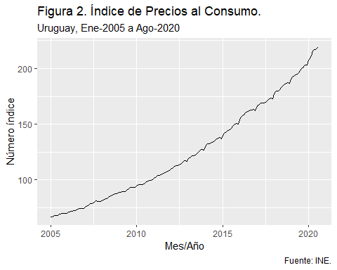 Dada las características de la serie, se estudiará la existencia de raíces unitarias en la serie en logaritmos así como la primera y segunda diferencias de ésta. Previamente, se presenta el gráfico de las primeras diferencias de la serie original y en logaritmos, para mostrar el aumento de la varianza en la primera y su moderación en la segunda. (Ver figuras 3 y 4)

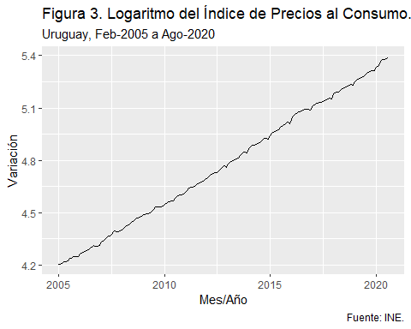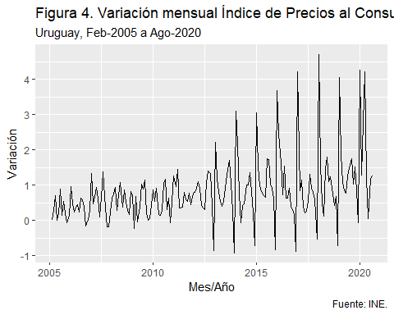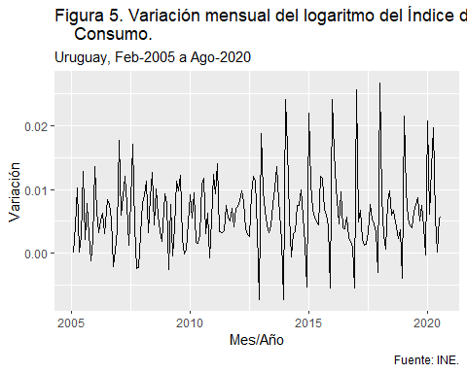

Se aplican tres pruebas de raíz unitaria, los test de Dickey-Fuller aumentado, Phillips-Perron y KPSS sobre el logaritmo de la serie original, su primera y segunda diferencias. Los dos primeros test postulan como H0 la existencia de una raíz unitaria en la serie, al tiempo que el tercero postula su estacionariedad. A partir de los resultados obtenidos de los distintos test, se establece la existencia de una única raíz unitaria en el logaritmo del IPC, por lo que se trabajará en adelante con la primera diferencia.

## # A tibble: 3 x 7  
## Variable trend ADF trend2 PP trend3 KPSS   
## <chr> <chr> <chr> <chr> <chr> <chr> <chr>   
## 1 log(ipc) no -3.513 *** sí -3.4566 * si 0.2205 ***   
## 2 diff(log(ipc)) no -11.912 *~ no -15.2994 *~ no 5.9400000000000001~  
## 3 diff2(log(ipc)) no -15.731*** no -43.4501 *~ no 4.6800000000000001~

### Patrones estacionales de la serie logarítmica diferenciada.

Es posible plantear revelar patrones estacionales en la serie mediante inspección gráfica. En la figura 5 se presenta un gráfico estacional, donde se puede observar un patrón estacional, con el mes de enero por encima del resto. Esto es consistente con la forma de ajuste de las tarifas públicas, que suelen darse mayoritariamente en dicho mes. Adicionalmente, es consistente con una caída en los meses de diciembre, observada a partir de 2012 cuando se implementara un plan de descuentos anuales en las cuentas de electricidad (UTE premia). Esto llevó a un cambio en el patrón para el último mes del año que, hasta ese entonces solía ser de variaciones promedio y pasó a ubicarse en el extremo inferior. Para el año 2020 se observa además una anomalía en el mes de abril, dado que en este año las tarifas públicas se incrementaron en dicho mes en vez de en enero. Algo similar se había observado en 2005, con una postergación de los aumentos de enero, que luego se efectivizaron en marzo y quedaron registrados en abril.

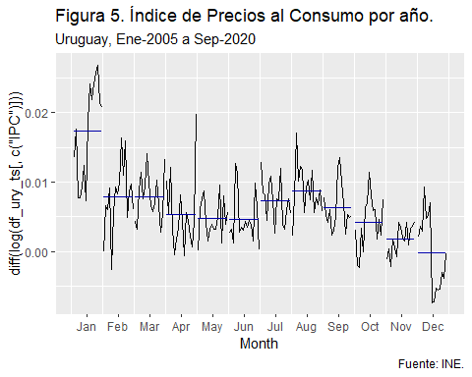

A modo de cierre, en la figura 6 se presenta el correlograma de la serie, que da cuenta en forma muy clara del patrón estacional anual mencionado, así como la posibilidad de dos rezagos en el corto plazo. Esto debiera ser reconocible en un modelo SARIMA, que se presentará en la siguiente sección.

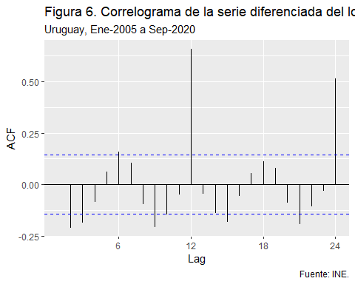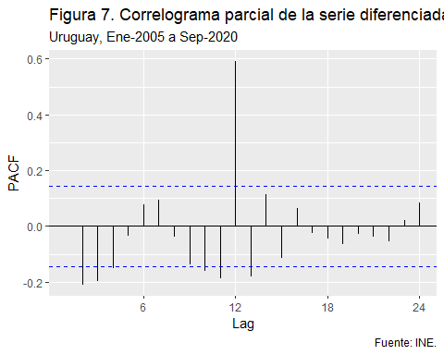 ## Modelos de pronóstico unidimensionales: ARIMA y ETS.

La primera etapa de construcción de modelos se enfoca en modelos unidimensionales. En particular, se estimarán modelos ARIMA, mediante la función auto ARIMA y mo- delos ETS de suavizado exponencial. Respecto del modelo ARIMA seleccio- nado, este resulta tener dos componentes autorregresivos, más uno estacional anual tal como pudo anticiparse del análisis gráfico anterior.El estudio de los resi- duos no permite descartar que se traten de ruido blanco. Respecto del modelo ETS, los residuos del modelo no alcanzan a ser ruido blanco, permaneciendo un compo- nente autorregresivo asociado al patrón de variación anual de la inflación. Por último, la comparación de la performance entre ambos modelos no arroja resul- tados conclusivos en lo que refiere a su capacidad predictiva. En efecto, alguno de los indicadores son mejores en el modelo ETS y otros en el ARIMA o similares entre ambos, lo que hace difícil la selección. En las siguientes secciones se estimarán otros modelos lo que podría dar lugar a la aparición de uno mejor a los presentados hasta ahora.

## [1] 151

## [1] 36

## Series: train   
## ARIMA(2,0,0)(1,0,0)[12] with non-zero mean   
##   
## Coefficients:  
## ar1 ar2 sar1 mean  
## 0.1064 -0.1982 0.6984 0.0058  
## s.e. 0.0809 0.0799 0.0599 0.0009  
##   
## sigma^2 estimated as 1.655e-05: log likelihood=614.92  
## AIC=-1219.84 AICc=-1219.43 BIC=-1204.76  
##   
## Training set error measures:  
## ME RMSE MAE MPE MAPE MASE  
## Training set 7.824421e-05 0.004013321 0.003177538 -Inf Inf 0.9224995  
## ACF1  
## Training set 0.01369515

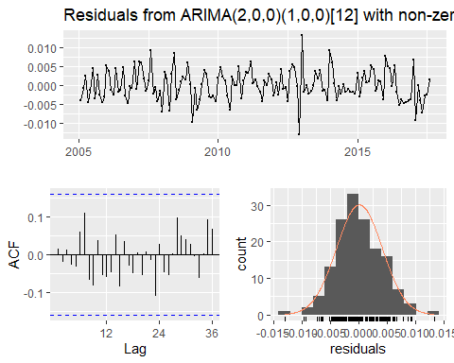

##   
## Ljung-Box test  
##   
## data: Residuals from ARIMA(2,0,0)(1,0,0)[12] with non-zero mean  
## Q* = 11.995, df = 20, p-value = 0.9162  
##   
## Model df: 4. Total lags used: 24

## ETS(A,N,A)   
##   
## Call:  
## ets(y = train)   
##   
## Smoothing parameters:  
## alpha = 1e-04   
## gamma = 0.07   
##   
## Initial states:  
## l = 0.0061   
## s = 0.0094 -0.0056 -0.0051 -0.0019 8e-04 0.0028  
## 0.0018 -0.0019 -0.0014 -0.0016 0.0014 0.0012  
##   
## sigma: 0.0044  
##   
## AIC AICc BIC   
## -867.2047 -863.6491 -821.9455   
##   
## Training set error measures:  
## ME RMSE MAE MPE MAPE MASE  
## Training set 0.0001046569 0.004171347 0.003263654 -Inf Inf 0.9475006  
## ACF1  
## Training set 0.00105954

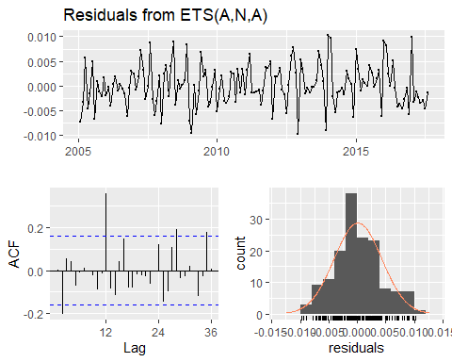

##   
## Ljung-Box test  
##   
## data: Residuals from ETS(A,N,A)  
## Q* = 43.826, df = 10, p-value = 3.538e-06  
##   
## Model df: 14. Total lags used: 24

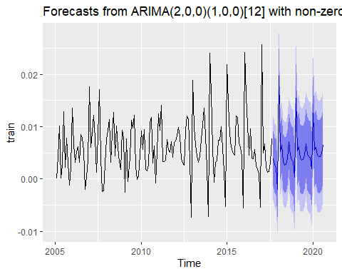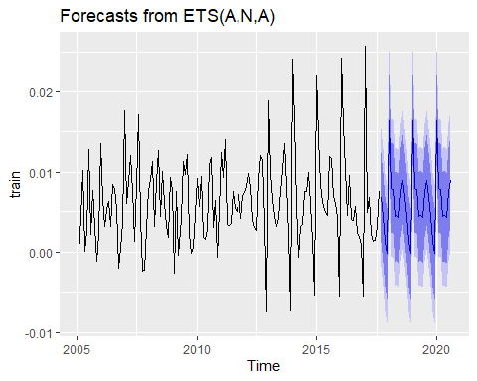

## ME RMSE MAE MPE MAPE ACF1  
## Test set 0.001791531 0.004261223 0.002962403 -31.25437 127.1595 0.1149402  
## Theil's U  
## Test set 0.371732

## ME RMSE MAE MPE MAPE ACF1  
## Test set 0.0006871109 0.004147688 0.002962687 -70.16337 117.1277 0.06970092  
## Theil's U  
## Test set 0.2481328

## Un mayor grado de complejidad: modelos multivariados, complejidad y selección de variables

La estrategia en este caso supone estimar un modelo multivariado para prdecir la inflación, a partir de un conjunto amplio de covariables.Inicialmente, se presenta la matriz de corre- laciones, donde destacan algunas muy fuertes, especialmente entre variables que representan al sector real. Sin embargo, debe tomarse en cuenta que las variables se encuentran en su mayoría en niveles por lo que la correlación elevada puede deberse a la existencia de raíces unitarias.

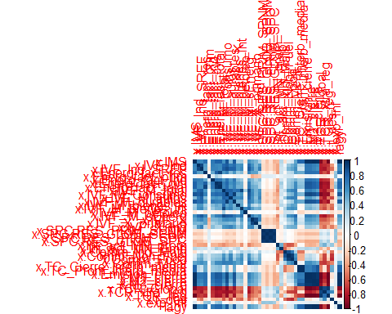 A continuación, se ajustaron dos modelos multivariados para predecir el IPC, utilizando el set completo de variables y aplicando dos metodologías alternativas, backward y forward selection. El primero parte del modelo completo, eliminando paso a paso aquellas variables de menor aporte según un criterio de información, en este caso el de Akaike (AIC).La predicción out sample se realiza en forma recursiva, tomando los últimos 37 datos de la serie como set de testeo. El ajuste resulta muy similar aplicando ambas metodologías, reproduciendo bastante bien la trayectoria del índice. El modelo backward conserva 27 variables de las 41 originales mientras que el forward se queda con 19.

## (Intercept) x.IMS x.IVF_Ind   
## -2.961132e+00 8.931272e-02 2.131496e-02   
## x.IVF_Ind_SREF x.Energ_fact_res x.Energ_fact_prim   
## -1.447411e-02 2.097780e-02 1.508554e-02   
## x.Energ_fact_total x.IVF_M_total x.IVF_M_Consumo   
## -1.063139e-02 1.441278e-01 -3.668674e-02   
## x.IVF_M_autos x.IVF_M_durables x.IVF_M_bienes_K   
## 2.414470e-03 4.043636e-03 -1.528218e-02   
## x.IVF_M_bienes_Int x.IVF_M_petoleo x.IVF_M_sEnerg   
## -1.322289e-01 1.227389e-02 1.795711e-02   
## x.SPC.RES_PRIM_SPNM `x.SPC.RES_ PRIM_SPC` x.SPC.RES_GLOB_SPC   
## 7.891302e-04 -7.015303e-04 -8.416004e-05   
## x.Int_act_MN_Emp x.Comm_Non_Fuel x.Comm_Meat   
## 8.021105e-02 2.653284e-02 -1.617649e-02   
## x.TC_Cierre_Interb_media x.Emision_cierre x.M2_cierre   
## 4.552912e-01 1.501534e-04 2.320522e-05   
## x.M3_cierre x.TCR_Global x.TCR_reg   
## -7.643551e-06 -4.343033e-02 5.155773e-02   
## lagy   
## 7.270310e-01

## (Intercept) lagy x.M2_cierre   
## -8.762581e+00 7.575460e-01 1.933096e-05   
## x.TC_Cierre_Interb_media x.Emision_cierre x.TCR_reg   
## 5.123003e-01 1.483801e-04 6.893800e-02   
## x.Energ_fact_total x.IVF_Ind x.IVF_M_sEnerg   
## 1.011936e-02 1.068682e-02 -2.298847e-03   
## x.IVF_M_bienes_K x.IMS x.Int_act_MN_prom   
## 1.587454e-03 7.685713e-02 6.049982e-02   
## x.Energ_fact_cys x.TCR_Global x.M3_cierre   
## -2.289805e-02 -7.710374e-02 -9.242272e-06   
## x.Comm_Food x.t_des x.Comm_Meat   
## 3.190968e-02 1.257504e-01 -1.161584e-02   
## x.IVF_M_autos   
## 1.245141e-03

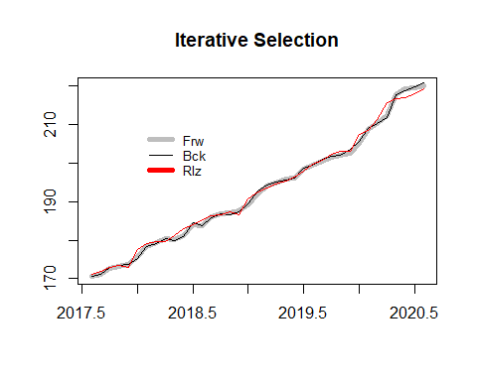 Dado que el número de predictores resulta elevado en ambas opciones (28 en el backward y 18 en el forward, contando el intercepto), se aplicará una regresión de tipo Lasso, que permite penalizar a aquellos coeficientes que menos aportan a la predicción. A posteriori, se evaluará la precisión de las diferentes predicciones, es decir, el modelo backward, el forward y dos versiones de regresión Lasso, contrastándolas con el modelo de predicción naive (media de la serie).Los dos modelos de Lasso estimados no aportan gran ganancia en simplicidad. En efecto, el primero de ellos descarta 10 coeficientes en tanto el segundo descarta 14, dejando un número similar al backward.

## 41 x 1 sparse Matrix of class "dgCMatrix"  
## s0  
## x.IMS 4.298128e-01  
## x.IVF_Ind 9.442535e-03  
## x.IVF_Ind_SREF -1.170758e-02  
## x.Energ_fact_res 1.622800e-02  
## x.Energ_fact_prim -3.132574e-02  
## x.Energ_fact_Ind 2.437877e-02  
## x.Energ_fact_cys -3.503320e-02  
## x.Energ_fact_total .   
## x.IVF_M_total .   
## x.IVF_M_Consumo .   
## x.IVF_M_autos -5.757111e-04  
## x.IVF_M_durables 8.681268e-04  
## x.IVF_M_bienes_K 1.089392e-03  
## x.IVF_M_bienes_Int -2.702135e-05  
## x.IVF_M_petoleo 5.402042e-04  
## x.IVF_M_sEnerg 2.686027e-03  
## x.IVF_X -2.419133e-04  
## x.IVF_X_primario -8.205638e-04  
## x.IVF_X_Ind .   
## x.SPC.RES_PRIM_SPNM .   
## x.SPC.RES_GLOB_SPNM -3.086209e-05  
## x.SPC.RES_ PRIM_SPC .   
## x.SPC.RES_GLOB_SPC -9.191897e-06  
## x.Int_act_MN_prom 3.391564e-02  
## x.Int_act_MN_Emp 4.328695e-02  
## x.Cpmm_Ind_Mats .   
## x.Comm_Non_Fuel 6.084447e-02  
## x.Comm_Food 4.625134e-02  
## x.Comm_Meat -4.226952e-02  
## x.TC_Cierre_Interb_media 4.643860e-01  
## x.TC_Prom_Interb_media 3.673481e-01  
## x.Emision_cierre 9.700028e-05  
## x.M1_cierre .   
## x.M2_cierre 3.072491e-06  
## x.M3_cierre .   
## x.TCR_Global -8.813686e-03  
## x.TCR_xtra_reg -4.731094e-02  
## x.TCR_reg .   
## x.t_des 7.113477e-02  
## x.exp_inf -4.519079e-01  
## lagy 8.594173e-03

## 41 x 1 sparse Matrix of class "dgCMatrix"  
## s0  
## x.IMS 4.501244e-01  
## x.IVF_Ind 3.932278e-03  
## x.IVF_Ind_SREF .   
## x.Energ_fact_res 6.520293e-03  
## x.Energ_fact_prim -4.285051e-02  
## x.Energ_fact_Ind 1.835295e-02  
## x.Energ_fact_cys -1.148647e-02  
## x.Energ_fact_total .   
## x.IVF_M_total 2.458082e-04  
## x.IVF_M_Consumo .   
## x.IVF_M_autos .   
## x.IVF_M_durables 5.024495e-04  
## x.IVF_M_bienes_K 1.056092e-03  
## x.IVF_M_bienes_Int .   
## x.IVF_M_petoleo 2.392962e-04  
## x.IVF_M_sEnerg .   
## x.IVF_X .   
## x.IVF_X_primario -3.290358e-04  
## x.IVF_X_Ind .   
## x.SPC.RES_PRIM_SPNM .   
## x.SPC.RES_GLOB_SPNM -5.661713e-05  
## x.SPC.RES_ PRIM_SPC .   
## x.SPC.RES_GLOB_SPC .   
## x.Int_act_MN_prom 1.811888e-02  
## x.Int_act_MN_Emp .   
## x.Cpmm_Ind_Mats .   
## x.Comm_Non_Fuel 6.625706e-02  
## x.Comm_Food 3.835381e-02  
## x.Comm_Meat -3.806175e-02  
## x.TC_Cierre_Interb_media 4.518847e-01  
## x.TC_Prom_Interb_media 3.302067e-01  
## x.Emision_cierre 2.602087e-05  
## x.M1_cierre .   
## x.M2_cierre 1.636305e-08  
## x.M3_cierre .   
## x.TCR_Global -4.936619e-02  
## x.TCR_xtra_reg -2.400844e-03  
## x.TCR_reg .   
## x.t_des 3.199622e-02  
## x.exp_inf -3.407495e-01  
## lagy 1.159797e-04

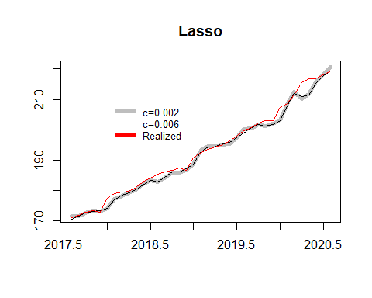 Cuando se analizan las medidas de precisión en la predicción, se observa que cualquiera de los cuatro modelos presentan menor error que el benchmark. Adicionalmente, tanto los modelos forward, backward y lasso resultan muy similares, con una escasa diferencia a favor del primero el que, según el test de Diebold y Mariano, tiene errores de predicción equivalentes en media con el segundo.

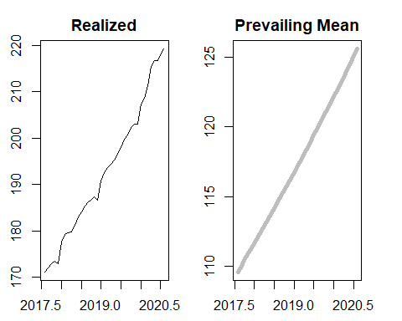

## ME RMSE MAE MPE MAPE ACF1 Theil's U  
## Test set 0.3154805 1.121679 0.8592275 0.1700484 0.4385551 0.1648049 0.6042279

## ME RMSE MAE MPE MAPE ACF1 Theil's U  
## Test set 0.23993 1.174108 0.9072176 0.1331214 0.4631636 0.09194398 0.6338707

## ME RMSE MAE MPE MAPE ACF1 Theil's U  
## Test set 0.883885 1.78703 1.244726 0.4509138 0.6328992 0.2365566 0.9563229

## ME RMSE MAE MPE MAPE ACF1 Theil's U  
## Test set 1.015266 1.748034 1.190162 0.5152932 0.6064047 0.2512952 0.9370673

## ME RMSE MAE MPE MAPE ACF1 Theil's U  
## Test set 75.68713 76.30136 75.68713 39.06037 39.06037 0.9120726 41.54195

##   
## Diebold-Mariano Test  
##   
## data: e.fcst.forwarde.fcst.pm  
## DM = -23.308, Forecast horizon = 1, Loss function power = 2, p-value <  
## 2.2e-16  
## alternative hypothesis: two.sided

##   
## Diebold-Mariano Test  
##   
## data: e.fcst.backwarde.fcst.pm  
## DM = -23.309, Forecast horizon = 1, Loss function power = 2, p-value <  
## 2.2e-16  
## alternative hypothesis: two.sided

##   
## Diebold-Mariano Test  
##   
## data: e.fcst.lasso1e.fcst.pm  
## DM = -23.328, Forecast horizon = 1, Loss function power = 2, p-value <  
## 2.2e-16  
## alternative hypothesis: two.sided

##   
## Diebold-Mariano Test  
##   
## data: e.fcst.lasso2e.fcst.pm  
## DM = -23.326, Forecast horizon = 1, Loss function power = 2, p-value <  
## 2.2e-16  
## alternative hypothesis: two.sided

##   
## Diebold-Mariano Test  
##   
## data: e.fcst.pme.fcst.forward  
## DM = 23.308, Forecast horizon = 1, Loss function power = 2, p-value <  
## 2.2e-16  
## alternative hypothesis: two.sided

##   
## Diebold-Mariano Test  
##   
## data: e.fcst.backwarde.fcst.forward  
## DM = 0.88063, Forecast horizon = 1, Loss function power = 2, p-value =  
## 0.3844  
## alternative hypothesis: two.sided

##   
## Diebold-Mariano Test  
##   
## data: e.fcst.lasso1e.fcst.forward  
## DM = 2.1991, Forecast horizon = 1, Loss function power = 2, p-value =  
## 0.03438  
## alternative hypothesis: two.sided

##   
## Diebold-Mariano Test  
##   
## data: e.fcst.lasso2e.fcst.forward  
## DM = 1.9924, Forecast horizon = 1, Loss function power = 2, p-value =  
## 0.05395  
## alternative hypothesis: two.sided

## Modelo de factores

Para finalizar, plantearemos un modelo de factores, en base a los datos utilizados hasta ahora. A partir del mejor modelo anterior, seleccionaremos algunas variables que ingresarán como tales al modelo de predicción multivariado. El resto de las variables se integrarán a través de la construcción de factores. Si queremos estimar un modelo VAR(p) a partir de las tres variables seleccionadas y deseáramos incluir las 38 restantes se reduciría bastante el número de grados de libertad. Como se ha visto antes además, varias de las variables están correlacionadas entre sí, lo que será aprovechado para la construcción de los factores, permitiendo reducir la dimensionalidad del problema. En ese modelo el factor que más explica la caída del AIC es la propia variable rezagada, la que ya será considerada en la parte autorregresiva del modelo. Las dos siguientes son la M2 y el tipo de cambio interbancario, por lo que se tomarán estas dos variables como tales. Con las otras 37 se construirán algunos factores para representarlas en forma conjunta.

step.model$anova

## Step Df Deviance Resid. Df Resid. Dev AIC  
## 1 NA NA 185 345794.96879 1402.18096  
## 2 + lagy -1 3.456670e+05 184 127.95115 -65.58226  
## 3 + x.M2_cierre -1 1.480108e+01 183 113.15007 -86.44789  
## 4 + x.TC_Cierre_Interb_media -1 1.461330e+01 182 98.53677 -110.16894  
## 5 + x.Emision_cierre -1 1.385291e+01 181 84.68387 -136.34881  
## 6 + x.TCR_reg -1 6.837371e+00 180 77.84650 -150.00745  
## 7 + x.Energ_fact_total -1 3.177749e+00 179 74.66875 -155.75942  
## 8 + x.IVF_Ind -1 2.123229e+00 178 72.54552 -159.12504  
## 9 + x.IVF_M_sEnerg -1 3.021433e+00 177 69.52408 -165.03766  
## 10 + x.IVF_M_bienes_K -1 2.117592e+00 176 67.40649 -168.79099  
## 11 + x.IMS -1 1.508988e+00 175 65.89750 -171.00218  
## 12 + x.Int_act_MN_prom -1 1.194708e+00 174 64.70280 -172.40526  
## 13 + x.Energ_fact_cys -1 1.124770e+00 173 63.57803 -173.66705  
## 14 + x.TCR_Global -1 1.173499e+00 172 62.40453 -175.13225  
## 15 + x.M3_cierre -1 9.942421e-01 171 61.41029 -176.11950  
## 16 + x.Comm_Food -1 1.836734e+00 170 59.57355 -179.76750  
## 17 + x.t_des -1 1.142527e+00 169 58.43102 -181.36934  
## 18 + x.Comm_Meat -1 1.285887e+00 168 57.14514 -183.50834  
## 19 + x.IVF_M_autos -1 6.288128e-01 167 56.51632 -183.56639

#doy formato de series temporales, eliminando fecha y expectativas:  
#ojo que reutilizo nombre  
df_ury_ts <- ts(df_ury[ ,2:41], start = c(2005,1), frequency = 12) #declaro ts

En el Anexo se presenta la información sobre la estacionariedad de las covariables. Se realizó un análisis gráfico, del que se concluye la necesidad de aplicar loga- ritmos y una diferenciación, para todas las series salvo las de resultado fiscal las que, por tener valores negativos, sólo han sido diferenciadas.

x.1 <- cbind(df_ury_ts[,"IPC"],df_ury_ts[,"M2_cierre"], df_ury_ts[,"TC_Cierre_Interb_media"])  
colnames(x.1) <- c("IPC","M2_cierre", "TC_Cier_med")  
plot(diff(log(x.1)), main="")

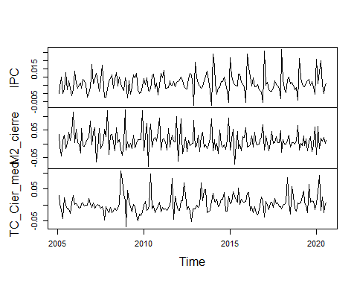 Aplicamos los test de raíces unitarias para las dos series aún no testeadas. La aplicación de los tests y la salida se presentan en el Anexo. La tabla de resumen se presenta más abajo, pudiéndose observar que la serie diff log no presenta raíces unitarias para M2 ni TC.Sólo el test de PP arroja cierta duda sobre el tipo de cambio, pero los otros dos dan evidencia de su no existencia.

## # A tibble: 2 x 5  
## Variable trend ADF PP KPSS   
## <chr> <chr> <chr> <chr> <chr>   
## 1 diff(log(M2_cierre)) sí -13.095 *** -3.774 *** 0.0585   
## 2 diff(log(TC_Cier_med)) sí -8.691 *** -2.451 * 4.5699999999999998E-2

Se procederá a transformar las series de covariables, mediante la aplicación del análisis de componentes principales. La matriz X incluye 37 variables, las que serán transformadas en logaritmos y diferenciadas y posteriormente centradas y llevadas a varianza unitaria para evitar que las de mayor variaabilidad influyan sobremanera en la conformación de los factores. Como se comentara, las series de resultado fiscal sólo se diferenciarán, dado que cuentan con valores negativos.La conformación y características de los factores se presentan en el anexo.

lista <- c("IMS","IVF_Ind","IVF_Ind_SREF", "Energ_fact_res", "Energ_fact_prim",  
 "Energ_fact_Ind", "Energ_fact_cys", "Energ_fact_total", "IVF_M_total",  
 "IVF_M_Consumo", "IVF_M_autos", "IVF_M_durables", "IVF_M_bienes_K",  
 "IVF_M_bienes_Int", "IVF_M_petoleo", "IVF_M_sEnerg", "IVF_X",  
 "IVF_X_primario", "IVF_X_Ind", "Int_act_MN_prom", "Int_act_MN_Emp",  
 "Cpmm_Ind_Mats", "Comm_Non_Fuel", "Comm_Food", "Comm_Meat",  
 "TC_Prom_Interb_media", "Emision_cierre",   
 "M1_cierre", "M3_cierre", "TCR_Global", "TCR_xtra_reg",  
 "TCR_reg", "t_des"  
 )  
  
lista.1 <- c("SPC.RES_PRIM_SPNM", "SPC.RES_GLOB_SPNM",  
 "SPC.RES_ PRIM_SPC", "SPC.RES_GLOB_SPC")  
  
library(dplyr)

##   
## Attaching package: 'dplyr'

## The following objects are masked from 'package:stats':  
##   
## filter, lag

## The following objects are masked from 'package:base':  
##   
## intersect, setdiff, setequal, union

x.2 <- df_ury %>% dplyr::select(one_of(lista))  
x.2 <- ts(x.2, start = c(2005,1), frequency = 12)  
x.3 <- df_ury %>% dplyr::select(one_of(lista.1))  
x.3 <- ts(x.3, start = c(2005,1), frequency = 12)  
x.4 <- cbind(x.2,x.3)  
  
x.21 <- diff(log(x.2[,1]))  
for(i in 2:33){  
 x.21 <- cbind(x.21, diff(log(x.2[,i])))  
}  
colnames(x.21) <- lista  
  
x.31 <- diff(x.3[,1])  
for(i in 2:4){  
 x.31 <- cbind(x.31, diff(x.3[,i]))  
}  
colnames(x.31) <- lista.1  
x.4 <- cbind(x.21,x.31)  
  
pr.out <- prcomp(x.4, scale =TRUE)

Graficamos los cinco primeros componentes principales.

PC1 <- ts(pr.out$x[,1], start = c(2005,2), frequency = 12)  
PC2 <- ts(pr.out$x[,2], start = c(2005,2), frequency = 12)  
PC3 <- ts(pr.out$x[,3], start = c(2005,2), frequency = 12)  
PC4 <- ts(pr.out$x[,4], start = c(2005,2), frequency = 12)  
PC5 <- ts(pr.out$x[,5], start = c(2005,2), frequency = 12)  
PCs <- cbind(PC1,PC2,PC3,PC4,PC5)  
colnames(PCs) <- c("PC1","PC2", "PC3","PC4", "PC5")  
plot(PCs, main="Primeros cinco componentes principales", ylab="", xlab="")

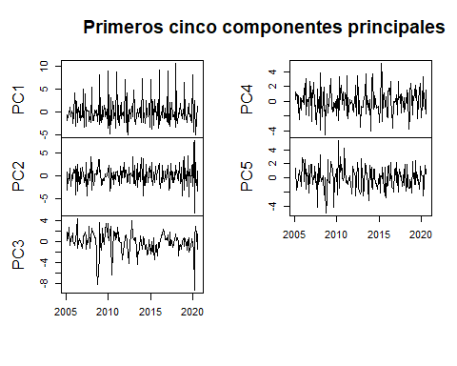 Chequeamos que la suma de proporciones de la varianza de cada componente es 1.

prop_varianza <- pr.out$sdev^2 / sum(pr.out$sdev^2)   
sum(prop_varianza) #chequeo que me da 1 la suma de las proporciones

## [1] 1

Ahora verificamos cuánto es el aporte de cada factor a la varianza total. Los 3 primeros factores acumulan 43,25% del total, mientras que los primeros 5 explican el 57,67% del total.

library(ggplot2)  
ggplot(data = data.frame(prop_varianza, pc = 1:37),  
 aes(x = pc, y = prop_varianza)) +  
 geom_col(width = 0.3) +  
 scale_y_continuous(limits = c(0,0.25)) +  
 theme_bw() +  
 labs(x = "Componente principal",  
 y = "Prop. de varianza explicada")

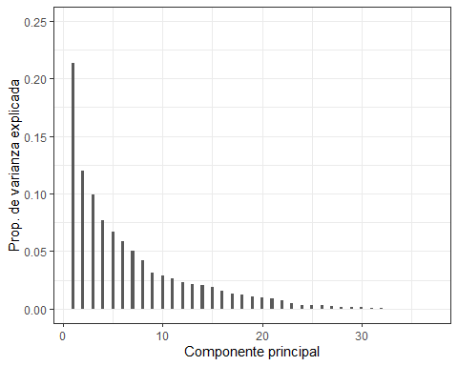

A continuación, conformamos la base de datos final con los cinco primeros factores, más las dos variables reservadas, con el objeto de estimar un modelo FAVAR. Vamos a seleccionar la longitud de rezago óptima de la estimación del VAR a partir del uso de criterios de información.

factores <- ts(PCs, start = c(2005,2), frequency = 12)  
y <- ts(diff(log(x.1)), start = c(2005,2), frequency = 12)  
ynew <- cbind(y,factores[,1]) #esta matriz contiene a Yt y Ft  
ynew <- ts(ynew, start = c(2005,2), frequency = 12)  
library(vars)

## Loading required package: MASS

##   
## Attaching package: 'MASS'

## The following object is masked from 'package:dplyr':  
##   
## select

## Loading required package: strucchange

## Loading required package: sandwich

## Loading required package: lmtest

VARselect(ynew, type = "const")

## $selection  
## AIC(n) HQ(n) SC(n) FPE(n)   
## 10 2 2 10   
##   
## $criteria  
## 1 2 3 4 5  
## AIC(n) -2.315931e+01 -2.367365e+01 -2.356530e+01 -2.364443e+01 -2.363101e+01  
## HQ(n) -2.301376e+01 -2.341166e+01 -2.318686e+01 -2.314956e+01 -2.301970e+01  
## SC(n) -2.280043e+01 -2.302765e+01 -2.263219e+01 -2.242421e+01 -2.212368e+01  
## FPE(n) 8.751131e-11 5.233806e-11 5.836899e-11 5.399910e-11 5.484458e-11  
## 6 7 8 9 10  
## AIC(n) -2.360091e+01 -2.373456e+01 -2.369529e+01 -2.382580e+01 -2.392023e+01  
## HQ(n) -2.287316e+01 -2.289037e+01 -2.273465e+01 -2.274873e+01 -2.272671e+01  
## SC(n) -2.180648e+01 -2.165301e+01 -2.132663e+01 -2.117004e+01 -2.097735e+01  
## FPE(n) 5.669656e-11 4.981834e-11 5.211158e-11 4.607334e-11 4.231109e-11

Los rezagos no coinciden, podrían ser 2 o 10. Se probó con 10, pero el tamaño de la muestra impidió aplicar el test de Portmentau. Por ello, se tomó el modelo con dos rezagos. Adicionalmente, se intentaron varias especificaciones arribándose a la presentada, donde se utilizan como predictores las dos variables reservadas y sólo el primer factor. Se intentaron otras varias, con distintas combinaciones de factores y variables, e incluso pasando una de las variables a conformar los factores, pero la que se presenta es la que más se aproxima a una estructura de errores no autocorrelacionados.La especificación, así como la aplicación del test de Granger, se presentan en el anexo.

favar1 <- VAR(ynew, p=2, type = "const")  
serial.test(favar1, lags.pt = 5)

##   
## Portmanteau Test (asymptotic)  
##   
## data: Residuals of VAR object favar1  
## Chi-squared = 66.896, df = 48, p-value = 0.03693

Con base en la estructura del modelo para toda la serie (dos covariables, un factor y dos rezagos) se evaluará la capacidad de predecir de un modelo de similares características, derivado a partir de una ventana móvil de datos, de longitud fija, lo que permitirá además analizar si se produce algún cambio estructural en la serie.

#PronÃ³sticos rolling del FAVAR para h=1  
  
fcst.favar <- matrix(0, nrow = 37, ncol = 4) #matriz para almacenar prostico, li, ls etc  
fcst.favar <- ts(fcst.favar, start=c(2017,8), frequency = 12)  
for(i in 1:37){  
 y.train <- window(y, start = 2005.083 + (i-1)/12, end = 2017.500 + (i-1)/12) #ventana fija que se corre  
 x.4.train <- window(x.4, start = 2005.083 + (i-1)/12, end = 2017.500 + (i-1)/12)  
 pr.out <- prcomp(x.4.train, scale =TRUE)   
 PC <- scale(x.4.train)%*%pr.out$rotation #scale normaliza, %*% multiplica matrices  
 factores <- PC[,1]  
 y.train <- cbind(y.train, factores)  
 var2 <- VAR(y.train, p=2, type = "const")  
 forecasts <- predict(var2, n.ahead = 1)  
 fcst.favar[i,] <- forecasts$fcst$y.train.IPC  
}

## Warning in window.default(x, ...): 'start' value not changed  
  
## Warning in window.default(x, ...): 'start' value not changed

Para contrastar el poder predictivo del modelo, se toman dos benchmarks, un modelo VAR y un modelo AR(1).

## Warning in window.default(x, ...): 'start' value not changed

## Warning in window.default(x, ...): 'start' value not changed

Finalmente, se grafican los tres modelos y se comparan con la serie original. Se observa que el FAVAR y el VAR se comportan de una manera muy similar y ambos recogen la mayoría de los movimientos de la inflación, aunque con menor varianza. Lamentablemente, lo limitado de la base de datos impidió incluir más factores y rezagos, lo que podría haber mejorado el ajuste.

#Grafico los pronÃ³sticos de los 3 modelos:  
y.rlz <- ts(ynew[151:187,1], start=c(2017,8), frequency = 12)  
plot(fcst.favar[,"Series 1"], col = "grey", lwd = 5, main="Forecasts", ylab = "", xlab = "")  
lines(fcst.var[,"Series 1"])  
lines(fcst.ar1, col = "red")  
lines(y.rlz, col = "green")  
legend(2018.800, 0.011, legend=c("FAVAR", "VAR", "AR(1)", "RLZ"), col=c("grey", "black", "red", "green"), lwd = c(5,1,1), box.lty=0, ncol = 1, cex = 0.8, y.intersp=0.8)

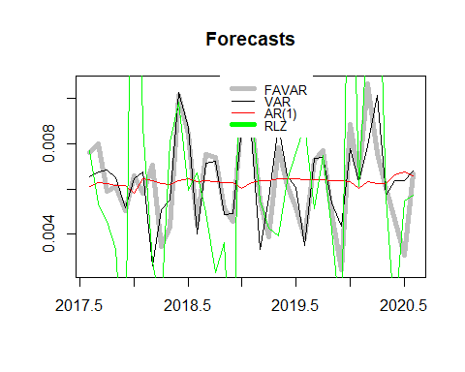 En lo que respecta a las medidas de precisión, los modelos muestran performances similares aunque el test de Giacomini y Rossi muestra que performan mejor cualquiera de los dos modelos más complejos, respecto del AR(1). Al hacer la comparación entre el FAVAR y el VAR, se observa a su vez que son similares.

## ME RMSE MAE MPE MAPE ACF1 Theil's U  
## Test set 193.0088 193.5413 193.0088 99.99669 99.99669 0.9154564 105.9596

## ME RMSE MAE MPE MAPE ACF1 Theil's U  
## Test set 193.0087 193.5411 193.0087 99.99666 99.99666 0.9154546 105.9596

## ME RMSE MAE MPE MAPE ACF1 Theil's U  
## Test set 193.0088 193.5413 193.0088 99.99671 99.99671 0.9154521 105.9596

##   
## Diebold-Mariano Test  
##   
## data: e.fcst.favare.fcst.ar1  
## DM = -2.5561, Forecast horizon = 1, Loss function power = 2, p-value =  
## 0.01495  
## alternative hypothesis: two.sided

##   
## Diebold-Mariano Test  
##   
## data: e.fcst.vare.fcst.ar1  
## DM = -2.2681, Forecast horizon = 1, Loss function power = 2, p-value =  
## 0.02942  
## alternative hypothesis: two.sided

## Warning in sqrt(m) * dm_num/sqrt(s2hat): Recycling array of length 1 in vector-array arithmetic is deprecated.  
## Use c() or as.vector() instead.

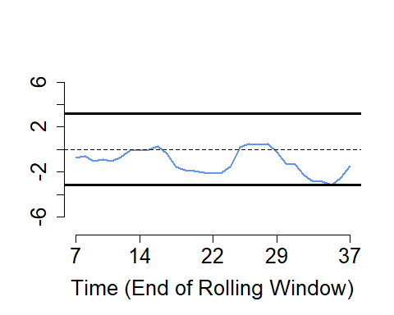

## $df  
## time dmstat  
## 1 7 -0.70215065  
## 2 8 -0.57877169  
## 3 9 -1.03261392  
## 4 10 -0.85292212  
## 5 11 -1.03462697  
## 6 12 -0.64519909  
## 7 13 -0.07482287  
## 8 14 -0.05515129  
## 9 15 0.01170959  
## 10 16 0.29834323  
## 11 17 -0.35678726  
## 12 18 -1.57361961  
## 13 19 -1.84641680  
## 14 20 -1.93821024  
## 15 21 -2.07561580  
## 16 22 -2.08804660  
## 17 23 -2.01401573  
## 18 24 -1.44982540  
## 19 25 0.24497859  
## 20 26 0.47111148  
## 21 27 0.46543580  
## 22 28 0.46783204  
## 23 29 -0.24107427  
## 24 30 -1.26771155  
## 25 31 -1.33882859  
## 26 32 -2.26760792  
## 27 33 -2.85447511  
## 28 34 -2.83962992  
## 29 35 -3.10835216  
## 30 36 -2.47333364  
## 31 37 -1.44518510  
##   
## $CV  
## [1] -3.179 3.179

## Warning in sqrt(m) * dm_num/sqrt(s2hat): Recycling array of length 1 in vector-array arithmetic is deprecated.  
## Use c() or as.vector() instead.

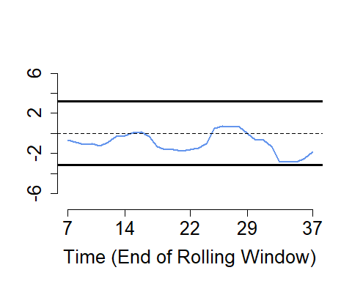

## $df  
## time dmstat  
## 1 7 -0.669575023  
## 2 8 -0.859133559  
## 3 9 -1.064714579  
## 4 10 -1.053147053  
## 5 11 -1.278208814  
## 6 12 -0.880915316  
## 7 13 -0.324123577  
## 8 14 -0.258860227  
## 9 15 0.074601948  
## 10 16 0.173868371  
## 11 17 -0.290039145  
## 12 18 -1.307914651  
## 13 19 -1.593065837  
## 14 20 -1.645577743  
## 15 21 -1.733877082  
## 16 22 -1.580276632  
## 17 23 -1.490775889  
## 18 24 -1.059142225  
## 19 25 0.511589845  
## 20 26 0.726643013  
## 21 27 0.645093391  
## 22 28 0.635679399  
## 23 29 -0.008832724  
## 24 30 -0.646761085  
## 25 31 -0.662684978  
## 26 32 -1.337681897  
## 27 33 -2.863299486  
## 28 34 -2.849468331  
## 29 35 -2.845046844  
## 30 36 -2.491827818  
## 31 37 -1.847127694  
##   
## $CV  
## [1] -3.179 3.179

## Warning in sqrt(m) * dm_num/sqrt(s2hat): Recycling array of length 1 in vector-array arithmetic is deprecated.  
## Use c() or as.vector() instead.

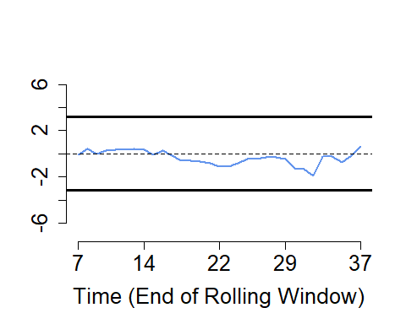

## $df  
## time dmstat  
## 1 7 -0.11433290  
## 2 8 0.46495001  
## 3 9 -0.02251204  
## 4 10 0.29759457  
## 5 11 0.36227020  
## 6 12 0.37847864  
## 7 13 0.44791447  
## 8 14 0.36646988  
## 9 15 -0.11355940  
## 10 16 0.24995610  
## 11 17 -0.14946250  
## 12 18 -0.60698767  
## 13 19 -0.60588415  
## 14 20 -0.68458005  
## 15 21 -0.78473425  
## 16 22 -1.08792030  
## 17 23 -1.11027577  
## 18 24 -0.82477052  
## 19 25 -0.46608555  
## 20 26 -0.42819260  
## 21 27 -0.29053102  
## 22 28 -0.26884609  
## 23 29 -0.44162499  
## 24 30 -1.22963013  
## 25 31 -1.33566777  
## 26 32 -1.87040776  
## 27 33 -0.20768729  
## 28 34 -0.20467789  
## 29 35 -0.72292061  
## 30 36 -0.16021025  
## 31 37 0.61833813  
##   
## $CV  
## [1] -3.179 3.179

## Conclusiones

Las conclusiones del trabajo pueden resumirse en lo siguiente: 1. La inflación en Uruguay en los últimos 15 años muestra una tendencia estable con dos rezagos y uno estacional.Presenta una raíz unitaria y un incremento de la varianza a partir de 2013, por lo que se trabajó en varias especificaciones con la serie en logaritmos, diferenciada. 2. No se observaron grandes diferencias en el poder predictivo, al trabajar con modelos univariados y ETS. 3. La aplicación de modelos multivariados, en niveles, mejoró la calidad de la predicción. Tanto el modelo de selección forward como el backward presentaron mejor performance de predicción que un modelo basado en la media de la serie. Adicionalmente, se estimó un modelo lasso con dos especificaciones distintas del hiperparámetro resultando que el poder predictivo de los modelos resultaron muy similares. 4. Finalmente, se aplicó un modelo de factores. La construcción de estos, con la muestra completa, implicó que fueron necesarios 5 de 37 para alcanzar el 55% de la varianza explicada. Sin embargo, dado la limitación en el largo de varias de las series utilizadas, la muestra resulta ser lo suficientemente pequeña como para tener que limitar el modelo FAVAR a dos covariables y uno solo de los factores. A partir de ello, se consigue con este modelo una performance similar al modelo VAR, de formulación más sencilla, siendo ambos son mejores que el AR(1). En suma, el trabajo permitió identificar algunos hechos estilizados interesantes sobre la inflación en Uruguay. La limitación de alguna de las series incluidas en el estudio llevaron a que no se pueda ser conclusivo respecto de modelos más ricos, como el FAVAR. La elección de series más largas podría ayudar en futuros desarrollos.

## Anexo

### Test de raíces unitarias de la serie de IPC

##   
## ###############################################   
## # Augmented Dickey-Fuller Test Unit Root Test #   
## ###############################################   
##   
## Test regression trend   
##   
##   
## Call:  
## lm(formula = z.diff ~ z.lag.1 + 1 + tt + z.diff.lag)  
##   
## Residuals:  
## Min 1Q Median 3Q Max   
## -0.0147929 -0.0033238 -0.0004807 0.0022056 0.0192130   
##   
## Coefficients:  
## Estimate Std. Error t value Pr(>|t|)   
## (Intercept) 0.5055738 0.1422788 3.553 0.000484 ***  
## z.lag.1 -0.1200096 0.0341597 -3.513 0.000558 ***  
## tt 0.0007770 0.0002193 3.544 0.000501 ***  
## z.diff.lag 0.0475127 0.0731631 0.649 0.516894   
## ---  
## Signif. codes: 0 '***' 0.001 '**' 0.01 '*' 0.05 '.' 0.1 ' ' 1  
##   
## Residual standard error: 0.005629 on 182 degrees of freedom  
## Multiple R-squared: 0.06766, Adjusted R-squared: 0.05229   
## F-statistic: 4.402 on 3 and 182 DF, p-value: 0.005126  
##   
##   
## Value of test-statistic is: -3.5132 40.5445 6.6035   
##   
## Critical values for test statistics:   
## 1pct 5pct 10pct  
## tau3 -3.99 -3.43 -3.13  
## phi2 6.22 4.75 4.07  
## phi3 8.43 6.49 5.47

##   
## ###############################################   
## # Augmented Dickey-Fuller Test Unit Root Test #   
## ###############################################   
##   
## Test regression trend   
##   
##   
## Call:  
## lm(formula = z.diff ~ z.lag.1 + 1 + tt + z.diff.lag)  
##   
## Residuals:  
## Min 1Q Median 3Q Max   
## -0.0133604 -0.0033529 -0.0003663 0.0028785 0.0191226   
##   
## Coefficients:  
## Estimate Std. Error t value Pr(>|t|)   
## (Intercept) 6.981e-03 1.025e-03 6.810 1.39e-10 ***  
## z.lag.1 -1.225e+00 1.028e-01 -11.912 < 2e-16 ***  
## tt 8.799e-06 7.882e-06 1.116 0.26572   
## z.diff.lag 2.161e-01 7.239e-02 2.985 0.00323 **   
## ---  
## Signif. codes: 0 '***' 0.001 '**' 0.01 '*' 0.05 '.' 0.1 ' ' 1  
##   
## Residual standard error: 0.005694 on 181 degrees of freedom  
## Multiple R-squared: 0.527, Adjusted R-squared: 0.5191   
## F-statistic: 67.22 on 3 and 181 DF, p-value: < 2.2e-16  
##   
##   
## Value of test-statistic is: -11.9116 47.3011 70.9506   
##   
## Critical values for test statistics:   
## 1pct 5pct 10pct  
## tau3 -3.99 -3.43 -3.13  
## phi2 6.22 4.75 4.07  
## phi3 8.43 6.49 5.47

##   
## ###############################################   
## # Augmented Dickey-Fuller Test Unit Root Test #   
## ###############################################   
##   
## Test regression drift   
##   
##   
## Call:  
## lm(formula = z.diff ~ z.lag.1 + 1 + z.diff.lag)  
##   
## Residuals:  
## Min 1Q Median 3Q Max   
## -0.0151790 -0.0042469 -0.0006446 0.0034294 0.0275113   
##   
## Coefficients:  
## Estimate Std. Error t value Pr(>|t|)   
## (Intercept) -2.072e-05 5.294e-04 -0.039 0.969   
## z.lag.1 -1.845e+00 1.173e-01 -15.731 < 2e-16 ***  
## z.diff.lag 3.210e-01 7.023e-02 4.570 8.99e-06 ***  
## ---  
## Signif. codes: 0 '***' 0.001 '**' 0.01 '*' 0.05 '.' 0.1 ' ' 1  
##   
## Residual standard error: 0.007181 on 181 degrees of freedom  
## Multiple R-squared: 0.7305, Adjusted R-squared: 0.7276   
## F-statistic: 245.4 on 2 and 181 DF, p-value: < 2.2e-16  
##   
##   
## Value of test-statistic is: -15.7307 123.7285   
##   
## Critical values for test statistics:   
## 1pct 5pct 10pct  
## tau2 -3.46 -2.88 -2.57  
## phi1 6.52 4.63 3.81

##   
## ##################################   
## # Phillips-Perron Unit Root Test #   
## ##################################   
##   
## Test regression with intercept and trend   
##   
##   
## Call:  
## lm(formula = y ~ y.l1 + trend)  
##   
## Residuals:  
## Min 1Q Median 3Q Max   
## -0.0148933 -0.0033303 -0.0004649 0.0025015 0.0186325   
##   
## Coefficients:  
## Estimate Std. Error t value Pr(>|t|)   
## (Intercept) 0.566873 0.156039 3.633 0.000363 ***  
## y.l1 0.882431 0.032728 26.963 < 2e-16 ***  
## trend 0.000762 0.000210 3.629 0.000369 ***  
## ---  
## Signif. codes: 0 '***' 0.001 '**' 0.01 '*' 0.05 '.' 0.1 ' ' 1  
##   
## Residual standard error: 0.005607 on 184 degrees of freedom  
## Multiple R-squared: 0.9997, Adjusted R-squared: 0.9997   
## F-statistic: 3.576e+05 on 2 and 184 DF, p-value: < 2.2e-16  
##   
##   
## Value of test-statistic, type: Z-tau is: -3.4566   
##   
## aux. Z statistics  
## Z-tau-mu 4.1794  
## Z-tau-beta 3.4517  
##   
## Critical values for Z statistics:   
## 1pct 5pct 10pct  
## critical values -4.009825 -3.434709 -3.141047

##   
## ##################################   
## # Phillips-Perron Unit Root Test #   
## ##################################   
##   
## Test regression with intercept and trend   
##   
##   
## Call:  
## lm(formula = y ~ y.l1 + trend)  
##   
## Residuals:  
## Min 1Q Median 3Q Max   
## -0.0137321 -0.0031922 -0.0008444 0.0029344 0.0199023   
##   
## Coefficients:  
## Estimate Std. Error t value Pr(>|t|)   
## (Intercept) 6.405e-03 6.318e-04 10.137 <2e-16 ***  
## y.l1 -6.041e-03 7.374e-02 -0.082 0.935   
## trend 7.169e-06 7.946e-06 0.902 0.368   
## ---  
## Signif. codes: 0 '***' 0.001 '**' 0.01 '*' 0.05 '.' 0.1 ' ' 1  
##   
## Residual standard error: 0.005801 on 183 degrees of freedom  
## Multiple R-squared: 0.004429, Adjusted R-squared: -0.006452   
## F-statistic: 0.407 on 2 and 183 DF, p-value: 0.6662  
##   
##   
## Value of test-statistic, type: Z-tau is: -15.2994   
##   
## aux. Z statistics  
## Z-tau-mu 21.6405  
## Z-tau-beta 0.9396  
##   
## Critical values for Z statistics:   
## 1pct 5pct 10pct  
## critical values -4.01008 -3.43483 -3.141119

##   
## ##################################   
## # Phillips-Perron Unit Root Test #   
## ##################################   
##   
## Test regression with intercept   
##   
##   
## Call:  
## lm(formula = y ~ y.l1)  
##   
## Residuals:  
## Min 1Q Median 3Q Max   
## -0.0139817 -0.0043581 -0.0007016 0.0027565 0.0285839   
##   
## Coefficients:  
## Estimate Std. Error t value Pr(>|t|)   
## (Intercept) 1.926e-05 5.561e-04 0.035 0.972   
## y.l1 -3.949e-01 6.786e-02 -5.819 2.6e-08 ***  
## ---  
## Signif. codes: 0 '***' 0.001 '**' 0.01 '*' 0.05 '.' 0.1 ' ' 1  
##   
## Residual standard error: 0.007563 on 183 degrees of freedom  
## Multiple R-squared: 0.1561, Adjusted R-squared: 0.1515   
## F-statistic: 33.86 on 1 and 183 DF, p-value: 2.602e-08  
##   
##   
## Value of test-statistic, type: Z-tau is: -43.4501   
##   
## aux. Z statistics  
## Z-tau-mu 0.0853  
##   
## Critical values for Z statistics:   
## 1pct 5pct 10pct  
## critical values -3.466782 -2.877144 -2.575004

##   
## #######################   
## # KPSS Unit Root Test #   
## #######################   
##   
## Test is of type: tau with 14 lags.   
##   
## Value of test-statistic is: 0.2205   
##   
## Critical value for a significance level of:   
## 10pct 5pct 2.5pct 1pct  
## critical values 0.119 0.146 0.176 0.216

##   
## #######################   
## # KPSS Unit Root Test #   
## #######################   
##   
## Test is of type: tau with 14 lags.   
##   
## Value of test-statistic is: 0.0594   
##   
## Critical value for a significance level of:   
## 10pct 5pct 2.5pct 1pct  
## critical values 0.119 0.146 0.176 0.216

##   
## #######################   
## # KPSS Unit Root Test #   
## #######################   
##   
## Test is of type: mu with 14 lags.   
##   
## Value of test-statistic is: 0.0468   
##   
## Critical value for a significance level of:   
## 10pct 5pct 2.5pct 1pct  
## critical values 0.347 0.463 0.574 0.739

### Estudio de estacionariedad de las covariables. Análisis gráfico.

Se plantea en forma inicial la inspección gráfica. La mayoría de ellas aparece con tendencia temporal y varias con incremento de varianza en el período por lo que se procederá a tomar logaritmos y diferenciarlas.Dado que existen variables con valores negativos asociadas con el resultado fiscal, estas variables serán sólo diferenciadas. Finalmente, la última variable (expectativas de inflación promedio) no será considerada.

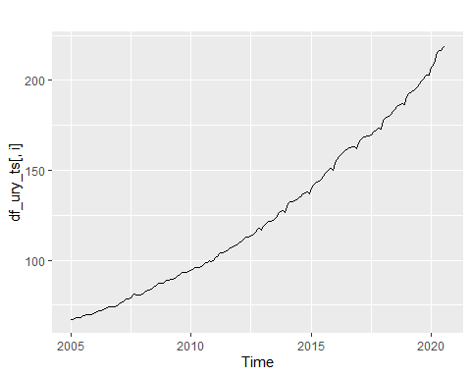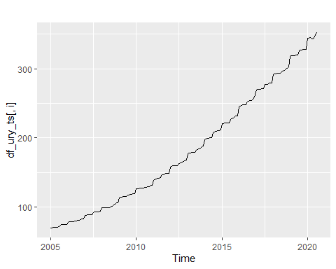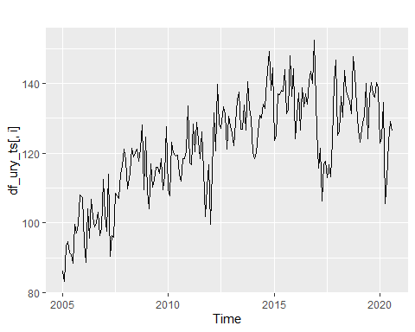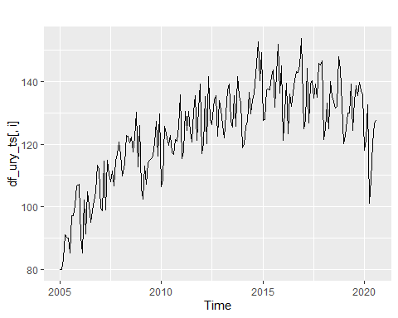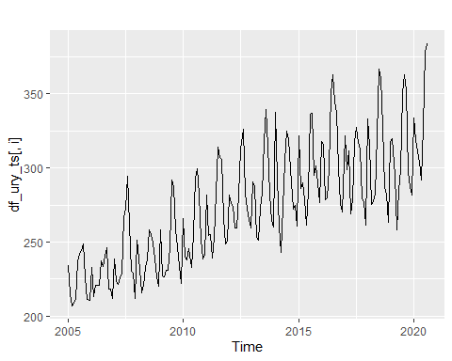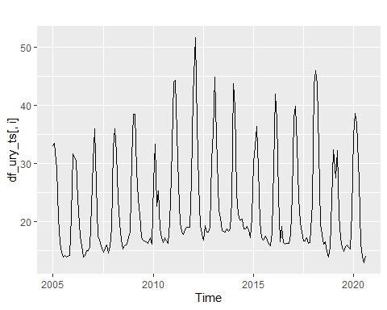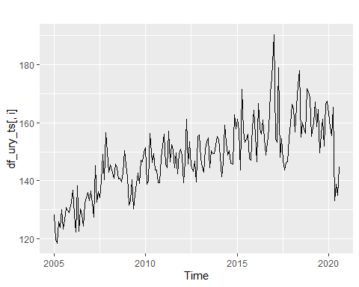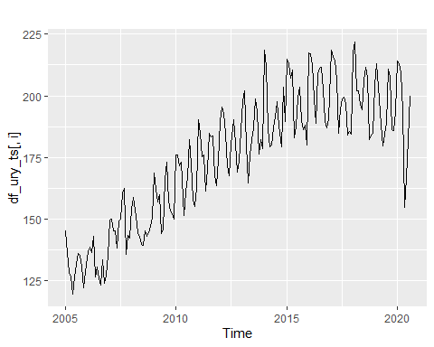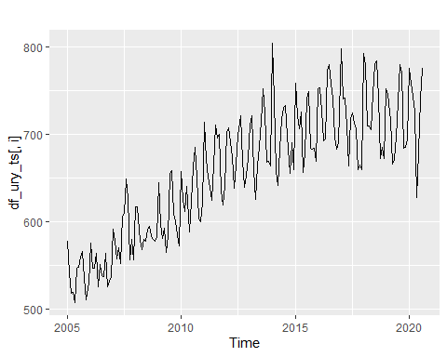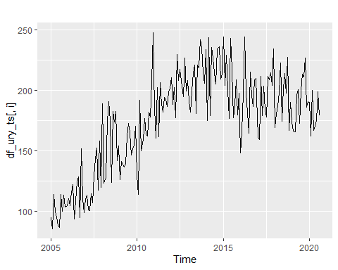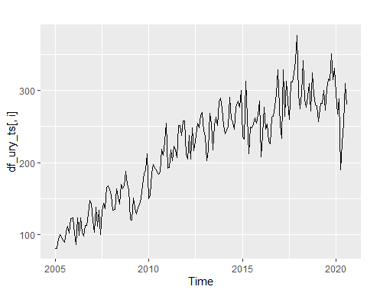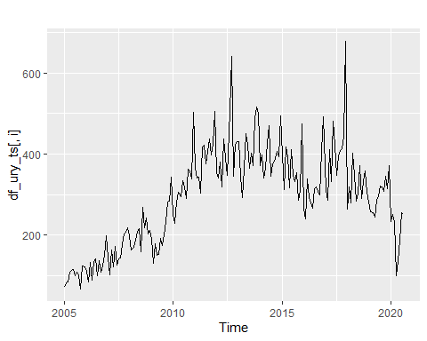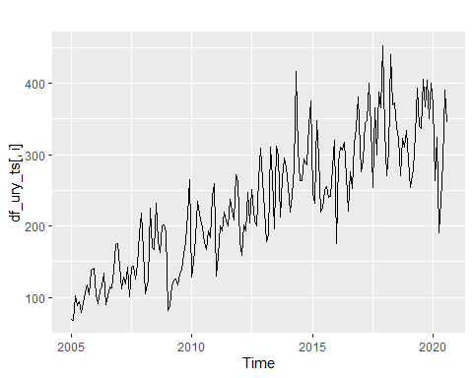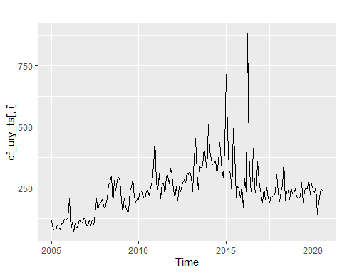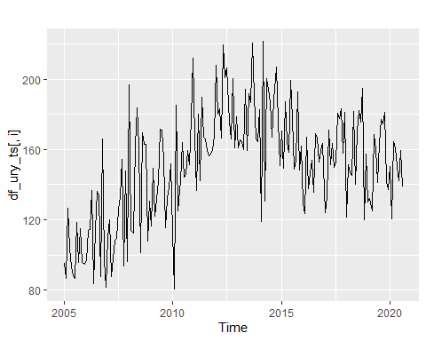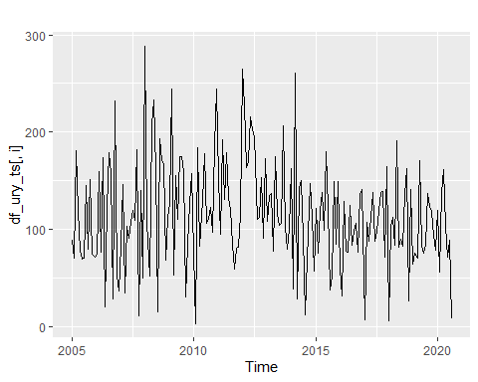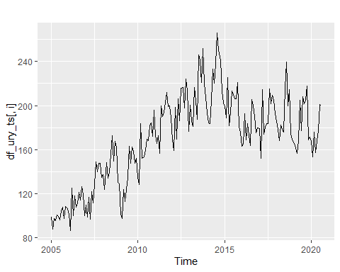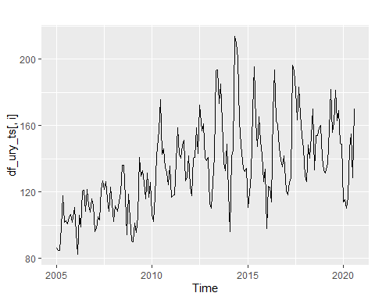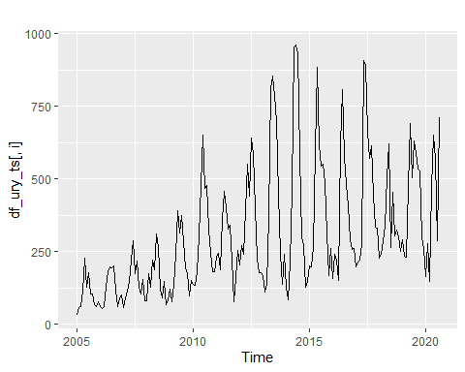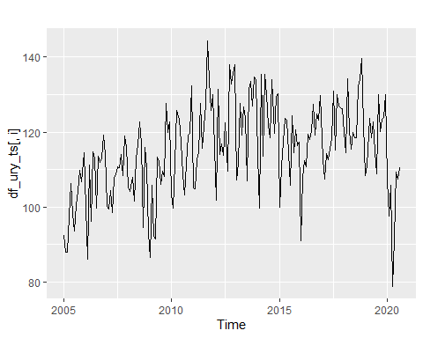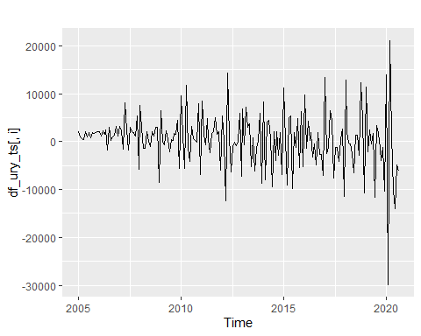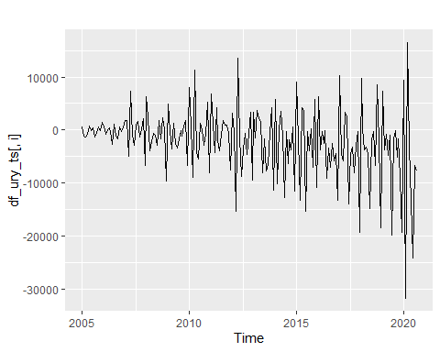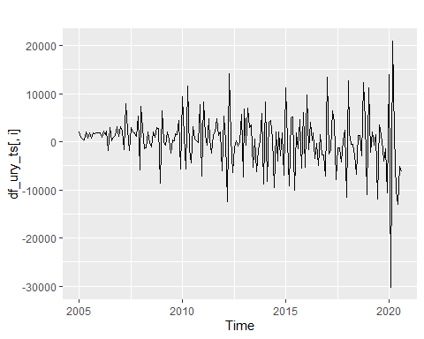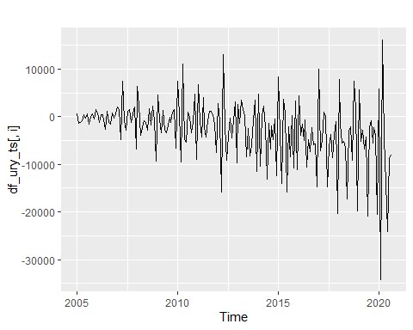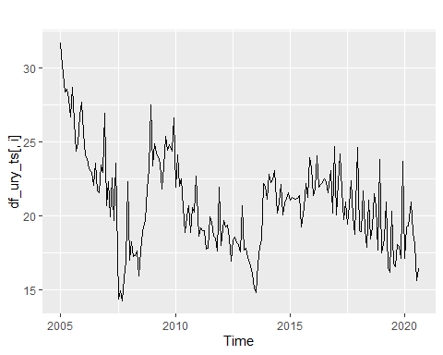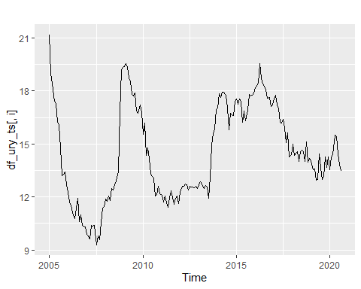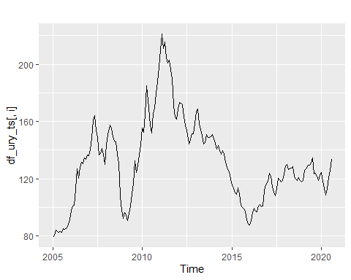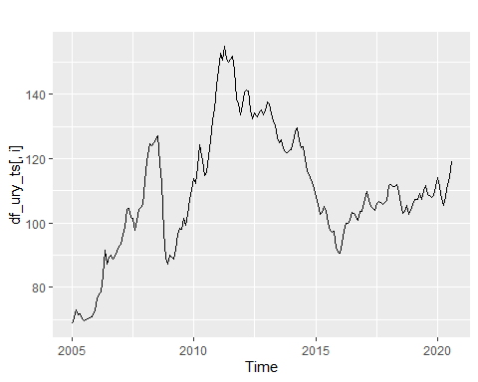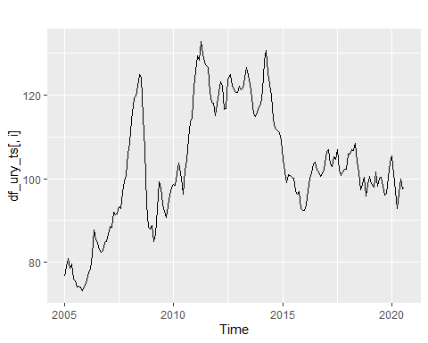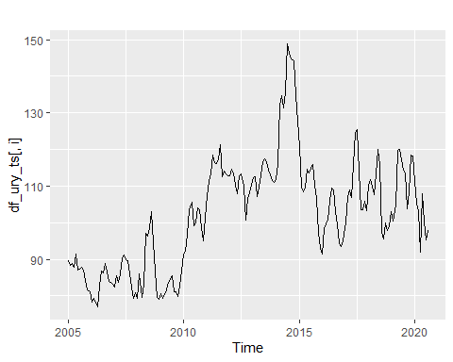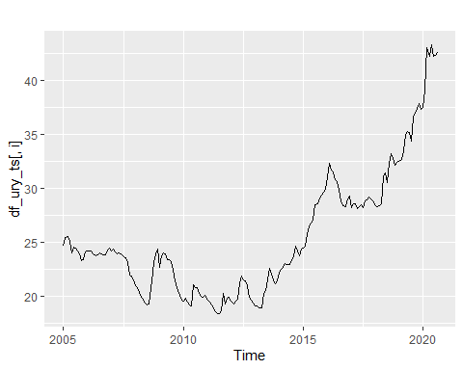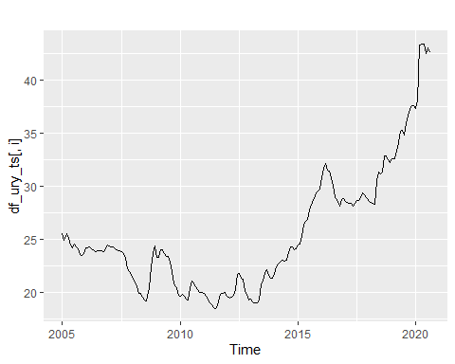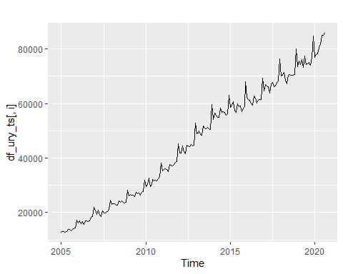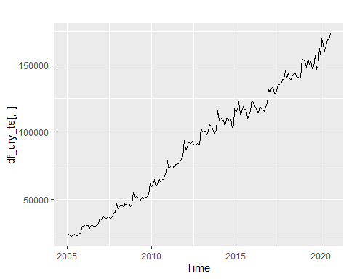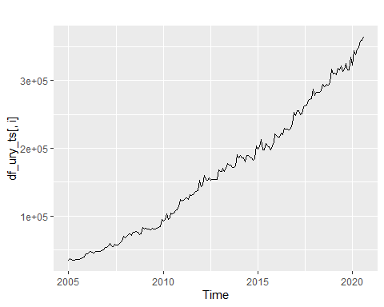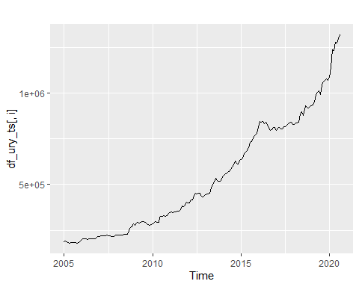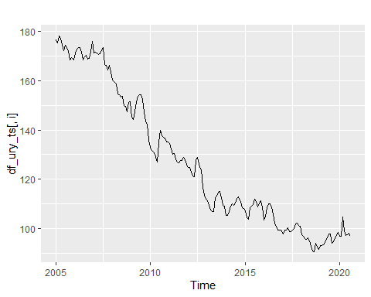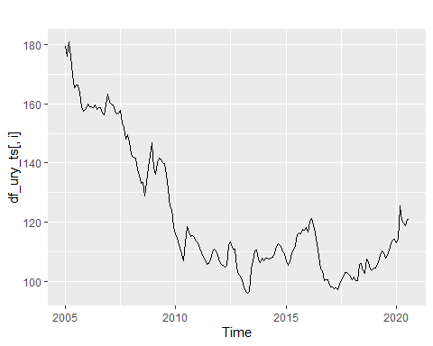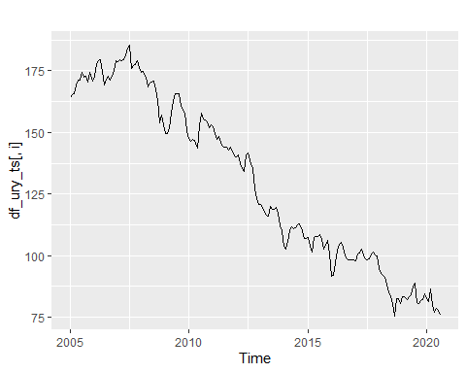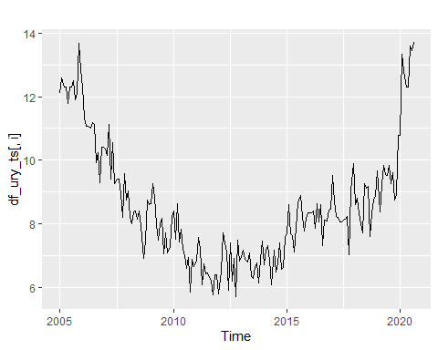

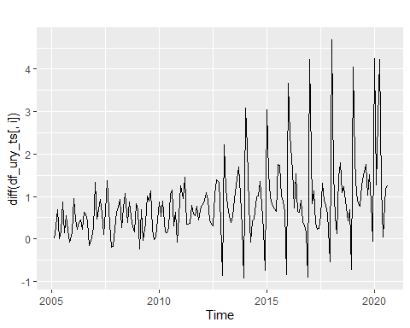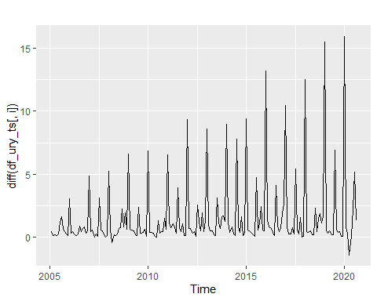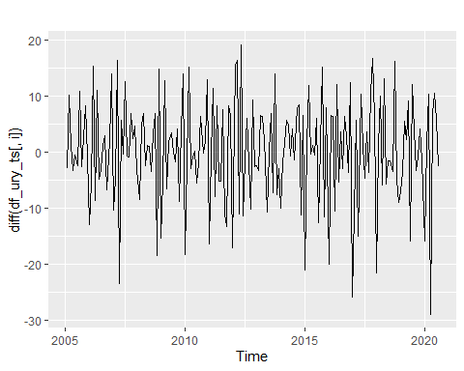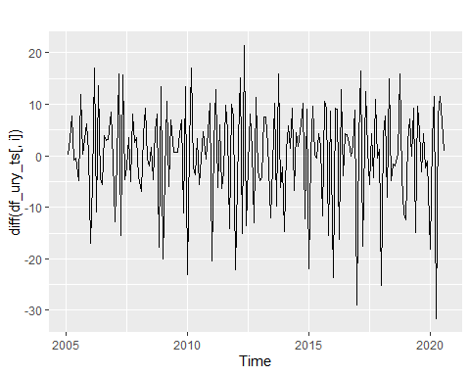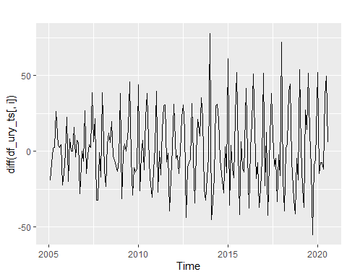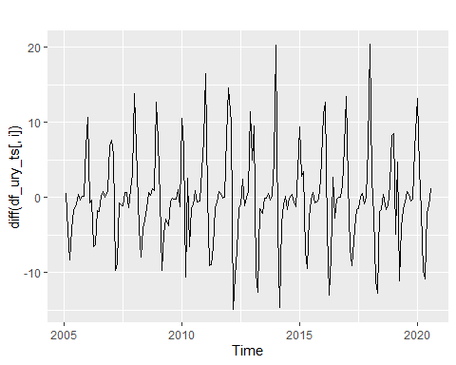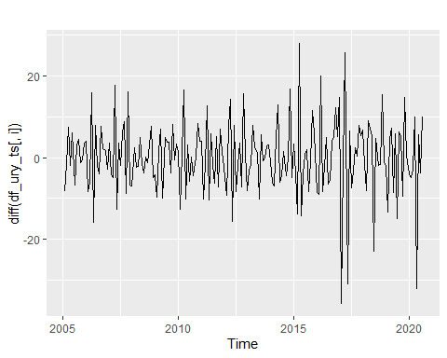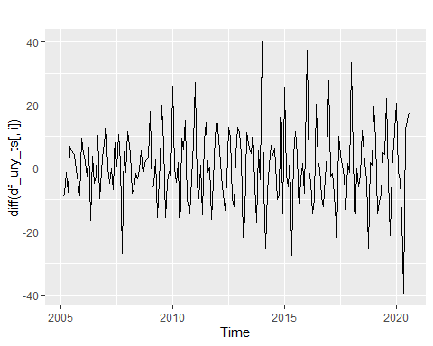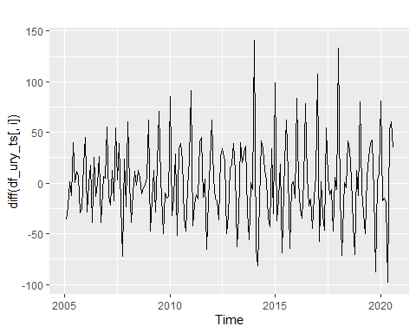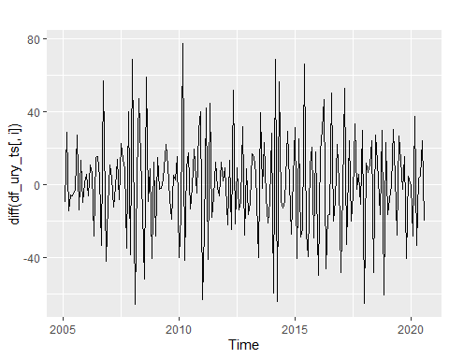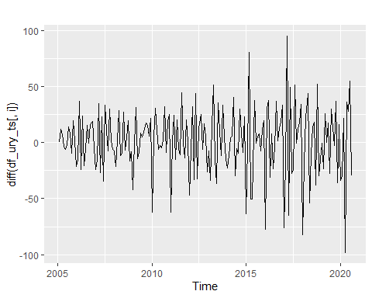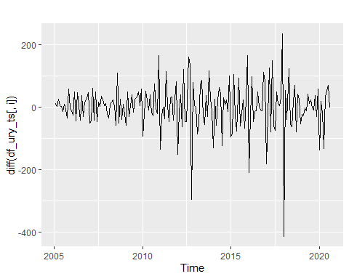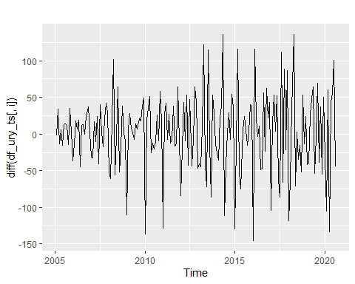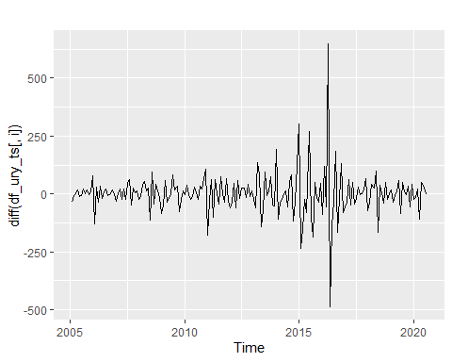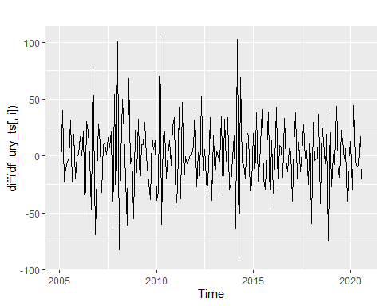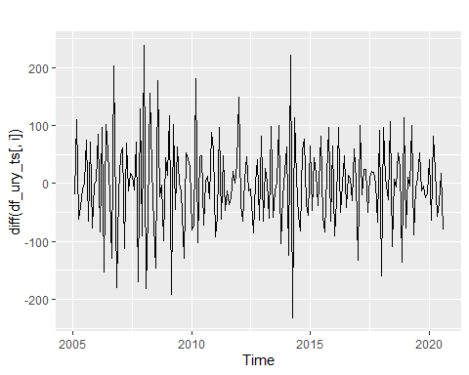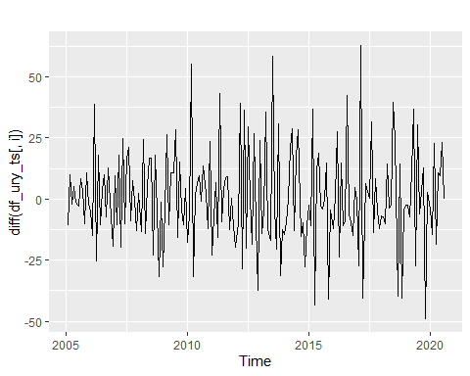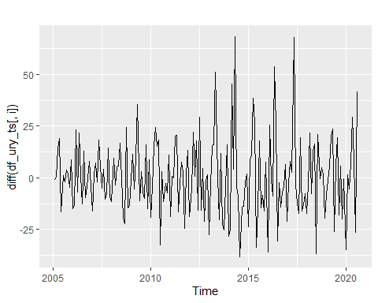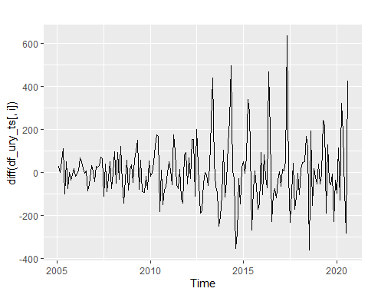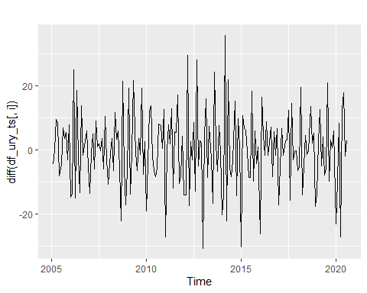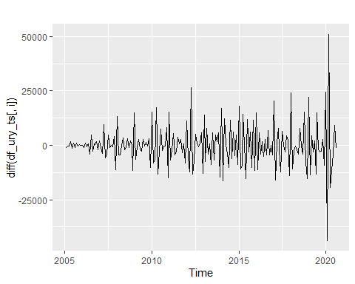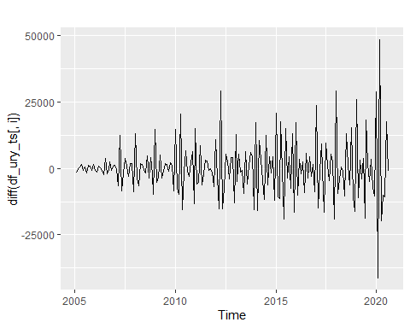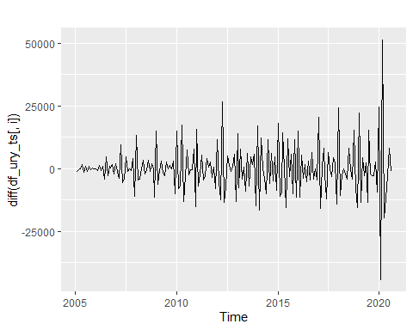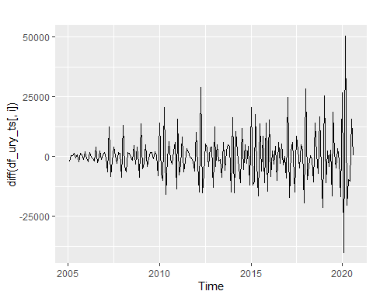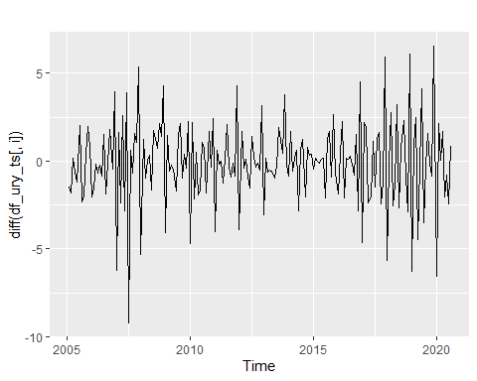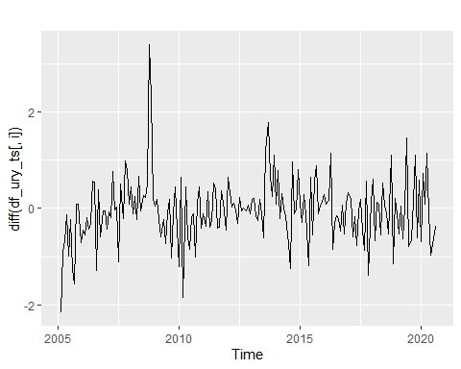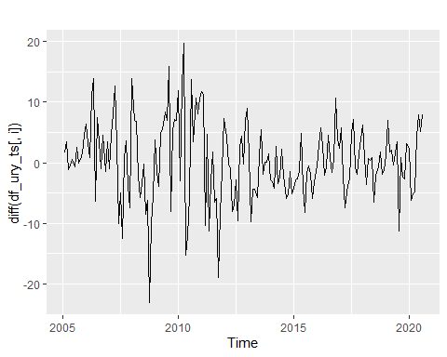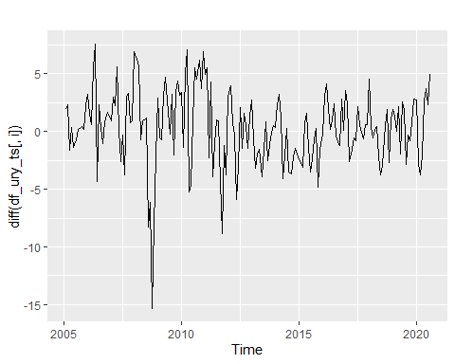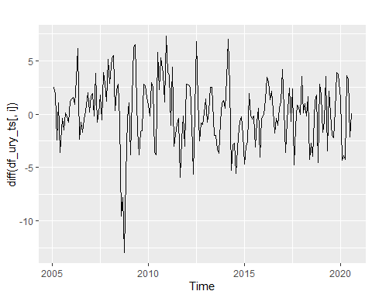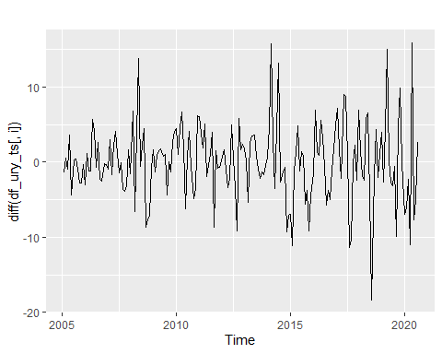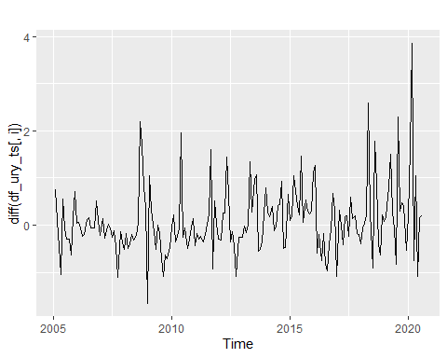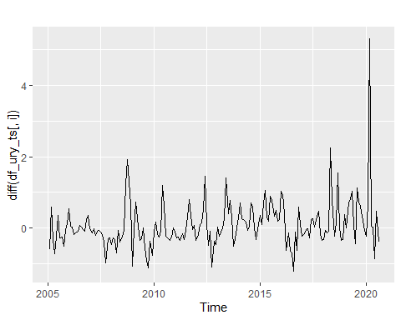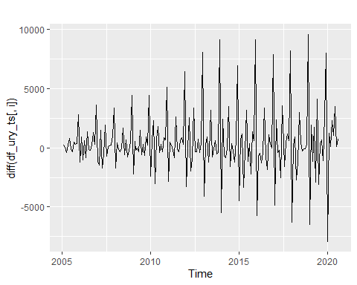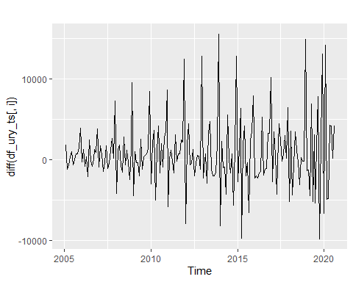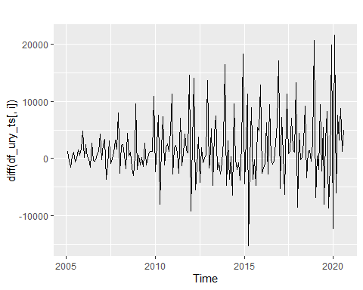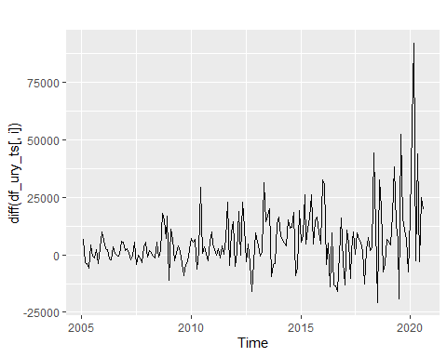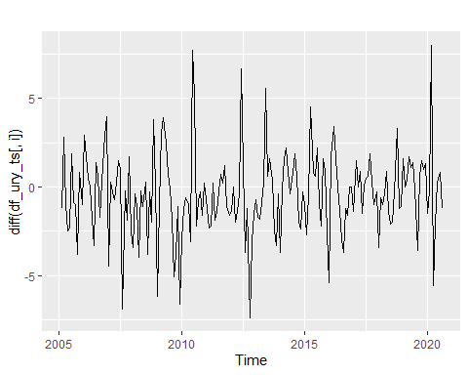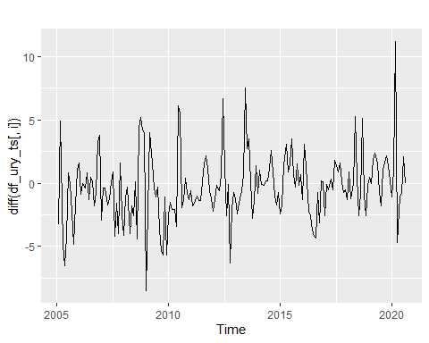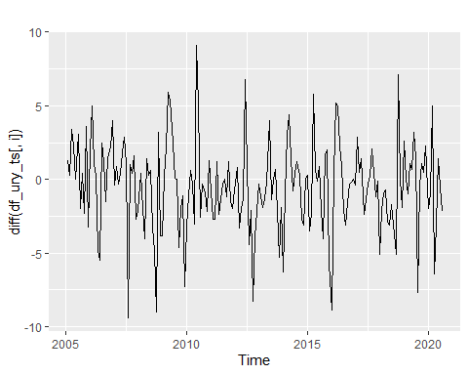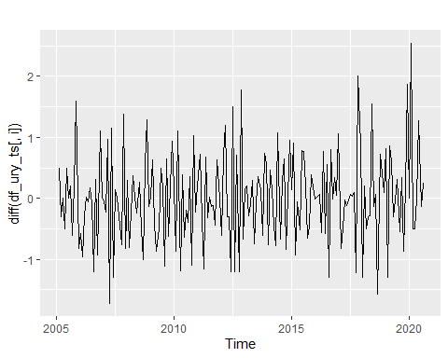

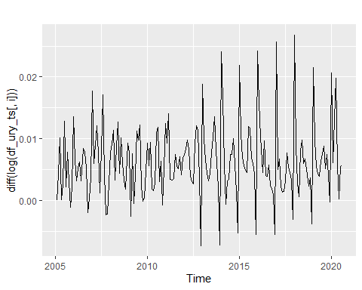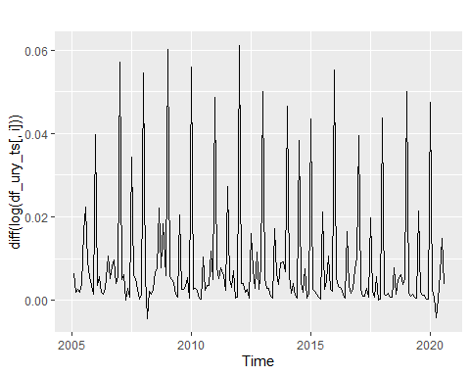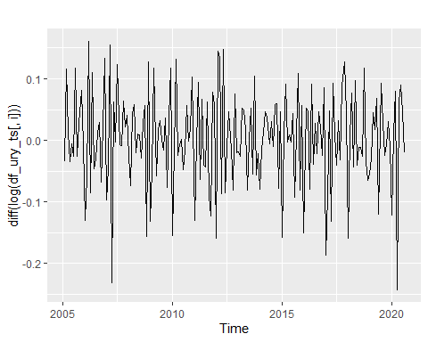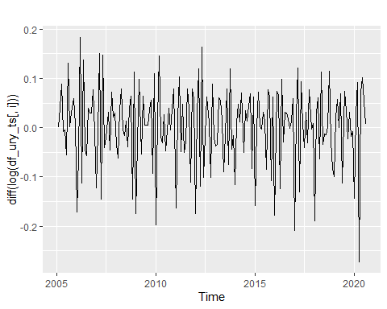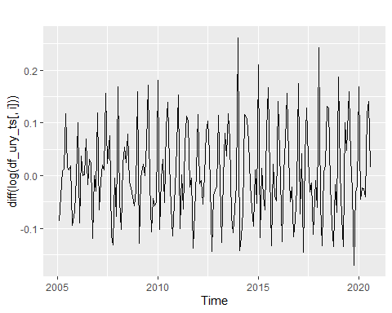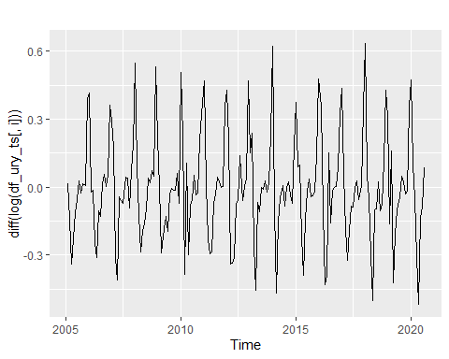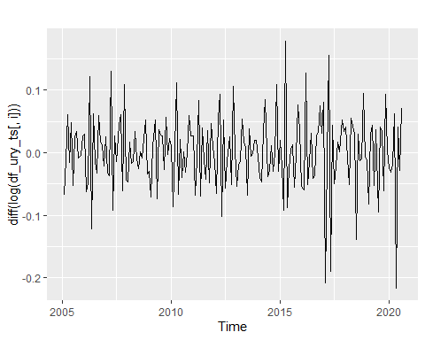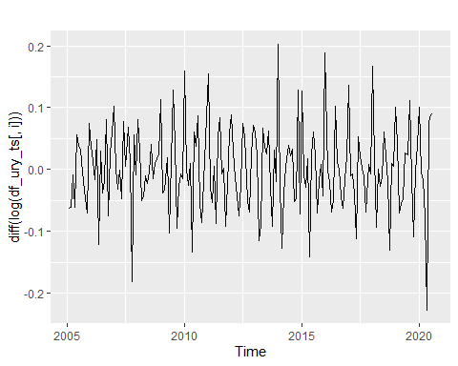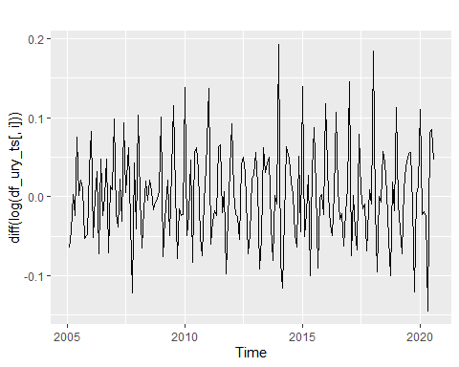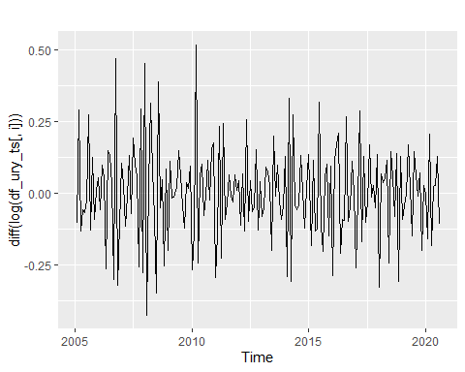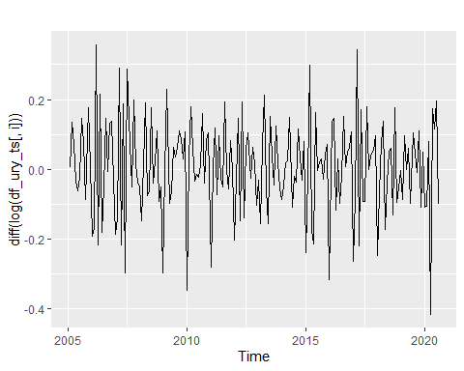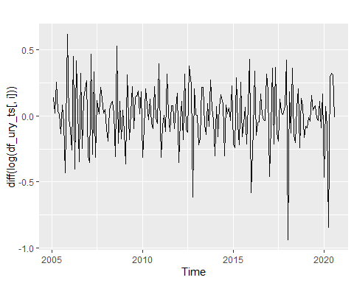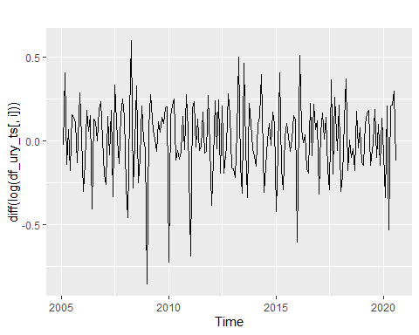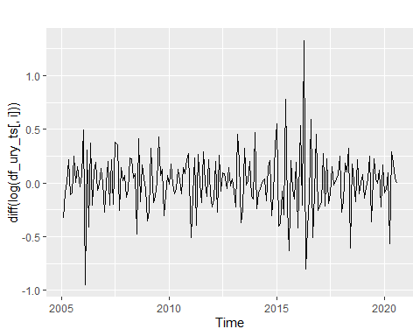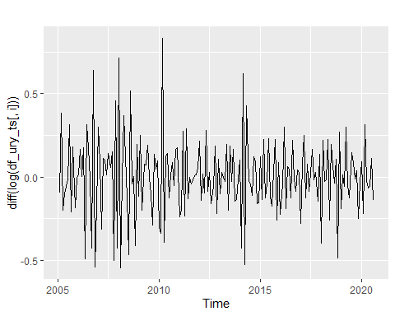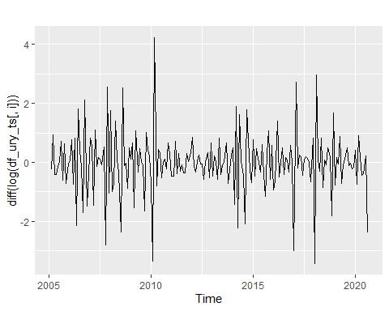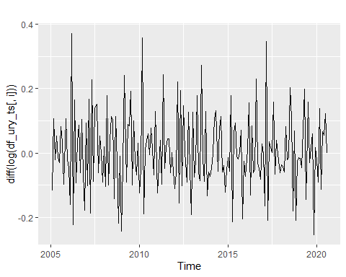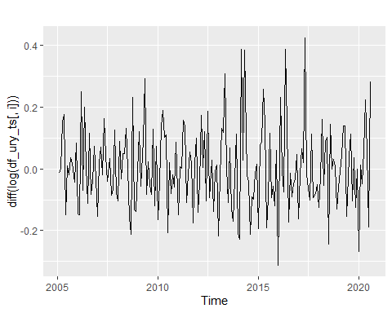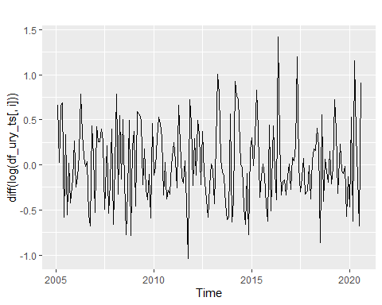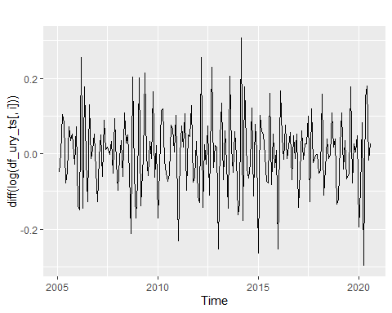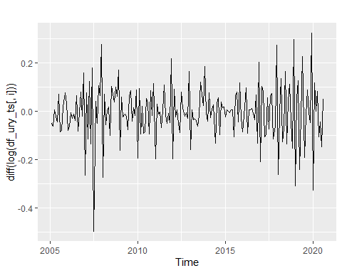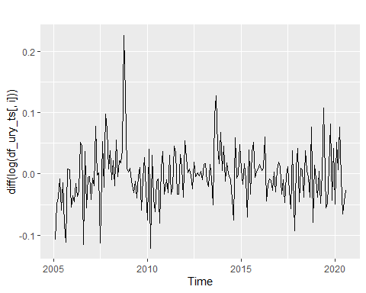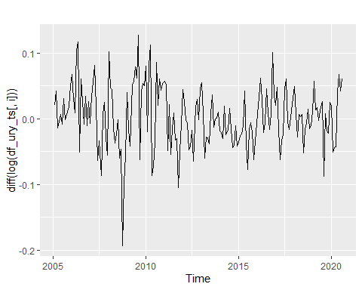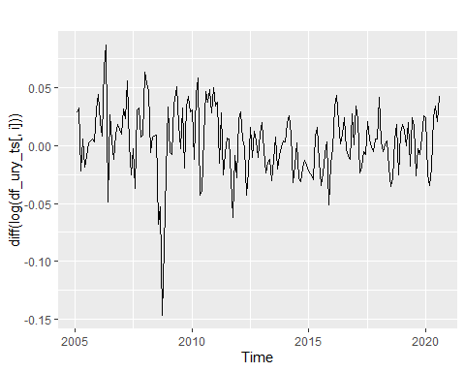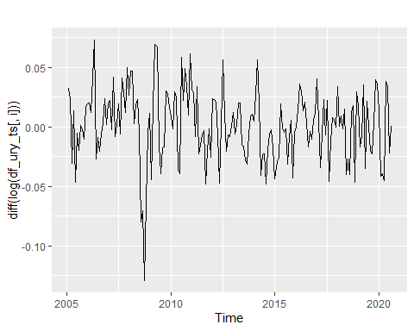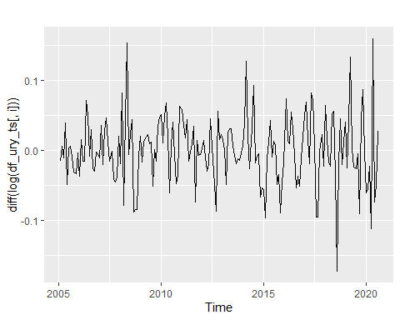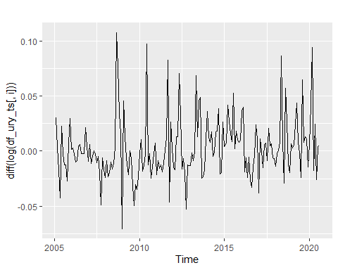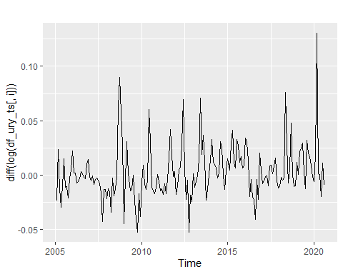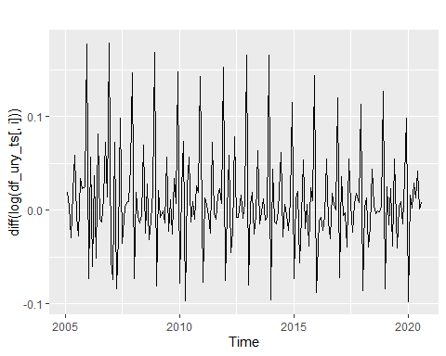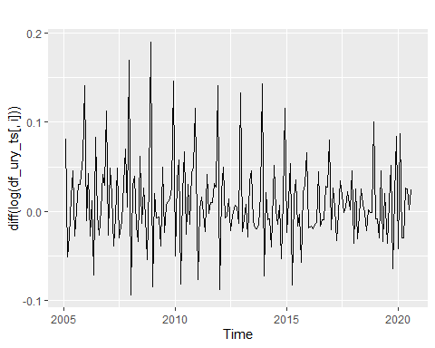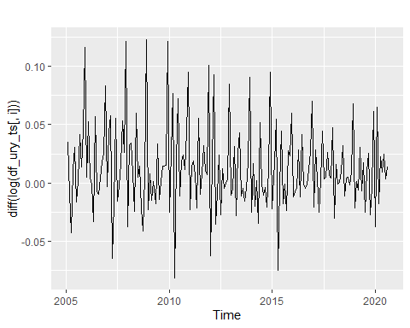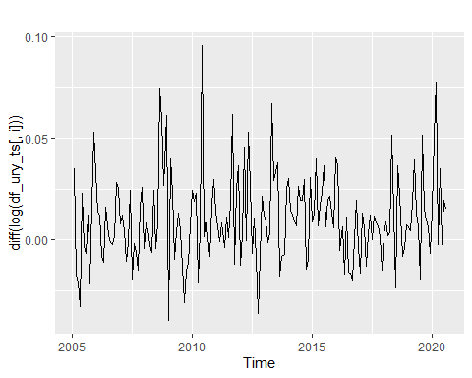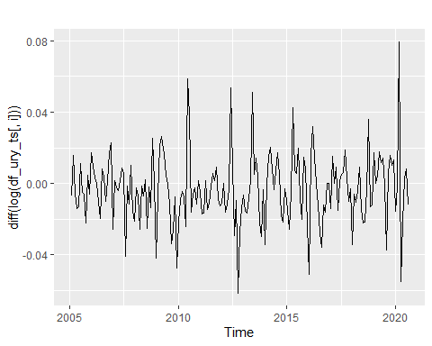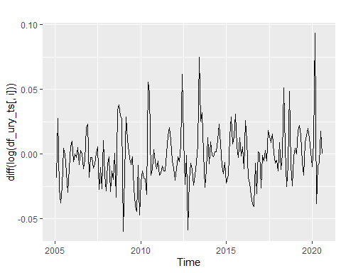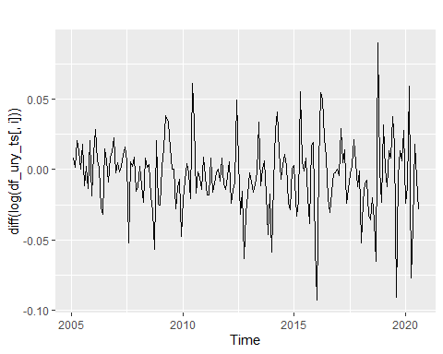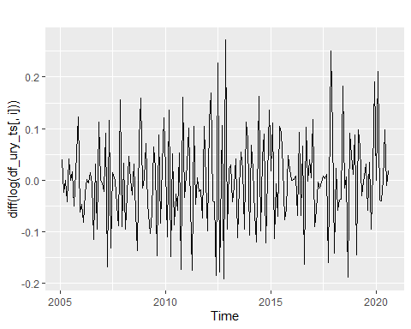

 ### Estudio de estacionariedad de las covariables. Tests de RU.

##   
## ###############################################   
## # Augmented Dickey-Fuller Test Unit Root Test #   
## ###############################################   
##   
## Test regression trend   
##   
##   
## Call:  
## lm(formula = z.diff ~ z.lag.1 + 1 + tt + z.diff.lag)  
##   
## Residuals:  
## Min 1Q Median 3Q Max   
## -0.073570 -0.019036 -0.004532 0.012957 0.115437   
##   
## Coefficients:  
## Estimate Std. Error t value Pr(>|t|)   
## (Intercept) 2.773e-02 5.463e-03 5.076 9.54e-07 ***  
## z.lag.1 -1.518e+00 1.159e-01 -13.095 < 2e-16 ***  
## tt -9.349e-05 4.717e-05 -1.982 0.04897 *   
## z.diff.lag 1.976e-01 7.274e-02 2.717 0.00724 **   
## ---  
## Signif. codes: 0 '***' 0.001 '**' 0.01 '*' 0.05 '.' 0.1 ' ' 1  
##   
## Residual standard error: 0.03388 on 181 degrees of freedom  
## Multiple R-squared: 0.6485, Adjusted R-squared: 0.6427   
## F-statistic: 111.3 on 3 and 181 DF, p-value: < 2.2e-16  
##   
##   
## Value of test-statistic is: -13.0952 57.1618 85.7427   
##   
## Critical values for test statistics:   
## 1pct 5pct 10pct  
## tau3 -3.99 -3.43 -3.13  
## phi2 6.22 4.75 4.07  
## phi3 8.43 6.49 5.47

##   
## ##################################   
## # Phillips-Perron Unit Root Test #   
## ##################################   
##   
## Test regression with intercept and trend   
##   
##   
## Call:  
## lm(formula = y ~ y.l1 + trend)  
##   
## Residuals:  
## Min 1Q Median 3Q Max   
## -0.079041 -0.020604 -0.004876 0.014597 0.107927   
##   
## Coefficients:  
## Estimate Std. Error t value Pr(>|t|)   
## (Intercept) 1.578e-02 2.677e-03 5.894 1.78e-08 ***  
## y.l1 -2.686e-01 7.117e-02 -3.774 0.000217 ***  
## trend -7.445e-05 4.721e-05 -1.577 0.116503   
## ---  
## Signif. codes: 0 '***' 0.001 '**' 0.01 '*' 0.05 '.' 0.1 ' ' 1  
##   
## Residual standard error: 0.03442 on 183 degrees of freedom  
## Multiple R-squared: 0.07927, Adjusted R-squared: 0.06921   
## F-statistic: 7.878 on 2 and 183 DF, p-value: 0.0005226  
##   
##   
## Value of test-statistic, type: Z-tau is: -21.6777   
##   
## aux. Z statistics  
## Z-tau-mu 11.0878  
## Z-tau-beta -1.9443  
##   
## Critical values for Z statistics:   
## 1pct 5pct 10pct  
## critical values -4.01008 -3.43483 -3.141119

##   
## #######################   
## # KPSS Unit Root Test #   
## #######################   
##   
## Test is of type: tau with 14 lags.   
##   
## Value of test-statistic is: 0.0585   
##   
## Critical value for a significance level of:   
## 10pct 5pct 2.5pct 1pct  
## critical values 0.119 0.146 0.176 0.216

##   
## ###############################################   
## # Augmented Dickey-Fuller Test Unit Root Test #   
## ###############################################   
##   
## Test regression trend   
##   
##   
## Call:  
## lm(formula = z.diff ~ z.lag.1 + 1 + tt + z.diff.lag)  
##   
## Residuals:  
## Min 1Q Median 3Q Max   
## -0.071775 -0.014418 -0.002089 0.009438 0.108730   
##   
## Coefficients:  
## Estimate Std. Error t value Pr(>|t|)   
## (Intercept) -5.409e-03 4.054e-03 -1.334 0.1838   
## z.lag.1 -8.264e-01 9.509e-02 -8.691 2.11e-15 ***  
## tt 8.189e-05 3.821e-05 2.143 0.0334 *   
## z.diff.lag 3.660e-03 7.399e-02 0.049 0.9606   
## ---  
## Signif. codes: 0 '***' 0.001 '**' 0.01 '*' 0.05 '.' 0.1 ' ' 1  
##   
## Residual standard error: 0.02695 on 181 degrees of freedom  
## Multiple R-squared: 0.4118, Adjusted R-squared: 0.4021   
## F-statistic: 42.24 on 3 and 181 DF, p-value: < 2.2e-16  
##   
##   
## Value of test-statistic is: -8.691 25.1799 37.7695   
##   
## Critical values for test statistics:   
## 1pct 5pct 10pct  
## tau3 -3.99 -3.43 -3.13  
## phi2 6.22 4.75 4.07  
## phi3 8.43 6.49 5.47

##   
## ##################################   
## # Phillips-Perron Unit Root Test #   
## ##################################   
##   
## Test regression with intercept and trend   
##   
##   
## Call:  
## lm(formula = y ~ y.l1 + trend)  
##   
## Residuals:  
## Min 1Q Median 3Q Max   
## -0.071957 -0.014346 -0.001889 0.009268 0.108714   
##   
## Coefficients:  
## Estimate Std. Error t value Pr(>|t|)   
## (Intercept) 2.215e-03 1.976e-03 1.121 0.2639   
## y.l1 1.775e-01 7.240e-02 2.451 0.0152 *  
## trend 8.092e-05 3.720e-05 2.175 0.0309 *  
## ---  
## Signif. codes: 0 '***' 0.001 '**' 0.01 '*' 0.05 '.' 0.1 ' ' 1  
##   
## Residual standard error: 0.0268 on 183 degrees of freedom  
## Multiple R-squared: 0.06667, Adjusted R-squared: 0.05647   
## F-statistic: 6.536 on 2 and 183 DF, p-value: 0.001812  
##   
##   
## Value of test-statistic, type: Z-tau is: -11.1745   
##   
## aux. Z statistics  
## Z-tau-mu 1.6462  
## Z-tau-beta 2.1414  
##   
## Critical values for Z statistics:   
## 1pct 5pct 10pct  
## critical values -4.01008 -3.43483 -3.141119

##   
## #######################   
## # KPSS Unit Root Test #   
## #######################   
##   
## Test is of type: tau with 14 lags.   
##   
## Value of test-statistic is: 0.0457   
##   
## Critical value for a significance level of:   
## 10pct 5pct 2.5pct 1pct  
## critical values 0.119 0.146 0.176 0.216

### Anállisis factorial

Los factores seleccionados tienen las siguentes características.

pr.out$rotation #es la matriz de pesos (loadings) que recibe cada variable en cada componente (las columnas son los autovectores)

## PC1 PC2 PC3 PC4  
## x.21.IMS 0.274997912 0.04561372 -0.028246346 0.1492639460  
## x.21.IVF_Ind -0.238396161 0.17764796 -0.039722867 0.0344751850  
## x.21.IVF_Ind_SREF -0.264199947 0.17933974 -0.025147566 0.0259326330  
## x.21.Energ_fact_res 0.194744654 0.06472311 0.020801088 0.1276493668  
## x.21.Energ_fact_prim 0.160317759 -0.14627656 0.031634319 0.1936059519  
## x.21.Energ_fact_Ind 0.067569062 -0.04608339 0.060072417 -0.1365295866  
## x.21.Energ_fact_cys 0.225677736 -0.06436877 0.061134910 0.1490704086  
## x.21.Energ_fact_total 0.234849391 -0.01147556 0.050073024 0.1179522002  
## x.21.IVF_M_total -0.178856299 0.23925181 -0.025940353 0.2828499661  
## x.21.IVF_M_Consumo -0.225917105 0.22227533 -0.047692435 0.1513132317  
## x.21.IVF_M_autos -0.217691901 0.10069306 -0.028260442 0.0876095912  
## x.21.IVF_M_durables -0.205533049 0.19261819 -0.039516449 0.0672309649  
## x.21.IVF_M_bienes_K -0.096562837 0.16526433 0.005660691 0.2181242329  
## x.21.IVF_M_bienes_Int -0.141355214 0.19599966 -0.029863921 0.2285493677  
## x.21.IVF_M_petoleo -0.115154032 0.09472682 -0.027643779 0.1356107859  
## x.21.IVF_M_sEnerg -0.125458680 0.23987470 -0.043922928 0.1556583707  
## x.21.IVF_X -0.161970176 0.07492681 -0.081788588 -0.2336475000  
## x.21.IVF_X_primario -0.080492533 0.01878546 -0.081239092 -0.2249898963  
## x.21.IVF_X_Ind -0.172403120 0.08815282 -0.055805770 -0.1176409139  
## x.21.Int_act_MN_prom -0.148231214 -0.19609998 0.060209858 -0.0070743946  
## x.21.Int_act_MN_Emp 0.012749397 -0.10823445 0.170761145 0.0308402911  
## x.21.Cpmm_Ind_Mats 0.060479397 0.01562886 -0.342395846 -0.0963141660  
## x.21.Comm_Non_Fuel 0.062699794 0.02364724 -0.393908925 -0.1899090656  
## x.21.Comm_Food 0.031702156 0.03927931 -0.330718109 -0.2608431965  
## x.21.Comm_Meat 0.009267525 0.06450005 -0.191171643 -0.2220123389  
## x.21.TC_Prom_Interb_media -0.017234528 0.09433825 0.441994580 -0.1500347450  
## x.21.Emision_cierre -0.205528956 -0.21987240 0.031726380 0.0002335062  
## x.21.M1_cierre -0.170215766 -0.20846418 0.014382088 0.0491544191  
## x.21.M3_cierre -0.070959177 0.02480621 0.333673143 -0.0061506149  
## x.21.TCR_Global -0.049630864 0.16827139 0.236667421 -0.3609199610  
## x.21.TCR_xtra_reg -0.048528105 0.10501185 0.375505586 -0.2315374204  
## x.21.TCR_reg -0.035225853 0.16266372 0.052403161 -0.3406307667  
## x.21.t_des -0.041165263 -0.04865004 0.003681336 0.0375510468  
## x.31.SPC.RES_PRIM_SPNM 0.230133166 0.30742175 0.023022511 -0.0182295400  
## x.31.SPC.RES_GLOB_SPNM 0.235155345 0.30355210 0.013282722 -0.0065596707  
## x.31.SPC.RES_ PRIM_SPC 0.230294776 0.30744718 0.022078950 -0.0189705134  
## x.31.SPC.RES_GLOB_SPC 0.231622415 0.30823369 0.019794433 -0.0066294974  
## PC5 PC6 PC7 PC8  
## x.21.IMS -0.11562974 0.05431051 -0.05643323 0.129932462  
## x.21.IVF_Ind -0.07190610 -0.13798771 -0.19998603 -0.004660857  
## x.21.IVF_Ind_SREF -0.04569409 -0.10137026 -0.16693656 -0.013957645  
## x.21.Energ_fact_res -0.31832230 0.08244540 -0.28651375 -0.010039913  
## x.21.Energ_fact_prim -0.20475353 -0.18503185 0.03789700 -0.065491088  
## x.21.Energ_fact_Ind -0.01166869 -0.14941071 0.03403619 -0.537650234  
## x.21.Energ_fact_cys -0.32632949 -0.07909024 -0.10896344 -0.183845399  
## x.21.Energ_fact_total -0.33715084 -0.02408301 -0.20099643 -0.188607866  
## x.21.IVF_M_total -0.13389166 0.15485964 0.23103772 -0.017479221  
## x.21.IVF_M_Consumo 0.03949392 -0.24826843 -0.13968250 -0.017747784  
## x.21.IVF_M_autos -0.07724334 -0.20934792 -0.05537958 -0.127527147  
## x.21.IVF_M_durables 0.08967116 -0.22690121 -0.09101260 -0.073673604  
## x.21.IVF_M_bienes_K -0.04246718 -0.14778225 0.07804378 0.202060568  
## x.21.IVF_M_bienes_Int -0.17524083 0.33757639 0.27789622 -0.112158284  
## x.21.IVF_M_petoleo -0.16462448 0.35992567 0.40537491 -0.199673971  
## x.21.IVF_M_sEnerg -0.09458987 -0.04428952 -0.23008469 0.223208434  
## x.21.IVF_X 0.02462567 0.31933979 -0.26060981 -0.281874977  
## x.21.IVF_X_primario -0.04222400 0.35691313 -0.33194131 -0.114816846  
## x.21.IVF_X_Ind 0.06564315 0.02059068 -0.03747929 -0.308328132  
## x.21.Int_act_MN_prom 0.01429645 -0.15875916 0.13087400 -0.187682870  
## x.21.Int_act_MN_Emp 0.20263789 -0.08373251 0.12915492 -0.035353672  
## x.21.Cpmm_Ind_Mats -0.21196586 -0.15244698 0.10993133 0.018308931  
## x.21.Comm_Non_Fuel -0.21126578 -0.10698817 0.09578433 0.073764248  
## x.21.Comm_Food -0.17926939 -0.06360457 0.08332587 0.101298913  
## x.21.Comm_Meat -0.14791474 0.14662828 -0.04873169 0.166514967  
## x.21.TC_Prom_Interb_media -0.08579551 0.05866958 -0.01534553 0.082790340  
## x.21.Emision_cierre -0.22240817 -0.09319099 0.13718280 -0.140922710  
## x.21.M1_cierre -0.26513870 -0.11824606 0.07959621 -0.037754449  
## x.21.M3_cierre -0.23767427 0.12725837 -0.13552681 0.104673787  
## x.21.TCR_Global -0.20775226 -0.13150818 0.16718074 0.078590053  
## x.21.TCR_xtra_reg -0.18318582 -0.04497554 0.03740569 0.116469967  
## x.21.TCR_reg -0.15488140 -0.17445202 0.20835721 0.022281035  
## x.21.t_des -0.05633536 -0.15109991 -0.17854704 -0.243526857  
## x.31.SPC.RES_PRIM_SPNM 0.08870707 -0.06016869 0.06705357 -0.149013455  
## x.31.SPC.RES_GLOB_SPNM 0.09601500 -0.04612377 0.05970186 -0.107644210  
## x.31.SPC.RES_ PRIM_SPC 0.08838198 -0.05962376 0.06707364 -0.147941444  
## x.31.SPC.RES_GLOB_SPC 0.09913677 -0.05368073 0.04816466 -0.111354663  
## PC9 PC10 PC11 PC12  
## x.21.IMS -0.094336143 0.044566425 -0.166723627 -2.336424e-02  
## x.21.IVF_Ind -0.161342184 -0.180711246 -0.055673681 2.084385e-02  
## x.21.IVF_Ind_SREF -0.183935679 -0.071451813 0.047325757 -3.424891e-02  
## x.21.Energ_fact_res 0.165530212 0.211070397 -0.018659130 -7.284216e-02  
## x.21.Energ_fact_prim -0.344839996 0.095750256 -0.096912105 1.019658e-01  
## x.21.Energ_fact_Ind 0.234078012 -0.113776874 0.219031172 2.242702e-01  
## x.21.Energ_fact_cys -0.005352635 0.128199335 0.102599564 -5.944876e-02  
## x.21.Energ_fact_total 0.104981432 0.163555102 0.047570176 -1.422320e-02  
## x.21.IVF_M_total 0.070088418 0.102116756 -0.061936642 5.689612e-02  
## x.21.IVF_M_Consumo -0.051026055 0.108395559 0.038815068 8.749599e-03  
## x.21.IVF_M_autos 0.208567800 -0.034305987 -0.050550765 9.373992e-02  
## x.21.IVF_M_durables -0.076503726 0.117923183 0.097967650 1.098693e-01  
## x.21.IVF_M_bienes_K 0.190351736 0.183226312 -0.152321761 3.134590e-01  
## x.21.IVF_M_bienes_Int -0.005009566 0.011651102 -0.009824483 -6.828785e-02  
## x.21.IVF_M_petoleo 0.015044863 -0.050167577 -0.034363868 -6.927487e-02  
## x.21.IVF_M_sEnerg 0.085714156 0.072461117 0.145049050 -8.321021e-02  
## x.21.IVF_X -0.091356701 0.200020266 -0.020855989 4.068706e-02  
## x.21.IVF_X_primario 0.079561577 0.092090240 -0.051137670 4.727869e-01  
## x.21.IVF_X_Ind -0.230004321 0.194167280 -0.006085844 -4.879562e-01  
## x.21.Int_act_MN_prom -0.236656198 0.336137948 0.103543473 4.100061e-02  
## x.21.Int_act_MN_Emp -0.168395272 0.537013712 -0.373830333 1.670478e-01  
## x.21.Cpmm_Ind_Mats -0.065352385 0.104137420 0.214436551 -1.347491e-01  
## x.21.Comm_Non_Fuel -0.106879451 0.045577013 0.080594807 -5.513678e-02  
## x.21.Comm_Food -0.129269986 -0.023682218 -0.098911320 1.067657e-01  
## x.21.Comm_Meat -0.235927608 0.013727343 -0.334840265 9.636007e-02  
## x.21.TC_Prom_Interb_media -0.147380658 -0.023891728 0.025319376 -6.637041e-02  
## x.21.Emision_cierre -0.096216764 -0.152610627 -0.037769894 1.671795e-01  
## x.21.M1_cierre -0.153824890 -0.295033064 -0.062287848 2.543104e-01  
## x.21.M3_cierre -0.245536523 -0.127083192 0.063685022 7.069486e-02  
## x.21.TCR_Global 0.172795580 0.098349503 -0.038731861 -5.720499e-02  
## x.21.TCR_xtra_reg -0.107978217 -0.003437776 0.096196596 -1.029206e-01  
## x.21.TCR_reg 0.356208169 0.158653074 -0.155503925 -5.123368e-05  
## x.21.t_des 0.152044695 -0.262612754 -0.675766580 -3.127169e-01  
## x.31.SPC.RES_PRIM_SPNM -0.133208219 -0.105378672 -0.042345486 7.687542e-02  
## x.31.SPC.RES_GLOB_SPNM -0.140637649 -0.088790981 -0.010552336 1.179755e-01  
## x.31.SPC.RES_ PRIM_SPC -0.131135711 -0.105074310 -0.042768999 7.824303e-02  
## x.31.SPC.RES_GLOB_SPC -0.131156574 -0.097615624 -0.008662309 1.221102e-01  
## PC13 PC14 PC15 PC16  
## x.21.IMS 0.055777637 0.151727871 -0.085785907 -0.042010678  
## x.21.IVF_Ind 0.122450924 0.069406576 -0.207927505 0.147096657  
## x.21.IVF_Ind_SREF 0.082139871 0.064998295 -0.255611585 0.096354235  
## x.21.Energ_fact_res 0.060010208 -0.237169282 0.055960221 -0.011692713  
## x.21.Energ_fact_prim 0.013526075 0.108491470 -0.207859875 -0.203077858  
## x.21.Energ_fact_Ind -0.179520572 0.056445597 0.187948262 0.392678493  
## x.21.Energ_fact_cys -0.033691266 -0.048082993 -0.068308080 0.075641252  
## x.21.Energ_fact_total -0.005820406 -0.133733249 0.019736854 0.065671784  
## x.21.IVF_M_total -0.108843307 0.022151831 0.100846105 0.012978216  
## x.21.IVF_M_Consumo 0.105361049 -0.058829738 0.030039428 0.046418746  
## x.21.IVF_M_autos 0.006657240 -0.032419551 -0.541734217 0.111502347  
## x.21.IVF_M_durables -0.030098548 -0.055094047 0.377672532 0.064988355  
## x.21.IVF_M_bienes_K -0.598196719 0.057254510 -0.034328792 -0.050398110  
## x.21.IVF_M_bienes_Int 0.125190779 0.020417533 0.127427930 0.026467102  
## x.21.IVF_M_petoleo 0.117328311 0.100527195 -0.125300532 0.167126610  
## x.21.IVF_M_sEnerg 0.292379072 0.034023427 0.382705138 -0.074229961  
## x.21.IVF_X -0.127149334 0.027568864 -0.022822267 -0.265336580  
## x.21.IVF_X_primario 0.153502250 0.274881578 -0.037063564 -0.103458991  
## x.21.IVF_X_Ind -0.379470316 -0.201932667 -0.024225351 -0.228651680  
## x.21.Int_act_MN_prom 0.341747138 0.020058898 -0.019810037 0.086047262  
## x.21.Int_act_MN_Emp 0.067391789 0.150525724 0.114896249 0.142280774  
## x.21.Cpmm_Ind_Mats -0.033633935 0.365681467 -0.018674161 -0.003598468  
## x.21.Comm_Non_Fuel -0.081885845 0.262705459 0.074654422 0.047439784  
## x.21.Comm_Food -0.099175530 0.007692488 0.149346127 0.135356373  
## x.21.Comm_Meat -0.015197366 -0.498824920 -0.024490032 0.429563826  
## x.21.TC_Prom_Interb_media -0.050976818 0.120455683 0.031013902 0.173364734  
## x.21.Emision_cierre 0.054647397 -0.243911032 0.131147107 -0.205883189  
## x.21.M1_cierre 0.005818601 -0.143995879 0.191509383 -0.312512927  
## x.21.M3_cierre -0.238622750 0.236709408 0.024206045 -0.049668072  
## x.21.TCR_Global 0.091890332 -0.014920501 -0.032738894 -0.105096296  
## x.21.TCR_xtra_reg -0.056322522 0.064765050 0.073215031 0.168987976  
## x.21.TCR_reg 0.184309537 -0.075832148 -0.106797514 -0.301646255  
## x.21.t_des 0.036787847 0.310949996 0.226007620 0.045902664  
## x.31.SPC.RES_PRIM_SPNM 0.049643127 -0.026131241 0.021057471 -0.078108985  
## x.31.SPC.RES_GLOB_SPNM 0.049575300 -0.026173864 0.003062965 -0.107709499  
## x.31.SPC.RES_ PRIM_SPC 0.049550052 -0.026945026 0.021591603 -0.079892093  
## x.31.SPC.RES_GLOB_SPC 0.038278543 -0.045149991 -0.020664299 -0.102655723  
## PC17 PC18 PC19 PC20  
## x.21.IMS 0.01688596 0.197949861 0.008876633 -0.202266522  
## x.21.IVF_Ind 0.12003241 -0.048606880 0.207168959 -0.207585546  
## x.21.IVF_Ind_SREF 0.12749148 -0.042152970 0.121845937 -0.168235638  
## x.21.Energ_fact_res 0.07997380 -0.110427865 0.025000393 0.223063255  
## x.21.Energ_fact_prim -0.26988947 0.361005268 0.095771179 -0.319146145  
## x.21.Energ_fact_Ind 0.14571808 0.101810546 0.010447342 -0.393943493  
## x.21.Energ_fact_cys -0.04407490 -0.008358766 0.040882877 0.080349231  
## x.21.Energ_fact_total 0.02195000 -0.012204324 0.037672128 0.053150890  
## x.21.IVF_M_total -0.03637244 -0.037438451 0.029772865 -0.091326678  
## x.21.IVF_M_Consumo -0.09779218 0.235947802 -0.146358123 0.139427254  
## x.21.IVF_M_autos 0.19519158 0.048475866 -0.110755596 0.338309043  
## x.21.IVF_M_durables -0.37338367 0.351262695 -0.209279897 0.197872324  
## x.21.IVF_M_bienes_K -0.15504715 -0.337634321 0.126810723 -0.096673638  
## x.21.IVF_M_bienes_Int 0.04294403 0.056269119 0.043446935 -0.103670550  
## x.21.IVF_M_petoleo -0.07961976 0.108463930 -0.025504466 0.173077910  
## x.21.IVF_M_sEnerg 0.26317122 -0.104956366 0.097999491 -0.263688681  
## x.21.IVF_X -0.05284933 0.017754585 -0.014747264 0.002471199  
## x.21.IVF_X_primario -0.10896575 -0.018465585 0.018467636 0.026969507  
## x.21.IVF_X_Ind 0.14100534 0.003595695 0.075537708 -0.089042802  
## x.21.Int_act_MN_prom -0.33406575 -0.528904850 0.149031418 0.003637953  
## x.21.Int_act_MN_Emp 0.53197855 0.115658802 -0.078778639 0.092696292  
## x.21.Cpmm_Ind_Mats 0.07809134 -0.192735151 -0.497419389 -0.012137737  
## x.21.Comm_Non_Fuel 0.07978109 -0.039736566 0.034810791 0.091046941  
## x.21.Comm_Food 0.05887607 0.187403873 0.557904892 0.270458402  
## x.21.Comm_Meat -0.10985156 -0.091146802 -0.344002599 -0.236326892  
## x.21.TC_Prom_Interb_media 0.00173389 -0.074617943 0.005536556 0.026198654  
## x.21.Emision_cierre 0.17479320 -0.078347880 0.016479462 0.029227388  
## x.21.M1_cierre 0.16570946 -0.056240563 -0.130581148 0.102082749  
## x.21.M3_cierre 0.09066691 0.013366158 -0.256705508 0.039831943  
## x.21.TCR_Global -0.08205154 0.077385427 0.012448866 -0.044410857  
## x.21.TCR_xtra_reg -0.09195511 0.022549561 0.126128931 0.168050610  
## x.21.TCR_reg -0.02176510 0.107042646 -0.079249644 -0.227885438  
## x.21.t_des -0.18321522 -0.146126868 -0.030765237 0.056691029  
## x.31.SPC.RES_PRIM_SPNM 0.02420725 -0.121731688 0.009757372 0.055965598  
## x.31.SPC.RES_GLOB_SPNM 0.01844086 -0.099850918 -0.033218168 0.079711809  
## x.31.SPC.RES_ PRIM_SPC 0.02443173 -0.120852940 0.011625707 0.055759707  
## x.31.SPC.RES_GLOB_SPC 0.04625373 -0.105502181 -0.042117035 0.066603233  
## PC21 PC22 PC23 PC24  
## x.21.IMS 0.113599808 0.0152196919 0.8050463180 -0.061609304  
## x.21.IVF_Ind -0.428323958 0.1592839272 -0.0440325299 -0.035684951  
## x.21.IVF_Ind_SREF -0.277958456 -0.0078146770 0.0677513376 0.098364562  
## x.21.Energ_fact_res -0.202734610 0.1675757498 -0.0007797481 -0.419606214  
## x.21.Energ_fact_prim 0.213123679 0.1506278149 -0.3685669775 -0.113152804  
## x.21.Energ_fact_Ind 0.081209713 -0.0397160996 0.1017649952 -0.130415639  
## x.21.Energ_fact_cys -0.067064915 -0.2360100275 -0.0319508820 0.674056205  
## x.21.Energ_fact_total -0.118979370 0.0445470725 -0.0791485864 -0.067223285  
## x.21.IVF_M_total 0.055191706 -0.0004016143 -0.0855029095 -0.112860195  
## x.21.IVF_M_Consumo 0.101735631 -0.0482788881 0.0733677371 -0.058834798  
## x.21.IVF_M_autos 0.471961579 -0.0704703358 0.0032960784 -0.072514309  
## x.21.IVF_M_durables -0.194604583 0.0342711432 0.0997889998 0.026025248  
## x.21.IVF_M_bienes_K -0.034917311 0.0855554557 0.0736292199 0.100711310  
## x.21.IVF_M_bienes_Int 0.069595193 -0.0069717253 -0.1387628363 -0.076997186  
## x.21.IVF_M_petoleo -0.150881500 0.0154005961 0.1315471119 0.150476517  
## x.21.IVF_M_sEnerg 0.380876927 -0.0944216331 -0.0647275764 0.183150715  
## x.21.IVF_X 0.076992264 0.0127786732 0.0008390340 0.058359928  
## x.21.IVF_X_primario 0.066968924 0.1479825123 0.0143627245 0.095862549  
## x.21.IVF_X_Ind 0.088889798 0.0094792478 0.1250003781 0.014616325  
## x.21.Int_act_MN_prom 0.080520505 -0.2444477291 0.1750298379 -0.162698662  
## x.21.Int_act_MN_Emp -0.130770342 0.0381550993 -0.0716113660 0.072037630  
## x.21.Cpmm_Ind_Mats -0.011530797 0.2661183386 0.0078742880 -0.007386656  
## x.21.Comm_Non_Fuel -0.013229430 -0.0375317916 -0.1132661246 -0.061044000  
## x.21.Comm_Food 0.085373815 -0.2137607870 0.0236476294 -0.069486343  
## x.21.Comm_Meat 0.127158476 -0.0481971226 -0.0493777351 0.065728981  
## x.21.TC_Prom_Interb_media 0.181374539 0.1902112224 -0.0348331554 0.033724364  
## x.21.Emision_cierre 0.037496919 0.2736991742 0.0810545132 -0.073450940  
## x.21.M1_cierre -0.027002117 -0.0024093856 0.1637306939 0.166104692  
## x.21.M3_cierre -0.090794086 -0.5882945700 -0.0508875115 -0.279397468  
## x.21.TCR_Global -0.034977985 0.0367009078 0.0202837928 0.029679807  
## x.21.TCR_xtra_reg 0.136662050 0.3488506487 0.0708769693 0.083334085  
## x.21.TCR_reg -0.175257457 -0.2337240239 -0.0042178669 -0.014352508  
## x.21.t_des 0.055224166 -0.0197164587 -0.0656653613 0.016028994  
## x.31.SPC.RES_PRIM_SPNM 0.044713043 0.0073376605 0.0145852480 -0.107785998  
## x.31.SPC.RES_GLOB_SPNM -0.004568315 -0.0165334270 -0.0401518349 0.123738082  
## x.31.SPC.RES_ PRIM_SPC 0.040571167 0.0080826378 0.0170617997 -0.108101286  
## x.31.SPC.RES_GLOB_SPC -0.020493330 -0.0079977611 -0.0806794289 0.098090714  
## PC25 PC26 PC27 PC28  
## x.21.IMS -0.102908472 0.101865593 0.009288903 0.018635206  
## x.21.IVF_Ind -0.141641993 -0.054877865 0.199160698 0.498066007  
## x.21.IVF_Ind_SREF 0.081557526 0.113814324 -0.137339512 -0.645640036  
## x.21.Energ_fact_res 0.052782097 -0.110615090 0.064809990 -0.087006038  
## x.21.Energ_fact_prim 0.133657449 -0.098566253 0.099258614 -0.066586922  
## x.21.Energ_fact_Ind 0.017919630 -0.122084293 -0.003480849 -0.027913121  
## x.21.Energ_fact_cys -0.108692882 0.182297823 -0.119458822 0.138938276  
## x.21.Energ_fact_total 0.004460077 -0.025166337 0.020248826 -0.031997861  
## x.21.IVF_M_total -0.301265157 0.075151041 -0.141887131 0.020190222  
## x.21.IVF_M_Consumo 0.066367496 -0.293798243 -0.587911195 0.312814043  
## x.21.IVF_M_autos -0.089174218 0.100743872 0.232536049 -0.068115788  
## x.21.IVF_M_durables -0.023045004 0.276928727 0.338699585 -0.137649578  
## x.21.IVF_M_bienes_K 0.171997161 -0.058340847 0.029418668 0.010901789  
## x.21.IVF_M_bienes_Int -0.394961830 0.145287419 -0.048207385 -0.087907613  
## x.21.IVF_M_petoleo 0.548719162 -0.248168244 0.149609429 0.062163519  
## x.21.IVF_M_sEnerg 0.308996787 -0.075979932 0.210933588 -0.008079806  
## x.21.IVF_X -0.028294151 -0.089147914 0.241374896 0.073751577  
## x.21.IVF_X_primario -0.003270764 0.050563783 -0.242225818 -0.017963912  
## x.21.IVF_X_Ind 0.025394090 -0.027447611 -0.063781401 0.024253204  
## x.21.Int_act_MN_prom -0.054014122 -0.038007341 0.055919157 0.004888077  
## x.21.Int_act_MN_Emp -0.002310775 -0.037695473 0.019725778 -0.031144140  
## x.21.Cpmm_Ind_Mats -0.010639236 0.080048727 0.104615095 0.096318643  
## x.21.Comm_Non_Fuel -0.037831513 -0.064046767 -0.195965671 -0.101184160  
## x.21.Comm_Food 0.014501614 0.089301702 0.102272661 0.088659254  
## x.21.Comm_Meat 0.033048772 -0.027977337 0.001939029 -0.025785995  
## x.21.TC_Prom_Interb_media -0.076014558 0.228423899 0.119671934 0.245499924  
## x.21.Emision_cierre 0.328264998 0.520218932 -0.242297416 0.103197821  
## x.21.M1_cierre -0.294714335 -0.454333730 0.162432852 -0.085267332  
## x.21.M3_cierre 0.150392202 0.064995628 -0.038469681 0.028199099  
## x.21.TCR_Global -0.028253580 -0.063577587 -0.024580991 -0.047113787  
## x.21.TCR_xtra_reg -0.059678015 -0.236092570 -0.106124964 -0.194942587  
## x.21.TCR_reg 0.006131601 0.069699268 0.023283708 0.061792079  
## x.21.t_des 0.023490370 0.021126326 -0.036676703 -0.065535832  
## x.31.SPC.RES_PRIM_SPNM 0.066009965 -0.004382698 0.005411527 0.020811134  
## x.31.SPC.RES_GLOB_SPNM -0.001841744 0.012401915 0.041536950 -0.029764689  
## x.31.SPC.RES_ PRIM_SPC 0.062987364 0.001797837 0.010294579 0.021408655  
## x.31.SPC.RES_GLOB_SPC -0.024055394 0.012603981 -0.084711882 -0.059279135  
## PC29 PC30 PC31 PC32  
## x.21.IMS 0.046251313 0.065339866 0.040220720 -0.1074125824  
## x.21.IVF_Ind 0.218979404 0.142872429 -0.054099503 0.0010826908  
## x.21.IVF_Ind_SREF -0.240898263 -0.231249688 0.054451651 -0.0300457521  
## x.21.Energ_fact_res -0.103440198 0.037703053 0.078725675 0.0171651333  
## x.21.Energ_fact_prim -0.029078451 0.014385761 0.013840241 0.0455980331  
## x.21.Energ_fact_Ind -0.017378875 0.007432965 0.079532934 -0.0199481104  
## x.21.Energ_fact_cys 0.076452245 -0.096862585 -0.141728247 -0.0202011230  
## x.21.Energ_fact_total -0.053011552 0.018068386 0.009431396 0.0110670172  
## x.21.IVF_M_total 0.054171403 -0.056780365 0.024816309 -0.0114018577  
## x.21.IVF_M_Consumo -0.165941576 -0.168497523 0.124203822 -0.0645987012  
## x.21.IVF_M_autos 0.081159563 0.121220974 -0.053904019 -0.0144955821  
## x.21.IVF_M_durables 0.015539810 0.160763436 -0.117125642 0.0198842582  
## x.21.IVF_M_bienes_K -0.033751299 -0.006454704 -0.003268655 -0.0189871610  
## x.21.IVF_M_bienes_Int 0.040848267 -0.027697050 0.001005235 0.0345786167  
## x.21.IVF_M_petoleo -0.093639307 0.086895016 -0.004353707 0.0051597313  
## x.21.IVF_M_sEnerg 0.056176706 0.065748435 -0.024868082 0.0180752092  
## x.21.IVF_X 0.098171623 -0.349325270 0.159647687 -0.5250893345  
## x.21.IVF_X_primario -0.045510625 0.225120743 -0.153123935 0.3789123407  
## x.21.IVF_X_Ind -0.050498780 0.284591771 -0.093944058 0.3492378428  
## x.21.Int_act_MN_prom 0.018366146 0.057870894 0.051302033 0.0122088368  
## x.21.Int_act_MN_Emp 0.051692642 -0.017126635 -0.029033219 -0.0037166723  
## x.21.Cpmm_Ind_Mats 0.020020192 -0.292444918 0.158444873 0.2731875568  
## x.21.Comm_Non_Fuel -0.078098573 0.454480096 -0.261193488 -0.5048201589  
## x.21.Comm_Food -0.078052927 -0.252429945 0.204283251 0.2407565164  
## x.21.Comm_Meat 0.037409265 0.018697067 -0.028313202 0.0076777129  
## x.21.TC_Prom_Interb_media -0.672860890 0.047070998 0.028020246 -0.1102393867  
## x.21.Emision_cierre 0.160303170 -0.004150202 0.051361129 -0.1584964186  
## x.21.M1_cierre -0.224089857 0.007257920 -0.057353082 0.0643137391  
## x.21.M3_cierre 0.180111079 0.027727440 0.016846670 0.0725989674  
## x.21.TCR_Global 0.129673786 0.035193774 0.003307132 -0.0007574034  
## x.21.TCR_xtra_reg 0.434187275 -0.055792768 -0.005608659 0.0155472672  
## x.21.TCR_reg -0.133272616 -0.014669947 -0.012217168 0.0177654003  
## x.21.t_des 0.020412073 -0.019822845 0.069697295 -0.0048787149  
## x.31.SPC.RES_PRIM_SPNM 0.003929205 -0.213807047 -0.417891273 0.0048989765  
## x.31.SPC.RES_GLOB_SPNM 0.052792264 0.275790294 0.445561646 -0.0225239742  
## x.31.SPC.RES_ PRIM_SPC 0.002650842 -0.225768476 -0.432281093 0.0268400595  
## x.31.SPC.RES_GLOB_SPC 0.025801780 0.177098514 0.396382063 0.0018322172  
## PC33 PC34 PC35  
## x.21.IMS -0.035989293 -0.0012077533 -0.0238326776  
## x.21.IVF_Ind -0.022682956 -0.0130814551 0.0079165437  
## x.21.IVF_Ind_SREF 0.052819211 0.0377197995 -0.0162586131  
## x.21.Energ_fact_res 0.037303318 0.0581740581 0.4707663930  
## x.21.Energ_fact_prim 0.003640542 0.0254998243 0.1026541117  
## x.21.Energ_fact_Ind 0.014010550 0.0129349429 0.1368830093  
## x.21.Energ_fact_cys 0.027040267 0.0565900158 0.2529575544  
## x.21.Energ_fact_total -0.046518782 -0.1077671487 -0.7496419517  
## x.21.IVF_M_total 0.098227321 0.7098801650 -0.0728597923  
## x.21.IVF_M_Consumo 0.033900437 -0.1344159890 -0.0171955442  
## x.21.IVF_M_autos -0.015455770 -0.0102053626 0.0063104986  
## x.21.IVF_M_durables -0.044955777 0.0010319834 0.0173137936  
## x.21.IVF_M_bienes_K -0.032240289 -0.2509417741 0.0181657005  
## x.21.IVF_M_bienes_Int -0.052821075 -0.6006999301 0.0666400279  
## x.21.IVF_M_petoleo -0.032896030 0.0542428997 -0.0030609404  
## x.21.IVF_M_sEnerg -0.031249505 0.0344547806 -0.0099846973  
## x.21.IVF_X -0.019173596 -0.0012658981 -0.0070862130  
## x.21.IVF_X_primario 0.015750704 0.0224252435 0.0076622075  
## x.21.IVF_X_Ind -0.001682977 0.0119731958 0.0038701196  
## x.21.Int_act_MN_prom -0.025933597 -0.0083791443 0.0019467503  
## x.21.Int_act_MN_Emp 0.001830945 -0.0057206677 -0.0031015455  
## x.21.Cpmm_Ind_Mats 0.005810203 -0.0051892037 -0.0023576601  
## x.21.Comm_Non_Fuel -0.008996546 -0.0063623724 0.0242242782  
## x.21.Comm_Food -0.007148995 0.0085188409 -0.0120883160  
## x.21.Comm_Meat 0.005468590 0.0004756136 0.0006968200  
## x.21.TC_Prom_Interb_media -0.002966634 0.0215101766 0.0155569300  
## x.21.Emision_cierre 0.009580604 -0.0131028937 -0.0007597595  
## x.21.M1_cierre -0.005459808 0.0239404087 -0.0088149953  
## x.21.M3_cierre -0.001159792 -0.0263507323 -0.0006977840  
## x.21.TCR_Global -0.075647310 0.0919903043 -0.2423428411  
## x.21.TCR_xtra_reg 0.040818478 -0.0510340587 0.1246797826  
## x.21.TCR_reg 0.052212154 -0.0682961018 0.1669394592  
## x.21.t_des -0.004514942 -0.0015051182 0.0077773128  
## x.31.SPC.RES_PRIM_SPNM 0.024648073 0.0066200772 -0.0293607192  
## x.31.SPC.RES_GLOB_SPNM 0.667490044 -0.0667631266 -0.0450319495  
## x.31.SPC.RES_ PRIM_SPC 0.031507572 -0.0096220505 0.0107935365  
## x.31.SPC.RES_GLOB_SPC -0.716280617 0.0788824247 0.0709008342  
## PC36 PC37  
## x.21.IMS -0.0048794015 -0.0014426302  
## x.21.IVF_Ind -0.0056678482 0.0015152476  
## x.21.IVF_Ind_SREF 0.0205083486 -0.0001098624  
## x.21.Energ_fact_res 0.1549952948 0.0081163129  
## x.21.Energ_fact_prim 0.0303675894 0.0005452500  
## x.21.Energ_fact_Ind 0.0528854365 0.0001314115  
## x.21.Energ_fact_cys 0.0904319679 0.0059990985  
## x.21.Energ_fact_total -0.2491660301 -0.0124411561  
## x.21.IVF_M_total -0.1076463784 -0.0060758080  
## x.21.IVF_M_Consumo 0.0302177497 -0.0042543005  
## x.21.IVF_M_autos -0.0101466744 -0.0005036107  
## x.21.IVF_M_durables -0.0159139119 0.0037522858  
## x.21.IVF_M_bienes_K 0.0406862774 0.0022107755  
## x.21.IVF_M_bienes_Int 0.0970737453 0.0071523338  
## x.21.IVF_M_petoleo -0.0234207401 -0.0021542695  
## x.21.IVF_M_sEnerg -0.0093332973 -0.0017378585  
## x.21.IVF_X 0.0023860792 -0.0066448551  
## x.21.IVF_X_primario -0.0039339837 0.0057747767  
## x.21.IVF_X_Ind -0.0064903905 0.0033877057  
## x.21.Int_act_MN_prom -0.0105536765 -0.0012312764  
## x.21.Int_act_MN_Emp 0.0162573889 -0.0002997955  
## x.21.Cpmm_Ind_Mats 0.0120722993 0.0047522060  
## x.21.Comm_Non_Fuel -0.0273884521 -0.0084319607  
## x.21.Comm_Food 0.0026298664 0.0048617993  
## x.21.Comm_Meat -0.0017170673 -0.0008324699  
## x.21.TC_Prom_Interb_media -0.0265660398 -0.0003331947  
## x.21.Emision_cierre -0.0026638399 -0.0015614974  
## x.21.M1_cierre 0.0007746896 0.0009026454  
## x.21.M3_cierre 0.0015129544 -0.0001957426  
## x.21.TCR_Global 0.7106391657 -0.0302504549  
## x.21.TCR_xtra_reg -0.3777659665 0.0144475370  
## x.21.TCR_reg -0.4665417930 0.0226262668  
## x.21.t_des 0.0075555287 -0.0015722495  
## x.31.SPC.RES_PRIM_SPNM 0.0381172820 0.7117072470  
## x.31.SPC.RES_GLOB_SPNM 0.0412155677 -0.0058794722  
## x.31.SPC.RES_ PRIM_SPC -0.0052206958 -0.7008266398  
## x.31.SPC.RES_GLOB_SPC -0.0792148795 -0.0059670257

pr.out$x #son los componentes principales

## PC1 PC2 PC3 PC4 PC5 PC6  
## [1,] 1.95902814 -3.10537304 -2.07177263 -3.816343714 -0.38351760 -0.08254193  
## [2,] -1.77105609 0.12684068 -1.87971854 -0.066508982 0.58252803 -1.56145209  
## [3,] -2.26867626 2.08604387 -2.26362186 1.945931782 0.80483133 1.34672961  
## [4,] 0.33749804 0.76416301 -0.91601100 -0.960474105 0.13376931 1.00100495  
## [5,] -0.72478629 -0.44319447 -0.94876438 -0.723011688 -0.25616973 0.51067240  
## [6,] 0.74951968 -0.73799291 -0.42438968 -1.616524736 1.45963913 -2.34968476  
## [7,] -0.52440294 0.38668978 1.43091067 4.569278234 0.24420118 1.63028641  
## [8,] 0.32454622 -0.30375140 4.94187735 1.587688216 0.70842058 0.38012017  
## [9,] -2.10803273 0.61488506 8.23697791 2.385150393 3.94479868 1.51718029  
## [10,] 1.80538724 -2.81706442 6.14573500 -0.514396051 2.14028421 -1.83878152  
## [11,] -2.93572737 -2.66724601 2.70783084 1.560162630 -3.46508088 -0.41104048  
## [12,] 8.11054585 -1.24921822 -3.45837924 0.712203896 0.53578584 2.46919666  
## [13,] -1.69492397 -0.91438849 0.56407145 0.406776492 1.13035098 1.50865020  
## [14,] -2.18491820 2.26504422 1.15952182 -1.076698481 -0.04971018 -1.76239667  
## [15,] 1.10698712 0.88360945 -1.53681977 -3.190751304 -1.28969929 0.97760128  
## [16,] -1.57862950 1.41366329 -2.83137873 -3.158433385 -0.14574043 1.01352610  
## [17,] -0.91675674 0.64618441 -1.11953590 0.549391095 -2.02006286 -0.59151896  
## [18,] 1.40551589 1.24843428 -0.06950507 1.489024843 -1.80092050 -0.40494400  
## [19,] 0.44745868 -0.59142147 -2.11414054 0.329044115 0.35681374 -1.72422187  
## [20,] -0.74802311 -0.34625296 -1.90213868 1.434850563 3.54630079 -1.82973936  
## [21,] -0.74686698 -0.15546697 -3.63517562 0.291037224 0.80312351 0.19217440  
## [22,] 0.50713344 -0.19740095 -2.05379327 0.060320761 0.08007108 -1.31438627  
## [23,] -3.69735062 -1.89306074 -3.62726201 1.590745223 -1.17756892 -0.51111995  
## [24,] 8.96555747 -1.05727729 -1.14987545 0.308321317 -2.05742973 0.88851611  
## [25,] -0.59742263 -2.25250715 0.47282479 -0.393944035 1.56355617 -1.97815640  
## [26,] -5.40892541 3.39334191 -3.51375190 1.608616494 -4.00231540 2.73239674  
## [27,] 3.32075405 1.92536409 -3.07110504 -2.974370408 1.68020088 -1.33566671  
## [28,] -2.64187895 -1.62630885 -0.20208884 0.751293314 2.01251015 2.98492008  
## [29,] -1.46826053 1.49174712 5.43732233 -1.394662445 -3.54876257 0.90928217  
## [30,] 2.22823577 1.32340119 1.51782482 -1.747142924 -1.51523849 -1.34287236  
## [31,] 0.75253148 -0.83543031 -2.22851707 -0.122786881 -1.45262984 -0.08034925  
## [32,] -1.54105792 1.56409646 -2.52110681 0.303215068 -0.03367814 -1.06303689  
## [33,] -0.63457809 -0.38883327 -1.87377398 -1.088706152 0.87938166 -1.08739674  
## [34,] -0.15832086 0.89251162 -0.86367614 1.301057104 -0.28960995 -1.43694365  
## [35,] -3.58132319 -0.89909978 -2.16291517 0.160951006 -4.53987040 -1.34527964  
## [36,] 8.64971590 -0.74660866 -0.84509516 -1.104266093 -1.78460849 0.96287154  
## [37,] -0.70831065 -1.40910994 -2.45298131 -0.892055028 0.60545798 -0.66474687  
## [38,] -2.49652318 1.25300050 -0.59816232 1.842896130 0.96812129 0.55925193  
## [39,] 1.59820378 -0.13482187 -1.66396745 -3.420780171 0.95661746 0.82098867  
## [40,] -2.94635310 1.96716359 -0.62600301 1.989038086 0.92787214 1.43314757  
## [41,] 0.99470699 -1.84968199 0.33355569 0.754920799 -0.43338510 -0.60079650  
## [42,] 1.93355019 -0.15892268 0.01820584 0.286173021 -0.63122990 -0.10560761  
## [43,] -1.43465754 1.77454510 0.29684231 -0.058648733 -0.12631392 -0.64173093  
## [44,] -0.25908019 0.28982027 3.16040658 0.341176106 0.02758167 0.04909823  
## [45,] 0.05075078 -1.35283137 2.39420147 0.199975292 2.57760798 0.08424317  
## [46,] -1.74501794 0.63122900 0.23445545 0.347846809 0.52656519 -0.16015644  
## [47,] -2.38370862 -2.52153853 0.78957509 0.985456250 -2.35490602 -0.08742629  
## [48,] 6.87149913 0.19201667 -1.37484785 1.325426100 -0.68133535 1.94432481  
## [49,] -0.08249819 -1.28910378 -1.20878177 -0.594249459 -0.72284019 -1.00165618  
## [50,] -4.28415516 0.07575580 -0.51888318 0.325977635 -0.82133024 -0.58461021  
## [51,] 3.79795210 1.56699644 0.36524505 -1.634773949 3.03084173 0.79076823  
## [52,] -5.09123611 1.79126146 1.66004221 1.767998914 0.20209588 1.51099206  
## [53,] 0.54438007 -0.84712465 3.85685677 -3.350087092 -2.08009608 0.44901777  
## [54,] 0.43870297 1.63608204 -0.73939498 -0.593597677 -1.04895409 -0.13387555  
## [55,] 0.67992716 -0.24652391 -0.42203903 1.953910076 0.66873142 -0.79150440  
## [56,] -1.24804649 -0.76923543 -0.45708882 -0.207290055 1.91560793 -0.92182778  
## [57,] 1.11263934 -0.41525241 -3.83890769 3.380966155 2.80153998 1.12927109  
## [58,] 0.30747422 -0.11705488 -0.92888869 0.667487558 1.24331813 -2.00380831  
## [59,] -1.17683088 -4.04752286 -0.80869555 0.808468999 -2.88184873 0.04655380  
## [60,] 4.66331146 1.62213260 -0.79780727 1.108292488 -0.89550693 -0.60756643  
## [61,] 0.94827400 -2.13188859 -0.46276260 0.502321605 0.22275238 0.62830808  
## [62,] -1.72965060 1.47688393 -0.38786491 0.205600534 2.97677084 0.65718539  
## [63,] -2.59661257 2.00030870 -1.06571584 -0.498253478 1.51571174 0.29633966  
## [64,] -0.54603698 0.32528790 1.02752646 -1.213963954 -1.97692005 2.56154040  
## [65,] 0.33928075 -1.74599231 4.36559925 -3.608755303 -1.91662508 0.62505675  
## [66,] 0.27248463 2.93003293 1.05862515 1.989579272 -1.42569465 -0.21337141  
## [67,] -1.06818037 -0.14212417 1.98937812 -0.715576135 -1.18827287 -0.70088920  
## [68,] 0.67614927 -0.55280139 1.35126750 0.522203738 1.79244240 0.10477799  
## [69,] -1.18949824 1.03425364 -1.16325012 1.560411669 2.77560105 -2.41504608  
## [70,] 1.01898566 -1.28827016 -0.76338176 0.858509476 1.65776116 -1.34291185  
## [71,] -2.15379943 -3.69456972 0.31447267 -0.598442784 -1.92080292 0.30886750  
## [72,] 6.90656852 1.31647155 0.78798744 4.306695785 -1.95073045 0.66870044  
## [73,] -0.85546412 -3.64830268 0.59848734 -1.839443195 0.88735193 -1.87777164  
## [74,] -2.75587165 4.37093237 -1.92897136 -3.023637293 0.62295982 4.08538082  
## [75,] 0.30549667 0.13785630 -0.15497334 -3.360224495 1.11839178 -2.07085404  
## [76,] -2.77386306 2.44247932 0.64307616 0.673635033 -0.73445246 2.28351811  
## [77,] -0.14574044 -2.17181090 0.72118711 0.463249898 -1.72465054 0.78096246  
## [78,] 2.42219980 1.73229877 0.11199517 -0.553697927 -0.59711857 0.45995780  
## [79,] -0.24118446 -0.41459153 2.32579098 0.079548356 -0.21094558 -1.87725239  
## [80,] -1.32372826 1.84850861 1.90143015 1.066401957 0.94873182 -0.17399922  
## [81,] -0.71874085 -0.23825457 -0.32422422 0.748564149 2.04158172 0.72514953  
## [82,] 1.96522021 -1.25525234 -0.02565568 0.847631076 1.08029566 -1.35000606  
## [83,] -3.22945681 -1.96425060 1.17231601 0.737161056 -0.10361695 -1.58543213  
## [84,] 6.50764313 1.07861540 1.81151008 3.109574274 -1.16534545 1.40897438  
## [85,] -1.00992323 -2.86357916 0.47275474 0.352462331 1.97404942 0.39150188  
## [86,] -3.85484500 0.70742707 1.24555043 1.387444231 -0.58736953 0.65829355  
## [87,] 2.14966559 2.38054746 1.48806047 -5.030844983 0.47246310 0.70047456  
## [88,] -0.66325956 -0.06352905 -0.81330409 -3.029507699 0.91773343 2.09397719  
## [89,] -2.96711423 -0.33652049 1.21135197 2.651398829 -2.03479317 -0.67803650  
## [90,] 2.62811060 2.02662560 2.84211763 -0.426657366 -0.98759393 -0.33348692  
## [91,] 0.50380193 -1.93012581 1.30030629 -1.149376903 1.33251587 0.16406063  
## [92,] -0.38423645 0.98896987 0.43993681 1.169532360 2.68611642 0.11067377  
## [93,] -1.66696938 0.17346790 0.80999737 0.179193778 -1.33597583 0.48782112  
## [94,] 1.71999594 -0.41728326 2.81337893 -0.007141278 2.16646831 -2.21909450  
## [95,] -3.57161756 -1.84426958 0.18314141 1.650078926 -0.43841061 0.12409096  
## [96,] 9.01704189 -2.27733474 1.44142804 2.568828534 -0.27441807 1.24056557  
## [97,] -2.49396332 1.00797344 -0.17493869 -1.183245072 -1.61007823 -0.39079513  
## [98,] -1.73487574 2.79492864 -1.07137546 -1.848148081 -1.02419186 -1.29192624  
## [99,] 0.15575565 0.45061010 -1.05426617 -0.705182690 0.92676140 -0.59881412  
## [100,] -1.14432023 1.17554856 -1.93023815 -3.051994145 0.65020318 2.26570384  
## [101,] 0.92039944 -2.22974750 -1.25891398 -0.309347001 -2.24003745 1.31002331  
## [102,] 1.46384893 -0.31766334 -2.33178386 0.915219785 0.96523400 -1.00134179  
## [103,] -1.54864826 0.98579242 -2.30659335 3.556354215 1.54995214 0.16861331  
## [104,] 0.70669153 -0.10583283 -0.39387028 0.039358660 1.42946129 -0.45023987  
## [105,] -1.14900145 -1.17943416 -0.84161430 0.467908508 2.08050864 -1.20874754  
## [106,] -0.51643325 0.90000707 -0.82315285 0.007480351 -0.97623343 -1.05630998  
## [107,] -2.11175635 -1.37779372 -0.58100571 -0.025175048 -1.70739895 -1.60025518  
## [108,] 9.12262564 -0.32242478 -1.24884045 -0.564620358 -0.38925041 -1.29633135  
## [109,] -1.97898372 -2.08905536 -1.03884984 -1.072971558 -1.11504699 1.80000392  
## [110,] -3.02323238 3.13421519 -0.08239999 1.956481539 -0.18710494 -0.48717858  
## [111,] 2.04023739 -0.55240788 0.88552241 -2.663233185 2.87838645 0.95389643  
## [112,] -3.14696424 2.40230644 -2.24014327 -0.388246188 0.81827812 2.68508080  
## [113,] -0.34733909 -2.42516276 0.75395881 -0.741961709 -1.77211668 0.41332951  
## [114,] 2.01212296 0.56027679 -0.45648960 -0.783613183 -0.55334689 0.22842924  
## [115,] -1.30045514 1.70283614 0.29615244 1.783721328 -0.06738388 -1.43533534  
## [116,] -0.68033628 -0.48930536 0.86587247 -1.122641719 -0.14963904 0.05283662  
## [117,] -1.02662585 1.53329136 0.30153306 -0.198453783 1.32197030 -0.83211599  
## [118,] 0.13574360 0.32652092 -1.02940980 0.034527595 -0.20709259 -1.67202935  
## [119,] -3.46951606 -2.36474729 -0.90151836 1.290844544 -1.34726780 -1.82822683  
## [120,] 10.76494748 -0.31746899 -1.26664091 -0.090349726 -0.19262693 -0.48555567  
## [121,] -1.44474371 -1.02009810 -0.53129288 0.636027828 -1.32577460 1.90011298  
## [122,] -2.48411677 0.16782256 -0.76836676 -0.503374454 2.35110990 0.39924364  
## [123,] -0.26615951 1.16507008 -0.33651641 0.427255708 0.76930346 -0.66944701  
## [124,] -1.41455344 1.57465301 1.94309655 -1.663024596 -1.64977185 2.52648343  
## [125,] 0.27666871 -2.79448182 1.08438068 -1.066749194 0.28658541 0.29563884  
## [126,] 1.51737163 1.83250718 0.08469219 3.933791682 0.76531224 -0.18613517  
## [127,] -0.66423277 0.02201847 1.36086012 1.881326529 1.09594852 0.73814837  
## [128,] -0.25052888 -1.53920472 1.46778355 -1.254371721 0.65834049 1.36130734  
## [129,] -1.63231204 4.32362242 -0.77281643 -2.038937743 1.14008402 -1.97232375  
## [130,] 1.15383815 -2.78325362 0.04669010 -0.867255069 1.47742970 -1.14950294  
## [131,] -1.91983137 -3.97394440 -0.49188264 1.536390847 -1.98529124 0.19482950  
## [132,] 6.24588434 3.13643810 0.07458837 -0.445864730 -1.67457873 -0.72605214  
## [133,] -0.66943365 -1.64866760 -0.59332380 -0.321500126 -0.53067679 0.74041548  
## [134,] -0.96966229 0.87084173 0.47496687 -1.056981849 0.90333505 -0.77270092  
## [135,] -2.36376008 1.83140281 -0.66253330 -2.584478807 -1.40420258 2.22916082  
## [136,] -1.16599687 2.51498650 1.07489101 -0.379051886 0.43379776 0.10115542  
## [137,] 0.29479860 -4.07174492 0.51133320 -1.597891925 -0.74965027 -1.14518960  
## [138,] 1.62007680 4.31983658 -1.80152519 1.364304494 -0.67889147 0.03987722  
## [139,] -0.51968217 0.05776045 1.68376721 2.184102174 -0.18114371 1.62440663  
## [140,] -0.38534410 -1.19615422 1.51695231 0.211281856 -0.01070722 -0.83750871  
## [141,] -1.83664325 1.55323650 0.64440990 -1.248223369 2.25428169 0.01856002  
## [142,] 1.09335213 -1.37038629 0.03615768 -2.509684757 -0.31423512 -1.02539888  
## [143,] -2.15849415 -2.31906291 -0.61888882 -0.424481247 -2.11743156 -2.72722273  
## [144,] 7.80435229 2.40876333 -0.39098082 2.411482318 -0.87448343 0.49949428  
## [145,] -3.82114458 -6.81564554 2.44054368 -0.065069352 -0.97664932 0.54263137  
## [146,] 1.56204625 9.39113882 7.21251210 -2.097969154 -0.55887988 -1.15214998  
## [147,] 2.11984526 -7.26070345 0.55214049 0.100591267 3.52834653 5.21635860  
## [148,] -4.64586638 0.91885226 -2.97693065 -1.282373050 1.27910328 1.53539724  
## [149,] -1.52227609 0.60888699 -2.07080492 0.080887947 -2.36557007 -2.18527574  
## [150,] 0.98632457 3.46262820 0.39301064 2.032056592 -1.81110793 -1.87099765  
## PC7 PC8 PC9 PC10 PC11  
## [1,] -0.789669290 0.717233052 -0.767561422 0.35506739 0.410365362  
## [2,] 0.536422020 1.369000571 0.070976007 -0.04462457 0.948381922  
## [3,] 0.025380010 -0.922185144 0.484638607 0.06584432 -0.678504022  
## [4,] 0.512223700 -0.404084501 0.210281240 1.23730293 -1.676623897  
## [5,] -1.063791334 0.172693029 0.421219779 -0.57779504 -0.066030089  
## [6,] -2.718677441 0.626252747 -0.612438776 1.20566441 0.410770685  
## [7,] 3.256462856 -1.338812708 0.825583738 -0.23697180 -0.927978266  
## [8,] -0.392534587 2.137214713 -0.833028886 -0.46598289 1.858805111  
## [9,] -2.439519958 -2.631280587 -1.832683861 2.67975353 -1.970693607  
## [10,] 1.015380837 -0.461946631 0.986923953 0.57281661 -1.988734609  
## [11,] 0.565431001 0.435735961 -2.587232233 -1.82334541 -0.284868194  
## [12,] -0.280489790 -0.804623343 0.692445274 0.40350455 -1.371836165  
## [13,] 1.365811112 -0.342464419 -1.234488777 0.10952880 -0.470688023  
## [14,] -2.218746500 2.052223721 1.084841942 -0.04036797 0.527969098  
## [15,] 1.614127784 -0.665617462 0.810568746 0.60400067 0.978709770  
## [16,] -0.162818927 0.697497013 -0.310718602 1.45904582 0.138415665  
## [17,] 0.605460765 -0.452181732 1.501785038 -0.92581055 0.310651886  
## [18,] -1.427651721 -0.362627435 1.224261201 1.96543441 0.537409139  
## [19,] 1.170848115 -0.763668610 0.166877604 1.22839206 2.108088865  
## [20,] -1.443672708 0.789383306 0.689561984 -1.86256455 -0.484311848  
## [21,] 1.067734714 -2.218027150 -0.311552166 0.36589685 1.151046236  
## [22,] 1.856293987 0.210026771 -0.495310906 -0.32229135 -0.481214017  
## [23,] -0.891011826 -1.467012197 -1.296482380 -1.73354550 -0.591307956  
## [24,] -0.769215156 0.863721039 0.132768708 -0.93340751 -0.254160972  
## [25,] -1.165422659 2.286105782 -1.377090058 1.01017808 0.197938757  
## [26,] 1.229897905 -1.091488435 0.783650095 -1.82407910 0.207899116  
## [27,] -0.828572981 -2.297606627 -1.151622189 2.14110943 1.319724130  
## [28,] -0.630494931 0.999745291 1.463331468 -1.36364213 -0.943122931  
## [29,] -0.252685360 0.257952974 1.496334903 -0.74100532 1.263916677  
## [30,] 0.641363721 1.636297970 0.744171000 0.65690485 -0.007557693  
## [31,] 0.123234299 -0.005258206 -0.744327094 0.44563280 1.010147279  
## [32,] 0.408528503 0.882185676 0.400527884 -1.21292221 0.170285846  
## [33,] 2.086274955 0.706618450 -0.922723855 0.23687687 1.668360148  
## [34,] 1.385730255 -1.477705929 -0.893982361 -0.64089822 -1.075434176  
## [35,] 0.197433024 -0.346051769 -1.127742793 0.34095690 0.205604483  
## [36,] -0.628055642 0.384562951 0.034448649 -0.37703898 -0.704430795  
## [37,] -0.461188698 1.019325446 -0.885627973 -0.60310372 -0.441446513  
## [38,] 0.424080729 0.023795049 -0.136051975 0.35484495 -0.295970610  
## [39,] -0.139922581 -0.865632327 -0.150554221 -0.24779553 1.719048083  
## [40,] -1.464237923 0.286704948 1.596005820 0.25267588 -0.943938985  
## [41,] -0.087912786 -0.390124147 0.837741190 0.33533886 0.217528245  
## [42,] -0.082306433 -0.560297354 -0.334783993 1.45331325 -0.147959588  
## [43,] -0.800421849 0.807617654 -0.648813554 -0.02428141 -0.020740332  
## [44,] -0.333327625 -0.471644460 -0.047023135 -0.73817542 1.406826573  
## [45,] 2.997784458 1.735036463 0.407762599 -0.72002712 -0.724463386  
## [46,] -1.022786603 -0.659920769 0.208548145 -0.90061350 -0.923814501  
## [47,] -0.497697622 -1.974989615 -1.489567199 -0.80313001 0.367350261  
## [48,] 1.930548073 0.581045306 0.182599559 1.61375957 -0.641837039  
## [49,] -0.492981842 0.563618374 -0.602189553 -0.04790119 -1.326379741  
## [50,] -2.247209648 -0.731244211 -0.295724108 -0.38858687 -0.399812495  
## [51,] 1.151951158 -1.896618001 0.006310487 -1.49827618 0.675936811  
## [52,] -1.859390722 1.838663970 0.487344924 0.41279413 0.288389929  
## [53,] 1.545028181 1.469185317 1.400839617 0.01974970 1.093231953  
## [54,] -1.302632525 -0.758873405 -0.001655173 1.54344201 -1.989209924  
## [55,] -1.114829372 0.425544775 -0.089413005 -0.09868833 1.185464963  
## [56,] 0.884169635 -1.422204897 0.211455416 -0.70217800 -0.015910805  
## [57,] 1.571639487 1.478491525 -1.074343345 0.47737675 1.239625064  
## [58,] -1.645273168 -2.444427978 0.164388867 -1.48387634 -1.499691656  
## [59,] 1.677855462 -0.950950643 -1.562969649 0.02184008 0.497583301  
## [60,] -0.706013771 2.024657579 0.183372222 -0.24128367 -0.760589187  
## [61,] 0.664268051 -0.131882237 -0.306148590 0.19695283 -0.343839978  
## [62,] 0.300701188 -0.294842962 -0.319302911 -0.74910456 -0.120773850  
## [63,] -2.193930675 0.340038054 1.466295509 0.19456008 0.451922928  
## [64,] -1.448873428 -1.870219905 -0.541717246 0.04631127 -0.595811261  
## [65,] 0.426584654 1.304784083 0.884799210 -0.10363785 0.733664822  
## [66,] -0.745687994 1.875316976 0.155502796 0.27681048 0.786559751  
## [67,] -0.642781590 -1.175656102 -0.834067958 2.36221363 -0.164785497  
## [68,] 2.981602507 -0.380047057 0.191173928 1.37338683 -1.463022212  
## [69,] 0.181326683 1.139441394 -0.508829137 -0.15394197 0.462966042  
## [70,] 0.433141974 -1.661420172 -1.183571805 -0.16938164 -0.374623782  
## [71,] 0.131878899 -0.684058005 -0.875440759 -0.32362405 -1.190067247  
## [72,] -0.082299097 0.270624515 -1.183861003 1.53916181 0.339119078  
## [73,] 0.009830307 2.694042297 -0.425177458 -0.78805158 -0.838057907  
## [74,] 1.812117148 -1.156167744 -1.457244647 0.17123557 -1.827428970  
## [75,] -1.881070979 1.425776306 0.863742931 0.26637930 0.512885555  
## [76,] -0.955305483 -2.842932736 1.135632850 2.61337998 1.466648223  
## [77,] -0.867830434 0.327914696 1.324820959 -1.03037142 -1.653781718  
## [78,] -0.524758920 1.253989985 -1.176601925 -0.33350850 0.431667144  
## [79,] -0.787194868 1.361866654 1.400151294 -0.69087186 1.029644834  
## [80,] 1.707536917 -0.245829377 -0.721264095 -0.49143901 -1.679610379  
## [81,] 0.734351609 0.561609621 -0.069839943 -0.47097594 0.994100085  
## [82,] 0.271629204 -2.547917669 0.527986476 -0.15422620 1.233695555  
## [83,] -0.406587203 0.048956800 -0.151781518 -0.64338468 -1.763619632  
## [84,] 0.856668564 -0.376645473 1.866573120 0.79222490 -0.925195208  
## [85,] -1.157167891 -0.616639134 -0.438179844 -1.02238675 0.325685168  
## [86,] -1.408200710 0.693371715 -1.428632195 0.62288671 1.066408773  
## [87,] 0.326754115 -2.778682567 1.138954039 0.33623869 0.189289488  
## [88,] 0.114967857 2.015461325 -0.307994904 -1.38537247 0.833817237  
## [89,] 0.682400460 1.373490207 2.148096992 1.00825504 -1.299962880  
## [90,] -1.642848965 -0.051364921 0.072637550 -1.23625435 -0.699263253  
## [91,] -1.318345172 -1.165041773 -0.713163527 0.96000613 0.304153594  
## [92,] 1.084974364 1.114466067 -1.157815846 0.18409253 0.434156254  
## [93,] 0.975526541 0.846088724 0.162611799 -0.10423648 0.605077660  
## [94,] 1.088218423 -2.000019346 0.823842871 -0.89791037 0.212003938  
## [95,] -0.446555603 -1.005842507 -0.103996291 -0.91147352 -0.032689223  
## [96,] -1.018110786 1.467190311 -2.367958179 -1.16129554 0.081976250  
## [97,] -1.365492853 1.074273543 -1.658772310 2.43009515 -0.463750581  
## [98,] 2.443251185 -1.500039977 0.710168279 0.49918524 0.539694517  
## [99,] 2.576003680 2.848037235 2.700291356 2.10230030 -1.400474995  
## [100,] -3.054031848 -1.815689029 0.310729850 -0.34548100 -0.540987231  
## [101,] -0.686061458 -1.491467216 0.449065698 0.55061471 0.549793802  
## [102,] -0.241385141 0.016329708 0.141321310 -0.60035402 -0.340770208  
## [103,] 0.389928247 0.780898624 0.749825895 1.44377086 1.687653741  
## [104,] 0.092186778 -0.961032041 0.257747947 -1.97272817 -0.091661218  
## [105,] 0.646763401 -0.520337746 0.040424972 -0.39303289 0.516483436  
## [106,] 1.295974844 -0.295596993 0.625500406 -0.89647456 0.305363631  
## [107,] 0.164183809 -1.376390074 -1.442575284 0.31184654 0.113058144  
## [108,] -1.127196888 -0.206316317 0.329964119 -0.15818153 -1.422879230  
## [109,] 2.824148716 2.347006586 -0.740907830 1.23624403 -0.526142092  
## [110,] -1.104521537 0.021631242 0.838882097 1.02459131 0.963680604  
## [111,] 1.663134442 -1.825927061 1.910627268 -1.34474573 0.286168716  
## [112,] -2.586338110 1.419555794 -0.546043350 0.21269592 -1.307590047  
## [113,] -1.245880788 0.015935658 0.359515910 0.38767810 0.250251338  
## [114,] 1.076653680 0.529087481 -0.657869948 -0.11965346 -0.365296080  
## [115,] 0.513351173 0.462329805 0.950665839 0.24378307 1.613139017  
## [116,] 0.527643038 -0.963258613 1.113893862 0.10917491 0.970817542  
## [117,] 1.172044195 1.062701555 -0.826051873 -0.63764782 0.622525677  
## [118,] -1.166675364 -0.758917246 0.740582804 -2.59165196 -0.952250778  
## [119,] 1.473347698 -1.354951075 0.421993331 1.01359672 -0.480519486  
## [120,] -2.013639029 0.623272482 -2.519470554 0.87804774 0.624082380  
## [121,] 1.475695960 -0.268249899 0.351439766 -1.14402749 0.207643645  
## [122,] 0.320277027 0.027756197 -1.247694502 0.84052101 0.036773298  
## [123,] -0.408085580 0.175280087 2.052658576 0.13735549 0.902314928  
## [124,] -0.177877871 0.970335809 -0.473394333 -1.45081380 0.696119180  
## [125,] -2.423485228 -1.389201726 -0.622180638 0.53155210 -0.730349742  
## [126,] 0.324471801 1.176705687 0.850910504 -0.20668803 -0.388206197  
## [127,] -1.374022666 -1.606926583 0.783264737 0.15047726 1.666074671  
## [128,] 1.320327975 0.780818799 -2.254131751 -0.54093910 2.427713790  
## [129,] 1.928957858 0.068398377 0.086975324 0.32395811 -2.625890684  
## [130,] -1.990221830 -0.918682598 1.917264329 -1.56462008 0.604139919  
## [131,] 2.934856853 0.087662406 -1.016833848 0.34958433 -0.270277199  
## [132,] -1.104973489 0.459786077 0.576972704 -0.30686229 -1.936340491  
## [133,] 0.573315614 1.345175762 0.416013419 0.74375934 1.999606098  
## [134,] 0.008325275 -0.805485506 -1.533185151 0.06670172 -0.561066380  
## [135,] 0.494514559 0.860919409 0.495620539 -2.01079867 -0.871074656  
## [136,] -2.008413689 0.858386367 0.688903058 1.16558582 0.343550900  
## [137,] 1.879562251 -0.151309494 1.308867218 2.25702971 -0.241552607  
## [138,] -1.124747506 0.451274095 1.049337289 -0.24401697 -0.415824715  
## [139,] -1.959837932 -1.699172330 -1.965622118 -0.72483808 1.587805579  
## [140,] 0.797237034 -0.027709328 0.652658050 -0.32280668 0.709056354  
## [141,] 1.344900334 1.776479277 -0.689980235 1.43600238 -0.593495878  
## [142,] 0.870612536 -0.314612071 -0.154662968 -1.97931923 -0.331945866  
## [143,] 1.060151511 -1.085286353 -0.281012947 1.56404049 -1.629359669  
## [144,] 0.634370940 0.662282886 -0.091488723 -1.36983085 0.225399356  
## [145,] -2.033196207 1.524898992 1.485177109 0.35298502 -1.425301481  
## [146,] 2.701521882 -0.808654147 -2.836902246 -1.27098051 0.183093843  
## [147,] 0.244345386 -0.047363441 2.002508733 0.47924147 1.266019069  
## [148,] -1.599915174 3.670280194 -1.798782578 -0.24590759 -1.591367847  
## [149,] -1.441750216 -1.431210696 1.561508854 0.15394999 0.778638202  
## [150,] -0.277171705 0.098500654 0.442186069 -0.62145150 1.298591262  
## PC12 PC13 PC14 PC15 PC16  
## [1,] 1.273828281 -0.507858481 3.085479e-02 -0.8299643880 -0.2792820879  
## [2,] -0.250107169 -0.828754595 1.440154e+00 1.1616687663 -0.4807714535  
## [3,] 1.242111932 0.156581496 -3.139544e-01 0.3379622382 1.2841191272  
## [4,] -0.250934717 -0.221050256 -2.110900e+00 -0.2360140956 1.6192881606  
## [5,] 1.208142728 -0.432267516 -5.439122e-01 0.6570340430 -1.5571996425  
## [6,] -1.258112802 1.520349581 -1.003562e+00 1.3105744168 -0.0855076876  
## [7,] 0.730232547 -0.229398684 -2.018013e+00 -2.3113717842 0.8627640477  
## [8,] 0.195228051 1.119905672 1.555337e+00 -0.0429149600 0.7186317457  
## [9,] 0.525127061 -0.566021189 5.399381e-01 -0.4785787540 0.5247057147  
## [10,] -0.312440614 -0.497175205 1.314790e-02 0.7674004328 -0.4854095376  
## [11,] 2.365766130 1.305664571 -4.219652e-02 -0.1410121804 -0.6311273432  
## [12,] -0.454523972 0.389903416 3.389448e-01 -2.4287516420 -0.4874636840  
## [13,] -2.161099043 -0.265874917 2.409547e-01 0.9310984301 -1.6273728500  
## [14,] 1.680134971 0.585098192 1.859992e-01 0.1034658007 1.0425812873  
## [15,] 0.540406241 0.236709095 2.974584e-02 0.5224160375 0.1172312083  
## [16,] -1.089272094 -0.219022051 4.666089e-01 -0.2696078009 -1.3005097232  
## [17,] -0.547302442 0.166805116 -1.226622e-01 0.2444703491 -0.0312679179  
## [18,] 0.050143135 0.204317973 2.537440e-01 0.5817003173 0.3919988670  
## [19,] -0.001829163 -0.205297207 5.033449e-01 -1.0786914047 -0.3458795335  
## [20,] -0.148622137 0.185069716 -1.155629e+00 -0.2539210525 -0.4463204599  
## [21,] -0.263069156 -0.004537597 -5.097826e-01 -0.2349599523 -0.5019900401  
## [22,] -0.169344376 0.227241525 6.795158e-02 0.6053946838 0.8374846631  
## [23,] 1.548331472 0.056588178 -1.720222e-01 0.7586626530 -0.0820527165  
## [24,] -0.327950525 -1.116418183 7.170414e-01 -1.2363005085 -0.2596169882  
## [25,] 1.216286363 -0.497756932 -5.752474e-01 -0.2342903012 -1.0583652752  
## [26,] -1.490495053 0.785090841 8.566455e-01 1.3586399193 0.6215944596  
## [27,] 1.062144796 -0.899471455 1.801263e-01 -1.1671689963 0.9728520116  
## [28,] -0.099872115 0.183376720 -7.922730e-01 0.0206304524 -0.5731298877  
## [29,] 0.779056520 -0.491688129 -2.350402e-01 -0.3674118124 -1.7525874498  
## [30,] -0.524260427 0.807932413 -9.919430e-01 0.3739184821 0.4586603813  
## [31,] 0.203097260 0.035392941 2.568204e-01 0.1808699376 0.4526240079  
## [32,] -1.173151557 -0.677445862 2.633164e-01 -0.1777123833 0.1336131397  
## [33,] 0.319093375 -0.375968760 5.671046e-01 0.0444660579 -0.8503929526  
## [34,] 0.326571448 -0.767575896 1.585001e+00 1.1228213965 0.0430945103  
## [35,] 0.902060473 -0.683780089 -5.821430e-01 -0.1825749374 -0.1626814522  
## [36,] -0.070826737 0.650987634 9.882236e-01 -1.0196196649 0.5971515138  
## [37,] -0.681347941 -0.074330702 8.367993e-01 0.1806948262 0.0883671120  
## [38,] 0.046024202 -0.203335430 -1.010824e+00 0.2673082888 0.7149946322  
## [39,] 1.231643643 0.026333247 -5.439759e-01 -0.0800156284 -0.0568257393  
## [40,] -1.019941455 0.102372075 -2.306992e-01 0.1099664081 -0.3476766138  
## [41,] 1.058958472 0.179068507 -1.232062e+00 0.3560409155 0.1624970052  
## [42,] -0.884326507 0.803406758 -4.613758e-01 0.3043472835 0.0005066777  
## [43,] 0.194083877 -0.563174915 -4.661980e-01 -0.4661305175 -0.0924847410  
## [44,] -1.146162633 -1.360539987 1.684653e-01 -0.0668140799 -0.9885515969  
## [45,] -0.323536702 0.624239646 -2.107145e+00 0.2691801823 -0.2634672079  
## [46,] 1.704288970 -0.224233674 9.114422e-01 0.3280867633 0.4126245699  
## [47,] 1.479072280 0.655798614 -7.976426e-01 -0.7609652908 -1.5199754435  
## [48,] -0.477711253 0.229596983 7.815128e-01 -0.4189992254 0.0589744215  
## [49,] 0.229782458 1.495279924 1.169068e+00 -0.9160338904 0.2804024930  
## [50,] -1.350328595 -1.625526475 5.057375e-01 1.5405375301 0.3871790212  
## [51,] 2.009176871 0.649783469 4.903822e-01 0.6994190917 -0.0301044865  
## [52,] -0.305759853 0.038165700 5.331137e-01 -0.8270776827 0.1593265195  
## [53,] 0.028173939 -0.631922171 -2.062052e+00 0.0540784112 0.3611296371  
## [54,] -0.836647336 0.558994699 4.186076e-01 1.6765679280 -0.3699362207  
## [55,] 1.484505407 0.296575723 -9.710228e-01 -2.1697896053 0.3349397766  
## [56,] -1.884413329 -1.146335554 1.019416e+00 -0.6427535786 -0.7647779910  
## [57,] 0.395814901 0.052133493 -1.690526e+00 2.3719454742 0.0799164080  
## [58,] -0.419707663 -0.298765951 2.351119e-01 -0.1841621522 1.4276501861  
## [59,] 1.285842808 -0.500324663 -8.099491e-01 -0.7084562570 -1.0934585315  
## [60,] 0.317089556 1.328335222 1.266349e+00 -0.3620172846 0.2972147580  
## [61,] -1.264544680 -0.038015629 -8.787884e-02 -0.3210477399 -0.2339252384  
## [62,] 0.797397691 -1.287381476 -1.852356e-01 0.1193361361 -1.3031049864  
## [63,] 1.796645393 0.259487946 1.456998e-01 0.9892733387 1.2299063482  
## [64,] 0.395247308 -0.145947273 2.157510e-01 -0.5967750057 -0.0292387272  
## [65,] -0.328085743 -0.178133786 -1.392972e+00 -0.2326000013 -0.0910684256  
## [66,] 0.223817785 0.543987805 -1.861941e-05 1.8309345218 0.0808429796  
## [67,] -1.627111974 -0.603395279 9.942598e-01 -0.5023123299 1.0339226191  
## [68,] -0.458401777 0.597682195 1.648332e-01 -0.1938292736 0.2512644729  
## [69,] 0.694517181 0.572874090 -1.183033e-01 -0.8392224554 0.7289006327  
## [70,] -0.680864479 -0.167821579 -1.198246e-01 0.2575098021 0.5778239543  
## [71,] 1.367280020 -0.096925494 4.137870e-01 1.0927693961 -1.0515948788  
## [72,] 0.558367809 -1.385567061 -1.207818e-01 -0.2775542851 1.2768801631  
## [73,] -0.403472379 0.535212711 3.720734e-01 -0.2091438136 1.5667907975  
## [74,] -0.274879817 -0.323292059 -5.173102e-01 0.8594452546 -0.5388412586  
## [75,] 2.082757448 1.166613802 5.764102e-01 -0.1033191052 -0.0328036198  
## [76,] 0.115141675 0.252058462 -5.379046e-01 -0.0008730847 -0.1411122726  
## [77,] -0.577694894 -0.554546548 -6.544510e-01 -0.3166313918 -0.2520802601  
## [78,] -0.009855125 1.246499980 -8.655634e-01 -0.2452035941 0.0766688849  
## [79,] -1.200503965 -0.072363513 -4.044133e-01 -0.1133227190 0.0843691966  
## [80,] -0.986683906 -0.787921823 5.856701e-02 -0.2547897987 0.2058460252  
## [81,] 0.049417425 1.489519237 -1.039407e-01 -1.3426540238 1.5715094931  
## [82,] -0.659353464 -1.093117898 -1.034321e+00 0.7560138372 0.2197425334  
## [83,] 1.281207785 -0.642312367 4.603341e-01 -0.0934369433 -1.6472769702  
## [84,] 1.804833395 0.169376687 8.208877e-01 -0.2806218997 -0.8599680968  
## [85,] -1.725042505 0.064549240 1.069911e+00 0.0653397682 -1.0941718907  
## [86,] -0.150889905 1.387086177 -2.985379e-01 -0.1049819740 -0.2794930536  
## [87,] 0.837693828 -0.645329812 7.716086e-01 -1.0257183412 0.7272369168  
## [88,] -0.667495577 0.732959381 2.670813e-01 -0.0988960863 -1.0603099326  
## [89,] 0.115513285 -1.030658881 -1.859867e-01 0.5820805130 1.0595787443  
## [90,] -0.382760743 0.678461872 -9.078545e-01 0.3212580146 0.3755147529  
## [91,] -1.494552716 0.484537327 -8.042359e-01 0.5428427323 -0.1894319431  
## [92,] 0.511106632 0.150360010 1.581185e+00 -0.9834669277 0.6897435363  
## [93,] -1.237895962 0.197910338 6.670804e-02 0.3035084242 0.0936332685  
## [94,] 0.345818161 0.354830258 -8.436835e-01 -0.0452888376 -0.9679785923  
## [95,] 1.393297821 -0.727290618 2.006096e-01 -0.4023825453 0.2208893223  
## [96,] -0.450964939 0.189751814 1.057911e+00 0.2739186871 0.6160100708  
## [97,] -0.074003901 -2.129671478 7.026692e-01 0.1656499475 -0.0362957147  
## [98,] -0.397064378 1.460280235 1.141247e+00 -0.0426489780 1.3861652452  
## [99,] 1.194902764 -3.613160547 -1.207159e-01 0.4194443666 -0.7602612727  
## [100,] -0.353558412 2.825324045 -5.008226e-01 -0.0579004735 -0.5791200389  
## [101,] 0.328566958 0.636923090 -1.518629e+00 -0.2509330740 -0.4424792926  
## [102,] -1.144934276 0.534876947 4.750872e-02 -1.1742785670 0.3144699598  
## [103,] 0.313379766 -0.804956309 -2.346590e-01 0.4237841570 -0.7107454581  
## [104,] -0.736020254 1.658000372 6.040413e-02 -0.0784907487 0.3046840899  
## [105,] -0.139537174 0.085295394 1.603939e-01 0.1819013971 -0.5168201143  
## [106,] 0.446230903 -2.086488021 1.675589e+00 -0.5933615048 0.4806257943  
## [107,] 0.352355307 1.390859971 -5.338371e-01 -0.2298946717 -0.1691414459  
## [108,] 0.278290275 -0.319894623 -4.502323e-01 1.7223298595 -0.3268608534  
## [109,] -0.779899358 1.170019444 -1.876898e-02 -1.3959649183 -0.5192029191  
## [110,] 0.032900324 0.954166948 -1.108544e+00 0.0146337557 -0.0670584274  
## [111,] 0.681362407 -0.683513841 -3.997418e-01 0.7438918795 0.3038392316  
## [112,] 0.997032437 -0.052925311 -4.632853e-01 -1.6401686491 -0.8611634393  
## [113,] -0.627274671 0.102667212 -1.672257e+00 0.4628919715 1.2541445546  
## [114,] -1.348344396 -0.207398704 -1.678023e-02 0.3112791997 -0.6307102237  
## [115,] -0.178208769 1.105805439 1.700236e+00 0.3796090051 -0.3456656234  
## [116,] -1.130223185 -0.333873837 5.899943e-01 -0.7105252797 -1.5321075064  
## [117,] 0.901718492 0.138604407 -3.880137e-01 -0.0342773800 0.2010393777  
## [118,] -0.982979086 -0.512720770 9.564734e-02 -0.1224503060 0.7426809244  
## [119,] 0.482630436 0.523842834 4.594077e-01 -0.6361689757 0.4563710881  
## [120,] 0.351440711 -1.360206165 -1.038892e+00 1.8727601952 -0.4703552910  
## [121,] -0.722781686 0.490250753 5.716545e-01 -1.2689504020 1.1667676625  
## [122,] -0.090854586 -0.446489514 1.835619e-01 -0.5719619810 -0.5800287675  
## [123,] 0.987285883 -0.254027112 1.562372e-01 0.6615942270 0.9719525359  
## [124,] 0.415809570 -1.651540544 9.276398e-01 0.2694273171 2.1652049150  
## [125,] -1.285539338 1.236210732 -5.301993e-01 1.2948036466 0.9925407563  
## [126,] -1.161569584 0.859463891 -2.048714e+00 0.1402263671 -0.9496331835  
## [127,] 0.368913084 -0.003880751 2.128138e+00 -0.2373014213 -1.2713479203  
## [128,] -1.242888729 -1.312858037 9.632040e-02 -0.4712904511 1.1156459990  
## [129,] 0.873197023 1.228225577 5.565970e-01 -0.2981656804 -0.7822180289  
## [130,] -0.475570119 -1.491078709 -8.619385e-01 -1.3689754028 -0.5468382068  
## [131,] 1.026786029 1.078182677 -4.869632e-02 1.3745181389 0.3410699432  
## [132,] 0.538195889 -0.147932788 9.892547e-02 -0.2727281793 -0.9265843091  
## [133,] -1.486564154 0.263657088 -1.362830e-01 -0.8307291496 -0.4820863671  
## [134,] -0.678696440 -0.107812908 6.157374e-01 -0.2585351445 0.8833151949  
## [135,] 0.912133291 -0.958664806 3.044903e-01 1.5654517169 1.1379653555  
## [136,] -0.116852414 0.253035585 -7.104150e-02 -0.2543168687 -0.3203686902  
## [137,] -0.347164725 1.165872954 -3.420945e-02 0.3786748304 0.7257968853  
## [138,] -0.240622828 0.914944751 1.380212e-01 -0.7572634809 -1.3319665004  
## [139,] -0.340395288 -2.124417449 -9.597840e-01 0.1459804836 1.0377057398  
## [140,] -0.003568383 0.462861651 1.274091e+00 0.4983249015 -0.3125049531  
## [141,] 0.247775986 0.122493735 2.522096e-01 -0.5363936691 0.4649993661  
## [142,] -0.364309918 -0.894529323 -1.613229e+00 -0.5177121621 1.6061138489  
## [143,] -0.013973303 0.725544491 2.959578e-01 0.7132895132 -0.4760350410  
## [144,] -0.302185394 -0.198859703 9.794767e-01 0.7747829063 -0.8578550723  
## [145,] -0.611103881 -0.089444849 2.150997e+00 -0.7624518112 0.2338862897  
## [146,] -0.186433687 0.821167825 8.583630e-02 0.4754346321 -1.1340266958  
## [147,] 1.253788454 1.071182699 1.989676e+00 2.6304511226 0.2532768173  
## [148,] -0.364257317 -1.515049090 -6.723282e-01 -0.2882630677 0.1080099113  
## [149,] -1.491889444 -0.980039889 2.546590e-01 -0.2287797625 -0.5789282931  
## [150,] -1.063555811 0.166689483 -1.703791e-01 -0.0876973324 0.0375327897  
## PC17 PC18 PC19 PC20 PC21  
## [1,] 0.01250018 -0.884574622 0.124059091 -0.20637368 0.4228779096  
## [2,] 1.29331723 0.225306453 1.024351382 0.34190613 0.0541791376  
## [3,] -1.63015005 0.405960837 -0.545338756 0.87363903 -1.3383509774  
## [4,] 1.18479520 -0.909084351 0.203717828 -0.80276471 0.6610151173  
## [5,] 1.23695850 -0.048227991 0.339705880 0.29183141 -0.1029048410  
## [6,] -0.45372777 0.260172488 -0.378975995 0.10946017 -0.7650697300  
## [7,] 0.09036475 -1.045245194 -1.212202894 -0.26746211 0.5503694673  
## [8,] 0.64040015 0.221961397 -0.455705575 -0.66981720 -0.4231582163  
## [9,] 0.95474888 0.395698628 -0.059422131 -0.14514104 0.0725104337  
## [10,] -0.25526490 0.531341645 -0.652942268 0.34885360 -0.0499967623  
## [11,] 0.18889114 -0.040571259 0.756007047 -0.33172968 -0.4992190075  
## [12,] 0.67206242 -0.090046836 0.310578263 0.03863767 0.3546442869  
## [13,] -0.60508403 0.296508576 -1.072285867 -0.75803780 -0.4052168382  
## [14,] 0.13124842 0.117652845 0.693191433 0.03725025 0.4868125322  
## [15,] -0.55749609 0.513171870 0.640125974 0.64924470 -0.4359324380  
## [16,] 0.47424720 0.235301769 0.933157634 -0.05401112 0.2007265449  
## [17,] 0.93602033 -0.603732880 -1.368660649 -0.08028720 -0.0816236203  
## [18,] -0.55460519 -1.418815219 -0.782937500 -0.78482261 -0.3593743163  
## [19,] 0.41021086 -0.579126659 -1.278282510 0.31482183 -0.6204617581  
## [20,] -0.76962855 -0.073565687 0.456043809 -0.68150878 0.6351617927  
## [21,] 0.80843911 0.946370162 -0.136053176 0.33433229 0.3867459140  
## [22,] -0.03113440 0.609761103 -0.564507722 0.61788490 -0.2609335232  
## [23,] 0.61764593 -0.977909193 -0.673359155 0.01041233 -0.3290212953  
## [24,] -0.51043309 -0.534487838 -0.643811656 -0.79474043 0.7160344650  
## [25,] -0.45137346 -0.013652009 -0.088600432 -0.42124856 0.0619654126  
## [26,] 0.35345446 0.007112068 -0.431412735 -0.62228789 0.2368242991  
## [27,] -0.34145303 0.119290478 -1.254867238 0.39659107 -0.1740894483  
## [28,] -0.39541867 0.113180141 -0.139374198 -0.40517646 0.1981772756  
## [29,] -0.05329947 0.411982596 -0.263424048 0.02282872 -0.3968060703  
## [30,] -0.47561724 -0.362186237 1.927823127 1.19282316 0.3233976750  
## [31,] 0.15354470 -0.470625618 -0.706688092 0.23965699 -0.2522127637  
## [32,] -0.48912899 0.698647416 0.805783780 0.23979871 0.5702820908  
## [33,] 0.86825758 -0.435661227 0.698876514 0.09130008 0.2894889510  
## [34,] -0.06021614 0.407119608 -0.410838606 0.02978502 -0.5569101066  
## [35,] 0.61109556 0.067051701 0.499177732 -0.64254990 0.9004733557  
## [36,] 0.12619177 0.663883703 -0.187979318 -0.37413246 0.4501332375  
## [37,] -1.11110536 0.069025927 -0.438803538 0.38361198 -0.0431354645  
## [38,] 0.53389859 0.226838452 0.488298299 -0.42587053 -1.0792741057  
## [39,] 0.15710016 0.183466016 -0.340896487 0.16634806 0.0313744155  
## [40,] 0.15358114 -0.263400791 0.601495335 -0.05011577 0.7642101584  
## [41,] 1.03602316 -0.260571732 -0.435091495 0.63993304 -0.7486013921  
## [42,] 0.19504088 -0.504836969 0.037633666 0.11852119 -0.1672453048  
## [43,] -0.88263704 0.186258727 0.182693035 -0.14412962 0.0809848532  
## [44,] 0.39122254 -0.016517898 -0.537492134 -0.18124769 0.8563676787  
## [45,] -0.36041147 0.992716464 0.125070337 -0.08710935 0.8608534870  
## [46,] -0.41389901 0.534808755 0.264838311 -0.27901145 -0.5304770788  
## [47,] -0.42547389 -0.831434835 -0.262051389 -0.29709994 0.0450796347  
## [48,] 0.44915235 1.899190835 0.183787543 -0.56073107 0.2411042852  
## [49,] -0.39817783 -0.292358471 0.593700847 0.03091919 -1.2984668152  
## [50,] 1.43286944 -0.129864928 0.429285679 -0.49204078 -0.1124599655  
## [51,] 0.02962091 -1.219943130 -0.498814791 1.15385295 -0.0565163556  
## [52,] 0.33649344 0.323444643 -0.375854737 -0.25692438 -0.4315151421  
## [53,] 0.04518430 0.760788093 0.096258170 -0.16152016 0.2256008846  
## [54,] -0.96669417 -0.432233370 1.618593978 1.07009888 0.3895358281  
## [55,] 0.77105006 0.258334958 1.295917915 0.60862681 0.0754359698  
## [56,] 0.48120460 0.098168593 0.079629856 0.20966235 0.6755854512  
## [57,] -0.57444565 -0.072720017 -0.674431825 -0.93166949 -0.2489862272  
## [58,] -0.02791685 -0.248880198 -0.099098929 -0.34053203 -0.2888116911  
## [59,] -0.23566157 -0.221587203 -0.373131192 -0.32971601 -0.1024708338  
## [60,] 0.70816849 0.404877712 -0.608660550 0.03882671 0.2847845773  
## [61,] 0.04943134 0.194889170 0.060906937 -0.78017458 -0.5554888757  
## [62,] -0.02241012 -0.525208329 1.270919767 -0.38539857 -0.5288116677  
## [63,] -0.47512761 0.461708041 0.082803352 0.22862409 0.5131414512  
## [64,] 0.78520883 0.443769172 -0.202228595 0.98692114 -0.0089070246  
## [65,] 0.18466922 0.329181265 -0.167865191 0.34007705 0.5488258747  
## [66,] -1.46233796 -0.188628213 -0.516875640 0.23331200 0.2444640818  
## [67,] 1.09678976 -0.476320629 -0.449615762 -0.15785509 -0.5029835642  
## [68,] 1.04862837 -0.506613705 0.005173321 -0.31552843 0.2137800790  
## [69,] 1.05644464 0.145379100 0.100707849 -0.70629863 -0.1890027272  
## [70,] -0.75983746 -0.748282604 0.138263870 1.12212756 0.5224353624  
## [71,] 1.14848764 0.806773634 -0.339624906 0.31476053 0.2262044648  
## [72,] -1.17757495 0.120072977 0.861703745 0.16691363 -0.3157761007  
## [73,] 0.46358455 0.047121148 0.231780464 0.39774576 0.5039195952  
## [74,] -0.25344842 -0.131960761 0.445512773 -0.19005157 0.4494440821  
## [75,] 0.19811130 0.068655102 -0.329341102 -0.42354547 -0.0462483864  
## [76,] -0.32193814 1.116773838 -0.060533428 -0.83804726 -0.0962242660  
## [77,] 0.39532084 -0.324141245 -0.620001252 0.37566369 -0.2465318825  
## [78,] -0.27185941 -0.936048895 -0.710021000 -1.32851312 -0.4145662327  
## [79,] -1.06554825 -0.950650135 -0.121746144 -1.24000747 0.8064046100  
## [80,] 0.38721159 0.757551333 -0.262308275 0.17602199 -0.8428401451  
## [81,] -0.28193396 0.809407729 0.823579514 -0.46415178 -0.2686232491  
## [82,] -0.01410708 0.191250184 0.213142478 0.89532327 -0.2821205496  
## [83,] 0.43844755 0.165731533 -0.063747769 0.21102611 -0.1740919065  
## [84,] -0.85299376 -1.261348689 0.372686809 -0.54567681 0.2637812403  
## [85,] -0.42161388 0.613488860 0.368647395 -0.35948792 -0.3363986908  
## [86,] 0.31347202 1.853240055 -0.826527154 0.72154900 0.4876990426  
## [87,] -0.49142993 -0.332736486 0.771207546 -0.67951025 -0.4345893794  
## [88,] 0.07787979 -1.633267280 -0.438743197 -0.38678591 0.1344154278  
## [89,] 0.21758139 -0.398630003 0.435881287 0.51346622 -0.0004225523  
## [90,] -0.61377249 0.526149062 0.525224365 0.45889606 -1.0267857083  
## [91,] 0.04022801 0.494241473 -0.839384916 0.28783810 1.1476422332  
## [92,] 0.27577746 -0.703114260 0.446269484 0.34387620 0.1141837899  
## [93,] 0.59647062 0.873960503 1.063373763 -0.99837439 -1.4367937524  
## [94,] -0.95970432 -0.045516385 -0.578688622 0.91890022 -0.1771306198  
## [95,] 0.55921085 0.777811427 0.693645022 0.55783174 0.9047676392  
## [96,] 0.30404754 -0.389179343 0.303115449 0.50451129 0.4378049590  
## [97,] -1.96052219 0.853825665 -0.346817409 -0.69026581 -0.1289395600  
## [98,] 0.66302962 0.455742078 0.140243738 -0.94043547 1.1153170899  
## [99,] 0.07226287 -1.346562360 -0.071211955 0.30494215 -1.3391959313  
## [100,] -0.03883959 -0.038819221 0.303934924 -0.04172727 -0.5667268533  
## [101,] 0.39185630 0.566564128 0.171270966 0.14866218 -0.6620774115  
## [102,] 0.75649339 -1.029474877 -0.094496889 0.57244782 -0.4156296610  
## [103,] -0.06218917 -0.058466993 0.386536679 -0.76247010 0.3475553488  
## [104,] 0.05166605 0.246349126 0.587241918 0.07786946 -0.2095216566  
## [105,] -0.24764299 0.487816392 -0.266613331 -0.52097351 -0.5312277917  
## [106,] -0.07465464 0.310817338 -1.329477198 -0.00336413 0.7787189772  
## [107,] -0.02218136 0.167331470 0.149906878 -0.57189096 0.4997784425  
## [108,] 0.45139414 0.227768570 0.186614251 -0.74265923 0.9496777343  
## [109,] -1.52300166 0.539947162 -1.288406696 1.18740756 -1.0183984910  
## [110,] 0.12113280 -0.729474371 -0.245231381 -0.77061360 1.2256368749  
## [111,] -0.47075051 0.695651293 0.145472334 -0.20424249 0.0407931448  
## [112,] -1.01953508 0.065280604 0.213916640 1.46461680 0.5156230132  
## [113,] 0.37233474 -0.529183347 0.259911349 -0.53828291 -0.3987626200  
## [114,] 1.01103917 -0.547125698 0.220872184 0.41781623 0.1173201468  
## [115,] -0.98438349 -0.184919685 -0.947991023 0.16718121 -0.0671436722  
## [116,] -0.83100507 -0.220703947 0.827758151 -0.01050632 0.3817505614  
## [117,] 1.14061969 1.203274825 0.134992493 -0.46865113 -0.7278208383  
## [118,] -0.94855566 -0.744061993 0.271386082 -0.51909706 -0.1595912870  
## [119,] -1.27716550 -0.110412379 0.320589641 -0.12208329 0.7572454752  
## [120,] 0.95851036 0.583723937 0.063078637 -0.92394693 -0.2867074672  
## [121,] -0.50871053 0.387379395 0.150518648 0.31165260 0.1878146670  
## [122,] -0.80502982 -0.243542553 1.111144252 -0.47595577 -0.5191807129  
## [123,] 0.26038867 0.986265542 -0.901473008 1.23424766 0.7488298749  
## [124,] 0.52055421 -1.651284318 0.577681365 -0.05910026 -0.7805808384  
## [125,] -0.19634908 -1.138826513 -1.259727030 0.30315510 0.0735958303  
## [126,] 1.08324390 -0.633172098 0.654956515 0.83171965 -0.0596531802  
## [127,] 0.26679140 -0.223899788 0.464404296 0.53150255 0.8314415072  
## [128,] -0.55819081 -0.489031895 1.156575302 0.68828366 0.2185966309  
## [129,] 0.73148400 0.327606767 -0.349529948 -1.16047338 -0.6110800922  
## [130,] -0.83125564 0.816912096 -0.804143867 -1.03807392 -0.2983589727  
## [131,] -1.45364579 0.082753027 0.787238554 -0.03449273 0.6447026776  
## [132,] -0.07795524 1.190838558 -0.453007072 0.15721403 0.2310365551  
## [133,] -0.07382062 -0.576971330 -0.277942269 0.16173744 -0.6426771695  
## [134,] -1.08855345 -0.372137311 -0.262771160 -0.66510563 0.4387355591  
## [135,] 0.01337067 0.781696020 -1.196096272 -0.49057384 0.5879439783  
## [136,] 0.07648131 -0.852196111 -0.301339951 -0.05554367 -0.0069983765  
## [137,] 0.84088316 0.033511650 -0.069587069 1.04296997 -0.3262739612  
## [138,] 0.08227455 -0.318669996 0.547503760 0.19528884 -0.6820686500  
## [139,] -0.50774403 0.205483227 0.657579693 0.55400381 0.1420174949  
## [140,] 0.05827692 -0.507460700 0.144715017 0.09377411 0.1602682071  
## [141,] 0.25049174 0.826228656 -0.174021670 -0.33535577 0.8778854514  
## [142,] -0.34692866 0.386075982 0.492934456 -0.30688433 -0.7070885021  
## [143,] -0.98212755 -0.721250775 0.787304258 0.13461856 0.7972245050  
## [144,] -0.60018922 1.580288573 0.145747512 0.43838424 -0.3538328330  
## [145,] -0.16615415 0.293884971 0.006702396 -0.49507758 -0.3749707854  
## [146,] 0.10287067 -1.471536551 -0.244336106 0.30831372 0.1254684674  
## [147,] 0.36122231 -0.876777690 0.259318995 0.09696432 -0.1366703182  
## [148,] 0.47411756 -0.567275913 -1.573611068 1.60215029 0.6706393780  
## [149,] 0.38326639 0.097248816 0.799758594 0.54443055 -0.6892734007  
## [150,] 0.51510881 0.333931599 -0.815075217 1.39886481 -0.3432382438  
## PC22 PC23 PC24 PC25 PC26  
## [1,] -0.415653063 0.010284207 0.6599702407 0.926141924 -0.653727598  
## [2,] -0.161518481 -0.512023183 0.3186167124 -0.238907579 -0.300979260  
## [3,] -0.070587843 0.148746258 -0.3884479960 -0.557838827 0.431087503  
## [4,] -0.589851412 -0.619896627 -0.1700266868 0.065095284 -0.086433905  
## [5,] -0.444115842 0.008250067 0.1578979200 0.705583675 0.070157761  
## [6,] -0.231170299 0.287610424 -0.1954413142 0.216630859 -0.491969680  
## [7,] -0.550232724 -0.165208680 0.0570981022 -0.450125563 0.084109020  
## [8,] -0.528610146 0.568237323 -0.5092357974 0.233945280 -0.211845082  
## [9,] 0.548642939 0.214486780 0.6384115399 0.228505802 0.252744677  
## [10,] -0.116498780 1.118740940 0.2937968627 0.127949533 -0.078413131  
## [11,] 0.189036752 -0.150063214 -0.0473207446 -0.383210828 -0.090431617  
## [12,] 0.365136564 0.986031087 -0.0785739663 -0.280274969 0.217914009  
## [13,] -1.180072706 -0.087235816 -0.0295687177 -0.228228789 0.172359976  
## [14,] -0.106807504 0.379551703 0.1167724845 0.053760463 0.054395211  
## [15,] 0.169870509 0.166933932 0.2616844238 -0.076124386 0.118661157  
## [16,] -0.139185595 -0.384189280 -0.7114788394 -0.012707569 0.376769838  
## [17,] 0.211493483 -0.294389153 -0.2038790024 -0.188156217 -0.040272847  
## [18,] 0.400492532 0.489444504 0.6912577661 0.454178334 -0.058748819  
## [19,] 0.449640053 0.080006278 0.1689818911 -0.172050654 0.085233409  
## [20,] -0.130947182 -0.100790850 0.0791147946 0.128986685 -0.471281639  
## [21,] -0.621046994 0.207140912 -0.2790824383 0.392420540 -0.031140310  
## [22,] 0.266346408 -0.459528140 -0.0184061058 -0.437531750 -0.246035785  
## [23,] 0.138562371 0.468516085 0.1939842647 -0.146120569 0.281723831  
## [24,] -0.280408059 0.325281062 -0.2720570594 0.504393700 0.115127487  
## [25,] -0.506706099 -0.498998993 0.2690513270 -0.957703090 0.799883975  
## [26,] -0.326413423 0.316827536 0.3151239697 0.717466158 0.079121460  
## [27,] 0.507535485 -0.524634960 -0.2855429102 0.207079696 -0.423792809  
## [28,] 0.056472875 -0.014940691 -0.3648979841 0.002176679 -0.007858847  
## [29,] -1.051831974 -0.147396858 -0.1576693551 -0.063489174 -0.017386953  
## [30,] -0.034673970 -0.012453829 -0.2939274337 0.174127238 -0.120190917  
## [31,] -0.326602068 -0.657492923 0.5230360239 -0.198167680 -0.111886030  
## [32,] -0.400546238 -0.308018847 -0.4938616482 0.069001089 0.094788803  
## [33,] 0.402489617 0.298727617 -0.2248353352 -0.196113789 -0.533974384  
## [34,] 0.106691402 -0.005884687 -0.3965511931 -0.145945131 -0.292053264  
## [35,] -0.471439680 -0.030817148 -0.1680229237 0.018774972 0.331244959  
## [36,] -0.187371591 -0.248918123 -0.0521375109 0.371715050 0.126358305  
## [37,] -0.238209132 0.065450591 0.2364602168 0.267581267 0.576091310  
## [38,] 0.076934476 0.373713654 -0.1669363350 -0.402156471 -0.208384425  
## [39,] -0.834769566 0.672124906 0.3127855035 0.065082865 -0.039731088  
## [40,] 0.303514065 -0.006354517 -0.3357796735 -0.179526734 -0.094810705  
## [41,] -0.030758411 -0.149418201 -0.1585307590 0.385455507 0.034155448  
## [42,] -0.193232590 1.007102094 0.1869037737 -0.265073226 0.040403380  
## [43,] -0.044716550 -0.089354016 0.2901987799 -0.026416788 -0.411577062  
## [44,] -0.712380131 -0.116384533 -0.4953091481 0.487235238 0.163435960  
## [45,] 0.007117486 0.221555725 0.2875926352 -0.067941166 -0.314843293  
## [46,] -0.244978426 -0.284196318 0.1912134667 0.050959086 -0.044074170  
## [47,] -0.074174520 0.138749838 0.0529471055 -0.002695807 0.160998668  
## [48,] 0.372333320 0.721645170 -0.3450006515 -0.250778984 0.401136863  
## [49,] 0.018108278 -0.893284325 0.3505425281 -0.273090875 -0.233482988  
## [50,] -0.804646208 0.852187089 0.0001785263 0.357330943 0.069657690  
## [51,] -0.045649019 -0.102741415 -0.1144230399 -0.286420979 -0.215038594  
## [52,] -0.405514246 0.077969899 -0.2798617474 -0.428157471 0.197361622  
## [53,] 0.997354668 -0.044348988 -0.6371307345 0.264835979 0.227258105  
## [54,] -0.170800723 0.273857318 0.7045481015 0.174355172 0.209027502  
## [55,] -0.909266694 -0.337806462 -0.1135885098 0.208058650 -0.253112658  
## [56,] 0.585493402 0.283837401 0.1556866394 -0.172315448 0.001759048  
## [57,] 0.433112484 -0.034229694 0.0594858521 0.284037669 -0.305760444  
## [58,] 0.188488626 -0.315362970 0.2562989485 0.444214929 0.260315188  
## [59,] 0.399583121 0.209226405 0.0534736073 -0.164292591 0.161911164  
## [60,] -0.146768521 0.801098415 -0.0080853251 -0.003337219 0.012859711  
## [61,] -0.352519545 -0.916274412 -0.0086361044 0.140073624 0.197892273  
## [62,] 0.279755953 0.660113631 0.0135314950 0.274480585 -0.114905634  
## [63,] -0.093037109 0.619028709 -0.1905521855 0.042901425 0.214555724  
## [64,] -1.501126368 -0.629223423 -0.1596545490 -0.395764991 -0.213130935  
## [65,] 1.051380988 0.048165090 0.5899727530 -0.118761913 -0.211423425  
## [66,] 0.130866193 0.067512255 -0.1656137688 0.215383027 0.221069501  
## [67,] 0.127464589 0.065939602 -0.0045442285 -0.075338153 -0.168147232  
## [68,] 0.705630092 -0.567058026 0.1885152368 -0.225807999 -0.203660977  
## [69,] -0.137600128 0.224271180 -0.1586141722 0.394001474 0.105222054  
## [70,] -0.535692870 0.488227158 0.0924540250 -0.346423321 -0.204301231  
## [71,] 1.136014258 0.282383459 0.0904115158 0.191546849 -0.136467586  
## [72,] -0.417425068 -0.098666095 -0.5195658390 0.163167488 0.011392826  
## [73,] -0.533419179 0.141793299 0.3535399702 0.093817761 0.633163705  
## [74,] -0.724469469 0.197648155 0.0147499502 -0.671577934 0.163479410  
## [75,] -0.357630345 -0.005520370 0.3328732599 0.307037022 0.244457243  
## [76,] 0.570471910 0.048642745 -0.2834288505 0.089635257 -0.109357645  
## [77,] 0.351712132 -0.804298285 0.0462133547 0.193341664 -0.133846699  
## [78,] -0.165121566 1.482235697 -0.0070994440 -0.212886650 -0.332723260  
## [79,] -0.101442703 -0.229379546 0.1070578144 -0.526542860 0.771189570  
## [80,] -0.074474471 -0.293156069 0.0212495704 0.739658523 -0.517462801  
## [81,] 0.183972945 -0.025715221 0.0318247385 -0.107452228 0.260645422  
## [82,] -0.414188575 0.120292710 0.7659935592 -0.112018552 0.109295885  
## [83,] 0.318105265 0.122555704 -0.4346172935 0.158441677 -0.027704409  
## [84,] -0.108158958 0.232745408 -0.0497244062 0.119626441 -0.197724107  
## [85,] -0.034206958 -0.172858111 0.4171981661 -0.001135989 0.101780796  
## [86,] 0.101755874 -0.202300529 -0.1557428145 -0.357686239 -0.330211744  
## [87,] -0.018311481 -0.111396327 0.2516811183 -0.147923364 0.167759825  
## [88,] 0.240894642 0.010145084 -0.3687183247 -0.125524705 -0.130784042  
## [89,] -0.113706288 -0.152437457 -0.1057919385 0.075710899 -0.165845480  
## [90,] -0.222988520 0.296523308 -0.3208445192 0.154481860 0.130145029  
## [91,] 0.157601744 -0.219361683 0.1134113529 -0.291477851 0.032742116  
## [92,] -0.304354971 -0.359388499 -0.1507365162 0.349155074 0.308995352  
## [93,] 0.121688077 0.239916083 -0.1721013382 -0.044588746 -0.144035694  
## [94,] -0.857678526 0.399184803 -0.4341176139 -0.180902462 -0.244569524  
## [95,] 1.662665058 0.267314755 -0.1733810508 0.336177318 0.562823387  
## [96,] -0.664745172 0.242060466 0.2573811555 -0.123926003 0.195914879  
## [97,] 0.483055281 -0.516946010 0.1021102911 0.020311891 0.168312165  
## [98,] -0.640226961 0.038506216 0.0738456099 -0.084939155 -0.179765913  
## [99,] -0.429333343 0.194433215 -0.2560831454 0.068864102 0.085046197  
## [100,] 0.143412181 0.053867475 0.1721956196 -0.166203379 0.113613703  
## [101,] -0.711970659 -0.736292644 -0.1896617729 0.198345207 0.033368377  
## [102,] -0.071224097 0.326559805 -0.1585106181 -0.183123572 0.414746531  
## [103,] -0.213656214 -0.225173334 0.7355243506 0.107590529 -0.223943523  
## [104,] 0.798552328 -0.541040762 -0.3388387840 0.049791186 0.016440255  
## [105,] -0.482433971 0.273136618 -0.2828293786 -0.183783805 -0.097251558  
## [106,] 0.557611164 -0.083869448 0.0158200435 -0.054691044 -0.033971892  
## [107,] 0.724650246 0.541585573 -0.1367452736 -0.111640324 0.201357812  
## [108,] -0.153644416 -0.702166570 0.0408073868 -0.683743230 0.210611816  
## [109,] -0.247958925 0.018867329 0.8714599374 0.869846683 0.258747808  
## [110,] -0.495553079 0.034070808 0.0923395556 -0.101100952 -0.503853740  
## [111,] -0.001141510 0.304549450 0.4652469861 0.139070278 0.298784106  
## [112,] 0.615076898 -0.224938971 -0.0159804934 -0.337811384 -0.460864076  
## [113,] 0.373051590 -0.081802501 -0.0515645695 0.045930201 -0.280220782  
## [114,] 0.605150729 0.418510883 0.4356659935 -0.157341854 -0.176182737  
## [115,] 0.267361616 -0.378552303 0.1526873787 -0.333076259 -0.094733604  
## [116,] 0.112000257 0.051302922 -0.3279445506 -0.135805469 -0.564620459  
## [117,] 0.392726529 0.011508963 0.2601416476 -0.084230393 0.310585260  
## [118,] 0.225745543 -0.644073439 -0.1549681114 -0.004655229 -0.139583526  
## [119,] 0.804766152 0.102869852 -0.4567718114 0.011322576 0.370921410  
## [120,] 0.582814821 -0.840748147 -0.0644672829 -0.340197051 -0.217617252  
## [121,] 0.125955637 -0.278013632 0.7662170955 0.581308145 -0.755089051  
## [122,] -0.052867729 0.293418061 -0.2264776503 0.246189386 0.188767543  
## [123,] -0.112037122 -0.085647246 0.1889503194 -0.383787435 -0.122289716  
## [124,] 0.676464107 0.196930554 0.1880131342 -0.660281250 -0.097383334  
## [125,] 0.668074133 -0.054789596 -0.8358245452 0.402077485 -0.026634977  
## [126,] 0.412177898 -0.762367434 0.8633214373 0.096969761 0.302252024  
## [127,] -0.441030155 -0.459160007 -0.1499007399 0.175773922 0.168251376  
## [128,] 0.705383763 0.665285466 -0.0015243571 -0.399807572 -0.268029672  
## [129,] -0.104873011 -0.195442838 -0.0222237502 0.024526999 -0.057004325  
## [130,] 0.426297301 -0.113094851 -0.0707047656 0.015844131 0.241776438  
## [131,] -0.168168418 0.038190061 -0.2292683172 0.286273365 -0.095557625  
## [132,] 0.356578762 0.553734696 0.2642562617 -0.214491733 -0.511570555  
## [133,] 0.235940303 -0.052095336 0.5527909488 -0.115292298 0.572651510  
## [134,] 0.213602566 -0.347329519 -0.6396833898 0.240927082 -0.318039016  
## [135,] -0.226851275 -0.050573619 0.7694426121 -0.349994723 0.185165353  
## [136,] 0.722151022 -0.341657517 -0.0909711957 0.140184197 -0.046000825  
## [137,] -0.978079143 0.007190444 -0.7883770792 -0.156198023 0.271360980  
## [138,] 0.974407652 -0.228216684 0.2020758349 -0.055099892 0.097402517  
## [139,] -0.551613549 -0.175046493 0.5088896595 0.054329341 0.048697950  
## [140,] 0.226789144 -0.138837105 -0.1425686149 -0.321905011 -0.683738176  
## [141,] 0.023223924 -0.543220933 0.2734101591 0.328027426 0.260236384  
## [142,] -0.050365008 -0.087917262 -0.4764526044 0.067938769 -0.085862495  
## [143,] -0.183989988 -0.059745948 0.0573246265 -0.048599584 -0.021671287  
## [144,] 0.147971677 -0.194144585 -0.3173572668 0.181189882 -0.135313356  
## [145,] -0.643782392 -0.082640643 0.2233915853 -0.694347715 -0.787695575  
## [146,] 0.115165633 -0.737838102 -0.1790807697 0.440397495 0.557367230  
## [147,] 0.570396107 -0.785817883 -0.5130673211 0.262166963 0.358586292  
## [148,] 0.116814684 0.361094063 -0.9135103837 0.237594519 -0.018759196  
## [149,] 0.255424962 0.611976004 -0.1209472500 -0.086435351 0.345684558  
## [150,] 0.428030397 0.004975873 0.1643001179 -0.149285782 0.257475336  
## PC27 PC28 PC29 PC30 PC31  
## [1,] -0.431671388 0.142932667 -0.122428647 2.267029e-01 -0.1836181102  
## [2,] 0.578297543 -0.200585197 0.174132880 -4.960432e-02 -0.3050823908  
## [3,] -0.428306968 -0.390190446 0.126198483 -1.198737e-02 0.0589801457  
## [4,] 0.025161315 -0.264668440 0.083421104 1.456006e-01 -0.1614374995  
## [5,] 0.330252685 0.076729651 0.299899157 3.296120e-01 -0.0606618166  
## [6,] -0.367097833 -0.070364606 0.080025893 8.125038e-02 -0.0886122817  
## [7,] 0.412297931 0.147640811 0.044582321 6.953557e-02 -0.0031840881  
## [8,] -0.071772085 0.144978102 -0.061250851 -2.340279e-01 -0.1071974797  
## [9,] 0.073941536 0.245821886 0.178049471 1.881703e-01 0.0469955987  
## [10,] 0.367779207 0.091125815 -0.248385074 -4.203735e-01 0.1588799446  
## [11,] 0.119180670 -0.444138853 0.146337043 2.089454e-01 0.0789310235  
## [12,] -0.323365822 0.307680672 0.059129444 1.209601e-01 -0.2157884222  
## [13,] -0.290585300 0.129004840 0.270838461 2.679909e-01 -0.0049436717  
## [14,] -0.322261831 0.261651194 0.001915818 8.984149e-03 -0.2824319825  
## [15,] 0.147028308 0.037559088 -0.172802093 -1.284102e-01 0.2524906169  
## [16,] 0.495026375 -0.453836743 0.250009206 -1.205250e-01 -0.0084189500  
## [17,] -0.303175437 0.149720275 0.243097483 2.991902e-02 0.2245108474  
## [18,] 0.236431260 0.021480627 0.147942597 -2.407952e-01 -0.1069184815  
## [19,] -0.162779465 0.210610464 -0.182931925 -1.308259e-01 0.0277080480  
## [20,] 0.219442918 -0.308792058 -0.011956713 1.893562e-02 -0.2972324497  
## [21,] -0.261277523 -0.806781262 -0.207356764 -1.016078e-01 0.3250014055  
## [22,] 0.428119527 0.714949567 0.420291378 1.656540e-01 -0.3303194804  
## [23,] -0.223605663 0.009438790 -0.218280949 1.528854e-01 0.1325806750  
## [24,] 0.229501704 0.220871830 0.173422825 -5.606377e-02 -0.0538991918  
## [25,] -0.249311400 -0.050527109 -0.254540871 -3.169229e-01 -0.1314862948  
## [26,] 0.041311966 0.278832509 -0.367095870 4.445660e-02 0.0111430471  
## [27,] 0.215905263 0.023051780 -0.324707140 3.032233e-01 -0.0194538239  
## [28,] 0.007275440 0.242118810 -0.268863376 9.084026e-02 -0.1433166068  
## [29,] -0.168774659 -0.072534331 0.238126438 -4.030545e-02 0.0816839927  
## [30,] -0.156555512 -0.172902576 0.006069758 2.562400e-02 0.0856607815  
## [31,] -0.255665323 0.166948227 -0.179788416 -3.371732e-01 0.0366466330  
## [32,] -0.263666144 0.264928441 -0.121773300 9.297071e-02 -0.1000282282  
## [33,] 0.239949683 -0.154446265 0.284811739 3.029917e-01 0.1059515334  
## [34,] -0.173019317 -0.486467128 0.020182255 -1.590060e-01 -0.0243932259  
## [35,] 0.286926172 0.472843181 -0.319985677 2.465116e-01 0.2895102536  
## [36,] -0.331914912 0.054251466 0.480363486 -2.339475e-01 -0.0142142213  
## [37,] 0.026575452 -0.135355264 0.024789399 3.192188e-02 -0.0129624674  
## [38,] -0.068278879 -0.228512330 -0.055741717 -6.020446e-02 -0.2086883687  
## [39,] -0.231100980 0.065258703 0.312753621 1.471818e-01 0.0190020534  
## [40,] 0.490181423 -0.121572484 0.223192737 2.641428e-01 -0.1333803760  
## [41,] -0.274980160 -0.070025142 0.279347073 8.535026e-02 -0.0417156165  
## [42,] 0.054705272 -0.239680525 0.265301311 1.734066e-01 -0.1533789649  
## [43,] -0.553704815 0.056346110 -0.208512492 1.591346e-01 -0.0408862029  
## [44,] -0.199488381 -0.651073669 -0.360681842 -2.112716e-01 -0.1119363410  
## [45,] 0.435678576 -0.100912475 -0.049931218 -2.134707e-01 0.4388495881  
## [46,] -0.275448131 -0.307862188 0.021483336 1.709519e-01 -0.4522125578  
## [47,] 0.070945460 0.111660696 -0.119572946 4.872332e-02 0.1788922695  
## [48,] -0.103148598 0.052363134 0.286347816 -1.738891e-01 -0.0101678890  
## [49,] 0.181222239 0.598415417 0.233520645 1.912791e-01 -0.0396282982  
## [50,] 0.169251470 0.352622606 0.156056412 -4.889265e-02 0.1419509887  
## [51,] 0.135547571 -0.040449836 0.033701049 1.849546e-01 -0.0821554074  
## [52,] 0.167704819 0.062907295 0.010328590 -1.535464e-01 -0.1591429429  
## [53,] -0.098002940 0.232847891 -0.296183963 2.111033e-01 0.1780944238  
## [54,] 0.095446024 0.046803104 0.161202228 -2.156702e-01 0.2156101597  
## [55,] -0.331451855 0.009902684 0.083436193 -8.196312e-02 0.0282060406  
## [56,] 0.019668631 -0.280975168 0.157723952 3.520167e-01 -0.3831956348  
## [57,] -0.013528065 0.270762181 -0.160861449 -2.234352e-02 0.1588324998  
## [58,] 0.320084278 -0.531000475 0.271717273 -3.294292e-01 0.0528874345  
## [59,] -0.189073648 -0.041511074 0.523908937 -1.127812e-01 0.0504757735  
## [60,] 0.320387067 -0.011341043 -0.069008652 -1.805259e-01 -0.1979492863  
## [61,] 0.342909879 -0.024232319 0.095851231 -5.385274e-02 0.3450179986  
## [62,] -0.425187059 0.244134715 -0.194502221 -2.912777e-01 -0.1062054557  
## [63,] -0.039529930 0.015484262 -0.061060669 6.525853e-02 0.3145334393  
## [64,] 0.342239462 0.008385909 0.371213548 -4.136201e-01 -0.0248426501  
## [65,] -0.084613074 0.170149295 0.075068758 -1.074290e-01 -0.0277699767  
## [66,] 0.085288977 -0.005346886 0.424825457 -5.782647e-02 -0.0050679081  
## [67,] -0.197828185 -0.121220854 0.149309502 2.856562e-01 0.0879972101  
## [68,] -0.511151395 0.280735448 0.060118405 -1.886613e-01 -0.1792858860  
## [69,] 0.556510761 -0.314306642 0.242447796 8.924173e-02 0.2731380131  
## [70,] 0.227045653 -0.122177116 0.126096687 -2.153823e-01 0.0931512304  
## [71,] -0.196121377 -0.277669245 0.277264579 -1.164645e-01 0.1130784252  
## [72,] 0.244544684 0.210140414 -0.127096407 2.807484e-03 -0.1020314244  
## [73,] -0.229427451 -0.002183507 -0.434838547 2.274774e-01 0.0367697899  
## [74,] -0.422296204 -0.066603196 -0.195875411 2.112560e-01 -0.2318007102  
## [75,] 0.385525473 0.318102532 -0.006039271 4.299837e-02 0.0362288043  
## [76,] 0.398330256 -0.093644731 0.023673869 -5.997331e-02 0.0605657008  
## [77,] -0.078536934 0.030991966 0.474842298 -9.053933e-02 -0.0689547408  
## [78,] -0.300682413 -0.169921881 0.495886195 -6.593666e-04 -0.0511859169  
## [79,] -0.070237499 -0.354383628 0.234410482 2.129162e-01 -0.0797666205  
## [80,] -0.020709338 0.272981142 -0.276692634 1.550286e-03 -0.0494873336  
## [81,] -0.091420459 -0.038331561 -0.005836341 -7.074723e-02 0.2483670529  
## [82,] 0.368994651 0.182991200 0.073215422 -3.418081e-01 -0.0009458841  
## [83,] -0.164397018 -0.227986626 -0.253531464 9.876386e-05 -0.1869221495  
## [84,] 0.242948424 -0.261165633 -0.621863677 4.632793e-01 -0.0758880303  
## [85,] -0.149659560 0.373763067 -0.196554380 -1.572203e-01 0.0776035741  
## [86,] 0.115743010 0.487391795 -0.260601253 6.199006e-02 -0.2571159675  
## [87,] 0.060080709 -0.049297121 -0.059852475 3.302638e-02 0.3145662488  
## [88,] 0.677812270 -0.129688674 0.264394827 -8.824677e-02 -0.1305147747  
## [89,] -0.824788110 -0.195286055 -0.025331157 -2.142154e-01 0.0052710539  
## [90,] -0.003361836 -0.121987076 0.211036109 1.059908e-01 0.2694563032  
## [91,] -0.035378760 0.277021311 -0.236068014 5.865569e-02 -0.1141964230  
## [92,] -0.262120837 -0.349335001 0.091626295 -3.044973e-01 0.0567708153  
## [93,] 0.337468980 0.224685162 -0.070669035 2.982353e-01 0.1248068676  
## [94,] 0.045618015 0.253968571 0.046636777 3.142391e-02 0.2464573991  
## [95,] -0.161986073 -0.101464729 0.112781615 1.227773e-02 -0.2061818580  
## [96,] 0.252642839 0.212645229 -0.397006530 -5.904247e-02 -0.0288192292  
## [97,] -0.006046498 -0.091785391 -0.126777341 3.079342e-01 -0.0166331746  
## [98,] -0.048782758 0.140794501 -0.168214890 -1.603166e-02 -0.0230720238  
## [99,] 0.194274600 0.416463436 0.146374239 -7.526734e-02 0.0812211361  
## [100,] 0.048781431 -0.072731418 -0.479692075 4.169208e-02 0.1474539628  
## [101,] 0.267935115 0.033778264 -0.356250116 -3.855226e-01 -0.2573657876  
## [102,] -0.219463319 -0.055461638 -0.293308648 3.961796e-01 0.1041621643  
## [103,] -0.064548752 -0.119614234 -0.054692536 -1.128355e-01 -0.1261725810  
## [104,] -0.209593860 -0.005894402 0.006304324 -2.200451e-01 0.0586310456  
## [105,] 0.348981515 0.174335087 -0.066939146 6.512988e-02 0.1739849794  
## [106,] 0.056651434 -0.020042767 -0.620415557 -3.004162e-01 0.2588964651  
## [107,] 0.163913747 0.373769294 -0.041686916 -3.161542e-01 -0.0260116408  
## [108,] 0.203059285 -0.404043131 -0.265139537 4.129167e-02 0.1864333244  
## [109,] 0.134110565 -0.635328096 -0.279050461 2.313860e-03 -0.3136625073  
## [110,] -0.618388996 -0.106477667 -0.156352202 -3.468653e-01 0.0658662908  
## [111,] 0.057854030 -0.300439101 0.393493895 2.863744e-01 -0.2376891845  
## [112,] 0.192098200 0.010400093 0.136969591 -4.326717e-01 0.1222603532  
## [113,] -0.084284173 -0.299643590 0.201827562 8.174887e-04 -0.2220866192  
## [114,] -0.242535438 0.009102082 0.062489563 5.246195e-02 0.2050658136  
## [115,] -0.048413376 -0.067517603 0.306852073 -1.338856e-02 -0.0235953631  
## [116,] -0.337814993 0.183695012 0.043983830 -1.206712e-02 0.0452204913  
## [117,] 0.481892228 0.017429448 -0.213697141 3.532610e-02 -0.1944089231  
## [118,] -0.163830900 0.830939473 0.309408178 4.590365e-02 0.2572092250  
## [119,] 0.164729058 0.190780260 0.216623284 1.056511e-01 -0.1620922814  
## [120,] -0.225466099 -0.229682953 0.106187433 -1.105554e-01 0.0853843180  
## [121,] 0.305806701 -0.322666780 0.111336918 8.437147e-02 0.0705548791  
## [122,] -0.223873827 0.483657927 0.107008498 -5.620322e-02 -0.0047091027  
## [123,] 0.187748579 0.076659615 0.137496821 1.505538e-01 -0.2034858884  
## [124,] 0.387668495 -0.321409426 -0.505185120 -2.492461e-01 0.2078735545  
## [125,] 0.095589786 -0.105594052 -0.235142710 -1.688686e-01 -0.1260083118  
## [126,] -0.042034855 0.041242680 -0.277900131 1.333020e-01 0.1367391488  
## [127,] -0.127414689 0.348128661 0.384861585 -9.344335e-02 0.1807725025  
## [128,] -0.031850080 -0.065036418 -0.016471301 -9.960276e-02 -0.0883317527  
## [129,] -0.197075751 0.024194067 -0.232540678 -1.069258e-01 0.0588069482  
## [130,] 0.110700348 -0.164257336 -0.258078452 3.088030e-02 -0.1076203675  
## [131,] 0.236843067 -0.011806275 0.135925568 6.852680e-02 -0.0295229771  
## [132,] -0.102893996 0.134467724 -0.275163468 1.367201e-01 0.0653589410  
## [133,] -0.123633985 -0.095321609 0.052337400 -1.237225e-01 0.0842395479  
## [134,] -0.238663264 -0.114428323 0.095239485 -1.861136e-02 0.1392357219  
## [135,] -0.191622233 0.143272394 0.236380705 -1.849970e-01 -0.1869408317  
## [136,] 0.662997491 -0.138681805 -0.097266184 1.394508e-01 -0.0347336171  
## [137,] -0.084873786 0.054953157 -0.290673715 1.781043e-01 -0.2131748844  
## [138,] -0.172249754 0.056902303 -0.175950676 -1.130315e-01 0.1128117343  
## [139,] -0.063344561 0.156301393 -0.083465069 5.224158e-01 -0.0389902210  
## [140,] -0.058563646 -0.108005722 -0.262272093 -2.380483e-02 -0.0830785956  
## [141,] -0.330808793 -0.087227138 0.552037419 3.934867e-02 0.4451228355  
## [142,] -0.064181438 0.192003956 0.007450664 -3.340101e-01 -0.3356575904  
## [143,] 0.287672031 -0.042800852 -0.207463966 -1.800977e-02 -0.0677424385  
## [144,] -0.074472739 -0.231972919 -0.075092285 1.948697e-01 0.0320416327  
## [145,] -0.025650612 -0.413255084 -0.167067387 3.207270e-01 0.3304219411  
## [146,] 0.038839589 0.120405882 -0.111198579 -1.807153e-02 -0.3154571401  
## [147,] -0.340953792 0.249738044 -0.168409776 9.945906e-02 0.0567664856  
## [148,] 0.187588564 0.151580081 -0.027836477 5.712914e-02 0.3189303962  
## [149,] 0.041055018 0.014331241 -0.139987935 -3.196534e-01 -0.3624935667  
## [150,] -0.325945197 -0.174093703 0.160497303 6.040441e-01 0.2830378193  
## PC32 PC33 PC34 PC35 PC36  
## [1,] 0.1064961893 -0.017573853 -0.1769943865 -7.063804e-03 0.0047180844  
## [2,] -0.0243178771 -0.064830359 -0.0150498367 -1.310311e-02 0.0053972892  
## [3,] 0.2090538407 0.053089592 0.0015306124 6.719076e-03 -0.0023304767  
## [4,] -0.1229776625 0.071962403 0.0555438183 -1.397115e-02 0.0440620497  
## [5,] -0.0005367591 -0.069266122 -0.0139654810 -2.157661e-02 0.0413874880  
## [6,] -0.0953371112 -0.009213602 -0.0790940781 6.674072e-03 0.0477705384  
## [7,] -0.0272863093 0.040719974 -0.0249008440 -2.489937e-04 0.0192549613  
## [8,] -0.0342843224 0.017762665 -0.0057827329 -7.058676e-03 -0.1005539061  
## [9,] 0.2490221799 0.030987886 -0.0310649177 1.632173e-02 -0.0538941850  
## [10,] -0.1022151664 -0.021586049 -0.0564763022 -7.119480e-02 0.0963601870  
## [11,] 0.1941980511 -0.066677200 0.0230334206 -9.026535e-03 -0.0326925198  
## [12,] -0.1926751154 0.023307631 -0.0004180584 2.370531e-02 0.0053617239  
## [13,] -0.3296017826 -0.050456910 0.0077062845 -4.837488e-03 -0.0334110221  
## [14,] 0.0988810798 0.028327882 -0.0147362461 5.264092e-02 0.0526516482  
## [15,] 0.4217986929 -0.054844614 0.0497852462 -3.138088e-03 0.0051368163  
## [16,] 0.1818783835 0.003434021 0.0846980315 1.325824e-04 0.0141543270  
## [17,] 0.1325633058 0.034282347 0.0350609537 -3.618832e-02 0.0194334704  
## [18,] -0.0581847374 -0.034937115 -0.0788903569 -2.972509e-02 0.0410372525  
## [19,] 0.1109877787 0.029417847 -0.0811599998 6.383475e-02 0.0692391689  
## [20,] -0.1345572901 0.020632296 0.0128403554 -4.165316e-02 0.0019346467  
## [21,] -0.1027111235 0.008395250 0.0314002460 -5.214393e-02 0.0502167787  
## [22,] -0.3165813260 -0.047522754 -0.0531774247 3.929613e-02 -0.0180762180  
## [23,] -0.0606038935 -0.005151042 0.0380787464 -2.041913e-02 -0.0567189164  
## [24,] 0.1535235771 -0.021093774 -0.0638084934 7.842825e-02 -0.0015325312  
## [25,] 0.1010667939 0.063578460 0.0182497202 -6.123361e-02 0.0614496705  
## [26,] 0.0129296831 -0.050600837 0.1189046309 -4.686804e-02 0.0058604582  
## [27,] 0.1014158860 -0.014407315 -0.0143775206 -1.241281e-02 0.0372540560  
## [28,] -0.0620125016 0.035115335 -0.0082662614 -4.234431e-02 0.0392881781  
## [29,] -0.2762688339 -0.001432880 -0.0152976684 -2.289549e-03 0.0460912201  
## [30,] 0.3536740518 0.014187774 -0.0184776620 -4.757165e-03 -0.0713406868  
## [31,] -0.2229948966 0.040736897 0.0353910761 5.401284e-02 0.0145768024  
## [32,] 0.1147011603 0.032420815 -0.0160639909 4.915774e-05 0.0191906865  
## [33,] -0.0745308824 -0.080768986 -0.0235147279 1.838585e-02 -0.0650803811  
## [34,] -0.1274833726 0.019691107 -0.0525913914 -6.584984e-03 -0.0247675097  
## [35,] -0.2243057805 -0.041561818 0.0193056197 -5.494667e-02 0.0416192240  
## [36,] 0.1666709336 -0.034395407 0.0480495483 -4.350463e-02 -0.0108594300  
## [37,] -0.0842631039 0.059551117 -0.0358574446 -5.657311e-03 -0.0418611888  
## [38,] -0.0832055828 -0.077577905 0.0066311347 3.830014e-02 0.0224931926  
## [39,] 0.0068027424 -0.004224915 0.0608408425 -3.342381e-02 0.0246676420  
## [40,] -0.0021753304 -0.031704548 0.0014669601 -4.125211e-02 -0.0180757265  
## [41,] -0.1194620105 0.038531623 -0.0878094027 5.202946e-02 0.0687306390  
## [42,] -0.1018785184 -0.069647158 0.0563004154 -1.739150e-02 -0.0422792436  
## [43,] -0.3951166203 0.085699999 -0.0141704091 1.337817e-02 -0.0464705621  
## [44,] -0.0641157183 0.062641230 -0.0138639695 3.686069e-02 -0.1290281988  
## [45,] -0.1857353357 -0.040817294 -0.0165152874 5.005909e-03 0.0099570812  
## [46,] 0.2700986427 0.081007941 0.0121960215 2.650189e-04 0.0095849906  
## [47,] 0.3034663708 -0.040445035 0.0512935185 1.679249e-02 -0.0257846199  
## [48,] 0.0296896154 -0.045569747 -0.0308926170 -1.083810e-01 0.0382472676  
## [49,] -0.0170746152 -0.042494654 0.0555378972 -9.688377e-02 0.0513512586  
## [50,] -0.0264115449 -0.019115301 -0.0302087089 1.333326e-01 -0.0351853746  
## [51,] 0.0729406710 -0.011647478 0.0237962974 3.627607e-02 -0.1024808596  
## [52,] 0.0124291064 0.063680943 -0.0257241729 -1.377453e-02 -0.0313697918  
## [53,] 0.0815038567 0.016459512 -0.0531581302 -2.486863e-02 -0.0777678890  
## [54,] -0.1423547731 -0.101546215 0.0680945283 3.726122e-02 -0.0006387052  
## [55,] -0.1597158985 0.052698841 -0.0297983710 3.505519e-02 -0.0390823232  
## [56,] -0.0447136155 0.015902177 -0.0135209061 3.673001e-02 -0.0442505421  
## [57,] 0.1497804100 -0.045050404 -0.0228168154 8.509969e-03 -0.0726161314  
## [58,] -0.0658354941 0.050748493 0.0109235435 -1.455869e-02 -0.0231723681  
## [59,] 0.0990404620 -0.002066774 -0.0519067033 2.295984e-02 -0.0247541842  
## [60,] 0.0583351752 -0.019091395 0.0348777527 -5.283354e-03 0.0615300624  
## [61,] 0.1281512974 -0.078729236 0.0205648794 -7.579582e-02 -0.0013395807  
## [62,] 0.0781431374 0.070428804 -0.0388256677 -1.391341e-01 -0.0165396179  
## [63,] 0.3142447486 0.030719511 0.0774503444 1.490900e-01 0.0531034057  
## [64,] 0.2037733439 0.056479436 -0.0219249320 -5.628251e-02 -0.0316993833  
## [65,] 0.0025366950 -0.005119845 0.0136349386 -3.300356e-02 -0.1113890061  
## [66,] 0.0981114377 -0.051103311 -0.0471851306 4.035610e-03 -0.0616778506  
## [67,] 0.0983094296 0.025988849 -0.0091120352 7.467616e-02 -0.0129761873  
## [68,] 0.1211726745 -0.011381608 -0.0379008616 -3.040553e-02 0.0462497927  
## [69,] 0.0024913876 0.042321159 -0.0391327818 3.020023e-02 0.0353756450  
## [70,] -0.0471519734 -0.047361586 -0.0224718345 -1.766940e-01 -0.0900788325  
## [71,] -0.0467932900 -0.038743278 0.0587863087 9.378707e-02 0.0032422421  
## [72,] -0.2559130459 -0.008832966 -0.0773991150 -2.957332e-02 -0.0888547669  
## [73,] -0.3774917415 -0.039972822 0.0787696260 5.312776e-02 -0.0379908812  
## [74,] 0.2516164660 -0.026959752 -0.0404649905 8.426194e-02 0.0240447377  
## [75,] 0.0561620012 0.043018851 0.0577957575 -1.720910e-01 -0.0108547491  
## [76,] -0.1708218908 -0.034218680 0.0016436303 8.291533e-03 0.0422276725  
## [77,] 0.0603119941 0.027848867 -0.0625158943 4.600337e-02 0.0169696808  
## [78,] -0.1936077496 0.045089991 0.0424418660 1.257733e-02 0.0339835167  
## [79,] 0.3028284602 -0.005721060 -0.0638855973 3.436468e-02 0.0323890667  
## [80,] 0.3215482514 -0.002425705 0.0293046076 6.587465e-03 0.0306299885  
## [81,] -0.1063269688 0.103252132 0.0436820420 8.812969e-02 -0.0331846601  
## [82,] -0.1977775119 -0.027761434 0.0090075635 1.410109e-01 0.0513720399  
## [83,] -0.1279648809 0.044425398 0.0825997743 -2.826075e-02 0.0522023460  
## [84,] 0.0907090869 -0.061266868 0.0710114146 4.691543e-02 -0.0107461570  
## [85,] 0.1215691799 0.057594351 -0.0731405580 -4.903689e-03 -0.0129368581  
## [86,] 0.3313625336 -0.055827364 0.0204602361 1.441547e-02 -0.0131909825  
## [87,] -0.2097821544 -0.015935466 -0.0096993403 -4.677257e-02 -0.0226468353  
## [88,] -0.0401070621 0.108482748 0.0095853050 2.621503e-02 -0.0027794155  
## [89,] 0.0289598787 -0.054003948 -0.0823161033 -4.907757e-02 0.0298649803  
## [90,] 0.1224863180 0.077226248 0.0048228016 -5.104959e-03 0.0435797935  
## [91,] 0.1475940146 0.172924121 0.0736490171 1.770300e-02 -0.0441688631  
## [92,] 0.0058849933 -0.230222734 -0.0137675872 2.292486e-02 0.0084808812  
## [93,] -0.1014707819 0.173455447 -0.0439928970 2.121645e-02 0.0336533224  
## [94,] 0.0445856694 -0.093092666 0.0121670252 -5.765131e-03 -0.0300030631  
## [95,] -0.1806300345 -0.098634883 0.0074813611 -1.900407e-02 0.0257664511  
## [96,] 0.0785046452 0.017234158 0.0198233302 3.302070e-02 0.0187077878  
## [97,] -0.2073988371 -0.147983409 0.0525964092 -2.566512e-02 -0.0162317332  
## [98,] -0.0966706010 0.060421836 0.0245087088 -2.510012e-02 -0.0448818476  
## [99,] 0.0673471090 0.092600639 0.2411804151 4.492265e-02 -0.0390585237  
## [100,] -0.0376849667 -0.149459964 -0.3086623486 1.235888e-02 -0.0014005294  
## [101,] -0.1811448477 0.095802182 -0.0535249805 2.683601e-02 0.0136897666  
## [102,] 0.2296737810 0.014921786 0.0257847184 -3.836839e-02 -0.0086587411  
## [103,] 0.2085922884 -0.054961322 -0.0208406519 -3.729042e-02 -0.0088195399  
## [104,] -0.0341683806 0.027354778 0.0675464970 6.605547e-02 0.0055909125  
## [105,] 0.3207627383 -0.017128507 0.0115349203 1.059000e-02 0.0281915091  
## [106,] 0.0317931085 0.098061917 -0.0908694411 -1.779804e-02 0.0029107647  
## [107,] 0.0309048980 0.013100969 0.1110139851 -3.816293e-03 -0.0112450675  
## [108,] -0.0506840341 -0.095575670 -0.0369080470 4.187261e-02 0.0520517321  
## [109,] 0.1058305828 0.060246366 0.0672143550 4.496767e-02 0.0064800026  
## [110,] -0.0152318912 -0.080993735 0.0992627454 -2.023866e-02 0.0286923543  
## [111,] -0.0313996957 0.137466668 -0.0792162236 -7.159190e-02 0.0057370350  
## [112,] -0.3293818580 0.038379694 0.0763485795 3.897537e-02 -0.0368972514  
## [113,] 0.0774757755 -0.046405342 0.0365060302 -4.408881e-02 -0.0328653032  
## [114,] 0.3524130987 0.047233135 0.0139141862 -9.500013e-03 -0.0057273982  
## [115,] -0.1254923584 -0.108143545 -0.0071905905 1.367449e-03 -0.0117933743  
## [116,] -0.0392368054 0.025997581 0.0013042685 4.540534e-02 0.0392958110  
## [117,] -0.0111781881 0.026137972 0.0288308686 -1.244599e-02 0.0036985394  
## [118,] 0.0501840890 0.023504811 0.0001431143 4.672350e-02 -0.0154416900  
## [119,] 0.0569755356 -0.040736514 -0.1244227560 1.822666e-02 0.0037762756  
## [120,] 0.1058450649 0.095410782 0.0303835469 -6.551113e-03 -0.0391958367  
## [121,] 0.1364764354 -0.049828589 0.0727109743 -1.418603e-02 -0.0294111205  
## [122,] -0.0171809037 -0.022424953 -0.0137119666 -2.073532e-02 0.0024260487  
## [123,] 0.0567533552 -0.004356924 0.0226920991 3.431910e-02 -0.0156803651  
## [124,] -0.0923683948 0.022952911 -0.1368867171 -2.533603e-03 -0.0035922401  
## [125,] -0.0905454042 0.057203304 0.1449849688 -4.323317e-02 0.0115891782  
## [126,] 0.2098019248 -0.042326254 -0.0234230394 -2.552180e-02 -0.0057731014  
## [127,] 0.0428438010 0.026096942 0.0004428909 1.717005e-03 0.0343822320  
## [128,] -0.0665399951 0.008373463 0.0839924256 -2.918651e-02 0.1451316509  
## [129,] -0.1751445987 -0.012325119 -0.0383469275 6.139686e-02 -0.1174442439  
## [130,] -0.0020255912 -0.217150754 0.0738730263 4.875982e-02 -0.0317911113  
## [131,] -0.0727882577 0.169987466 -0.1212063888 2.894580e-02 0.0328777006  
## [132,] -0.1511425724 0.007974855 0.0717947982 4.026655e-02 -0.0041553390  
## [133,] -0.0770375050 -0.001151437 -0.0079304915 6.628141e-02 -0.0017332676  
## [134,] 0.2002702542 0.059097283 0.0708187636 -4.599816e-02 0.0360570724  
## [135,] 0.0294004946 0.004625039 -0.0528801592 -5.300695e-02 -0.0084307135  
## [136,] -0.0424298746 0.062792856 -0.0111011164 1.636652e-02 0.0136861536  
## [137,] -0.0564210050 -0.150812294 -0.0449034101 -4.330678e-03 -0.0589616371  
## [138,] -0.2896613984 0.021342932 0.0097195484 -1.141979e-02 -0.0523068631  
## [139,] -0.1365839999 -0.005547346 0.0816826937 -1.817137e-02 0.0424156701  
## [140,] 0.0534139907 -0.023071379 0.0028540445 -8.217862e-04 0.0778909425  
## [141,] -0.0950450133 0.014455762 -0.0135102175 4.676856e-02 -0.0021144842  
## [142,] 0.0490931435 -0.256722377 0.0701218047 3.384424e-02 0.0337963770  
## [143,] -0.0294248129 0.307641884 -0.0379308717 3.448506e-02 0.0081399077  
## [144,] 0.0484876469 0.067472584 -0.0598837003 2.481726e-02 0.0506187391  
## [145,] 0.0536339609 -0.076266528 0.0182160263 -2.561362e-03 0.0282377433  
## [146,] -0.1668744484 -0.099351928 0.0183636219 1.900499e-02 0.0970971784  
## [147,] -0.3354798368 -0.001786608 0.0754280266 -2.842201e-02 0.0101067334  
## [148,] 0.0057377766 -0.084183246 -0.1740845307 -4.236312e-02 0.0441278979  
## [149,] 0.1860492020 0.022418830 -0.0180630312 -5.448626e-02 -0.0744891411  
## [150,] -0.3200362719 0.112789061 0.0275961402 -1.477202e-01 0.0266855065  
## PC37  
## [1,] -0.0016349469  
## [2,] 0.0040356564  
## [3,] 0.0037473982  
## [4,] -0.0007273785  
## [5,] 0.0107021661  
## [6,] -0.0113967693  
## [7,] -0.0118721411  
## [8,] 0.0052613080  
## [9,] -0.0048372474  
## [10,] 0.0045386462  
## [11,] -0.0132695411  
## [12,] 0.0101043244  
## [13,] -0.0143974504  
## [14,] 0.0073190761  
## [15,] 0.0135616172  
## [16,] 0.0092218295  
## [17,] -0.0015693822  
## [18,] -0.0006295605  
## [19,] 0.0036345737  
## [20,] 0.0001975881  
## [21,] -0.0121015637  
## [22,] -0.0001066715  
## [23,] -0.0024239504  
## [24,] 0.0117983656  
## [25,] 0.0011878279  
## [26,] -0.0056845427  
## [27,] -0.0013093086  
## [28,] -0.0052817909  
## [29,] 0.0014890679  
## [30,] 0.0076574377  
## [31,] -0.0031423493  
## [32,] -0.0027311926  
## [33,] -0.0044819201  
## [34,] 0.0070079559  
## [35,] -0.0054359515  
## [36,] -0.0053379310  
## [37,] 0.0004023816  
## [38,] 0.0052752385  
## [39,] -0.0010656971  
## [40,] -0.0004159040  
## [41,] -0.0001703916  
## [42,] -0.0003919532  
## [43,] -0.0088588587  
## [44,] 0.0002355512  
## [45,] -0.0041749253  
## [46,] 0.0048689892  
## [47,] 0.0050632410  
## [48,] 0.0014392954  
## [49,] -0.0049952407  
## [50,] 0.0050900461  
## [51,] 0.0027341941  
## [52,] 0.0078769701  
## [53,] 0.0051966550  
## [54,] -0.0029601432  
## [55,] -0.0285811656  
## [56,] 0.0268056265  
## [57,] 0.0033276434  
## [58,] -0.0001805414  
## [59,] 0.0037960717  
## [60,] 0.0042550967  
## [61,] -0.0029467296  
## [62,] 0.0114212210  
## [63,] -0.0024398407  
## [64,] 0.0108278871  
## [65,] 0.0019718857  
## [66,] 0.0024544096  
## [67,] -0.0075175185  
## [68,] 0.0002538059  
## [69,] -0.0080220612  
## [70,] -0.0014988014  
## [71,] 0.0012125001  
## [72,] -0.0015634149  
## [73,] 0.0020398118  
## [74,] -0.0003558493  
## [75,] 0.0018860762  
## [76,] -0.0031262383  
## [77,] 0.0055430540  
## [78,] -0.0061672851  
## [79,] -0.0062359737  
## [80,] 0.0088228419  
## [81,] 0.0001423473  
## [82,] 0.0037354267  
## [83,] -0.0010164772  
## [84,] 0.0016303532  
## [85,] 0.0140248664  
## [86,] -0.0092089744  
## [87,] -0.0034629461  
## [88,] 0.0089362117  
## [89,] -0.0012082593  
## [90,] -0.0012923714  
## [91,] -0.0055107224  
## [92,] 0.0078124032  
## [93,] -0.0084400086  
## [94,] -0.0015778153  
## [95,] -0.0036902806  
## [96,] -0.0002930570  
## [97,] -0.0068385431  
## [98,] 0.0049983612  
## [99,] 0.0020751024  
## [100,] 0.0092070540  
## [101,] 0.0137267913  
## [102,] -0.0130887325  
## [103,] 0.0094376012  
## [104,] 0.0153557451  
## [105,] -0.0108528237  
## [106,] -0.0020717597  
## [107,] 0.0083297097  
## [108,] -0.0018454080  
## [109,] -0.0029806338  
## [110,] 0.0226910162  
## [111,] -0.0189972568  
## [112,] 0.0036478977  
## [113,] 0.0029782746  
## [114,] -0.0090130836  
## [115,] 0.0012585091  
## [116,] -0.0031895264  
## [117,] 0.0070415378  
## [118,] -0.0020015766  
## [119,] 0.0075177540  
## [120,] -0.0003524253  
## [121,] -0.0075542421  
## [122,] 0.0153047779  
## [123,] -0.0115397785  
## [124,] 0.0056679413  
## [125,] -0.0060429309  
## [126,] -0.0024367676  
## [127,] -0.0064942443  
## [128,] -0.0103089719  
## [129,] 0.0097660500  
## [130,] 0.0031382563  
## [131,] 0.0030333342  
## [132,] -0.0039167886  
## [133,] 0.0032946661  
## [134,] 0.0049891321  
## [135,] -0.0104231386  
## [136,] 0.0016784258  
## [137,] 0.0076897588  
## [138,] -0.0268269347  
## [139,] 0.0172707200  
## [140,] -0.0137066385  
## [141,] -0.0103057496  
## [142,] 0.0061029012  
## [143,] 0.0055435571  
## [144,] -0.0030858578  
## [145,] 0.0037770964  
## [146,] -0.0157724771  
## [147,] -0.0107974478  
## [148,] -0.0098488107  
## [149,] -0.0557046622  
## [150,] 0.0556693327

pr.out$center #es la media de cada x (antes de ser estandarizadas)

## x.21.IMS x.21.IVF_Ind x.21.IVF_Ind_SREF   
## 8.467282e-03 5.940407e-04 5.589405e-04   
## x.21.Energ_fact_res x.21.Energ_fact_prim x.21.Energ_fact_Ind   
## 2.733833e-03 -6.200444e-03 -3.858691e-04   
## x.21.Energ_fact_cys x.21.Energ_fact_total x.21.IVF_M_total   
## 1.124216e-03 1.214854e-03 3.504155e-04   
## x.21.IVF_M_Consumo x.21.IVF_M_autos x.21.IVF_M_durables   
## 4.616676e-03 1.706005e-03 5.697811e-03   
## x.21.IVF_M_bienes_K x.21.IVF_M_bienes_Int x.21.IVF_M_petoleo   
## 2.079937e-03 -1.402547e-03 -7.855965e-03   
## x.21.IVF_M_sEnerg x.21.IVF_X x.21.IVF_X_primario   
## 2.530953e-03 1.503230e-03 8.571203e-03   
## x.21.IVF_X_Ind x.21.Int_act_MN_prom x.21.Int_act_MN_Emp   
## 1.315214e-04 -5.455917e-04 1.011542e-03   
## x.21.Cpmm_Ind_Mats x.21.Comm_Non_Fuel x.21.Comm_Food   
## -8.835279e-04 8.739856e-05 -7.160726e-04   
## x.21.Comm_Meat x.21.TC_Prom_Interb_media x.21.Emision_cierre   
## 1.228835e-03 4.722407e-03 8.755231e-03   
## x.21.M1_cierre x.21.M3_cierre x.21.TCR_Global   
## 9.163909e-03 1.176379e-02 -3.258616e-03   
## x.21.TCR_xtra_reg x.21.TCR_reg x.21.t_des   
## -1.113694e-03 -5.365187e-03 2.650082e-03   
## x.31.SPC.RES_PRIM_SPNM x.31.SPC.RES_GLOB_SPNM x.31.SPC.RES_ PRIM_SPC   
## -8.300056e+01 -8.628056e+01 -8.308368e+01   
## x.31.SPC.RES_GLOB_SPC   
## -9.879044e+01

pr.out$scale #es el desvío estándar de cada x (antes de ser estandarizadas)

## x.21.IMS x.21.IVF_Ind x.21.IVF_Ind_SREF   
## 1.375117e-02 7.519488e-02 8.008579e-02   
## x.21.Energ_fact_res x.21.Energ_fact_prim x.21.Energ_fact_Ind   
## 9.139411e-02 2.287511e-01 5.935540e-02   
## x.21.Energ_fact_cys x.21.Energ_fact_total x.21.IVF_M_total   
## 6.874307e-02 6.112506e-02 1.582751e-01   
## x.21.IVF_M_Consumo x.21.IVF_M_autos x.21.IVF_M_durables   
## 1.270177e-01 2.287263e-01 2.347313e-01   
## x.21.IVF_M_bienes_K x.21.IVF_M_bienes_Int x.21.IVF_M_petoleo   
## 2.792994e-01 2.085163e-01 9.844656e-01   
## x.21.IVF_M_sEnerg x.21.IVF_X x.21.IVF_X_primario   
## 1.169015e-01 1.366876e-01 4.456203e-01   
## x.21.IVF_X_Ind x.21.Int_act_MN_prom x.21.Int_act_MN_Emp   
## 1.081325e-01 1.070160e-01 4.457074e-02   
## x.21.Cpmm_Ind_Mats x.21.Comm_Non_Fuel x.21.Comm_Food   
## 4.613607e-02 2.872883e-02 3.053095e-02   
## x.21.Comm_Meat x.21.TC_Prom_Interb_media x.21.Emision_cierre   
## 5.121627e-02 2.577114e-02 5.260183e-02   
## x.21.M1_cierre x.21.M3_cierre x.21.TCR_Global   
## 4.545897e-02 2.214374e-02 2.049784e-02   
## x.21.TCR_xtra_reg x.21.TCR_reg x.21.t_des   
## 2.302941e-02 2.754770e-02 9.397879e-02   
## x.31.SPC.RES_PRIM_SPNM x.31.SPC.RES_GLOB_SPNM x.31.SPC.RES_ PRIM_SPC   
## 1.070729e+04 1.149971e+04 1.074763e+04   
## x.31.SPC.RES_GLOB_SPC   
## 1.146340e+04

pr.out$sdev #es el desvío estándar de cada PC (notar que el PC1 es el que maximizó la varianza de las X)

## [1] 2.90709045 2.10205643 1.94654264 1.68177689 1.58494683 1.37222810  
## [7] 1.34458873 1.25393046 1.05823465 1.02506493 0.99722612 0.91449753  
## [13] 0.88701350 0.85311220 0.81563124 0.78471789 0.67315945 0.65721954  
## [19] 0.63355362 0.58940490 0.54490203 0.48694045 0.41326555 0.34532260  
## [25] 0.30892078 0.28894071 0.27033615 0.25447057 0.23717637 0.19643185  
## [31] 0.17572124 0.16165206 0.07325258 0.06341825 0.04969805 0.04400977  
## [37] 0.01041574

pr.out$sdev^2 #los autovalores (ordenados en forma descendente)

## [1] 8.4511748967 4.4186412504 3.7890282307 2.8283735240 2.5120564473  
## [6] 1.8830099577 1.8079188614 1.5723415869 1.1198605678 1.0507581206  
## [11] 0.9944599284 0.8363057385 0.7867929442 0.7278004271 0.6652543141  
## [16] 0.6157821725 0.4531436513 0.4319375287 0.4013901853 0.3473981400  
## [21] 0.2969182256 0.2371110042 0.1707884137 0.1192476948 0.0954320477  
## [26] 0.0834867347 0.0730816328 0.0647552715 0.0562526325 0.0385854709  
## [31] 0.0308779525 0.0261313877 0.0053659400 0.0040218739 0.0024698964  
## [36] 0.0019368600 0.0001084877

Chequeamos la suma de los autovectores al cuadrado, observando que son ortogonales.

colSums(pr.out$rotation^2)

## PC1 PC2 PC3 PC4 PC5 PC6 PC7 PC8 PC9 PC10 PC11 PC12 PC13 PC14 PC15 PC16   
## 1 1 1 1 1 1 1 1 1 1 1 1 1 1 1 1   
## PC17 PC18 PC19 PC20 PC21 PC22 PC23 PC24 PC25 PC26 PC27 PC28 PC29 PC30 PC31 PC32   
## 1 1 1 1 1 1 1 1 1 1 1 1 1 1 1 1   
## PC33 PC34 PC35 PC36 PC37   
## 1 1 1 1 1

zapsmall(cor(pr.out$x))

## PC1 PC2 PC3 PC4 PC5 PC6 PC7 PC8 PC9 PC10 PC11 PC12 PC13 PC14 PC15 PC16  
## PC1 1 0 0 0 0 0 0 0 0 0 0 0 0 0 0 0  
## PC2 0 1 0 0 0 0 0 0 0 0 0 0 0 0 0 0  
## PC3 0 0 1 0 0 0 0 0 0 0 0 0 0 0 0 0  
## PC4 0 0 0 1 0 0 0 0 0 0 0 0 0 0 0 0  
## PC5 0 0 0 0 1 0 0 0 0 0 0 0 0 0 0 0  
## PC6 0 0 0 0 0 1 0 0 0 0 0 0 0 0 0 0  
## PC7 0 0 0 0 0 0 1 0 0 0 0 0 0 0 0 0  
## PC8 0 0 0 0 0 0 0 1 0 0 0 0 0 0 0 0  
## PC9 0 0 0 0 0 0 0 0 1 0 0 0 0 0 0 0  
## PC10 0 0 0 0 0 0 0 0 0 1 0 0 0 0 0 0  
## PC11 0 0 0 0 0 0 0 0 0 0 1 0 0 0 0 0  
## PC12 0 0 0 0 0 0 0 0 0 0 0 1 0 0 0 0  
## PC13 0 0 0 0 0 0 0 0 0 0 0 0 1 0 0 0  
## PC14 0 0 0 0 0 0 0 0 0 0 0 0 0 1 0 0  
## PC15 0 0 0 0 0 0 0 0 0 0 0 0 0 0 1 0  
## PC16 0 0 0 0 0 0 0 0 0 0 0 0 0 0 0 1  
## PC17 0 0 0 0 0 0 0 0 0 0 0 0 0 0 0 0  
## PC18 0 0 0 0 0 0 0 0 0 0 0 0 0 0 0 0  
## PC19 0 0 0 0 0 0 0 0 0 0 0 0 0 0 0 0  
## PC20 0 0 0 0 0 0 0 0 0 0 0 0 0 0 0 0  
## PC21 0 0 0 0 0 0 0 0 0 0 0 0 0 0 0 0  
## PC22 0 0 0 0 0 0 0 0 0 0 0 0 0 0 0 0  
## PC23 0 0 0 0 0 0 0 0 0 0 0 0 0 0 0 0  
## PC24 0 0 0 0 0 0 0 0 0 0 0 0 0 0 0 0  
## PC25 0 0 0 0 0 0 0 0 0 0 0 0 0 0 0 0  
## PC26 0 0 0 0 0 0 0 0 0 0 0 0 0 0 0 0  
## PC27 0 0 0 0 0 0 0 0 0 0 0 0 0 0 0 0  
## PC28 0 0 0 0 0 0 0 0 0 0 0 0 0 0 0 0  
## PC29 0 0 0 0 0 0 0 0 0 0 0 0 0 0 0 0  
## PC30 0 0 0 0 0 0 0 0 0 0 0 0 0 0 0 0  
## PC31 0 0 0 0 0 0 0 0 0 0 0 0 0 0 0 0  
## PC32 0 0 0 0 0 0 0 0 0 0 0 0 0 0 0 0  
## PC33 0 0 0 0 0 0 0 0 0 0 0 0 0 0 0 0  
## PC34 0 0 0 0 0 0 0 0 0 0 0 0 0 0 0 0  
## PC35 0 0 0 0 0 0 0 0 0 0 0 0 0 0 0 0  
## PC36 0 0 0 0 0 0 0 0 0 0 0 0 0 0 0 0  
## PC37 0 0 0 0 0 0 0 0 0 0 0 0 0 0 0 0  
## PC17 PC18 PC19 PC20 PC21 PC22 PC23 PC24 PC25 PC26 PC27 PC28 PC29 PC30 PC31  
## PC1 0 0 0 0 0 0 0 0 0 0 0 0 0 0 0  
## PC2 0 0 0 0 0 0 0 0 0 0 0 0 0 0 0  
## PC3 0 0 0 0 0 0 0 0 0 0 0 0 0 0 0  
## PC4 0 0 0 0 0 0 0 0 0 0 0 0 0 0 0  
## PC5 0 0 0 0 0 0 0 0 0 0 0 0 0 0 0  
## PC6 0 0 0 0 0 0 0 0 0 0 0 0 0 0 0  
## PC7 0 0 0 0 0 0 0 0 0 0 0 0 0 0 0  
## PC8 0 0 0 0 0 0 0 0 0 0 0 0 0 0 0  
## PC9 0 0 0 0 0 0 0 0 0 0 0 0 0 0 0  
## PC10 0 0 0 0 0 0 0 0 0 0 0 0 0 0 0  
## PC11 0 0 0 0 0 0 0 0 0 0 0 0 0 0 0  
## PC12 0 0 0 0 0 0 0 0 0 0 0 0 0 0 0  
## PC13 0 0 0 0 0 0 0 0 0 0 0 0 0 0 0  
## PC14 0 0 0 0 0 0 0 0 0 0 0 0 0 0 0  
## PC15 0 0 0 0 0 0 0 0 0 0 0 0 0 0 0  
## PC16 0 0 0 0 0 0 0 0 0 0 0 0 0 0 0  
## PC17 1 0 0 0 0 0 0 0 0 0 0 0 0 0 0  
## PC18 0 1 0 0 0 0 0 0 0 0 0 0 0 0 0  
## PC19 0 0 1 0 0 0 0 0 0 0 0 0 0 0 0  
## PC20 0 0 0 1 0 0 0 0 0 0 0 0 0 0 0  
## PC21 0 0 0 0 1 0 0 0 0 0 0 0 0 0 0  
## PC22 0 0 0 0 0 1 0 0 0 0 0 0 0 0 0  
## PC23 0 0 0 0 0 0 1 0 0 0 0 0 0 0 0  
## PC24 0 0 0 0 0 0 0 1 0 0 0 0 0 0 0  
## PC25 0 0 0 0 0 0 0 0 1 0 0 0 0 0 0  
## PC26 0 0 0 0 0 0 0 0 0 1 0 0 0 0 0  
## PC27 0 0 0 0 0 0 0 0 0 0 1 0 0 0 0  
## PC28 0 0 0 0 0 0 0 0 0 0 0 1 0 0 0  
## PC29 0 0 0 0 0 0 0 0 0 0 0 0 1 0 0  
## PC30 0 0 0 0 0 0 0 0 0 0 0 0 0 1 0  
## PC31 0 0 0 0 0 0 0 0 0 0 0 0 0 0 1  
## PC32 0 0 0 0 0 0 0 0 0 0 0 0 0 0 0  
## PC33 0 0 0 0 0 0 0 0 0 0 0 0 0 0 0  
## PC34 0 0 0 0 0 0 0 0 0 0 0 0 0 0 0  
## PC35 0 0 0 0 0 0 0 0 0 0 0 0 0 0 0  
## PC36 0 0 0 0 0 0 0 0 0 0 0 0 0 0 0  
## PC37 0 0 0 0 0 0 0 0 0 0 0 0 0 0 0  
## PC32 PC33 PC34 PC35 PC36 PC37  
## PC1 0 0 0 0 0 0  
## PC2 0 0 0 0 0 0  
## PC3 0 0 0 0 0 0  
## PC4 0 0 0 0 0 0  
## PC5 0 0 0 0 0 0  
## PC6 0 0 0 0 0 0  
## PC7 0 0 0 0 0 0  
## PC8 0 0 0 0 0 0  
## PC9 0 0 0 0 0 0  
## PC10 0 0 0 0 0 0  
## PC11 0 0 0 0 0 0  
## PC12 0 0 0 0 0 0  
## PC13 0 0 0 0 0 0  
## PC14 0 0 0 0 0 0  
## PC15 0 0 0 0 0 0  
## PC16 0 0 0 0 0 0  
## PC17 0 0 0 0 0 0  
## PC18 0 0 0 0 0 0  
## PC19 0 0 0 0 0 0  
## PC20 0 0 0 0 0 0  
## PC21 0 0 0 0 0 0  
## PC22 0 0 0 0 0 0  
## PC23 0 0 0 0 0 0  
## PC24 0 0 0 0 0 0  
## PC25 0 0 0 0 0 0  
## PC26 0 0 0 0 0 0  
## PC27 0 0 0 0 0 0  
## PC28 0 0 0 0 0 0  
## PC29 0 0 0 0 0 0  
## PC30 0 0 0 0 0 0  
## PC31 0 0 0 0 0 0  
## PC32 1 0 0 0 0 0  
## PC33 0 1 0 0 0 0  
## PC34 0 0 1 0 0 0  
## PC35 0 0 0 1 0 0  
## PC36 0 0 0 0 1 0  
## PC37 0 0 0 0 0 1

Dada la baja dimensionalidad del problema, se intentaron varias especificaciones, arribándose a la presentada, donde se utilizan como predictores las dos variables reservadas y sólo el primer facto, con dos rezagos. Con ello se logra el valor más cercano al no rechazo del test de Portmanteau, aunque no se consigue estrictamente una estructura de errores no autocorrelacionados.

summary(favar1)

##   
## VAR Estimation Results:  
## =========================   
## Endogenous variables: y.IPC, y.M2_cierre, y.TC_Cier_med, factores...1.   
## Deterministic variables: const   
## Sample size: 185   
## Log Likelihood: 1178.514   
## Roots of the characteristic polynomial:  
## 0.6917 0.6917 0.6694 0.6694 0.4956 0.4956 0.3396 0.1292  
## Call:  
## VAR(y = ynew, p = 2, type = "const")  
##   
##   
## Estimation results for equation y.IPC:   
## ======================================   
## y.IPC = y.IPC.l1 + y.M2_cierre.l1 + y.TC_Cier_med.l1 + factores...1..l1 + y.IPC.l2 + y.M2_cierre.l2 + y.TC_Cier_med.l2 + factores...1..l2 + const   
##   
## Estimate Std. Error t value Pr(>|t|)   
## y.IPC.l1 -0.0564937 0.0837776 -0.674 0.50099   
## y.M2_cierre.l1 0.0551655 0.0122424 4.506 1.20e-05 ***  
## y.TC_Cier_med.l1 0.0421201 0.0140532 2.997 0.00312 **   
## factores...1..l1 0.0002707 0.0002053 1.318 0.18916   
## y.IPC.l2 -0.2347743 0.0800239 -2.934 0.00379 **   
## y.M2_cierre.l2 0.0440850 0.0135877 3.244 0.00141 **   
## y.TC_Cier_med.l2 0.0256400 0.0145132 1.767 0.07902 .   
## factores...1..l2 0.0007170 0.0001790 4.006 9.11e-05 ***  
## const 0.0068122 0.0008846 7.701 9.39e-13 ***  
## ---  
## Signif. codes: 0 '***' 0.001 '**' 0.01 '*' 0.05 '.' 0.1 ' ' 1  
##   
##   
## Residual standard error: 0.005052 on 176 degrees of freedom  
## Multiple R-Squared: 0.2733, Adjusted R-squared: 0.2403   
## F-statistic: 8.276 on 8 and 176 DF, p-value: 1.701e-09   
##   
##   
## Estimation results for equation y.M2_cierre:   
## ============================================   
## y.M2_cierre = y.IPC.l1 + y.M2_cierre.l1 + y.TC_Cier_med.l1 + factores...1..l1 + y.IPC.l2 + y.M2_cierre.l2 + y.TC_Cier_med.l2 + factores...1..l2 + const   
##   
## Estimate Std. Error t value Pr(>|t|)   
## y.IPC.l1 -1.510325 0.527732 -2.862 0.00472 **   
## y.M2_cierre.l1 -0.334128 0.077117 -4.333 2.47e-05 ***  
## y.TC_Cier_med.l1 -0.089751 0.088524 -1.014 0.31204   
## factores...1..l1 0.003824 0.001293 2.957 0.00354 **   
## y.IPC.l2 -1.236398 0.504087 -2.453 0.01515 *   
## y.M2_cierre.l2 -0.268128 0.085592 -3.133 0.00203 **   
## y.TC_Cier_med.l2 -0.201880 0.091422 -2.208 0.02852 *   
## factores...1..l2 0.002667 0.001128 2.366 0.01909 *   
## const 0.038327 0.005572 6.878 1.02e-10 ***  
## ---  
## Signif. codes: 0 '***' 0.001 '**' 0.01 '*' 0.05 '.' 0.1 ' ' 1  
##   
##   
## Residual standard error: 0.03182 on 176 degrees of freedom  
## Multiple R-Squared: 0.2415, Adjusted R-squared: 0.207   
## F-statistic: 7.004 on 8 and 176 DF, p-value: 5.209e-08   
##   
##   
## Estimation results for equation y.TC_Cier_med:   
## ==============================================   
## y.TC_Cier_med = y.IPC.l1 + y.M2_cierre.l1 + y.TC_Cier_med.l1 + factores...1..l1 + y.IPC.l2 + y.M2_cierre.l2 + y.TC_Cier_med.l2 + factores...1..l2 + const   
##   
## Estimate Std. Error t value Pr(>|t|)   
## y.IPC.l1 -0.8717905 0.4470772 -1.950 0.05277 .   
## y.M2_cierre.l1 -0.1099328 0.0653313 -1.683 0.09421 .   
## y.TC_Cier_med.l1 0.2139881 0.0749945 2.853 0.00484 **  
## factores...1..l1 0.0017054 0.0010958 1.556 0.12142   
## y.IPC.l2 -0.2858817 0.4270458 -0.669 0.50409   
## y.M2_cierre.l2 -0.0019104 0.0725105 -0.026 0.97901   
## y.TC_Cier_med.l2 0.0595226 0.0774493 0.769 0.44320   
## factores...1..l2 0.0018218 0.0009552 1.907 0.05813 .   
## const 0.0107777 0.0047207 2.283 0.02362 *   
## ---  
## Signif. codes: 0 '***' 0.001 '**' 0.01 '*' 0.05 '.' 0.1 ' ' 1  
##   
##   
## Residual standard error: 0.02696 on 176 degrees of freedom  
## Multiple R-Squared: 0.09179, Adjusted R-squared: 0.05051   
## F-statistic: 2.223 on 8 and 176 DF, p-value: 0.0278   
##   
##   
## Estimation results for equation factores...1.:   
## ==============================================   
## factores...1. = y.IPC.l1 + y.M2_cierre.l1 + y.TC_Cier_med.l1 + factores...1..l1 + y.IPC.l2 + y.M2_cierre.l2 + y.TC_Cier_med.l2 + factores...1..l2 + const   
##   
## Estimate Std. Error t value Pr(>|t|)   
## y.IPC.l1 20.46016 33.02856 0.619 0.53641   
## y.M2_cierre.l1 36.42858 4.82645 7.548 2.29e-12 ***  
## y.TC_Cier_med.l1 -2.42559 5.54034 -0.438 0.66206   
## factores...1..l1 -0.47614 0.08095 -5.882 2.00e-08 ***  
## y.IPC.l2 -99.29154 31.54871 -3.147 0.00194 **   
## y.M2_cierre.l2 24.05670 5.35683 4.491 1.28e-05 ***  
## y.TC_Cier_med.l2 7.69167 5.72169 1.344 0.18058   
## factores...1..l2 -0.09465 0.07057 -1.341 0.18158   
## const -0.25514 0.34875 -0.732 0.46540   
## ---  
## Signif. codes: 0 '***' 0.001 '**' 0.01 '*' 0.05 '.' 0.1 ' ' 1  
##   
##   
## Residual standard error: 1.992 on 176 degrees of freedom  
## Multiple R-Squared: 0.5235, Adjusted R-squared: 0.5018   
## F-statistic: 24.17 on 8 and 176 DF, p-value: < 2.2e-16   
##   
##   
##   
## Covariance matrix of residuals:  
## y.IPC y.M2_cierre y.TC_Cier_med factores...1.  
## y.IPC 2.552e-05 -5.674e-05 -7.131e-06 0.005585  
## y.M2_cierre -5.674e-05 1.013e-03 -1.096e-05 -0.024451  
## y.TC_Cier_med -7.131e-06 -1.096e-05 7.268e-04 -0.004665  
## factores...1. 5.585e-03 -2.445e-02 -4.665e-03 3.966949  
##   
## Correlation matrix of residuals:  
## y.IPC y.M2_cierre y.TC_Cier_med factores...1.  
## y.IPC 1.00000 -0.35292 -0.05235 0.55500  
## y.M2_cierre -0.35292 1.00000 -0.01278 -0.38576  
## y.TC_Cier_med -0.05235 -0.01278 1.00000 -0.08687  
## factores...1. 0.55500 -0.38576 -0.08687 1.00000

Aplicamos el test de causalidad de Granger, de modo de corroborar si alguno de los determinantes se anticipa al IPC. Esto se corrobora a partir de los test de Granger y Wald, rechazámdp.

lista2 <- colnames(ynew)   
causality(favar1, cause = c("y.M2_cierre","y.TC_Cier_med","factores...1."))

## $Granger  
##   
## Granger causality H0: y.M2_cierre y.TC_Cier_med factores...1. do not  
## Granger-cause y.IPC  
##   
## data: VAR object favar1  
## F-Test = 9.2473, df1 = 6, df2 = 704, p-value = 9.063e-10  
##   
##   
## $Instant  
##   
## H0: No instantaneous causality between: y.M2_cierre y.TC_Cier_med  
## factores...1. and y.IPC  
##   
## data: VAR object favar1  
## Chi-squared = 45.986, df = 3, p-value = 5.711e-10

El modelo VAR que se utiliza para comparar performances con FAVAR y AR(1) es el que sigue.

##   
## VAR Estimation Results:  
## =========================   
## Endogenous variables: IPC, M2_cierre, TC_Cier_med   
## Deterministic variables: const   
## Sample size: 148   
## Log Likelihood: 1196.317   
## Roots of the characteristic polynomial:  
## 0.5522 0.5522 0.5485 0.5485 0.2984 0.04899  
## Call:  
## VAR(y = y.train, p = 2, type = "const")  
##   
##   
## Estimation results for equation IPC:   
## ====================================   
## IPC = IPC.l1 + M2_cierre.l1 + TC_Cier_med.l1 + IPC.l2 + M2_cierre.l2 + TC_Cier_med.l2 + const   
##   
## Estimate Std. Error t value Pr(>|t|)   
## IPC.l1 0.0188408 0.0828962 0.227 0.82053   
## M2_cierre.l1 0.0661019 0.0143104 4.619 8.60e-06 ***  
## TC_Cier_med.l1 0.0395247 0.0155867 2.536 0.01231 *   
## IPC.l2 -0.1039670 0.0809145 -1.285 0.20093   
## M2_cierre.l2 0.0402115 0.0151967 2.646 0.00907 **   
## TC_Cier_med.l2 0.0117170 0.0157638 0.743 0.45855   
## const 0.0056553 0.0009564 5.913 2.42e-08 ***  
## ---  
## Signif. codes: 0 '***' 0.001 '**' 0.01 '*' 0.05 '.' 0.1 ' ' 1  
##   
##   
## Residual standard error: 0.005429 on 141 degrees of freedom  
## Multiple R-Squared: 0.2092, Adjusted R-squared: 0.1755   
## F-statistic: 6.215 on 6 and 141 DF, p-value: 8.238e-06   
##   
##   
## Estimation results for equation M2_cierre:   
## ==========================================   
## M2_cierre = IPC.l1 + M2_cierre.l1 + TC_Cier_med.l1 + IPC.l2 + M2_cierre.l2 + TC_Cier_med.l2 + const   
##   
## Estimate Std. Error t value Pr(>|t|)   
## IPC.l1 -0.298883 0.463309 -0.645 0.51991   
## M2_cierre.l1 -0.467083 0.079981 -5.840 3.45e-08 ***  
## TC_Cier_med.l1 -0.129795 0.087114 -1.490 0.13848   
## IPC.l2 -1.231629 0.452233 -2.723 0.00728 **   
## M2_cierre.l2 -0.347368 0.084935 -4.090 7.22e-05 ***  
## TC_Cier_med.l2 -0.228115 0.088104 -2.589 0.01063 *   
## const 0.031601 0.005345 5.912 2.43e-08 ***  
## ---  
## Signif. codes: 0 '***' 0.001 '**' 0.01 '*' 0.05 '.' 0.1 ' ' 1  
##   
##   
## Residual standard error: 0.03034 on 141 degrees of freedom  
## Multiple R-Squared: 0.261, Adjusted R-squared: 0.2296   
## F-statistic: 8.301 on 6 and 141 DF, p-value: 1.046e-07   
##   
##   
## Estimation results for equation TC_Cier_med:   
## ============================================   
## TC_Cier_med = IPC.l1 + M2_cierre.l1 + TC_Cier_med.l1 + IPC.l2 + M2_cierre.l2 + TC_Cier_med.l2 + const   
##   
## Estimate Std. Error t value Pr(>|t|)   
## IPC.l1 -0.317431 0.447004 -0.710 0.4788   
## M2_cierre.l1 -0.144818 0.077166 -1.877 0.0626 .  
## TC_Cier_med.l1 0.190608 0.084049 2.268 0.0249 *  
## IPC.l2 -0.071204 0.436319 -0.163 0.8706   
## M2_cierre.l2 -0.012628 0.081946 -0.154 0.8778   
## TC_Cier_med.l2 0.005796 0.085004 0.068 0.9457   
## const 0.008300 0.005157 1.609 0.1098   
## ---  
## Signif. codes: 0 '***' 0.001 '**' 0.01 '*' 0.05 '.' 0.1 ' ' 1  
##   
##   
## Residual standard error: 0.02927 on 141 degrees of freedom  
## Multiple R-Squared: 0.06039, Adjusted R-squared: 0.02041   
## F-statistic: 1.51 on 6 and 141 DF, p-value: 0.1789   
##   
##   
##   
## Covariance matrix of residuals:  
## IPC M2_cierre TC_Cier_med  
## IPC 2.947e-05 -3.625e-05 -1.923e-07  
## M2_cierre -3.625e-05 9.205e-04 8.977e-06  
## TC_Cier_med -1.923e-07 8.977e-06 8.569e-04  
##   
## Correlation matrix of residuals:  
## IPC M2_cierre TC_Cier_med  
## IPC 1.00000 -0.22009 -0.00121  
## M2_cierre -0.22009 1.00000 0.01011  
## TC_Cier_med -0.00121 0.01011 1.00000