Reginald Edwards
ECON 41701 – Homework I
09 April 2012

Problem 1: Unix Essentials

- Determining File types
Using the command ls -sh I find that the file size is 9.2 megabytes.

- Checksums
Using md5sum -c md5.txt and sha1sum -c sha1.txt, both return “OK”.

- Tar & Counting Files
The expression

ls | sed 's/-.*//' | uniq > filetypes.txt

gives the different file types and dumps them in a file “filetypes.txt.”

To get the count of each file type I loop over the lines in the file types file, use the directory listing function with a wildcard to get all of a given file type within that directory, and then pipe that output to the generic word count function with the flag to count lines. I dump the file types and associated counts into the file “filetype-counts.txt.”

for fileType in $(cat filetypes.txt)
do
echo $fileType >> filetype-counts.txt
ls $fileType* | wc -l >> filetype-counts.txt
done

- Solver Exit Codes
The model was estimated 5000 times. To find how many times the model was estimated I count the number of times “SNOPTA EXIT” occurs in all of the “BLP.char.T1.J12.pbs.o” output files:

for outputFile in $(ls BLP.char.T1.J12.pbs.o*)
do
grep "SNOPTA EXIT" $outputFile >> exitcodes.txt
done

wc exitcodes.txt -l

The model found an optimum 4987 times.

I found this by getting a list of unique exit codes then counting the occurrence of “SNOPTA EXIT 0” in the file of concatenated exit codes.

sort ../../exitcodes.txt | uniq > ../../exitcodes-unique.txt

for exitCode in "SNOPTA EXIT 0" "SNOPTA EXIT 10" "SNOPTA EXIT 40"
do
echo $exitCode
grep "$exitCode" exitcodes.txt | wc -l
done

The exit codes when the solver failed were “SNOPTA EXIT 10 -- the problem appears to be infeasible” and “SNOPTA EXIT 40 -- terminated after numerical difficulties.”

- Job Runtimes
The fastest job finished in 00:00:07 (7 seconds) time. I found this by looping over each file, extracting the walltimes, and passing the walltime to a file “walltimes.txt”:

for outputFile in $(ls BLP.char.T1.J12.pbs.o*)
do
sed -n '/Resources/p' $outputFile | sed -e 's/^.*walltime=//' >> ../../walltimes.txt
done

cat walltimes.txt | sort > walltimes-sorted.txt

head -1 walltimes-sorted.txt

The slowest job finished in 2 minutes and 53 seconds. I found it in a similar way to the fastest time:

tail -1 walltimes-sorted.txt

The median execution time was 2 minutes and 8 seconds. I found it by combining head and tail to get the 51st element in the sorted list of walltimes:

head -51 walltimes-sorted.txt | tail -1

- Aliases & Functions & Shell Scripts

- A screenshot of my finger:

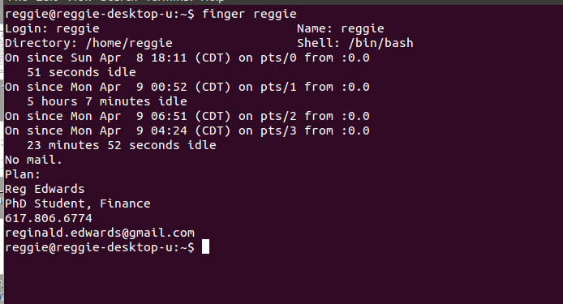
Problem 2: Basic Programming: Rabbits and Coyotes

(Code attached)

The initial values are those given in the problem satement.

