2018-02-09

Tengine

Performance Report

Reversion Record

|  |  |  |  |
| --- | --- | --- | --- |
| Date | Rev | Change Description | Author |
| 2018-02-09 | 0.4.0 | Test on ACL v17.12 | Huifang |
|  |  |  |  |
|  |  |  |  |

**catalog**

1 Purpose 3

1.1 Test Environment 3

2 Preparation 3

2.1 Other models 3

2.2 OpenCV path 4

3 Functionality Test 4

3.1 Network test 4

1.1.1 squeezenet 4

1.1.2 mobilenet 4

1.1.3 ResNet50 5

3.2 Application Demo Test 5

1.1.4 MTCNN 5

1.1.5 LightenCNN 5

3.3 Caffe Wrapper Test 6

1.1.6 Squeeznet 6

1.1.7 Mobilenet 6

1.1.8 MTCNN 7

3.4 Mxnet Serializer Test 7

1.1.9 squeezenet 7

1.1.10 mobilenet 7

4 Performance Test 8

4.1 Single A72 8

1.1.11 Squeezenet 8

1.1.12 Mobilenet 8

4.2 Two A72 9

1.1.13 Squeezenet 9

1.1.14 Mobilenet 9

4.3 Single A53 9

1.1.15 Squeezenet 9

1.1.16 Mobilenet 9

4.4 Four A53 10

1.1.17 Squeezenet 10

1.1.18 Mobilenet 10

# Purpose

This Report is tested on RK3399 platform and the Arm Compute Library is version 17.12. We did function testing and collected the performance data on SqueezeNet and MobileNet. Note that the performance data is on a different core.

## Test Environment

Hardware SoC: Rockchip RK3399

<http://www.t-firefly.com/product/rk3399.html>

* GPU: Mali T864 (800MHz)
* CPU: Dual-core Cortex-A72 up to 2.0GHz (real frequency is 1.8GHz); Quad-core Cortex-A53 up to 1.5GHz (real frequency is 1.4GHz) Operating System: Ubuntu 16.04

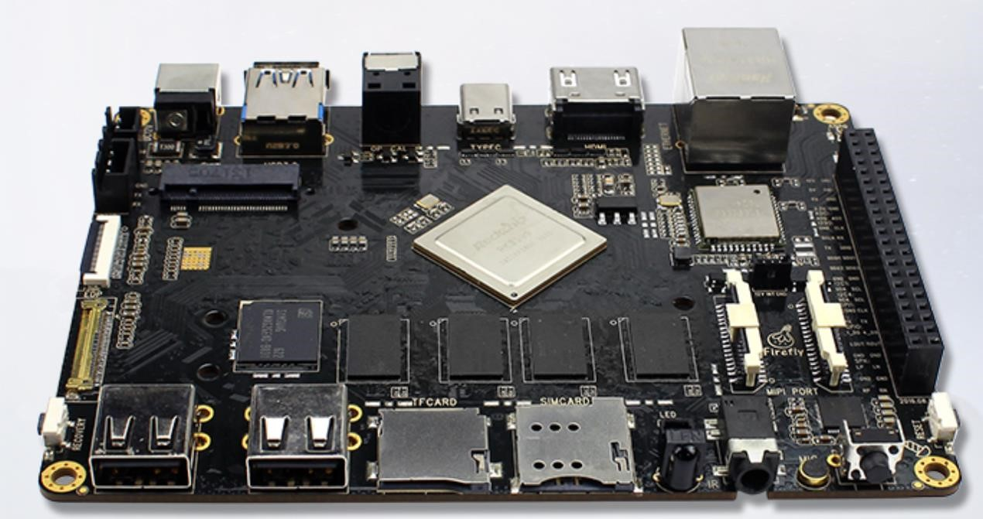

# Preparation

## Other models

When running examples, need some other models, you can get these from GitLab which is named Tengine_models.

<https://219.139.34.186/openailab/Tengine_models>

## OpenCV path

If you want to use the user-defined OpenCV during build **Tengine**, you need set an environment.

>export PKG_CONFIG_PATH=$ PKG_CONFIG_PATH:(opencv_path)/lib/pkgconfig If you want to use the user-defined OpenCV during build **examples**, you need set an environment.

>export CMAKE_PREFIX_PATH=(opencv_path)/share/OpenCV

# Functionality Test

## Network test

### squeezenet

Test Steps

> ./build/tests/bin/test_sqz

Validation

Should get output as below:

0.2763 - "n02123045 tabby, tabby cat"

0.2673 - "n02123159 tiger cat"

0.1766 - "n02119789 kit fox, Vulpes macrotis"

0.0827 - "n02124075 Egyptian cat"

0.0777 - "n02085620 Chihuahua"

### mobilenet

Test Steps

> ./build/tests/bin/test_mobilenet

Validation

Should get output as below:

8.5976 - "n02123159 tiger cat"

7.9550 - "n02119022 red fox, Vulpes vulpes"

7.8679 - "n02119789 kit fox, Vulpes macrotis"

7.4274 - "n02113023 Pembroke, Pembroke Welsh corgi"

6.3647 - "n02123045 tabby, tabby cat"

### ResNet50

Test Steps

>cd examples/resnet50 >cmake .

>make

> cp etc/config.example etc/config

>./RESNET ../../tests/data/cat.jpg ../../../Tengine_models/resnet50/

Validation

Should get output as below:

0.2339 - "n02124075 Egyptian cat"

0.1705 - "n02119022 red fox, Vulpes vulpes"

0.1669 - "n02113023 Pembroke, Pembroke Welsh corgi"

0.1269 - "n02123159 tiger cat"

0.0970 - "n02119789 kit fox, Vulpes macrotis"

## Application Demo Test

### MTCNN

Test step:

>cd tengine/examples/mtcnn/ >cmake .

>make

>cp etc/config.example etc/config

>. /MTCNN 4.jpg /home/rk/Tengine_models/mtcnn result4.jpg Should get different jpg as below:

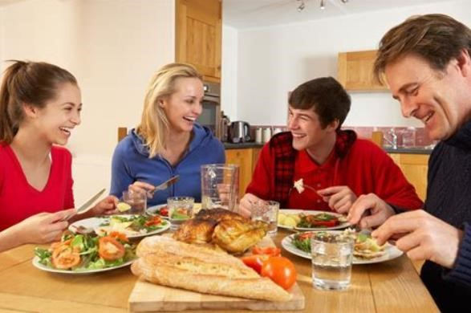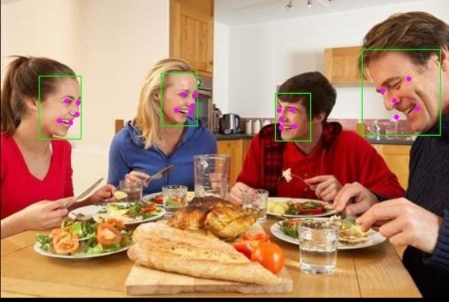

### LightenCNN

Test step:

>cd tengine

>./build/tests/bin/lighten_cnn

Should get output as below:

==================================== maxError is 0.000038

====================================

The value is max_error between pred_data and ground_truth_data.

## Caffe Wrapper Test

Build:

>cd examples/caffe_wrapper/cpp_classification >cmake .

>make

>cp etc/config.example etc/config

### Squeeznet

Test:

>. /classification ../../../tests/data/sqz.prototxt ../../../tests/data/squeezenet_v1.1.caffemod el ../../../tests/data/imagenet_mean.binaryproto ../../../tests/data/synset_words.txt ../../../ tests/data/cat.jpg

Should get output as below

0.2763 - "n02123045 tabby, tabby cat"

0.2673 - "n02123159 tiger cat"

0.1766 - "n02119789 kit fox, Vulpes macrotis"

0.0827 - "n02124075 Egyptian cat"

0.0777 - "n02085620 Chihuahua"

### Mobilenet

Test:

>./classification_mobilenet ../../../tests/data/mobilenet_deploy.prototxt ../../../tests/data/m obilenet.caffemodel ../../../tests/data/imagenet_mean.binaryproto ../../../tests/data/synset _words.txt ../../../tests/data/cat.jpg

Should get output as below:

8.5976 - "n02123159 tiger cat"

7.9550 - "n02119022 red fox, Vulpes vulpes"

7.8679 - "n02119789 kit fox, Vulpes macrotis"

7.4274 - "n02113023 Pembroke, Pembroke Welsh corgi"

6.3647 - "n02123045 tabby, tabby cat"

### MTCNN

Build:

>cd examples/caffe_wrapper/mtcnn >cmake .

>make

>cp etc/config.example etc/config Test:

> ./CAFFE_MTCNN ../../mtcnn/4.jpg /home/firefly/Tengine_models/mtcnn/ 4result.jpg Should get message: total detected: 4 faces

> ./CAFFE_MTCNN ../../mtcnn/6.jpg /home/firefly/Tengine_models/mtcnn/ 6result.jpg Should get message:

total detected: 6 faces

## Mxnet Serializer Test

### squeezenet

Test step:

>cd tengine

>./build/tests/bin/bench_sqz_mxnet #default run 100 times

Should get output as below:

0.2344 - "n02123045 tabby, tabby cat"

0.1864 - "n02119789 kit fox, Vulpes macrotis"

0.1474 - "n02120079 Arctic fox, white fox, Alopex lagopus"

0.1251 - "n02124075 Egyptian cat"

0.1087 - "n02123159 tiger cat"

### mobilenet

Test step:

> cd tengine

>./build/tests/bin/bench_mobilenet_mxnet #default run 100 times

Should get output as below:

|  |  |  |  |
| --- | --- | --- | --- |
| 8.0579 - "n02124075 Egyptian cat" | |  | |
| 7.9089 - "n02123159 tiger cat" |  |
| 7.8721 - "n02127052 lynx, catamount" | | |  |
| 7.6147 - "n02123045 tabby, tabby cat" | | |
| 7.0937 - "n02119789 kit fox, Vulpes macrotis" | | | |

# Performance Test

>sudo –s

>echo performance > /sys/devices/system/cpu/cpufreq/policy0/scaling_governor

>echo performance > /sys/devices/system/cpu/cpufreq/policy4/scaling_governor >cat /sys/devices/system/cpu/cpufreq/policy4/cpuinfo_cur_freq

1800000

>cat /sys/devices/system/cpu/cpufreq/policy0/cpuinfo_cur_freq

1416000

For looking the profile of each layer, we need set an enviroment variable >export PROF_TIME=1

## Single A72

### Squeezenet

Test step:

Update etc/config . device.default= cpu.rk3399.a72.0 # use position 0 of A72

> ./build/tests/bin/bench_sqz –r90 # loop run 100 , count will +10 interiorly

The avg time of per test case and each layer as below ,and the data in micro second us,

|  |  |  |  |  |  |
| --- | --- | --- | --- | --- | --- |
| Squeezenet | TPI | SoftMax | Convolution | Pooling | Concat |
| TimeElapse | 89453 | 70.1 | 84411 | 2406.62 | 2564.75 |
| Percentage | 100.00% | 0.08% | 94.36% | 2.69% | 2.87% |

### Mobilenet

Test step:

Update etc/config . device.default= cpu.rk3399.a72.0 # use position 0 of A72

> ./build/tests/bin/bench_mobilenet –r90 # loop run 100 , count will +10 interiorly

The avg time of per test case and each layer as below ,and the data in micro second us

|  |  |  |  |  |
| --- | --- | --- | --- | --- |
| Mobilenet | TPI | Pooling | Fused.BNScaleRelu | Convolution |
| TimeElapse | 119985 | 37.11 | 7990.78 | 111957.39 |
| Percentage | 100.00% | 0.03% | 6.66% | 93.31% |

## Two A72

### Squeezenet

Test step:

*Update etc/config .* ***device.default= cpu.rk3399.a72.all*** *# use all of A72*

*> ./build/tests/bin/bench_sqz –r90 # loop run 100 , count will +10 interiorly*

The avg time of **per** test case and each layer as below ,and the data in micro second **us**

|  |  |  |  |  |  |
| --- | --- | --- | --- | --- | --- |
| Squeezenet | TPI | SoftMax | Convolution | Pooling | Concat |
| TimeElapse | 54209 | 67.05 | 49039.39 | 2410.01 | 2692.25 |
| Percentage | 100.00% | 0.12% | 90.46% | 4.45% | 4.97% |

### Mobilenet

Test step:

Update etc/config . device.default= cpu.rk3399.a72.all # use all of A72

> ./build/tests/bin/bench_mobilenet –r90 #loop run 100, count will +10 interiorly

The avg time of per test case and each layer as below ,and the data in micro second us

|  |  |  |  |  |
| --- | --- | --- | --- | --- |
| Mobilenet | TPI | Pooling | Fused.BNScaleRelu | Convolution |
| TimeElapse | 75699 | 39.35 | 8210.26 | 67450.43 |
| Percentage | 100.00% | 0.05% | 10.85% | 89.10% |

## Single A53

### Squeezenet

Test step:

Update etc/config . device.default= cpu.rk3399.a53.2 # use posit2ion 2 of A53

> ./build/tests/bin/bench_sqz –r90 # loop run 100 , count will +10 interiorly

The avg time of per test case and each layer as below ,and the data in micro second us

|  |  |  |  |  |  |
| --- | --- | --- | --- | --- | --- |
| Squeezenet | TPI | SoftMax | Convolution | Pooling | Concat |
| TimeElapse | 231812 | 163.74 | 221378.26 | 5357.22 | 4912.6 |
| Percentage | 100% | 0.07% | 95.50% | 2.31% | 2.12% |

### Mobilenet

Test step:

Update etc/config . device.default= cpu.rk3399.a53.2 # use position 2 of A53

> ./build/tests/bin/bench_ mobilenet –r90 # loop run 100 , count will +10 interiorly The avg time of per test case and each layer as below ,and the data in micro second us

|  |  |  |  |  |
| --- | --- | --- | --- | --- |
| Mobilenet | TPI | Pooling | Fused.BNScaleRelu | Convolution |
| TimeElapse | 338560 | 133.71 | 26076.79 | 312349.97 |
| Percentage | 100% | 0.04% | 7.70% | 92.26% |

## Four A53

### Squeezenet

Test step:

Update etc/config . device.default= cpu.rk3399.a53.all # use all of A53

>./build/tests/bin/bench_sqz –r90 # loop run 100 , count will +10 interiorly

The avg time of per test case and each layer as below ,and the data in micro second us

|  |  |  |  |  |  |
| --- | --- | --- | --- | --- | --- |
| Squeezenet | TPI | SoftMax | Convolution | Pooling | Concat |
| TimeElapse | 91426 | 166.54 | 80903.79 | 5228.66 | 5126.79 |
| Percentage | 100.00% | 0.18% | 88.49% | 5.72% | 5.61% |

### Mobilenet

Test step:

Update etc/config . device.default= cpu.rk3399.a53.all # use all of A53

> ./build/tests/bin/bench_mobilenet –r90 #loop run 100

The avg time of per test case and each layer as below, and the data in micro second us,

|  |  |  |  |  |
| --- | --- | --- | --- | --- |
| Mobilenet | TPI | Pooling | Fused.BNScaleRelu | Convolution |
| TimeElapse | 137292 | 123.26 | 26286.55 | 110883.14 |
| Percentage | 100% | 0.09% | 19.15% | 80.76% |

**5. Notes:**

All items in the above tables are:

* TPI: The average total time for per inference within the whole loops.
* SoftMax: The average SoftMax time consumption for per inference within the whole loops.
* Convolution: The average Convolution time consumption for per inference within the whole loops.
* Pooling: The average Pooling time consumption for per inference within the whole loops.
* Dropout: The average Dropout time consumption for per inference within the whole loops.
* Concat: The average Concat time consumption for per inference within the whole loops.