重庆理工大学毕业设计（论文）

文 献 翻 译

学 院 (全称)
班 级 (写全)
学生姓名 学 号 (写全)

译 文 要 求
1、译文内容必须与课题（或专业）内容相关，并需注明详细出处。
2、外文翻译译文不少于2000字；外文参考资料阅读量至少3篇（相当于10万外文字符以上）。
3、译文原文（或复印件）应附在译文后备查。

译 文 评 阅
导师评语（应根据学校“译文要求”，对学生外文翻译的准确性、翻译数量以及译文的文字表述情况等作具体的评价）

（要求手写，封面为第一页，此页为第二页，不得改变格式。）

指导教师：
年 月 日
基于互联网 + 装修平台的分析与设计
0引言
随着社会的高速发展，人们的生活水平日益提高，同时，人们对高品质的物质生活越来越看重，而房子的装修方面就是其中的一类。针对寻找设计师、装修工人以及各类建材厂商困难，装饰方面不专业并难以匹配等繁琐流程问题，本文设计一款可以较好地解决这个问题的优质服务平台。
此项目采取客户+互联网+工人模式，搭建供应、需求的共享平台。它基于房地产行业，具有客户范围广、覆盖面大、需求量高、竞争力相对小等优势。该平台致力于将客户与工人、设计师和各种建材厂商联系起来，搜集客户提出的需求，然后平台把装修信息提供给设计师、工人和供应商，他们按需提供解决方案并以详细参数的形式提交给平台，平台在反馈给客户，进而方便客户更好的选择。这样，不仅能让客户很快选出自己比较满意的工人团队，打造出自己心中的美居室，而且还为客户提供了便捷、低廉的装修服务，为工人提供了工作机会。
1平台功能分析
1.1平台流程介绍
本平台的服务对象统称为客户。客户向平台提出需求后，平台向建材商（各种砖厂、水泥厂、家具商、电器商）、设计师以及工人（装修工、水电工、修筑工）收集信息，建材商（各种砖厂、水泥厂、家具商、电器商）、设计师以及工人（装修工、水电工、修筑工）提供平台，然后经过平台的筛选后将相应信息反馈给客户。
从用图一中可以看出，该平台包括四种角色：建材商、工人、客户、设计师。建材商包括各种砖厂、水泥厂、家具商、电器商。工人包括装修工、水电工、修筑工。客户可以先向平台提出需求，然后平台收集工人的信息，工人给平台提供建议，平台把信息反馈给客户。除此之外，客户还可以直接与工人进行交流商谈，自行达成协议。客户向平台提出需求，平台收集建材商的信息，建材商给平台提供建议，平台把信息反馈给客户。客户向平台提出需求，平台收集设计师的信息，设计师给平台提供建议后，平台将信息发送给客户。系统的工作流程如下图所示：
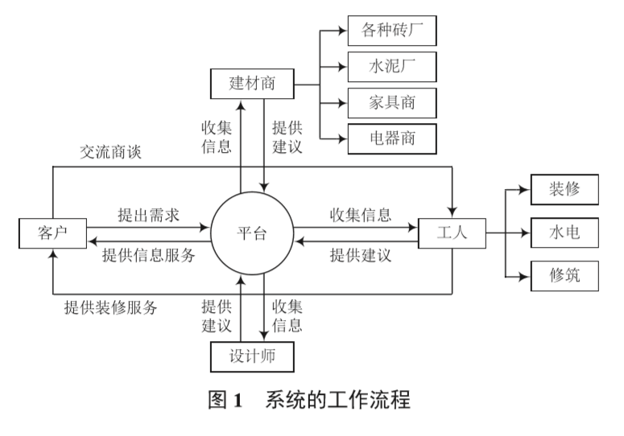
1.2平台需求分析
根据分析客户可能需要的要求，先设计出数据流图。客户向平台查询自己需要的信息，平台通过查询自身存储的信息，包括建材商信息、工人团队信息以及设计师信息，然后筛选出满足客户要求的信息反馈给客户，过程如图2所示：
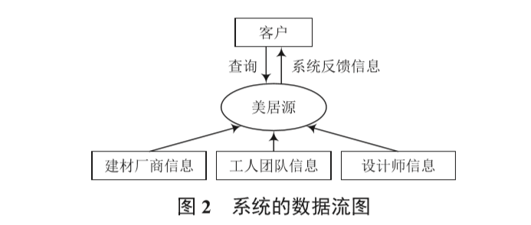
1.3平台功能设计
设计平台功能模块如图所示，系统总共包括装修案例、装修团队、建材厂商、设计师、关于我们、注册、登录7个模块。装修案例有查询装修案例信息，装修团队有查询装修团队信息，建材厂商有查询建材厂商信息，设计师有查询设计师信息。建材厂商有查询建材厂商信息，设计师有查询设计师信息。查询建材厂商信息包括查询水泥供应商、查询地板供应商、查询家居供应商、查询电器供应商。
2市场分析
2.1市场描述
这里的市场针对范围比较广泛，凡是需要买房、装修房，建筑房的人都是服务对象。但由于前期投入资金规模比较小，无法全方位的顾及全体，所以前期可能针对一些急需装修房子的人，而本平台正好符合他们的要求，而且这些服务所体现出来的价值更能吸引人，后期的话，随着规模的扩大，系统平台将会扩大服务力度。
2.2目标群体
平台的目标群体是每个需要设计、建筑、装修以及各大家具商、材料商的客户。市场需求基于房地产行业，客户范围广、覆盖面大、需求量高、竞争力相对小。装修客源主要以“80后”“90后”和“00后”互联网用户为主，工人团队以进城务工的农民工为主，设计师以公司设计师兼职为主。
2.3市场前景
许多首饰亦或家居设计等公司吸引人的地方在于好的创意，因此他们从来不会缺少顾客的来源。本文平台更广泛地将客户与各大建筑源联系起来，所体现出来的思想相信具有极大的优势，而且好的服务加上价格适中的条件会比较符合大部分人的心理需求以及消费能力，使得该平台具有较好的发展前景。
2.4未来发展空间
该系统致力于开拓更广阔的空间，所以将来的服务领域也会更加广泛。如将更多的商家与企业引入平台中、引入更多的优秀的工人团队等。
该系统已满足客户的一切创意需要为宗旨，为客户提供跟多的有效信息，在不断搜索中前进，追求更优质的服务，以满足客户不断增长的需求。
3结语
一个企业想要在市场中立于不败之地，就必须具有强大的创新创造能力，把低成本、高质量的产品快速交到客户在手中。在计算机技术和网络技术高速发展的当今社会，充分利用当前的信息技术来进行生产运作管理是企事业优先选择的策略，总之，基于互联网思维模式下的装修装饰体系的设计需要结合客户的实际需求，做好系统的优化设计，题号系统的性能。
原文：
Analysis and design based on Internet + decoration platform
0 Preface
With the rapid development of society, people's living standards are improving day by day. At the same time, people are paying more and more attention to high-quality material life, and the decoration of houses is one of them. Aiming at the cumbersome process problems of finding designers, decoration workers and various building material manufacturers, decoration is not professional and difficult to match, this article designs a high-quality service platform that can better solve this problem.
This project adopts the customer + Internet + worker model to build a sharing platform for supply and demand. Based on the real estate industry, it has the advantages of wide range of customers, large coverage, high demand, and relatively small competitiveness. The platform is committed to connecting customers with workers, designers and various building materials manufacturers, collecting the needs of customers, and then providing decoration information to designers, workers and suppliers, who provide solutions on demand and provide detailed parameters The form is submitted to the platform, and the platform is giving feedback to the customer, thus facilitating better choices. In this way, it not only allows customers to quickly select a team of workers they are more satisfied with and create their own beautiful bedroom, but also provides customers with convenient and low-cost decoration services and provides workers with job opportunities.
1 platform function analysis
1.1 Platform process introduction
The service objects of this platform are collectively referred to as customers. After customers put forward their needs to the platform, the platform collects information from building materials vendors (various brick factories, cement factories, furniture vendors, and electrical appliances vendors), designers, and workers (decorators, plumbers, and builders). Plants, cement plants, furniture dealers, electrical appliance dealers), designers and workers (decorators, plumbers, repairers) provide platforms, and then feedback the corresponding information to customers after screening by the platform.
As can be seen from Figure 1, the platform includes four roles: building materials dealers, workers, customers, and designers. Building materials dealers include various brick factories, cement factories, furniture dealers, and electrical appliances dealers. Workers include decorators, plumbers, and builders. Customers can first make demands to the platform, and then the platform collects workers’ information, the workers provide suggestions to the platform, and the platform feeds back the information to the customers. In addition, customers can also directly communicate with workers and reach agreements on their own. Customers put forward demands to the platform, the platform collects information from building materials vendors, the building materials vendors provide suggestions to the platform, and the platform feeds back the information to the customers. Customers put forward requirements to the platform, the platform collects information from the designer, and after the designer provides suggestions to the platform, the platform sends the information to the customer. The workflow of the system is shown in the figure below:
1.2 Platform demand analysis
According to the requirements of the analysis customer may need, first design the data flow diagram. Customers query the platform for the information they need. The platform queries its own stored information, including building material vendor information, worker team information, and designer information, and then filters out the information that meets the customer's requirements and feeds it back to the customer. The process is shown in Figure 2:

1.3 Platform function design
The functional modules of the design platform are shown in the figure. The system includes 7 modules including decoration case, decoration team, building material manufacturer, designer, about us, registration, and login. For decoration cases, you can query decoration case information, decoration teams can query decoration team information, building materials manufacturers can query building materials manufacturers information, and designers can query designer information. Building materials manufacturers have to inquire about building materials manufacturers, and designers have to inquire about designers. Querying building material manufacturer information includes querying cement suppliers, querying flooring suppliers, querying home furnishing suppliers, and querying electrical appliances suppliers.
2 market analysis
2.1 Market description
The market here has a wide range of targets. Anyone who needs to buy, renovate, or build houses is the target of services. However, due to the relatively small scale of investment in the early stage and the inability to fully consider the whole, the early stage may be aimed at some people who urgently need to renovate their houses, and this platform just meets their requirements, and the value reflected by these services is more attractive. As the scale expands, the system platform will expand its services.
2.2 Target group
The target group of the platform is every customer who needs design, construction, decoration and major furniture dealers and material dealers. The market demand is based on the real estate industry, with a wide range of customers, large coverage, high demand, and relatively small competitiveness. The decoration customers are mainly Internet users of "post-80s", "post-90s" and "post-00s". The worker team is mainly migrant workers who work in cities, and the designers are mainly part-time designers of the company.
2.3 Market Prospects
The attractiveness of many jewelry or home design companies is their good ideas, so they never lack a source of customers. The platform of this article connects customers with major architectural sources more widely. The ideas embodied are believed to have great advantages, and good service and moderate price conditions will be more in line with most people’s psychological needs and spending power. Makes the platform has a better development prospects.
2.4 Future development space
The system is committed to opening up a broader space, so the service areas in the future will be more extensive. Such as introducing more merchants and enterprises into the platform, introducing more outstanding worker teams, etc.
The system has met all the creative needs of customers as its purpose, provides customers with more effective information, advances in continuous search, pursues better services, and meets the growing needs of customers.
3 Conclusion
If an enterprise wants to be invincible in the market, it must have a strong ability to innovate and create, and quickly deliver low-cost, high-quality products to customers. In today’s society with the rapid development of computer technology and network technology, making full use of current information technology for production and operation management is the preferred strategy for enterprises and institutions. In short, the design of the decoration system based on the Internet thinking mode needs to be combined with the actual needs of customers , Do a good job in the optimization design of the system, and the performance of the question number system.

