导入相关的包
In [1]:
import numpy as np
import pandas as pd
import matplotlib.pyplot as plt
import seaborn as sns

读取数据并展示前五行
In [2]:
luohu_data = pd.read_csv('/home/kesci/input/beijing3313/bj_luohu.csv', index_col = 'id')
luohu_data.head(5)

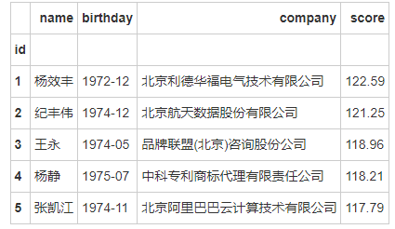

分析落户人数
接下来我们以公司进行聚类，统计每个公司的落户人数
In [3]:
company_data = luohu_data.groupby('company', as_index=False).count()[['company', 'name']]
#as_index ： bool，默认为True
#对于聚合输出，返回以组标签作为索引的对象。仅与DataFrame输入相关。as_index = False实际上是“SQL风格”的分组输出。
company_data.rename(columns={'name':'人数'}, inplace=True) # 替换 1
company_data.rename(columns={'company':'公司名'},inplace=True) # 替换 2
company_data.head(20)
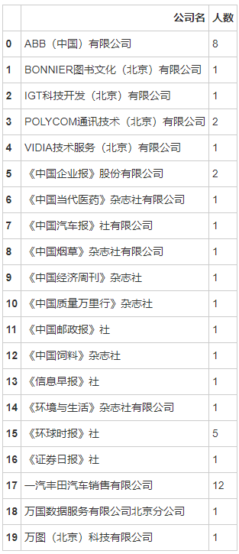
下面按照每个公司落户的人数进行降序排列，并且输出前15行
In [4]:
company_sorted_data = company_data.sort_values('人数', ascending=False)
company_sorted_data.head(15) # 前15
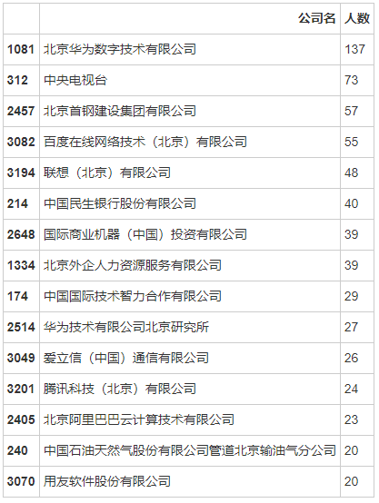
满眼科技公司，华为、百度、联想、爱立信、腾讯均在前15名，其次是一些国企央企垄断企业之类的。（第一列是表格行号，可忽略）

分析落户分数
下面将落户的分数进行分段统计
In [5]:
cut_bins = np.arange(90, 130, 5) #分段设置
bins = pd.cut(luohu_data['score'], cut_bins) # 将落户数据，按照cutbins来切一下
bin_counts = luohu_data['score'].groupby(bins).count()
bin_counts.head(10)
score
(90, 95] 3344
(95, 100] 1757
(100, 105] 653
(105, 110] 218
(110, 115] 32
(115, 120] 13
(120, 125] 2
Name: score, dtype: int64
可视化落户分数和人数的关系
In [6]:
plt.figure(figsize=(15,8))
plt.rcParams['font.family']='Arial Unicode MS'
plt.rcParams['axes.unicode_minus']=False
plt.rcParams['font.size']=12

x_name=['90-95','95-100','100-105','105-110','110-115','115-120','120-125']
sns.barplot(x_name,bin_counts)
plt.ylabel('人数')
plt.xlabel('分数区间')

for x, y in zip(range(7), bin_counts):
plt.text(x, y+20 , y, ha='center', va='bottom')

plt.show()
findfont: Font family ['Arial Unicode MS'] not found. Falling back to DejaVu Sans.
/opt/conda/lib/python3.6/site-packages/matplotlib/backends/backend_agg.py:211: RuntimeWarning: Glyph 20998 missing from current font.
font.set_text(s, 0.0, flags=flags)
/opt/conda/lib/python3.6/site-packages/matplotlib/backends/backend_agg.py:211: RuntimeWarning: Glyph 25968 missing from current font.
font.set_text(s, 0.0, flags=flags)
/opt/conda/lib/python3.6/site-packages/matplotlib/backends/backend_agg.py:211: RuntimeWarning: Glyph 21306 missing from current font.
font.set_text(s, 0.0, flags=flags)
/opt/conda/lib/python3.6/site-packages/matplotlib/backends/backend_agg.py:211: RuntimeWarning: Glyph 38388 missing from current font.
font.set_text(s, 0.0, flags=flags)
/opt/conda/lib/python3.6/site-packages/matplotlib/backends/backend_agg.py:180: RuntimeWarning: Glyph 20998 missing from current font.
font.set_text(s, 0, flags=flags)
/opt/conda/lib/python3.6/site-packages/matplotlib/backends/backend_agg.py:180: RuntimeWarning: Glyph 25968 missing from current font.
font.set_text(s, 0, flags=flags)
/opt/conda/lib/python3.6/site-packages/matplotlib/backends/backend_agg.py:180: RuntimeWarning: Glyph 21306 missing from current font.
font.set_text(s, 0, flags=flags)
/opt/conda/lib/python3.6/site-packages/matplotlib/backends/backend_agg.py:180: RuntimeWarning: Glyph 38388 missing from current font.
font.set_text(s, 0, flags=flags)
/opt/conda/lib/python3.6/site-packages/matplotlib/backends/backend_agg.py:211: RuntimeWarning: Glyph 20154 missing from current font.
font.set_text(s, 0.0, flags=flags)
/opt/conda/lib/python3.6/site-packages/matplotlib/backends/backend_agg.py:180: RuntimeWarning: Glyph 20154 missing from current font.
font.set_text(s, 0, flags=flags)
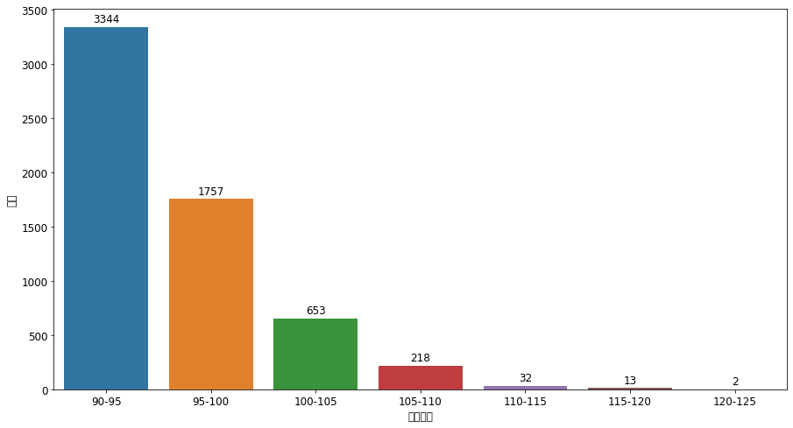
分析到此可以看到，落户人数主要集中在90-100分之间，合计5101人，如果想落户，达到95分就没什么问题了。

分析落户年龄
那么现在又有个问题，比如达到90分以上我都60了也没啥意义了，那么这些落户的主要集中在什么年龄段呢？年龄与积分有相关性吗？来看看。
首先根据生日算一下落户年龄
In [7]:
luohu_data['age'] = (pd.to_datetime('2018-07') - pd.to_datetime(luohu_data['birthday'])) / pd.Timedelta('365 days')
luohu_data.describe()
#luohu_data['score'].mean() >95
 | score | age
count | 6019.000000 | 6019.000000
mean | 95.654552 | 41.960493
std | 4.354445 | 2.814382
min | 90.750000 | 32.852055
25% | 92.330000 | 40.027397
50% | 94.460000 | 41.942466
75% | 97.750000 | 43.945205
max | 122.590000 | 60.041096
In [8]:
mean=luohu_data['age'].mean()
std =luohu_data['age'].std()

# 得到上下限
lower , upper =mean -3*std , mean+3*std

print('均值',mean)
print('标准差',std)
print('下限',lower)
print('上限',upper)
均值 41.96049314158134
标准差 2.814381679708812
下限 33.5173481024549
上限 50.40363818070777
In [9]:
#fig.set_size_inches(15,5) # 设置画布大小
sns.distplot(luohu_data['age'])
<matplotlib.axes._subplots.AxesSubplot at 0x7f5419d296d8>
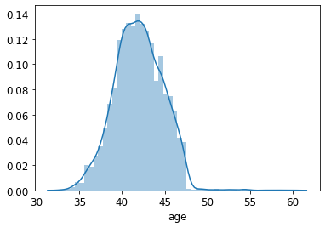
可以看到，最小的年龄也32岁了最大年龄60岁，75%分位数在43岁左右。年龄均值42岁。

总结：
拿户口年龄段集中在35岁到46岁之间，主要为42±2岁之间，分数集中在90分左右，行业集中在IT和国企央企及金融行业。准备想靠积分落户方式留北京的同学们，加油啦！

