/*对住宿表、学生表进行增加、删除、修改、查询操作*/

/*增加*/

/*住宿表*/

insert into Relationship values('221','20172044');

insert into Relationship values('222','20172258');

insert into Relationship values('223','20172277');

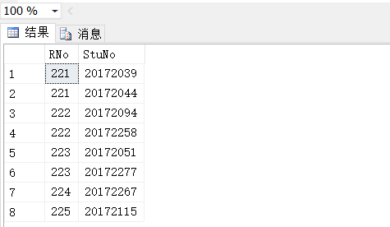

/*修改*/

/*修改学号为20172039的学生的住宿号*/

update Relationship set Rno='222' where StuNo='20172039';

/*修改学号为20172044的学生的住宿号*/

update Relationship set Rno='221' where StuNo='20172258';

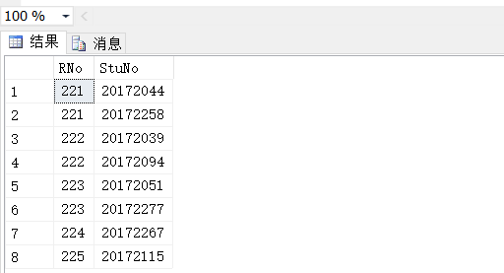

/*删除*/

/*从Relationship表中删除学号为20172115的学生的记录*/

delete from Relationship where stuno='20172115';

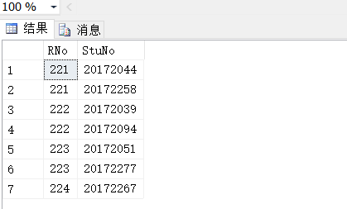

/*建立视图*/

/***（1）建立住宿学生学号、姓名、住宿号的视图***/

create view IS_Stu

As

select Relationship.StuNo,StuName,Rno

From Student,Relationship

Where Student.StuNo=Relationship.StuNo;

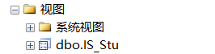

/*查询*/

/*查询视图*/

/*（1）查询住宿学生学号、姓名、住宿号的视图*/

select * from IS_S2

