SocioGoulash, is a mashup for getting updates from Google Buzz, Twitter and Various RSS feeds.

**How to Use SocioGoulash**

We have 4 Tabs Settings, My Buzz, My Tweets, My Feed.

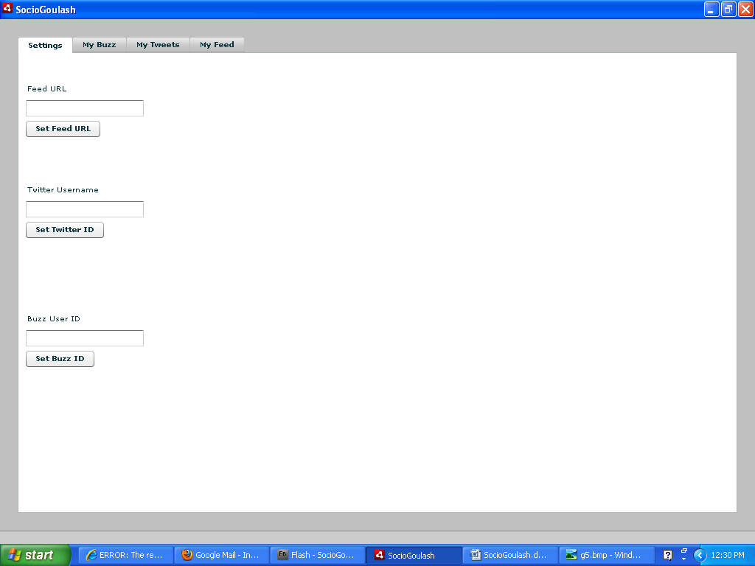

We have some default initial Ids and URLs for Buzz, Twitter and Feeds which can be changed using Settings Tab. Lets Start with Twitter First

**Twitter**

Write twitter username in second text field and click Set Twitter Id button. Now it will be your twitterId untill you change it again.

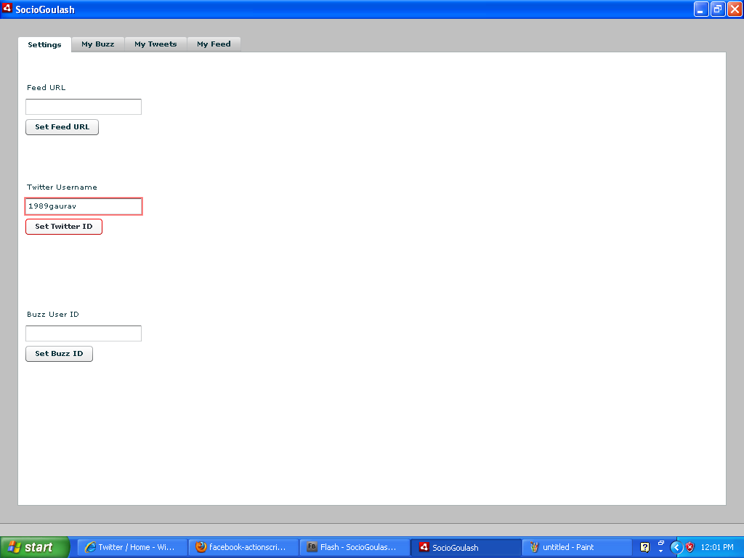

Click on the My Twitter Tab to see all the tweets :

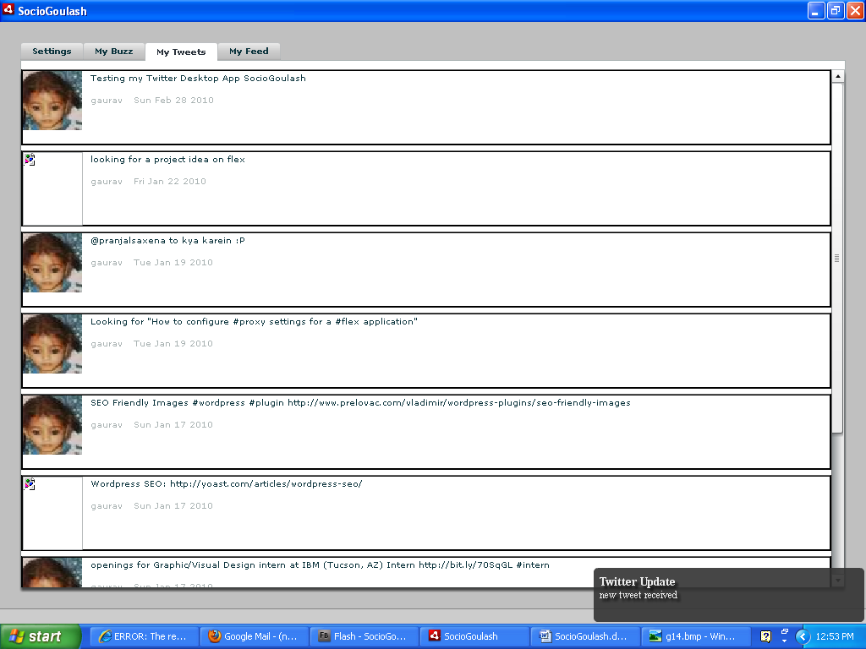

You will get all notification about any updates on Buzz, Twitter and Feed at bottom right corner as shown in this snap shot:

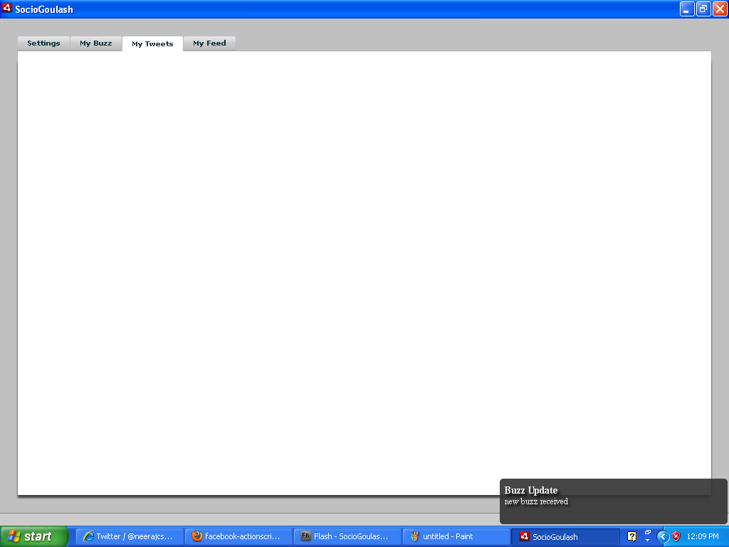

**Buzz** update received, so Lets check the My Buzz tab

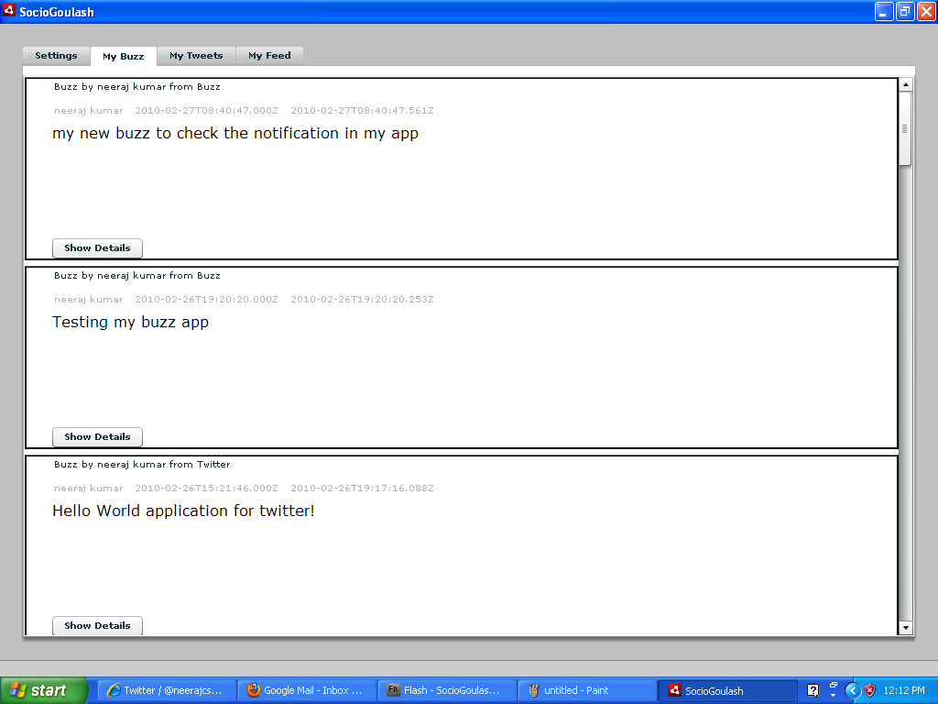

This was Buzz for default set Id, lets move to settings tab and change it

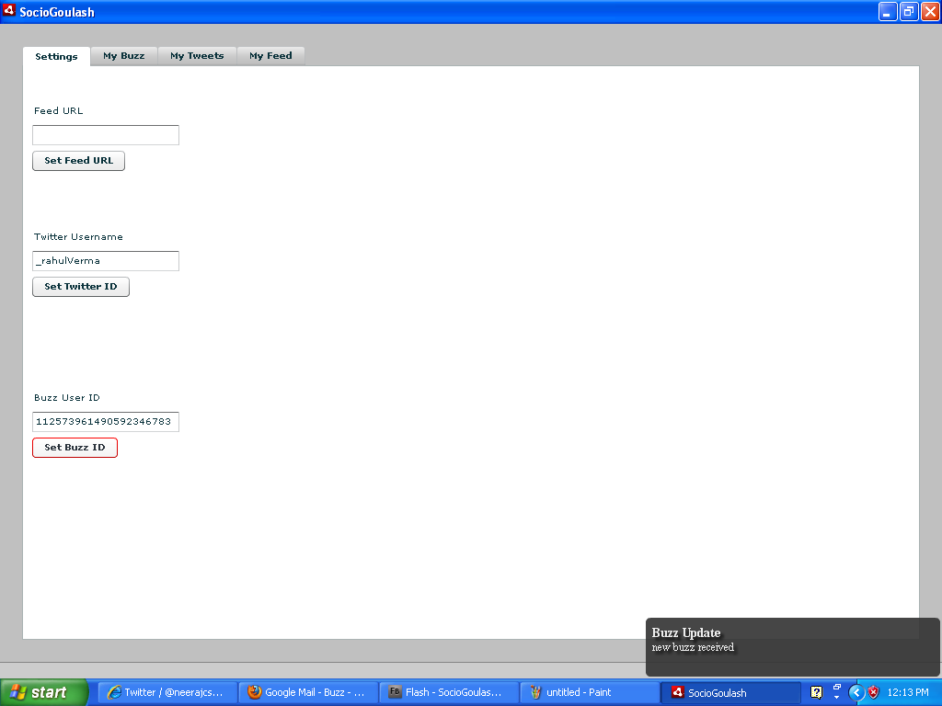

Now Move to My Buzz tab to see Buzz of gaurav gupta (112573961490592346783 ).

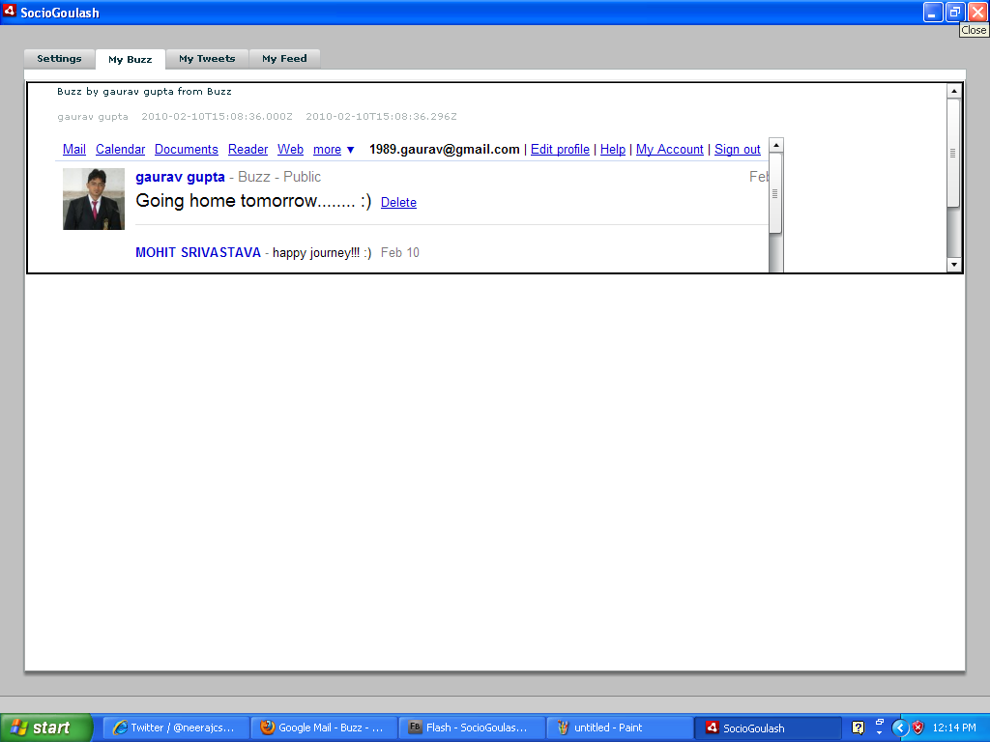

You can click on more details buttons for all comments received on you buzz.

Now to check If its getting new updates or not, Lets Start a new Buzz

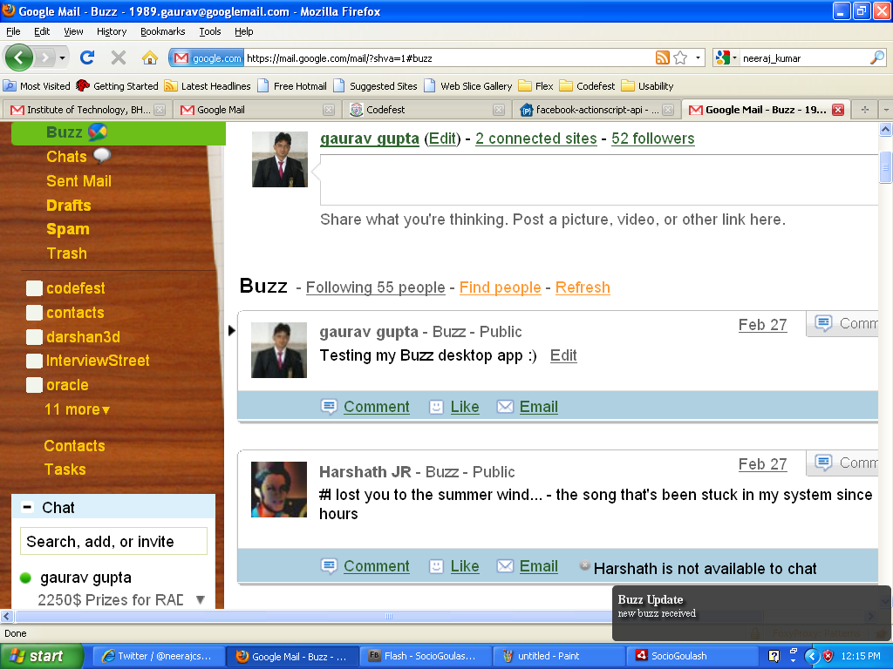

When SocioGoulash is minimized, then also it shows the notification that you have received a new buzz. Go to My Buzz tab in SocioGoulash to check new Buzz

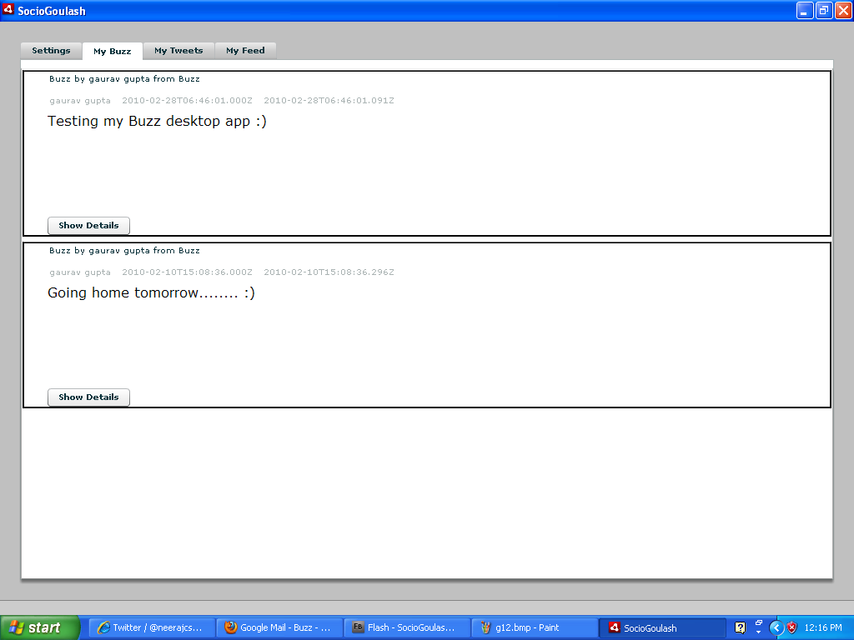

**Feeds**

Similary you can change Feed URL from settings tab. My Feeds tab look like

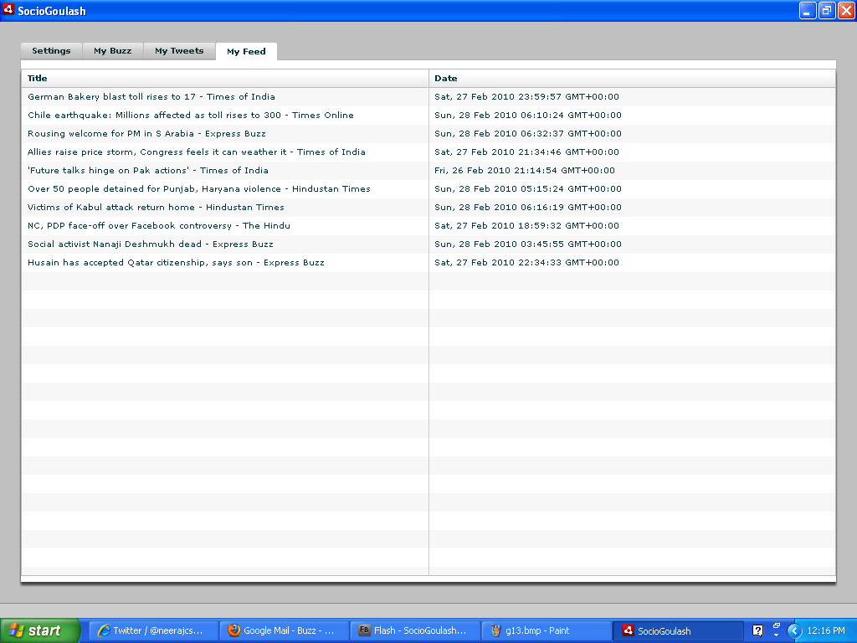

To get more details double click on respective news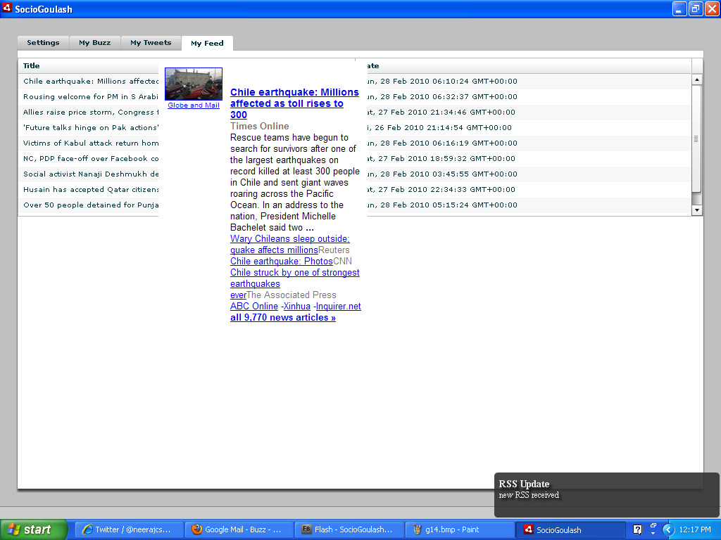

Team & Contact Details :

Present Address: 136, Vivekanand Hostel, ITBHU ,Varanasi-221005

DOB: 11/03/1988

Contact :09369031633, 08081775493  
College: ITBHU

Team Name:Titans

Team Members:

Neeraj Kumar 4th CSE ITBHU neeraj.kumar.cse06@itbhu.ac.in

Gaurav Gupta 4th CSE ITBHU gaurav.gupta.cse06@itbhu.ac.in