各param类型及文件说明

V1.0

北京睿海峰信系统集成有限公司

2018.9.26

目录

一、摘要 3

二、各列及列名解释 3

三、包括的step文件 3

1. 15个基本体step文件 3

2. 0926_DOOR.step 3

3. 0926_54106_001.step 6

# 一、摘要

本文件对“各param类型说明V1.0_0926.xlsx”及发送文件进行相应说明。

# 二、各列及列名解释

|  |  |
| --- | --- |
| 列名 | 解释 |
| Param_Type | 基本体的类型号。该号从1-92。 |
| Type | 基本体的类型描述。 |
| Abbrev1 | 基本体的名称(3-4个字符)，与quick parametric objects.pdf上的名称保持一致。 |
| 批次 | 按发邮件给一所和华科的日期来区分。 |
| FileName | 生成的Step的文件名。 |
| NO. | 基本体的参数个数。 |
| para1 | 第1个参数，与quick parametric objects.pdf上次序保持一致。 |
| para2 | 第2个参数。 |
| para3 | 第3个参数。 |
| para4 | 第4个参数。 |
| para5 | 第5个参数。 |
| para6 | 第6个参数。 |
| para7 | 第7个参数。 |
| para8 | 第8个参数。 |
| para9 | 第9个参数。 |

# 三、包括的step文件

## 15个基本体step文件

## 0926_DOOR.step

为门把手设备模型step文件，由此次支持的15个基本体不同参数及平移旋转后组成的组合模型step文件。

|  |  |  |
| --- | --- | --- |
| 类型 | 参数 | 3X4的位置矩阵 |
| Box | 0.005,0.065,0.165, | 0.000000 1.000000 0.000000 -1.000000 0.000000 0.000000 0.000000 0.000000 1.000000 -0.592500 0.342500 -0.082500 |
| Cylinder | 0.005,0.0325, | 0.000000 0.000000 -1.000000 -1.000000 0.000000 0.000000 0.000000 1.000000 0.000000 -0.592500 0.345000 0.049500 |
| Cylinder | 0.04,0.0195, | 0.000000 0.000000 -1.000000 -1.000000 0.000000 0.000000 0.000000 1.000000 0.000000 -0.592500 0.345000 -0.033000 |
| Cylinder | 0.08,0.0195, | 0.000000 1.000000 0.000000 0.000000 0.000000 1.000000 1.000000 0.000000 0.000000 -0.573000 0.404500 -0.033000 |
| Box | 0.005,0.065,0.165, | 0.000000 1.000000 0.000000 -1.000000 0.000000 0.000000 0.000000 0.000000 1.000000 -0.592500 0.307500 -0.08250 |
| Cylinder | 0.005,0.0325, | 0.000000 0.000000 -1.000000 -1.000000 0.000000 0.000000 0.000000 1.000000 0.000000 -0.592500 0.300000 0.04950 |
| Cylinder | 0.04,0.0195, | 0.000000 0.000000 -1.000000 -1.000000 0.000000 0.000000 0.000000 1.000000 0.000000 -0.592500 0.265000 -0.03300 |
| Elbow | 0.0195,0.0195,90.0002, | 1.000000 0.000000 0.000000 0.000000 1.000000 0.000000 0.000000 0.000000 1.000000 -0.592500 0.245500 -0.03300 |
| Cylinder | 0.08,0.0195, | 0.000000 1.000000 0.000000 0.000000 0.000000 -1.000000 -1.000000 0.000000 0.000000 -0.493000 0.245500 -0.033000 |
| Elbow | 0.0195,0.0195,-90.0002, | -1.000000 0.000000 0.000000 0.000000 -1.000000 0.000000 0.000000 0.000000 1.000000 -0.592500 0.404500 -0.03300 |

示意图(FORAN效果)—门把手

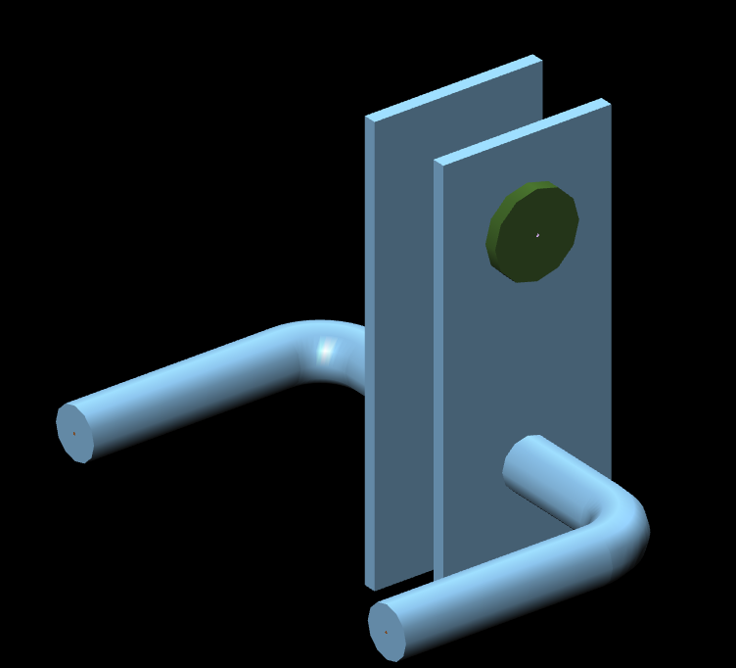

示意图 (OCC效果)—门把手

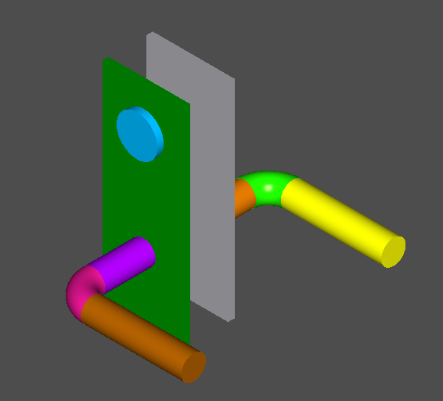

## 0926_54106_001.step

为54106-001模型step文件，由此次支持的15个基本体不同参数及平移旋转后组成的组合模型step文件。

|  |  |  |
| --- | --- | --- |
| 类型 | 参数 | 3X4的位置矩阵 |
| Box | 1.1,1.45,1.5 | 1.000000 0.000000 0.000000 0.000000 1.000000 0.000000 0.000000 0.000000 1.000000 0.550000 0.725000 0.000000 |
| Box | 0.3,0.2,0.15 | 1.000000 0.000000 0.000000 0.000000 1.000000 0.000000 0.000000 0.000000 1.000000 0.430000 1.310000 1.500000 |
| Box | 0.19,0.28,0.15 | 1.000000 0.000000 0.000000 0.000000 1.000000 0.000000 0.000000 0.000000 1.000000 0.652000 0.775000 1.500000 |
| Box | 0.19,0.28,0.15 | 1.000000 0.000000 0.000000 0.000000 1.000000 0.000000 0.000000 0.000000 1.000000 0.652000 0.275000 1.500000 |
| Box | 0.19,0.28,0.15 | 1.000000 0.000000 0.000000 0.000000 1.000000 0.000000 0.000000 0.000000 1.000000 0.259500 0.275000 1.500000 |
| Box | 0.2,0.3,0.15 | 1.000000 0.000000 0.000000 0.000000 1.000000 0.000000 0.000000 0.000000 1.000000 0.259500 0.775000 1.500000 |
| Elbow | 0.042,0.04,90 | -1.000000 0.000000 0.000000 0.000000 -1.000000 0.000000 0.000000 0.000000 1.000000 1.015170 1.550200 0.686730 |
| Nozzle | 0.61,0.032,0.14,0.042 | 0.000000 0.000000 1.000000 0.000000 1.000000 0.000000 -1.000000 0.000000 0.000000 0.975170 1.550200 0.686730 |
| Cylinder | 0.042,0.06 | 1.000000 0.000000 0.000000 0.000000 0.000000 -1.000000 0.000000 1.000000 0.000000 1.015000 1.450000 0.688000 |
| Nozzle | 0.61,0.032,0.14,0.042 | 0.000000 0.000000 1.000000 0.000000 1.000000 0.000000 -1.000000 0.000000 0.000000 0.975170 1.550200 0.386730 |
| Elbow | 0.042,0.04,90 | -1.000000 0.000000 0.000000 0.000000 -1.000000 0.000000 0.000000 0.000000 1.000000 1.015170 1.550200 0.386730 |
| Cylinder | 0.042,0.06 | 1.000000 0.000000 0.000000 0.000000 0.000000 -1.000000 0.000000 1.000000 0.000000 1.015000 1.450000 0.388000 |
| Nozzle | 0.096,0.032,0.115,0.03 | 1.000000 0.000000 0.000000 0.000000 0.000000 -1.000000 0.000000 1.000000 0.000000 1.015000 1.450000 0.217000 |
| Nozzle | 0.096,0.032,0.115,0.03 | 1.000000 0.000000 0.000000 0.000000 0.000000 -1.000000 0.000000 1.000000 0.000000 0.550000 1.450000 0.064000 |

示意图(FORAN效果)—54106_001

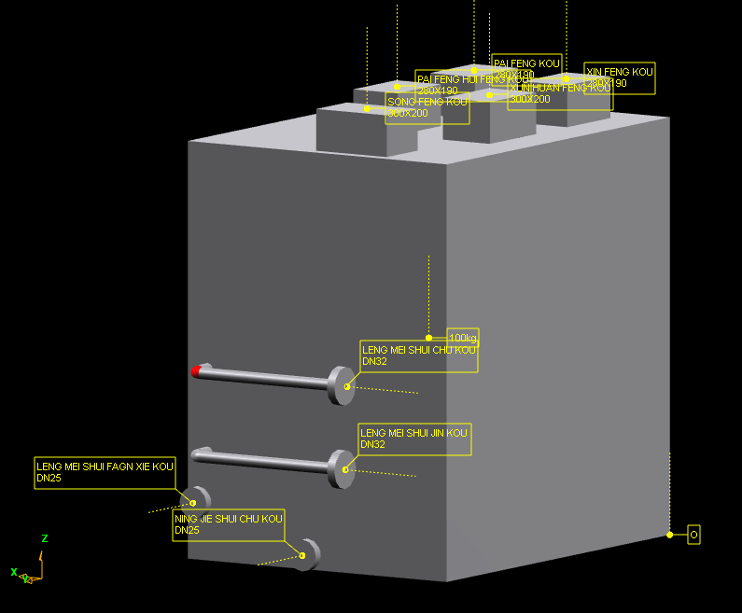

示意图 (OCC效果)—54106_001

