By

Gaurav Dhiman

https://github.com/1991991/Book-sales-Prediction-analysis

**Regression Analysis:-**

This is a graph of percent purchased against price.

Percent purchased- Y axis – Dependent variable

Price- X axis – Independent variable

Perform a power regression to determine the predicted % column for each price

|  |  |  |  |
| --- | --- | --- | --- |
| **Price (X)** | **Purchased % (Y)** | **Predicted %** | **Predicted Sales** |
| 7.00 | 80% | 63% | 634 |
| 8.00 | 60% | 48% | 476 |
| 9.00 | 45% | 37% | 370 |
| 10.00 | 35% | 30% | 295 |
| 11.00 | 30% | 24% | 241 |
| 12.00 | 20% | 20% | 200 |
| 11.00 | 14% | 24% | 241 |
| 14.00 | 15% | 14% | 144 |
| 15.00 | 11% | 12% | 124 |
| 16.00 | 10% | 11% | 108 |
| 17.00 | 8% | 9% | 95 |
| 16.00 | 7% | 11% | 108 |
| 19.00 | 6% | 7% | 75 |
| 20.00 | 6% | 7% | 67 |
| 22.00 | 5% | 5% | 55 |
| 24.00 | 5% | 5% | 45 |
| 23.00 | 5% | 5% | 50 |
| 28.00 | 4% | 3% | 33 |
| 30.00 | 4% | 3% | 28 |
| 29.00 | 4% | 3% | 30 |
| 20.00 | 4% | 7% | 67 |

**Equation Calculated:** y = 40.78x-2.14

R2is the statistical measure of how close the data is fit to the regression line. It is also called coefficient of determination. It is the percentage of response variable variation that is explained by a model.

* 0 percent indicated none of the variability of response data
* 100 percent indicates all the variability of response data

In this model R squared is 0.921 which means the power regression curve can explain 92.1% of the predicted values.

Assuming there are 1000 customers who visit your website and the publisher cost is 6.0, estimate the number of books sold (predicted sales column) for each price point

* 1. Calculate the revenue column (price * predicted sales)
  2. Calculate the profit column ((price – book cost) * predicted sales)
  3. Use conditional formatting to highlight the profit values for all prices

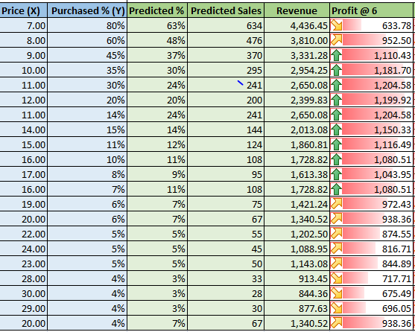

Optimization analysis (with constraints)

* 1. Calculate the price point for the highest profit possible
     1. The publisher will sell the books to you at 6.50 each with no minimum order (10%)
     2. The publisher has agreed to sell you the books at 6.25 each if you sell at least 30,000 (10%)

To solve these questions, we prepare a table for calculating Predicted Sales and profit by entering different values of price. The formulas for profit and sales are taken from Q.1.

So Predicted Sales = [14.344*(Price^-1.88)]*100000 and Profit = (Price – Book cost)*Predicted Sales.