Lin Hua, Liu Ruohan, Lovallo Nicholas M, Maniago Nathaniel P
Professor Gao
Intermediate Accounting II
26 September 2026

- Financial Liabilities Overview
Exxon Mobil Corporation (XOM) has several financing-related liabilities, including short-term debt, the current portion of long-term debt, long-term debt and lease liabilities. Based on the financial data from Chartmill, XOM reported $3.06 billion of short-term debt, $6.24 billion of the current portion of long-term debt and $34.35 billion of long-term debt in 2025. These items provide a basis for evaluating the company’s debt structure and changes in financing over time, so they are financing-related liabilities.

Short-term debt covers borrowings due in the near term. And the current portion of long-term debt represents long-term borrowings that are scheduled to mature within the next year. In XOM’s 2025 Form 10-K, the company reported $9.296 billion of notes and loans payable and $34.241 billion of long-term debt. The notes and loans payable included bank loans, commercial paper and $6.234 billion of long-term debt due within one year. Although the numbers are not exactly the same, the difference can be explained. For example, the short-term and current portion of long-term debt from Chartmill add up to approximately the amount of notes and loans payable reported in the 10-K. The numbers are not the same also because they used slightly different data classification methods.

XOM also has lease liabilities, including operating and finance lease liabilities. These obligations arise from leases for assets such as drilling equipment, tankers, office buildings, railcars and other equipment. In 2024, XOM reported $6.478 billion of operating lease liabilities and $2.361 billion of finance lease liabilities in 10-K Note 13. And in 2025, XOM reported $6.834 billion of operating lease liabilities and $2.659 billion of finance lease liabilities in 10-K Note 13. Some lease liabilities are reported within other balance-sheet accounts, including accounts payable and accrued liabilities, notes and loans payable, long-term debt and other long-term obligations. But lease liabilities cannot be added to total debt because some of them are already included in accounts such as long-term debt. Not adding them to total debt is to avoid double counting.

The table below compares XOM’s debt structure for 2024 and 2025. The short-term portion includes short-term debt and the current portion of long-term debt, while the long-term portion consists of long-term debt.

 | 2024 | 2025
Short-term portion | $4.955B | $9.296B
Long-term portion | $36.755B | $34.241B
Total debt | $41.710B | $43.537B
The table also shows that the short-term portion was higher in 2025, while the long-term portion was lower. However, long-term debt was still larger than short-term debt in both years. (Data from XOM’s 2025 Form 10-K).

- Analysis of Debt Changes
From 2024 to 2025, ExxonMobil’s total debt increased slightly from $41.710 billion to $43.537 billion, an increase of approximately $1.827 billion, or 4.4%. However, the debt structure also changed. The short-term portion increased from $4.955 billion to $9.296 billion, while the long-term portion decreased from $36.755 billion to $34.241 billion. This shows that a larger portion of ExxonMobil’s debt was classified as short-term in 2025.
One reason for this change is that some long-term debt was approaching maturity. In 2025, approximately $6.234 billion of long-term debt was due within one year and was therefore classified as a current liability. ExxonMobil also had short-term borrowings, including commercial paper and bank loans. These items contributed to the increase in short-term obligations. At the same time, the noncurrent portion of long-term debt decreased.
Overall, ExxonMobil did not experience a dramatic increase in total debt. Instead, an important part of the change reflects the timing and classification of debt, as some obligations moved closer to maturity. Therefore, the main change was not only the amount of debt, but also the shift in the debt structure toward more short-term obligations.
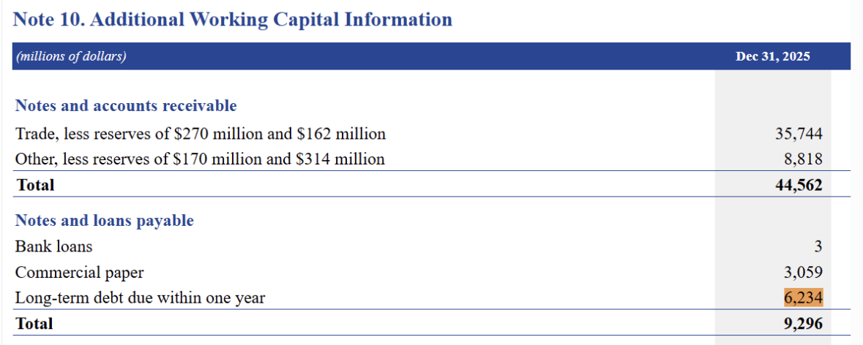

- Credit Risk and Ratios
Moody’s: Aa2 | S&P: AA-

**Numbers derived from 2025 10-K Report

Funds from Operations (FFO) / Total Debt
- FFO ((NI+D+A+PSL)−PSG−II) / 43,537 = ((28,844 + 25,993) - 603) / 43,537 = 1.2457
Debt / EBITDA [NI+Int+T+D+A]
- 43,537 / (28,844 + 603 + 11,504 + 25,993) = 0.6503
What do these ratios suggest about the company’s ability to repay debt
- These ratios suggest that ExxonMobil is capable of paying off its debt due to the influx of income being greater than its debt, since both ratios show that debt is being outweighed by “raw” earnings and the flow of funding from its operations alone.

- Compare your findings with investment-grade vs. speculative-grade firms
Our FFO/Total debt ratios, along with Debt/EBITDA, fall within the correct ranges for AA-rated bonds. They are some of the safest types of bonds. A 0.65x Debt-to-EBITDA ratio indicates the company is not highly leveraged, and it would take less than a year for Exxon to pay off all its debt (not adjusting for interest, taxes, or changing oil prices, etc.). For a good comparison, speculative-grade firms operate at a 3-4x multiple, meaning it takes multiple years to pay off all debts. Exxon has a big debt cushion and an extremely low chance of default if you bought one of its corporate bonds.

- Evaluate if the credit ratings seem consistent with the financial ratios, and explain why or why not
While the credit ratings are semi-consistent, with AA ratings, with an FFO multiple of 1.25 and a Debt to EBITDA far below 1 at 0.65, Exxon could potentially qualify for AAA ratings. Unfortunately, bond rating companies do take business and economic risk into account when deciding bond ratings, and not just final numbers. Oil is a volatile commodity, and geopolitical factors such as current world events in the Middle East can drastically shift oil prices. Due to these volatile price shifts, Exxon can’t be AAA-rated and must stay at AA. Given that factor, I believe an AA rating is fair.

