[Playwright (TypeScript / JavaScript) Notes - Google Docs](https://docs.google.com/document/d/1O5NSFhHGc9icU3rfERSolAhLUxy2NxyiujsztN3ICL8/edit?tab=t.0)

**Playwright Installation Ways**

1. Using Playwright Extension
2. Using command npm – init Playwright@latest

**Using Playwright Extension**

Add below extension in vs code

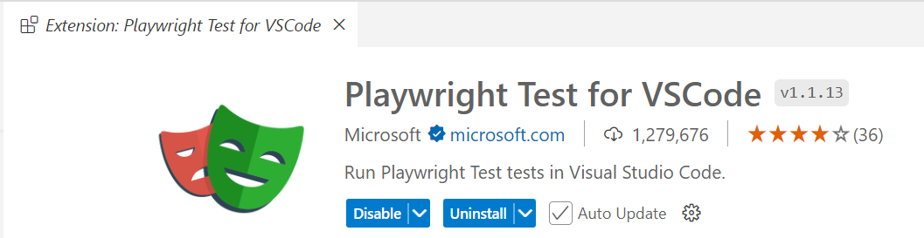

Playwright Test for VS Code

This extension integrates Playwright into your VS Code workflow. Here is what it can do:

* [Playwright Test for VS Code](vscode-webview://01mcvlqvf9dg3meh5iur8cas7j1p57klvhls0seecj0j1g2c1d28/index.html?id=530bd14d-5da5-469a-8af4-3c2719e61dd2&origin=ff5be2a0-1edc-49f9-8c10-0e893c02c6be&swVersion=4&extensionId=&platform=electron&vscode-resource-base-authority=vscode-resource.vscode-cdn.net&parentOrigin=vscode-file%3A%2F%2Fvscode-app&disableServiceWorker=true#playwright-test-for-vs-code)
  + [Requirements](vscode-webview://01mcvlqvf9dg3meh5iur8cas7j1p57klvhls0seecj0j1g2c1d28/index.html?id=530bd14d-5da5-469a-8af4-3c2719e61dd2&origin=ff5be2a0-1edc-49f9-8c10-0e893c02c6be&swVersion=4&extensionId=&platform=electron&vscode-resource-base-authority=vscode-resource.vscode-cdn.net&parentOrigin=vscode-file%3A%2F%2Fvscode-app&disableServiceWorker=true#requirements)
  + [Install Playwright](vscode-webview://01mcvlqvf9dg3meh5iur8cas7j1p57klvhls0seecj0j1g2c1d28/index.html?id=530bd14d-5da5-469a-8af4-3c2719e61dd2&origin=ff5be2a0-1edc-49f9-8c10-0e893c02c6be&swVersion=4&extensionId=&platform=electron&vscode-resource-base-authority=vscode-resource.vscode-cdn.net&parentOrigin=vscode-file%3A%2F%2Fvscode-app&disableServiceWorker=true#install-playwright)
  + [Run tests with a single click](vscode-webview://01mcvlqvf9dg3meh5iur8cas7j1p57klvhls0seecj0j1g2c1d28/index.html?id=530bd14d-5da5-469a-8af4-3c2719e61dd2&origin=ff5be2a0-1edc-49f9-8c10-0e893c02c6be&swVersion=4&extensionId=&platform=electron&vscode-resource-base-authority=vscode-resource.vscode-cdn.net&parentOrigin=vscode-file%3A%2F%2Fvscode-app&disableServiceWorker=true#run-tests-with-a-single-click)
  + [Run multiple tests](vscode-webview://01mcvlqvf9dg3meh5iur8cas7j1p57klvhls0seecj0j1g2c1d28/index.html?id=530bd14d-5da5-469a-8af4-3c2719e61dd2&origin=ff5be2a0-1edc-49f9-8c10-0e893c02c6be&swVersion=4&extensionId=&platform=electron&vscode-resource-base-authority=vscode-resource.vscode-cdn.net&parentOrigin=vscode-file%3A%2F%2Fvscode-app&disableServiceWorker=true#run-multiple-tests)
  + [Run tests in watch mode](vscode-webview://01mcvlqvf9dg3meh5iur8cas7j1p57klvhls0seecj0j1g2c1d28/index.html?id=530bd14d-5da5-469a-8af4-3c2719e61dd2&origin=ff5be2a0-1edc-49f9-8c10-0e893c02c6be&swVersion=4&extensionId=&platform=electron&vscode-resource-base-authority=vscode-resource.vscode-cdn.net&parentOrigin=vscode-file%3A%2F%2Fvscode-app&disableServiceWorker=true#run-tests-in-watch-mode)
  + [Show browsers](vscode-webview://01mcvlqvf9dg3meh5iur8cas7j1p57klvhls0seecj0j1g2c1d28/index.html?id=530bd14d-5da5-469a-8af4-3c2719e61dd2&origin=ff5be2a0-1edc-49f9-8c10-0e893c02c6be&swVersion=4&extensionId=&platform=electron&vscode-resource-base-authority=vscode-resource.vscode-cdn.net&parentOrigin=vscode-file%3A%2F%2Fvscode-app&disableServiceWorker=true#show-browsers)
  + [Show trace viewer](vscode-webview://01mcvlqvf9dg3meh5iur8cas7j1p57klvhls0seecj0j1g2c1d28/index.html?id=530bd14d-5da5-469a-8af4-3c2719e61dd2&origin=ff5be2a0-1edc-49f9-8c10-0e893c02c6be&swVersion=4&extensionId=&platform=electron&vscode-resource-base-authority=vscode-resource.vscode-cdn.net&parentOrigin=vscode-file%3A%2F%2Fvscode-app&disableServiceWorker=true#show-trace-viewer)
  + [Pick locators](vscode-webview://01mcvlqvf9dg3meh5iur8cas7j1p57klvhls0seecj0j1g2c1d28/index.html?id=530bd14d-5da5-469a-8af4-3c2719e61dd2&origin=ff5be2a0-1edc-49f9-8c10-0e893c02c6be&swVersion=4&extensionId=&platform=electron&vscode-resource-base-authority=vscode-resource.vscode-cdn.net&parentOrigin=vscode-file%3A%2F%2Fvscode-app&disableServiceWorker=true#pick-locators)
  + [Debug step-by-step, explore locators](vscode-webview://01mcvlqvf9dg3meh5iur8cas7j1p57klvhls0seecj0j1g2c1d28/index.html?id=530bd14d-5da5-469a-8af4-3c2719e61dd2&origin=ff5be2a0-1edc-49f9-8c10-0e893c02c6be&swVersion=4&extensionId=&platform=electron&vscode-resource-base-authority=vscode-resource.vscode-cdn.net&parentOrigin=vscode-file%3A%2F%2Fvscode-app&disableServiceWorker=true#debug-step-by-step-explore-locators)
  + [Tune locators](vscode-webview://01mcvlqvf9dg3meh5iur8cas7j1p57klvhls0seecj0j1g2c1d28/index.html?id=530bd14d-5da5-469a-8af4-3c2719e61dd2&origin=ff5be2a0-1edc-49f9-8c10-0e893c02c6be&swVersion=4&extensionId=&platform=electron&vscode-resource-base-authority=vscode-resource.vscode-cdn.net&parentOrigin=vscode-file%3A%2F%2Fvscode-app&disableServiceWorker=true#tune-locators)
  + [Record new tests](vscode-webview://01mcvlqvf9dg3meh5iur8cas7j1p57klvhls0seecj0j1g2c1d28/index.html?id=530bd14d-5da5-469a-8af4-3c2719e61dd2&origin=ff5be2a0-1edc-49f9-8c10-0e893c02c6be&swVersion=4&extensionId=&platform=electron&vscode-resource-base-authority=vscode-resource.vscode-cdn.net&parentOrigin=vscode-file%3A%2F%2Fvscode-app&disableServiceWorker=true#record-new-tests)
  + [Record at cursor](vscode-webview://01mcvlqvf9dg3meh5iur8cas7j1p57klvhls0seecj0j1g2c1d28/index.html?id=530bd14d-5da5-469a-8af4-3c2719e61dd2&origin=ff5be2a0-1edc-49f9-8c10-0e893c02c6be&swVersion=4&extensionId=&platform=electron&vscode-resource-base-authority=vscode-resource.vscode-cdn.net&parentOrigin=vscode-file%3A%2F%2Fvscode-app&disableServiceWorker=true#record-at-cursor)

**How to Search in VS Code Command Palette**

1. **Open Command Palette**
   * Press **Ctrl + Shift + P** (Windows/Linux)
   * Press **Cmd + Shift + P** (Mac)
2. **Type your search**
   * In the command palette, type **"install playwright"** or **"Playwright"** to find the relevant options.
3. **Execute the command**
   * Select the correct command from the dropdown.

Press Ctrl + Shift + P

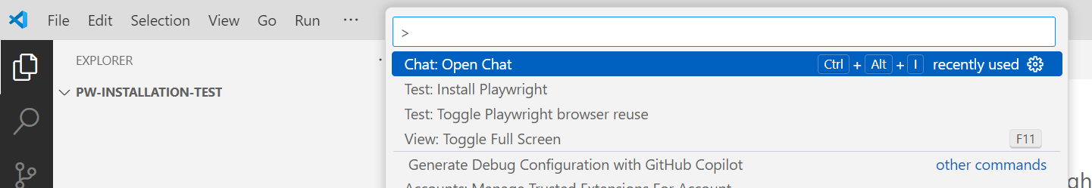

Select Install Playwright and u will get below options [select all browsers and github acions workflows if you want it]

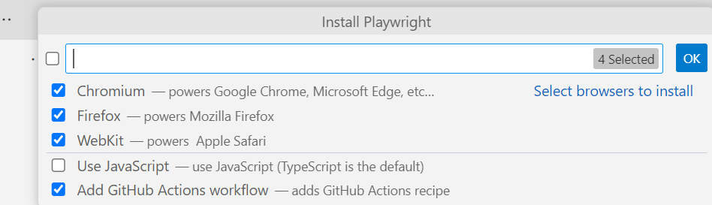

Once selected then click on “Ok”

And then installation will start in selected folder and pw directories will be created and below folder structure will be created in your vs code

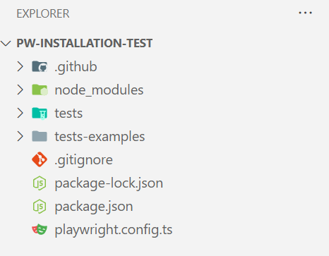

**Using command npm – init Playwright@latest**

**Installing Playwright**[**​**](https://playwright.dev/docs/intro#installing-playwright)

Get started by installing Playwright using npm, yarn or pnpm. Alternatively you can also get started and run your tests using the [VS Code Extension](https://playwright.dev/docs/getting-started-vscode).

Installing playwright via npm command - npm init playwright@latest

Run the install command and select the following to get started:

* Choose between TypeScript or JavaScript (default is TypeScript)
* Name of your Tests folder (default is tests or e2e if you already have a tests folder in your project)
* Add a GitHub Actions workflow to easily run tests on CI
* Install Playwright browsers (default is true)

**Whats Installed**

Playwright will download the browsers needed as well as create the following files.

playwright.config.ts  
package.json  
package-lock.json  
tests/  
 example.spec.ts  
tests-examples/  
 demo-todo-app.spec.ts

The [playwright.config](https://playwright.dev/docs/test-configuration) is where you can add configuration for Playwright including modifying which browsers you would like to run Playwright on. If you are running tests inside an already existing project then dependencies will be added directly to your package.json.

The tests folder contains a basic example test to help you get started with testing. For a more detailed example check out the tests-examples folder which contains tests written to test a todo app.

**Running Example Test**

By default tests will be run on all 3 browsers, Chromium, Firefox and WebKit using 3 workers. This can be configured in the [playwright.config file](https://playwright.dev/docs/test-configuration). Tests are run in headless mode meaning no browser will open up when running the tests. Results of the tests and test logs will be shown in the terminal.

Npm command to run tests – npx playwright test

**HTML Test Reports**

After your test completes, an [HTML Reporter](https://playwright.dev/docs/test-reporters#html-reporter) will be generated, which shows you a full report of your tests allowing you to filter the report by browsers, passed tests, failed tests, skipped tests and flaky tests. You can click on each test and explore the test's errors as well as each step of the test. By default, the HTML report is opened automatically if some of the tests failed

Npm command to open reports – npx playwright show-report

**Running the example test in UI Mode**

Run your tests with [UI Mode](https://playwright.dev/docs/test-ui-mode) for a better developer experience with time travel debugging, watch mode and more.

Npm command - npx playwright test –ui

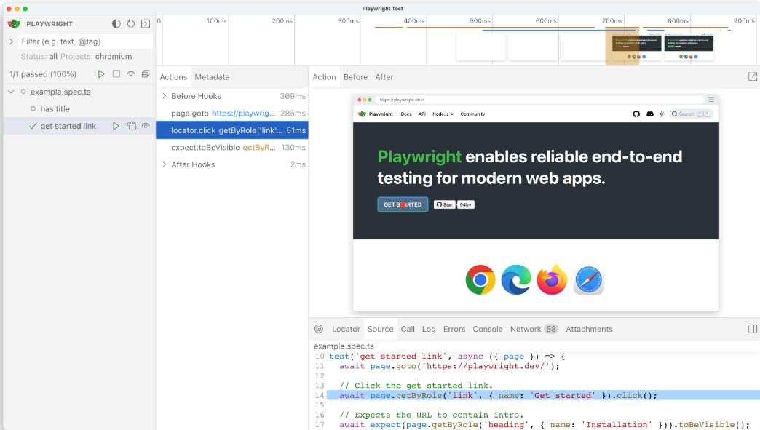

**Updating Playwright**

To update Playwright to the latest version run the following command:

npm install -D @playwright/test@latest

# Also download new browser binaries and their dependencies:

npx playwright install --with-deps

You can always check which version of Playwright you have by running the following command - npx playwright –version

**System requirements**[**​**](https://playwright.dev/docs/intro#system-requirements)

* Latest version of Node.js 18, 20 or 22.
* Windows 10+, Windows Server 2016+ or Windows Subsystem for Linux (WSL).
* macOS 13 Ventura, or later.
* Debian 12, Ubuntu 22.04, Ubuntu 24.04, on x86-64 and arm64 architecture.

**Some Important Commands**

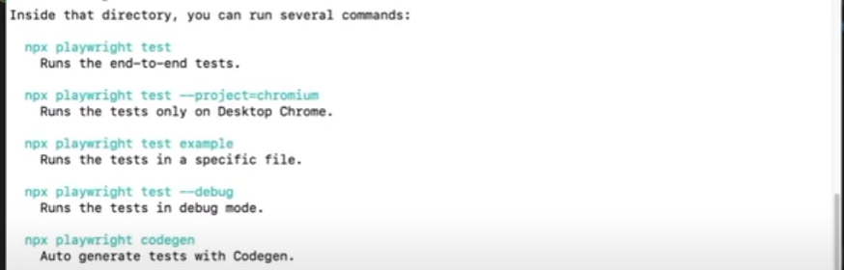

**Package.json file** – suppose you want to upgrade your playwright version or you want to add any additional dependencies while working with your project then modify this file and add the

additional dependencies here.

**Playwright.config.js** – its heart of playwright .