**what are the attributes test annotation provides in Playwright?**

In Playwright Test (@playwright/test), the **test** function is used to define test cases. The test object provides several attributes or **modifiers** that can be used to annotate or customize the behavior of your test cases. These attributes help you define **focus**, **skipping**, **conditional execution**, **retry logic**, **tags**, and more.

Here are the common attributes that test provides:

**1. test.describe()**

* **Purpose**: Groups related tests together.
* **Usage**: It is useful to organize multiple test cases logically. describe helps in running related tests together and providing structure to your test suite.
* **Example**:

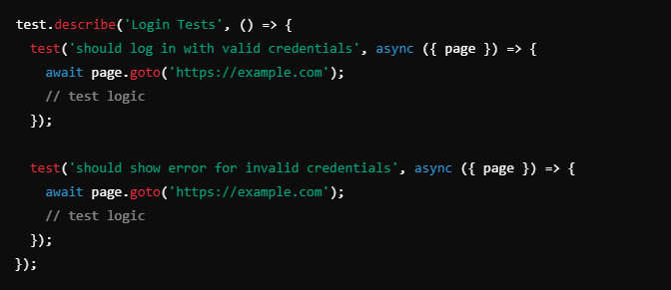

**2. test.beforeEach() and test.afterEach()**

* **Purpose**: Runs code before or after each test within a describe block or globally.
* **Usage**: Used to set up or tear down preconditions, such as logging in, creating data, or clearing cookies.
* **Example**:

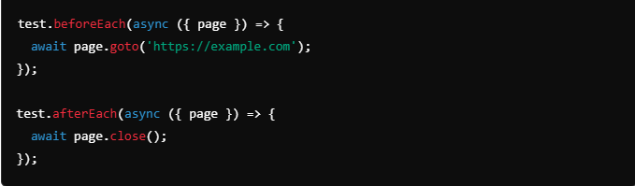

**3. test.beforeAll() and test.afterAll()**

* **Purpose**: Runs code before or after all tests within a describe block or globally.
* **Usage**: Useful for initializing things once, like opening a database connection, setting up a mock server, or launching a browser.
* **Example**:

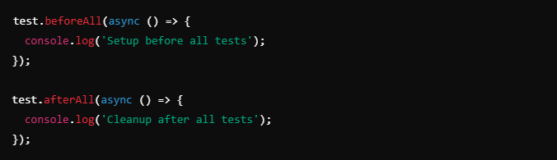

**4. test.only()**

* **Purpose**: Marks a test or describe block as the **only** one that should run.
* **Usage**: Useful for debugging, when you want to run only a specific test without running the entire suite.
* **Example**:

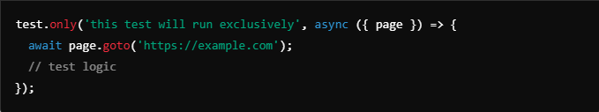

**5. test.skip()**

* **Purpose**: Skips a particular test or describe block.
* **Usage**: Useful for marking tests that are not ready to run yet or should be skipped temporarily.
* **Example**:

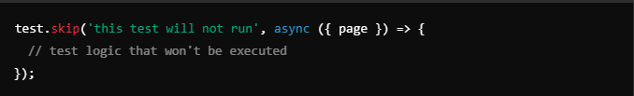

**6. test.fixme()**

* **Purpose**: Marks a test as not yet implemented or broken.
* **Usage**: Similar to test.skip(), but serves as a reminder that a particular test needs fixing or implementation.
* **Example**:

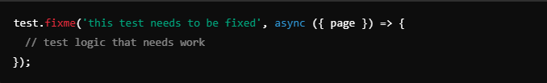

**7. test.slow()**

* **Purpose**: Marks a test as **slow** and increases the timeout.
* **Usage**: Useful for tests that take a longer time due to the nature of the actions being performed (e.g., file uploads, animations).
* **Example**:

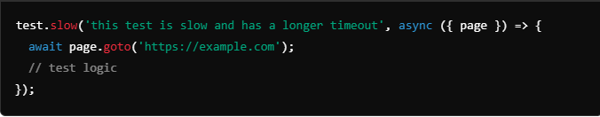

**8. test.setTimeout()**

* **Purpose**: Sets the timeout for a specific test or describe block.
* **Usage**: If a test requires more time than the default (usually 30 seconds), you can extend the timeout for that test.
* **Example**:

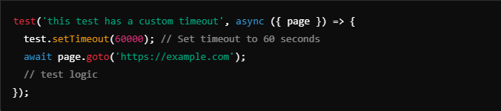

**9. test.retry()**

* **Purpose**: Specifies the number of times a particular test should be retried on failure.
* **Usage**: This is helpful for flaky tests that may intermittently fail.
* **Example**:

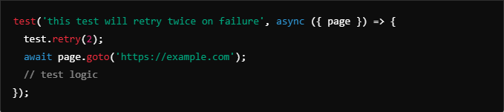

**10. test.use()**

* **Purpose**: Allows using a specific configuration for a particular test.
* **Usage**: You can override settings such as viewport, browser, baseURL, etc., on a per-test basis.
* **Example**:

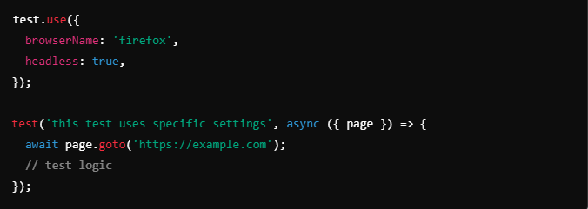

**11. test.step()**

* **Purpose**: Wraps test actions inside named steps to generate more readable traces and reports.
* **Usage**: Useful to break the test logic into logical steps that help debug a failed test trace.
* **Example**:

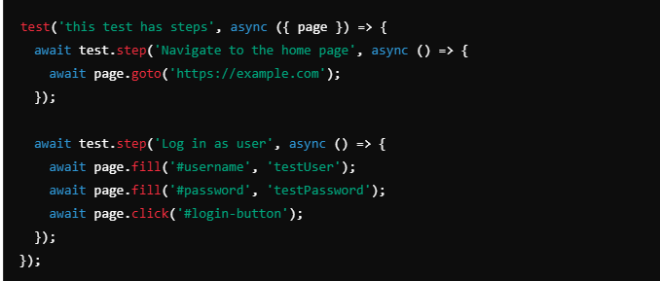

**Summary of Attributes**

