**What is a Browser Context?**

Think of a **Browser Context** as a separate, isolated session in the browser. In Playwright, a single browser instance can have multiple **browser contexts**, and each **context** behaves like a completely separate browser.

It’s similar to opening multiple browser windows in incognito or private mode—each one is isolated from the others.

**Key Points of Browser Context:**

1. **Isolation**: Each browser context is independent. That means:
   * Cookies, session storage, and local storage are not shared across contexts.
   * If you login in one context, it won’t be visible in another context.
2. **Multiple Pages within a Context**: You can create multiple **pages** inside a single **browser context**. All pages created under the same context **do share** cookies, storage, and sessions.

In summary:

* **Different Browser Contexts** are **completely isolated** from each other.
* **Pages within the same Browser Context** share **cookies, storage, and sessions**.

**Example to Understand Browser Contexts and Pages**

**Scenario 1: Using Different Browser Contexts**

Imagine you need to test two different user accounts (User A and User B) accessing the same website at the same time. You want to ensure their data stays separate. Here's how you can do it with Browser Contexts:

**Scenario 1: Different Browser Contexts for Different Users**

In this scenario, we'll create two different browser contexts to simulate two independent users (User A and User B) logging in.

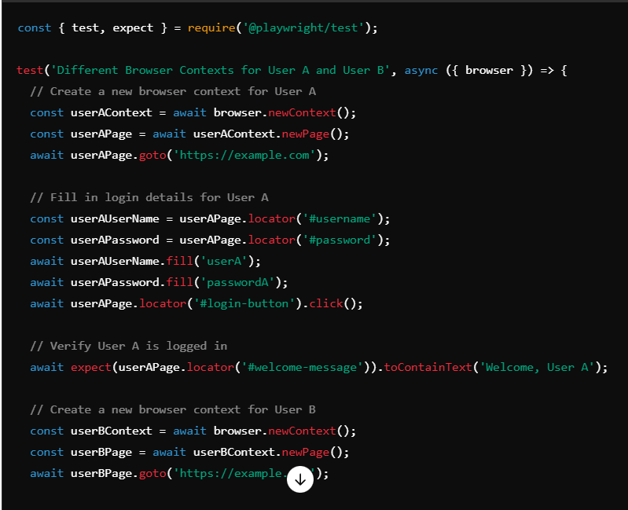

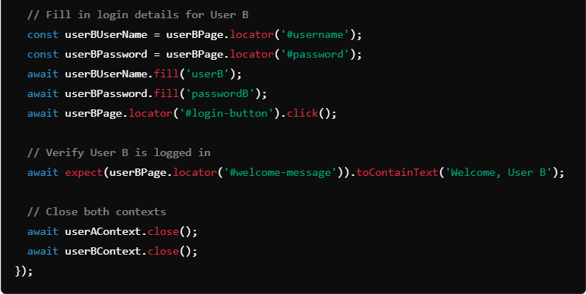

**Explanation:**

* **User A and User B** each get their own browser context, ensuring complete isolation.
* Both users can log in without any interference with each other’s session or cookies.
* **userAContext** and **userBContext** are separate, meaning the login state or cookies of one does not affect the other.

**Scenario 2: Multiple Pages within the Same Browser Context**

In this scenario, we'll create a single browser context and then create two pages within that context to simulate multiple tabs being opened by the same user.

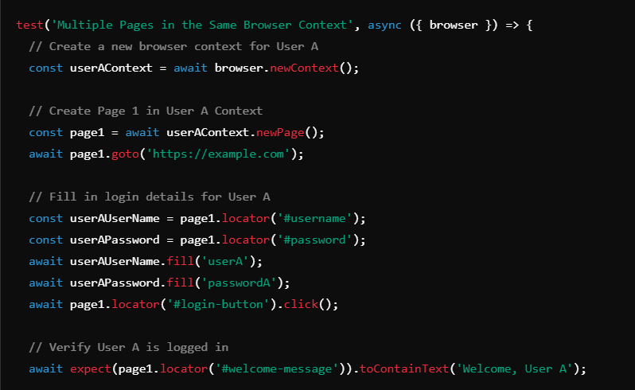

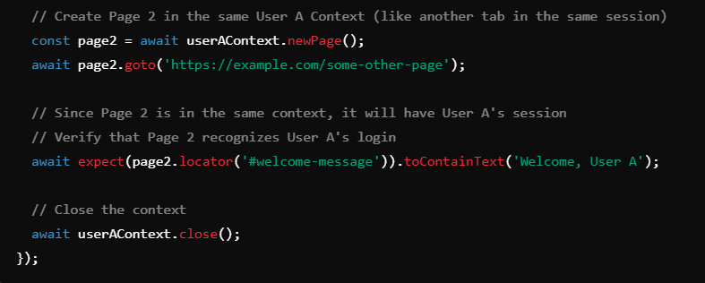

**Explanation:**

* **userAContext** is created for User A.
* **page1** is used to log in as User A.
* **page2** is created in the same context, and because they share the context, **page2** automatically has access to the session information (cookies, storage, etc.) from **page1**.
* This setup is similar to having multiple tabs open for the same logged-in user.

**Summary:**

1. **Different Browser Contexts**:
   * Different browser contexts create **completely isolated sessions**.
   * Use different contexts for simulating **different users**.
2. **Multiple Pages in the Same Browser Context**:
   * Pages within the same context **share cookies, sessions, and local storage**.
   * Useful for simulating **multiple tabs** for the same user.