In **Playwright**, the method **page.waitForLoadState()** is used to **wait until a certain page load state** is reached. It helps to ensure that the page has loaded to a desired state before further actions are performed, thus avoiding potential **flaky tests** due to elements not being ready. The "networkidle" is one of the possible states you can wait for.

**Explanation of page.waitForLoadState("networkidle")**

* **page.waitForLoadState("networkidle")** waits until there are **no network requests for at least 500ms**.
* This is useful for ensuring that a **page** has completed all network activity, including **loading external resources** like images, JavaScript, and CSS, and the **page is idle**.
* It is typically used to verify that the page has fully loaded and is in a steady state before interacting with it.

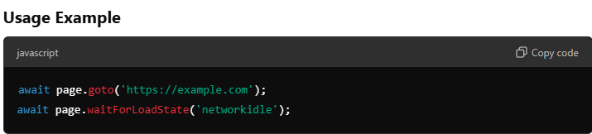

In this code, Playwright will:

1. **Navigate** to the specified URL.
2. **Wait** until there are no network requests in progress (i.e., until the page is completely idle) before continuing.

This helps ensure that the page is ready to be interacted with, reducing the chance of **timing issues** in the script.

**Load States that You Can Pass to waitForLoadState()**

There are **four main load states** you can pass to page.waitForLoadState():

1. **"load"**:
   * Waits until the **load event** is fired.
   * The load event is fired when the **document** and **all resources** (e.g., images, scripts) are completely loaded.



1. **"domcontentloaded"**:
   * Waits until the **DOMContentLoaded event** is fired.
   * This means the initial **HTML document** has been completely loaded and parsed, but **stylesheets** and **images** may still be loading.



1. **"networkidle"**:
   * Waits until there are **no network connections** for at least **500 ms**.
   * Useful to wait for **background network activity** to settle down.



1. **"commit"** (This is the default state if no argument is provided):
   * Waits for the **navigation to be committed** (meaning that the server has responded with a page, and it's in the process of loading).



**Summary of Load States**

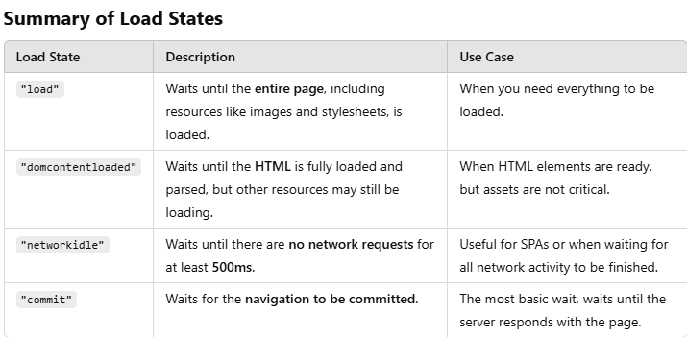

**Choosing the Right Load State**

* Use **"load"** when you want to ensure everything has been **completely loaded**, including **images and CSS**.
* Use **"domcontentloaded"** when you only care about the HTML being parsed, but other resources can be loaded later.
* Use **"networkidle"** for **Single Page Applications (SPAs)** or complex pages where you need to ensure that **all network requests** are completed before proceeding.
* Use **"commit"** for a **quick check** that a navigation has started.

**Example Scenario**

Consider testing a shopping cart feature:

* After navigating to the **product page**, you might use await page.waitForLoadState("domcontentloaded") to start interacting with elements as soon as the HTML is ready.
* Before checking the cart, you could use await page.waitForLoadState("networkidle") to ensure that all background API calls are complete and the page is stable.

**Summary for Interviews**

* The **page.waitForLoadState()** method helps ensure that a page reaches a particular **loading state** before further actions are taken.
* You can pass "load", "domcontentloaded", "networkidle", and "commit" as parameters to wait for different stages of the **page loading lifecycle**.
* Use **"networkidle"** for complex pages or SPAs to ensure all network activity is completed.
* Understanding when to use each state is crucial for **avoiding flakiness** in automation scripts.

This understanding is valuable for interview questions about **page load handling** and **flakiness reduction** in automated UI testing.

**Can we increase time from 500ms to 10 secs in networkidle?**

No, the **networkidle** load state in Playwright is a predefined condition that waits until **there are no network connections for at least 500 milliseconds**. This **500 ms duration is not configurable**, as it is an internal parameter used by Playwright to determine when the network is idle.

However, you can achieve similar functionality by adding a custom **wait** after the page reaches the "networkidle" state, allowing more time for any other background processes to settle. Here's how you can do it:

**Alternative Approach to Wait for 10 Seconds After Network Is Idle**

You can wait for the "networkidle" state and then add a custom delay using page.waitForTimeout(), like this:

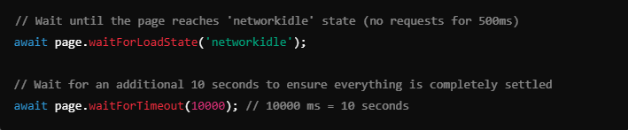

In this approach:

* The page first waits until there are **no network requests for 500 ms**.
* Then, it **waits for an additional 10 seconds** to make sure everything has completely loaded.

**Why Can't We Directly Configure the 500 ms?**

* The **networkidle** parameter is used internally by Playwright as a **heuristic** to determine if the network activity has ceased, and it uses a default wait time of **500 ms**.
* This is part of the Playwright library's **design** and cannot be directly configured.

If you have a use case that requires more than just a **network idle** state and you need a longer delay, the best approach is to use a combination of **waitForLoadState()** and **manual wait**, as shown above.

**Summary**

* The **500 ms** for "networkidle" is **not configurable** in Playwright.
* You can add a **manual wait** using page.waitForTimeout() to extend the waiting time if needed.
* This approach helps you wait for **more than just network activity**, ensuring everything is stable before proceeding.

This kind of wait can be useful if you're dealing with **complex UI interactions** or **Single Page Applications (SPAs)** where certain background processes might take longer to settle.