1) Requirement / Problem Statement
What we need
A single, reusable logger for our Playwright API framework that:
- Shows every step clearly
  - info/debug go to STDOUT (separate console stream).
  - warn/error go to STDERR so problems stand out in CI.
- Highlights issues
  - warn/error are colored and always visible (independent of debug noise).
- Is reused everywhere
  - Only one shared instance per worker process (no duplicate loggers).
  - Works across multiple workers in parallel and stays consistent.
Must-haves (acceptance criteria)
- Levels: error, warn, info, debug.
- Output split:
  - info, debug → STDOUT
  - warn, error → STDERR
- Visibility control: LOG_LEVEL env var gates logs (error ⟶ debug).
- Run correlation: Every line includes a RUN_ID (same for all workers in one run).
- Worker traceability: Each line shows PID (so parallel workers are distinguishable).
- Singleton per worker: Importing logger anywhere returns the same instance in that worker.
- No setup surprises: If RUN_ID isn’t provided, it’s auto-generated in globalSetup.
Nice-to-haves (not required for v1)
- Optional JSON output mode for log shippers.
- Context tagging (e.g., test name, module).
- File sink/rotation (we start console-only).
Non-goals
- No external logging libraries (keep tiny, zero-dep).
- No persistent storage or remote transport.
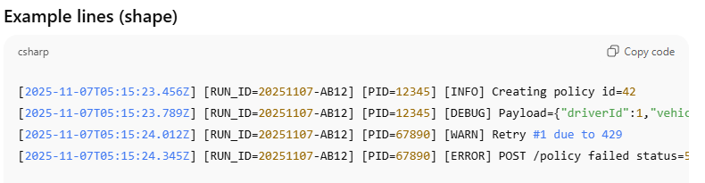
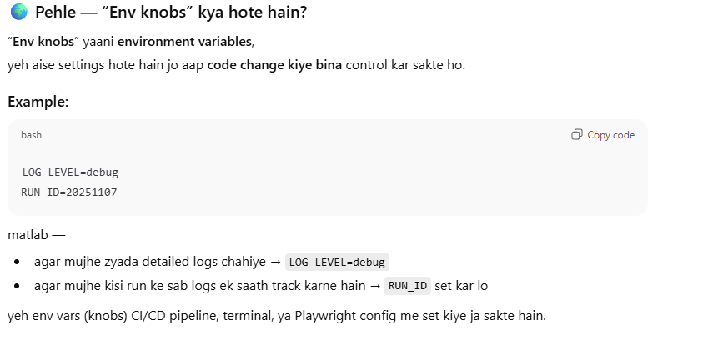
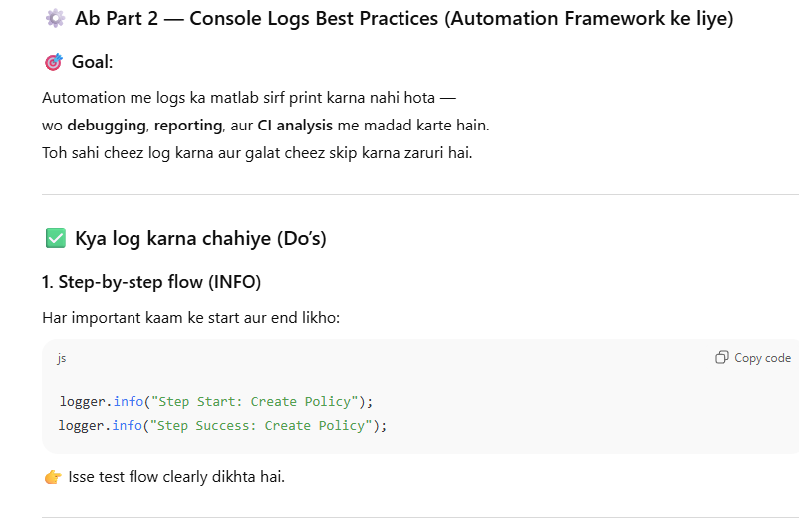
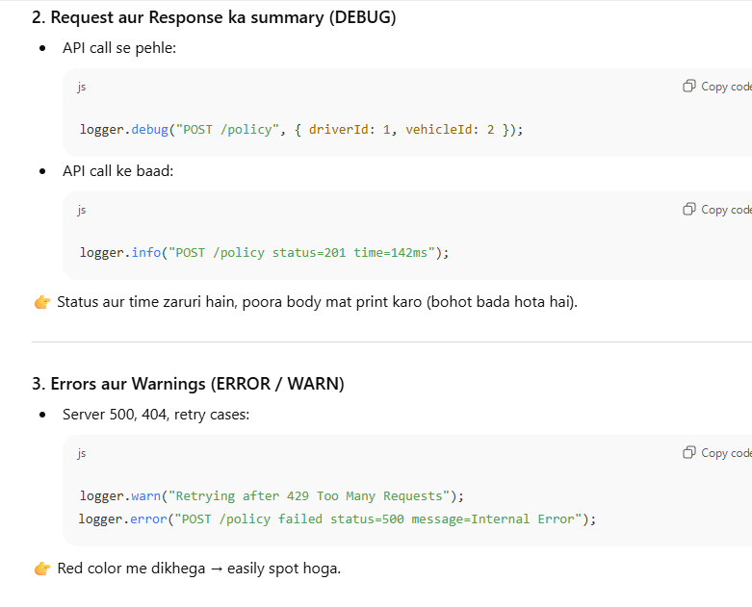
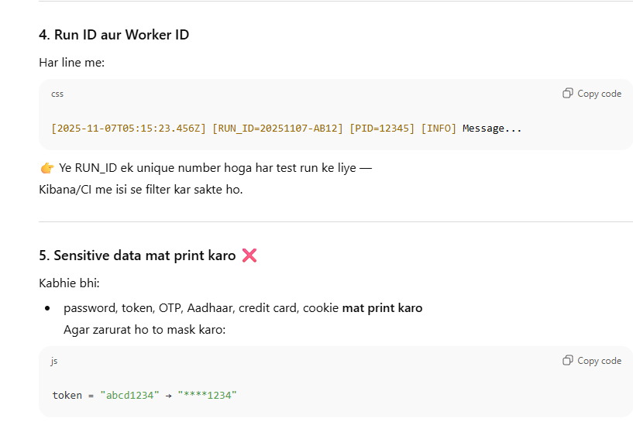
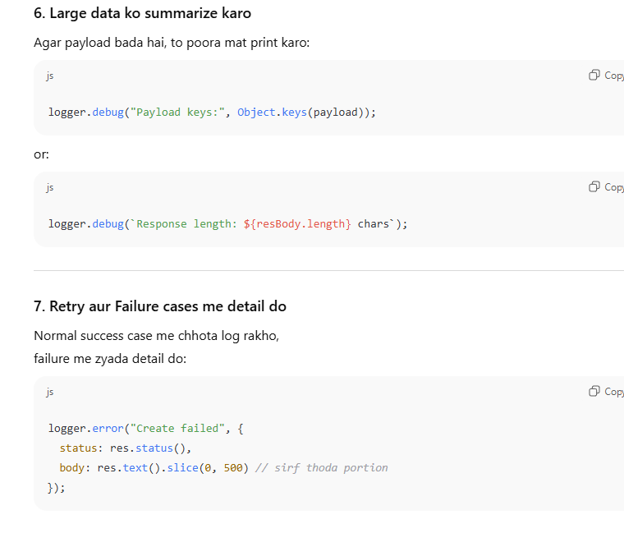
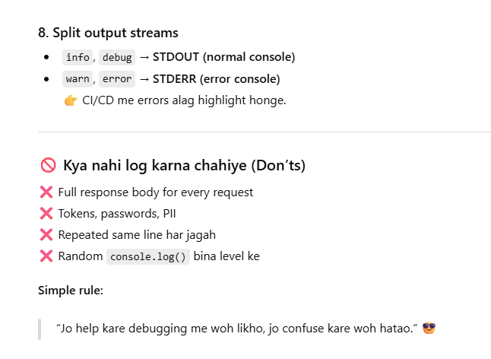
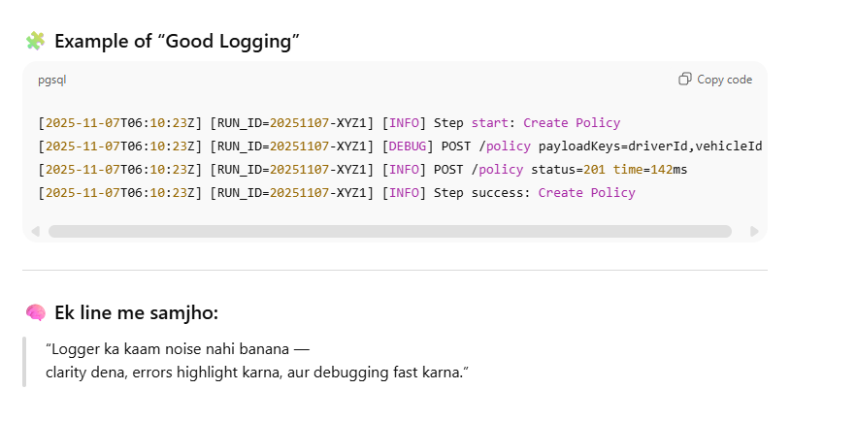

✅ Good: Minimal Playwright spec (API) with clean logging
