🔹 Jenkins Freestyle Project → General Section (Hinglish Explanation)

🔹 General
1. Description
👉 Simple text box jaha tu apne job ka intro likh sakta hai.
- SDET Example: "Ye job nightly regression suite run karega Playwright tests ke liye."
Team members ko turant samajh aa jata hai ye job kya karta hai.

2. Discard Old Builds
👉 Purane builds ko delete karne ka option.
- SDET use: Agar tu daily regression chalata hai, to unnecessary 100 builds store karne ki zarurat nahi.
Example: Sirf last 20 builds rakhna hai.

3. GitHub Project
👉 Isme apna repo ka URL dal sakta hai.
- Kaam ka point: Jenkins dashboard pe ek direct link milta hai → click karke turant apna automation repo open kar sakta hai.

4. This Project is Parameterized
👉 Isse tu job chalate waqt inputs de sakta hai.
- SDET Example:
  - Parameter: BROWSER = chrome/firefox
  - Parameter: ENV = dev/stage/prod
Matlab tu apne suite ko run kar sakta hai: firefox + stage env pe.

5. Throttle Builds
👉 Ye control karta hai ek time me kitne builds parallel chal sakte hai.
- Helpful kab: Agar tere regression heavy hai aur ek server ko load zyada ho raha hai, tu bol sakta hai: ek time pe sirf 1 build run ho.

6. Execute Concurrent Builds if Necessary
👉 Opposite of throttle. Ye allow karta hai ki ek hi job multiple bar ek saath chale.
- Helpful kab: Agar do log same regression ek time pe chalate hai aur tere infra support karta hai parallel runs, to ye option enable karke dono parallel chal jayenge.

7. Restrict Where This Project Can Be Run
👉 Job ko specific node/agent pe hi run karwana.
- SDET Example:
  - Node A = Windows (Edge ke liye)
  - Node B = Linux (Chrome ke liye)
Agar tu Edge tests run karna chahta hai → sirf Node A pe run hoga.

8. Advanced
👉 Rarely used basic SDET cases me.
- Purpose: Extra cheezein set karne ke liye jaise Quiet Period (job start hone se pehle kuch second wait karo).
- Helpful kab: Agar frequent commits ho rahe hai aur tu chahata hai ki ek hi job trigger ho, baar-baar na chale.

💡 Simple bolun to:
SDET ke liye General section me useful mainly:
- Description (for clarity)
- Discard old builds (storage bachane ke liye)
- GitHub project (easy access)
- Parameterized project (browser/env choose karne ke liye)
- Restrict node (specific OS/browser ke liye)

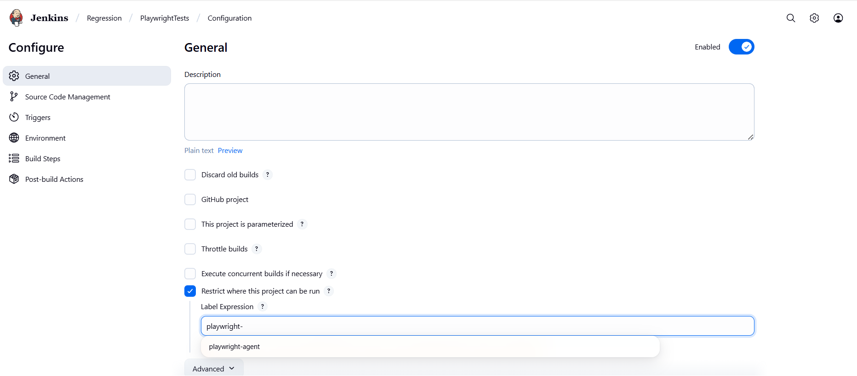

🔹 Source Code Management (SCM)
Git select karna
Repo URL dena
Credentials (agar private repo hai)
Branch select karna (mostly main nightly build ke liye)
Kabhi-kabhi Additional Behaviours → “Clean before checkout”

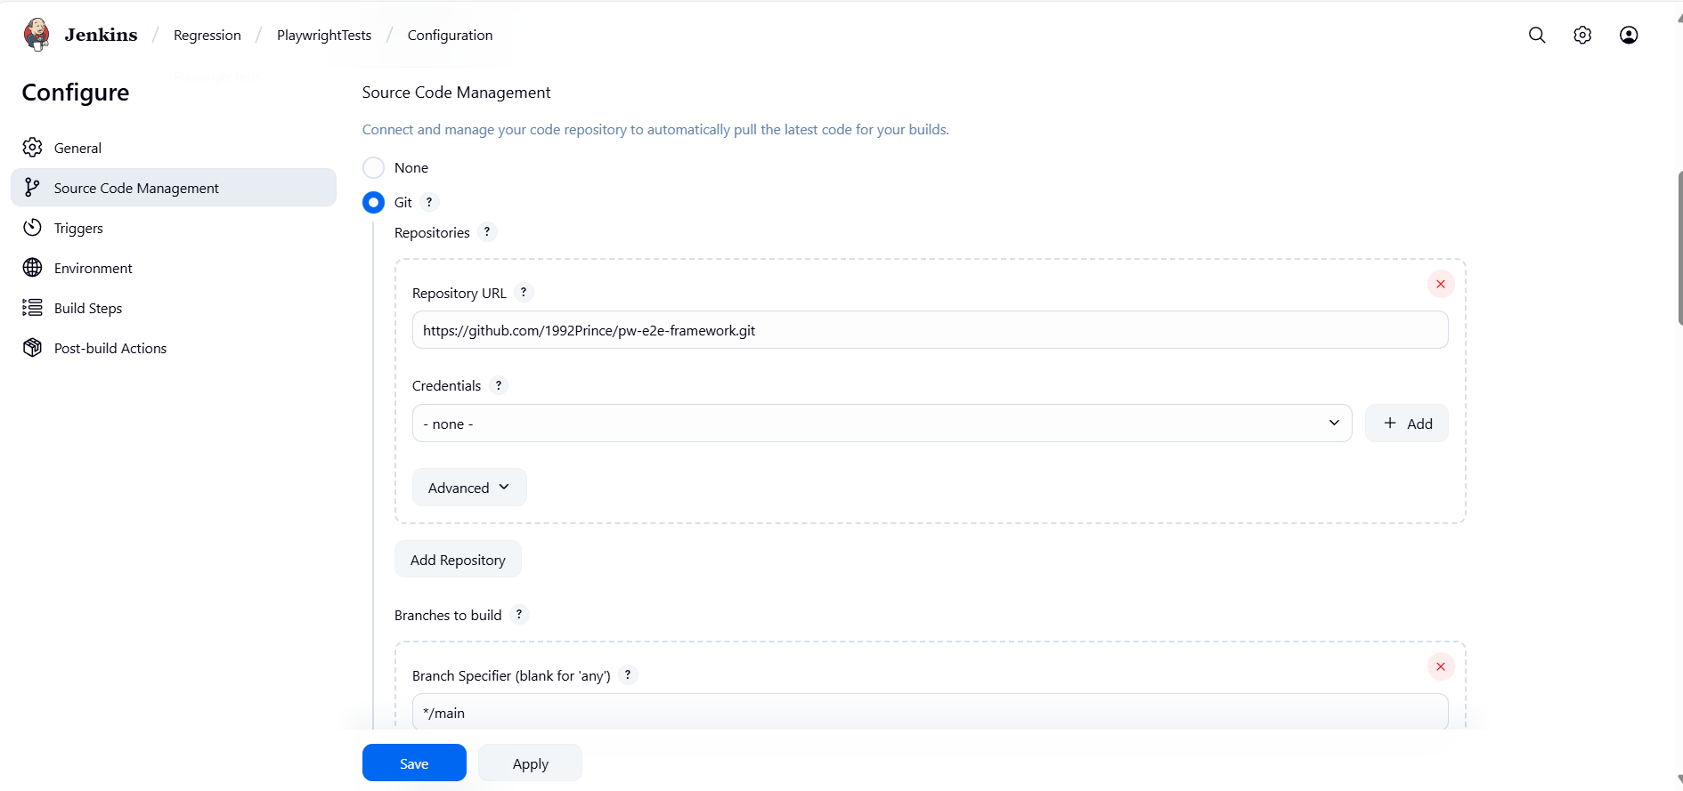

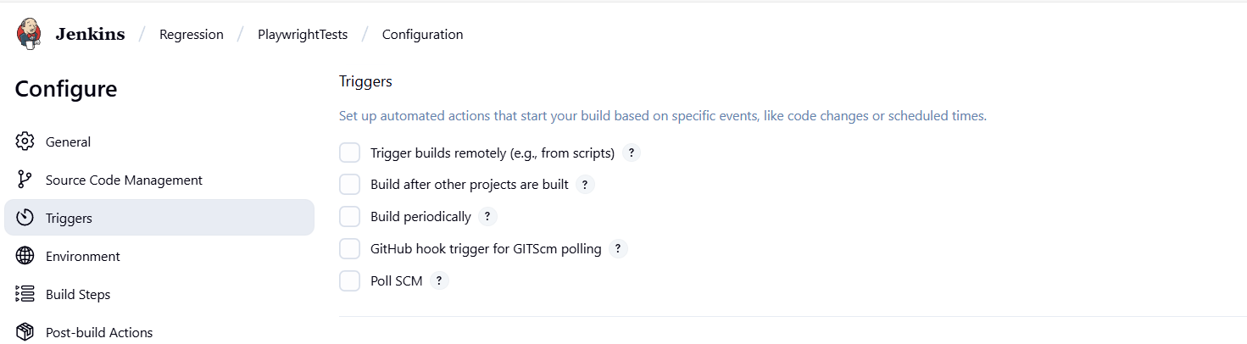

🔹 Triggers:
Set up automated actions that start your build based on specific events, like code changes or scheduled times.
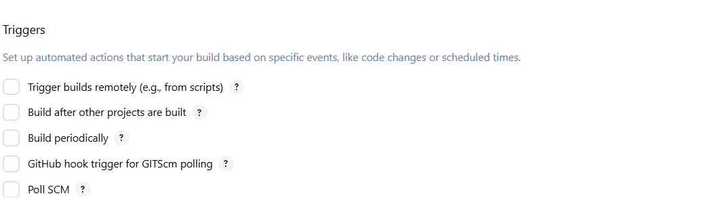
If u check Build after other projects and build periodically
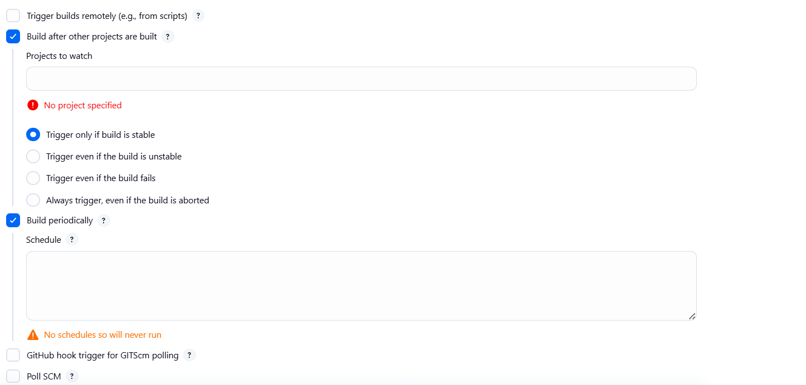
If u select Poll SCM
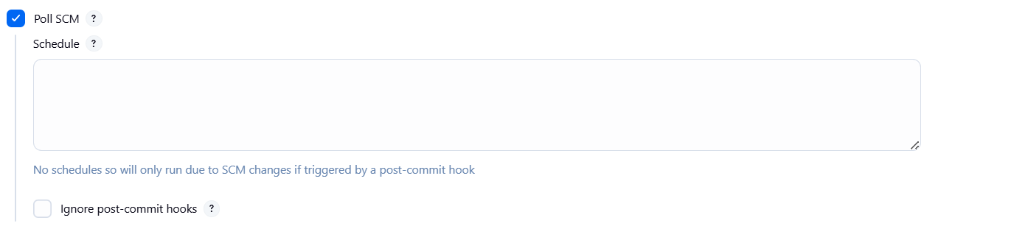
1. Trigger builds remotely (e.g., from scripts)
👉 Isse tu ek URL token generate karta hai. Agar wo URL hit karega (via script, curl, Postman), to Jenkins job trigger ho jayega.
- SDET Example:
  - Tu apne CI/CD pipeline ya external test management tool (jaise Jira/Xray) se job trigger karna chahta hai → ye option kaam aata hai.

2. Build after other projects are built
👉 Ye ek chaining option hai. Matlab ek job ke complete hone ke baad dusra job trigger ho.
- SDET Example:
  - Pehle ek job “Deploy to QA Env” chalega.
  - Uske khatam hone ke baad automatically “Run Automation Regression” job trigger ho jayega.

3. Build periodically
👉 Ye sabse important hai SDET ke liye → yaha tu CRON expression set karke scheduled builds run kar sakta hai.
- SDET Example:
Nightly regression:
H 2 * * *
  - Matlab daily raat ko 2 AM pe automation suite chalega.
Har 15 min:
H/15 * * * *

4. GitHub hook trigger for GITScm polling
👉 Ye repo ke saath integrate hota hai. Agar GitHub pe code push hota hai, to Jenkins job turant trigger ho jayega.
- SDET Example:
  - Jab bhi tester/QA code commit kare Playwright repo me, Jenkins automatically test suite run karega without manual trigger.

5. Poll SCM
👉 Jenkins khud repo ko har thodi der me check karega (poll karega) ki koi naya commit hai ya nahi. Agar hoga to build trigger hoga.
- Difference from GitHub hook:
  - Hook = GitHub Jenkins ko notify karega.
  - Poll SCM = Jenkins khud bar-bar check karega.
- SDET Example:
  - Tu poll set karta hai H/5 * * * * → Jenkins har 5 min repo check karega, agar code change hua hai to build run karega.

💡 Most useful for SDET testing:
- Build periodically → Nightly/weekly regression ke liye.
- GitHub hook trigger → Code commit pe automatic run ke liye.
- Build after other projects → Deployment ke baad regression run ke liye.

🔹 Environments:
Configure settings and variables that define the context in which your build runs, like credentials, paths, and global parameters.
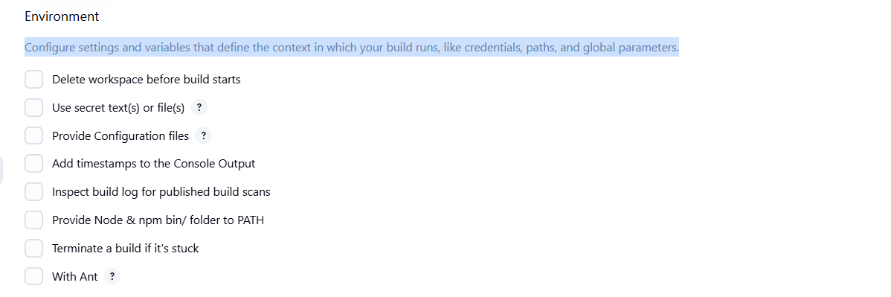
Purpose:
Ye section mainly build execution ka context/environment setup karta hai. Matlab job start hone se pehle ya during execution Jenkins kya prepare kare.

1. Delete workspace before build starts
👉 Job start hone se pehle pura workspace (old files, reports, node_modules etc.) delete kar dega.
- SDET Example:
  - Agar tere Playwright tests me purane reports/data reh gaye to build fail ho sakta hai.
  - Ye option enable karke hamesha fresh clean workspace milega.

2. Use secret text(s) or file(s)
👉 Isse tu passwords, API keys, tokens safely inject kar sakta hai.
- SDET Example:
  - ENV = stage me run karna hai jaha auth token chahiye.
  - Tu token ko Jenkins credentials me store karke yaha inject kar sakta hai.

3. Provide Configuration files
👉 External config files (properties, yaml, json) Jenkins job me inject karne ke liye.
- SDET Example:
  - Test data ya env specific config file (jaise stage-config.json) provide karna.

4. Add timestamps to the Console Output
👉 Console log me har line ke saath timestamp add hoga.
- Helpful for debugging: Jab tu dekhega “test run slow hai” to samajh aayega kitna time kis step pe laga.

5. Inspect build log for published build scans
👉 Ye mainly Gradle/Maven build scan integration ke liye hota hai.
- SDET point: Rarely use hota hai agar tu detailed build reports scan karna chahta hai.

6. Provide Node & npm bin/folder to PATH
👉 Ye Node.js based projects (Playwright, Cypress, etc.) ke liye useful hai.
- SDET Example:
  - Playwright tests run karne ke liye Node & npm PATH me hona zaroori hai.
  - Agar Jenkins agent me Node global PATH me nahi hai, to is option se provide kar sakta hai.

7. Terminate a build if it's stuck
👉 Agar build hang ho gaya (jaise test infinite wait me chala gaya), to Jenkins usse kill kar dega.
- SDET Example:
  - Agar Playwright test hang ho gaya aur job 2 ghante se chal raha hai → auto terminate ho jayega.

8. With Ant
👉 Ye Apache Ant build tool ke integration ke liye hai.
- SDET point: Agar tu Playwright ya Java Maven project use kar raha hai to ye relevant nahi.

💡 SDET ke liye most useful:
- ✅ Delete workspace before build starts (clean run)
- ✅ Use secret text(s) or file(s) (credentials, tokens)
- ✅ Provide Node & npm bin/folder to PATH (for Playwright/Cypress)
- ✅ Add timestamps to Console Output (debugging)
- ✅ Terminate build if stuck (avoid hung jobs)

🔹 Build Steps:
Purpose:
Yaha pe tu define karta hai ki Jenkins job chalne ke baad kya kaam karna hai → jaise code compile, dependencies install, automation scripts run, reports generate.

Example jo tune diya hai 👇
call npm ci
call npx playwright install --with-deps
call npx playwright test --project=advantage-app --headed --reporter=html

- npm ci → Clean install karega project dependencies from package-lock.json.
✔️ Ensures har build reproducible ho (fresh node_modules).
- npx playwright install --with-deps → Playwright browsers aur dependencies install karega.
✔️ Useful agar Jenkins agent me browsers already nahi hai.
- npx playwright test --project=advantage-app --headed --reporter=html
✔️ Ye actual automation test suite run karega:
  - --project=advantage-app → specific Playwright project config se run.
  - --headed → browser visible mode me chalega (debugging ke liye).
  - --reporter=html → HTML report generate hoga.
👉 Matlab yaha tune poora flow bana diya: dependencies install → Playwright setup → test run + report generate

Common Options Available (jo SDET ke liye kaam ke hai)
- Execute NodeJS script
  - Direct JS/TS script run kar sakta hai.
  - Rarely use hota hai kyunki hum mostly npm test ya npx playwright test command dete hain.
- Execute Windows batch command
  - Tu Windows machine pe ho to ye use karega.
  - Example: call npm test
- Execute shell
  - Linux/Mac nodes ke liye.
  - Example: npm ci && npx playwright test
- Invoke Gradle script / Invoke Maven targets
  - Java-based projects ke liye.
  - Example: mvn clean test -Dsuite=regression (agar Selenium + Maven tests hote to use hota).
- Provide Configuration files
  - Agar external config JSON/properties file inject karni ho.
- Run with timeout
  - Agar tu chahata hai build max 30 mins chale, uske baad auto kill ho jaye.
  - Helpful jab test suite kabhi-kabhi hang ho jata hai.
- Set build status to "pending" on GitHub commit
  - Jab tu CI/CD pipeline bana raha hai → Jenkins GitHub pe status post kar sakta hai (pending, success, failed).

💡 SDET ke liye daily kaam me ye hi useful:
- ✅ Windows batch command / Shell (to run Playwright/Selenium commands)
- ✅ Run with timeout (stuck builds avoid karne ke liye)
- ✅ Maven/Gradle targets (agar Java Selenium project hai)
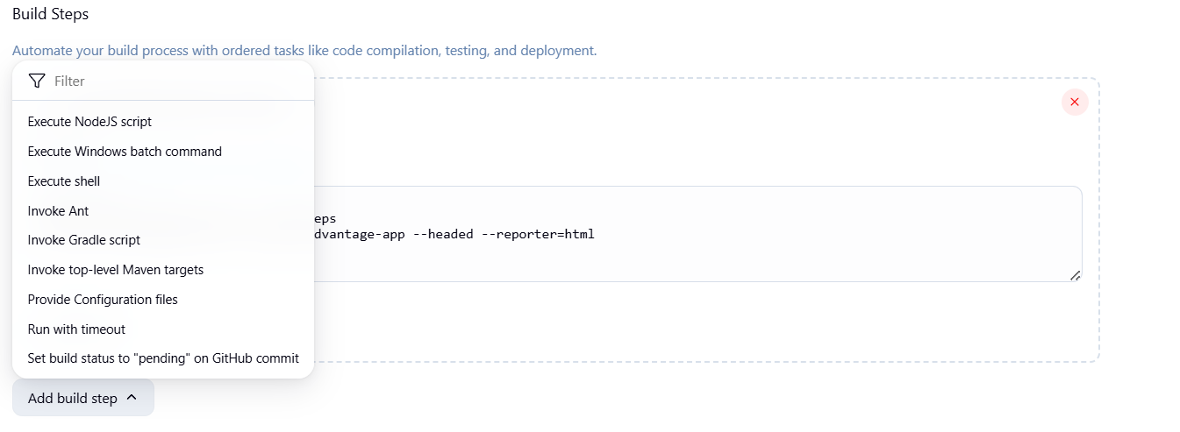

🔹 Post Build Actions:
Purpose:
Job run hone ke baad Jenkins kya kare? Report save karni hai? Email bhejna hai? Next job trigger karni hai?

1. Archive the artifacts ✅ (sabse important)
👉 Ye option build ke output files (reports, logs, screenshots, etc.) Jenkins me save kar deta hai.
- SDET Example:
  - Tune playwright-report/** diya hai → iska matlab pura Playwright HTML report folder Jenkins me archive ho jayega.
  - Matlab build khatam hone ke baad bhi tu Jenkins se report download/open kar sakta hai.

2. Aggregate downstream test results
👉 Agar ek job dusre jobs ko trigger kar raha hai, to unke results bhi merge karke show karega.
- Rarely use for SDET.

3. Build other projects
👉 Ek job khatam hone ke baad dusra Jenkins job automatically trigger ho.
- SDET Example:
  - Job 1 = Deploy to QA
  - Job 2 = Run Playwright Tests
  - Job 1 complete → Job 2 start automatically.

4. Publish JUnit test result report ✅
👉 Agar tu Java/Maven ya Playwright ke JUnit XML reporter use kar raha hai, to Jenkins proper test result graph banayega.
- SDET Example:
Playwright run with:
npx playwright test --reporter=junit

  - Fir yaha Jenkins me XML path dega → Jenkins dashboard me pass/fail trend dikhne lagega.

5. Record fingerprints of files
👉 Mainly file tracking ke liye hota hai (not common for SDET).

6. Git Publisher
👉 Git related actions (jaise tag create karna after build).
- Rarely SDET kaam ka.

7. E-mail Notification / Editable Email Notification ✅
👉 Jab build success/fail ho to email bhej do QA/dev team ko.
- SDET Example:
  - Regression fail hua → email jisme Jenkins job ka link aur report ka link attached ho.
  - Editable wala advanced hai jisme tu custom email template bana sakta hai (report attach, HTML body etc.).

8. Set GitHub commit status
👉 Jab Jenkins build run kare to GitHub PR me status dikhata hai (pending → success/fail).
- Useful agar CI/CD integrate kiya hai.

9. Delete workspace when build is done
👉 Build ke end me workspace clean kar de.
- SDET Example: Agar tere reports aur logs sirf archive ho gaye hai aur workspace clean karna hai space bachane ke liye.

💡 SDET ke liye most useful:
- ✅ Archive the artifacts (reports/screenshots save karna)
- ✅ Publish JUnit test result report (trend analysis & graphs)
- ✅ Email Notifications (failure alerts)
- ✅ Build other projects (chaining jobs)

