❓How to schedule Jenkins job for nightly automation suite? Or How to schedule the Jenkins Job?
Open the job in edit configuration mode
Scroll down to “Triggers section”
Click on “Build Periodically" checkbox
Add Scheduled time in the Schedule field:: This will take cron expression as below
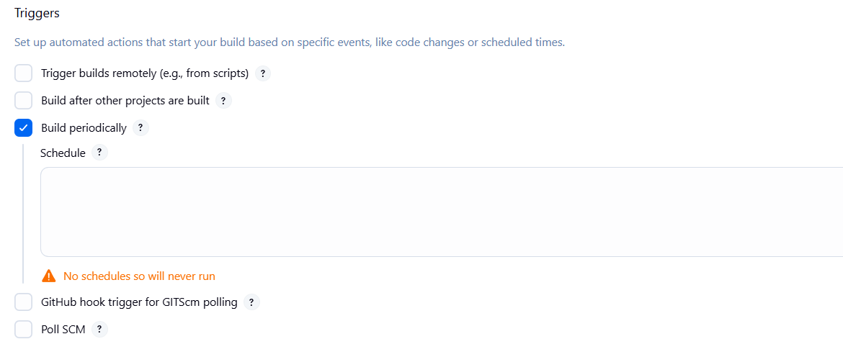

Jenkins uses a cron expression, the diff fields are:
MINUTES[0-59]
HOURS[0-23]
DAYMONTH [1-31]
MONTH[1-12]
DAYWEEK[0-7]
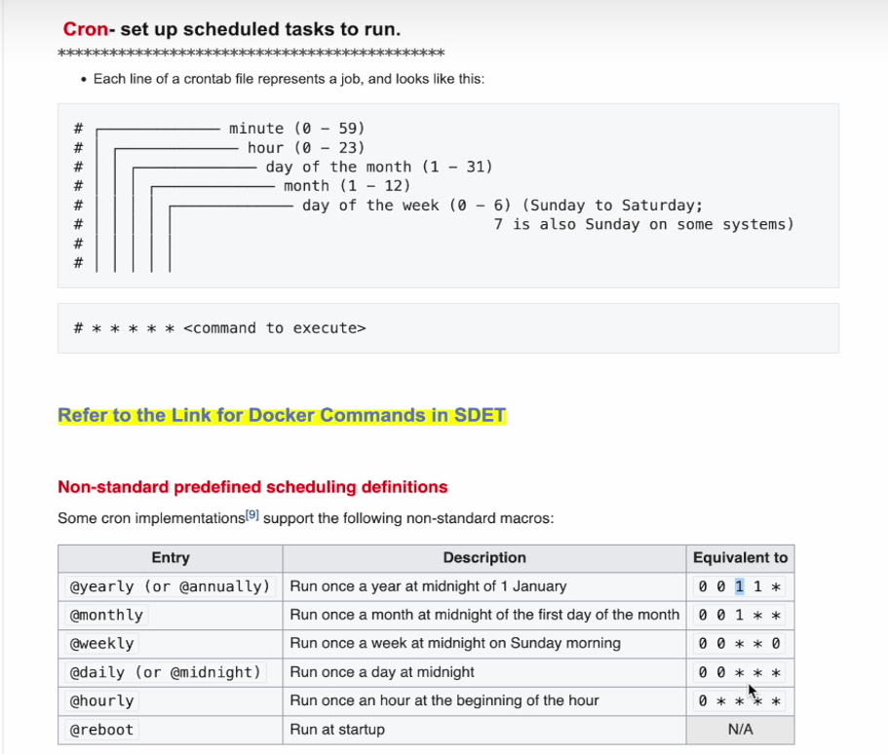

Pehle basics:
Cron expression me 5 parts hote hain (kabhi 6 bhi hota hai but basic 5 samajh le):
* * * * *
| | | | |
| | | | +---- Day of week (0-6) (0 = Sunday)
| | | +--------- Month (1-12)
| | +-------------- Day of month (1-31)
| +------------------- Hour (0-23)
+------------------------ Minute (0-59)

Example samajh:
- 0 0 1 1 *
  - Minute = 0
  - Hour = 0
  - Day of Month = 1
  - Month = 1
  - Day of week = * (koi bhi)
👉 Matlab 1 January ke din raat 12:00 baje run hoga (New Year midnight).
- Shortcut: @yearly ya @annually

- 0 0 1 * *
  - Minute = 0
  - Hour = 0
  - Day of Month = 1
  - Month = * (koi bhi)
  - Day of week = * (koi bhi)
👉 Matlab har mahine ke pehle din raat 12:00 baje run hoga.
- Shortcut: @monthly

- 0 0 * * 0
  - Minute = 0
  - Hour = 0
  - Day of Month = * (koi bhi)
  - Month = * (koi bhi)
  - Day of week = 0 (Sunday)
👉 Matlab har Sunday raat 12:00 baje run hoga.
- Shortcut: @weekly

- 0 0 * * *
👉 Matlab roz raat 12:00 baje run hoga.
Shortcut: @daily ya @midnight

- 0 * * * *
👉 Matlab har ghante ke start me run hoga (01:00, 02:00, 03:00 ...).
Shortcut: @hourly

- @reboot
👉 Matlab system restart hone ke turant baad run hoga. Iska cron equivalent nahi hota.

Hinglish Trick: Future me kaise likhe cron expression?
- Minute → Kab chalana hai minute level pe (0–59)
Example: 0 = exact ghante ke start, 30 = half past.
- Hour → Din me kaunse ghante me chalana hai (0–23).
Example: 0 = midnight, 12 = noon, 23 = 11 PM.
- Day of Month → Mahine ke kaunse date pe chalana hai (1–31).
Example: 1 = har month ka 1st din.
- Month → Kaunse month me chalana hai (1–12).
Example: 1 = January, 12 = December.
- Day of Week → Haftay ke kaunse din (0–6).
Example: 0 = Sunday, 5 = Friday.

Quick Hinglish Formula:
Minute Hour Day-of-Month Month Day-of-Week

So agar bolna ho → "Roz subah 6 baje"
→ 0 6 * * *
Agar bolna ho → "Har Monday 9:30 AM"
→ 30 9 * * 1

👉 Simple yaad rakh: chhote se bada (Minute → Hour → Day → Month → Weekday).

1st Expression:
30 8 * * 1-5

Breakdown:
- 30 → 30th minute
- 8 → 8th hour (subah 8 baje)
- * → koi bhi din of month
- * → koi bhi mahina
- 1-5 → Monday se Friday tak
👉 Matlab: Roz Monday to Friday, subah 8:30 AM pe run hoga.

2nd Expression:
30 16 * * 5

Breakdown:
- 30 → 30th minute
- 16 → 16th hour (4 PM ke baad 30 minute → 4:30 PM)
- * → koi bhi din of month
- * → koi bhi mahina
- 5 → Friday
👉 Matlab: Har Friday, shaam 4:30 PM pe run hoga.

Combine Both:
30 8 * * 1-5
30 16 * * 5

👉 Matlab:
- Roz Monday se Friday subah 8:30 AM
- Aur extra ek run Friday 4:30 PM ko

Even we can give multiple crons expression under schedule in jenkins

❓How to give multiple schedules in jenkins . Give example
Jenkins → Job → Build periodically → Schedule box me:
30 8 * * 1-5
30 16 * * 5

Yeh matlab:
- Monday–Friday subah 8:30 AM → run (maybe sanity/smoke)
- Har Friday shaam 4:30 PM → extra run (weekly sanity or report)
Jenkins dono lines ko padhega aur dono times pe job chalaye-ga.

✨ What is a Nightly Job in Jenkins (Automation Context)?
As an SDET, we schedule nightly jobs in Jenkins to run our full regression suite or heavy automation tests every night.
The idea is simple →
- We trigger the automation suite at a fixed late-night time (usually 11 PM or 12 midnight) when the system usage is low.
- The entire suite runs overnight.
- Next morning, when the team logs in, the execution results and reports are already available for quick analysis.

✅ Why Nightly Jobs?
- Regression suites are usually long-running (30 mins – few hours). Running them in the day would block resources.
- Nightly execution ensures that the latest codebase is validated daily.
- Failures or regressions are caught early, before developers start work the next day.

🕒 Example Schedule (Cron in Jenkins):
0 23 * * * → Run every night at 11 PM
0 0 * * * → Run every night at 12 AM

📌 Real Example:
Suppose we have an E-commerce automation suite.
- Nightly job will checkout the latest code from main branch
- Deploy to staging environment
- Run all regression tests (login, cart, payment, search, profile, etc.)
- Generate Allure/Extent report
- Send Slack/Email notification with pass/fail summary
Next morning, QA & Dev team open Jenkins → Reports are ready → Start analysis.

👉 Short summary you can use in interviews/resume:
“We schedule nightly jobs in Jenkins to run full regression every night around 11 PM or midnight, so that when we log in the next morning, execution results are already available for analysis. This helps us validate the latest code changes daily and detect regressions early.”

❓How to setup Email Notification from Jenkins using a Gmail account?
✅ Answer:
There are two ways to configure email notifications in Jenkins:
- Default Jenkins option → "E-mail Notification" (basic email support)
- Plugin option → "Editable Email Notification" (provided by the Email Extension Plugin)
Let’s first see the default Jenkins "E-mail Notification" method:

🔹 Pre-Setup (Gmail App Password)
Since Google has disabled “Less secure app access”, you need to generate an App Password for Gmail instead of using your normal Gmail password.
Steps:
- Open Google Account Security.
- Enable 2-Step Verification if not already enabled.
- Search for App Passwords in the Google Account search bar.
- Generate a new App Password (choose “Mail” as app and “Other/Device” as device).
  - Example App Password: ymae jqxl lcwf iagb
- Copy this password — this will be used in Jenkins config (instead of your Gmail login password). [My app password is - ymae jqxl lcwf iagb]

🔹 Jenkins Configuration (System Level)
- Go to Manage Jenkins → Configure System.
- Scroll down to E-mail Notification (⚠️ not “Extended Email Notification”).
- Configure as follows:
  - SMTP server: smtp.gmail.com
  - Use SSL: ✔ (checked)
  - SMTP Port: 465
  - Reply-To Address: (any valid email, e.g., your Gmail)
  - Charset: UTF-8
  - Advanced → Username: your Gmail address
  - Password: the App Password generated earlier (not Gmail login password)
- Test the setup:
  - Tick “Test configuration by sending test e-mail”
  - Enter a valid email address
  - Click Test configuration → you should receive a test email
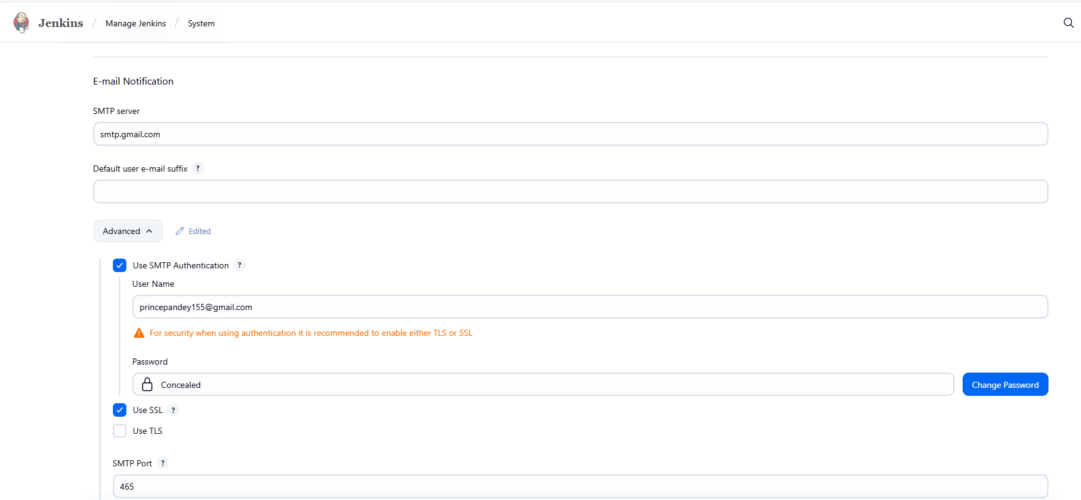
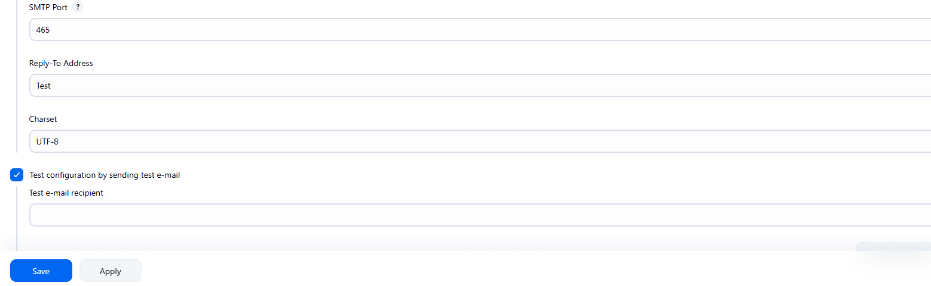

🔹 Jenkins Job Configuration (Job Level)
- Open your Jenkins job → Configure.
- Scroll to Post-build Actions.
- Add E-mail Notification.
- Enter Recipients (comma-separated email addresses).
- Options available:
  - Send e-mail for every unstable build
  - Send separate e-mails to individuals who broke the build
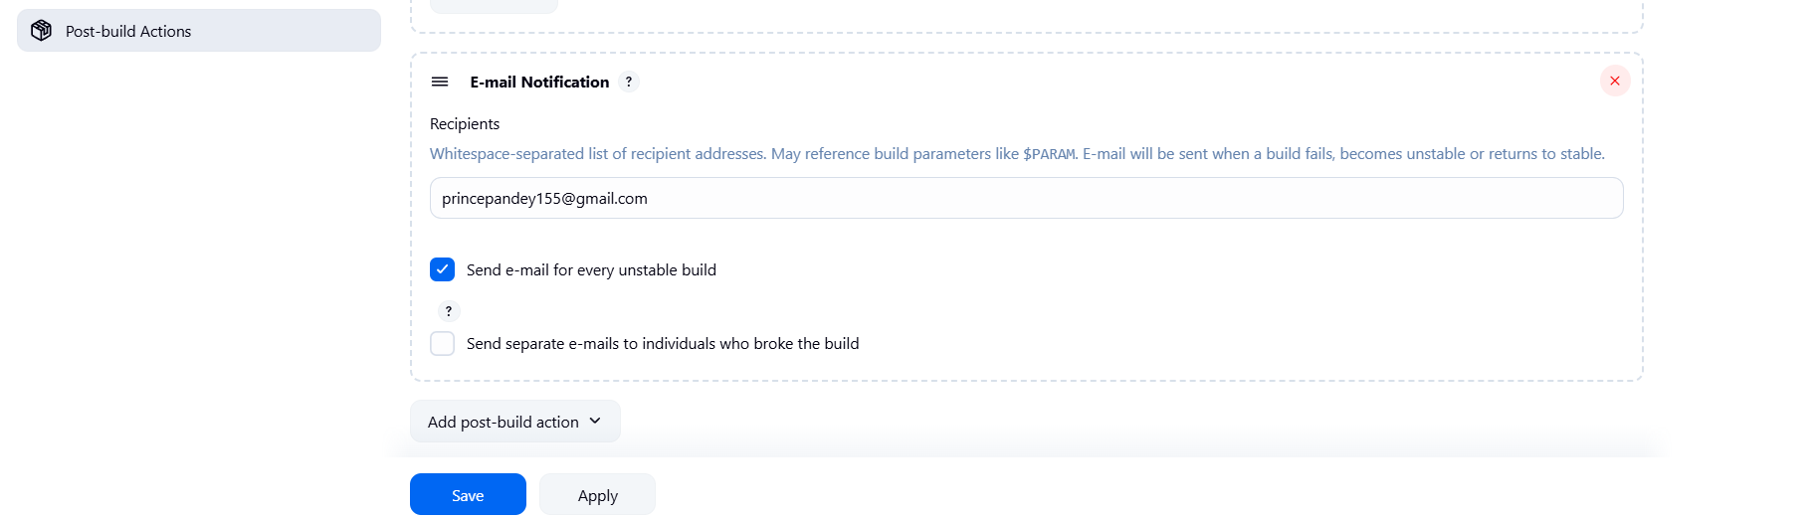
⚠️ Note: With the default “E-mail Notification”, emails are only sent for failed or unstable builds.
Successful builds will not trigger notifications.
That’s why many teams prefer the Email Extension Plugin, which provides more flexibility (subject, triggers for success/failure, attachments, etc.).
Email which I received is below:[Subject is : Job Name with build no]
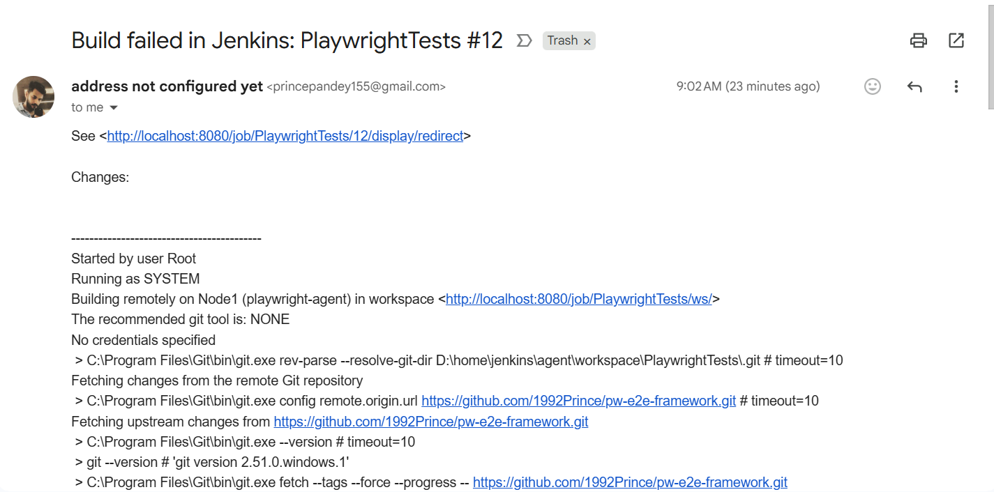

👉 This is the default Jenkins + Gmail setup. For more customization (success mails, HTML reports, logs, etc.), use the "Editable Email Notification" plugin.

⚙️ Another Way: Using “Email Extension Plugin” (Editable Email Notification)
This is a more advanced and customizable way to send emails from Jenkins. It provides features like:
- Custom subjects and bodies (HTML support)
- Multiple triggers (Success, Failure, Unstable, etc.)
- Control over when and how notifications are sent

🔹 Step 1: Install the Plugin
- Go to Manage Jenkins → Plugins → Available plugins
- Search for Email Extension Plugin
- Click Install (or if already installed, it will appear under Installed plugins)
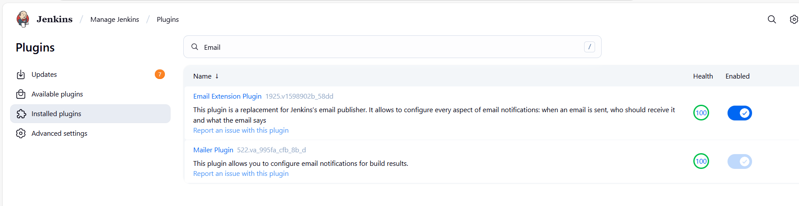

🔹 Step 2: Pre-Setup — Add Gmail Credentials in Jenkins
Before configuring, add your Gmail App Password in Jenkins Credentials Manager.
- Go to Manage Jenkins → Credentials → System → Global credentials
- Click on Add Credentials
- Select type → Username with password
- Enter:
  - Username → your Gmail address (e.g., dummy.jenkins@gmail.com)
  - Password → your Gmail App Password (not your Gmail login password)
  - ID or Name → any friendly name (e.g., gmail-credentials)
📝 Note: This credential ID will appear later when selecting credentials in configuration.

🔹 Step 3: Configure “Extended E-mail Notification”
- Go to Manage Jenkins → Configure System
- Scroll down to Extended E-mail Notification (this section appears only after installing the plugin)
- Fill in the details:
  - SMTP Server → smtp.gmail.com
  - SMTP Port → 465
  - Use SSL → ✔️ (checked)
  - Use TLS → ✔️ (checked)
  - Credentials → select the one you added earlier (e.g., gmail-credentials)
Default Subject →
$PROJECT_NAME - Build # $BUILD_NUMBER - $BUILD_STATUS!

  - Default Content → leave default (or customize later)
- Default Triggers section → make sure “Always” is checked.
This ensures emails are sent for all build outcomes (Success, Failure, Unstable).
- Click Save.

✅ Summary
Step | Description
1 | Install Email Extension Plugin
2 | Add Gmail App Password under Global Credentials
3 | Configure Extended E-mail Notification in system settings
4 | Ensure Always trigger is selected
5 | Save and test
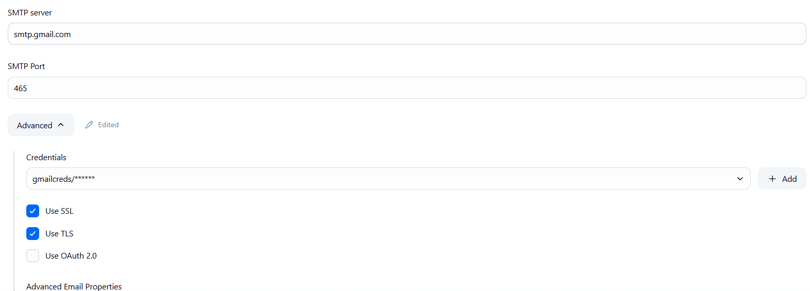
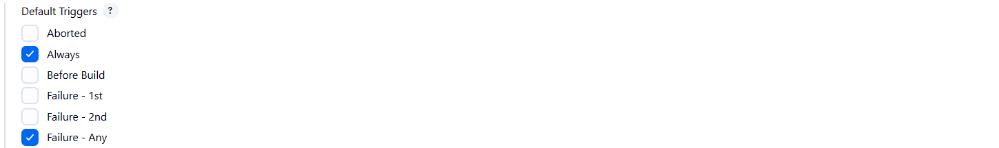

🧩 Step 4: Configure Email Notification at the Job Level
Once the Email Extension Plugin is installed and system-level settings are done,
you need to enable it inside each Jenkins job (so it knows when and to whom to send emails).

🔹 Step-by-Step Configuration
- Open your Jenkins Job
Go to the specific job → click Configure
- Scroll down to “Post-build Actions”
Click on “Add post-build action” → select “Editable Email Notification”
(This option appears only after installing the Email Extension Plugin).
- Fill the Email Details
Project Recipient List → enter the email IDs (comma-separated if multiple)
Example:
princepandey155@gmail.com, dummy.jenkins@gmail.com

  - Reply-To List → optional (you can leave blank or use the same address)
  - Content Type → HTML (text/html) (recommended for styled reports)
Subject → you can keep it default or customize, for example:
$PROJECT_NAME - Build # $BUILD_NUMBER - $BUILD_STATUS!

Content → write your own message or use variables:
Example:
Hi Team,<br><br>
The Jenkins build <b>$PROJECT_NAME</b> has completed.<br>
Build Number: <b>$BUILD_NUMBER</b><br>
Build Status: <b>$BUILD_STATUS</b><br>
Build URL: <a href="$BUILD_URL">$BUILD_URL</a><br><br>
Regards,<br>
Jenkins Automation

- Attach Build Log or Reports (optional)
You can attach files like HTML reports or logs using:
Attachments: **/target/*.html

- Add Triggers
  - Scroll to the “Triggers” section under this configuration.
  - Select which conditions should trigger an email:
    - Always
    - Success
    - Failure
    - Unstable
    - Aborted
    - Still Failing
    - etc.
- ✅ Common choice: Check “Always” to send on all build outcomes,
or “Failure” if you only want alerts for broken builds.
- Save Configuration
Click Save (or Apply and Save).

🔹 Step 5: Test the Configuration
- Run your Jenkins job manually.
Check the Console Output after build completes — you should see logs like:
Email was triggered for: Always
Sending email to: princepandey155@gmail.com
Finished: SUCCESS

- Check your Gmail inbox (and spam folder) to confirm you received the notification.

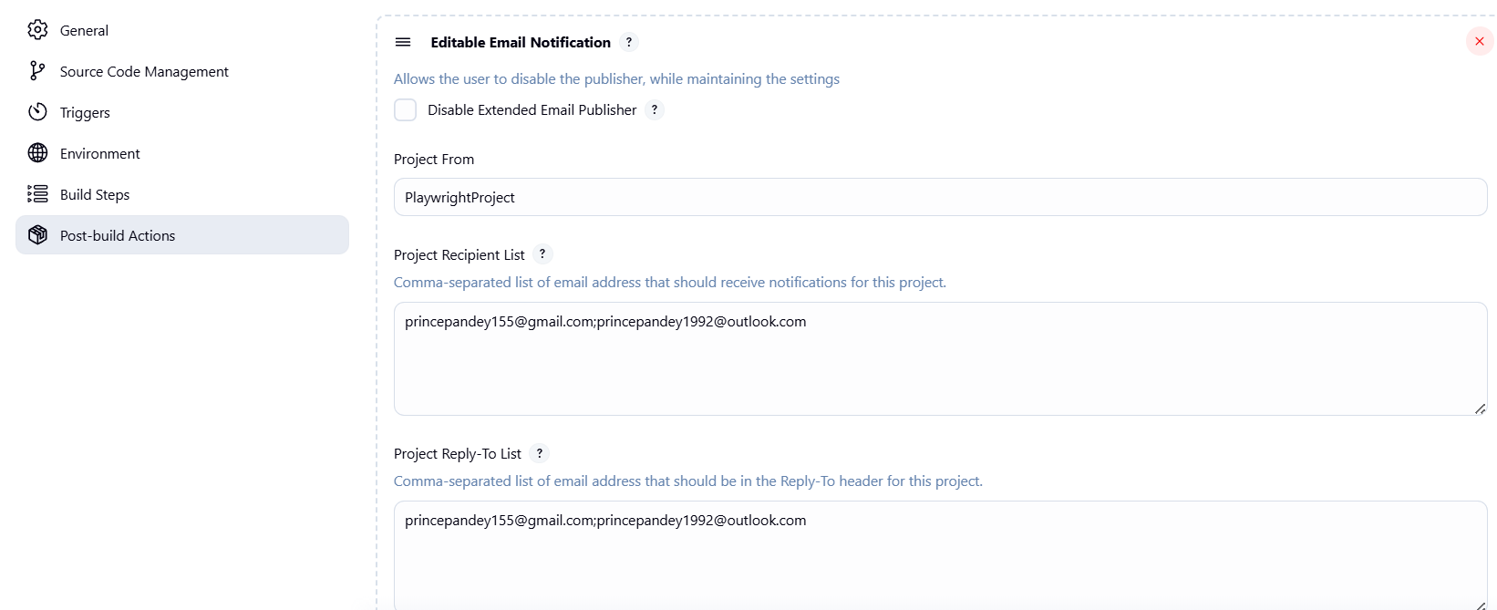
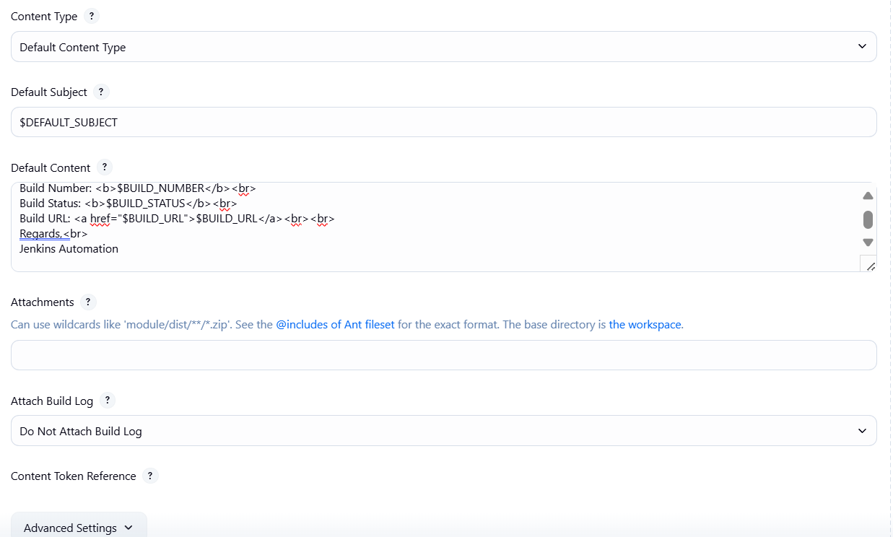

In Email subject u will get Project name with Build no and status like below:
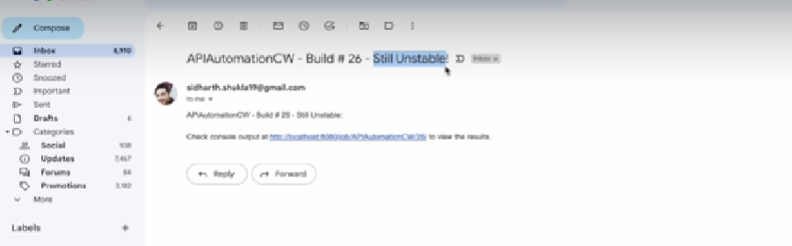
✅ Example Output
If everything is configured correctly, after every build Jenkins will send an email like:
Subject:
MyProject - Build #12 - FAILURE!

Body (HTML):
Hi Team,

The Jenkins build MyProject has completed.
Build Number: 12
Build Status: FAILURE
Build URL: http://localhost:8080/job/MyProject/12/

Regards,
Jenkins Automation

💡 Tip for Production:
- Use “Always” + “Failure - Any” triggers together.
- Customize your message with variables like:
  - $BUILD_URL, $BUILD_NUMBER, $BUILD_STATUS, $PROJECT_NAME, $CAUSE
- You can also include test report URLs (like Allure or Playwright HTML reports) in the email body.

✅ Note:
With the Email Extension Plugin, you can fully customize your email notifications.
You can define your own subject, content, recipients, and attachments.
The default subject is:
$PROJECT_NAME - Build # $BUILD_NUMBER - $BUILD_STATUS!

- The default content usually contains basic build details like project name, build number, build status, and build URL — but you can modify it freely using Jenkins environment variables.
In enterprise-level Jenkins setups, these configurations are usually pre-configured at the system level —
meaning the required plugins (like Email Extension Plugin) and SMTP details are already set up.
So, as an automation engineer or SDET, you typically just need to:
- Add “Editable Email Notification” under Post-build Actions in your job.
- Provide the From, To, Subject, and Content fields.
- Optionally attach reports or HTML results (for example, Playwright or Allure reports).
💡 Common example for attachments:
Attachments: **/index.html

This attaches your execution results page (index.html) in the email,
so recipients can directly view the test summary from their inbox.

