❓ Questions (Interview style)
- Q: Jenkins Freestyle job me parameters kaise enable karte ho?
- Q: ENV (QA/STG/DEV) ko dropdown se kaise select karoge?
- Q: Parameter ka value build step me kaise access karoge?
- Q: Agar token/password pass karna ho to kaise karoge?
- Q: Jenkins job ko remotely parameters ke saath trigger karna ho toh kaise karoge?

✅ Steps (Practical)

Step 1 – Enable Parameters
- Job → Configure → General section
- Tick ✔ This project is parameterized

Step 2 – Add Parameters
- Choice Parameter (dropdown)
  - Name: ENV
Choices (each on new line):
QA
STG
DEV

  - Description: Choose environment for tests
- String Parameter (free text)
  - Example: SUITE=smoke
- Boolean Parameter (checkbox)
  - Example: RUN_SMOKE = true/false

Step 3 – Use Parameters in Build Steps
Windows batch command
echo Selected ENV is %ENV%
call npm ci
call npx playwright test --project=%ENV% --reporter=html

Linux shell
echo "Selected ENV is $ENV"
npm ci
npx playwright test --project="$ENV" --reporter=html

Step 4 – Sensitive Values
- Add credentials in Jenkins → Manage Credentials
- In job, add parameter type Credentials
- Access in build step as env var, e.g. $API_TOKEN

Step 5 – Run Job
- Jenkins job page → Build with Parameters
- Select ENV from dropdown → Run.

✅ Best practices (short)
- Use Choice for environment to avoid typos.
- Use Credentials for secrets.
- Print params at start of build for debug.
- Provide default values and descriptions.
- Prefer Pipeline/Jenkinsfile for complex flows and versioning.
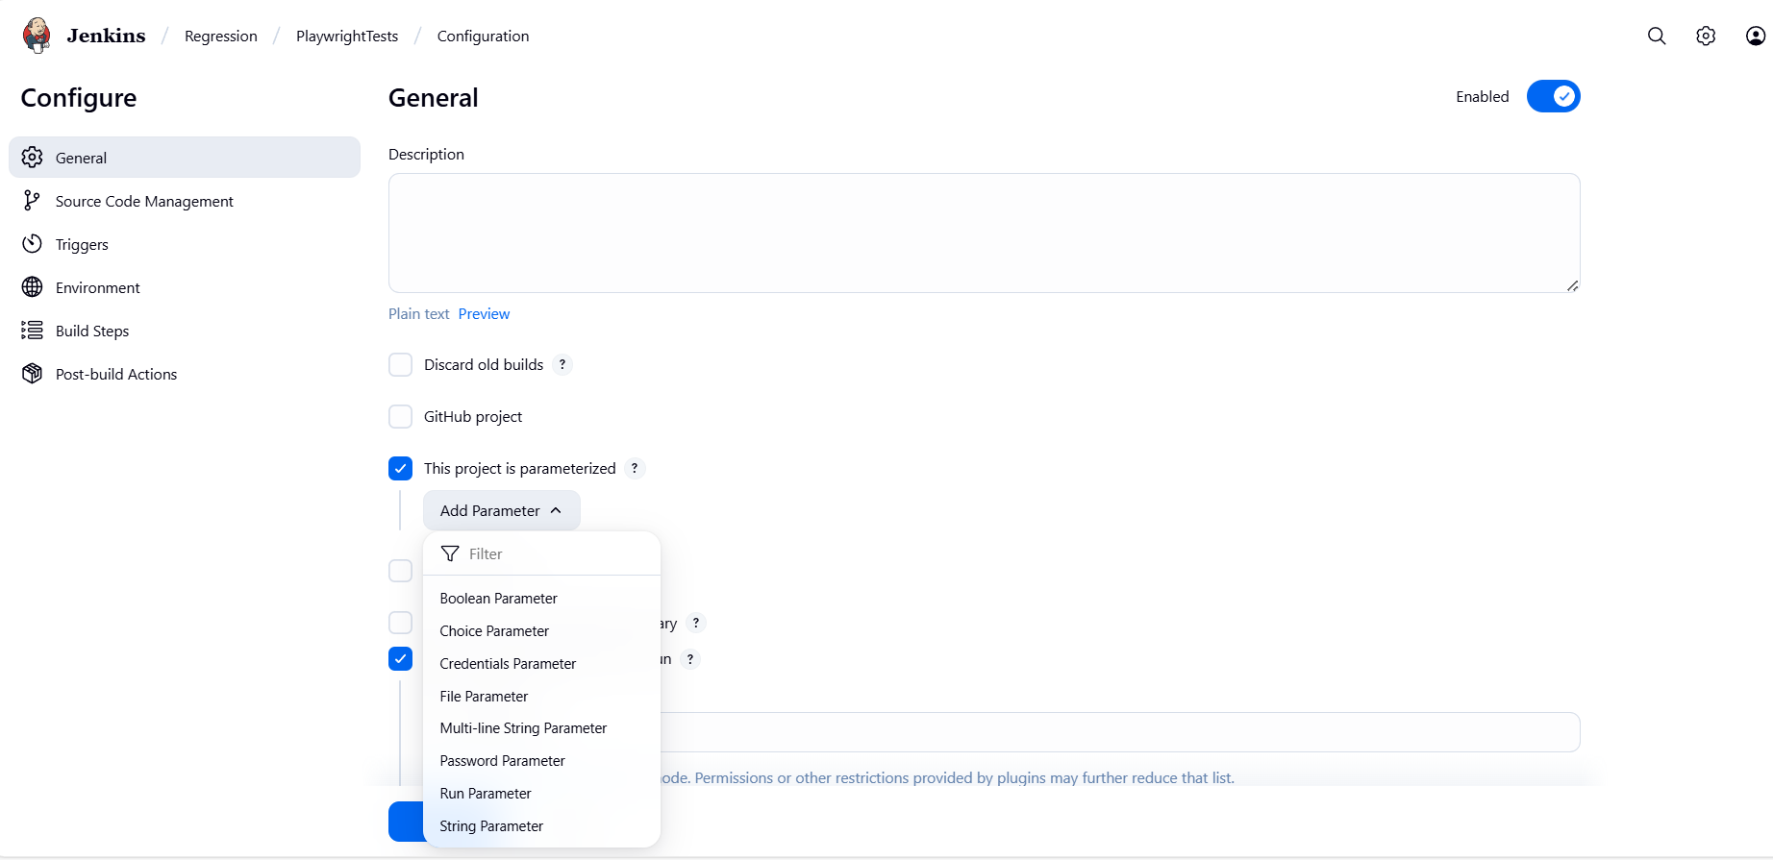
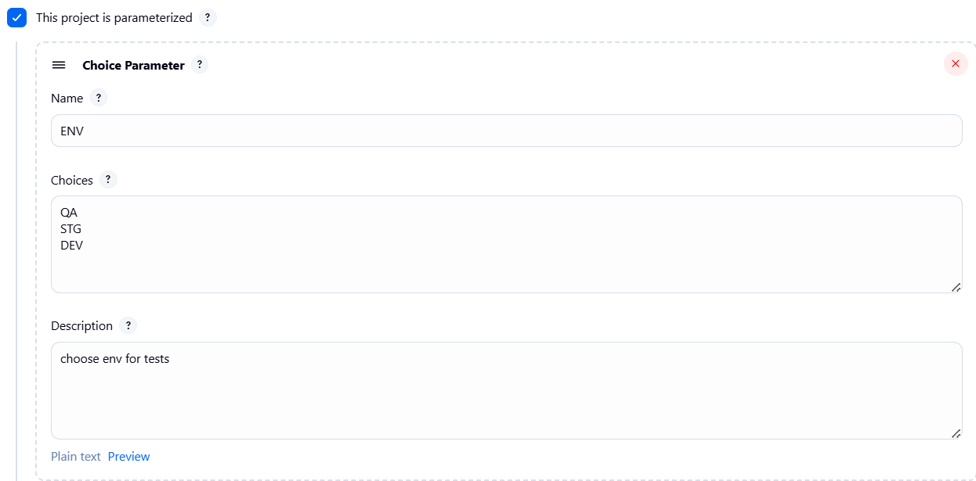
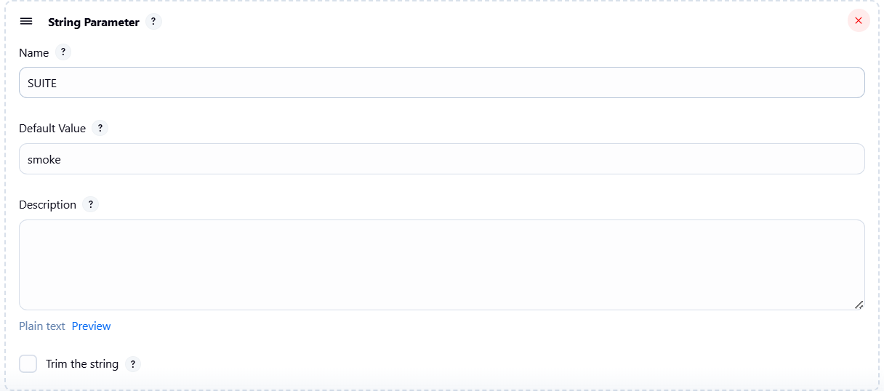
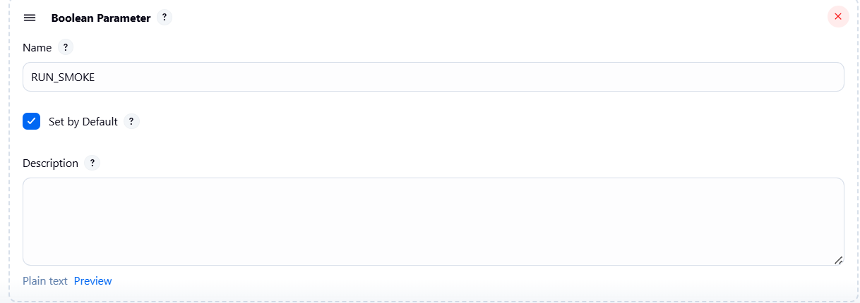
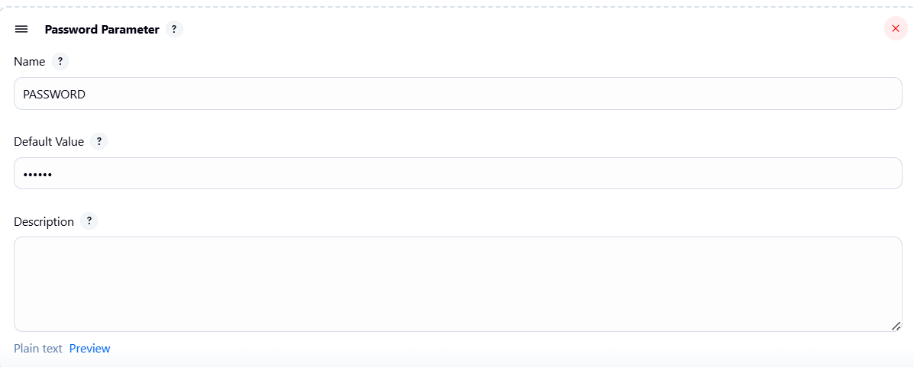

Once u add all parameters then save the job and then in LHS of job u will see “Build with Parameters” option -> click on it and u can select values from dropdown and enter values in textbox
