Assignment 5: Real Project
Build a simple blog:
- Backend API (Flask) with SQLite database
- Store database file in volume
- Use custom network
- Document everything
- Push all images to Docker Hub
Backend API (Flask) with SQLite database:
I created one directory called blog. Inside blog directory I have created two files called 1) app.py 2) requirement.txt
app.py
from flask import Flask, request, jsonify
import sqlite3
from datetime import datetime
import os
app = Flask(__name__)
# Database path (IMPORTANT for Docker Volume later)
DB_PATH = "/data/blog.db"
# ---------- Database Helper ----------
def get_db_connection():
os.makedirs("/data", exist_ok=True) # ensure folder exists
conn = sqlite3.connect(DB_PATH)
conn.row_factory = sqlite3.Row
return conn
# ---------- Create Table ----------
def init_db():
conn = get_db_connection()
cursor = conn.cursor()
cursor.execute("""
CREATE TABLE IF NOT EXISTS posts (
id INTEGER PRIMARY KEY AUTOINCREMENT,
title TEXT NOT NULL,
content TEXT NOT NULL,
created_at TEXT NOT NULL
)
""")
conn.commit()
conn.close()
# ---------- Routes ----------
@app.route("/")
def home():
return {"message": "Blog API is running"}
# Add new blog post
@app.route("/posts", methods=["POST"])
def add_post():
data = request.get_json()
title = data.get("title")
content = data.get("content")
if not title or not content:
return {"error": "Title and content required"}, 400
conn = get_db_connection()
cursor = conn.cursor()
cursor.execute(
"INSERT INTO posts (title, content, created_at) VALUES (?, ?, ?)",
(title, content, datetime.now().isoformat())
)
conn.commit()
conn.close()

return {"message": "Post added successfully"}, 201
# Get all blog posts
@app.route("/posts", methods=["GET"])
def get_posts():
conn = get_db_connection()
cursor = conn.cursor()
cursor.execute("SELECT * FROM posts ORDER BY id DESC")
rows = cursor.fetchall()
conn.close()
posts = []
for row in rows:
posts.append({
"id": row["id"],
"title": row["title"],
"content": row["content"],
"created_at": row["created_at"]
})
return jsonify(posts)
# ---------- App Start ----------
if __name__ == "__main__":
init_db()
app.run(host="0.0.0.0", port=5000)

Now I have created one Dockerfile:
FROM python:3.11-slim
# Set working directory inside container
WORKDIR /app
# Copy dependency file first (for better caching)
COPY requirements.txt .
# Install Python dependencies
RUN pip install --no-cache-dir -r requirements.txt
# Copy application code
COPY app.py .
# Create folder for SQLite DB (will be volume later)
RUN mkdir -p /data
# Expose Flask port
EXPOSE 5000
# Start Flask app
CMD ["python", "app.py"]
Now I have built one image: docker build -t blog1 .
Now I need to create one volume and store the database inside volume
Volume Location: /var/lib/docker/volumes
docker volume create volumename – docker volume create blog_volume
docker run -td --name blog-api -p 5000:5000 -v blog_volume:/data blog1
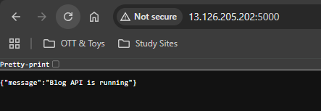
Now I don’t need to login to any container because SQLite is not a database it’s a API – so I need to give like this:
curl -X POST http 13.126.205.202:5000/posts \
-H "Content-Type: application/json" \
-d '{"title":"My First Blog","content":"Hello from Docker Volume"}'
curl http://13.126.205.202:5000/posts
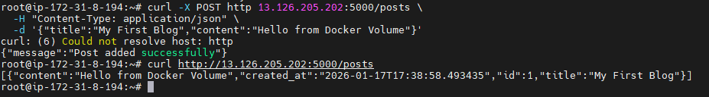
Now I need to delete the container: docker rm -f blog-api
Now I am creating one new container:
docker run -td --name blog-api2 -p 5000:5000 -v blog_volume:/data blog1
curl http://13.126.205.202:5000/posts
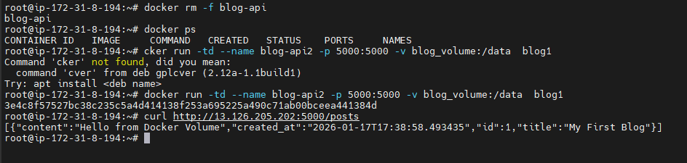
Now I need to create one Custom Network: docker network create blog-network
Now I have deleted the old container: docker rm -f <container_ID>
Command to write with both volume and network:
docker run -td --name blog-api --network blog-network -p 5000:5000 -v blog_volume:/data blog1
Now need to test the API:
curl -X POST http://13.126.205.202:5000/posts \
-H "Content-Type: application/json" \
-d '{"title":"Network Test","content":"Running inside custom network"}'
curl http:// 13.126.205.202:5000/posts
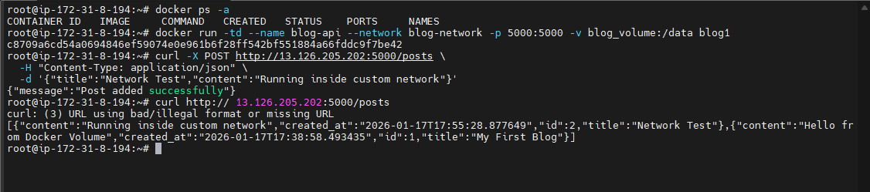
Now need to push the image to the docker hub repository – for that need to tag the image and then push it:
docker tag blog1 krishnan92/blog-api
docker push krishnan92/blog-apib
