Assignment 1: Build a Web App
Create a Flask app that shows:
- Your name
- Current date and time
- A list of your favorite movies
Package it in Docker and push to Docker Hub.
Created one Ubuntu (22.04) machine included security group as 5000 and installed – Python, Pip3 and Flask.
In ubuntu machine opened as Sudo Admin and commands to install the mentioned application
sudo apt update
sudo apt install -y python3 python3-pip
pip3 install flask
python3 -c "import flask; print(flask.__version__)"
pip3 install --upgrade pip
code for app.py
from flask import Flask
from datetime import datetime
app = Flask(__name__)
@app.route("/")
def home():
name = "Harikrishnan"
current_time = datetime.now().strftime("%d-%m-%Y %H:%M:%S")
movies = ["Interstellar", "Inception", "Bahubali", "Avengers"]
return f"""
<h1>Welcome</h1>
<p><b>Name:</b> {name}</p>
<p><b>Current Date & Time:</b> {current_time}</p>
<h3>Favorite Movies:</h3>
<ul>
<li>{movies[0]}</li>
<li>{movies[1]}</li>
<li>{movies[2]}</li>
<li>{movies[3]}</li>
</ul>
"""
if __name__ == "__main__":
app.run(host="0.0.0.0", port=5000)
vi Dockerfile
docker build -t app .
=====================================
FROM python:3.8-slim
WORKDIR /app
COPY requirements.txt .
COPY app.py .
RUN pip install -r requirements.txt
EXPOSE 5000
CMD ["python", "app.py"]
docker login (enter dockerhub credentials)
docker tag app krishnan92:app
docker push krishnan92/dummy_repository:app
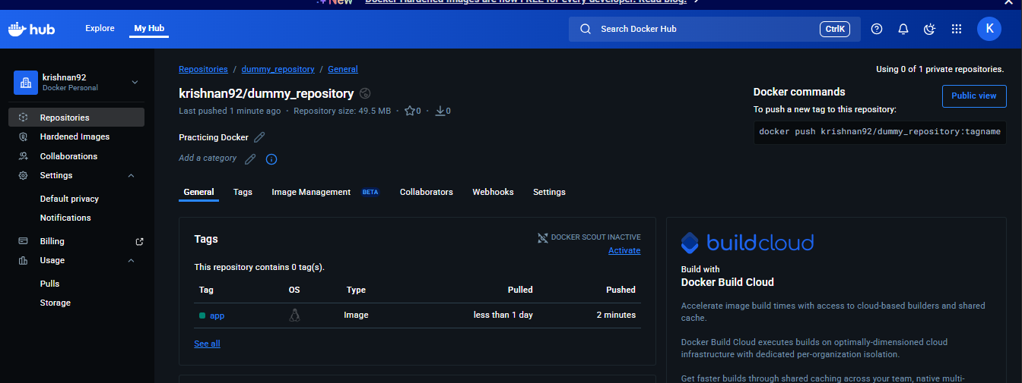
I can see the image is pushed to DockerHub

Assignment 2: Database with Volume
- Run a PostgreSQL container with a volume
- Create a table and add data
- Delete the container
- Start new container with same volume
- Verify data is still there
Volume Location: /var/lib/docker/volumes
Run a PostgreSQL container with a volume:
Command to Create a Volume: docker volume create pgdata
docker run -d --name postgres-db -e POSTGRES_USER=admin -e POSTGRES_PASSWORD=admin123 -e POSTGRES_DB=testdb -v pgdata:/var/lib/postgresql/data postgres:15
docker exec -it postgres-db psql -U admin -d testdb
Inside the container – need to give this
CREATE TABLE employees (
id SERIAL PRIMARY KEY,
name VARCHAR(50),
role VARCHAR(50)
);
INSERT INTO employees (name, role)
VALUES ('Hari', 'DevOps Engineer');
SELECT * FROM employees;
Now need to stop and remove the container:
docker stop postgres-db
docker rm postgres-db
Then need to check the volume: docker volume ls
Need to create one new container:
docker run -td --name postgres-db-new -e POSTGRES_USER=admin -e POSTGRES_PASSWORD=admin123 -e POSTGRES_DB=testdb -v pgdata:/var/lib/postgresql/data postgres:15
docker exec -it postgres-db-new psql -U admin -d testdb

Now the data is available inside the New Container
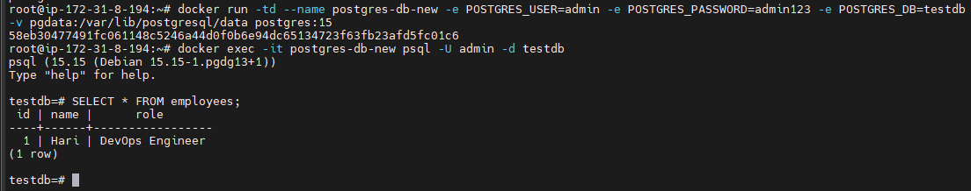

Assignment 3: Multi-Container
Create two apps:
- Backend API (returns random jokes)
- Frontend (calls backend and displays joke)
Both on same custom network.
Need to create Network - docker network create joke-network
docker network ls
mkdir joke-backend
cd joke-backend
in joke-backend directory – created one app.py file
from flask import Flask, jsonify
import random
app = Flask(__name__)
jokes = [
"Why do DevOps engineers love Docker? Because it always ships!",
"Why did Kubernetes break up with Docker? It found containerd.",
"Why did the developer go broke? Because he used up all his cache.",
"Why do programmers prefer dark mode? Because light attracts bugs."
]
@app.route("/joke")
def joke():
return jsonify({"joke": random.choice(jokes)})
if __name__ == "__main__":
app.run(host="0.0.0.0", port=5000)
Created requirements.txt file and entered flask
Then created one Docker File – called vi Dockerfile
FROM python:3.10-slim
WORKDIR /app
COPY requirements.txt .
RUN pip install -r requirements.txt
COPY app.py .
EXPOSE 5000
CMD ["python", "app.py"]
Then Build backend image: docker build -t joke-backend .
Now need to run backend container on custom network
docker run -td --name joke-backend --network joke-network joke-backend
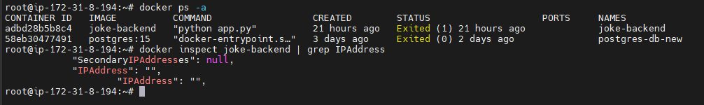
In the above screenshot we can see there is no IP address – because in custom networks, Docker provides automatic DNS.
So, containers can talk using container name instead of IP.
Now we need to create directory for front end:
mkdir joke-frontend
cd joke-frontend
inside frontend directory we need to create python app
from flask import Flask
import requests
app = Flask(__name__)
@app.route("/")
def home():
res = requests.get("http://joke-backend:5000/joke")
joke = res.json()["joke"]
return f"<h1>Random Joke 😂</h1><p>{joke}</p>"
if __name__ == "__main__":
app.run(host="0.0.0.0", port=3000)
And create one file called requirements.txt and enter
flask
requests
Now need to create Dockerfile
FROM python:3.10-slim
WORKDIR /app
COPY requirements.txt .
RUN pip install -r requirements.txt
COPY app.py .
EXPOSE 3000
CMD ["python", "app.py"]
Now need to build one image from the Docker file - docker build -t joke-frontend .
docker run -td --name joke-frontend --network joke-network -p 3000:3000 joke-frontend
Now we can see the below output if we paste the instance URL http://<EC2-PUBLIC-IP>:3000

The front end and Backend are in same network.

Assignment 4: Network Comparison
Run the same app on:
- Bridge network
- Host network
- Custom network
Document differences in access and performance
- Bridge Network
docker run -td --name backend-bridge joke-backend
docker run -td -p 3000:3000 --name frontend-bridge joke-frontend
Frontend tried to connect but container name won’t resolve in default bridge.
- Host Network
docker run -td --network host --name backend-host joke-backend
docker run -td --network host --name frontend-host joke-frontend
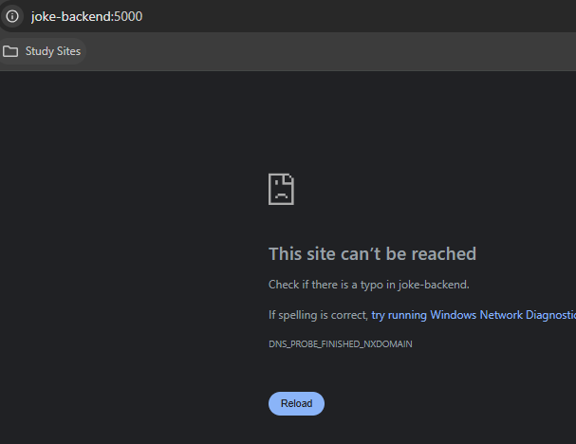
- Custom Network – I have deleted all the Images and Container to practice Custom Network
Since I deleted all the images and container – now I am going to build two images.
cd joke-backend
docker build -t joke-backend .
cd ..
cd joke-frontend
docker build -t joke-frontend .
Create Network: docker network create joke-network
docker run -d --name joke-backend --network joke-network joke-backend
docker run -d --name joke-frontend --network joke-network -p 3000:3000 joke-frontend
