**Spike:** 7

**Title:** Emergent Group Behaviour

**Author:** Steven Efthimiadis, 1627406

**Goals / deliverables:**

Create agent group behaviour which must be affected by group steering forces

* Include steering behaviours
  + Cohesion
  + Separation
  + Alignment
* Use a weighted sum to combine these steering forces
* Apply the weighted sum on top of the wandering behaviour
* Ability to adjust each parameter when the program is running

**Technologies, Tools, and Resources used:**

* Knowledge of python
  + <https://docs.python.org/3/tutorial/>
* Python Interpreter
  + Visual Studio
    - <https://www.visualstudio.com/downloads/>
* Knowledge of how an agents can interact in groups
  + <https://ilearn.swin.edu.au/bbcswebdav/pid-6302928-dt-content-rid-34403398_2/courses/2017-HS1-COS30002-220387/Autonomously%20Moving%20Agents.ppt.pdf>

**Tasks undertaken:**

* Created a function which groups agents together.
  + Must be within a radius of agent 0
  + Change colours once in the radius
* Created force variables for separation, cohesion and alignment within the world.
* Created functions for separation, cohesion and alignment
* Added each force individually to the agent.
  + Then applied the amount force from the world to increase/ decrease the factor of each force
* Added the ability to increase/ decrease each of the forces and radius

**What we found out:**

* The agents will wander around until they are within the radius of agent 0
  + Once they become neighbours they change to the colour blue
  + When they leave the neighbourhood, they turn back to orange
* You can increase and decrease the radius and the separation/ cohesion / alignment forces
* When you increase the separation force:
  + If an agent wanders into the radius. Bot agents react and separate
  + If there are multiple agents, they all go separate ways
  + When the separation factor is high enough the agents will be frozen to avoid people
* When you increase alignment:
  + If an agent wanders into the radius it aligns itself with agent 0
  + These agents traverse north east across the world
* When you increase cohesion:
  + When an agent wanders into the radius it will aligns it’s heading with agent 0
* For the best result you need to apply all forces and have 2 dominate behaviours which will show a better group behaviour on how each behaviour affects the agent individually

**Open issues/ Risks:**

* When you increase the separation factor, agent 0 likes to hide in the corners of the world if the world is made larger 800x600
* In cohesion it looks like they have an increased jitter value even when you don’t increase it
* Make sure you’re applying the forces to the agent

**Notes:**

Agent Modes

1. Seek (default)
2. Neighbourhood

Key Binds

A – Append agent

Q – Increase separation

W – Decrease separation

E – Increase cohesion

R – Decrease cohesion

T – Increase alignment

Y – Decrease alignment

U – Increase radius

I – Decrease radius

O – Reset to beginning values

J – Show agent information

# Appendix

### Figure 1.1 Separation

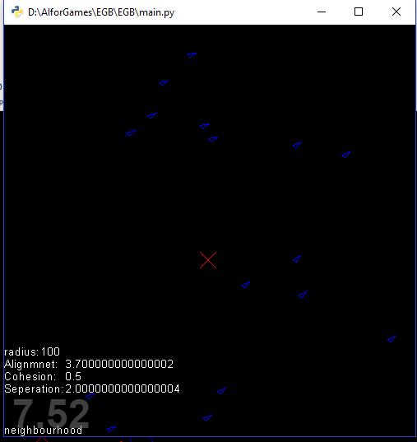

As we see from above when you apply separation and alignment together. The agents still align to the top right but are outside each other’s personal space

### Figure 1.2.1 Cohesion

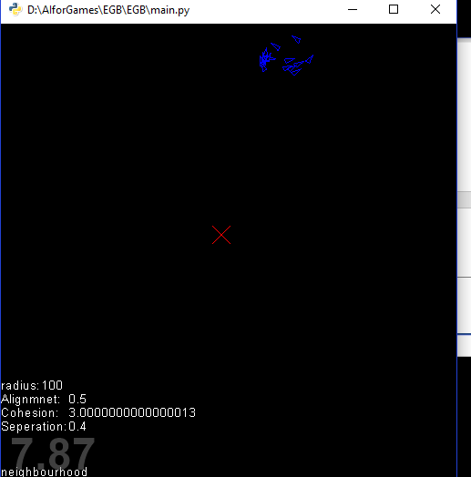

When you just apply cohesion to the agents they will still wander around trying to finds the centre point

### Figure 1.3 Alignment

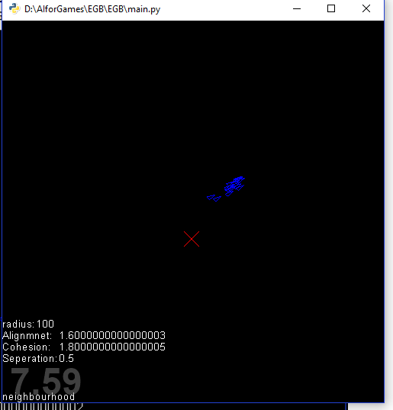

When you apply alignment, and add cohesion to it. You will notice that the agents group together and align to the top right corner