**Spike:** 11

**Title:** Tactical Analysis with Planet Wars

**Author:** Steven Efthimiadis, 1627406

**Goals / deliverables:**

Create two different bots for planet wars

* Create a Simple Bot that:
  + Must have a basic ability to attack the weakest, strongest, closest or most productive planet
* Create a Complex Bot that:
  + Event Detection
  + Scouting
  + Fog of War Deception
* Compare each bot over a number of maps and present the results over the performance of both

**Technologies, Tools, and Resources used:**

* Knowledge of python
  + <https://docs.python.org/3/tutorial/>
* Python Interpreter
  + Visual Studio
    - <https://www.visualstudio.com/downloads/>

**Tasks undertaken:**

* For the Simple Bot, I used the one I made during the Planet Wars lab.
* The Complex Bot can
  + Buff its own planets if they become weak
  + Attack the most productive planets to gain a quick advantage
* Conducted 4 games
  + Two maps that had the planets spread
  + Two maps with groups of planets
* Added more functionality to the Complex Bot
  + Can divert to other planets if they have a lower amount of ships and are within range
  + If you attack the same planet twice and can’t take over it
    - Find the most productive neutral planet
    - If no more neutral attack the planet with the least number of enemy fleets
* Conducted 2 games
  + Two randomly chosen maps to reduce any bias attemps

**What we found out:**

Player 1 – Red/ Simple Bot

Player 2 – Brown/Complex Bot

# Game 1 - Map 12

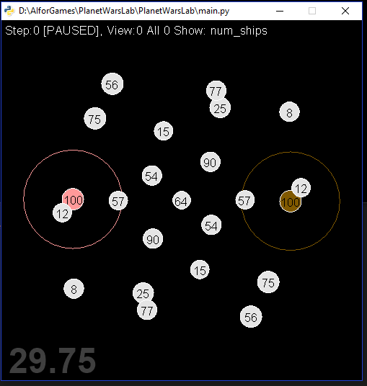

This game didn’t last long. The Simple Bot which attacks the smallest planets which slowly started to take over the map. The Complex bot attacked the home planet of the Simple Bot. Due to there being a large gap between the planets. The defending planet could build up enough fleets to stop an invasion. So after 12 turns the Simple Bot won because the Complex Bot couldn’t take over any planets

# Game 2 – Map 52

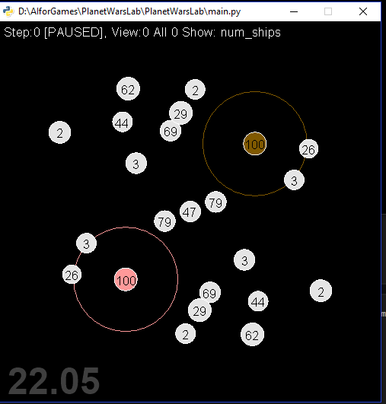

This game was more competitive than the first. Even though there was still a good distance between the planets are separated into smaller groups which gave the Complex bot an advantage. It took 4 turns to invade the Simple Bot’s home planet it was then able to use this an advantage and have two high producing planets. The game lasted 34 turns which the Complex bot took over the map because it had enough fire power to take over the map and defend itself when required. The Simple Bot couldn’t handle losing its home planet in the early game.

# Game 3 – Map 87

On this map, the you would believe that the Simple bot would win due to the distance between the home planets but the most productive planet isn’t any of the home planets. It’s the one in the middle. Yes, the neutral planet on 58. So, the Complex Bot was slowly able to take over the map because the other planets were grouped closely so it could constantly send fleets around the map and take over while the Simple Bot struggled to keep up because it didn’t have enough planets to survive

# Game 4 – Map 96

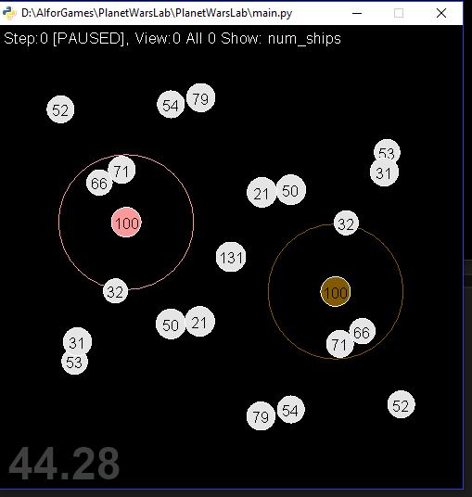

Just by looking at this, I would assume that the Complex Bot would win due to have a smaller distance between home and the planets are in small groups. It turned out differently than I thought. Due to the Simple bot sending two fleets to the Complex Bot’s home planet. The Complex Bot took a hit and was never able to recover and take over the Simple Bot’s home planet due to not having enough fleets to survive 12 rounds

**What does this mean:**

After going though these maps we see a pattern emerging. When the two home planets are far apart. The Simple Bot will most likely win barring a neutral planet having the best production rate. So to improve on the Complex Bot a planet detection system should be used so it can have a chance to grind out a win or last until the end game.

**Something Extra:**

After fiddling with the code, I could figure out how to make fleets deviate to other planets within a certain range. The fleet will analyse all the planets and if a planet is within range and it has less ships than fleet. Then it will check if the fleets destination has a higher amount of ships than the planet. Then I added a feature where it would detect if it has attacked the same planet twice it would choose the best growth neutral planet and if there are none left attack the enemy’s planet with the smallest amount of ships

# Game 5 – Map 15

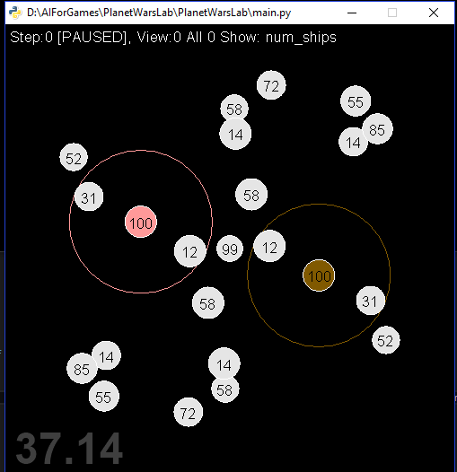Now the Complex Bot has been improved we can test it to see how it can cope with the update. The first thing we notice is that as the fleets are traveling they deviate if the original destination has more ships than the planet it passes. This is a tactical advantage because you can divert from your original path and with a map which has small clusters of planets it increases your chances of surviving the early game if you don’t have many home planets. As the game progresses we see that the Complex bot starts to take over the map and change destinations quite a bit. Once the Complex Bot has established a few planets it continues looking for the best growth planets and eventually takes over the map because the Simple Bot can’t handle the constant direction changing of the enemy fleets. This test has shown that the Complex Bot has a great advantage but to make sure it works well I have conducted another game.

# Game 6 – Map 56

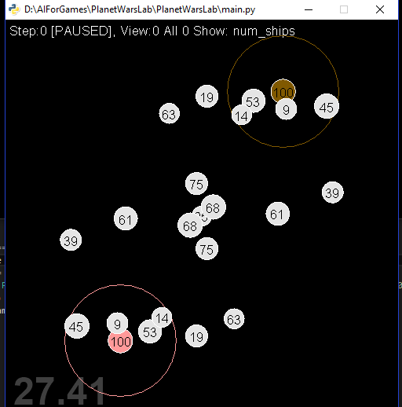

In previous attempts, we make the judgement that the Complex Bot will lose because the origin planets are so far away. But with the updated bot we can say the Complex Bot will win because within the first few fleets we can see the it will take over at least 3 planets within the first 5 turns and start to fortify its defences. As the game progresses we see the trend that the Complex Bot takes over the whole field while the Simple Bot struggles to keep up with the pace and eventually loses

After conducting all these games, I have concluded that the Complex Bot can defend most simple bots (even though it has won all games there might be a scenario it could lose). With the ability to change destination planets and buff week planets I believe this bot will be able to hold its own against other complex bots and possibly win depending on what happens in the early/ late game.

# Appendix

### Game 1 – Map 13 Logs

<https://github.com/1993Batman/AIforGames/tree/master/PlanetWarsLab/Logs/Game%201-%20map%2012/logs>

### Game 2 – Map 52 Logs

<https://github.com/1993Batman/AIforGames/tree/master/PlanetWarsLab/Logs/Game2-%20map%2052/logs>

### Game 3 – Map 87 Logs

<https://github.com/1993Batman/AIforGames/tree/master/PlanetWarsLab/Logs/Game3-%20map%2087/logs>

### Game 4 – Map 96 Logs

<https://github.com/1993Batman/AIforGames/tree/master/PlanetWarsLab/Logs/Game4-%20map%2096/logs>

### Game 5 – Map 15 Logs

<https://github.com/1993Batman/AIforGames/tree/master/PlanetWarsLab/Logs/Game5-%20map15/logs>

### Game 6 – Map 56 Logs

<https://github.com/1993Batman/AIforGames/tree/master/PlanetWarsLab/Logs/Game6%20-%20map%2056/logs>