**Spike:** 1

**Title:** Goal Oriented Behaviour with Simple Goal Insistence

**Author:** Steven Efthimiadis, 1627406

**Goals / deliverables:**

Create a simulation of a GOB using SGI.

* Code that simulates and displays the GOB using SGI
  + Demonstrate where SGI works appropriately
  + Demonstrate where SGI doesn’t work appropriately

**Technologies, Tools, and Resources used:**

* Knowledge of python
  + <https://docs.python.org/3/tutorial/>
* Python Interpreter
  + Visual Studio
    - <https://www.visualstudio.com/downloads/>
* Knowledge of how game loops work
  + <http://gameprogrammingpatterns.com/game-loop.html>

**Tasks undertaken:**

* Added a best action before you loop though the actions for comparing each action
* Compare each action and determine which action will used
  + See which one will drop the value down by the most
  + See if the action will be equal or greater than 0
* Once an action is found complete the action

**What we found out:**

Good SGI

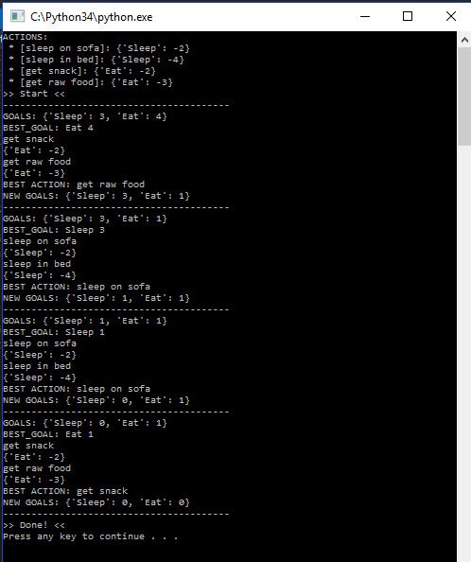

If we look at figure on the left, we see that the program can determine which action is best.

Now we notice that when you sleep you should be able to sleep in bed and knock of sleep in one hit. But you can’t because you need to have a value which is greater or equal to 0.

If you look at the code in Appendix (figure 1.1) we see that if the action has a value greater than the current best action’s value; it will check to see if the action’s value will drop your goal to under 0. If so than it’s not the best action. If it’s above 0 than it’s the best action.

Bad SGI

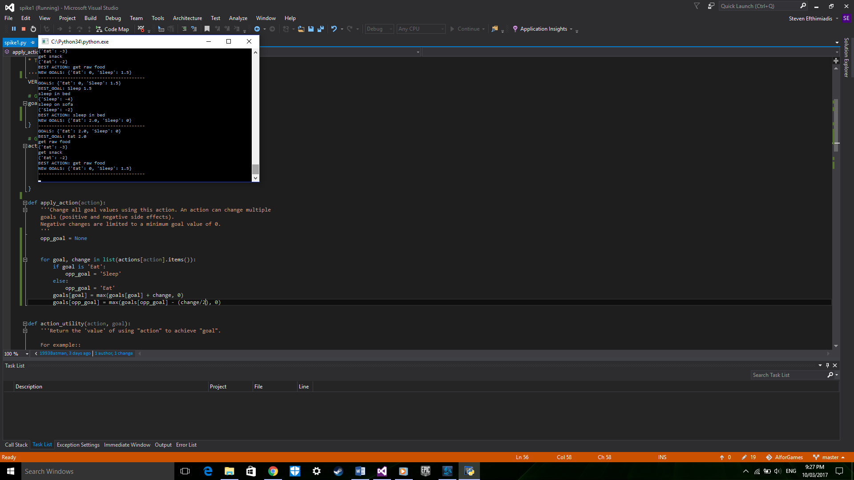

If you look at the picture on the left. You see that there is an endless loop which keeps repeated because as you sleep you get hungry and when you eat you get sleepy.

If you look at the code in the Appendix (figure 1.2) you see that you get half of what the change would be for the current goal added to the other goal so essentially you never completely full or tired.

# Appendix

### Figure 1.1 Code for selecting best action1

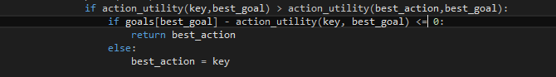

### Figure 1.2 Code for

