**元 智 大 學**

資 訊 工 程 學 系

碩 士 論 文

**Stock Market Prediction using Deep Learning Neural Networks and Candlestick Chart**

研 究 生：郭祿丁

指導教授：歐昱言 博士

中華民國 107 年 7 月

**Stock Market Prediction using Deep Learning Neural Networks and Candlestick Chart**

研 究 生 ：郭祿丁 Student : Rosdyana Mangir Irawan Kusuma

指 導 教 授 ：歐 昱 言 博士 Advisor : Dr. Yu-Yen Ou

元 智 大 學

資 訊 工 程 學 系

碩 士 論 文

A Thesis

Submitted to Department of Computer Science and Engineering

Yuan Ze University

in Partial Fulfillment of the Requirements

for the Degree of Master of Science

in

Computer Science and Engineering

July 2018

Chungli, Taiwan, Republic of China.

中華民國 107 年 7 月

Stock Market Prediction using Deep Learning Neural Networks and Candlestick Chart

**Student: Rosdyana Mangir Irawan Kusuma Advisor: Dr. Yu-Yen Ou**

Submitted to Department of Computer Science and Engineering

College of Informatics

Yuan Ze University

# ABSTRACT

Stock market prediction is still a challenging problem because there are many factors effect to the stock market price such as company news and performance, industry performance, investor sentiment, social media sentiment and economic factors. This thesis explores the predictability in the stock market using Deep Convolutional Network and candlestick charts. The outcome is utilized to design a decision support framework that can be used by traders to provide suggested indications of future stock price direction. We perform this work using various types of neural networks like convolutional neural network, residual network and visual geometry group network. From stock market historical data, we converted it to candlestick charts. After that, these candlestick charts will be feed as input for training a Convolution neural network model. This Convolution neural network model will help us to analyze the patterns inside the candlestick chart and predict the future movements of stock market. Using Taiwan 50 and Indonesian 10 stock market historical time series data, our proposed method achieved a promising results- 92.2 % and 92.1 % accuracy for Taiwan and Indonesia stock market respectively. Our performance results significantly outperform the existing methods.

Keywords: *Stock Market Prediction, Neural Network, Residual Network, Candlestick Chart*

# Acknowledgements

I would like to dedicate this thesis to Allah Subhanahu wa ta’ala, for your help through all the difficulties. A special thanks to my wife, my family, my lab mates, all the Yuan Ze University teachers and friends that I have ever met during my study in Taiwan.

I would like to express my gratitude for the supervision of my advisor, Dr. Yu-Yen Ou who suggested an interesting research topic to me. Moreover, gave me clear direction to make this paper possible. You have been a tremendous teacher for me during my study especially for your support, guidance, corrections, encouragement and advices. I would also like to thank my thesis committee for the insightful comments and advice.

Finally, I would like to acknowledge the generous financial support of Yuan Ze University’s Department of Computer Science and Engineering. Which has illuminated my long-lasting dream of obtaining a Master Degree in Computer Science and Engineering.

# Table of Contents

ABSTRACT iii

Acknowledgements iv

Table of Contents v

Table of Figures vii

Table of Tables viii

Chapter 1 Introduction 1

1.1. Background 1

1.1.1 Candlestick Chart 2

1.1.2 Candlestick Pattern 3

1.2. Related work 7

Chapter 2 Data Collection 9

2.1. Data Collection using Yahoo! Finance 9

2.2. Feature Investigation 12

2.2.1. Opening Price 13

2.2.2. Closing Price 13

2.2.3. Highest Price 13

2.2.4. Lowest Price 14

2.2.5. Volume 14

2.3. Data Preprocessing 14

Chapter 3 Methodology 16

3.1. Chart Encoding 17

3.2. Binary Classification 18

3.3. Learning Algorithm 18

3.3.1. Convolutional Neural Network 18

3.3.2. Residual Network 20

3.3.3 VGG Network 22

3.3.4 Random Forest 23

3.3.5 K-Nearest Neighbors 24

3.4. Performance Evaluation 25

Chapter 4 Experimental Results and Discussion 26

4.1. Classification for Each Stock Market 26

4.1.1 Classification for Taiwan 50 dataset 26

4.1.2 Classification for Indonesia 10 dataset 31

4.2. Independent testing result 35

4.3. Comparison 37

Chapter 5 Conclusion and Future Works 40

References 41

# Table of Figures

**Figure 1** – Candlestick formation of bearish and bullish. 3

**Figure 2** – Yahoo! Finance website, provide an API to download historical time series data 12

**Figure 3** - General way to visualizing the candlestick chart 15

**Figure 4** – Our methodology design 16

**Figure 5** – Proposed candlestick chart without volume indicator in different period time and size. 17

**Figure 6** - Proposed candlestick chart with volume indicator in different period time and size. 17

**Figure 7** - Logic statement of our binary classification 18

**Figure 8** - A regular 3-layer Neural Network 19

**Figure 9** – ResNet Architecture shows many layers for different configuration 21

**Figure 10** – The residual module in ResNet as originally proposed by (He, Zhang et al. 2016) 22

# Table of Tables

**Table 1** – Simple candlestick patterns 4

**Table 2** – Complex candlestick patterns 5

**Table 3** – List of 50 companies from Taiwan stock market taken on March 17th 2018, this group of companies called TW50. Currency value using Taiwan dollar. 9

**Table 4** – List of 10 companies of Indonesia stock market taken on March 17th 2018. This list named ID 10. Currency value using Indonesian Rupiah. 11

**Table 5 -** The period time of our dataset, separated between the training and testing 11

**Table 6** – Number of dataset following their period of trading days 15

**Table 7** – CNN configuration from our proposed method. 20

**Table 8** - Residual Network proved that this network have the most minimum error-rate 22

**Table 9** – VGG network configuration from (Simonyan and Zisserman 2014) 23

**Table 10** – Result of 5 period with volume indicator in 50-dimension image for Taiwan 50. 26

**Table 11** – Result of 10 period with volume indicator in 50-dimension image for Taiwan 50. 27

**Table 12** – Result of 20 period with volume indicator in 50-dimension image for Taiwan 50. 27

**Table 13** – Result of 5 period with volume indicator in 20-dimension image for Taiwan 50. 27

**Table 14** – Result of 10 period with volume indicator in 20-dimension image for Taiwan 50. 27

**Table 15** – Result of 20 period with volume indicator in 20-dimension image for Taiwan 50. 28

**Table 16** – Result of 5 period without volume indicator in 50-dimension image for Taiwan 50. 28

**Table 17** – Result of 10 period without volume indicator in 50-dimension image for Taiwan 50. 28

**Table 18** – Result of 20 periods without volume indicator in 50-dimension image for Taiwan 50. 29

**Table 19** – Result of 5 periods without volume indicator in 20-dimension image for Taiwan 50. 29

**Table 20** – Result of 10 periods without volume indicator in 20-dimension image for Taiwan 50. 29

**Table 21** – Result of 20 periods without volume indicator in 20-dimension image for Taiwan 50. 29

**Table 22** – Summary result of Taiwan 50 with their best classifier for each trading days and image dimension with volume indicator. 30

**Table 23** – Summary result of Taiwan 50 with their best classifier for each trading days and image dimension without volume indicator. 30

**Table 24** – Result of 5 periods with volume indicator in 50-dimension image for Indonesia 10. 31

**Table 25** – Result of 10 periods with volume indicator in 50-dimension image for Indonesia 10. 31

**Table 26** – Result of 20 periods with volume indicator in 50-dimension image for Indonesia 10. 31

**Table 27** – Result of 5 periods with volume indicator in 20-dimension image for Indonesia 10. 32

**Table 28** – Result of 10 periods with volume indicator in 20-dimension image for Indonesia 10. 32

**Table 29** – Result of 20 periods with volume indicator in 20-dimension image for Indonesia 10. 32

**Table 30** – Result of 5 periods without volume indicator in 50-dimension image for Indonesia 10. 33

**Table 31** – Result of 10 periods without volume indicator in 50-dimension image for Indonesia 10. 33

**Table 32** – Result of 20 periods without volume indicator in 50-dimension image for Indonesia 10. 33

**Table 33** – Result of 5 periods without volume indicator in 20-dimension image for Indonesia 10. 34

**Table 34** – Result of 10 periods without volume indicator in 20-dimension image for Indonesia 10. 34

**Table 35** – Result of 20 periods without volume indicator in 20-dimension image for Indonesia 10. 34

**Table 36** – Summary result of Indonesia 10 with their best classifier for each trading days and image dimension with volume indicator. 35

**Table 37** – Summary result of Indonesia 10 with their best classifier for each trading days and image dimension without volume indicator. 35

**Table 38** – Independent test result for Taiwan50 using 0050.tw with volume indicator. 36

**Table 39** – Independent test result for Taiwan50 using 0050.tw without volume indicator. 36

**Table 40** – Independent test result for Indonesia10 using JKSE with volume indicator. 36

**Table 41** – Independent test result for Indonesia10 using JKSE without volume indicator. 36

**Table 42** – Comparison result with Khaidem, Saha et al. 2016 for Samsung stock market. 37

**Table 43** – Comparison result with Khaidem, Saha et al. 2016 for Apple stock market. 37

**Table 44** – Comparison result with Khaidem, Saha et al. 2016 for GE stock market. 38

**Table 45** – Comparison result with Patel, Shah et al. 2015 38

**Table 46** – Comparison result with Zhang, Zhang et al. 2018 39

# Chapter 1 Introduction

## 1.1. Background

The stock market is something that cannot be separated from modern human life. The Investment in stock market is a natural thing done by people around the world. They set aside their income to try their luck by investing in stock market to generate more profit. Traders are more likely to buy a stock whose value is expected to increase in the future. On the other hand, traders are likely to refrain from buying a stock whose value is expected to fall in the future. Therefore, an accurate prediction for the trends in the stock market prices in order to maximize capital gain and minimize loss is urgent demand. Besides, stock market prediction is still a challenging problem because there are many factors effect to the stock market price such as company news and performance, industry performance, investor sentiment, social media sentiment and economic factors. With the current technological advances, machine learning is a breakthrough in aspects of human life today and deep neural network has shown potential in many research fields. In this research, we apply different types of machine learning algorithms to enhance our performance result for stock market prediction using convolutional neural network, residual network, virtual geometry group network, k-nearest neighborhood and random forest.

Dataset format in machine learning can be different. Many kind of dataset format such as text sequence, image, audio, video, from 1D (one dimension) to 3D (three dimension) can be applicable for machine learning. Taken as an example, the image is used not only as an input for image classification, but also as an input to predict a condition. We take the example of Google DeepMind in their research in Alpha Go(Silver, Huang et al. 2016). Recently, they are successfully get a lot of attention in the research field. By using the image as their input, where the image represents a Go game board, which later this image dataset is used to predict the next step of the opponent in the Go game(Silver, Huang et al. 2016).

On the other occasion, from historical data of stock market converted into audio wavelength using deep convolutional wave net architecture can be applied to forecast the stock market movement(Borovykh, Bohte et al.).

Our proposed method in this work is using a candlestick chart from Taiwan and Indonesia stock market to predict the price movement. We utilized three trading period times to analyze the correlation between those period times with the result. Our proposed candlestick chart will represent the sequence of time series with and without the daily volume stock data. Our experiments conduct two kind of image sizes (i.e. 50 and 20 dimension) for candlestick chart to analyze the correlation of hidden pattern in various image size. Thereafter our dataset will be feed as input for several learning algorithms of random forest and k-nearest neighborhood as traditional machine learning, CNN, residual network and VGG network as our modern machine learning. The goal is to analyze the correlation of some parameters such as period time, image size, feature set with the movement of stock market to check whether it will be going up or going down in the next day.

### 1.1.1 Candlestick Chart

Candlestick chart is a style of financial chart used to describe the price movements for a given period of time. Candlestick chart is also called a Japanese candlestick chart because it has been developed in the 18th century by Munehisa Hooma, a Japanese rice trader of financial instruments (Morris 2006). Each candlestick typically shows one day of trading data, thus a month chart may show the 20 trading days as 20 candlestick charts. Candlestick chart is like a combination of line-chart and a bar-chart, while each bar represents all four important pieces of information for that trading day. It consists of the open, the close, the high and low price.

Candlesticks are usually composed of the real body, an upper and a lower shadow. If the opening price is higher than the closing price, then the real body will filled by red or black color. Otherwise, the real body will be drawn with green or white color. The upper and a lower shadow represent the high and low price ranges within a specified time period. However, not all candlesticks have a shadows. The Figure 1 given clear explanation about real body and the shadows in candlestick.

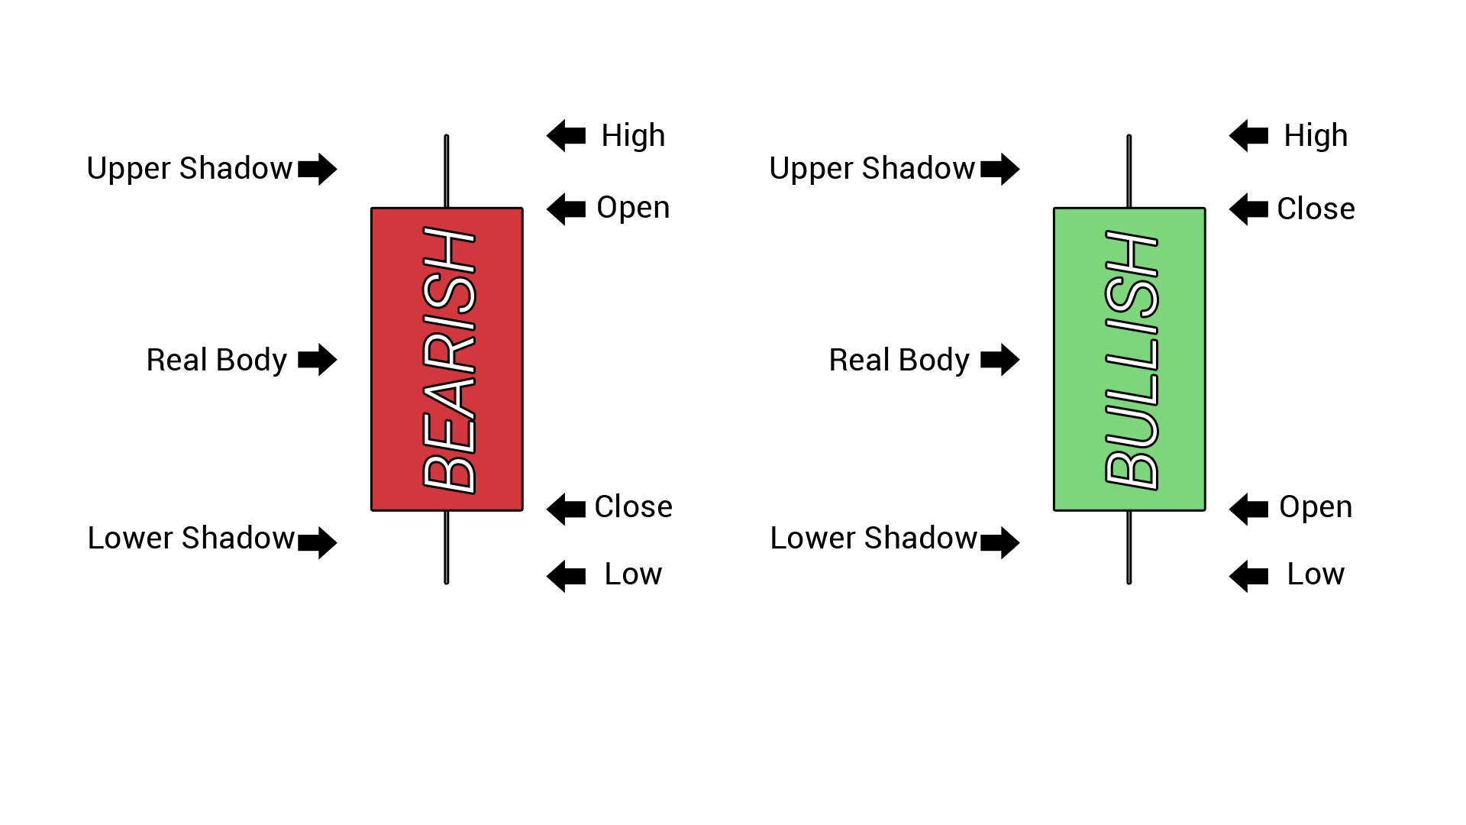

**Figure** 1 – Candlestick formation of bearish and bullish.

Candlestick chart are a visual aid for decision making in stock exchange. Each candlestick provides an easy-to-decipher picture of price action. Immediately a trader can compare the relationship between the open and close as well as the high and low. The relationship between the open and close is considered vital information and forms the essence of candlesticks. **Bullish** candlesticks, where the close is greater than the open, indicate buying pressure. **Bearish** candlesticks, where the close is less than the open, indicate selling pressure. It serves as a cornerstone of technical analysis. The main usage of a candlestick patterns is to identify trends. Looking at a candlestick, one can identify an asset’s opening and closing prices, highs and lows, and overall range for a specific time frame(Lu, Shiu et al. 2012).

### 1.1.2 Candlestick Pattern

In technical analysis, a candlestick pattern is a movement in prices shown graphically on a candlestick chart that some believe can predict a particular market movement. The recognition of the pattern is subjective and programs that are used for charting have to rely on predefined rules to match the pattern. Forty-one recognized patterns categorized into simple and complex patterns shown in Table 1 and Table 2 respectively.

**Table** 1 – Simple candlestick patterns

|  |  |  |
| --- | --- | --- |
| No | Name | Description |
| 1 | Big Black Candle | It has an unusually long black/red body with a wide range between high and low. Prices open near the high and close near the low. Considered as **bearish** pattern |
| 2 | Big White Candle | It has an unusually long white/green body with a wide range between high and low of the day. Prices open near the low and close near the high. Considered a **bullish** pattern. |
| 3 | Black Body | Formed when the opening price is higher than the closing price. Considered to be a **bearish** signal. |
| 4 | Doji | Formed when opening and closing prices are virtually the same. The lengths of shadows can vary. |
| 5 | Dragonfly Doji | Formed when the opening and the closing prices are at the highest of the day. If it has a longer lower shadow it signals a more **bullish** trend. When appearing at market bottoms it is considered to be a reversal signal. |
| 6 | Gravestone Doji | Formed when the opening and closing prices are at the lowest of the day. If it has a longer upper shadow it signals a **bearish** trend. When it appears at market top it is considered a reversal signal. |
| 7 | Long-Legged Doji | It consists of a Doji with very long upper and lower shadows. Indicates strong forces balanced in opposition. |
| 8 | Hanging Man | It consists of a small body near the high with a little or no upper shadow and a long lower tail. The lower tail should be two or three times the height of the body. Considered a **bearish** pattern during an uptrend. |
| 9 | Hammer | It consists of a small body near the high with a little or no upper shadow and a long lower tail. Considered a **bullish** pattern during a downtrend. |
| 10 | Inverted Black Hammer | A black/red body in an upside-down hammer position. Usually considered a bottom reversal signal. |
| 11 | Inverted Hammer | Candlestick in an upside-down hammer position. |
| 12 | Long Lower Shadow | Candlestick is formed with a lower tail that has a length of 2/3 or more of the total range of the candlestick. Normally considered a **bullish** signal when it appears around price support levels. |
| 13 | Long Upper Shadow | Candlestick with an upper shadow that has a length of 2/3 or more of the total range of the candlestick. Normally considered a **bearish** signal when it appears around price resistance levels. |
| 14 | Marubozu | A long or a normal candlestick with no shadow or tail. The high and the lows represent the opening and the closing prices. Considered a continuation pattern. |
| 15 | Shooting Star | Candlestick that has a small body, a long upper shadow and a little or no lower tail. Considered a **bearish** pattern in an uptrend. |
| 16 | Spinning Top | Candlestick with a small body. The size of shadows can vary. Interpreted as a neutral pattern but gains importance when it is part of other formations. |
| 17 | White Body | It formed when the closing price is higher than the opening price and considered a **bullish** signal. |
| 18 | Shaven Bottom | Candlestick with no lower tail. [Compare with Inverted Hammer.] |
| 19 | Shaven Head | Candlestick with no upper shadow. [Compared with hammer.] |

**Table** 2 – Complex candlestick patterns

|  |  |  |
| --- | --- | --- |
| No | Name | Description |
| 1 | Bearish Harami | It consists of an unusually large white body followed by a small black body (contained within large white body). It is considered as a **bearish** pattern when preceded by an uptrend. |
| 2 | Bearish Harami Cross | A large white body followed by a Doji. Considered as a reversal signal when it appears at the top. |
| 3 | Bearish 3-Method Formation | A long black body followed by three small bodies (normally white) and a long black body. The three white bodies are contained within the range of first black body. This is considered as a **bearish** continuation pattern. |
| 4 | Bullish 3-Method Formation | Consists of a long white body followed by three small bodies (normally black) and a long white body. The three black bodies are contained within the range of first white body. This is considered as a **bullish** continuation pattern. |
| 5 | Bullish Harami | Consists of an unusually large black body followed by a small white body (contained within large black body). It is considered as a **bullish** pattern when preceded by a downtrend. |
| 6 | Bullish Harami Cross | A large black body followed by a Doji. It is considered as a reversal signal when it appears at the bottom. |
| 7 | Dark Cloud Cover | Consists of a long white candlestick followed by a black candlestick that opens above the high of the white candlestick and closes well into the body of the white candlestick. It is considered as a **bearish** reversal signal during an uptrend. |
| 8 | Engulfing Bearish Line | Consists of a small white body that is contained within the followed large black candlestick. When it appears at top it is considered as a major reversal signal. |
| 9 | Engulfing Bullish | Consists of a small black body that is contained within the followed large white candlestick. When it appears at bottom it is interpreted as a major reversal signal. |
| 10 | Evening Doji Star | Consists of three candlesticks. First is a large white body candlestick followed by a Doji that gap above the white body. The third candlestick is a black body that closes well into the white body. When it appears at the top it is considered as a reversal signal. It signals more bearish trend than the evening star pattern because of the doji that has appeared between the two bodies. |
| 11 | Evening Star | Consists of a large white body candlestick followed by a small body candlestick (black or white) that gaps above the previous. The third is a black body candlestick that closes well within the large white body. It is considered as a reversal signal when it appears at top level. |
| 12 | Falling Window | A window (gap) is created when the high of the second candlestick is below the low of the preceding candlestick. It is considered that the window should be filled with a probable resistance. |
| 13 | Morning Doji Star | Consists of a large black body candlestick followed by a Doji that occurred below the preceding candlestick. On the following day, a third white body candlestick is formed that closed well into the black body candlestick which appeared before the Doji. It is considered as a major reversal signal that is more bullish than the regular morning star pattern because of the existence of the Doji. |
| 14 | Morning Star | Consists of a large black body candlestick followed by a small body (black or white) that occurred below the large black body candlestick. On the following day, a third white body candlestick is formed that closed well into the black body candlestick. It is considered as a major reversal signal when it appears at bottom. |
| 15 | On Neckline | In a downtrend, consists of a black candlestick followed by a small body white candlestick with its close near the low of the preceding black candlestick. It is considered as a bearish pattern when the low of the white candlestick is penetrated. |
| 16 | Three Black Crows | Consists of three long black candlesticks with consecutively lower closes. The closing prices are near to or at their lows. When it appears at top it is considered as a top reversal signal. |
| 17 | Three White Soldiers | Consists of three long white candlesticks with consecutively higher closes. The closing prices are near to or at their highs. When it appears at bottom it is interpreted as a bottom reversal signal. |
| 18 | Tweezer Bottoms | Consists of two or more candlesticks with matching bottoms. The candlesticks may or may not be consecutive and the sizes or the colors can vary. It is considered as a minor reversal signal that becomes more important when the candlesticks form another pattern. |
| 19 | Tweezer Tops | Consists of two or more candlesticks with matching tops. The candlesticks may or may not be consecutive and the sizes or the colors can vary. It is considered as a minor reversal signal that becomes more important when the candlesticks form another pattern. |
| 20 | Doji Star | Consists of a black or a white candlestick followed by a Doji that gap above or below these. It is considered as a reversal signal with confirmation during the next trading day. |
| 21 | Piercing Line | Consists of a black candlestick followed by a white candlestick that opens lower than the low of preceding but closes more than halfway into black body candlestick. It is considered as reversal signal when it appears at bottom. |
| 22 | Rising Window | A window (gap) is created when the low of the second candlestick is above the high of the preceding candlestick. It is considered that the window should provide support to the selling pressure. |

## 1.2. Related work

There are many researchers have been started to develop the computational tool for the stock market prediction. (Schöneburg 1990) conducted a study using data from a randomly selected German stock market, then using the back-propagation method for their machine learning architecture(!!! INVALID CITATION !!! {}). To our knowledge, stock market data consist of open price data, close price data, high price data, low price data and volume of the daily movement activity. In addition, to use the historical time series data from the stock market, some researchers in this field of stock market predictions began to penetrate the method of sentiment analysis to predict and analyze movements in the stock market.

(Bollen, Mao et al. 2011) used their sentiment analysis method by taking data from one of the famous microblogging site Twitter to predict the Dow Jones Industrial Average (DJIA) stock market movements. There are more studies on stock market predictions; they not only using input data format from elements of historical time series data, but also processing the input data into other different forms. (Borovykh, Bohte et al.) tried to use the deep convolutional wave net architecture method to perform analysis and prediction using data from S & P500 and CBOE.

We also found some related works using candlestick charts in their research. (do Prado, Ferneda et al. 2013) used the candlestick chart to learn the pattern contained in Brazilian stock market by using sixteen candlestick patterns. (Tsai and Quan 2014) utilized the candlestick chart to combine with seven different wavelet-based textures to analyze the candlestick chart. While, (Hu, Hu et al. 2017) used the candlestick chart to build a decision-making system in stock market investment. They used the convolutional encoder to learn the patterns contained in the candlestick chart.

(Patel, Shah et al. 2015) used ten technical parameters from stock trading data for their input data and compare four prediction models, Artificial Neural Network (ANN), Support Vector Machine (SVM), random forest and naïve-Bayes. Traditional machine learning like Random Forest has been applied to predict the stock market with a good result. (Khaidem, Saha et al. 2016) combine the Random Forest with technical indicator such as Relative Strength Index (RSI) shown a good performance. Adding more feature set can be one of the way to enrich your dataset and enhance the result of classification. According to (Zhang, Zhang et al. 2018) input data not only from historical stock trading data, a financial news and users’ sentiments from social media can be correlated to predict the movement in stock market.

Different from most of existing studies that only consider stock trading data, news events or sentiments in their models, our proposed method utilized a representation of candlestick chart images to analyze and predict the movement of stock market with a novel to compare modern and traditional neural network.

# Chapter 2 Data Collection

## 2.1. Data Collection using Yahoo! Finance

­Getting the right data in the right format is very important in machine learning because it will help our learning system go to the right way and achieve a good result. Getting the right data means gathering or identifying the data that correlates with the outcomes you want to predict; i.e. data that contains a signal about events which you care about. The data needs to be aligned with the problem you are trying to solve. Example, the Kitten pictures are not very useful when you are building a facial identification system. A data scientist must do verifying that the data is aligned with the problem you are seeking to solve. If you do not have the right data, then your efforts to build an AI solution must return to the data collection stage.

Deep learning and machine learning more generally, needs a good training set to work properly. Collecting and constructing the training set – a sizable body of known data – takes time and domain-specific knowledge of where and how to gather relevant information. The training set acts as the benchmark against which deep-learning nets are trained. That is what they learn to reconstruct before they are unleashed on data which they have not seen before.

We trained and evaluated our model on two different stock markets, i.e. Taiwan and Indonesia. We collected 50 company stock markets for Taiwan and 10 company stock markets for Indonesia based on their growth in technical analysis as a top stock market in both countries. The data statistics of two above datasets of 50 Taiwan company stock markets and 20 Indonesia company stock markets are shown in Table 3 and Table 4 respectively.

**Table** 3 – List of 50 companies from Taiwan stock market taken on March 17th 2018, this group of companies called TW50. Currency value using Taiwan dollar.

|  |  |  |  |  |
| --- | --- | --- | --- | --- |
| No | Name | Ticker | Volume | 52 Week Range |
| 1 | Advanced Semiconductor Engineering | 2311.TW | 86,190,484 | 44.15 - 46.10 |
| 2 | Advantech | 2395.TW | 1,174,771 | 187.00 - 239.00 |
| 3 | Asia Cement | 1102.TW | 6,401,159 | 26.10 - 36.15 |
| 4 | Asustek Computer Inc | 2357.TW | 736,167 | 241.00 - 301.50 |
| 5 | AU Optronics | 2409.TW | 43,954,252 | 11.60 - 14.45 |
| 6 | Catcher Technology | 2474.TW | 5,926,206 | 276.50 - 399.00 |
| 7 | Cathay Financial Holding | 2882.TW | 11,747,984 | 47.60 - 56.80 |
| 8 | Chang Hwa Commercial Bank | 2801.TW | 3,636,570 | 16.10 - 18.10 |
| 9 | Cheng Shin Rubber Industry | 2105.TW | 5,879,979 | 43.95 - 65.50 |
| 10 | China Development Financial Holdings | 2883.TW | 35,958,075 | 8.71 - 11.70 |
| 11 | China Life Insurance | 2823.TW | 4,618,403 | 28.10 - 33.30 |
| 12 | China Steel | 2002.TW | 7,224,897 | 23.20 - 25.95 |
| 13 | Chunghwa Telecom | 2412.TW | 5,586,401 | 101.50 - 115.00 |
| 14 | Compal Electronics | 2324.TW | 11,083,265 | 18.75 - 22.90 |
| 15 | CTBC Financial Holding | 2891.TW | 15,959 | 60.40 - 62.00 |
| 16 | Delta Electronics | 2308.TW | 4,494,421 | 98.30 - 165.50 |
| 17 | E.Sun Financial Holding | 2884.TW | 20,970,56 | 17.70 - 21.9 |
| 18 | Far Eastern New Century Corporation | 1402.TW | 10,601,923 | 23.85 - 32.95 |
| 19 | Far EasTone Telecommunications | 4904.TW | 5,178,396 | 70.20 - 79.40 |
| 20 | First Financial Holding | 2892.TW | 5,878,114 | 18.65 - 21.10 |
| 21 | Formosa Chemicals & Fibre | 1326.TW | 4,412,919 | 89.10 - 124.00 |
| 22 | Formosa Petrochemical | 6505.TW | 1,704,984 | 101.50 - 131.00 |
| 23 | Formosa Plastics Corp | 1301.TW | 8,386,377 | 88.70 - 113.50 |
| 24 | Foxconn Technology | 2354.TW | 2,351,570 | 71.60 - 102.00 |
| 25 | Fubon Financial Holdings | 2881.TW | 7,478,484 | 45.10 - 55.10 |
| 26 | Hon Hai Precision Industry | 2317.TW | 36,224,415 | 79.50 - 122.50 |
| 27 | Hotai Motor | 2207.TW | 488,891 | 260.00 - 388.00 |
| 28 | Hua Nan Financial Holdings | 2880.TW | 4,124,287 | 16.40 - 18.10 |
| 29 | Innolux | 3481.TW | 27,146,129 | 10.80 - 16.30 |
| 30 | Largan Precision | 3008.TW | 1,092,062 | 3,000.00 - 6,075.00 |
| 31 | Lite-On Technology | 2301.TW | 6,226,617 | 35.80 - 53.00 |
| 32 | MediaTek | 2454.TW | 3,278,038 | 248.50 - 374.50 |
| 33 | Mega Financial Holding | 2886.TW | 7,585,128 | 23.35 - 27.50 |
| 34 | Nan Ya Plastics | 1303.TW | 4,607,884 | 73.10 - 88.40 |
| 35 | Nanya Technology | 2408.TW | 16,327,613 | 57.30 - 107.50 |
| 36 | Pegatron | 4938.TW | 4,244,411 | 60.60 - 100.00 |
| 37 | Pou Chen | 9904.TW | 5,325,496 | 33.70 - 43.65 |
| 38 | President Chain Store | 2912.TW | 885,870 | 247.00 - 361.50 |
| 39 | Quanta Computer | 2382.TW | 4,050,033 | 51.10 - 80.00 |
| 40 | Siliconware Precision Industries | 2325.TW | 28,090,566 | 50.90 - 51.10 |
| 41 | SinoPac Financial Holdings Co. Ltd. | 2890.TW | 10,121,911 | 8.97 - 11.45 |
| 42 | Taishin Financial Holdings | 2887.TW | 6,485,948 | 12.85 - 15.05 |
| 43 | Taiwan Cement | 1101.TW | 19,271,854 | 33.35 - 47.30 |
| 44 | Taiwan Cooperative Financial Holding | 5880.TW | 6,415,733 | 15.30 - 18.20 |
| 45 | Taiwan High Speed Rail | 2633.TW | 4,977,816 | 21.40 - 26.85 |
| 46 | Taiwan Mobile | 3045.TW | 2,293,834 | 105.00 - 112.00 |
| 47 | Taiwan Semiconductor Manufacturing | 2330.TW | 29,716,311 | 210.00 - 270.50 |
| 48 | Uni-president Enterprises | 1216.TW | 6,725,605 | 56.40 - 80.00 |
| 49 | United Microelectronics | 2303.TW | 20,428,290 | 13.40 - 18.65 |
| 50 | Yuanta Financial Holding | 2885.TW | 10,191,720 | 12.75 - 14.65 |

**Table** 4 – List of 10 companies of Indonesia stock market taken on March 17th 2018. This list named ID 10. Currency value using Indonesian Rupiah.

|  |  |  |  |  |
| --- | --- | --- | --- | --- |
| No | Name | Ticker | Volume | 52 Week Range |
| 1 | Perusahaan Perseroan (Persero) PT Telekomunikasi Indonesia Tbk | TLKM.JK | 120,850,800 | 3,250.00 - 4,840.00 |
| 2 | PT Bank Central Asia Tbk | BBCA.JK | 14,787,200 | 18,100.00 - 24,700.00 |
| 3 | PT Bank Central Asia Tbk | HMSP.JK | 12,466,700 | 3,230.00 - 5,550.00 |
| 4 | PT Bank Rakyat Indonesia (Persero) Tbk | BBRI.JK | 101,906,100 | 2,720.00 - 3,920.00 |
| 5 | PT Bank Rakyat Indonesia (Persero) Tbk | ASII.JK | 27,647,800 | 6,250.00 - 8,850.00 |
| 6 | PT Bank Mandiri (Persero) Tbk | BMRI.JK | 35,536,800 | 6,250.00 - 9,050.00 |
| 7 | PT Unilever Indonesia Tbk | UNVR.JK | 1,317,800 | 43,875.00 - 58,100.00 |
| 8 | PT Gudang Garam Tbk | GGRM.JK | 413,900 | 61,925.00 - 86,400.00 |
| 9 | PT Bank Negara Indonesia (Persero) Tbk | BBNI.JK | 25,450,600 | 6,750.00 - 10,175.00 |
| 10 | PT United Tractors Tbk | UNTR.JK | 4,970,000 | 27,625.00 - 40,500.00 |

In this data collection, we use the application program interface (API) service from Yahoo! Finance to get historical time series data for each stock market shown in Figure 2. From the period that we have been set in the following Table 5, we certainly get some periods of trading day, starting from Monday until Friday is the period of trading day.

**Table** 5 **-** The period time of our dataset, separated between the training and testing

|  |  |  |  |  |  |
| --- | --- | --- | --- | --- | --- |
| STOCK DATA | TRAINING DATA | | | TESTING DATA | |
| **TW 50** | 2000/01/01 | 2016/12/31 | 2017/01/01 | | 2018/06/14 |
| **ID 10** | 2000/01/01 | 2016/12/31 | 2017/01/01 | | 2018/06/14 |

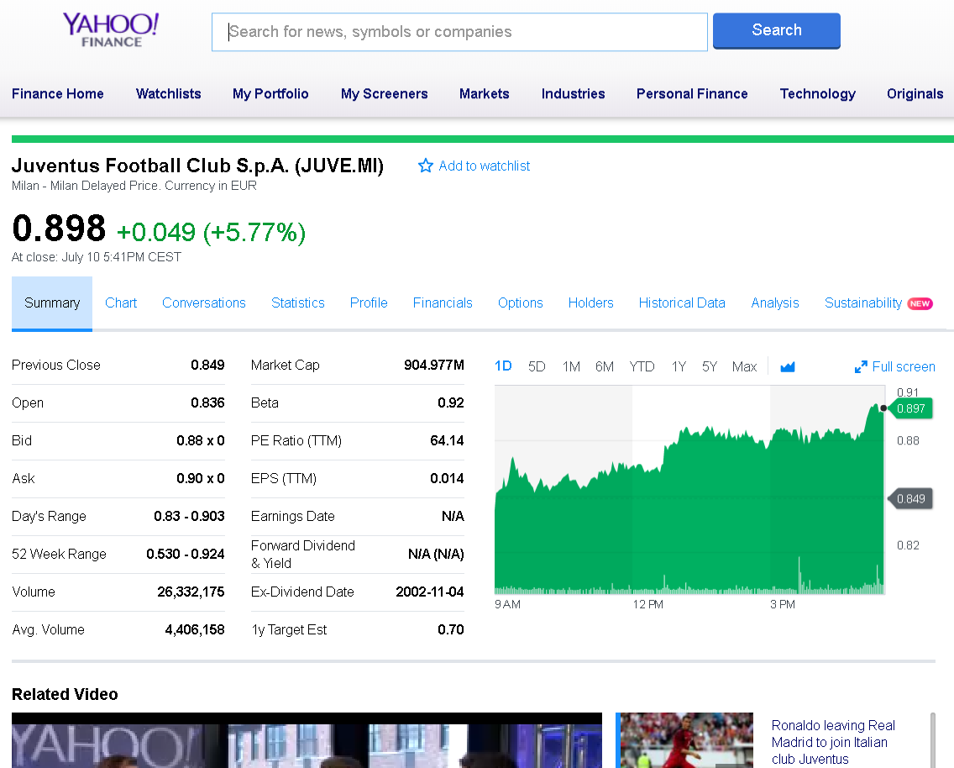

**Figure** 2 – Yahoo! Finance website, provide an API to download historical time series data

Segregation of data based on predetermined time for data training and data testing is important, while some studies make mistakes by scrambling data; this is certainly fatal because of the data, which we use, is time-series.

## 2.2. Time Series Data Feature Set

The data we get from the data collection is in the form of time-series data. This time series of data contains several elements in daily stock market activity. Some of these elements are open price, close price, high price, low price and volume. These elements are considered as feature sets which we will describe one by one in next section.

### 2.2.1. Opening Price

Opening price is the first price in daily activity of the stock market that is noted when the stock market opens in the specified period. In this work, Taiwan stock market and Indonesian stock market will open at 09:00 a.m.

The price of the first trade for any listed stock is its daily opening price. There are several day-trading strategies based on the opening of a market. Traders attempt to profit from the price correction that usually takes place subsequent to a sizable price gap at the opening. Another popular strategy is used to fade a stock at the opening price that shows the strong pre-market indication contrary to the rest of the market or similar stocks in a common sector or index.

### 2.2.2. Closing Price

The closing price is the final price at which a security is traded on a given trading day. The closing price represent the most up-to-date valuation of a security until trading commences on the next trading day. Taiwan stock market close precisely at 3:00 p.m. while Indonesian stock market will close precisely at 4:00 p.m.

Closing prices do not reflect corporate actions, which may return significantly. For example, on June 9, 2014, Apple Inc. (NASDAQ: AAPL) issued a seven-for-one stock split. Therefore, Apple's shares were increased by a multiple of seven, while its closing share price was divided by seven. On June 6, 2014, prior to Apple's stock split, it had a closing price of $ 645.57 per share. After Apple's seven-for-one stock split, the stock had a closing price of $ 93.70 per share on June 9, 2014. Since the closing price does not include adjustments for corporate actions, the calculation of Apple's returns based on closing prices would have indicated a return of -85.49%, or ($ 93.70 - $ 645.56) / $ 645.57, in just one trading day.

### 2.2.3. Highest Price

High price or today’s high is the highest price at which a stock traded during the course of the day. Today’s high is typically higher than the closing or opening price. More often than not this is higher than the closing price.

Traders and technical analysts use today's high, along with today's low to help them identify gaps or sudden jumps up or down in a stock's price with no trading in between those two prices. For example, if today's low is $25 and the previous day's high is $20, there is gap. The identification of a gap, along with other market signals such as changes in trading volume and overall bullish or bearish sentiment, helps market analysts generate buy and sell signals for particular stocks.

### 2.2.4. Lowest Price

Today’s low or low price is the lowest price at which a stock trades over the course of a trading day. Today’s low is typically lower than the opening or closing price.

Today's low and today's high are important to day traders and technical analysts, who seek to earn profits from a security's short-term price movements, identify, and track trends. One way that day traders use today's low along with today's high is to identify gaps, or sudden jumps up or down in a stock's price with no trading in between. Gaps are used in technical analysis to identify directional movement, average true range/price volatility, candlestick patterns and more. Traders then analyze these patterns to determine profitable entry and exit points.

### 2.2.5. Volume

Volume is the number of shares or contracts traded in a security or an entire market during a given period.

For every buyer, there is a seller, and each transaction contributes to the count of total volume. That is, when buyers and sellers agree to make a transaction at a certain price, it is considered one transaction. If only five transactions occur in a day, the volume for the day is five.

Volume is an important indicator in technical analysis as it is used to measure the relative worth of a market move. If the markets make a strong price movement, then the strength of that movement depends on the volume for that period. The higher the volume during the price move, the more significant the move.

## 2.3. Data Preprocessing

We are processing our time series data using library Matplotlib (Hunter 2007) in python programming to convert from the historical data that we have prepared into a candlestick chart. We divide the period used to create candlestick chart based on 5 trading days’ data, 10 trading days’ data and 20 trading days’ data.

The amount of data is shown in Table 6 can be different number because we will only generate a candlestick chart that is qualified based on the period set in the following Table 3.

**Table** 6 – Number of dataset following their period of trading days

|  |  |  |  |  |  |  |  |  |
| --- | --- | --- | --- | --- | --- | --- | --- | --- |
|  | **5 PERIOD** | | **10 PERIOD** | | | **20 PERIOD** | | |
| STOCK DATA | TRAINING | TESTING | | TRAINING | TESTING | | TRAINING | TESTING |
| **TW 50** | 198569 | 17164 | | 198151 | 16950 | | 197819 | 16414 |
| **ID 10** | 34350 | 3611 | | 34232 | 3582 | | 34233 | 3482 |

Besides the period time, we also divided our candlestick chart with and without volume indicator. The general candlestick chart usually only consists of time series data such as open price, close price, low price and high price shown in Figure 3. Adding a volume indicator into candlestick chart is one of our approaches to find out correlation between enrich candlestick chart information and prediction result.

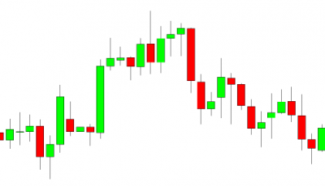

**Figure** 3 - General way to visualizing the candlestick chart

# Chapter 3 Methodology

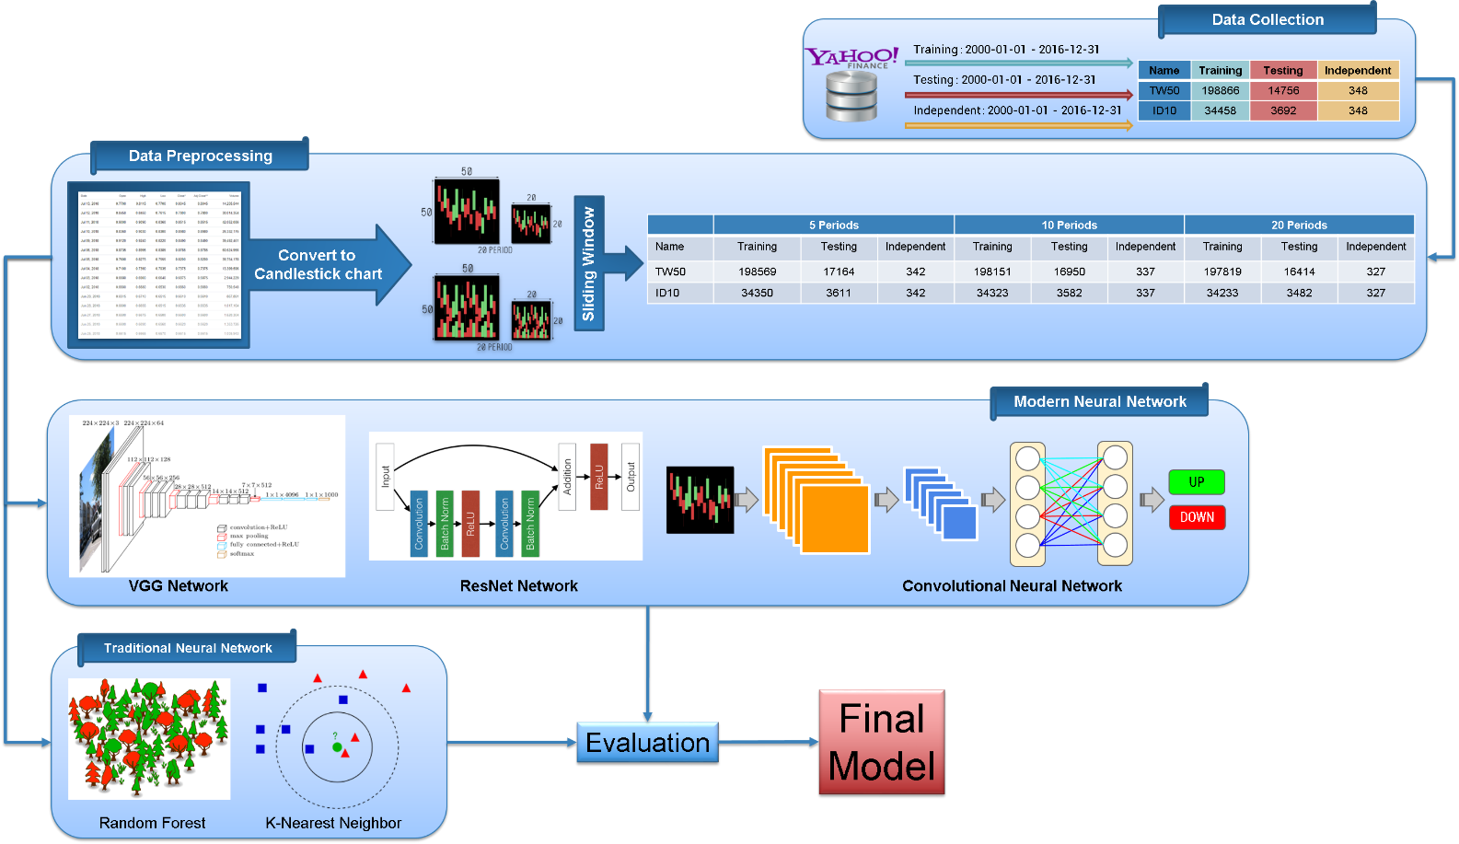

**Figure** 4 – Our methodology design

The architecture of our proposed stock market prediction is shown in Figure 4. The first, we collect the data from stock market historical data using Yahoo! Finance API. After that, we utilized the computer graphic technique to generate the candlestick chart images before using sliding window technique to generate the period data. Finally, our candlestick charts are feed as input into some deep learning neural networks models for stock market prediction, and the outputs will be binary class to indicate the price will going up or down in the near future.

## 3.1. Chart Encoding

Candlesticks show that emotion by visually representing the size of price moves with different colors. Traders use the candlestick chart to make trading decision based on regularly occurring patterns that help forecast the short-term direction of the price. Just like a bar chart, a candlestick chart shows the stock market’s open price, high, low, and close price during those period time. The candlestick chart has a wide part, which is called body, the body represents the price range between the open and close of that day’s trading. When the body is filled in red, it means the close was lower than the open price. If the body is filled in green, it means the close was higher than the open price.

We use computer graphics techniques implemented in python library called Matplotlib(Hunter 2007) to convert this time series data into a candlestick image size as 50x50 and 20x20 dimension with RGB(Red Green Blue) channel.

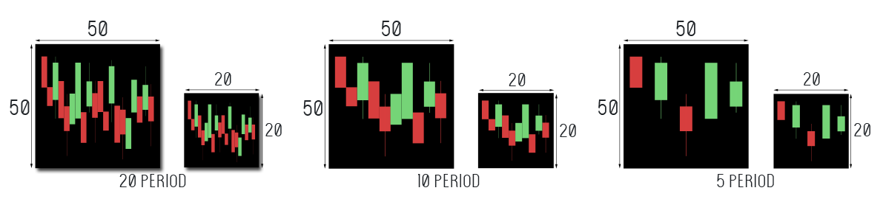 Figure 5 and Figure 6 describe our candlestick chart representation in different period time and size with volume and without volume respectively.

**Figure** 5 – Proposed candlestick chart without volume indicator in different period time and size.

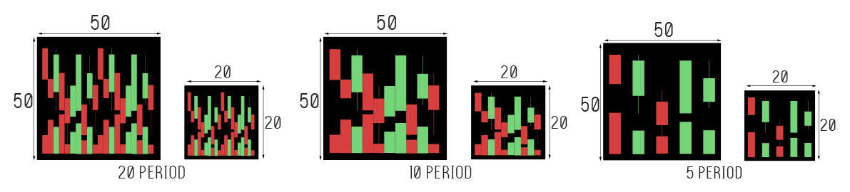**Figure** 6 - Proposed candlestick chart with volume indicator in different period time and size.

We utilized the black color as our candlestick chart background. For each candlestick chart, we configure the volume indicator to show a red bar if the closing price for the stock is lower than the opening price meaning negative volume, and green for days where the closing price is higher than opening price meaning positive volume.

## 3.2. Binary Classification

Our goal here is to perform binary classification of stock market movements by analyzing and find the hidden pattern inside candlestick chart. As shown in Figure 7, the indicator is labeled as 1 if our model predict the closing price will rise in the next day and labeled as 0 if our model predict the closing price will decrease in the next day.

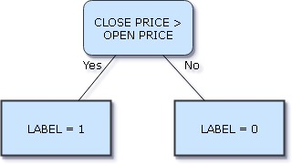

**Figure** 7 - Logic statement of our binary classification

## 3.3. Learning Algorithm

There is a lot of excitement surrounding the fields of Neural Networks (NN) and Deep learning (DL), due to numerous well-publicized successes that these systems have achieved in the last few years. We will use some Deep Learning Networks (DLN) based on Convolutional Neural Network to perform our classification on stock market prediction. Besides the DLN, we also apply some traditional Machine Learning (ML) algorithms to compare with DLN. Those traditional Machine Learning algorithms are Random Forest and K-Nearest Neighbors algorithms.

### 3.3.1. Convolutional Neural Network

Convolutional Neural Networks (CNNs) are very similar to ordinary Neural Networks (NN). They are made up of neurons with learnable weights and biases. Each neuron receives some inputs, performs a dot product and optionally follows it with a non-linearity. The whole network still expresses a single differentiable score function: from the raw image pixels on one end to class scores at the other. Moreover, they still have a loss function (e.g. SVM/Softmax) on the last (fully connected) layer and all the tips/tricks we developed for learning regular Neural Networks still apply.

As shown in Figure 8, Neural Networks receive an input (a single vector), and transform it through a series of hidden layers. Each hidden layer is made up of a set of neurons, where each neuron is fully connected to all neurons in the previous layer, and where neurons in a single layer function completely independently and do not share any connections. The last fully connected layer is called the “output layer” and in classification settings, it represents the class scores.

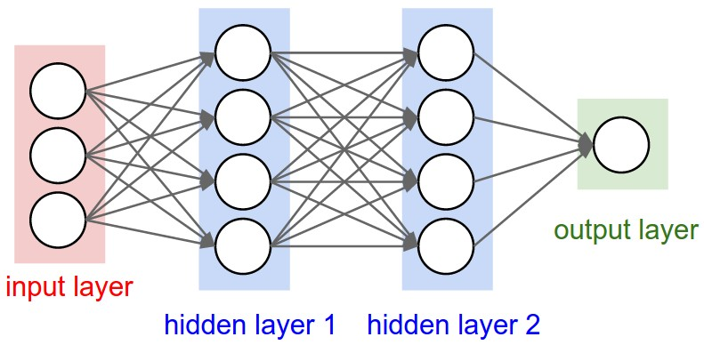

https://www.pyimagesearch.com/wp-content/uploads/2016/08/simple_neural_network_header-768x377.jpg

**Figure** 8 - A regular 3-layer Neural Network

Our CNN model architecture consist of 4 layers of convolutional 2d, 4 layers of max pooling 2d, and 3 dropouts. The detail of CNN model architecture is shown in Table 7. The Conv layer is the core building block of a Convolutional Network that does most of the computational heavy lifting. The pool layers are in charge of down sampling the spatial dimensions of the input. The most common setting is to use max pooling with 2x2 receptive fields (i.e. F=2), and with a stride of two (i.e. S=2). Note that this discards exactly 75% of the activations in an input volume (due to down sampling by 2 in both width and height). Another slightly less common setting is to use 3x3 receptive fields with a stride of two, but this makes. It is very uncommon to see receptive field sizes for max pooling that are larger than three because the pooling is then too lossy and aggressive. This usually leads to worse performance.

**Table** 7 – CNN architecture of our proposed method.

|  |
| --- |
| CNN Configuration |
| Input |
| Conv2D-32 ReLU |
| max-pooling |
| Conv2D-48 ReLU |
| max-pooling |
| Dropout |
| Conv2D-64 ReLU |
| max-pooling |
| Conv2D-96 ReLU |
| max-pooling |
| Dropout |
| Flatten |
| Dense-256 |
| Dropout |
| Dense-2 |

### 3.3.2. Residual Network

Developed by (He, Zhang et al. 2016) was the winner of ILSVRC 2015. It features special skip connections and a heavy use of batch normalization. The architecture is also missing fully connected layers at the end of the network. ResNets are currently by far state of the art Convolutional Neural Network models

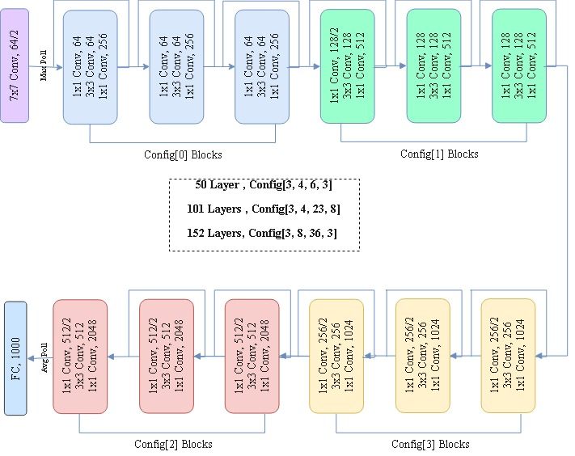

**Figure** 9 – ResNet Architecture shows many layers for different configuration

As we have seen so far, increasing the depth should increase the accuracy of the network, as long as overfitting is taken care of. Nevertheless, the problem with increased depth is that the signal required to change the weights, which arises from the end of the network by comparing ground-truth and prediction becomes very small at the earlier layers, because of increased depth. It essentially means that earlier layers are almost negligible learned. This is called vanishing gradient.

The second problem with training the deeper networks is performing the optimization on huge parameter space and therefore naively adding the layers leading to higher training error. Residual networks allow training of such deep networks by constructing the network through modules called residual models shown in Figure 10. This is called degradation problem.

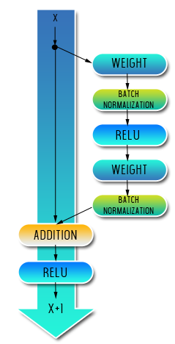

**Figure** 10 – The residual module in ResNet as originally proposed by (He, Zhang et al. 2016)

By comparing with other CNNs architecture, residual network has been proving with the most minimum error rate according to Table 8.

**Table** 8 - Residual Network proved that this network have the most minimum error-rate

|  |  |  |  |
| --- | --- | --- | --- |
| **Year** | **CNN** | **Developed by** | **Top-5-error-rate** |
| **2012** | AlexNet | (Krizhevsky, Sutskever et al. 2012) | 15.3 % |
| **2013** | ZFNet | (Zeiler and Fergus 2014) | 14.8 % |
| **2014** | GoogLeNet | (Szegedy, Ioffe et al. 2017) | 6.67 % |
| **2014** | VGG Net | (Simonyan and Zisserman 2014) | 7.3 % |
| **2015** | ResNet | (He, Zhang et al. 2016) | 3.57 % |

### 3.3.3 VGG Network

The VGG network architecture was introduced by (Simonyan and Zisserman 2014). It is named VGG because this architecture is from VGG group, Oxford. This network is characterized by its simplicity, using only 3x3 convolutional layers stacked on top of each other in increasing depth. Reducing volume size is handled by max pooling. Two fully connected layers, each with 4096 nodes are then followed by a softmax classifier shown in Table 9. The “16” and “19” stand for the number of weight layers in the network. Unfortunately, there are two major drawbacks with VGGNet. First, it is painfully slow to train and the second the network architecture weights themselves are quite large.

**Table** 9 – VGG network configuration from (Simonyan and Zisserman 2014)

|  |  |
| --- | --- |
| ConvNet Configuration | |
| 16 weight layers | 19 weight layers |
| Input (RGB Image) | |
| Conv3-64  Conv3-64 | Conv3-64  Conv3-64 |
| max-pooling | |
| Conv3-128  Conv3-128 | Conv3-128  Conv3-128 |
| max-pooling | |
| Conv3-256  Conv3-256  Conv3-256 | Conv3-256  Conv3-256  Conv3-256  Conv3-256 |
| max-pooling | |
| Conv3-512  Conv3-512  Conv3-512 | Conv3-512  Conv3-512  Conv3-512  Conv3-512 |
| max-pooling | |
| Conv3-512  Conv3-512  Conv3-512 | Conv3-512  Conv3-512  Conv3-512  Conv3-512 |
| max-pooling | |
| FC-4096 | |
| FC-4096 | |
| Soft-max | |

### 3.3.4 Random Forest

Random Forest classifier is a classifier with Consist of many decision trees and adopted the technique of random decision forest prioritizes predictive performance by using multiple learning algorithms (ensemble learning). In general, Decision trees are a learning methods used in data search technique. The method used by the idea of combining the "bagging" idea or called "Bootstrap Aggregating" (reduce variance) and the random selection of features in the training sets (classification and regression tree).

Next we will bring more detail how we can use the various options in Random Forest usefully. Most of the options depend on two data objects generated by random forests. When the training set for the current tree is drawn by sampling with replacement, about one-third of the cases are left out of the sample. This OOB (out-of-bag) data is used to get a running unbiased estimate of the classification error as trees are added to the forest. It is also used to get estimates of variable importance. After each tree is built, all of the data are run down the tree, and proximities are computed for each pair of cases. If two cases occupy the same terminal node, their proximity is increased by one. At the end of the run, the proximities are normalized by dividing by the number of trees. Proximities are used in replacing missing data, locating outliers, and producing illuminating low-dimensional views of the data.

The difference between Random Forest algorithm and the decision tree algorithm is that in Random Forest, the processes of finding the root node and splitting the feature nodes will run randomly. We applied our random forest algorithm from a machine learning python library called skicit-learn(Pedregosa, Varoquaux et al. 2011).

### 3.3.5 K-Nearest Neighbors

K-Nearest Neighbors (KNN) is a classifier with based on the Lazy learning and Instance-based (IBk) learning algorithms (selection K based value based on model evaluation method or cross validation). Further, Lazy learning is a learning method with the purposed to store training data and enables the training data is used when there is a query request is made (waits until it is given a test) by the system. Similarity measure applied to the KNN with the aim to compare every new case with available cases (training data) that has been previously saved. Conversely different with eager learning, eager learning is a learning method with the intention of preparing training process data earlier, then wait for the query request (a test). KNN implemented lazy learning method which has the distinct advantage that it can solve the problem by comparing the problem with similar past problem (case-based reasoning). KNN adopted a supervised learning approach by utilizing the data in this case must have class/label and this learning model of the algorithm can be used for classification and regression predictive problems.

We also using skicit-learn python library for our KNN classifier. Furthermore, we used a K-D Tree algorithm in our KNN to perform prediction with default parameter from scikit-learn library.

## 3.4. Performance Evaluation

There are some statistics measures of the performance evaluation to evaluate the result of all the classifiers by measuring the sensitivity (true positive rate or recall), specificity (true negative rate), accuracy and Matthew's correlation coefficient (MCC)**.** In general, TP is true positive or correctly identified, FP is false positive or incorrectly identified, TN is true negative or correctly rejected and FN is false negative or incorrectly rejected. Formulated as follows:

Sensitivity is called true positive rate or recall measures the performance of positives data are correctly identified.

Otherwise, to measure the proposition of negative rate the specificity formula is used during the prediction result and performance all classifiers.

The accuracy formula measures the quality all classifiers with based on the true value or maximum predicted values compared with measurement results.

Then, Matthews’s correlation coefficient or MCC is used to predict binary (two class) classifications and focus on the quality of predicted binary. During the prediction results, MCC returns a value between -1 and +1. If the correlation value closer to +1 indicates perfect prediction, and otherwise if the correlation value closer to -1 indicates total disagreement between prediction and observation.

# Chapter 4 Experimental Results and Discussion

## 4.1. Classification for Each Stock Market

In this study, we try to make stock market predictions by using binary classification. Where the value 1 on the label means price increasing on the next day, while the value 0 is the reverse of it.

We trained and evaluated our binary classification model on two challenging datasets, i.e. Taiwan 50 and Indonesia 10 stock market. Taiwan 50 dataset includes 50 company stock markets from Taiwan and Indonesia 10 dataset includes 10 company stock markets from Indonesia which most of them are the top stock market in both countries. We also divide the retrieval period based on the duration of the 5 days, 10 days and 20 days of trading days to create a sequence of sliding windows that will be converted to candlestick chart. Another hands, we also generate the candlestick chart with and without volume indicator for 2 different image sizes, 50 and 20 dimension.

### 4.1.1 Classification for Taiwan 50 dataset

Our first experiment is to compare several classifiers using Taiwan 50 dataset with different trading days and image dimension. Tables 10, 11, and 12 show our result of Taiwan 50 in different trading days’ period by 50 dimension of candlestick chart with combination of volume price indicator. Table 11 shows that CNN aim get better result than the other classifiers with 91.5 % accuracy in 10 trading days’ period by 50 dimension of candlestick chart with combination of volume price indicator.

**Table** 10 – Result of 5 period with volume indicator in 50-dimension image for Taiwan 50.

|  |  |  |  |  |  |  |  |  |
| --- | --- | --- | --- | --- | --- | --- | --- | --- |
| **Classifier** | **TN** | **FN** | **TP** | **FP** | **Sensitivity** | **Specificity** | **Accuracy** | **MCC** |
| **Random Forest** | 7090 | 1763 | 6927 | 1384 | 79.7 | 83.7 | 81.7 | 0.634 |
| **Resnet50** | 6792 | 1792 | 6898 | 1682 | 79.4 | 80.2 | 79.8 | 0.595 |
| **VGG16** | 6841 | 1625 | 7065 | 1633 | 81.3 | 80.7 | 81.0 | 0.62 |
| **VGG19** | 6718 | 1742 | 6948 | 1756 | 80.0 | 79.3 | 79.6 | 0.592 |
| **CNN** | 7100 | 1458 | 7232 | 1374 | 83.2 | 83.8 | 83.5 | 0.67 |

**Table** 11 – Result of 10 period with volume indicator in 50-dimension image for Taiwan 50.

|  |  |  |  |  |  |  |  |  |
| --- | --- | --- | --- | --- | --- | --- | --- | --- |
| **Classifier** | **TN** | **FN** | **TP** | **FP** | **Sensitivity** | **Specificity** | **Accuracy** | **MCC** |
| **Random Forest** | 6678 | 1428 | 7801 | 1043 | 84.5 | 86.5 | 85.4 | 0.708 |
| **Resnet50** | 6299 | 837 | 8524 | 790 | 91.1 | 88.9 | 90.1 | 0.799 |
| **VGG16** | 6298 | 887 | 8474 | 791 | 90.5 | 88.8 | 89.8 | 0.792 |
| **VGG19** | 6345 | 874 | 8487 | 744 | 90.7 | 89.5 | 90.2 | 0.8 |
| **CNN** | 6469 | 785 | 8576 | 620 | **91.6** | **91.3** | **91.5** | **0.827** |

**Table** 12 – Result of 20 period with volume indicator in 50-dimension image for Taiwan 50.

|  |  |  |  |  |  |  |  |  |
| --- | --- | --- | --- | --- | --- | --- | --- | --- |
| **Classifier** | **TN** | **FN** | **TP** | **FP** | **Sensitivity** | **Specificity** | **Accuracy** | **MCC** |
| **Random Forest** | 6354 | 1013 | 8348 | 735 | 89.2 | 89.6 | 89.4 | 0.785 |
| **Resnet50** | 6792 | 1792 | 6898 | 1682 | 79.4 | 80.2 | 79.8 | 0.595 |
| **VGG16** | 6841 | 1625 | 7065 | 1633 | 81.3 | 80.7 | 81.0 | 0.62 |
| **VGG19** | 6718 | 1742 | 6948 | 1756 | 80.0 | 79.3 | 79.6 | 0.592 |
| **CNN** | 7100 | 1458 | 7232 | 1374 | 83.2 | 83.8 | 83.5 | 0.67 |

Tables 13, 14, and 15 show our result for Taiwan 50 with 20-dimension image. Table 15 concludes that CNN method with volume indicator in 20-dimension image significantly outperforms the others with 90.6% accuracy.

**Table** 13 – Result of 5 period with volume indicator in 20-dimension image for Taiwan 50.

|  |  |  |  |  |  |  |  |  |
| --- | --- | --- | --- | --- | --- | --- | --- | --- |
| **Classifier** | **TN** | **FN** | **TP** | **FP** | **Sensitivity** | **Specificity** | **Accuracy** | **MCC** |
| **Random Forest** | 7160 | 1692 | 6998 | 1314 | 80.5 | 84.5 | 82.5 | 0.651 |
| **KNN** | 6095 | 2251 | 6439 | 2379 | 74.1 | 71.9 | 73.0 | 0.46 |
| **Resnet50** | 6792 | 1603 | 7087 | 1682 | 81.6 | 80.2 | 80.9 | 0.617 |
| **VGG16** | 6755 | 1561 | 7129 | 1719 | 82.0 | 79.7 | 80.9 | 0.618 |
| **VGG19** | 6750 | 1611 | 7079 | 1724 | 81.5 | 79.7 | 80.6 | 0.611 |
| **CNN** | 7005 | 1396 | 7294 | 1469 | 83.9 | 82.7 | 83.3 | 0.666 |

**Table** 14 – Result of 10 period with volume indicator in 20-dimension image for Taiwan 50.

|  |  |  |  |  |  |  |  |  |
| --- | --- | --- | --- | --- | --- | --- | --- | --- |
| **Classifier** | **TN** | **FN** | **TP** | **FP** | **Sensitivity** | **Specificity** | **Accuracy** | **MCC** |
| **Random Forest** | 6810 | 1200 | 8004 | 900 | 87.0 | 88.3 | 87.6 | 0.751 |
| **KNN** | 5902 | 2123 | 7106 | 1819 | 77.0 | 76.4 | 76.7 | 0.533 |
| **Resnet50** | 6638 | 1192 | 8012 | 1072 | 87.0 | 86.1 | 80.6 | 0.731 |
| **VGG16** | 6657 | 1275 | 7929 | 1053 | 86.1 | 86.3 | 86.2 | 0.723 |
| **VGG19** | 6440 | 1025 | 8179 | 1270 | 88.9 | 83.5 | 86.4 | 0.726 |
| **CNN** | 6781 | 1242 | 7987 | 940 | 86.5 | 87.8 | 87.1 | 0.742 |

**Table** 15 – Result of 20 period with volume indicator in 20-dimension image for Taiwan 50.

|  |  |  |  |  |  |  |  |  |
| --- | --- | --- | --- | --- | --- | --- | --- | --- |
| **Classifier** | **TN** | **FN** | **TP** | **FP** | **Sensitivity** | **Specificity** | **Accuracy** | **MCC** |
| **Random Forest** | 6390 | 870 | 8471 | 683 | 90.7 | 90.3 | 90.5 | 0.808 |
| **KNN** | 5199 | 1849 | 7512 | 1890 | 80.2 | 73.3 | 73.3 | 0.536 |
| **Resnet50** | 6232 | 757 | 8584 | 841 | 91.9 | 88.1 | 90.3 | 0.801 |
| **VGG16** | 6315 | 806 | 8535 | 758 | 91.4 | 89.3 | 90.5 | 0.806 |
| **VGG19** | 6280 | 813 | 8528 | 793 | 91.3 | 88.8 | 90.2 | 0.801 |
| **CNN** | 6397 | 860 | 8501 | 692 | 90.8 | 90.2 | **90.6** | 0.808 |

As we mentioned in our experiments method about finding the correlation between with or without volume indicator to enhance our result. Next we check our prediction result without combination of volume price indicator. Similar to using combination of volume price indicator, we also evaluate our method in 5, 10, 20 trading day period. Tables 16, 17 and 18 show our prediction result for Taiwan 50 in 5, 10, and 20 trading days’ period by 50-dimension image respectively. Table 18 shows that using 20 periods can achieve better result than the others with 92.2% accuracy.

**Table** 16 – Result of 5 period without volume indicator in 50-dimension image for Taiwan 50.

|  |  |  |  |  |  |  |  |  |
| --- | --- | --- | --- | --- | --- | --- | --- | --- |
| **Classifier** | **TN** | **FN** | **TP** | **FP** | **Sensitivity** | **Specificity** | **Accuracy** | **MCC** |
| **Random Forest** | 7217 | 1650 | 7040 | 1257 | 81.0 | 85.2 | 83.1 | 0.662 |
| **Resnet50** | 6643 | 1612 | 7078 | 1831 | 81.4 | 78.4 | 79.9 | 0.599 |
| **VGG16** | 6772 | 1585 | 7105 | 1702 | 81.8 | 79.9 | 80.8 | 0.617 |
| **VGG19** | 6737 | 1577 | 7113 | 1737 | 81.9 | 79.5 | 80.7 | 0.614 |
| **CNN** | 7213 | 1423 | 7267 | 1261 | 83.6 | 85.1 | 84.4 | 0.687 |

**Table** 17 – Result of 10 period without volume indicator in 50-dimension image for Taiwan 50.

|  |  |  |  |  |  |  |  |  |
| --- | --- | --- | --- | --- | --- | --- | --- | --- |
| **Classifier** | **TN** | **FN** | **TP** | **FP** | **Sensitivity** | **Specificity** | **Accuracy** | **MCC** |
| **Random Forest** | 6828 | 1198 | 8006 | 882 | 87.0 | 88.6 | 88.6 | 0.753 |
| **Resnet50** | 6535 | 1132 | 8072 | 1175 | 87.7 | 84.8 | 86.4 | 0.725 |
| **VGG16** | 6660 | 1197 | 8007 | 1050 | 87.0 | 86.4 | 86.7 | 0.733 |
| **VGG19** | 6311 | 1002 | 8202 | 1399 | 89.1 | 81.9 | 85.8 | 0.713 |
| **CNN** | 6794 | 994 | 8210 | 916 | 89.2 | 88.1 | 88.7 | 0.773 |

**Table** 18 – Result of 20 periods without volume indicator in 50-dimension image for Taiwan 50.

|  |  |  |  |  |  |  |  |  |
| --- | --- | --- | --- | --- | --- | --- | --- | --- |
| **Classifier** | **TN** | **FN** | **TP** | **FP** | **Sensitivity** | **Specificity** | **Accuracy** | **MCC** |
| **Random Forest** | 6403 | 897 | 8444 | 670 | 90.4 | 90.5 | 90.5 | 0.806 |
| **Resnet50** | 6348 | 908 | 8433 | 725 | 90.3 | 80.7 | 90.1 | 0.798 |
| **VGG16** | 6361 | 799 | 8542 | 712 | 91.4 | 89.9 | 90.8 | 0.813 |
| **VGG19** | 6316 | 798 | 8543 | 757 | 91.5 | 89.3 | 90.5 | 0.807 |
| **CNN** | 6415 | 629 | 8712 | 658 | **93.3** | **90.7** | **92.2** | **0.84** |

Tables 19, 20, and 21 show the result of Taiwan 50 in 5, 10, and 20 trading days’ period without volume indicator in 20-dimension image. Both of VGG19 and CNN in Table 21 show good performance with 91% accuracy.

**Table** 19 – Result of 5 periods without volume indicator in 20-dimension image for Taiwan 50.

|  |  |  |  |  |  |  |  |  |
| --- | --- | --- | --- | --- | --- | --- | --- | --- |
| **Classifier** | **TN** | **FN** | **TP** | **FP** | **Sensitivity** | **Specificity** | **Accuracy** | **MCC** |
| **Random Forest** | 7227 | 1649 | 7041 | 1247 | 81.0 | 85.3 | 83.1 | 0.663 |
| **KNN** | 6793 | 1502 | 7188 | 1681 | 82.7 | 80.2 | 81.5 | 0.629 |
| **Resnet50** | 7116 | 1685 | 7005 | 1358 | 80.6 | 84.0 | 82.3 | 0.646 |
| **VGG16** | 6937 | 1719 | 6971 | 1537 | 80.2 | 81.9 | 81.0 | 0.621 |
| **VGG19** | 6733 | 1727 | 6963 | 1741 | 80.1 | 79.5 | 79.8 | 0.596 |
| **CNN** | 7032 | 1321 | 7369 | 1442 | 84.8 | 83.0 | 83.9 | 0.678 |

**Table** 20 – Result of 10 periods without volume indicator in 20-dimension image for Taiwan 50.

|  |  |  |  |  |  |  |  |  |
| --- | --- | --- | --- | --- | --- | --- | --- | --- |
| **Classifier** | **TN** | **FN** | **TP** | **FP** | **Sensitivity** | **Specificity** | **Accuracy** | **MCC** |
| **Random Forest** | 6825 | 1227 | 7977 | 885 | 86.7 | 88.5 | 87.5 | 0.75 |
| **KNN** | 6449 | 1182 | 8022 | 1261 | 87.2 | 83.6 | 85.6 | 0.709 |
| **Resnet50** | 6557 | 1179 | 8025 | 1153 | 87.2 | 85.0 | 86.2 | 0.722 |
| **VGG16** | 6711 | 1277 | 7927 | 999 | 86.1 | 87.0 | 86.5 | 0.73 |
| **VGG19** | 6484 | 1142 | 8062 | 1226 | 87.6 | 84.1 | 86.0 | 0.718 |
| **CNN** | 6801 | 1105 | 8099 | 909 | 88.0 | 88.2 | 88.1 | 0.761 |

**Table** 21 – Result of 20 periods without volume indicator in 20-dimension image for Taiwan 50.

|  |  |  |  |  |  |  |  |  |
| --- | --- | --- | --- | --- | --- | --- | --- | --- |
| **Classifier** | **TN** | **FN** | **TP** | **FP** | **Sensitivity** | **Specificity** | **Accuracy** | **MCC** |
| **Random Forest** | 6377 | 871 | 8470 | 696 | 90.7 | 90.2 | 90.5 | 0.806 |
| **KNN** | 6060 | 905 | 8436 | 1013 | 90.3 | 85.7 | 88.3 | 0.761 |
| **Resnet50** | 6181 | 771 | 8570 | 892 | 91.7 | 87.4 | 89.9 | 0.793 |
| **VGG16** | 6212 | 754 | 8587 | 861 | 91.9 | 87.8 | 90.2 | 0.799 |
| **VGG19** | 6366 | 772 | 8569 | 707 | 91.7 | 90.0 | **91.0** | 0.817 |
| **CNN** | 6402 | 805 | 8536 | 671 | 81.7 | 91.4 | **91.0** | 0.817 |

From all experiments about Taiwan 50, we conclude a summary result with and without volume indicator for different trading days’ period and image dimension result. Table 22 shows that CNN in 20 trading days’ period with 50-dimension image and volume indicator is better than the others with 91.5% accuracy. In addition, without volume indicator for Taiwan 50, CNN in 20 trading days’ period with 50 dimension performs better than the others with 92.2% accuracy. From the result of both of those experiments, it indicates that the method using CNN model with longer trading day’s period without volume indicator can achieve the best result for Taiwan 50 dataset.

**Table** 22 – Summary result of Taiwan 50 with their best classifier for each trading days and image dimension with volume indicator.

|  |  |  |  |  |  |  |
| --- | --- | --- | --- | --- | --- | --- |
| **Classifier** | **Period** | **Dimension** | **Sensitivity** | **Specificity** | **Accuracy** | **MCC** |
| **CNN** | 5 | 50 | 83.2 | 83.8 | 83.5 | 0.67 |
| **CNN** | 10 | 50 | 88.6 | 87.3 | 88.0 | 0.758 |
| **CNN** | 20 | 50 | **91.6** | **91.3** | **91.5** | **0.827** |
| **CNN** | 5 | 20 | 83.9 | 82.7 | 83.3 | 0.666 |
| **Random Forest** | 10 | 20 | 87.0 | 88.3 | 87.6 | 0.751 |
| **CNN** | 20 | 20 | 90.8 | 90.2 | 90.6 | 0.808 |

**Table** 23 – Summary result of Taiwan 50 with their best classifier for each trading days and image dimension without volume indicator.

|  |  |  |  |  |  |  |
| --- | --- | --- | --- | --- | --- | --- |
| **Classifier** | **Period** | **Dimension** | **Sensitivity** | **Specificity** | **Accuracy** | **MCC** |
| **CNN** | 5 | 50 | 83.6 | 85.1 | 84.4 | 0.687 |
| **CNN** | 10 | 50 | 89.2 | 88.1 | 88.7 | 0.773 |
| **CNN** | 20 | 50 | **93.3** | 90.7 | **92.2** | **0.84** |
| **CNN** | 5 | 20 | 84.8 | 83.0 | 83.9 | 0.678 |
| **CNN** | 10 | 20 | 88.0 | 88.2 | 88.1 | 0.761 |
| **CNN** | 20 | 20 | 81.7 | 91.4 | 91.0 | 0.817 |

### 4.1.2 Classification for Indonesia 10 dataset

Our next experiment is performing our proposed method in Indonesia stock market dataset. Indonesia is a promising country with good growth for their gross domestic product(Wongbangpo and Sharma 2002). Tables 24, 25 and 26 show our prediction result for Indonesia 10 dataset with volume indicator by 50-dimension image. CNN with 20 trading days’ period get better result than the others with 90.0% accuracy.

**Table** 24 – Result of 5 periods with volume indicator in 50-dimension image for Indonesia 10.

|  |  |  |  |  |  |  |  |  |
| --- | --- | --- | --- | --- | --- | --- | --- | --- |
| **Classifier** | **TN** | **FN** | **TP** | **FP** | **Sensitivity** | **Specificity** | **Accuracy** | **MCC** |
| **Random Forest** | 1554 | 445 | 1334 | 278 | 75.0 | 84.8 | 80.0 | 0.602 |
| **KNN** | 1290 | 370 | 1306 | 301 | 77.9 | 81.1 | 77.9 | 0.59 |
| **Resnet50** | 1564 | 344 | 1435 | 268 | 80.7 | 85.4 | 83.1 | 0.661 |
| **VGG16** | 1447 | 307 | 1472 | 385 | 82.7 | 79.0 | 80.8 | 0.617 |
| **VGG19** | 1477 | 366 | 1413 | 355 | 79.4 | 80.6 | 80.0 | 0.601 |
| **CNN** | 1575 | 389 | 2390 | 257 | 78.1 | 86.0 | 82.1 | 0.643 |

**Table** 25 – Result of 10 periods with volume indicator in 50-dimension image for Indonesia 10.

|  |  |  |  |  |  |  |  |  |
| --- | --- | --- | --- | --- | --- | --- | --- | --- |
| **Classifier** | **TN** | **FN** | **TP** | **FP** | **Sensitivity** | **Specificity** | **Accuracy** | **MCC** |
| **Random Forest** | 1450 | 394 | 1511 | 227 | 79.3 | 86.5 | 82.7 | 0.657 |
| **KNN** | 1158 | 362 | 1543 | 519 | 81.0 | 69.1 | 75.4 | 0.505 |
| **Resnet50** | 1483 | 217 | 1688 | 194 | 88.6 | 88.4 | 88.5 | 0.77 |
| **VGG16** | 1404 | 268 | 1637 | 273 | 85.9 | 83.7 | 84.9 | 0.697 |
| **VGG19** | 1424 | 271 | 1634 | 253 | 85.8 | 84.9 | 85.4 | 0.706 |
| **CNN** | 1423 | 245 | 1660 | 254 | 87.1 | 84.9 | 86.1 | 0.72 |

**Table** 26 – Result of 20 periods with volume indicator in 50-dimension image for Indonesia 10.

|  |  |  |  |  |  |  |  |  |
| --- | --- | --- | --- | --- | --- | --- | --- | --- |
| **Classifier** | **TN** | **FN** | **TP** | **FP** | **Sensitivity** | **Specificity** | **Accuracy** | **MCC** |
| **Random Forest** | 1370 | 289 | 1652 | 171 | 85.1 | 88.9 | 86.8 | 0.736 |
| **KNN** | 1061 | 213 | 1728 | 480 | 89.0 | 68.9 | 80.1 | 0.597 |
| **Resnet50** | 1364 | 212 | 1729 | 177 | 89.1 | 88.5 | 88.8 | 0.774 |
| **VGG16** | 1346 | 194 | 1747 | 195 | 90.0 | 87.3 | 88.8 | 0.774 |
| **VGG19** | 1335 | 194 | 17147 | 206 | 90.0 | 86.6 | 88.5 | 0.767 |
| **CNN** | 1388 | 195 | 1746 | 153 | 90.0 | **90.1** | **90.0** | **0.798** |

Tables 27, 28 and 29 show our result for Indonesia 10 dataset with volume indicator in 20-dimension image. From those Table results, we see that the method using CNN with 20 trading days’ period outperforms the other methods with 87.1% accuracy.

**Table** 27 – Result of 5 periods with volume indicator in 20-dimension image for Indonesia 10.

|  |  |  |  |  |  |  |  |  |
| --- | --- | --- | --- | --- | --- | --- | --- | --- |
| **Classifier** | **TN** | **FN** | **TP** | **FP** | **Sensitivity** | **Specificity** | **Accuracy** | **MCC** |
| **Random Forest** | 1541 | 471 | 1308 | 291 | 73.5 | 84.1 | 78.9 | 0.58 |
| **KNN** | 1297 | 368 | 1308 | 294 | 78.0 | 81.5 | 79.7 | 0.596 |
| **Resnet50** | 1508 | 377 | 1402 | 324 | 78.8 | 82.3 | 80.6 | 0.612 |
| **VGG16** | 1403 | 361 | 1418 | 429 | 79.7 | 76.6 | 78.1 | 0.563 |
| **VGG19** | 1416 | 382 | 1397 | 416 | 78.5 | 77.3 | 77.9 | 0.558 |
| **CNN** | 1563 | 455 | 1324 | 269 | 74.4 | 85.3 | 80.0 | 0.602 |

**Table** 28 – Result of 10 periods with volume indicator in 20-dimension image for Indonesia 10.

|  |  |  |  |  |  |  |  |  |
| --- | --- | --- | --- | --- | --- | --- | --- | --- |
| **Classifier** | **TN** | **FN** | **TP** | **FP** | **Sensitivity** | **Specificity** | **Accuracy** | **MCC** |
| **Random Forest** | 1445 | 404 | 1501 | 232 | 78.8 | 86.2 | 82.2 | 0.649 |
| **KNN** | 1139 | 363 | 1542 | 538 | 80.9 | 67.9 | 74.8 | 0.494 |
| **Resnet50** | 1330 | 335 | 1570 | 347 | 82.4 | 79.3 | 81.0 | 0.618 |
| **VGG16** | 1357 | 298 | 1607 | 320 | 84.4 | 80.9 | 82.7 | 0.653 |
| **VGG19** | 1336 | 291 | 1614 | 341 | 84.7 | 79.7 | 82.4 | 0.645 |
| **CNN** | 1432 | 318 | 1587 | 245 | 83.3 | 85.4 | 84.3 | 0.686 |

**Table** 29 – Result of 20 periods with volume indicator in 20-dimension image for Indonesia 10.

|  |  |  |  |  |  |  |  |  |
| --- | --- | --- | --- | --- | --- | --- | --- | --- |
| **Classifier** | **TN** | **FN** | **TP** | **FP** | **Sensitivity** | **Specificity** | **Accuracy** | **MCC** |
| **Random Forest** | 1341 | 287 | 1654 | 200 | 85.2 | 87.0 | 86.0 | 0.719 |
| **KNN** | 1014 | 232 | 1709 | 527 | 88.0 | 65.8 | 78.2 | 0.558 |
| **Resnet50** | 1328 | 318 | 1623 | 213 | 83.6 | 86.2 | 84.8 | 0.694 |
| **VGG16** | 1360 | 285 | 1656 | 181 | 85.3 | 88.3 | 86.6 | 0.732 |
| **VGG19** | 1315 | 291 | 1650 | 226 | 85.0 | 85.3 | 85.2 | 0.701 |
| **CNN** | 1303 | 211 | 1730 | 238 | 89.1 | 84.6 | **87.1** | 0.738 |

The prediction result without using the volume indicator for Indonesia 10 with 50-dimension image of 5, 10 and 20 periods shown in Tables 30, 31 and 32 respectively. The best performance result achieved using CNN in 20 trading days’ period with 92.1% accuracy.

**Table** 30 – Result of 5 periods without volume indicator in 50-dimension image for Indonesia 10.

|  |  |  |  |  |  |  |  |  |
| --- | --- | --- | --- | --- | --- | --- | --- | --- |
| **Classifier** | **TN** | **FN** | **TP** | **FP** | **Sensitivity** | **Specificity** | **Accuracy** | **MCC** |
| **Random Forest** | 1358 | 426 | 1250 | 233 | 74.6 | 85.4 | 79.8 | 0.602 |
| **KNN** | 1290 | 370 | 1306 | 301 | 77.9 | 81.1 | 79.5 | 0.59 |
| **Resnet50** | 1398 | 351 | 1325 | 193 | 79.1 | 87.9 | 83.3 | 0.671 |
| **VGG16** | 1278 | 320 | 1356 | 313 | 80.9 | 80.3 | 80.6 | 0.612 |
| **VGG19** | 1274 | 338 | 1338 | 317 | 79.8 | 80.1 | 80.0 | 0.599 |
| **CNN** | 1362 | 342 | 1334 | 229 | 79.6 | 85.6 | 82.5 | 0.625 |

**Table** 31 – Result of 10 periods without volume indicator in 50-dimension image for Indonesia 10.

|  |  |  |  |  |  |  |  |  |
| --- | --- | --- | --- | --- | --- | --- | --- | --- |
| **Classifier** | **TN** | **FN** | **TP** | **FP** | **Sensitivity** | **Specificity** | **Accuracy** | **MCC** |
| **Random Forest** | 1248 | 345 | 1456 | 173 | 80.8 | 87.8 | 83.9 | 0.682 |
| **KNN** | 1153 | 270 | 1531 | 268 | 85.0 | 81.1 | 83.3 | 0.661 |
| **Resnet50** | 1241 | 344 | 1457 | 180 | 80.9 | 87.3 | 83.7 | 0.678 |
| **VGG16** | 1183 | 205 | 1596 | 238 | 88.6 | 83.3 | 86.3 | 0.721 |
| **VGG19** | 1191 | 241 | 1560 | 230 | 86.6 | 83.8 | 85.4 | 0.704 |
| **CNN** | 1231 | 225 | 1576 | 190 | 87.5 | 86.6 | 87.1 | 0.74 |

**Table** 32 – Result of 20 periods without volume indicator in 50-dimension image for Indonesia 10.

|  |  |  |  |  |  |  |  |  |
| --- | --- | --- | --- | --- | --- | --- | --- | --- |
| **Classifier** | **TN** | **FN** | **TP** | **FP** | **Sensitivity** | **Specificity** | **Accuracy** | **MCC** |
| **Random Forest** | 1245 | 256 | 1839 | 140 | 87.8 | 89.9 | 88.6 | 0.768 |
| **KNN** | 1165 | 220 | 1875 | 220 | 89.5 | 84.1 | 87.4 | 0.736 |
| **Resnet50** | 1206 | 144 | 1951 | 179 | 93.1 | 87.1 | 90.7 | 0.806 |
| **VGG16** | 1267 | 184 | 1911 | 118 | 91.2 | 91.5 | 91.3 | 0.821 |
| **VGG19** | 1255 | 169 | 1926 | 130 | 91.9 | 90.6 | 91.4 | 0.822 |
| **CNN** | 1276 | 165 | 1930 | 109 | **92.1** | **92.1** | **92.1** | **0.837** |

Tables 33, 34 and 35 show our prediction result for 20-dimension image without using the volume indicator in Indonesia 10. Table 35 shows that VGG16 with 90.7% accuracy is better with the other results.

**Table** 33 – Result of 5 periods without volume indicator in 20-dimension image for Indonesia 10.

|  |  |  |  |  |  |  |  |  |
| --- | --- | --- | --- | --- | --- | --- | --- | --- |
| **Classifier** | **TN** | **FN** | **TP** | **FP** | **Sensitivity** | **Specificity** | **Accuracy** | **MCC** |
| **Random Forest** | 1365 | 402 | 1274 | 226 | 76.0 | 85.8 | 80.8 | 0.62 |
| **KNN** | 1297 | 368 | 1308 | 294 | 78.0 | 81.5 | 79.7 | 0.596 |
| **Resnet50** | 1234 | 338 | 1338 | 348 | 79.8 | 78.1 | 79.0 | 0.58 |
| **VGG16** | 1328 | 410 | 1266 | 263 | 75.5 | 83.5 | 79.4 | 0.591 |
| **VGG19** | 1280 | 335 | 1341 | 311 | 80.0 | 80.5 | 80.2 | 0.604 |
| **CNN** | 1311 | 279 | 1397 | 380 | 83.4 | 82.4 | 82.9 | 0.658 |

**Table** 34 – Result of 10 periods without volume indicator in 20-dimension image for Indonesia 10.

|  |  |  |  |  |  |  |  |  |
| --- | --- | --- | --- | --- | --- | --- | --- | --- |
| **Classifier** | **TN** | **FN** | **TP** | **FP** | **Sensitivity** | **Specificity** | **Accuracy** | **MCC** |
| **Random Forest** | 1228 | 334 | 1467 | 193 | 81.5 | 86.4 | 83.6 | 0.674 |
| **KNN** | 1171 | 265 | 1536 | 250 | 85.3 | 82.4 | 84.0 | 0.676 |
| **Resnet50** | 1201 | 275 | 1526 | 220 | 84.7 | 84.5 | 84.6 | 0.69 |
| **VGG16** | 1196 | 278 | 1523 | 225 | 84.6 | 84.2 | 84.4 | 0.685 |
| **VGG19** | 1242 | 326 | 1475 | 179 | 81.9 | 87.4 | 84.3 | 0.688 |
| **CNN** | 1217 | 263 | 1538 | 204 | 85.4 | 85.6 | 85.5 | 0.708 |

**Table** 35 – Result of 20 periods without volume indicator in 20-dimension image for Indonesia 10.

|  |  |  |  |  |  |  |  |  |
| --- | --- | --- | --- | --- | --- | --- | --- | --- |
| **Classifier** | **TN** | **FN** | **TP** | **FP** | **Sensitivity** | **Specificity** | **Accuracy** | **MCC** |
| **Random Forest** | 1230 | 259 | 1836 | 155 | 87.6 | 88.8 | 88.1 | 0.756 |
| **KNN** | 1297 | 368 | 1308 | 294 | 68.0 | 81.5 | 79.7 | 0.596 |
| **Resnet50** | 1223 | 203 | 1892 | 162 | 90.3 | 88.3 | 89.5 | 0.782 |
| **VGG16** | 1242 | 179 | 1916 | 143 | 91.5 | 89.7 | **90.7** | 0.808 |
| **VGG19** | 1268 | 212 | 1883 | 117 | 89.9 | 91.6 | 90.5 | 0.806 |
| **CNN** | 1234 | 178 | 1917 | 151 | 91.5 | 89.1 | 90.5 | 0.803 |

From all experiment results with Indonesia 10 dataset, we conclude a summary result with and without volume indicator in Tables 36 and 37 respectively. It shows that the CNN method with 20 trading days’ period in 50 dimension using volume indicator show the best result with 90.0% accuracy in Table 37 While the VGG16 method in 20 trading days’ period with 20-dimension image without using the volume indicator performs better result with 90.7% accuracy. It indicates that the method using CNN model with longer trading day’s period without volume indicator can achieve the best result for Indonesia 10 dataset.

**Table** 36 – Summary result of Indonesia 10 with their best classifier for each trading days and image dimension with volume indicator.

|  |  |  |  |  |  |  |
| --- | --- | --- | --- | --- | --- | --- |
| **Classifier** | **Period** | **Dimension** | **Sensitivity** | **Specificity** | **Accuracy** | **MCC** |
| **Resnet50** | 5 | 50 | 80.7 | 85.4 | 83.1 | 0.661 |
| **Resnet50** | 10 | 50 | 88.6 | 88.4 | 88.5 | 0.77 |
| **CNN** | 20 | 50 | 90.0 | 90.1 | 90.0 | 0.798 |
| **Resnet50** | 5 | 20 | 78.8 | 82.3 | 80.6 | 0.612 |
| **CNN** | 10 | 20 | 83.3 | 85.4 | 84.3 | 0.686 |
| **CNN** | 20 | 20 | 89.1 | 84.6 | 87.1 | 0.738 |

**Table** 37 – Summary result of Indonesia 10 with their best classifier for each trading days and image dimension without volume indicator.

|  |  |  |  |  |  |  |
| --- | --- | --- | --- | --- | --- | --- |
| **Classifier** | **Period** | **Dimension** | **Sensitivity** | **Specificity** | **Accuracy** | **MCC** |
| **Resnet50** | 5 | 50 | 79.1 | 87.9 | 83.3 | 0.671 |
| **CNN** | 10 | 50 | 87.5 | 86.6 | 87.1 | 0.74 |
| **CNN** | 20 | 50 | 87.5 | 86.6 | 87.1 | 0.74 |
| **CNN** | 5 | 20 | 83.4 | 82.4 | 82.9 | 0.658 |
| **CNN** | 10 | 20 | 85.4 | 85.6 | 85.5 | 0.708 |
| **VGG16** | 20 | 20 | **91.5** | **89.7** | **90.7** | **0.808** |

## 4.2. Independent testing result

Measuring our model result not only used performance evaluation. We also performed an independent test to see that our proposed method is reasonable. During this independent test, we used two index stock exchange data from each country. Yuanta/P-shares Taiwan Top 50 ETF represented independent data test for our Taiwan50, whereas Jakarta Composite Index is our independent data set test for Indonesia10. Both of the stock exchange data are taken from 1st January, 2017 until 14th June 2018.

Tables 38 and 39 show our independent test result for Taiwan50 using volume indicator and without using volume indicator respectively. The independent test result for Indonesia10 using and without using volume indicator are shown in Tables 40 and 41 respectively. As shown in Tables 38, 39, 40 and 41, our CNN with 20 trading days’ period and 50-dimension image get best result for both independent test. It indicated again that our proposed method outperform the others.

**Table** 38 – Independent test result for Taiwan50 using 0050.tw with volume indicator.

|  |  |  |  |  |  |  |
| --- | --- | --- | --- | --- | --- | --- |
| **Classifier** | **Period** | **Dimension** | **Sensitivity** | **Specificity** | **Accuracy** | **MCC** |
| CNN | 5 | 50 | 82.1 | 77.1 | 79.9 | 0.593 |
| CNN | 10 | 50 | 85.7 | 81.5 | 84.0 | 0.669 |
| CNN | 20 | 50 | 95.8 | 87.1 | 92.7 | 0.839 |
| CNN | 5 | 20 | 82.6 | 83.0 | 82.8 | 0.654 |
| RF | 10 | 20 | 44.8 | 84.4 | 60.7 | 0.305 |
| CNN | 20 | 20 | 92.9 | 89.7 | 91.8 | 0.821 |

**Table** 39 – Independent test result for Taiwan50 using 0050.tw without volume indicator.

|  |  |  |  |  |  |  |
| --- | --- | --- | --- | --- | --- | --- |
| **Classifier** | **Period** | **Dimension** | **Sensitivity** | **Specificity** | **Accuracy** | **MCC** |
| CNN | 5 | 50 | 82.1 | 81.0 | 81.6 | 0.63 |
| CNN | 10 | 50 | 89.7 | 83.7 | 87.3 | 0.735 |
| CNN | 20 | 50 | 94.3 | 91.4 | **93.3** | 0.854 |
| CNN | 5 | 20 | 81.1 | 82.4 | 81.6 | 0.631 |
| CNN | 10 | 20 | 89.7 | 86.7 | 88.5 | 0.761 |
| CNN | 20 | 20 | 92.0 | 93.1 | 92.4 | 0.838 |

**Table** 40 – Independent test result for Indonesia10 using JKSE with volume indicator.

|  |  |  |  |  |  |  |
| --- | --- | --- | --- | --- | --- | --- |
| **Classifier** | **Period** | **Dimension** | **Sensitivity** | **Specificity** | **Accuracy** | **MCC** |
| RESNET50 | 5 | 50 | 80.0 | 88.8 | 83.9 | 0.681 |
| RESNET50 | 10 | 50 | 90.9 | 84.7 | 89.3 | 0.733 |
| CNN | 20 | 50 | 87.2 | 83.5 | 86.2 | 0.67 |
| RESNET50 | 5 | 20 | 75.0 | 82.1 | 77.8 | 0.558 |
| CNN | 10 | 20 | 83.9 | 75.3 | 81.7 | 0.559 |
| CNN | 20 | 20 | 83.9 | 82.4 | 83.5 | 0.616 |

**Table** 41 – Independent test result for Indonesia10 using JKSE without volume indicator.

|  |  |  |  |  |  |  |
| --- | --- | --- | --- | --- | --- | --- |
| **Classifier** | **Period** | **Dimension** | **Sensitivity** | **Specificity** | **Accuracy** | **MCC** |
| RESNET50 | 5 | 50 | 79.3 | 86.6 | 82.2 | 0.645 |
| CNN | 10 | 50 | 90.6 | 87.1 | 89.3 | 0.772 |
| CNN | 20 | 50 | 90.6 | 88.7 | **89.9** | 0.786 |
| CNN | 5 | 20 | 81.7 | 78.4 | 80.4 | 0.595 |
| CNN | 10 | 20 | 86.9 | 88.7 | 87.5 | 0.741 |
| VGG16 | 20 | 20 | 91.3 | 81.2 | 88.7 | 0.712 |

## 4.3. Comparison

To further evaluate the effectiveness of our predictive model, we also compare our result with the other related works. The first comparison is between our proposed method with (Khaidem, Saha et al. 2016), they used three different stock market datasets with different trading period time. Samsung, General Electric and Apple are their stock market data with one, two and three months of trading period respectively. We applied our proposed model in their datasets to compare our prediction performance with their result shown in (Khaidem, Saha et al. 2016). The comparison result for Samsung, Apple, and GE stock market shown in Table 42, 43, and 44 respectively. Based on these comparison results, it revealed that our performance results outperformed the prediction results from (Khaidem, Saha et al. 2016).

**Table** 42 – Comparison result with Khaidem, Saha et al. 2016 for Samsung stock market.

|  |  |  |  |  |  |
| --- | --- | --- | --- | --- | --- |
| **(****Khaidem, Saha et al. 2016) - Samsung** | | | | | |
| **Name** | Trading Period | ACC | Precision | Recall | Specificity |
| **Khaidem, Saha et al. 2016** | 1 month | 86.8 | 88.1 | 87.0 | 0.865 |
| **Our** | 1 month | **87.5** | 88.0 | **87.0** | **0.891** |
| **Khaidem, Saha et al. 2016** | 2 month | 90.6 | 91.0 | 92.5 | 0.88 |
| **Our** | 2 month | **94.2** | **94.0** | **94.0** | 0.862 |
| **Khaidem, Saha et al. 2016** | 3 month | 93.9 | 92.4 | **95.0** | 0.926 |
| **Our** | 3 month | **94.5** | **94.0** | **95.0** | 0.882 |

**Table** 43 – Comparison result with Khaidem, Saha et al. 2016 for Apple stock market.

|  |  |  |  |  |  |
| --- | --- | --- | --- | --- | --- |
| **(****Khaidem, Saha et al. 2016) - Apple** | | | | | |
| **Name** | Trading Period | ACC | Precision | Recall | Specificity |
| **Khaidem, Saha et al. 2016** | 1 month | 88.2 | 89.2 | 90.7 | 84.8 |
| **Our** | 1 month | **89.6** | **90.0** | 90.0 | **86.3** |
| **Khaidem, Saha et al. 2016** | 2 month | 93.0 | 94.1 | 93.8 | 91.9 |
| **Our** | 2 month | **93.6** | 94.0 | **94.0** | 87.7 |
| **Khaidem, Saha et al. 2016** | 3 month | 94.5 | 94.5 | 96.1 | 0.923 |
| **Our** | 3 month | **95.6** | **96.0** | 96.1 | 0.885 |

**Table** 44 – Comparison result with Khaidem, Saha et al. 2016 for GE stock market.

|  |  |  |  |  |  |
| --- | --- | --- | --- | --- | --- |
| **(****Khaidem, Saha et al. 2016) - GE** | | | | | |
| **Name** | Trading Period | ACC | Precision | Recall | Specificity |
| **Khaidem, Saha et al. 2016** | 1 month | 84.7 | 85.5 | 87.6 | 0.809 |
| **Our** | 1 month | **90.2** | **90.0** | **90.0** | 0.86 |
| **Khaidem, Saha et al. 2016** | 2 month | 90.8 | 91.3 | 93.0 | 0.876 |
| **Our** | 2 month | **97.8** | **98.0** | **98.0** | **0.993** |
| **Khaidem, Saha et al. 2016** | 3 month | 92.5 | 93.1 | 94.5 | 0.895 |
| **Our** | 3 month | **97.4** | **98.0** | **98.0** | **0.983** |

Second comparison is between our proposed method with (Patel, Shah et al. 2015). They utilized four different stock market datasets from India stock exchange. In this comparison, we followed their dataset using Nifty50, S7P BSE Sensex, Reliance Industry and Infosys stock market datasets. Accuracy and F-measure were used for their performance evaluation. As comparison results shown in Table 45, Our proposed model yielded 97.2 %, 93.9 %, 93.4 % and 93.9% for accuracy with S7P BSE Sensex, Reliance Industry, Nifty50 and Infosys stock market datasets respectively. It indicated that our proposed method is superior to Patel work (Patel, Shah et al. 2015).

**Table** 45 – Comparison result with Patel, Shah et al. 2015

|  |  |  |  |  |  |
| --- | --- | --- | --- | --- | --- |
| **(****Patel, Shah et al. 2015) –S&P BSE SENSEX** | | | **(****Patel, Shah et al. 2015) – NIFTY 50** | | |
|  | ACC | F-measure |  | ACC | F-measure |
| **Patel, Shah et al. 2015** | 89.84 | 0.9026 | Patel, Shah et al. 2015 | 89.52 | 0.8935 |
| **Our** | **97.2** | **0.97** | Our | **93.4** | **0.93** |
| **(****Patel, Shah et al. 2015) – Reliance Industry** | | | **(****Patel, Shah et al. 2015) - Infosys** | | |
| **Patel, Shah et al. 2015** | 92.22 | 0.9234 | Patel, Shah et al. 2015 | 90.01 | 0.9017 |
| **Our** | **93.9** | **0.94** | Our | **93.9** | **0.94** |

Last comparison is between our proposed method with (Zhang, Zhang et al. 2018). Their dataset composition is similar with us. They are using thirteen Hong Kong stock market, whereas we used fifty Taiwan stock market datasets and ten Indonesia stock market datasets. Their methodology is combine sentiment analysis on social media and finance news. As shown in Table 46, Our proposed method achieved 92 % accuracy significantly outperforms Zhang method (Zhang, Zhang et al. 2018).

**Table** 46 – Comparison result with Zhang, Zhang et al. 2018

|  |  |  |
| --- | --- | --- |
| **(****Zhang, Zhang et al. 2018) – Hong Kong 13** | | |
|  | Accuracy | MCC |
| **Zhang, Zhang et al. 2018** | 61.7 | 0.331 |
| **Our** | **92.6** | **0.846** |

# Chapter 5 Conclusion and Future Works

In this study, we present a new method for stock market prediction using 2 stock market datasets including 50 company stock markets for Taiwan50 datasets and 10 company stock market for Indonesian datasets. The first, to find out the correlation between enrich candlestick chart information and stock market prediction performance, we utilized the computer graphic technique to generate the candlestick chart images for stock market data. After that, we employ the sliding window technique to generate the period data. Finally, an CNN learning algorithm is employed to build our model for stock market prediction.

We found that the model using long-term trading days’ period with CNN learning algorithm achieved the highest performance of sensitivity, specificity, accuracy, and MCC. It is proved that Convolutional neural network can find the hidden pattern inside the candlestick chart images to forecast the movement of specific stock market in the future. Adding the indicator such as volume in candlestick chart not really help the algorithms increase finding the hidden pattern.

The comparison experiments indicated that our proposed method provide highly accurate forecast compare to the other existing methods. (Patel, Shah et al. 2015) used trading data from Reliance Industries, Infosys Ltd., CNX Nifty and S&P Bombay Stock Exchange (BSE) Sensex during 10 years with accuracy in the range of 89 – 92 % while we achieved accuracy in the range of 93 – 97 %. (Khaidem, Saha et al. 2016) method achieved the accuracy in the range of 86 – 94 % using three trading datasets from Samsung, GE and Apple while we achieved in the range of 87 – 97 %. (Zhang, Zhang et al. 2018) utilized 13 different companies in Hong Kong stock exchange with accuracy 61 %. Meanwhile, our method achieved 92 % for accuracy.

For the future works we will implement a web-based system for our stock market prediction and extend our work being able to predict the percentage change on the price movements. To make it easier for readers, the source code of this study is available in https://github.com/rosdyana/Going-Deeper-with-Convolutional-Neural-Network-for-Stock-Market-Prediction.

# References

Bollen, J., et al. (2011). "Twitter mood predicts the stock market." Journal of computational science **2**(1): 1-8.

Borovykh, A., et al. "Dilated Convolutional Neural Networks for Time Series Forecasting."

do Prado, H. A., et al. (2013). "On the effectiveness of candlestick chart analysis for the Brazilian stock market." Procedia Computer Science **22**: 1136-1145.

He, K., et al. (2016). Deep residual learning for image recognition. Proceedings of the IEEE conference on computer vision and pattern recognition.

Hu, G., et al. (2017). "Deep Stock Representation Learning: From Candlestick Charts to Investment Decisions." arXiv preprint arXiv:1709.03803.

Hunter, J. D. (2007). "Matplotlib: A 2D graphics environment." Computing in science & engineering **9**(3): 90-95.

Khaidem, L., et al. (2016). "Predicting the direction of stock market prices using random forest." arXiv preprint arXiv:1605.00003.

Krizhevsky, A., et al. (2012). Imagenet classification with deep convolutional neural networks. Advances in neural information processing systems.

Lu, T. H., et al. (2012). "Profitable candlestick trading strategies—The evidence from a new perspective." Review of Financial Economics **21**(2): 63-68.

Morris, G. L. (2006). Candlestick Charting Explained: Timeless Techniques for Trading Stocks and Futures: Timeless Techniques for Trading stocks and Sutures, McGraw Hill Professional.

Patel, J., et al. (2015). "Predicting stock and stock price index movement using trend deterministic data preparation and machine learning techniques." Expert Systems with Applications **42**(1): 259-268.

Pedregosa, F., et al. (2011). "Scikit-learn: Machine learning in Python." Journal of machine learning research **12**(Oct): 2825-2830.

Schöneburg, E. (1990). "Stock price prediction using neural networks: A project report." Neurocomputing **2**(1): 17-27.

Silver, D., et al. (2016). "Mastering the game of Go with deep neural networks and tree search." nature **529**(7587): 484-489.

Simonyan, K. and A. Zisserman (2014). "Very deep convolutional networks for large-scale image recognition." arXiv preprint arXiv:1409.1556.

Szegedy, C., et al. (2017). Inception-v4, inception-resnet and the impact of residual connections on learning. AAAI.

Tsai, C.-F. and Z.-Y. Quan (2014). "Stock prediction by searching for similarities in candlestick charts." ACM Transactions on Management Information Systems (TMIS) **5**(2): 9.

Wongbangpo, P. and S. C. Sharma (2002). "Stock market and macroeconomic fundamental dynamic interactions: ASEAN-5 countries." Journal of Asian Economics **13**(1): 27-51.

Zeiler, M. D. and R. Fergus (2014). Visualizing and understanding convolutional networks. European conference on computer vision, Springer.

Zhang, X., et al. (2018). "Improving stock market prediction via heterogeneous information fusion." Knowledge-Based Systems **143**: 236-247.