**Project Charter Document**



**Project Name:** Optimization of Pallets in supply Chain Management .

**Department:** Manufacturing

**Focus Area:** Cost saving

**Product/Process:** Crisp_MLQ methodology



**Prepared By**

|  |  |
| --- | --- |
| **Document Owner(s)** | **Project/Organization Role** |
| Padmavathy.D | intern |
|  |  |
|  |  |
|  |  |
|  |  |
|  |  |

**Project Charter Version Control**

|  |  |  |  |
| --- | --- | --- | --- |
| **Version** | **Date** | **Author** | **Change Description** |
| 1.0 | 15/02/2023 |  | Document created |

**TABLE OF CONTENTS**

**1** **PROJECT CHARTER PURPOSE 3**

**2** **PROJECT EXECUTIVE SUMMARY 3**

**3** **PROJECT OVERVIEW 3**

**4** **PROJECT SCOPE 4**

4.1 Goals and Objectives 4

4.2 Project Deliverables 4

4.3 Deliverables Out of Scope 4

4.4 Project Duration 4

**5** **PROJECT CONDITIONS 5**

5.1 Project Assumptions 5

5.2 Project Issues 5

5.3 Project Risks 5

5.4 Project Constraints 5

**6** **Project Structure Approach 6**

**7** **Project Team Organization Plans 6**

**8** **PROJECT REFERENCES 6**

**9** **APPROVALS 6**

**10** **APPENDICES 8**

10.1 Document Guidelines 8

10.2 Project Charter Document Sections Omitted 8

# PROJECT CHARTER PURPOSE

The project charter defines the scope, objectives, and overall approach for the work to be completed. It is a critical element for initiating, planning, executing, controlling, and assessing the project. It should be the single point of reference on the project for project goals and objectives, scope, organization, estimates, work plan, and budget. In addition, it serves as a contract between the Project Team and the Project Sponsors, stating what will be delivered according to the budget, time constraints, risks, resources, and standards agreed upon for the project.



# PROJECT EXECUTIVE SUMMARY

* Project goals
* Objectives
  + Data prepossessing
* Scope
* Assumptions
* Risks
* Costs
* Timeline
* Approach
* Organization



# PROJECT OVERVIEW



# PROJECT SCOPE

The goal of the project is to optimize the Quantity of pallets based on plastic pallets and wooden pallets. In this way we can forecast the future and the past Exploratory data analysis have to be used to achieve the goal. Tableau is used for data visualization.

The scope involves improve inventory management, cost saving and better customer service.

## Goals and Objectives

|  |  |
| --- | --- |
| **Goals** | **Objectives** |
| * The pallet manufacturing company suffers in analyzing the quantity of pallets and they following a method which is slow and time consuming. | * Improve quantity analysis * Inventory control * Maximize profits * Customer Satisfaction * Minimize process timings |

## Project Deliverables

|  |  |
| --- | --- |
| **Milestone** | **Deliverable** |
| * Identifying Constraints and design the project architecture, exploring various public forums to collect relevant data, Data Preparation. | * Deliverable 1.1—Identifying Constraints and designing the project architecture. * Deliverable 1.2—Data provided by the innodatatics team (secondary data). * Deliverable 1.3— Data Preparation |
| * EDA and Descriptive Analytics, Model Building | * Deliverable 2.1— EDA and Descriptive Analytics * Deliverable 2.2— Building Dashboard |
| * Show case and review, Final Presentation and documentation, Handover and KT. | * Deliverable3.1 – show case and review * Deliverable3.2 – Final Presentation and documentation * Deliverable3.3 – Handover and KT |

## Deliverables Out of Scope

* mobile app

## Project Duration (start date: 15/02/2023 End date: 31/03/2023)

|  |  |  |  |
| --- | --- | --- | --- |
| **Project Milestone** | **Date Estimate** | **Deliverable(s) Included** | **Confidence Level** |
| * Identifying Constraints and design the project architecture, exploring various public forums to collect relevant data, Data Preparation. | [16/02/2023]  -  [25/02/2023] | * Deliverable 1.1—Identifying Constraints and designing the project architecture. * Deliverable 1.2—Data provided by the innodatatics team (secondary data). * Deliverable 1.3— Data Preparation | [High] |
| * EDA and Descriptive Analytics, Model Building for Dashboard | [01/03/2023]  -  [20/03/2023] | * Deliverable 2.1— EDA and Descriptive Analytics   Deliverable 2.2— Building Dashboard | [High] |
| * Show case and review, Final Presentation and documentation, Handover and KT. | [31/03/2023] | * Deliverable3.1 – show case and review * Deliverable3.2 – Final Presentation and documentation * Deliverable3.3 – Handover and KT | [Medium] |



# PROJECT CONDITIONS

## Project Assumptions

* Work on data which is extracted from public sources.
* Can create a web API by using flask or streamlit.
* Cloud deployment should be done.
* **Robust Tested:** Application should be tested for noise data also.

## Project Issues

**Priority Criteria**

1 − High-priority/critical-path issue; requires immediate follow-up and resolution.

2 − Medium-priority issue; requires follow-up before completion of next project milestone.

3 − Low-priority issue; to be resolved prior to project completion.

4 − Closed issue.

|  |  |  |  |  |  |
| --- | --- | --- | --- | --- | --- |
| **#** | **Date** | **Priority** | **Owner** | **Description** | **Status & Resolution** |
| 1 |  | High |  |  |  |
| 2 |  | High |  |  |  |

## Project Risks

|  |  |  |  |  |
| --- | --- | --- | --- | --- |
| **#** | **Risk Area** | **Likelihood** | **Risk Owner** | **Project Impact-Mitigation Plan** |
| 1 | [Project Risk] | [High/Medium/Low] |  |  |
| 2 | [Project Risk] | [High/Medium/Low] |  |  |

## Project Constraints

* Sorting the pallets
* Delayed shipment time



# Project Structure Approach

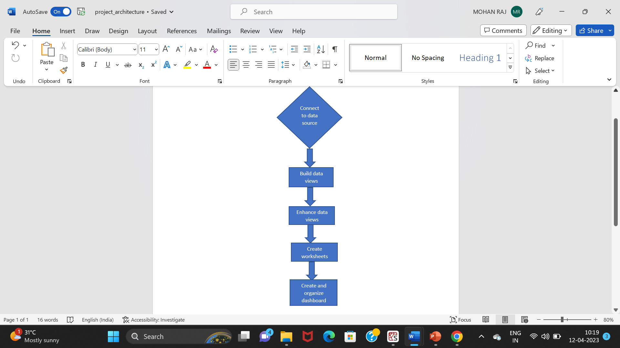



# Project Team Organization Plans

|  |
| --- |
| * Deliverable 1.1— * Deliverable 1.2— * Deliverable 1.3— |
| * Deliverable 2.1— * Deliverable 2.2— |
| * Deliverable3.1 – * Deliverable3.2 – * Deliverable3.3 – |



# PROJECT REFERENCES

|  |  |
| --- | --- |
| **Milestone** | **Deliverable** |
| [ |  |
|  |  |
|  |  |

# APPROVALS

**Prepared by** MOHANRAJ S__________________________________

Project Manager

**Approved by** Sharat Chandra M____________________

Project Sponsor

__________________________________

Executive Sponsor

__________________________________

Client Sponsor



# APPENDICES

## Document Guidelines

## Project Charter Document Sections Omitted

