Task carried out by Vijay S. Chavan,

Requirements:

1. STS- tool
2. MySQL
3. Java (1.8)
4. Postman

The Below image specifies about the data that is added for Product Details Specification, with data inserted successfully Status.

Link for the data adding is : localhost:8080/add

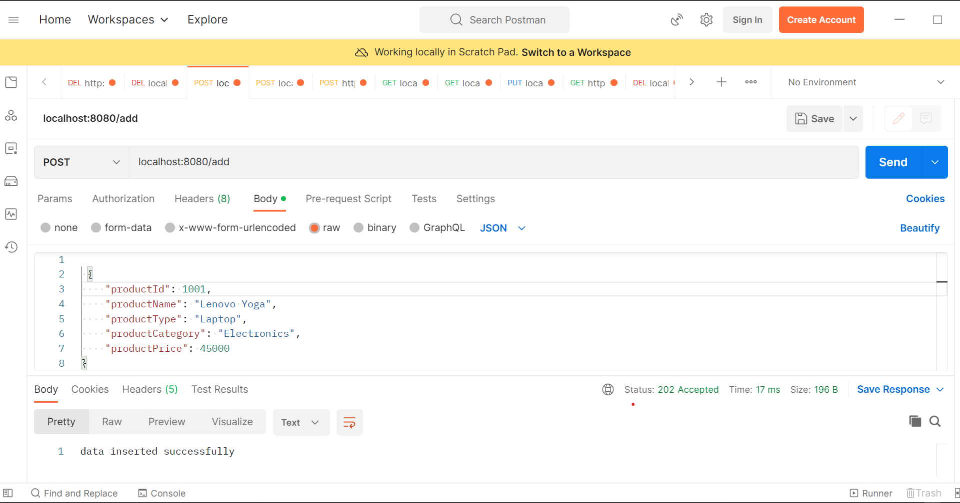

The Below image specifies about the data that is added for Product Charges Specification, with data inserted successfully Status.

Link for the data adding is: localhost:8080/store

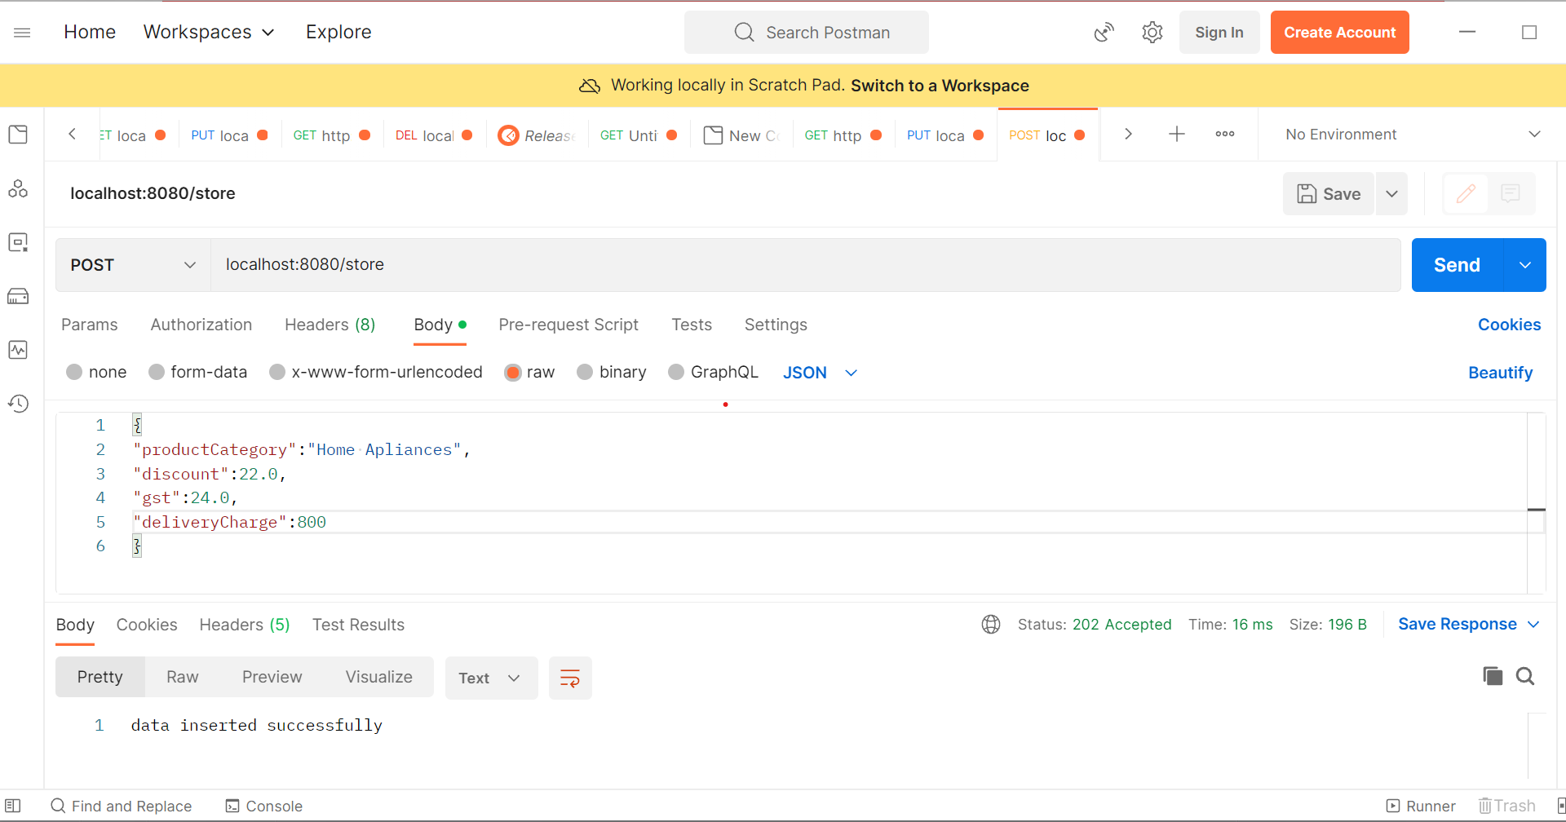

The below image specifies the data fetched using the get method in the given JSON format.

Using the link: localhost:8081/get?id=1001

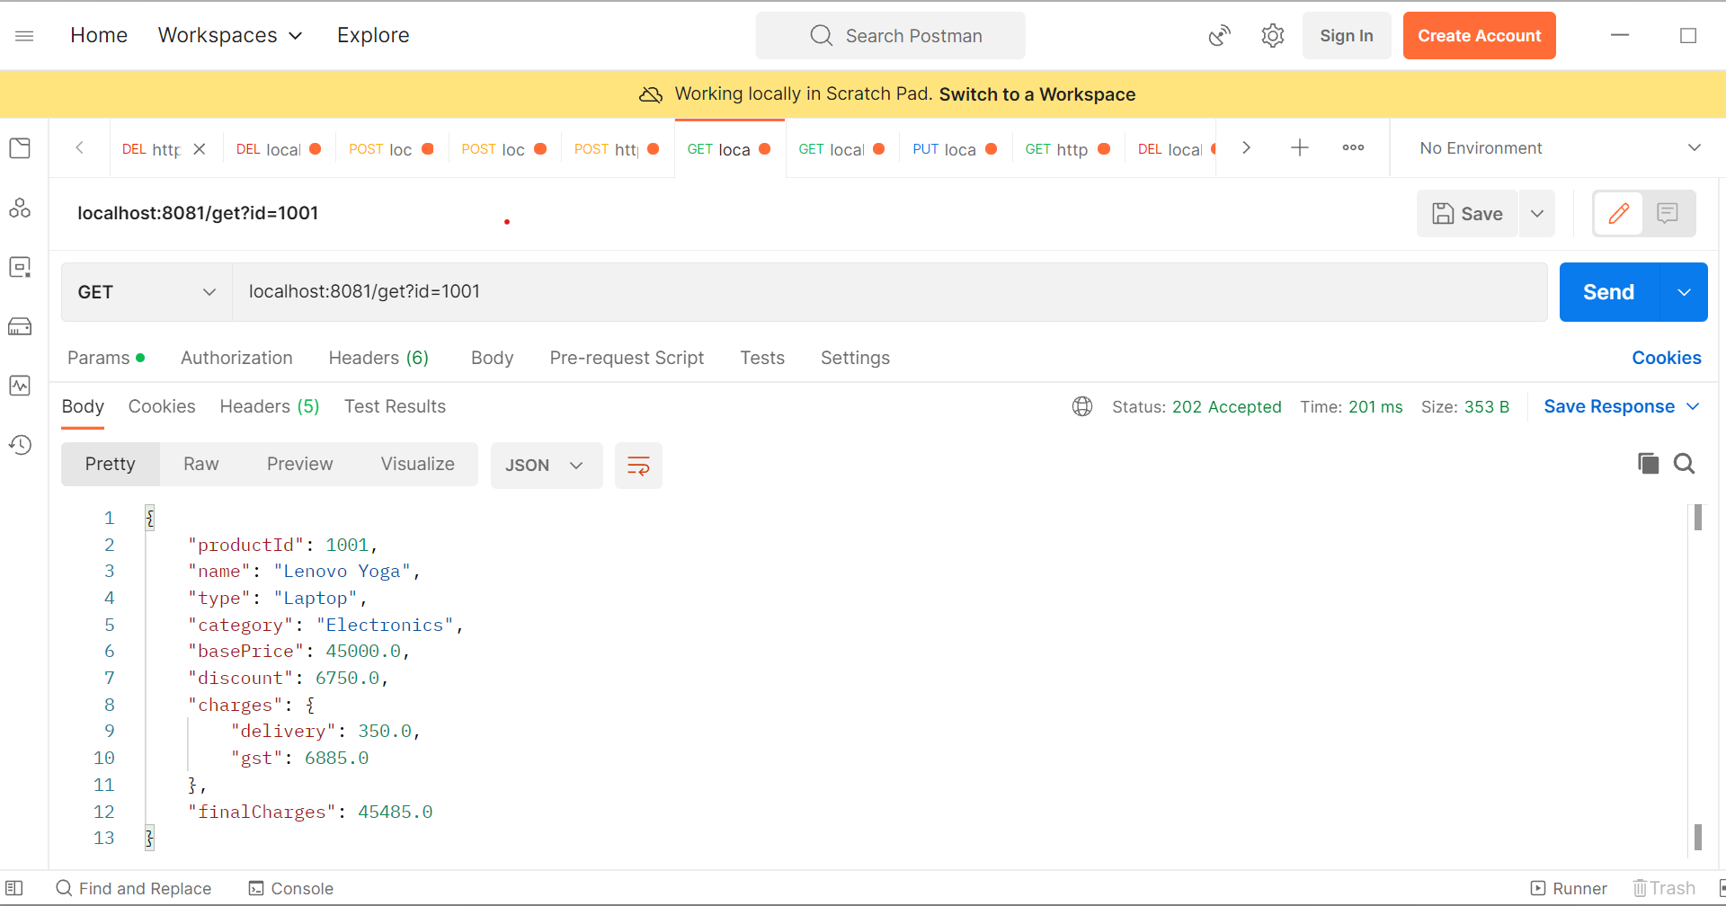

The below image specifies that the Update the data for Product Details.

Using the link: localhost:8081/update

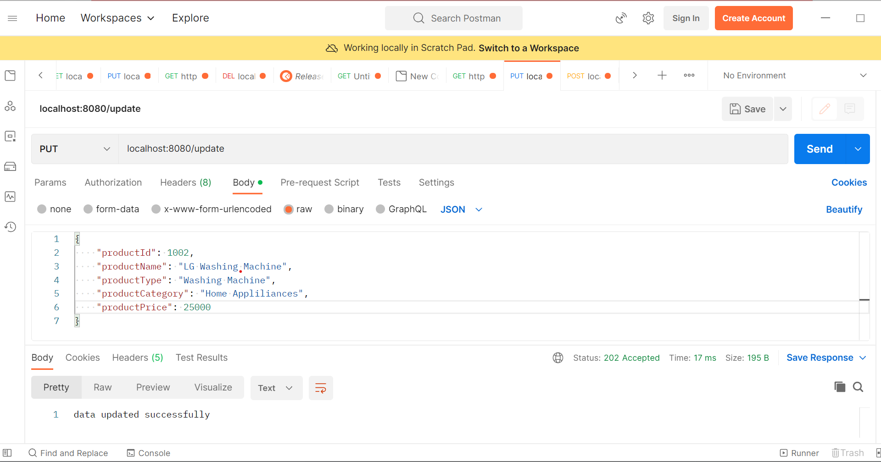

The below image specifies that the Update the data for Product Charges.

Using the link: localhost:8081/updateCharges

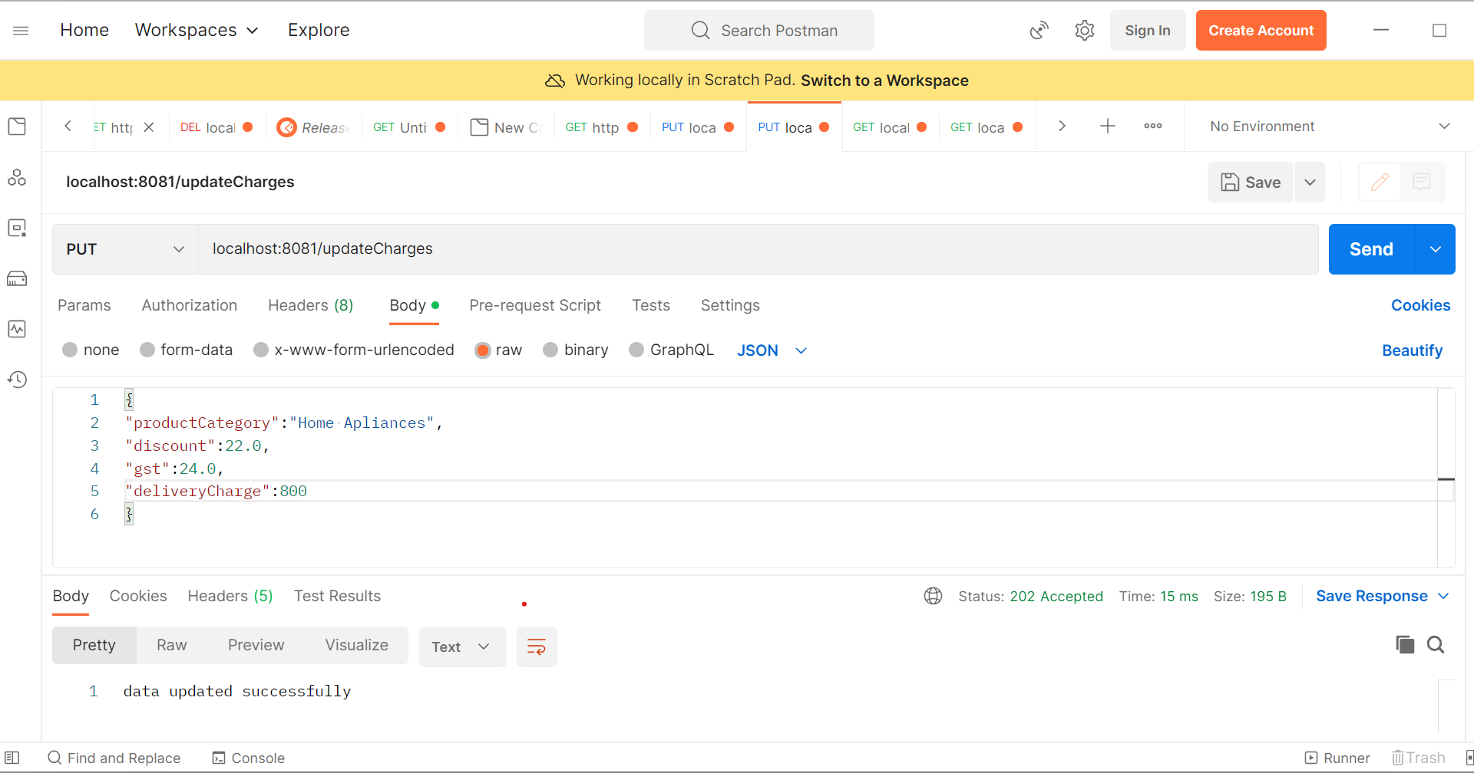

The below image specifies the delete the data regarding Product Details table.

Using the link: localhost:8080/delete?id=1009

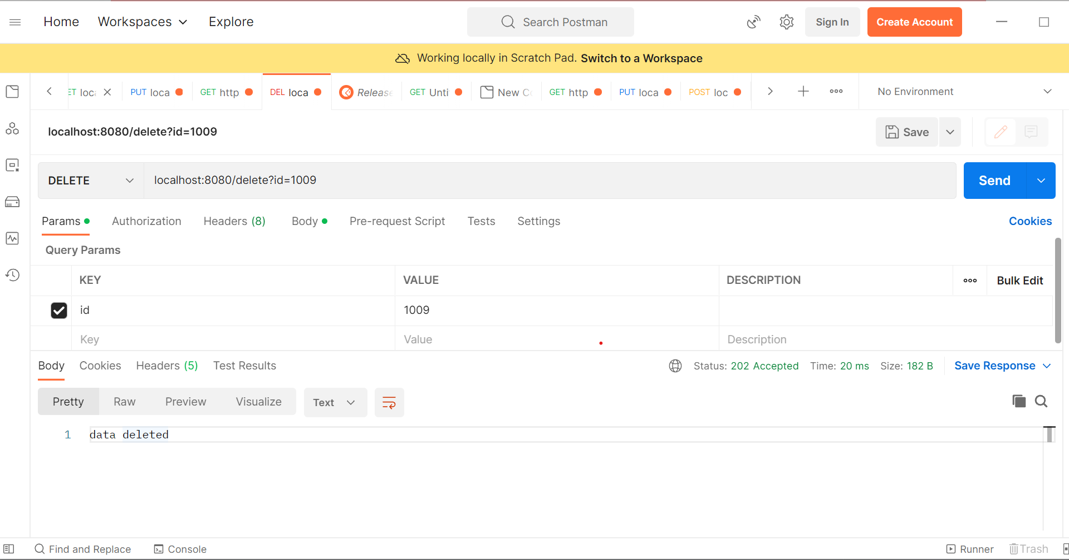

I wrote the JUnit test cases for controller and service classes. Also I use spring boot openapi ui dependencies for Swagger documentation.

Using the below link for documentation: <http://localhost:8081/context-path/swagger-ui.html>.

Thank You.