UML:

|  |
| --- |
| mainwindow |
| -begin : game  ui : MainWindow pointer |
| <<constructor>>+MainWindow  <<destructor>>+MainWindow  -on_startbutton_clicked() |

|  |
| --- |
| setup |
| +location : integer  +num : integer |
|  |

|  |
| --- |
| game |
| +dir : integer  +check[4][4] : integer  +temcheck[4][4] : i integer  +score : integer  +result : integer  +checkMove : bool  +block[16] : Set  +str : Qstring  -ui : game pointer |
| +<<constructor>>+game  +<<destructor>>+game  +Gamestart() : void  +Setpics(Set & b) : void  +CheckGame() :void  +NewGameInit() : void  +GetNumber() : void  +kerPressEvent(QKeyEvent *event) : void  +CheckScore() : void  +ProcessGame() : integer  +GetNumber() : integer  -on_resetbutton_clicked() : void |

↓

|  |
| --- |
| Set |
| +location : integer  +num : integer |
|  |

Scree shot:

1. 開始畫面:

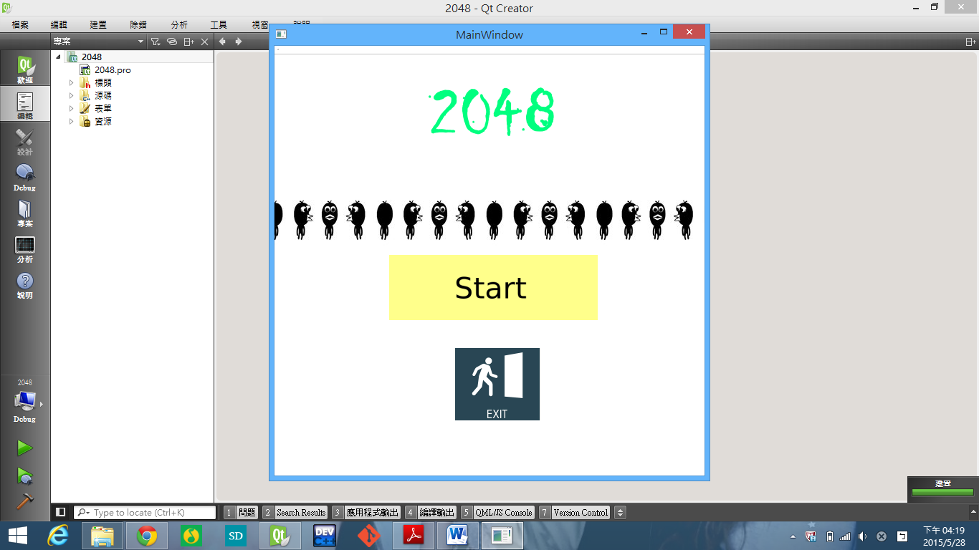

1. 遊戲畫面:

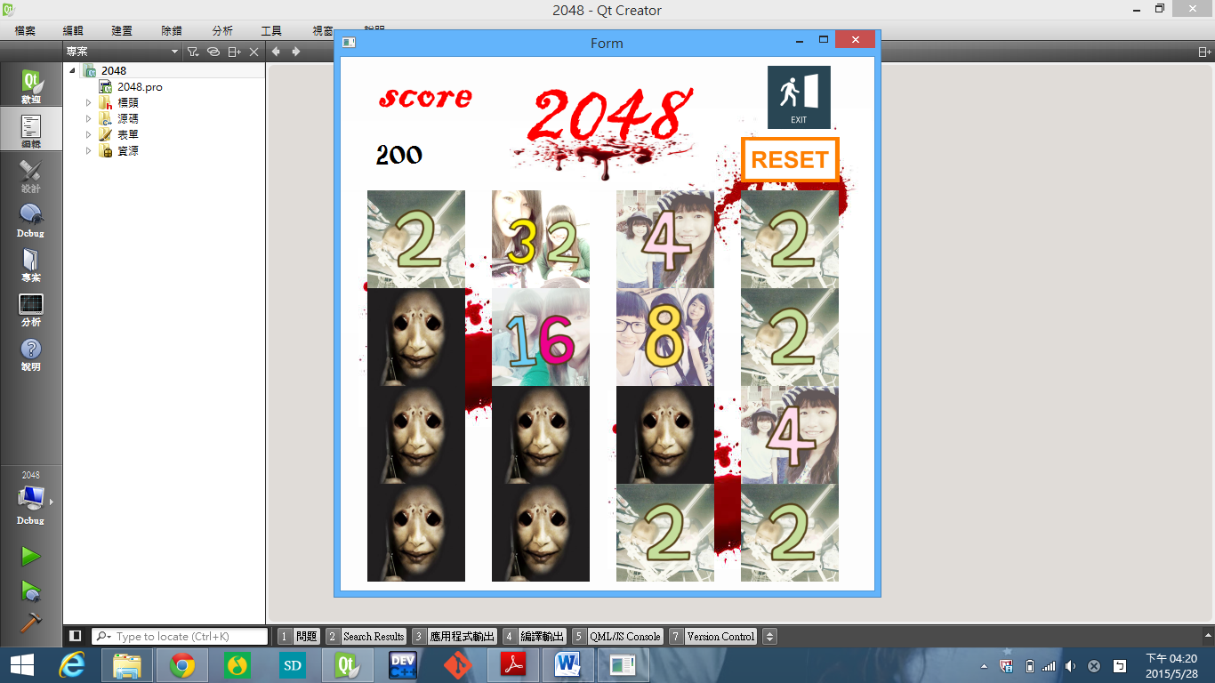

1. 輸了的畫面:

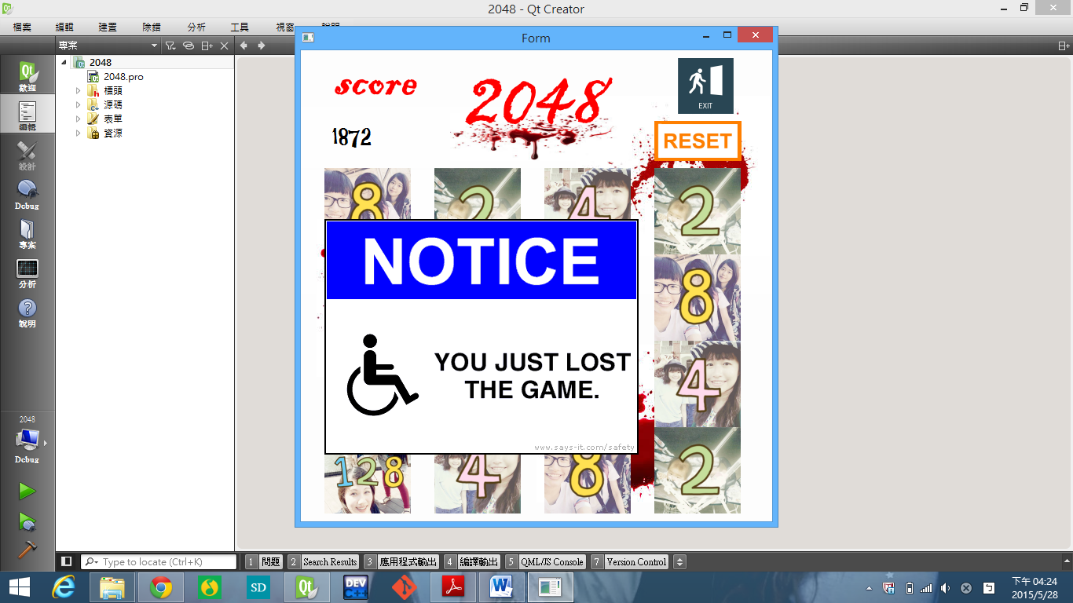

1. 贏了的畫面:

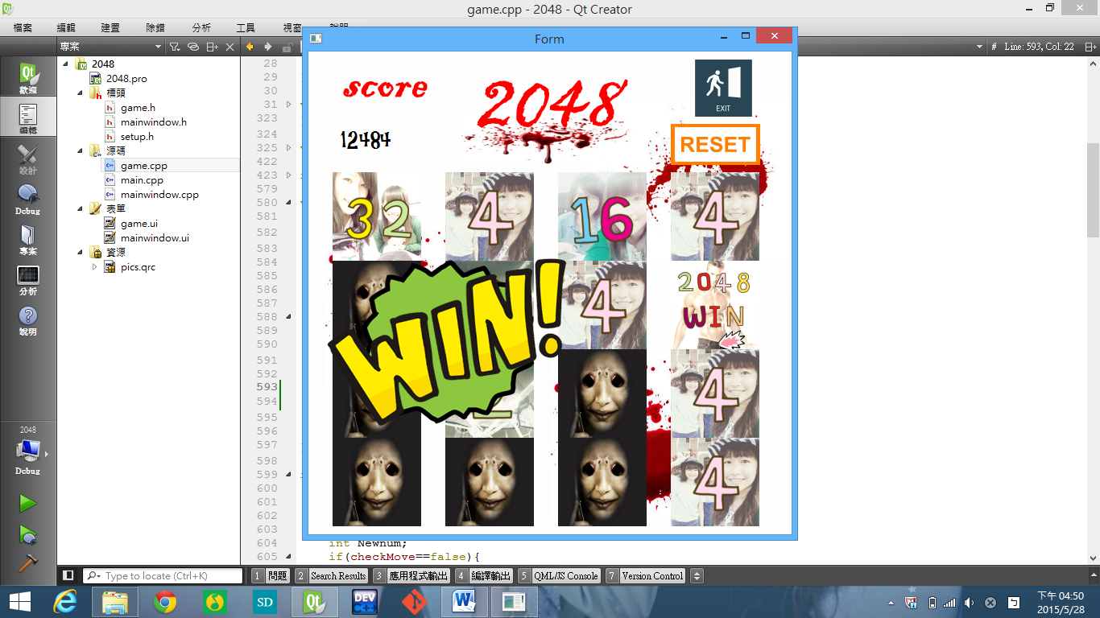

1. 按下reset後的畫面:

