# 数据库设计

E-R图

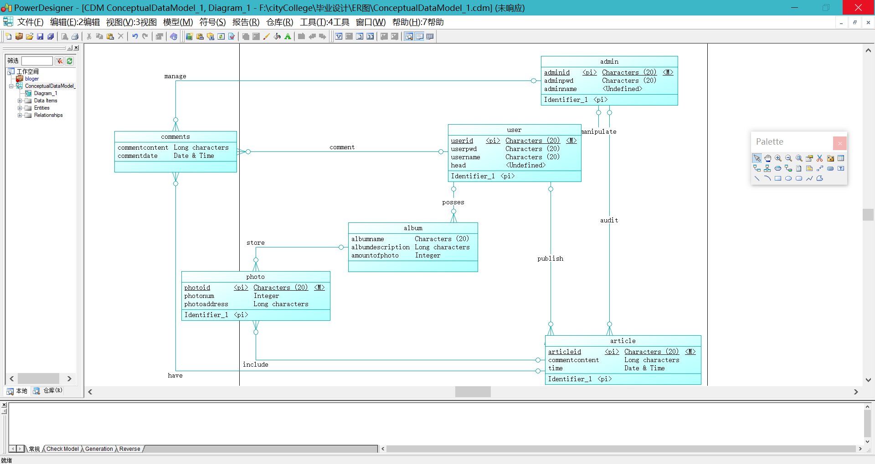

用户User

|  |  |  |
| --- | --- | --- |
| Name | Type | Description |
| id | VARCHAR(100) NOT NULL | PRIMARY KEY |
| pwd | VARCHAR(100) NOT NULL |  |
| name | VARCHAR(100) NOT NULL |  |
| head | VARCHAR(100) NOT NULL | 头像地址 |
| types | INT | 0为普通用户，1为admin |
| gender | INT |  |
| friend |  |  |

文章Article

|  |  |  |
| --- | --- | --- |
| Name | Type | Description |
| Id | VARCHAR(100) NOT NULL | PRIMARY KEY |
| title | VARCHAR(100) NOT NULL |  |
| content | VARCHAR(100) NOT NULL |  |
| writerid | VARCHAR(100) NOT NULL | 作者id |
| ctime | TIMESTAMP |  |
| photo | VARCHAR(100) | 图片地址 |
| audit | INT | 0成功1等待2失败 |
| zan | INT |  |

相册Album

|  |  |  |
| --- | --- | --- |
| Name | Type | Description |
| id | VARCH AR(100) NOT NULL | PRIMARY KEY |
| title | VARCHAR(100) NOT NULL |  |
| userid | VARCHAR(100) NOT NULL | 用户的id |
| time | TIMESTAMP |  |
| cover | VARCHAR(100) NOT NULL | 封面地址 |
| zan | INT |  |

图片Photo

|  |  |  |
| --- | --- | --- |
| Name | Type | Description |
| id | VARCHAR(100) NOT NULL | PRIMARY KEY |
| Title | INT | 图片标题 |
| userid | VARCHAR(100) |  |
| albumid | VARCHAR(100) |  |
| articleid | VARCHAR(100) |  |
| time | TIMESTAMP |  |

评论Comments

|  |  |  |
| --- | --- | --- |
| Name | Type | Description |
| id | VARCHAR(100) NOT NULL | PRIMARY KEY |
| userid | VARCHAR(100) NOT NULL |  |
| articleid | VARCHAR(100) NOT NULL |  |
| content | VARCHAR(100) NOT NULL |  |
| time | TIMESTAMP |  |
| zan | INT |  |

动态publish

|  |  |  |
| --- | --- | --- |
| Name | Type | Description |
| id | VARCHAR(100) NOT NULL | PRIMARY KEY |
| user | VARCHAR(100) NOT NULL |  |
| Article | VARCHAR(100) NOT NULL |  |
| Photo | VARCHAR(100) NOT NULL |  |
| Comment | TIMESTAMP |  |
| Ctime | INT |  |

创建数据库sql语句

CREATE DATABASE myblog;

use myblog;

创建数据库表sql语句：

DROP TABLE IF EXISTS`user`;

CREATE TABLE IF NOT EXISTS `user`(

`id` VARCHAR(100) NOT NULL,

`pwd` VARCHAR(100) NOT NULL,

`name` VARCHAR(100) NOT NULL,

`head` VARCHAR(100) NOT NULL,

`type` INT,

`gender` INT,

PRIMARY KEY ( `id` )

)ENGINE=InnoDB DEFAULT CHARSET=utf8;

DROP TABLE IF EXISTS `article`;

CREATE TABLE IF NOT EXISTS `article`(

`id` VARCHAR(100) NOT NULL,

`title` VARCHAR(100) NOT NULL,

`content` VARCHAR(100) NOT NULL,

`writerid` VARCHAR(100) NOT NULL,

`time` TIMESTAMP,

`photo` VARCHAR(100),

`audit` INT,

`zan` INT,

PRIMARY KEY ( `id` )

)ENGINE=InnoDB DEFAULT CHARSET=utf8;

DROP TABLE IF EXISTS `album`;

CREATE TABLE IF NOT EXISTS `album`(

`id` VARCHAR(100) NOT NULL,

`name` VARCHAR(100) NOT NULL,

`userid` VARCHAR(100) NOT NULL,

`time` TIMESTAMP,

`cover` VARCHAR(100) NOT NULL,

`zan` INT,

PRIMARY KEY ( `id` )

)ENGINE=InnoDB DEFAULT CHARSET=utf8;

DROP TABLE IF EXISTS `photo`;

CREATE TABLE IF NOT EXISTS `photo`(

`id` VARCHAR(100) NOT NULL,

`type` INT,

`userid` VARCHAR(100),

`albumid` VARCHAR(100),

`articleid` VARCHAR(100),

`time` TIMESTAMP,

PRIMARY KEY ( `id` )

)ENGINE=InnoDB DEFAULT CHARSET=utf8;

DROP TABLE IF EXISTS `comments`;

CREATE TABLE IF NOT EXISTS `comments`(

`id` VARCHAR(100) NOT NULL,

`userid` VARCHAR(100) NOT NULL,

`articleid` VARCHAR(100) NOT NULL,

`content` VARCHAR(100) NOT NULL,

`time` TIMESTAMP,

`zan` INT,

PRIMARY KEY ( `id` )

)ENGINE=InnoDB DEFAULT CHARSET=utf8;